

Up!Up!

Thanks for downloading the asset , for any help contact me at [madfireongames@gmail.com](mailto:madfireongames@gmail.com)

Scripts

GameManager – This script controls the game from start to end. It keep track of game , saves and loads the data , and do many important functions.

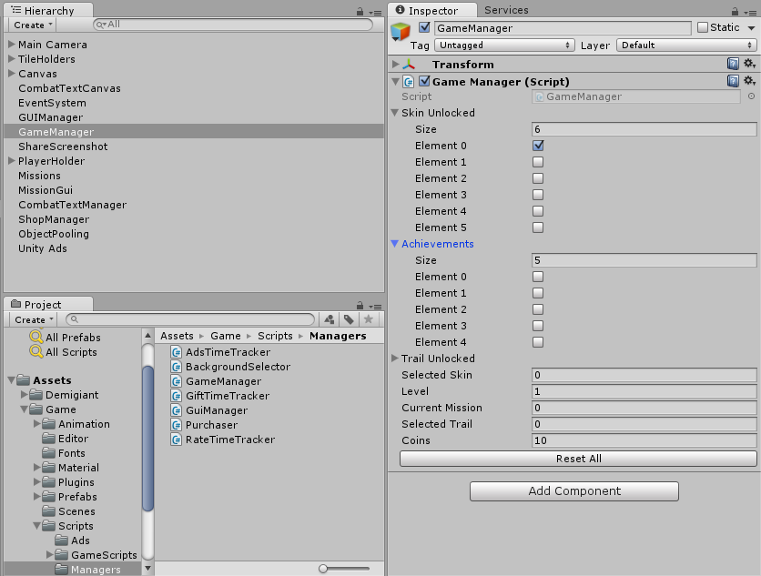

GUIManager- This script controls the function of the buttons in the game. Here you assign the buttons , and write the function for them.

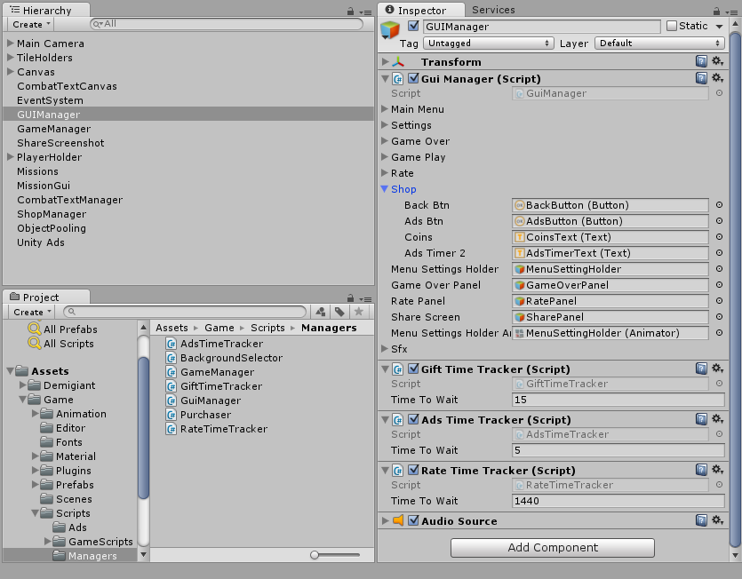

ObjectPooling – This creates the clone of object to be used repeatedly in the game. This help in increase in the smoothness of game.

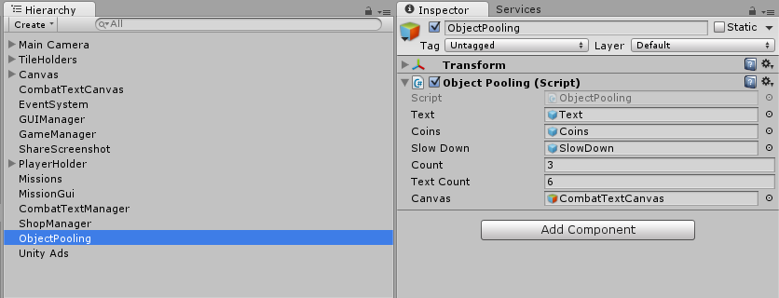

ShopItemList – This script controls the in game shop.

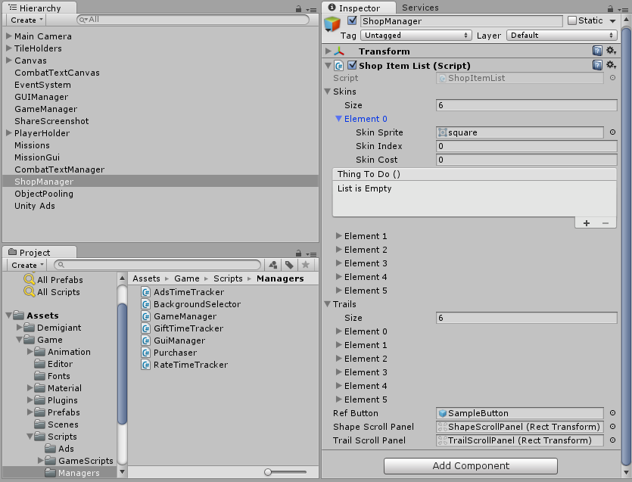

ShareScreenShot – This script handles the share score function , it works only for android and on iOS.

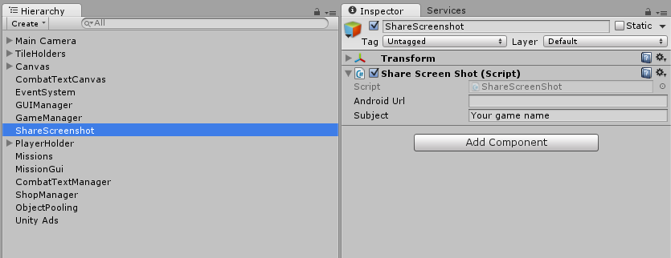

Missions – This script handles the game missions , right now only two types of missions is included “Score” and “GamePlayed”.

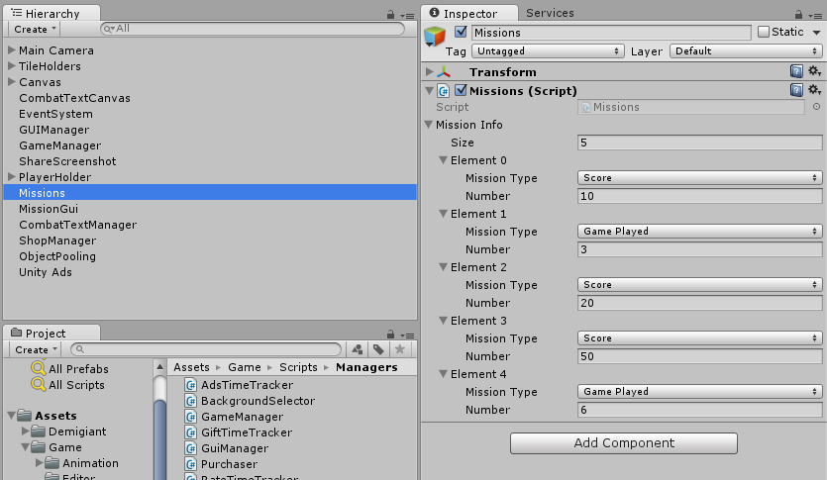

CombatTextManager – This script creates the floating text in the scene.

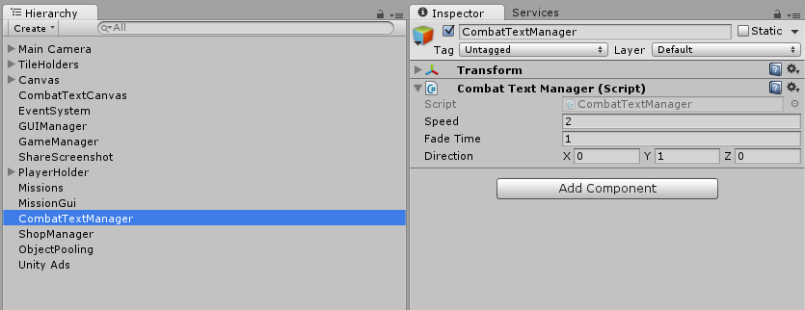

PlayerHolder – This script contains the reference to player shapes and trails and decide which to active and which to deactivate.

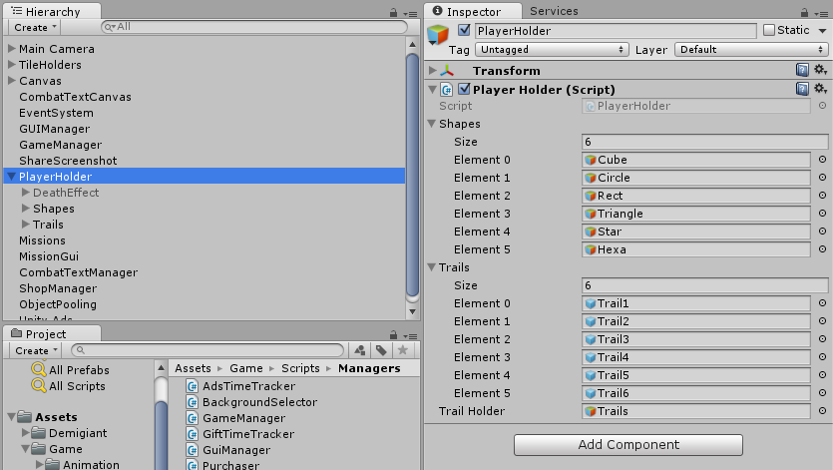

AdsManager – This script contains the methods of admob ads which are used to show ads. Always call this script in the scene which load only once in the game like Splash Scene.

