How To Reskin?

Shape Reskin:- To reskin shapes you will have to change the “Sprite” field sprite in SpriteRendere.

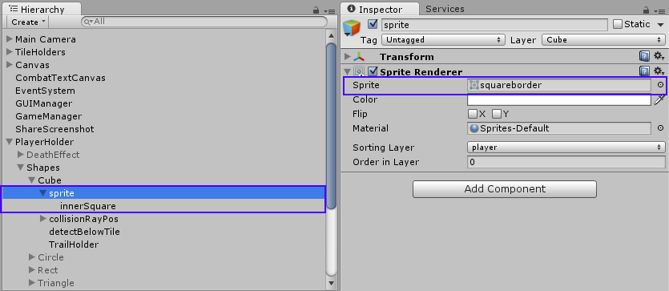

Trail Reskin:- To reskin trails you will have to change the material of M , B , T.

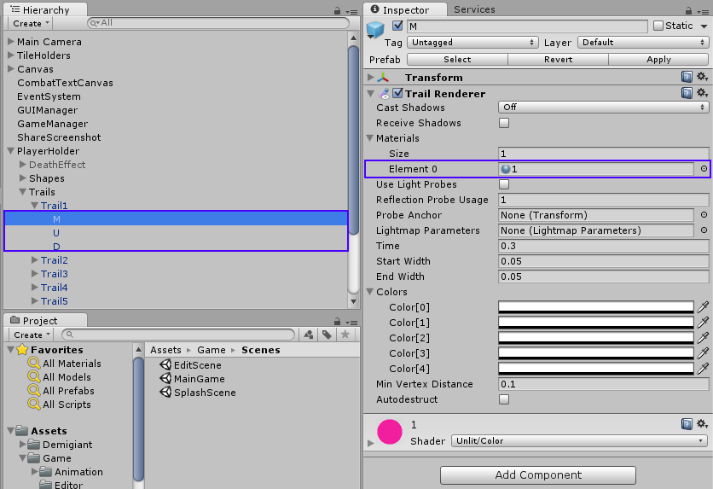

Background Reskin:- To reskin background you will have to change the sprite of “Sprite” field.

