Color splash effect in MATLAB

How to use?

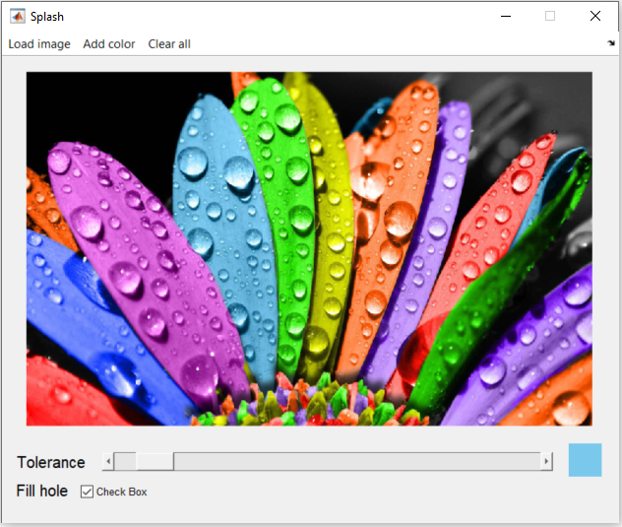

Menu:

1. Load image: load image file to edit
2. Add color: pick another color to current selection(s)
3. Clear all: re-start from original image

Tolerance bar: Adjust threshold of color tolerance for every single color. Selected color is displayed by the side of tolerance bar.

Fill hole: fill holes or not in the selected colors

Single-color splash



Multi-color splash



Filled hole

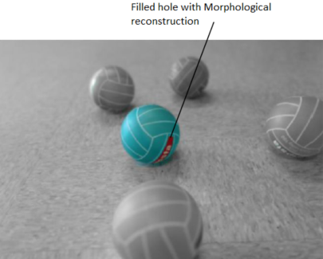

Examples

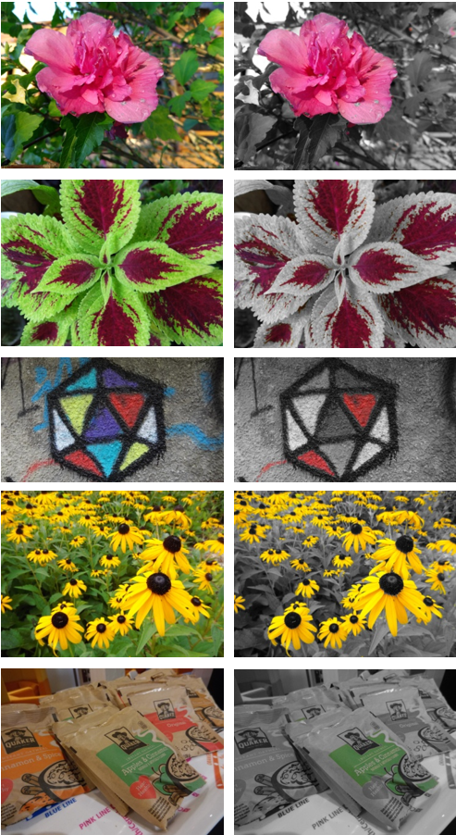

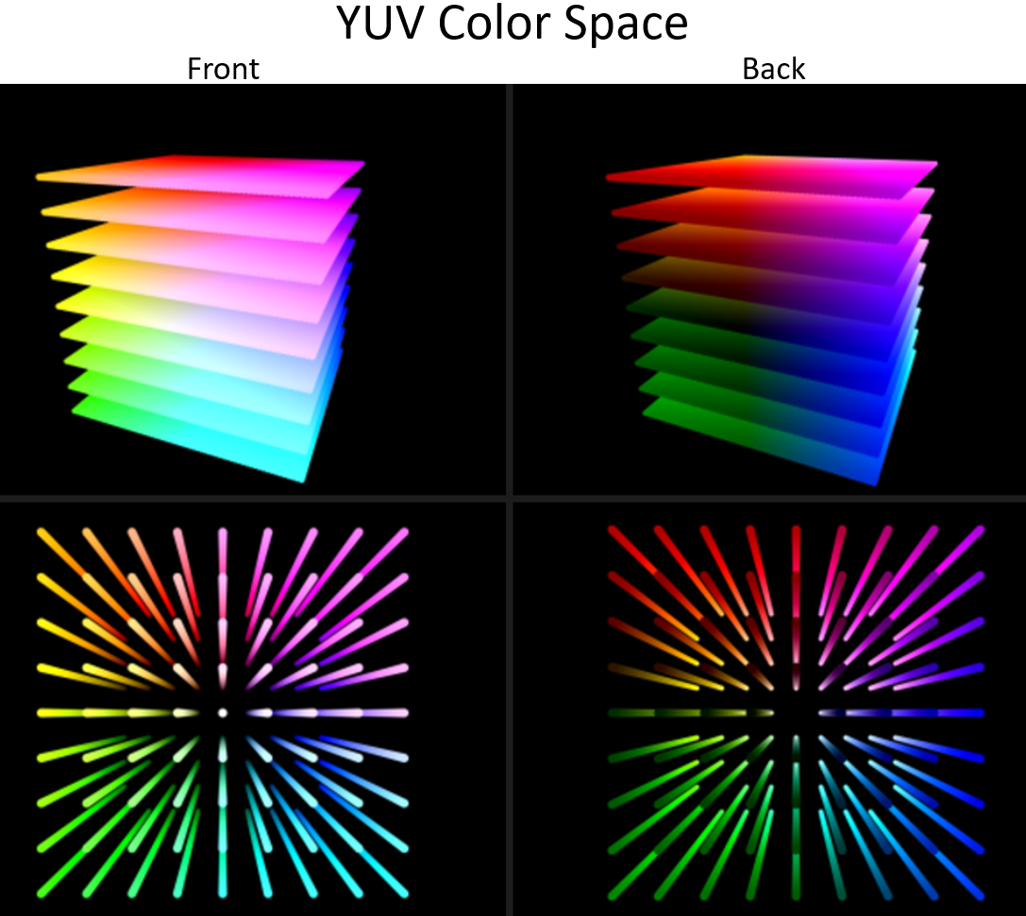

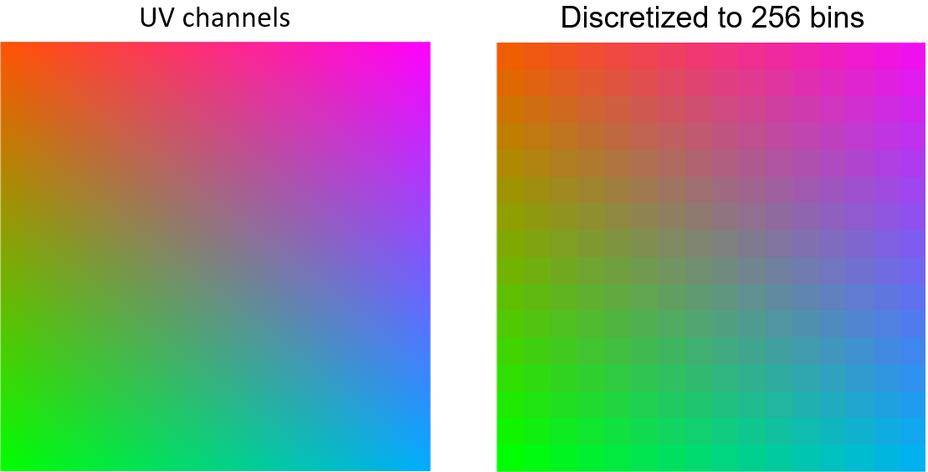

1. Convert the image into YUV color space. Only **blue luminance** (U) and **red luminance** (V) were used



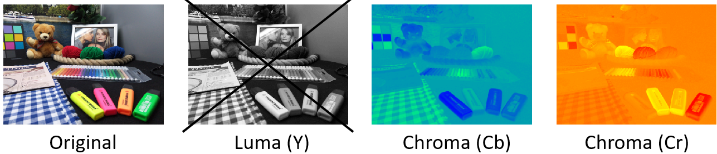

1. Obtain the selected color by averaging a very small region of selected points (e.g. 7*7 pixels)

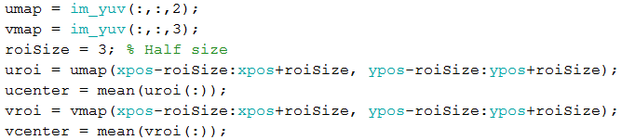

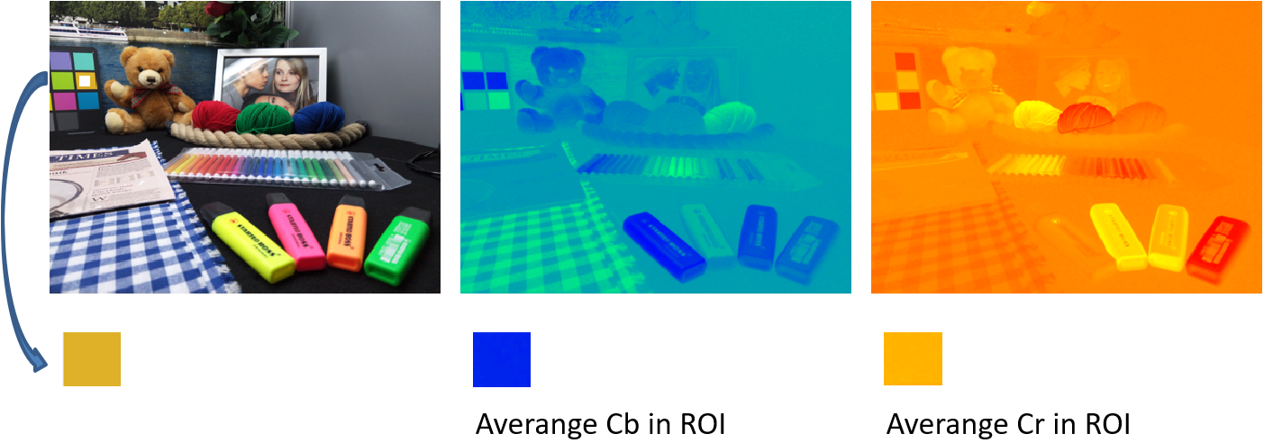

1. Calculate the Euclidean distance based on the selected color

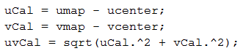

1. Normalize the distance by the feather parameter



1. Transform the normalized distance to a probability distribution by applying Sigmoid function and mapping it to the [0,1] range

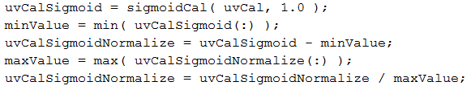

1. Estimate the mask by applying a threshold to the probability distribution. The threshold could be adjustable by the user.



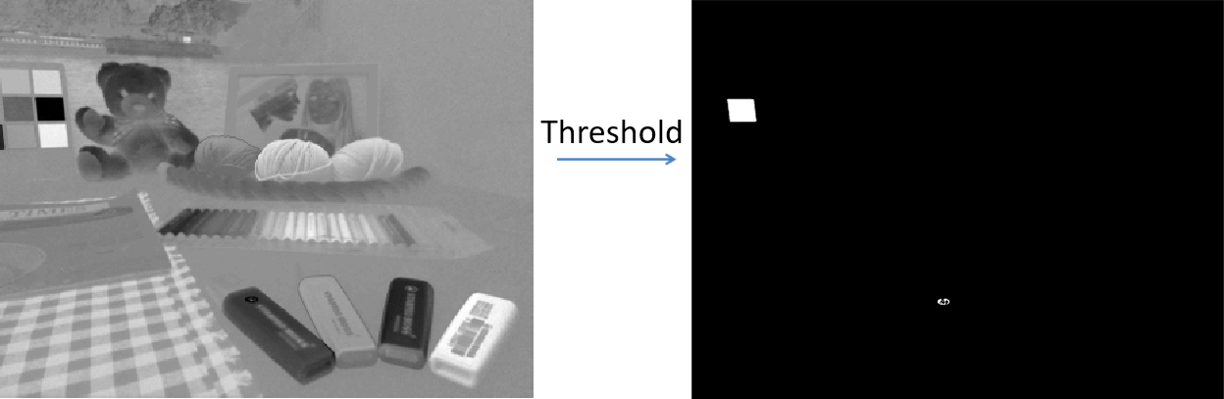

1. Fill the holes in the mask using Morphological reconstruction method. This is an optional step, user could simply enable or disable this feature.



1. Use the mask to combine the colored image and its mono version to get the final output

