**How to Use Random Group Assignment Application**

This document shows how to use the Shiny (a web-based R library) application Groups to randomly assign students to groups for group activities. The first step is to create a text file containing your class roster. Although this is the first step, we will describe it last in this write-up. We assume that your roster already exists and accessible in the file system of the computer you will be using to assign groups.

**Step 1.** Open the application itself. (<http://lmcstatistics.shinyapps.io/Groups/)>

The initial screen is shown below.

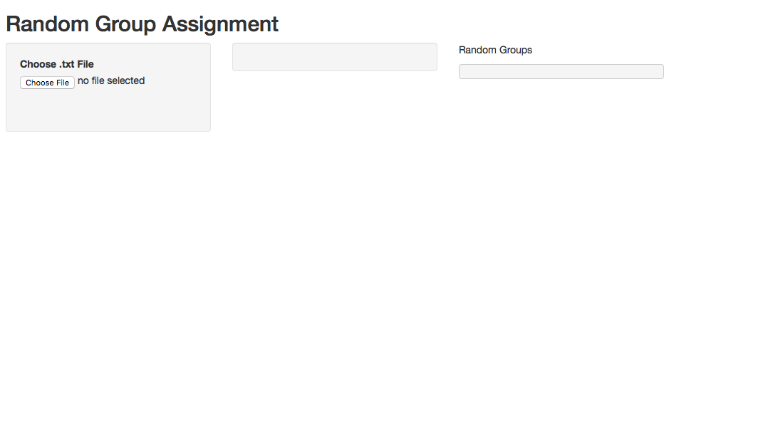

**Step 2.** On the left-hand column, click the Choose .txt File button. This will open a file browser, as shown below, and from that you select your roster (a text file). From the browser, select Choose.

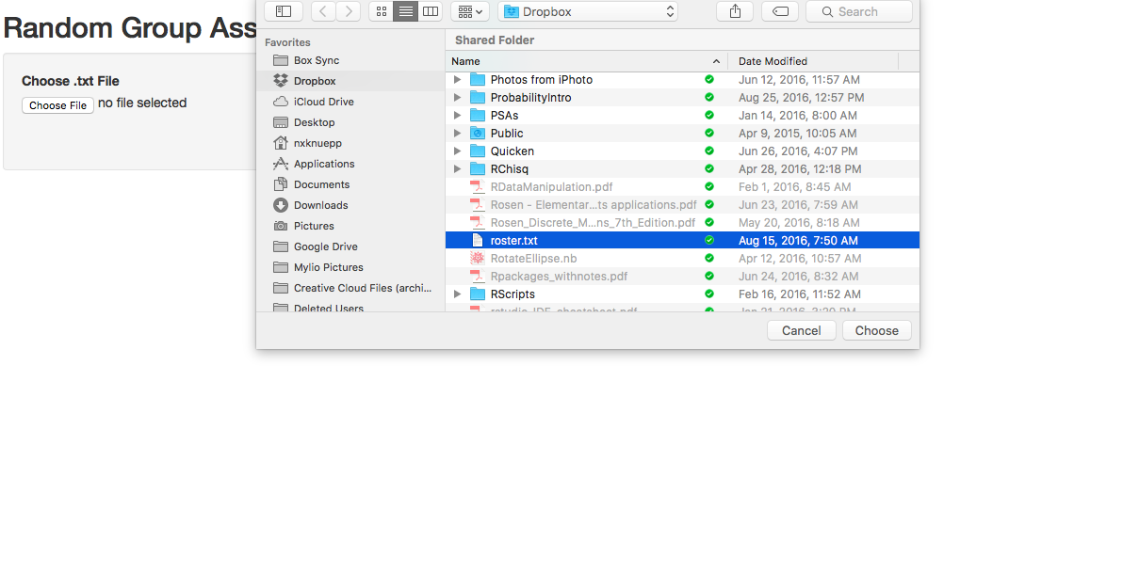

**Step 3.** The second column populates with the students from your roster. All students are checked initially.

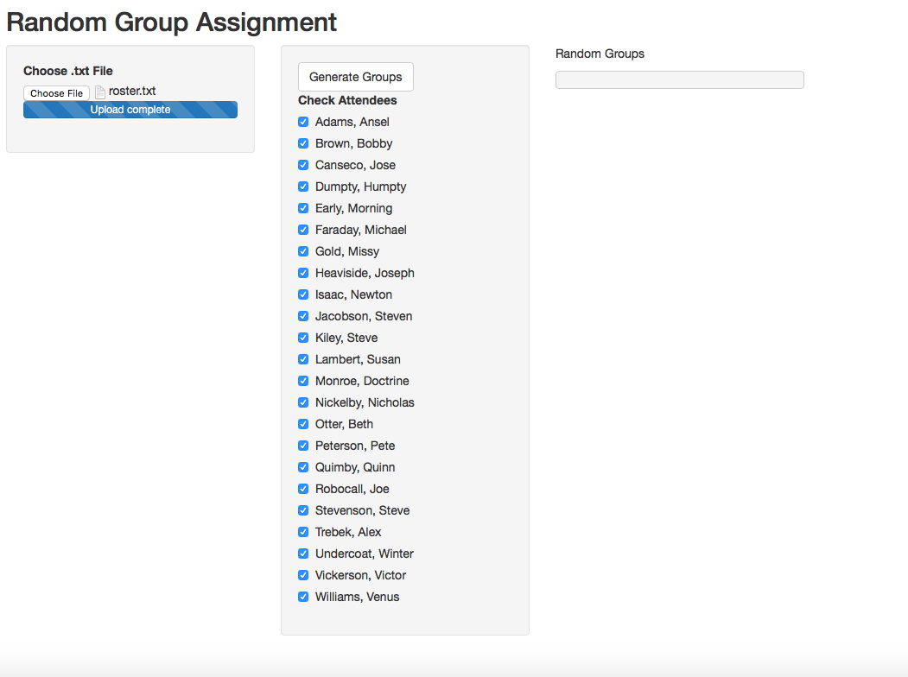

**Step 4.** Uncheck the absent students, as show in the example below.

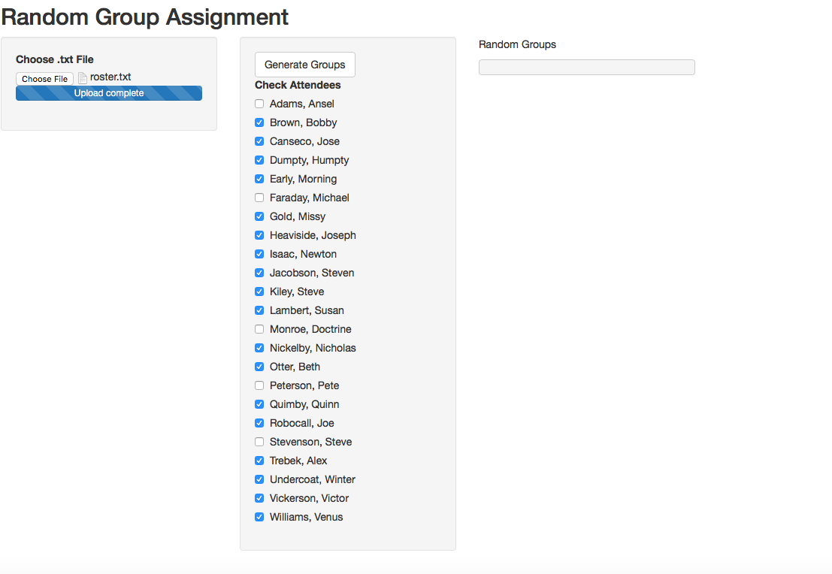

**Step 5.** Check the Generate Groups button in the second column. This will produce a random group assignment, as shown below.

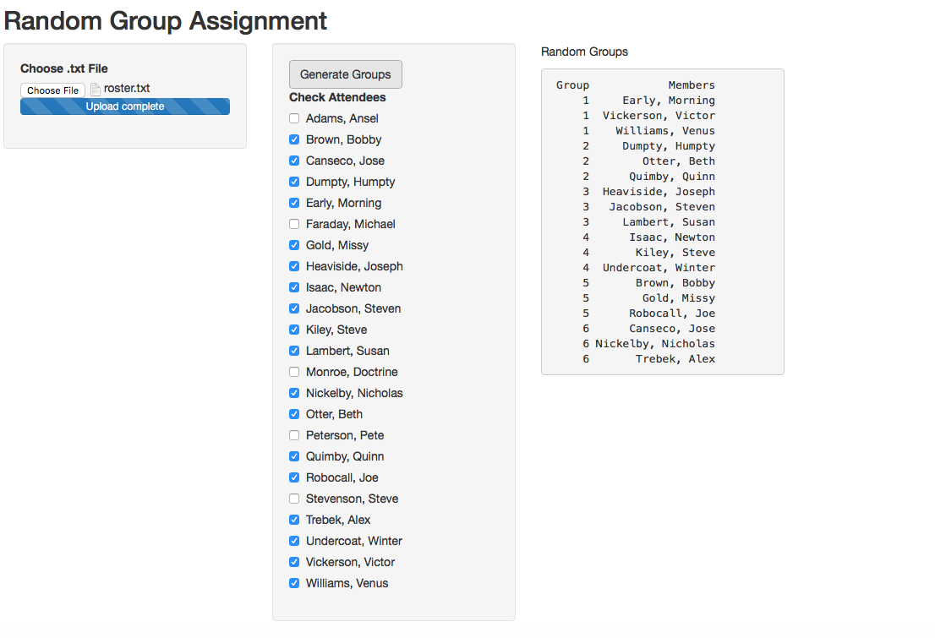

**Step 6.** If you want to generate a different group set, just click Generate Groups again. A different group will be produced. You won’t run of groups. You can do the math.

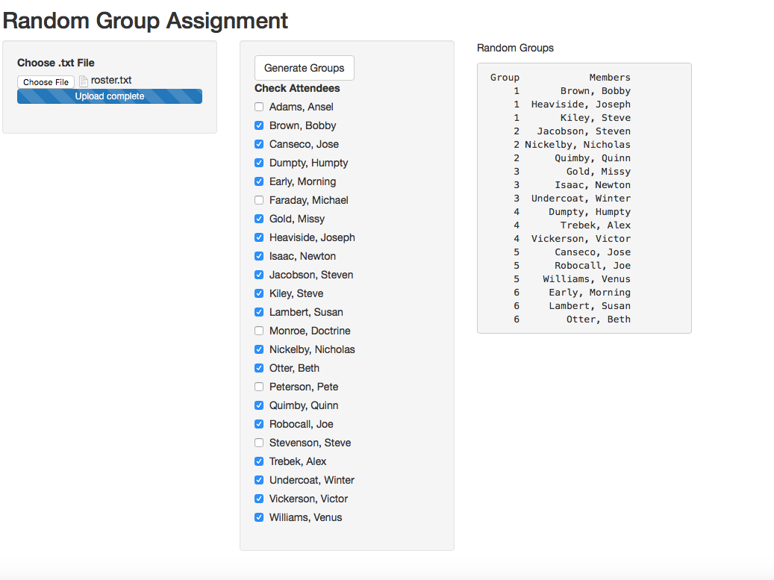

**The Class Roster.** The class roster we have been using appears below. The only thing special about the file is that the names appear within double quotes. There’s no requirement to have last name first. However you want your class list to appear is fine, as long as each student appears on a separate line, and the name is in double quotes.

You can use whatever program you like to generate your roster, as long as the software can save the roster as a plain text file. Here a two text editors that will do the job.

Mac: TextWrangler (free)

Windows: NotePad (free)

