OFFICE OF TRUST SERVICES

PATHWAYS INTERNSHIP PROGRAM

New Employee System Accesses On-Boarding Checklist and Guide
(Student Only)

Purpose: To guide employees through the normal on-barding workflow processes within the Bureau of Indian Affairs (BIA) for requesting basic government information systems accesses.

Student Name:

Completed
- Security Requirements and DOI Access-ID Badge (Smartcard)
- Request DOI Learn Account Access and Complete First-Time Login (DOI Learn)
- Complete FISSA+ Training
- BIA Email (Bison Connect) Account Setup
- QuickTime Training and Profile Account Setup
- BIA Email Activation – First-Time Login (After Favorable Screening Received)
- Log Into QuickTime

Complete if Travel Required
- “Travel Only” Government Charge Card (GOVCC) Training and J.P. Morgan Application
- Concur System Access Request Form/Profile Setup (Travel Arrangement System) and Complete First-Time Login (Concur)

After Tentative Selection Offer (Letter sent to student)

- Security Requirements and DOI ID Badge (Smartcard)
There are two critical steps that must be completed by the applicant before issuance of a DOI ID Badge (government-issued identity credential): 1) submission of the background investigation (BGI) forms through e-QIP (Electronic Questionnaires for Investigations Processing) and 2) electronic finger prints.

  - Employee to do:
    - Personnel Security will send the applicant an email providing detailed instructions to complete e-QIP and BGI requirements. Must be completed within 5 days of receiving.

    - Complete e-QIP online forms and upload required documents. When instructed, send signed original security forms (i.e., release forms) to the Personnel Security office.
    - Employee will then receive an email to schedule an appointment and complete enrollment at a Credentialing Center (includes photo and electronic fingerprinting).
    - Respond immediately to requests from Personnel Security for additional information or clarification if needed.
    - After the DOI ID Badge is activated, the Active Directory (AD) status will be changed from “Pending” to “Active” in DOI Access. Applicant will be notified through email when the DOI ID Badge is ready for pickup.
    - Schedule an appointment to pick-up and activate DOI ID Badge.

After the successful completion of a FBI finger print check, Personnel Security will issue a favorable screening. This is when HR will confirm the offer of employment and negotiate a start date.

Links and Help
e-QIP: www.opm.gov and click on “Investigations”, “e-QIP Application”, “Enter e-QIP Applicant Site” and follow the prompts.

DOI Access (Smartcard)
- Check DOI Access Card Status and Site: https://doiaccess.doi.net/app/
- Schedule appointment to pick-up/activate: https://timetrade.com/app/usaccess/workflows/usaccess001/schedule/?appointmentTypeGroupId=hspd12

Human Resources (HR)
- Geralyn Eckiwadau, Human Resources Specialist, 405-247-1603, geralyn.eckiwaudah@bia.gov
- Daniella Thompson, Human Resources Assistant, 405-247-1641, daniella.thompson@bia.gov

Personnel Security
- Lara Willie, Security Assistant, 505-563-5294, lara.willie@bia.gov
- Janet Nash, Security Specialist, 505-563-5238, Janet.Cook@bia.gov
- Jacqueline Honahni, Supervisor Security Specialist, 505-563-5287 Jacqueline.Johnson@bia.gov

After Favorable Screening and Before the First Day

- Request DOI Learn Account Access
Normally DOI Learn accounts are created automatically approximately 2-4 weeks after an employee starts. However, due to the limited time allotted for the internship, the Employee will need to expedite the process by sending an email to the DOI Learn Administrator.

- Employee to do:
    - Send an email to the Administrator as follows:

EMAIL
To: doilearn@bia.gov
CC: gayla.schock@bia.gov; otspathways@bia.gov
Subject: Request for manual creation of a DOI Learn account
Please create a DOI Learn account for me using the following information:
My legal full name is: First Name Last Name
The Office I work for is: Office of Trust Services, Bureau of Indian Affairs
My supervisor’s name is: [Gayla Schock]

    - If approved, the Administrator will send employee an email giving them their user name, temporary password, and instructions on how to login.
    - Employee must complete a first-time login to activate account at https://gm2.geolearning.com/geonext/doi/login.geo

- Complete FISSA+ Training

- Employee to do:
- Employee completes the Federal Information Systems Security Awareness + Privacy and Records Management (FISSA+) Training in DOI Learn at: https://gm2.geolearning.com/geonext/doi/login.geo?OriginalURL=%2fgeonext%2fdoi%2fmyhome.geo
- Save a PDF copy of the FISSA+ Training Certificate to your computer. This certificate will be needed to setup your BIA Email (Bison Connect).

- BIA Email (Bison Connect) Account Setup (After Favorable Screening)

- Employee to do:
- Employee sends an email to the BIA Helpdesk containing the following information and attaches a PDF copy of the FISSA+ Training Certificate:

EMAIL
To: biahelpdesk@bia.gov
CC: gayla.schock@bia.gov; otspathways@bia.gov
Subject: Expedite Request for BIA Email Account for New Employee

Re: Reason code "New User"
Attached is a FISSA+ training completion certificate. Please update my IIS eProfile to show FISSA+ training completed and ensure my information is listed as follows:

My legal full name is: First Name Last Name
The Office I work for is: Office of Trust Services
Organization Code is (Choose One): K00443 - Forestry or K00442 - Fire or K00460 - Rangeland
My supervisor’s name is: Gayla Schock
(If applicable) Also, employee will need to have his/her workstation setup at [address and room number].

- The employee will receive an e-mail with their new login and temporary password and login instructions. You will use this information to login to your BIA Email on or after your program start date. You will not be able to login from your home computer without a USB smart card reader.

Links and Help
BIA DOI Learn Webpage: http://www.bia.gov/WhoWeAre/AS-IA/OHCM/doilearn/
BisonConnect: https://mail.google.com/mail/u/0/#inbox
Bison Tips and Tricks: https://sites.google.com/a/doi.gov/bisonconnect-resource-site/tips-and-tricks
Bison Support: https://sites.google.com/a/doi.gov/bisonconnect-resource-site/support

On or After Employee’s Start Date

- BIA Email Activation – First-Time Login

- Employee to do:
- Employee should refer back to the e-mailed instructions sent from the BIA Helpdesk to complete the first-time login process to activate their BIA email account. Employees can complete this process using a USB smart card reader and their DOI Access Card (Smartcard) by going to: http://mail.doi.gov/

NOTE: Employee must have completed the email account activation process before proceeding. The reason this is necessary is because this is how your “active directory” profile account gets activated, which is what is required for any federal information systems accesses.

- QuickTime Training and Profile Account Setup

- Employee to do:
- Employee completes “QuickTime Employee eLearning” at: https://hrdtrainingportal.ibc.doi.gov//DMARTPORTAL/?LOAD=1&PGID=117#Quicktime
QuickTime Training and Profile Account Setup (continued)

- Using BIA email account, forward a PDF copy of the “Certificate of Course Completion” to the QT Administrator and provide the following:

EMAIL
To: carl.cook@bia.gov
CC: deborah.abeita@bia.gov; gayla.schock@bia.gov; otspathways@bia.gov
Subject: New Employee - BIA QuickTime Access
Attached is a QuickTime Employee Training Completion Certificate. I am requesting
QuickTime Employee ID and Password using the following information:

My legal full name is: First Name Last Name
The Office I work for is: Office of Trust Services

Organization Code is (Choose One): K00443 - Forestry or K00442 - Fire or K00460 - Rangeland
My supervisor’s name is: Gayla Schock

- The employee will receive an e-mail with their new login and temporary password and login instructions.

- Log Into QuickTime

- Employee to do:
- Update Internet Explorer browser’s security settings (enable TLS) 
- Using a USB card reader, insert DOI Access Card
- Go to DOI Application Access Portal at https://apps.doi.gov
Steps:
- Under DOI Access Card select “Connect”
    - A window will pop up, select your certificate name, click OK (If you select wrong cert, close all windows and start over)
    - Another window will pop up; enter your smart card PIN authentication number. This is the same 8 digit pin number you chose when you first registered for your DOI Access Card.
    - Then you will be directed to a new screen, select the “BIA / BIE T&A” link and you will be directed to the QuickTime application login
    - Select “I Agree” then the QT portal will open
    - Enter your QT Employee ID and Password to log in
Links and Help
Pathways QuickTime Program Administrator: monica.cooper@bia.gov

QuickTime Training: https://hrdtrainingportal.ibc.doi.gov/DMARTPORTAL/?LOAD=1&PGID=117
QuickTime Help: ttps://www3.ibc.doi.gov/services/hr/Quicktime/SSA_nonewd/WebHelp/qtime.htm

Leave and Attendance
- IBC QuickTime Site
- DOI Leave Handbook
- IA Leave Handbook (PDF)
- Time and Attendance Guide - 8/2015 (PDF) New
- Timekeepers Handbook (PDF)

Complete if Travel Required.
- “Travel Only” Government Charge Card (GOVCC) Training and J.P. Morgan Cardholder Application Form

  - Employee to do:
    - Complete the online “Cardholder Training” at https://cctrain.ibc.doi.gov/
      - Complete only modules A & B
    - Email copies of the 2 training certifications to supervisor and designated Pathways Coordinator to verify training has been completed.

EMAIL
To: gayla.schock@bia.gov; bradley.crest@bia.gov; otspathways@bia.gov
CC:
Subject: Cardholder training completed
Attached are Modules A & B “Travel Only” training completion certificates.

    - Upon receiving confirmation training completed, supervisor will works with employee to complete JP Morgan Cardholder Application form. (Digital signatures not accepted. The form must be printed, signed, and scanned)
    - See Attachment #1 for a prefilled copy of the “Travel Only” form
    - Supervisor will email the completed Application to your local Agency Organization Program Coordinator (A/OPC) for processing.

Complete if Travel Required.
- Concur System Access Request Form and Profile Setup (Travel Arrangement System)
Employee must have an AD account, BIA email and a valid GOVCC before they can use Concur.

  - Employee to do:
  - Employee and Supervisor complete the Concur Government Edition (CGE) System Access Request Form at:
https://sp.ia.doi.net/sites/ASIA/ocfo/IAConcur/SiteAssets/default/Concur%20Government%20Edition%20(CGE)%20System%20Access%20Request%20Form.pdf

Program  Hired Under | Part I(b): New User Information/Current Profile |  |  | Part V: Travel Reviewers or Approvers Only
Program  Hired Under | Default Line of Accounting (LOA) – FY 2017: | New Duty Station Street Address & City/State/Zip: | New Routing List Name | Name | Role
Fire | 17XA1125TR / AAK4004403 / AF1004040.999900 | * This is the Student’s College or University Address (Where they Physically Attend Classes | K00443 Forestry Projects - Student | Gayla Schock | Approver
Forestry | 178A2100DD / AAK4004403 / A0N3E7070.999900 |  | K00443 Forestry Projects – Student | Gayla Schock | Approver
Rangeland | 178A2100DD / AAK4004600 / A0N9B1010.999900 |  | K00460 Division of Natural Resources | Gayla Schock | Approver


  - Fax pages 1, 2 and 3 (only) to (703) 390-6570 to the attention of Jessica Massung -
Do not send this form via email
  - Concur Administrator will send the employee an e-mail with their new user login and temporary password.
Before you can make any travel arrangements in Concur, you must have your travel charge card number added to your Concur account profile.
  - Employee must complete the first-time login process to activate their Concur Account at: https://cge.concursolutions.com/
  - In the upper right hand corner, click on the “Profile” drop down and select the “Profile Setting” link and update your personal information.
  - You must add your GOVCC to the “Credit Card Information” section.

Links and Help
BIA Charge Card POCs:
- Cheryl Battle, 703-390-6477, cheryl.battle@bia.gov
- Pamela Zongo, 703-390-6710, pamela.zongo@bia.gov
- Gwen Hunt, 703-390-6764, gwen.hunt@bia.gov
- Bradley Russell, 703-390-6468, bradley.russell@bia.gov

Travel Support Helpdesk: TDYdesk@bia.gov.

AS-IA/BIA Charge Card Program Intranet website: http://iiamabqzucmw01p.ia.doi.net:16200/inside.indianaffairs/Org/AS-IA/OCFO/AP/CCS/TravPurch/index.htm
DOI Integrated Charge Card Program Purchase Cardholders Handbook: https://www.doi.gov/pam/programs/chargecard/cardholders

Concur Application Portal: https://cge.concursolutions.com/
BIA Concur SharePoint site: https://sp.ia.doi.net/sites/ASIA/ocfo/IAConcur/default.aspx
Concur Helpdesk: 1-855-847-6398 Option 1
Email: travel_helpdesk@ios.doi.gov

DOI E-Gov Travel Facts: https://www.doi.gov/pfm/etravel
Per Diem Rates: http://www.gsa.gov/portal/category/21287
DOI TDY Handbook: https://www.doi.gov/sites/doi.gov/files/uploads/FMM%202015-014%20Issuance%20of%20Amended%20DOI%20TDY%20Policy_0.pdf, and Attachment: https://www.doi.gov/sites/doi.opengov.ibmcloud.com/files/uploads/Amended%20DOI%20TDY%20Travel%20Policy.pdf

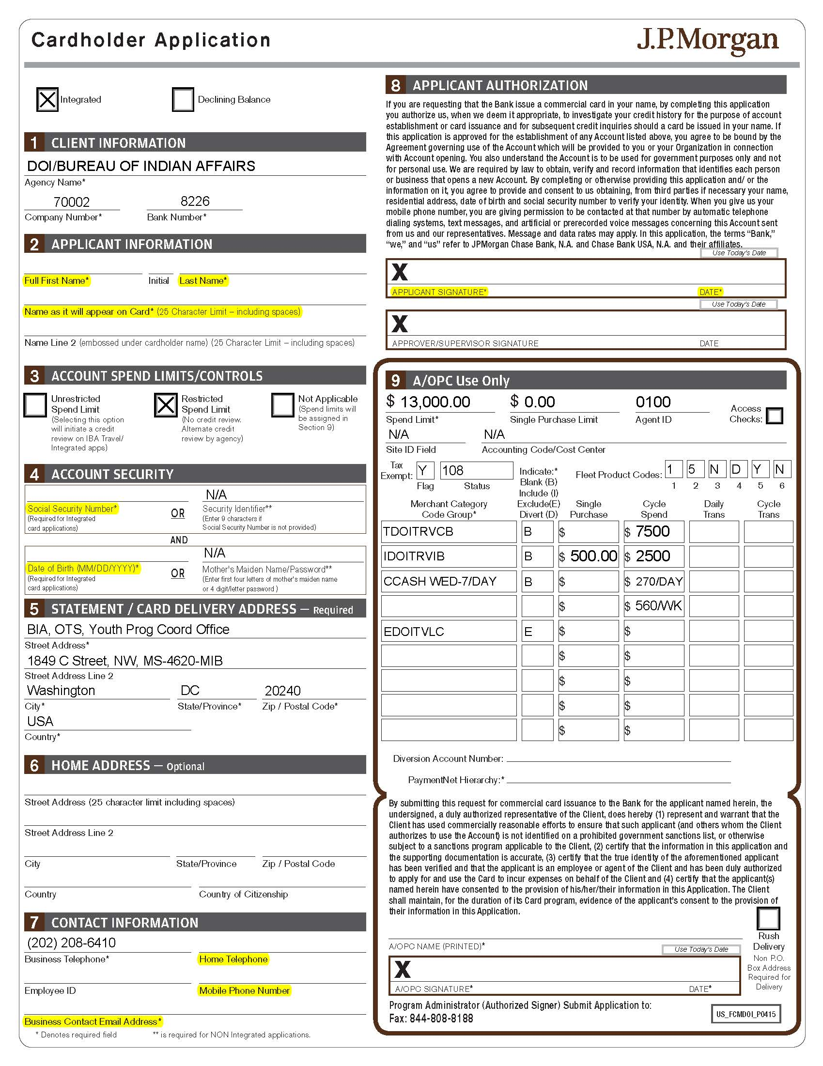
Attachment #1

