NRGP
Non-Returnable Gate Pass Portal
User Manual
Portal Admin · NX Employee · Supplier
Version 1.0 · October 2026
All names, companies, vehicles and e-mail addresses in the screenshots are fictitious demo data.
Contents

1. Introduction

1.1 What is NRGP?
NRGP (Non-Returnable Gate Pass) is a web portal for recording goods and packaging that leave the NX warehouse and are not expected to come back. Every outgoing load is entered as a dispatch (gate pass). The supplier who receives the load then confirms, line by line, what actually arrived. Any difference between what was sent and what was received is flagged automatically as a dispute, which the NX team investigates and closes with a resolution note.
This gives NX and its suppliers one shared record of every load, the date and time it was sent and received, who handled it, and how any shortage or excess was settled.

1.2 User roles
Everyone signs in through the same login page. What you see after signing in depends on the role on your account:
Role | Who it is for | Main responsibilities
Portal Admin | NX staff who manage the portal | Create and maintain NX employee and supplier accounts, reset passwords, activate or deactivate accounts. Can also do everything an NX employee can.
NX Employee (NX User) | NX warehouse / dispatch staff | Create dispatch entries, track what is pending with suppliers, investigate and resolve disputes, export reports.
Supplier | External companies that receive loads | Confirm the quantities received for each dispatch sent to them, and add remarks when something is short or excess.

What each role can do
Feature | Portal Admin | NX Employee | Supplier
View dashboard | Yes (all suppliers) | Yes (all suppliers) | Yes (own dispatches only)
Create a new dispatch | Yes | Yes | No
Confirm received quantities | No | No | Yes
Resolve a dispute | Yes | Yes | No
Filter lists and export CSV | Yes | Yes | Yes
Manage NX employee accounts | Yes | No | No
Manage supplier accounts | Yes | No | No

1.3 How a dispatch moves through the portal
Every dispatch has a status. The diagram below shows how the status changes and who moves it along.
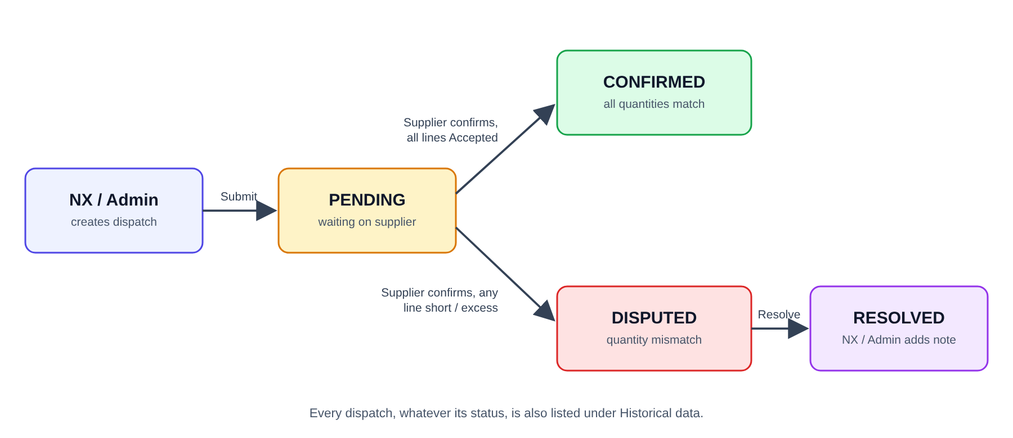
Figure 1 — Dispatch lifecycle
Status | Meaning | Who acts next
Pending | NX has submitted the dispatch. The supplier has not yet confirmed receipt. | Supplier
Confirmed | The supplier received exactly what was dispatched on every line. | Nobody — complete
Disputed | The supplier received a different quantity on at least one line and explained why in a remark. | NX employee or Portal Admin
Resolved | NX investigated the dispute and closed it with a resolution note. | Nobody — complete

1.4 Screen layout
After signing in, every screen has the same layout:
- Sidebar (left) — the menu. The items shown depend on your role. Your name, e-mail, role and the Log out button are at the bottom.
- Header (top) — shows where you are (for example Portal / Dashboard).
- Main area — the page you selected.

1.5 Package types
Dispatches record quantities against these fixed package types:
Package type | Code | Notes
Bin | BIN-001
Pallet | PAL-001
Steel pallet | STP-001
Trolley | TRO-001
Carton box | CB-001
Others | OTH-001 | A description of the item is mandatory when a quantity is entered.

2. Getting started (all users)

2.1 Before you begin
- You need a modern web browser (Chrome, Edge, Firefox or Safari) and the portal web address provided by your NX administrator.
- You need a login e-mail and password. NX employees and suppliers cannot sign up themselves — accounts are created by the Portal Admin.
- New accounts are created with the default password Password@123. Ask the Portal Admin to set a personal password for you (see section 3.5), as there is currently no self-service "change password" option.

2.2 Signing in
- Open the portal address in your browser. The Non-Returnable Gate Pass sign-in page appears.
- Enter your Email Address.
- Enter your Password. Click the eye icon on the right of the box if you want to check what you typed.
- Click Sign In.
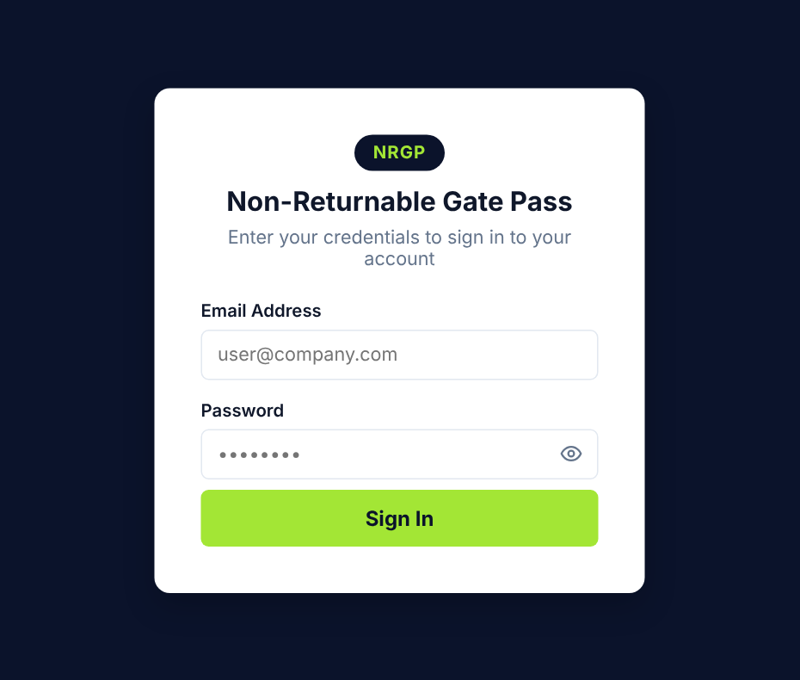
Figure 2 — Sign-in page
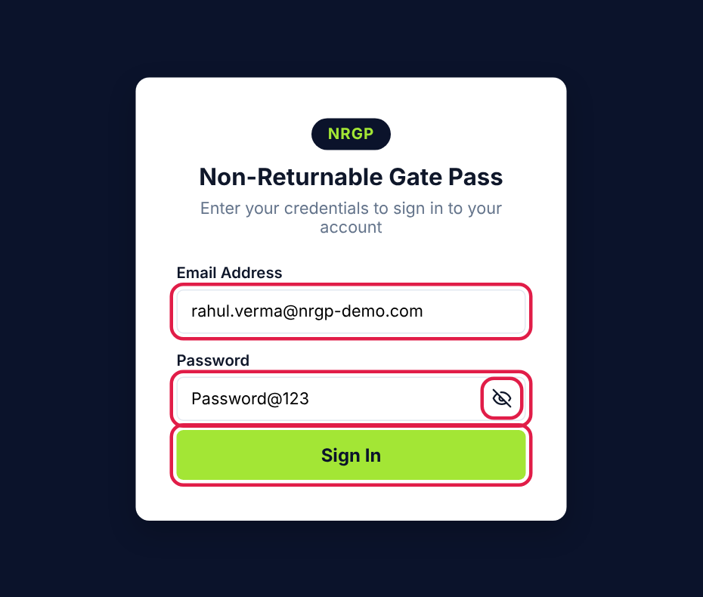
Figure 3 — Sign-in page with e-mail and password entered (eye icon shows the password)
After a successful sign-in you are taken straight to your starting page:
- Portal Admin → NX employee accounts
- NX Employee → Dispatch dashboard
- Supplier → Dispatch dashboard

2.3 If you cannot sign in
If sign-in fails, a red message above the form tells you why:
Message | What it means | What to do
Invalid email or password | The e-mail is not registered or the password is wrong. | Check the e-mail for typing mistakes and that Caps Lock is off, then try again. If you have forgotten your password, ask the Portal Admin to reset it.
This account has been deactivated | The Portal Admin has switched off your account (or your supplier company). | Contact the Portal Admin if you still need access.
Too many login attempts. Please try again later. | There were 20 failed attempts in 15 minutes. | Wait 15 minutes and try again.
Unable to connect to login service… | The portal server could not be reached. | Check your internet connection and try again in a few minutes.

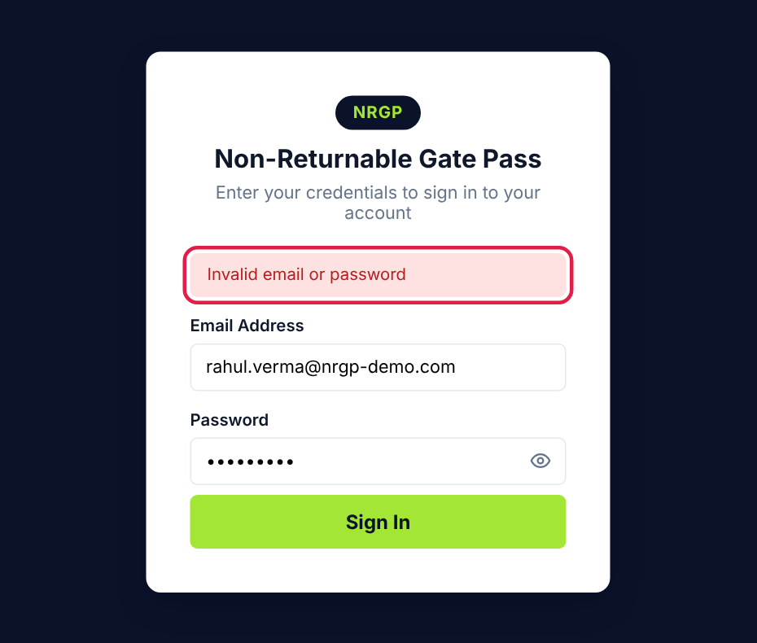
Figure 4 — Wrong e-mail or password
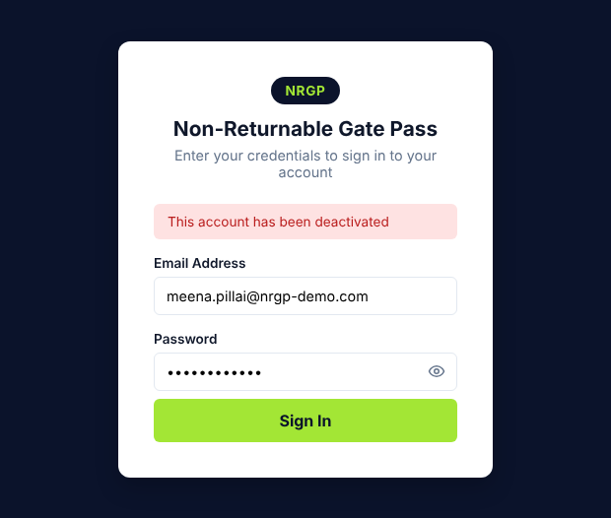
Figure 5 — Deactivated account

2.4 Signing out and sessions
- Click Log out at the bottom of the sidebar when you finish, especially on a shared computer. Closing the browser tab does not sign you out.
- Refreshing or reloading the page keeps you signed in and returns you to the page you were on.
- A session expires automatically after 12 hours. You will then see the sign-in page the next time you open or refresh the portal.
- If the Portal Admin deactivates your account while you are signed in, you are signed out the next time the page is opened or refreshed.

2.5 Working with dispatch lists (all roles)
The Pending with supplier, Disputed, Resolved and Historical data pages all share the same list layout and tools:
Tool | What it does
Supplier | Show only dispatches for one supplier.
Dispatch date from / to | Show only dispatches sent within a date range.
Search | Find a dispatch by transaction ID (e.g. NRGP-2026-0003) or vehicle number. Partial text works.
Clear filters | Appears when any filter is set; removes all filters.
Export CSV | Downloads the rows currently shown (after filters) as a spreadsheet-friendly CSV file.
Click a row | Opens the full dispatch detail page. Use ← Back to return.

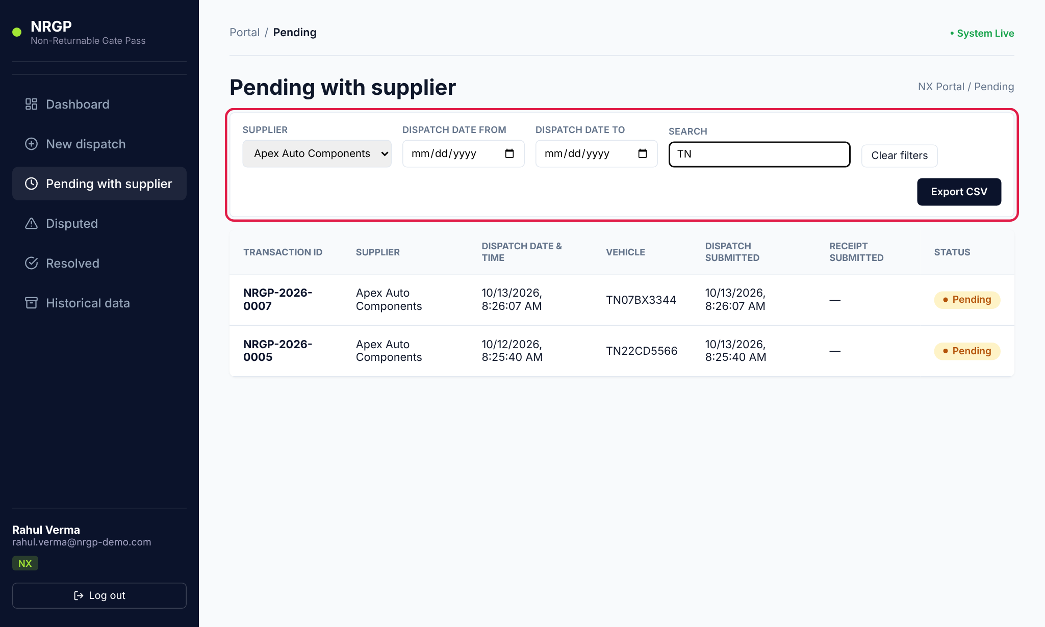
Figure 6 — Filter bar with a supplier and search text applied

3. Portal Admin guide
The Portal Admin manages who can use the portal. The admin sidebar contains all NX dispatch menus plus two extra items: NX employees and Suppliers.

3.1 Admin home page
After signing in, the admin lands on NX employee accounts. The table lists every NX and Admin account with its role and status.
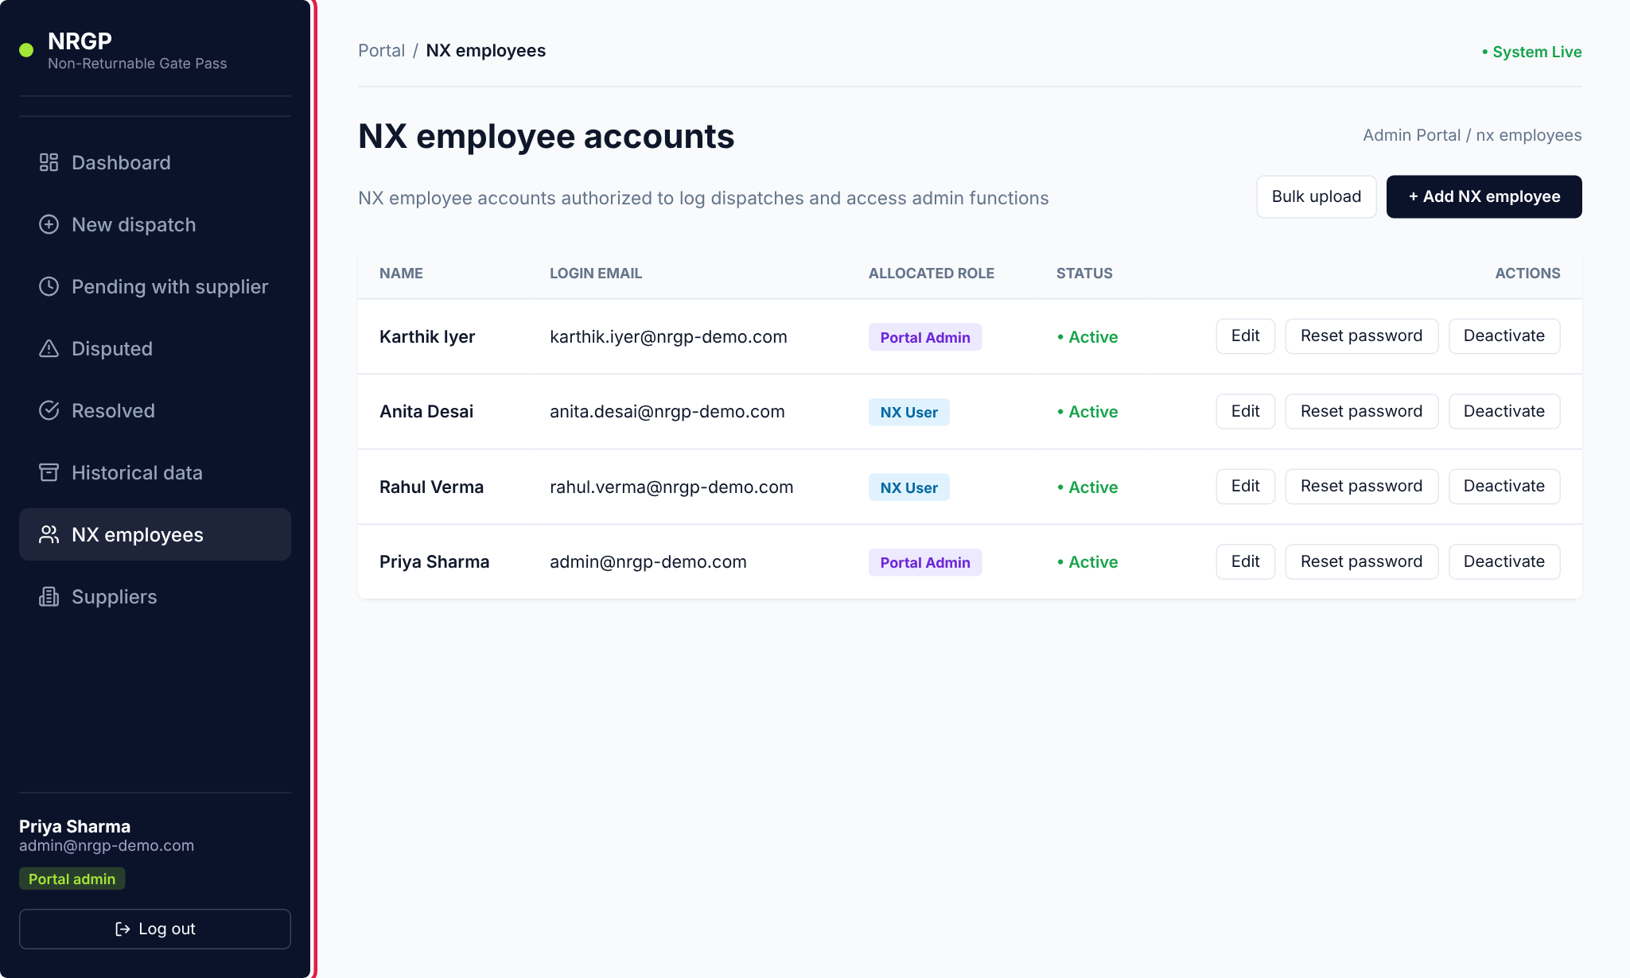
Figure 7 — Admin home — NX employee accounts (sidebar highlighted)
Column / button | Meaning
Allocated role | "NX User" (standard employee) or "Portal Admin".
Status | "Active" accounts can sign in; "Inactive" accounts cannot.
Edit | Change the name, login e-mail or role.
Reset password | Set a new password for the user.
Deactivate / Reactivate | Block or restore sign-in without deleting the account or its history.

3.2 Add an NX employee
- In the sidebar, click NX employees.
- Click + Add NX employee (top right).
- Enter the employee's Full Name and Login Email. The full name is shown as the Warehouse PIC on every dispatch they create.
- Under Allocate Role, choose User (Standard Employee) for normal dispatch staff, or Portal Admin to give full admin rights.
- Click Save Changes. A message confirms the account was created with the default password Password@123.
- Share the login e-mail and password with the employee securely, then reset the password to a personal one (section 3.5).
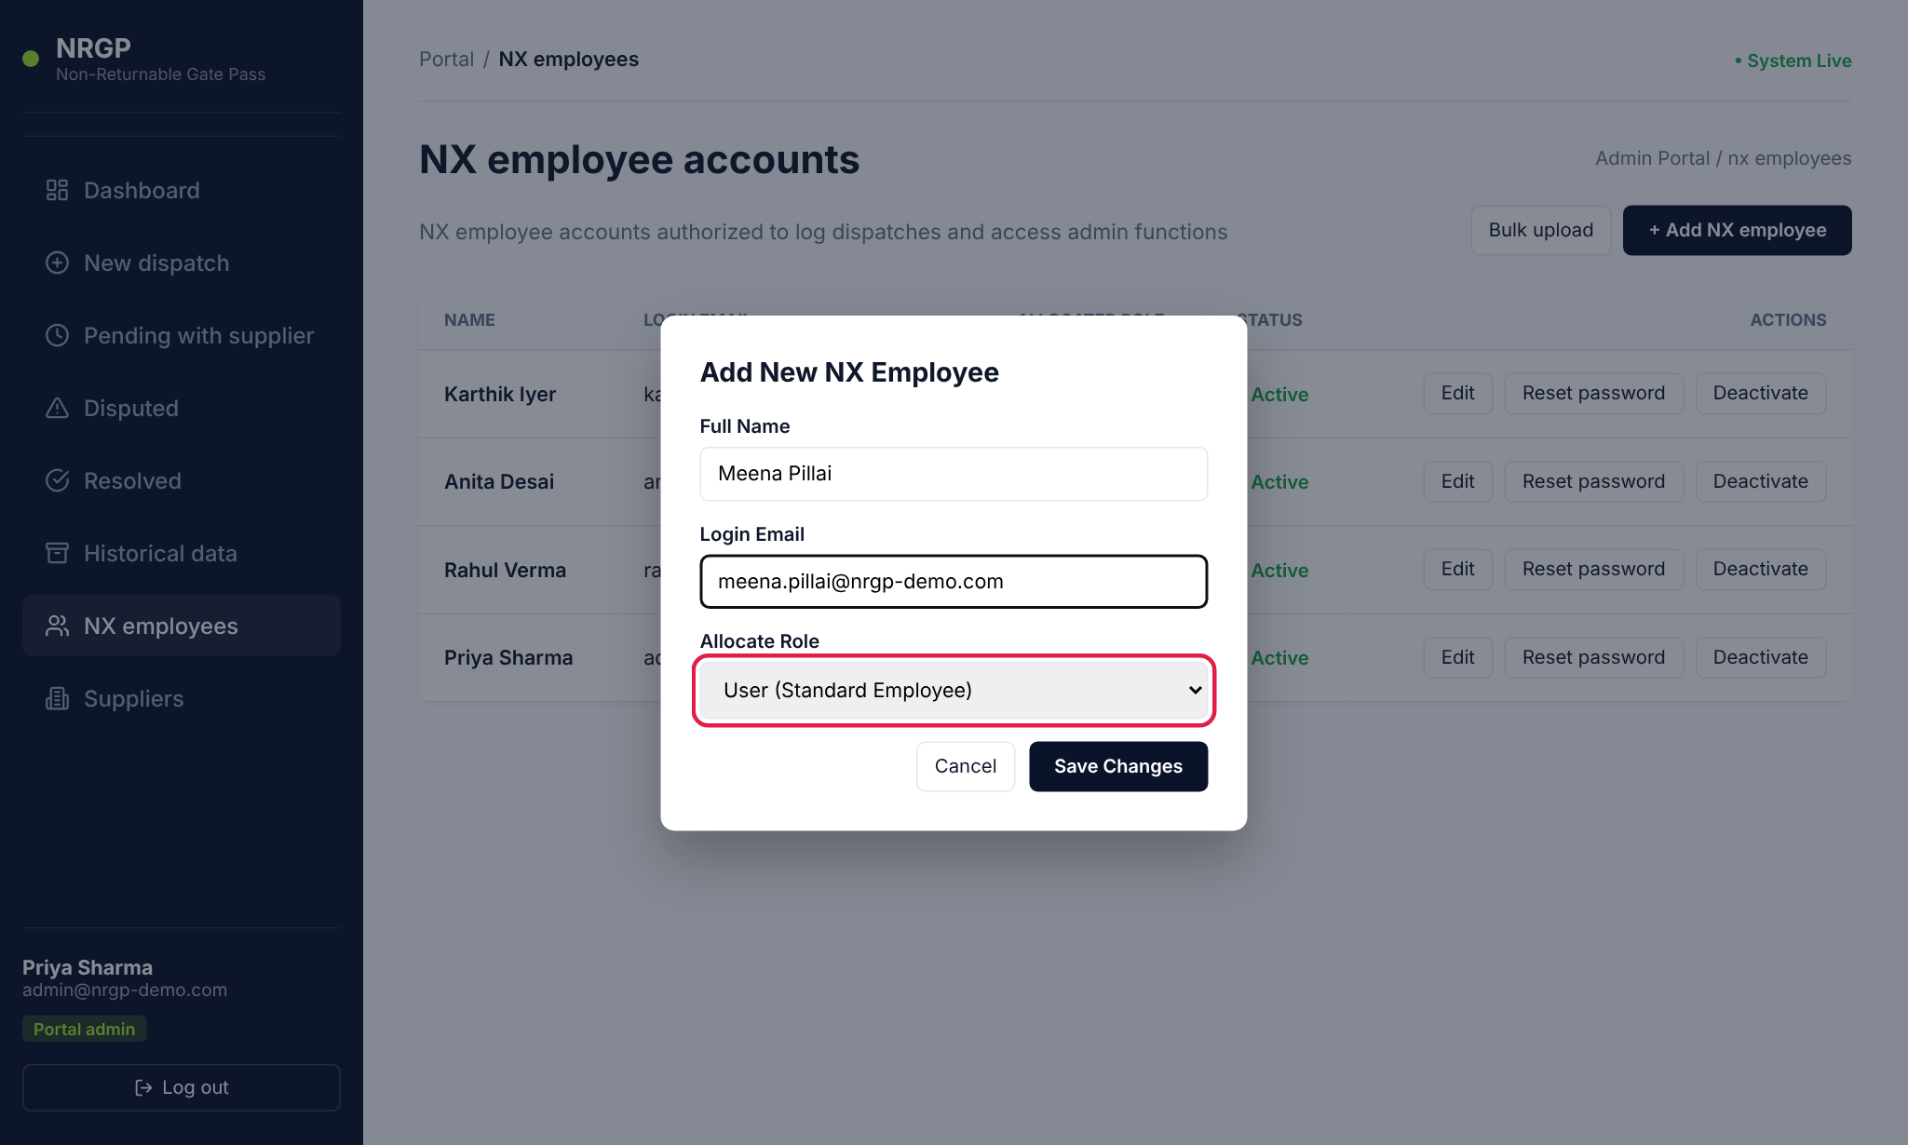
Figure 8 — Add New NX Employee form — role selector highlighted
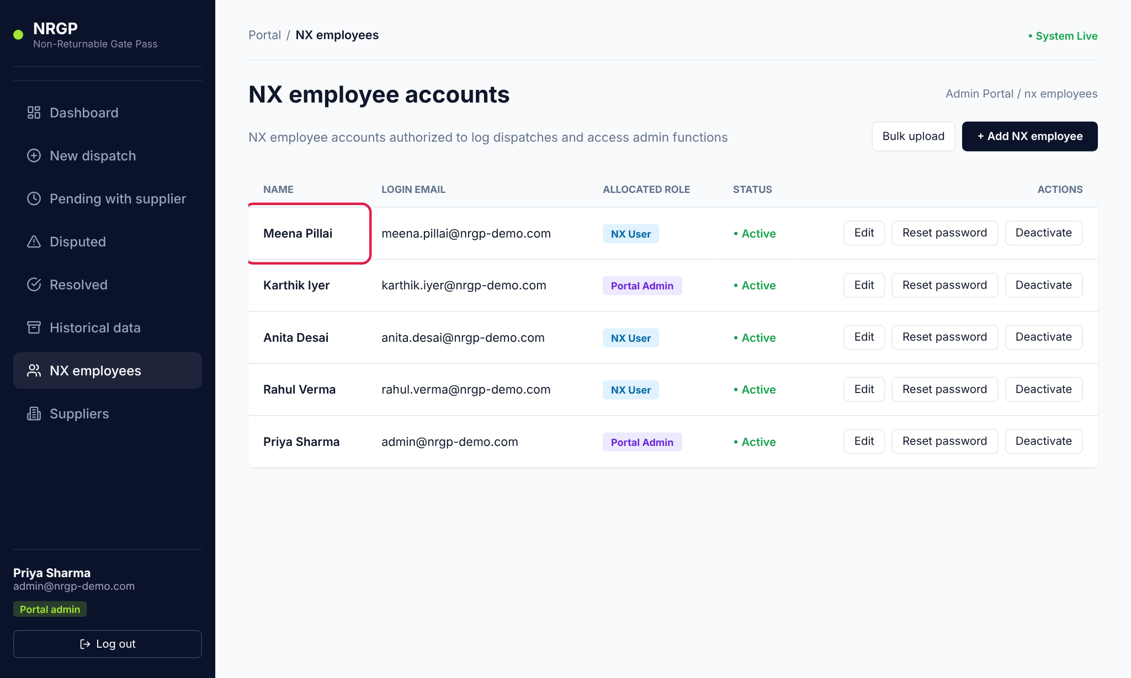
Figure 9 — The new employee appears at the top of the list
Note: Each login e-mail can be used for only one account. Adding an e-mail that already exists fails.

3.3 Edit an NX employee
- Find the employee in the list and click Edit.
- Change the name, login e-mail or role as needed.
- Click Save Changes.
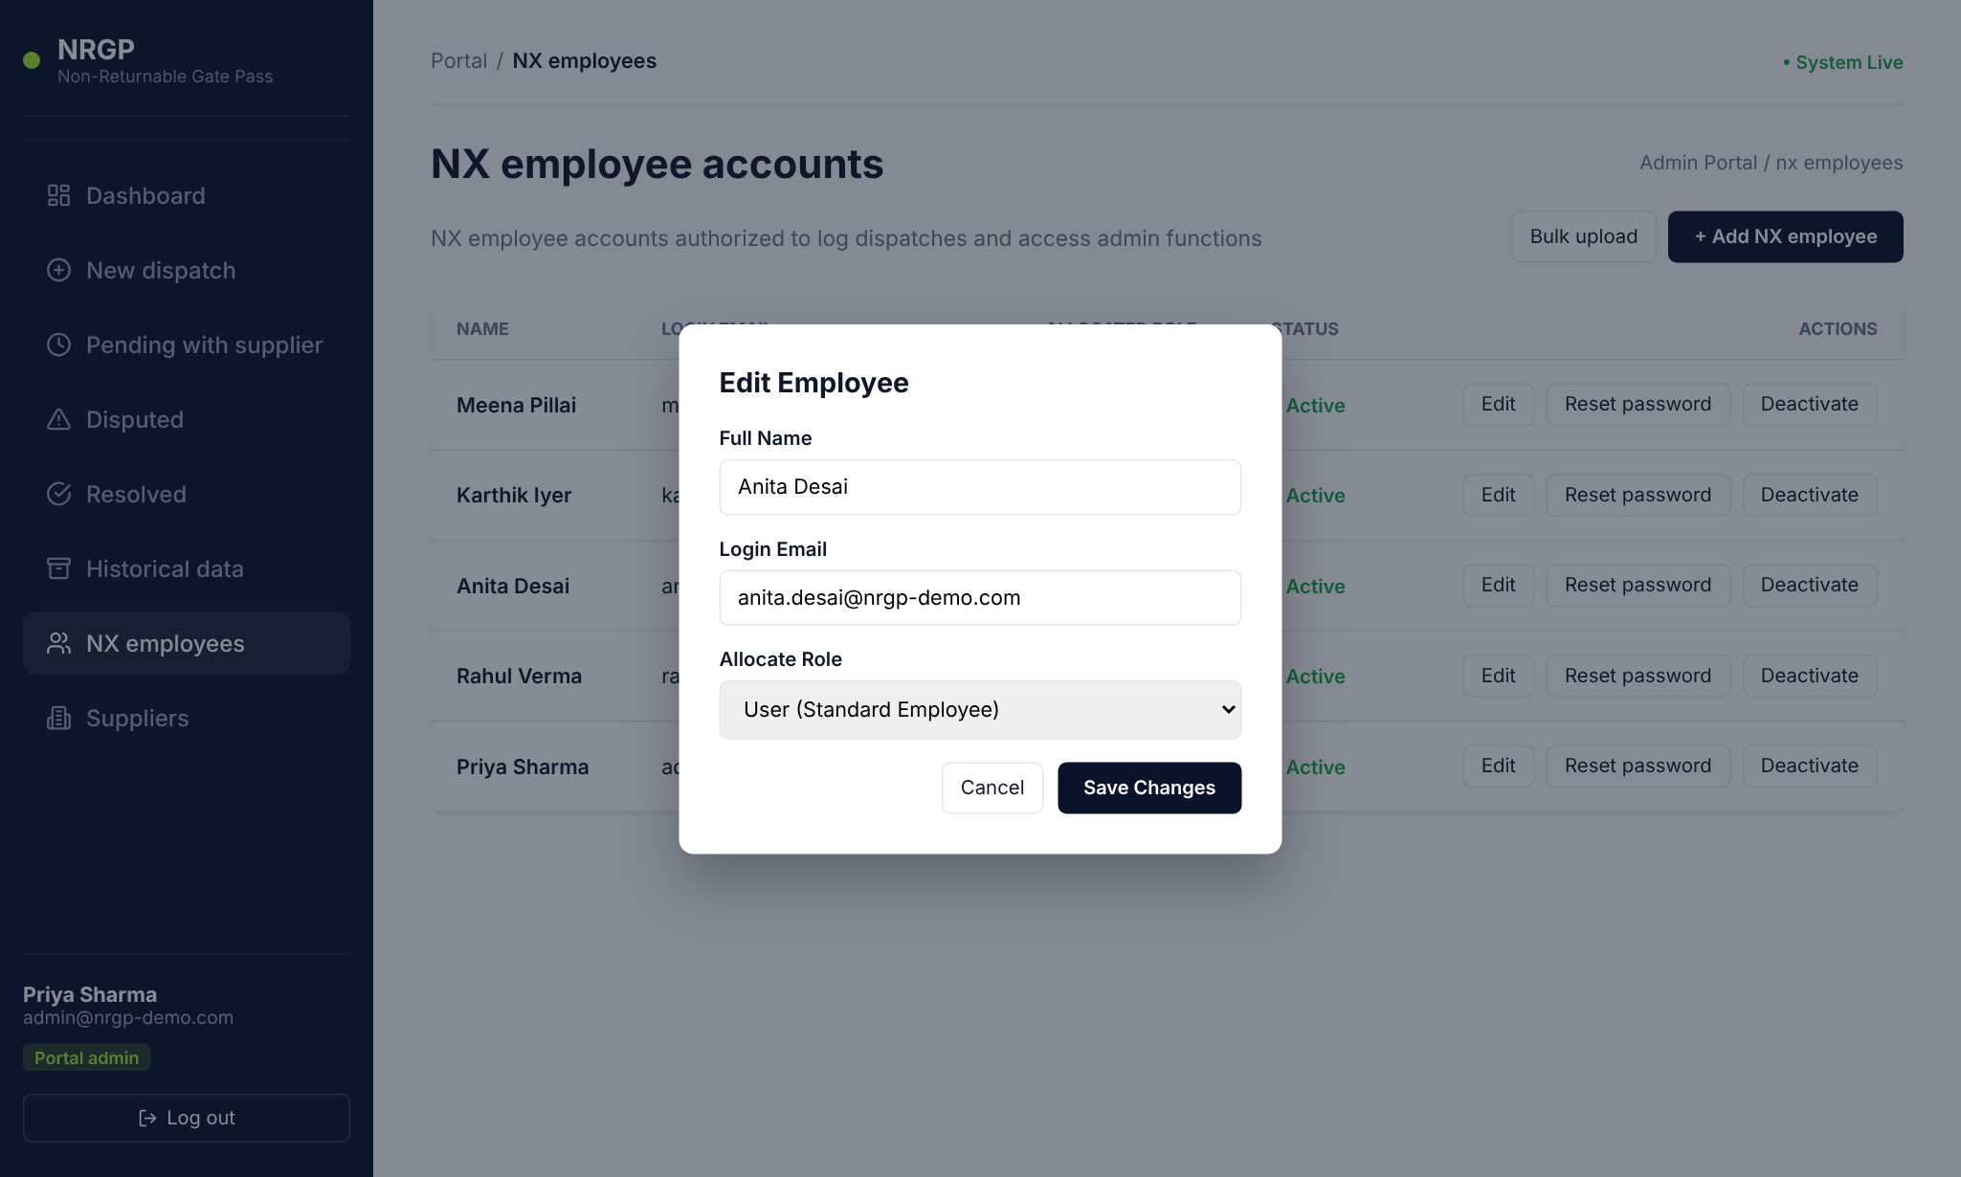
Figure 10 — Edit Employee form
Tip: If you change an employee's login e-mail, tell them — they must use the new e-mail at their next sign-in.

3.4 Deactivate or reactivate an account
Use deactivation when someone leaves or should no longer have access. Their past dispatches stay in the records.
- Click Deactivate on the employee's row.
- Confirm the browser prompt "Are you sure you want to deactivate …?" by clicking OK.
- The status changes to Inactive and the button changes to Reactivate. Click Reactivate at any time to restore access.
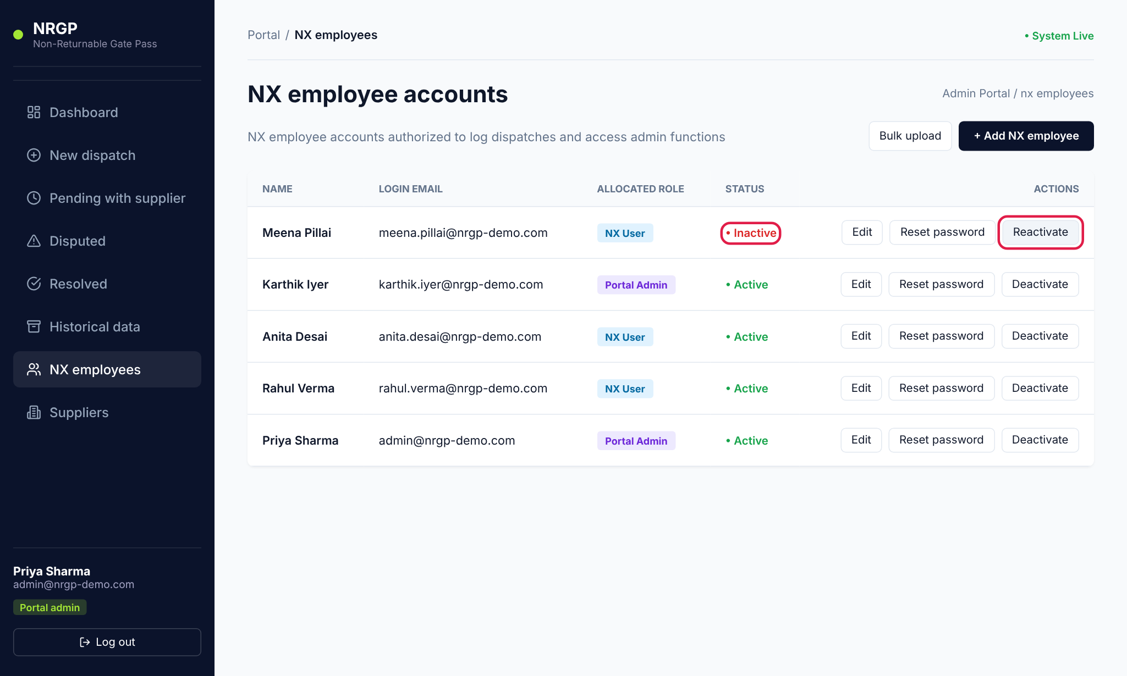
Figure 11 — A deactivated employee — status "Inactive" and the Reactivate button

3.5 Reset a password
- Click Reset password on the user's row.
- Type the New Password.
- Click Update Password. A message confirms the reset.
- Give the new password to the user securely.
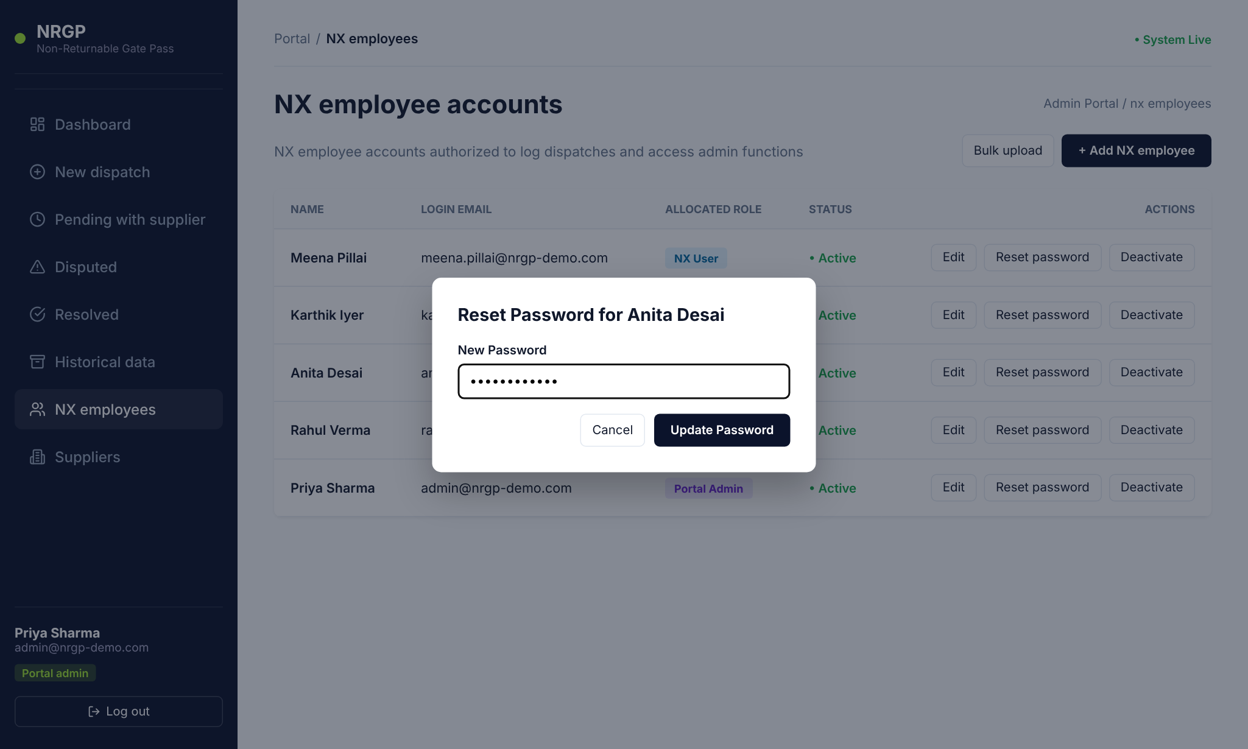
Figure 12 — Reset Password dialog
Important: There is no "forgot password" link on the sign-in page. All password resets for NX employees and suppliers are done by the Portal Admin from this screen.

3.6 Bulk upload NX employees (CSV)
To add many employees at once, upload a CSV file.
- On NX employees, click Bulk upload.
- Click Download sample CSV to get a template with the correct column headings.
- Open the template in Excel (or similar), replace the sample rows with your employees — one row per person — and save it as CSV.
- Click Choose File and select your CSV. The dialog shows how many rows are ready.
- Click Submit.
- Read the result: the green box shows how many accounts were created (all with the default password Password@123); any rows that were skipped are listed with the row number and the reason.
- Fix any skipped rows in your file and upload just those rows again, then click Done.
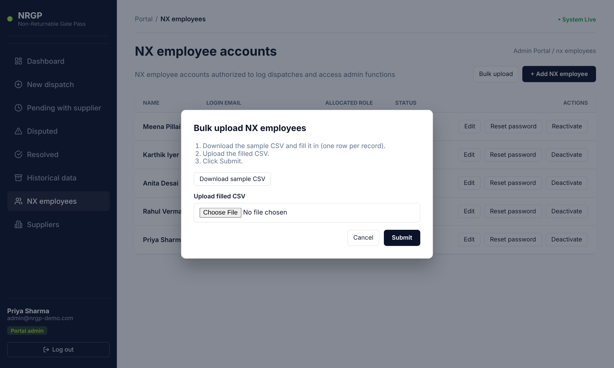
Figure 13 — Bulk upload dialog
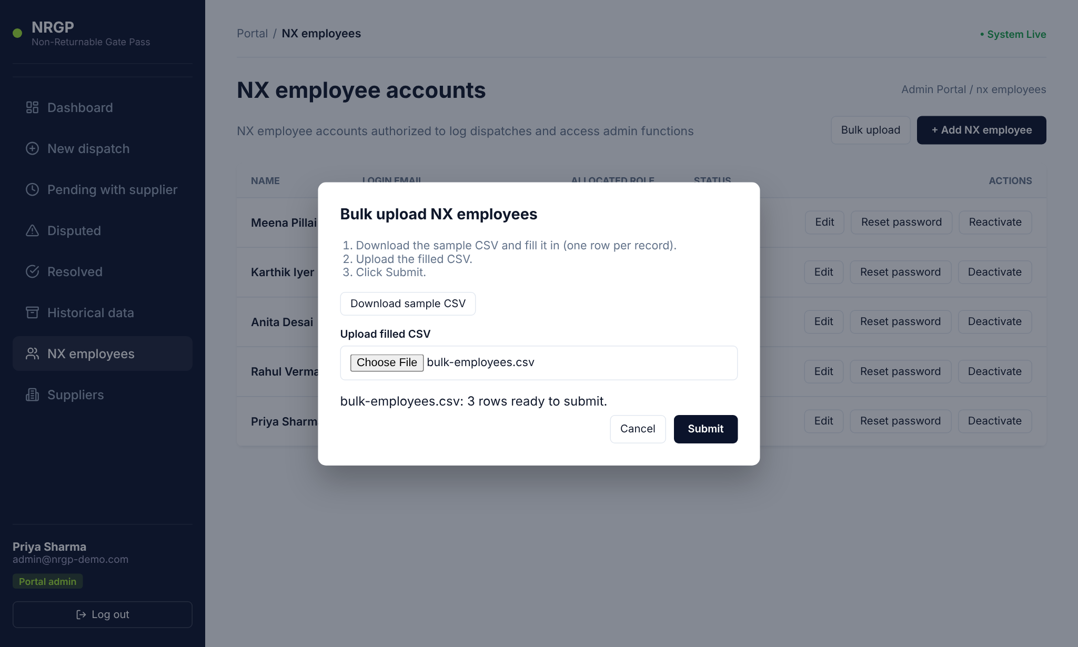
Figure 14 — File selected — 3 rows ready to submit
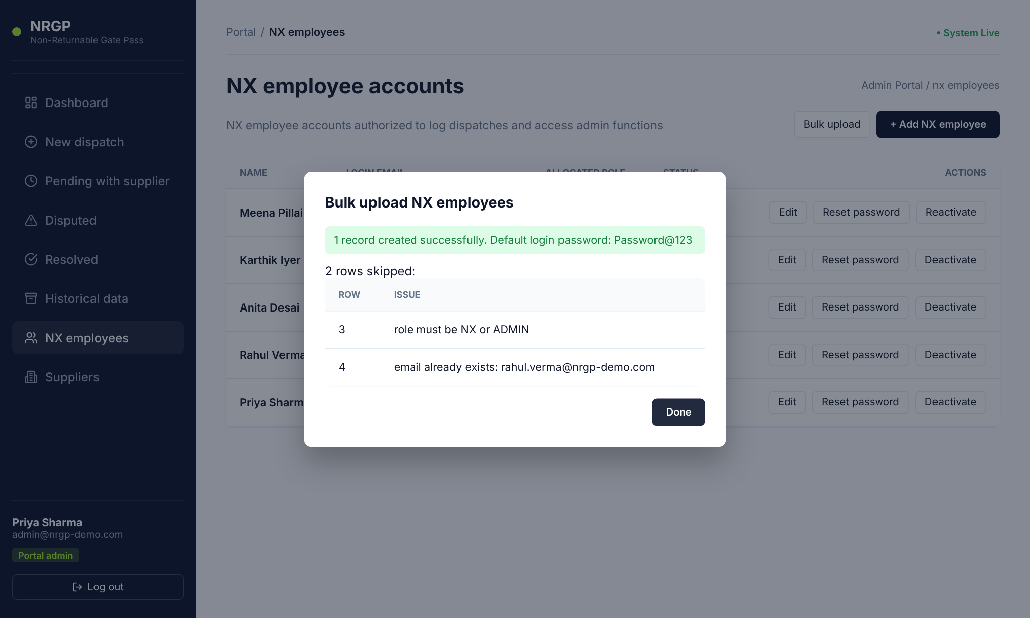
Figure 15 — Upload result — 1 created, 2 rows skipped with reasons

Employee CSV columns
Column | Required | Allowed values / example
name | Yes | John Doe
email | Yes | A valid e-mail not already used by another account, e.g. john.doe@company.com
role | Yes | NX (standard user) or ADMIN (Portal Admin). Anything else is rejected.
phone | No | 9900011122

3.7 Supplier accounts
Each supplier company has one portal login. Dispatches are sent to a supplier, and only that supplier's login can see and confirm them. In the sidebar, click Suppliers to open the supplier list. The Status column shows whether each supplier can currently sign in (Active) or has been switched off (Inactive).
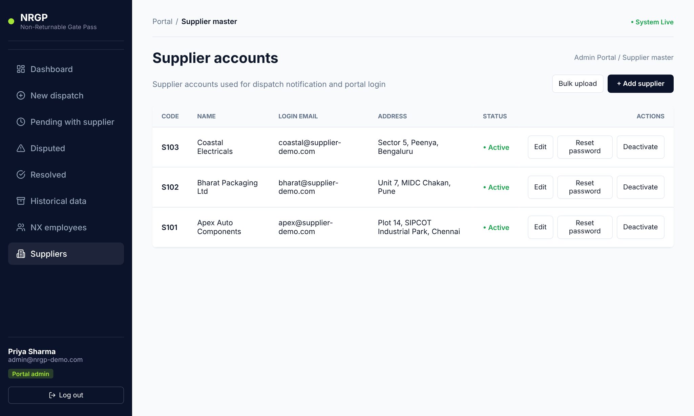
Figure 16 — Supplier accounts list with the Status column

Add a supplier
- Click + Add supplier.
- Enter the supplier Code (your internal supplier code, e.g. S104 — must be unique).
- Enter the Company / Contact Name — this is what NX staff pick from when creating a dispatch.
- Enter the Login Email the supplier will use to sign in.
- Optionally enter the Address.
- Click Save Supplier. The account is created with the default password Password@123.
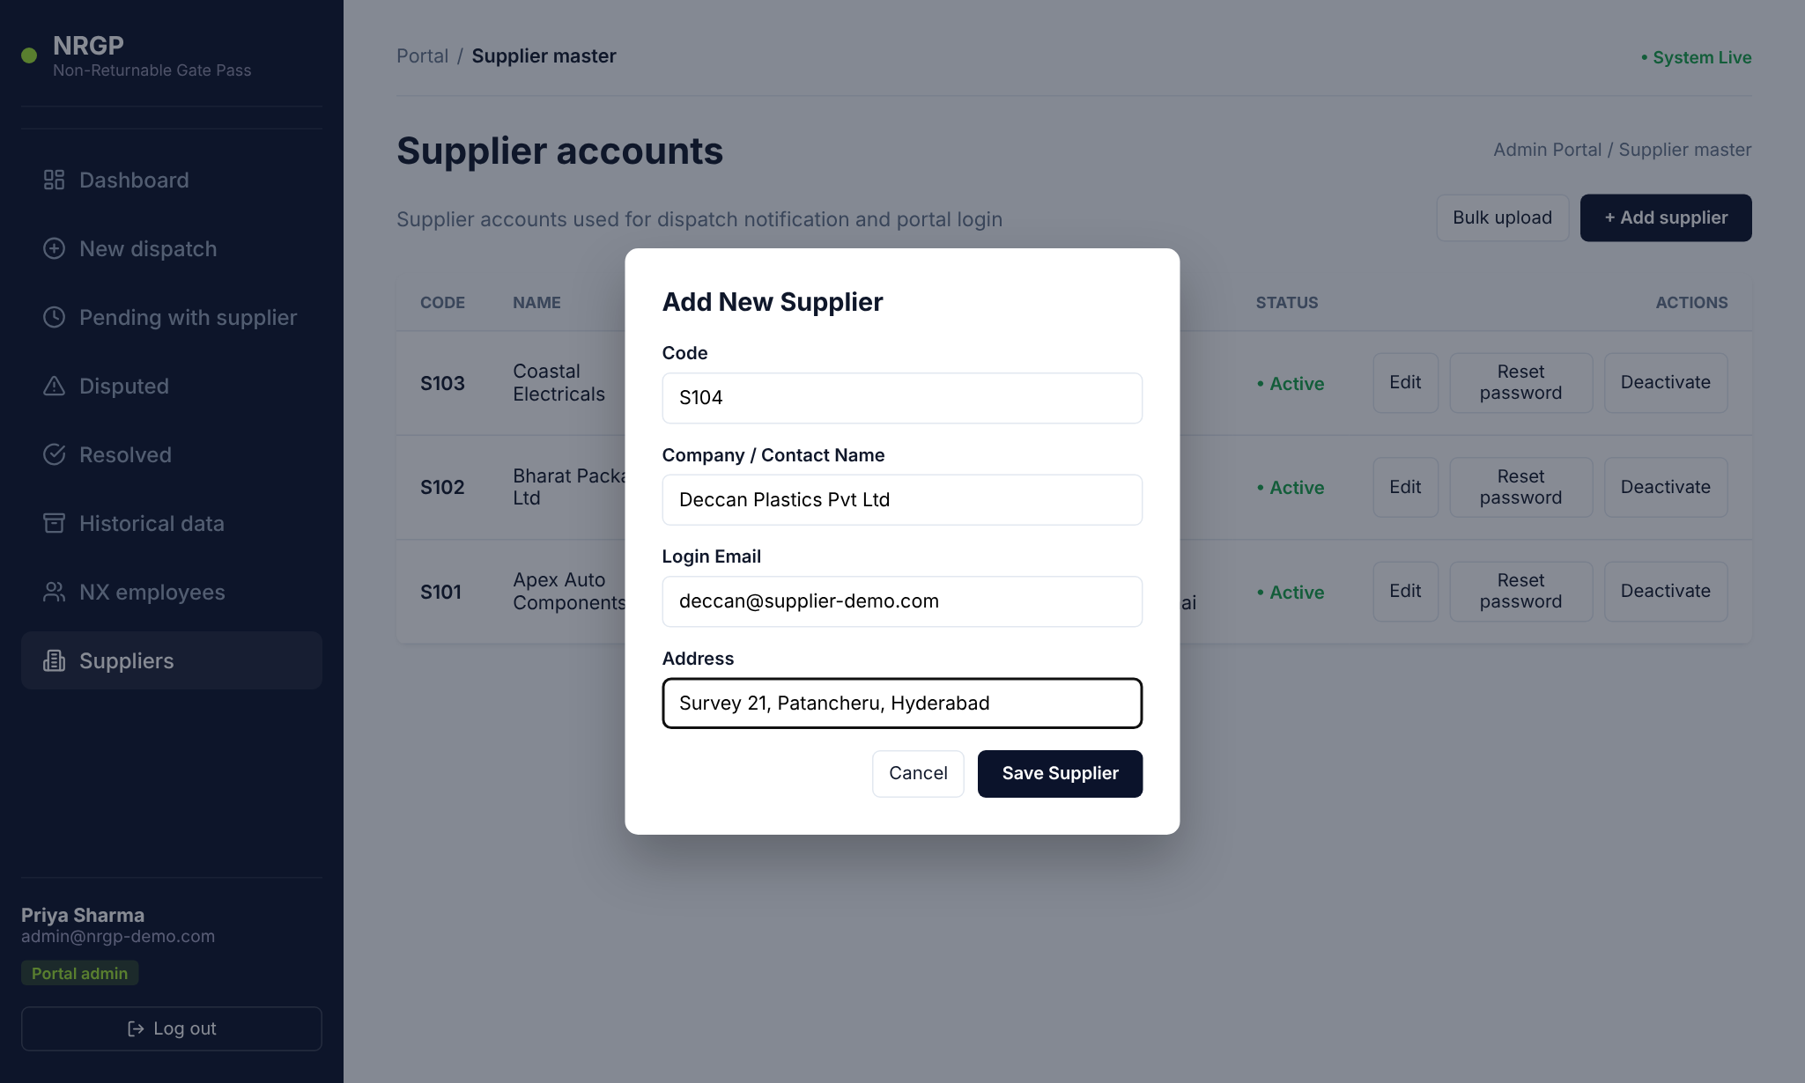
Figure 17 — Add New Supplier form

Edit, reset password, deactivate
These work exactly as for NX employees (sections 3.3 to 3.5), using the buttons on the supplier's row. After Deactivate, the supplier's Status changes to Inactive and the button changes to Reactivate.
Important: Deactivating a supplier blocks its login and removes it from the supplier list on the New dispatch form, so no new dispatches can be sent to it. Existing dispatches remain in the records.

Bulk upload suppliers
Click Bulk upload on the Suppliers page and follow the same steps as in section 3.6.
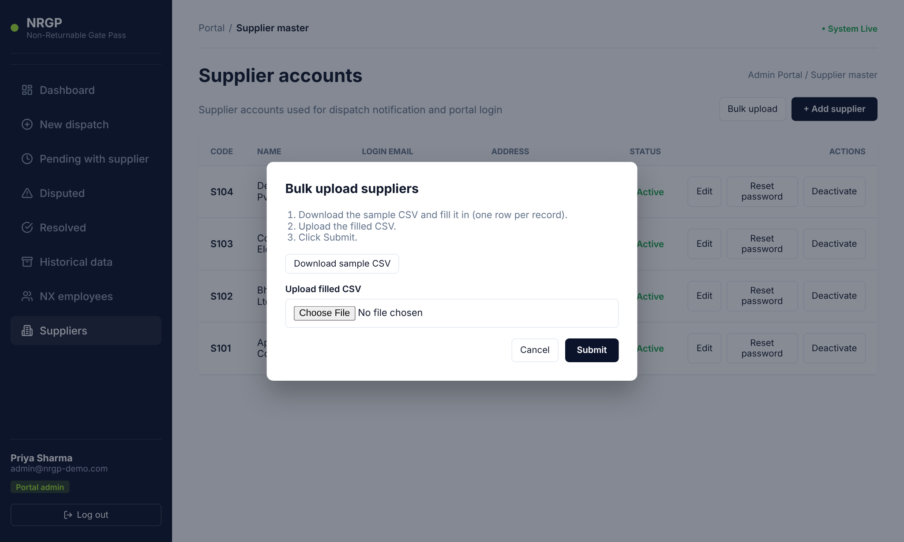
Figure 18 — Bulk upload suppliers dialog
Column | Required | Allowed values / example
code | Yes | Unique supplier code, e.g. I107
name | Yes | Company / contact name
email | Yes | Valid login e-mail not already in use
address | No | Plot 14, Ind. Area, Chennai

3.8 Dispatch functions for the admin
The admin has the same dispatch menus as an NX employee: Dashboard, New dispatch, Pending with supplier, Disputed, Resolved and Historical data. Breadcrumbs show Admin Portal instead of NX Portal. Follow section 4 for these tasks.
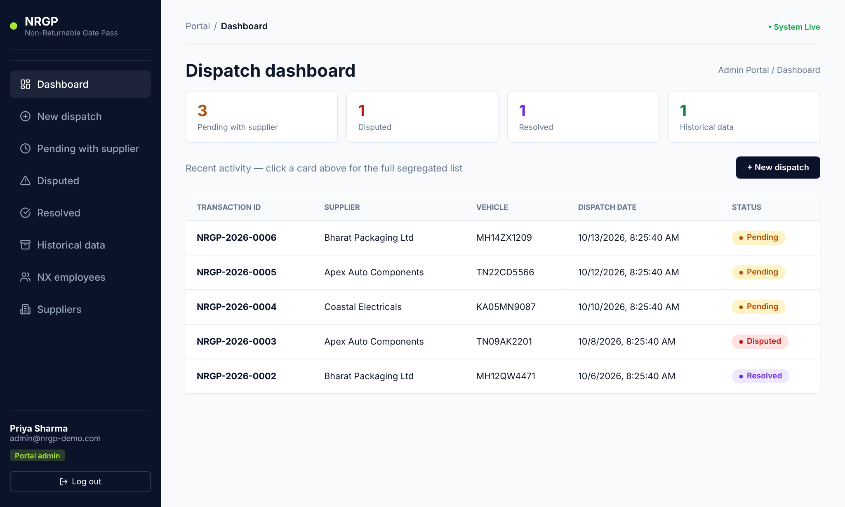
Figure 19 — Dispatch dashboard as seen by the admin

4. NX Employee guide
NX employees create dispatches, keep track of what suppliers still need to confirm, and settle disputes.

4.1 Dispatch dashboard
The dashboard is your starting page. It shows four summary cards and the five most recent dispatches.
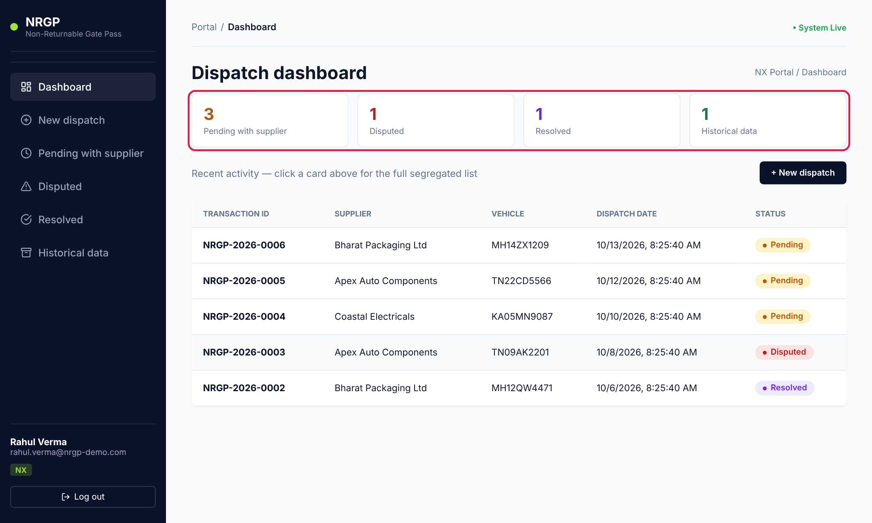
Figure 20 — NX dispatch dashboard — summary cards highlighted
Card | Shows | Click to open
Pending with supplier | Dispatches waiting for the supplier to confirm | Pending list
Disputed | Dispatches with a quantity mismatch that need NX action | Disputed list
Resolved | Disputes that have been closed | Resolved list
Historical data | Number of fully confirmed dispatches | Historical list (all dispatches)

Click any row in Recent activity to open that dispatch, or click + New dispatch to create one.

4.2 Create a new dispatch
- Click New dispatch in the sidebar (or + New dispatch on the dashboard).
- Under Dispatch details, choose the Supplier from the list (shown as Name — Code).
- Enter the Vehicle no. (mandatory), e.g. TN10BE8750.
- Optionally enter Driver details (name, phone).
- Warehouse PIC is filled in automatically with your name — you do not need to enter it.
- Under Package quantities, enter the number dispatched for each package type. Leave types that are not on this load at 0.
- If you enter a quantity for Others, type what the item is in the Description box (mandatory).
- Check the entries, then click Submit & notify supplier.
- A message confirms the new transaction ID, for example "NRGP-2026-0007 submitted — notification sent to Apex Auto Components", and you return to the dashboard.
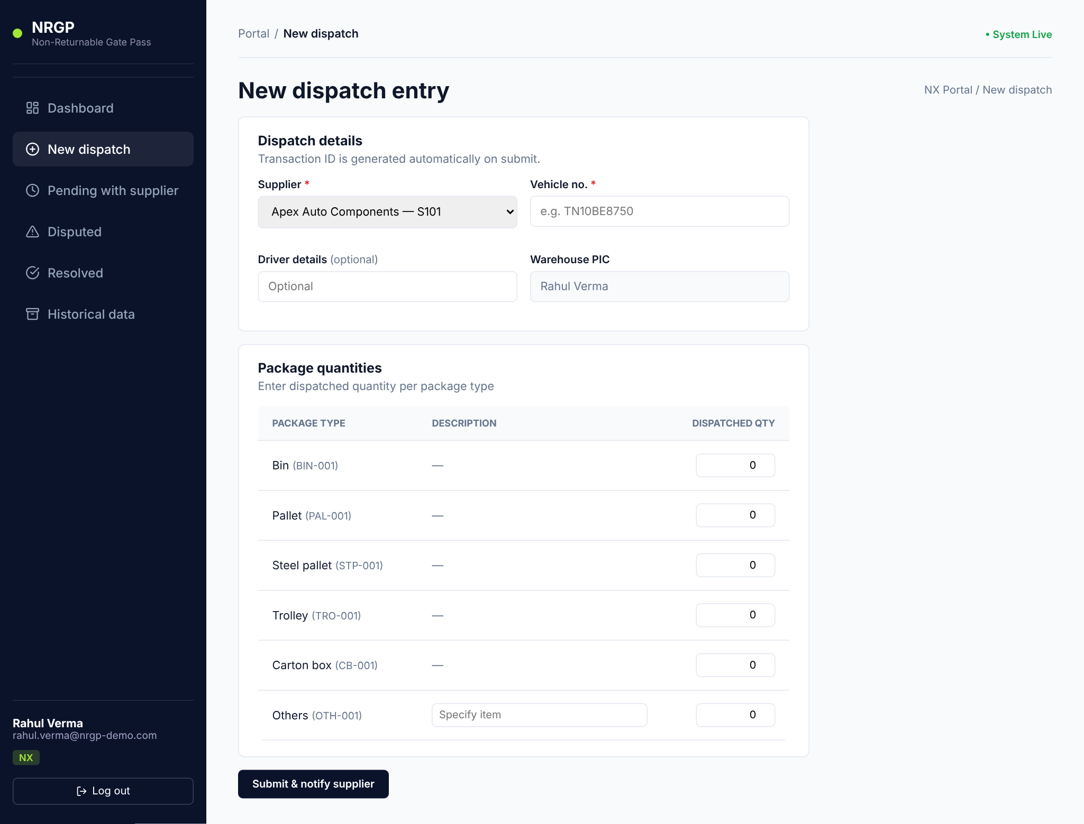
Figure 21 — New dispatch entry — blank form
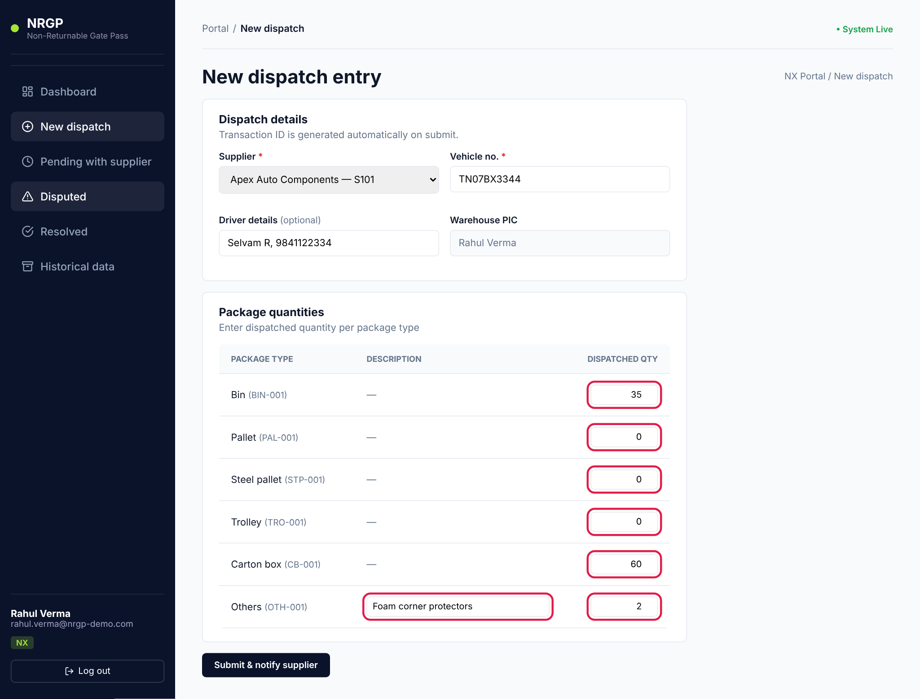
Figure 22 — Completed form — quantities and the "Others" description highlighted
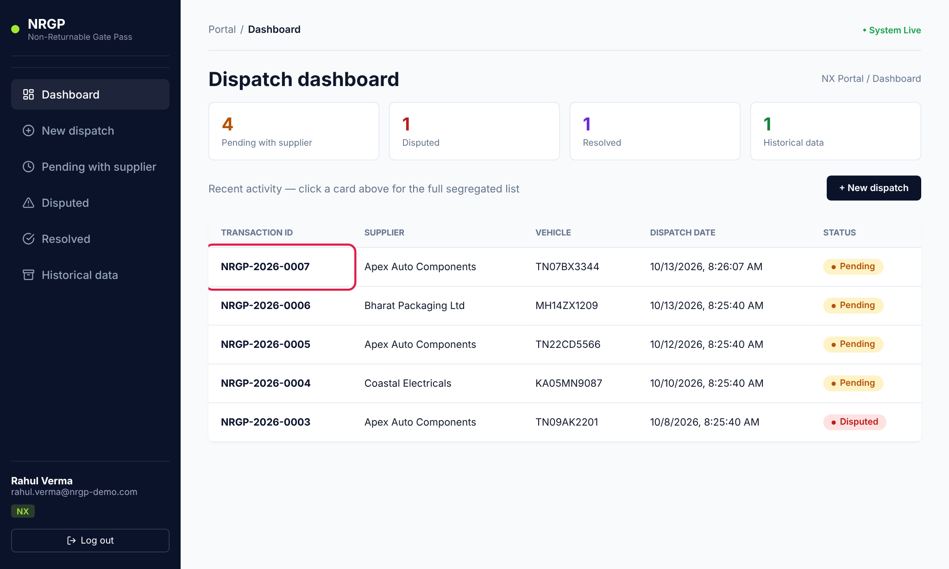
Figure 23 — The new dispatch appears on the dashboard with status Pending
Rule | What happens if not met
A supplier must be selected | "Select a supplier before submitting."
Vehicle no. is mandatory | The Submit button stays disabled.
At least one quantity must be greater than 0 | "Enter a quantity greater than zero for at least one package type."
"Others" needs a description | "Specify what the "Others" item is before submitting."

Important: The transaction ID (format NRGP-YYYY-####) and the dispatch date and time are generated automatically when you submit. A dispatch cannot be edited or deleted after submission, so check the quantities first.
Note: The portal does not currently send an e-mail to the supplier. The dispatch appears in the supplier's Pending with supplier list the next time they sign in. Let the supplier know separately if the load is urgent.

4.3 Track dispatches pending with suppliers
Click Pending with supplier to see every dispatch that suppliers have not yet confirmed. Use the filters (section 2.5) to narrow the list, for example to one supplier or one week. Click a row to see its details.
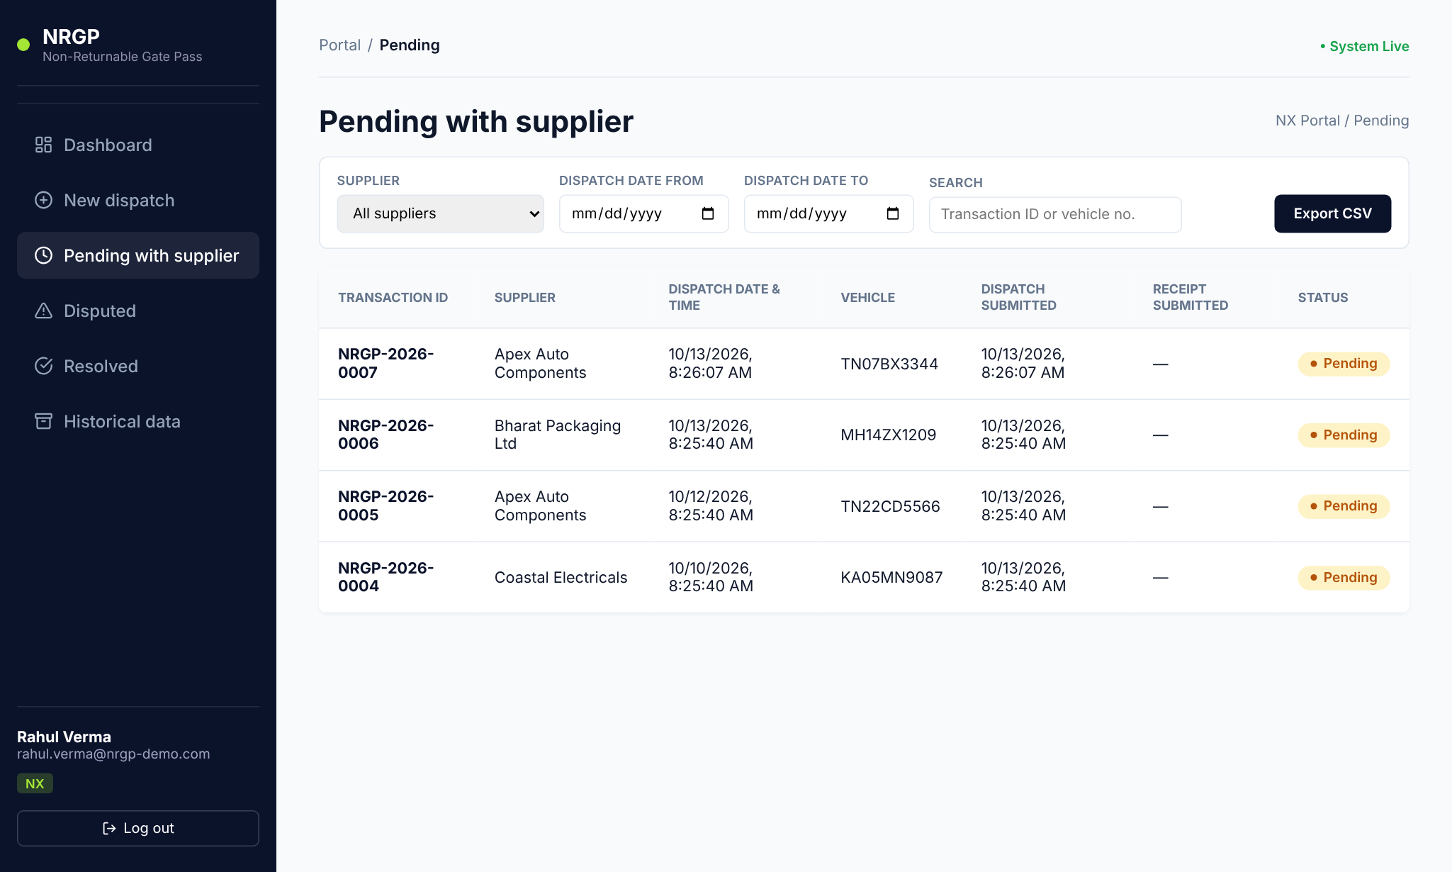
Figure 24 — Pending with supplier list

4.4 Review a disputed dispatch
A dispatch becomes Disputed when the supplier reports a different quantity on one or more lines.
- Click Disputed in the sidebar (or the Disputed card on the dashboard).
- Click the dispatch you want to review.
- Check the Package summary table: Short/Excess shows the difference (red minus = short, green plus = excess), and Remarks shows the supplier's explanation for each disputed line.
- Investigate offline as needed (loading sheet, CCTV, vehicle check, call the supplier).
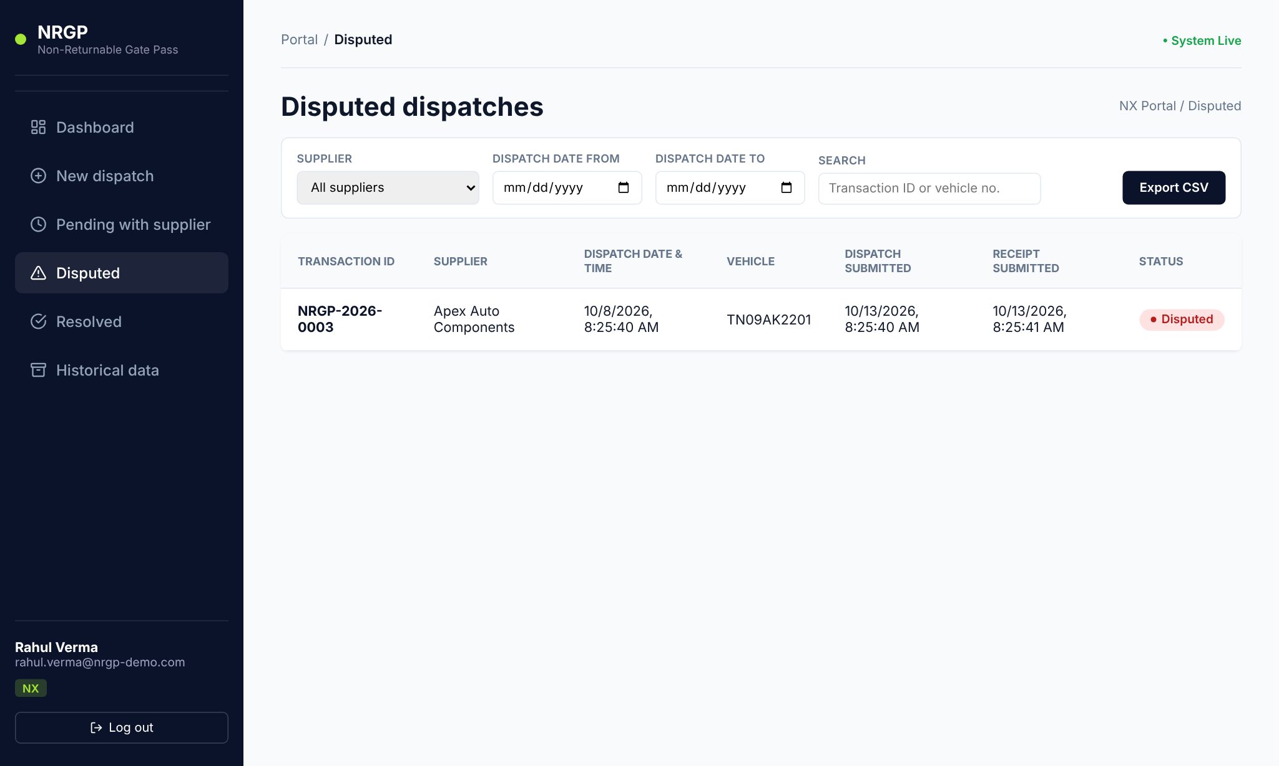
Figure 25 — Disputed dispatches list
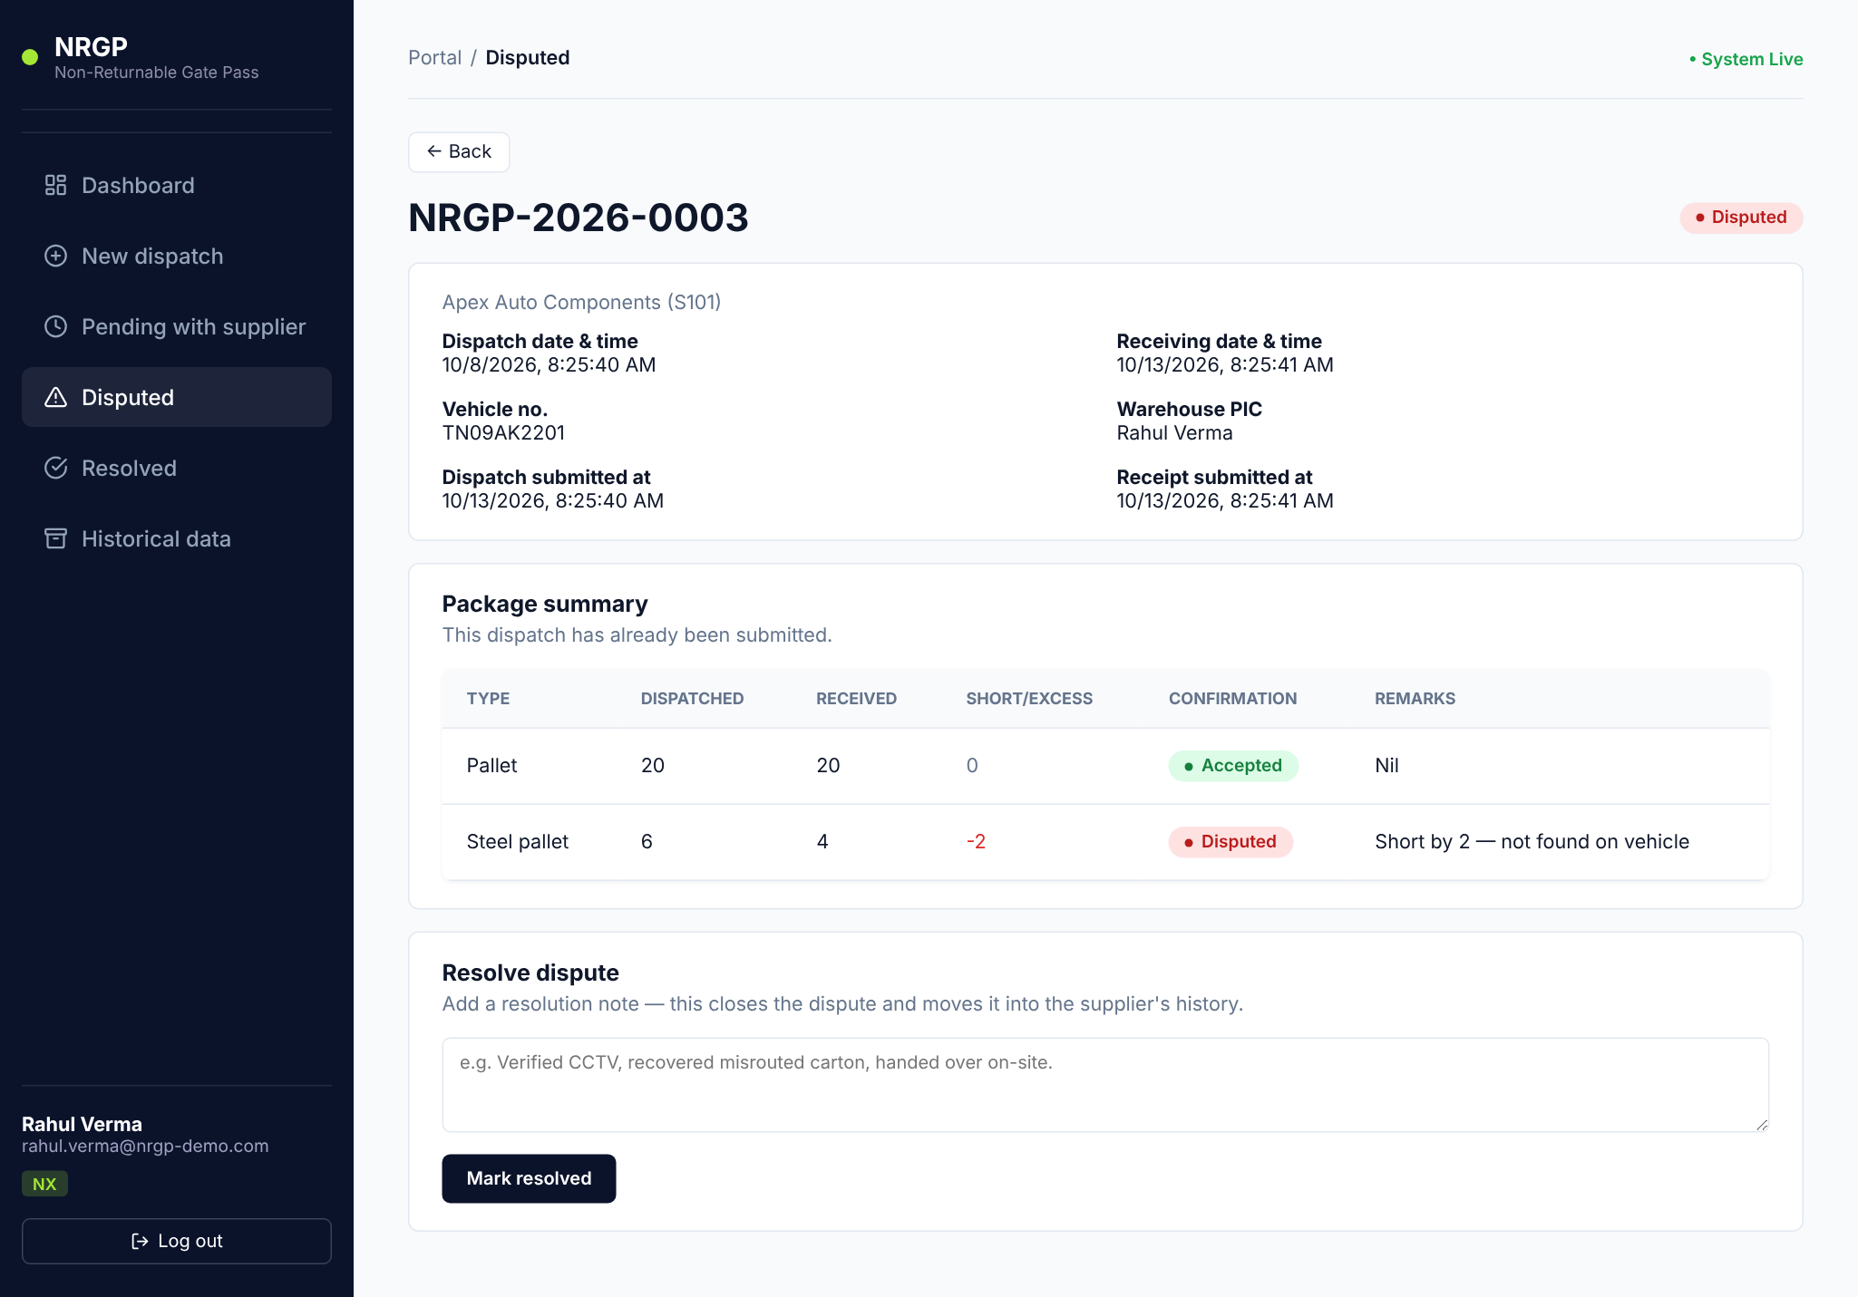
Figure 26 — Disputed dispatch detail — Steel pallet short by 2 with the supplier's remark

4.5 Resolve a dispute
- At the bottom of the disputed dispatch, find the Resolve dispute box.
- Type a clear resolution note — what you found and how it was settled (e.g. "2 steel pallets short-loaded; sent on vehicle TN07BX3344 the next day, supplier confirmed by phone.").
- Click Mark resolved.
- The status changes to Resolved and your note is shown on the dispatch for both NX and the supplier.
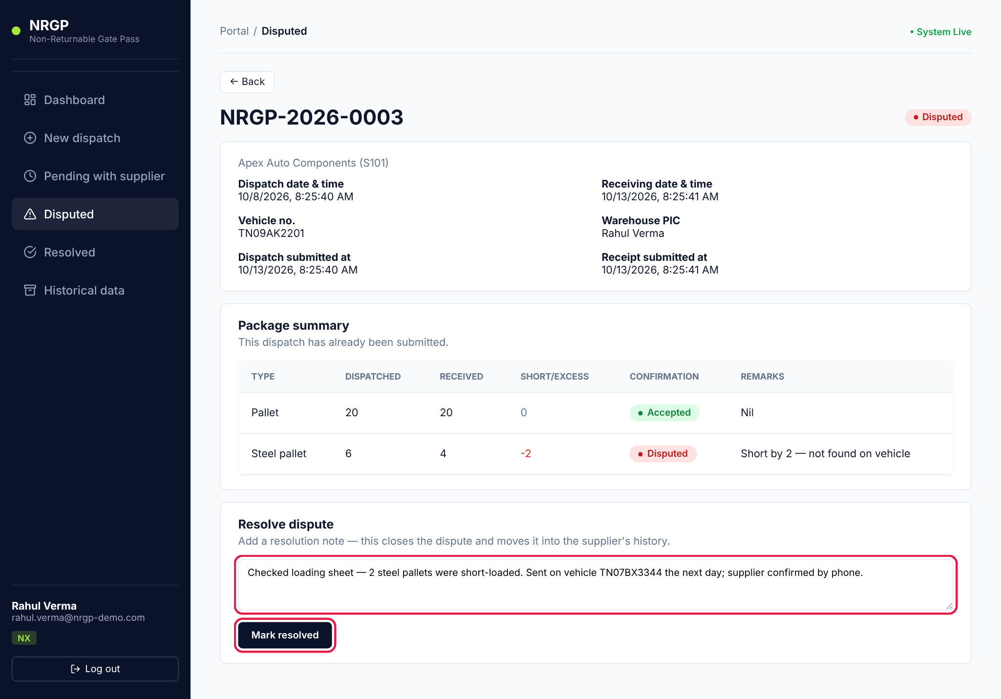
Figure 27 — Resolve dispute — note entered
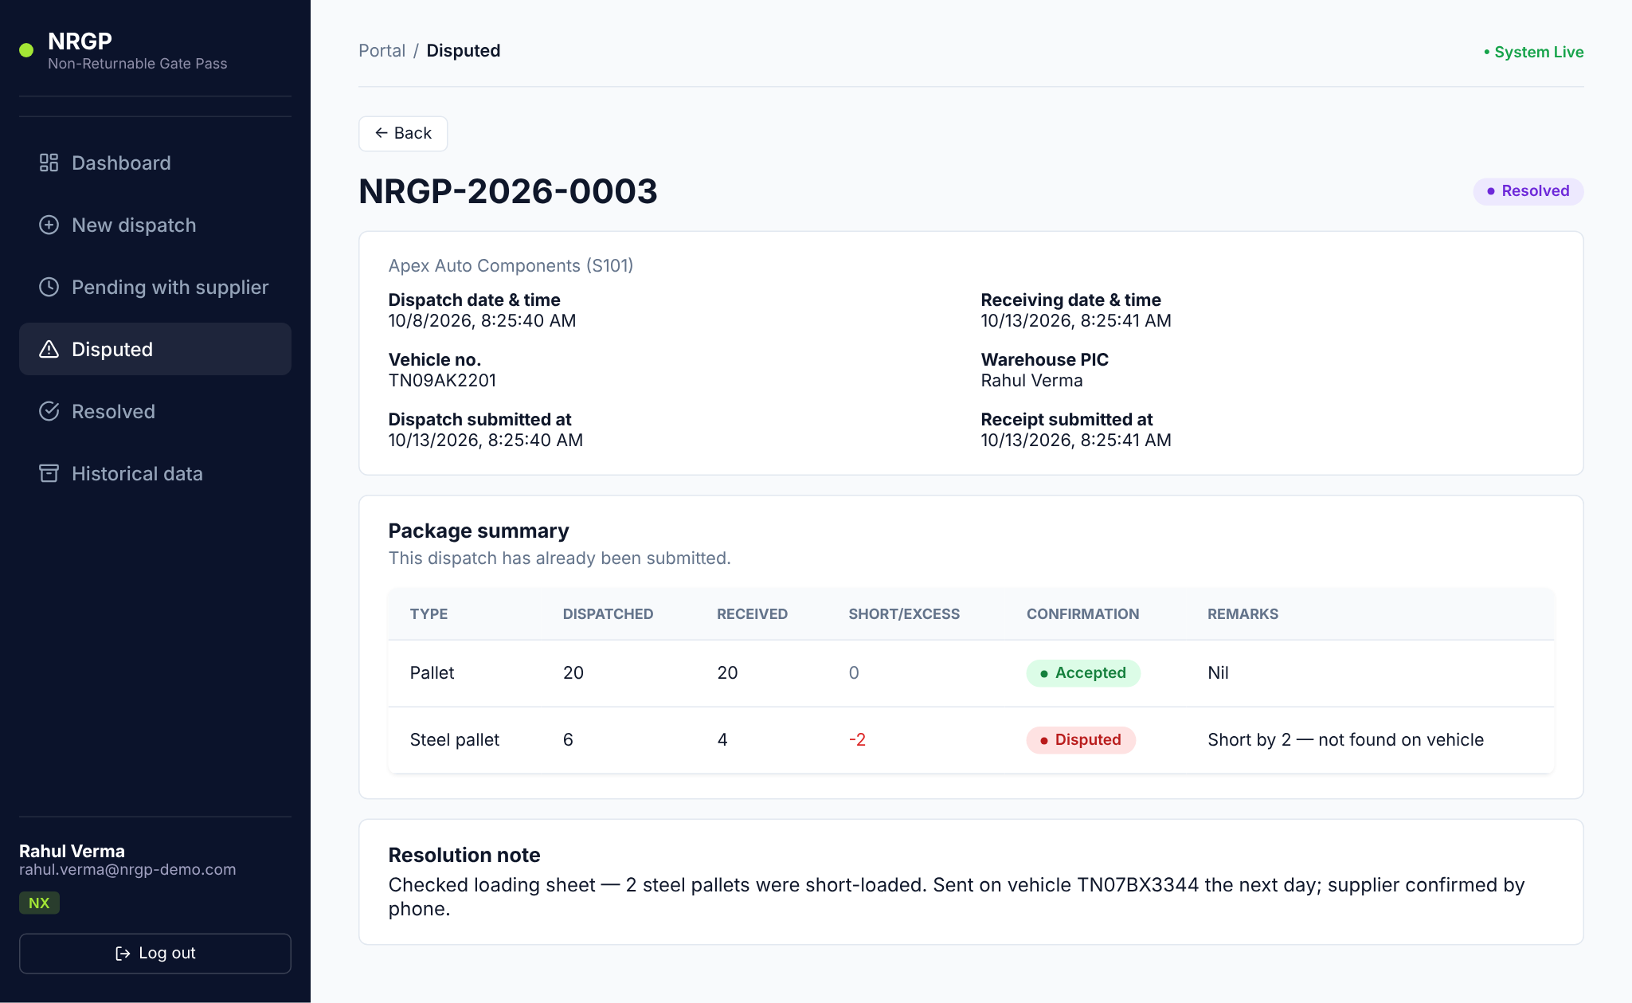
Figure 28 — After resolving — status Resolved with the resolution note
Tip: A resolution note is mandatory and cannot be changed afterwards. Write it so that someone reading it months later understands what happened.

4.6 Resolved disputes and historical data
- Resolved lists every dispute that has been closed.
- Historical data lists all dispatches in every status — use it for searching and reporting.
- Click Export CSV on any list to download the filtered rows (transaction ID, supplier, dates, vehicle, submission times, status).
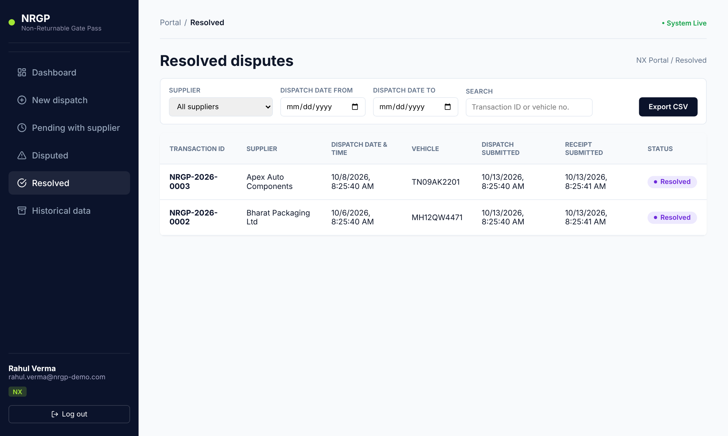
Figure 29 — Resolved disputes list
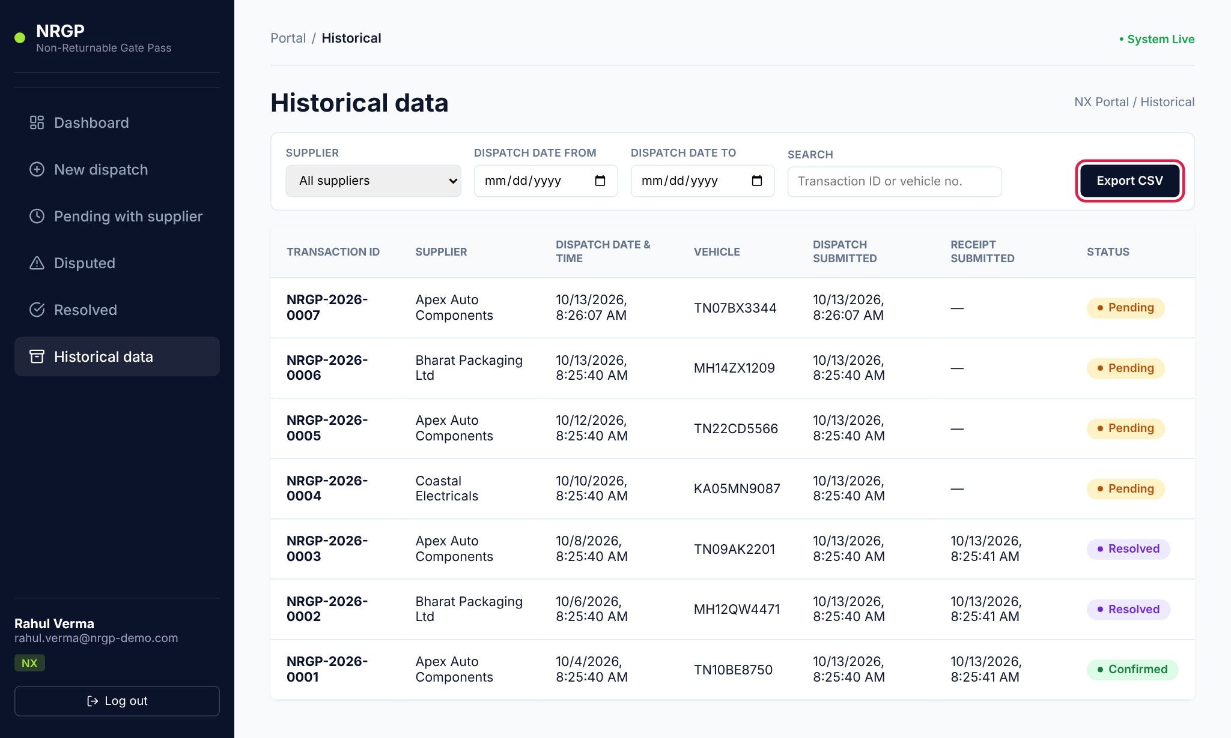
Figure 30 — Historical data — Export CSV highlighted

5. Supplier guide
As a supplier you confirm what you actually received for each dispatch NX sends you. You only ever see dispatches addressed to your own company.

5.1 Dashboard
After signing in you see the Dispatch dashboard for your company. The Pending with supplier card shows how many dispatches are waiting for your confirmation. The sidebar shows your company name and the role tag RECEIVER.
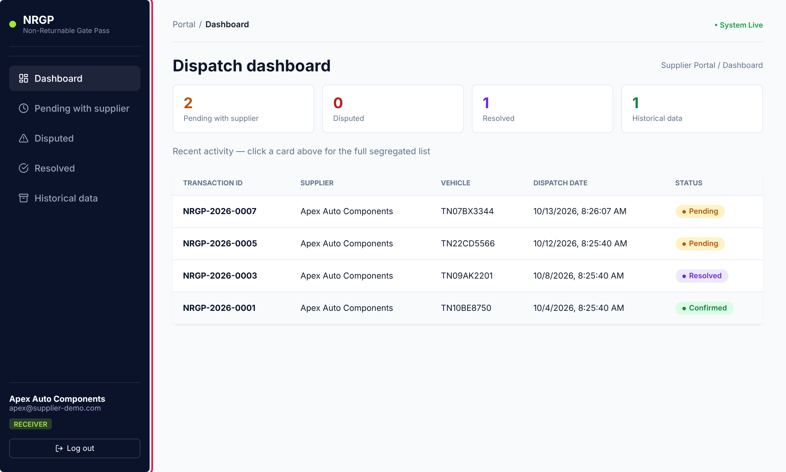
Figure 31 — Supplier dashboard

5.2 Find dispatches waiting for you
- Click Pending with supplier in the sidebar (or the Pending card on the dashboard).
- Find the dispatch by transaction ID or vehicle number — the vehicle number is on the paperwork that came with the load.
- Click the row to open it.
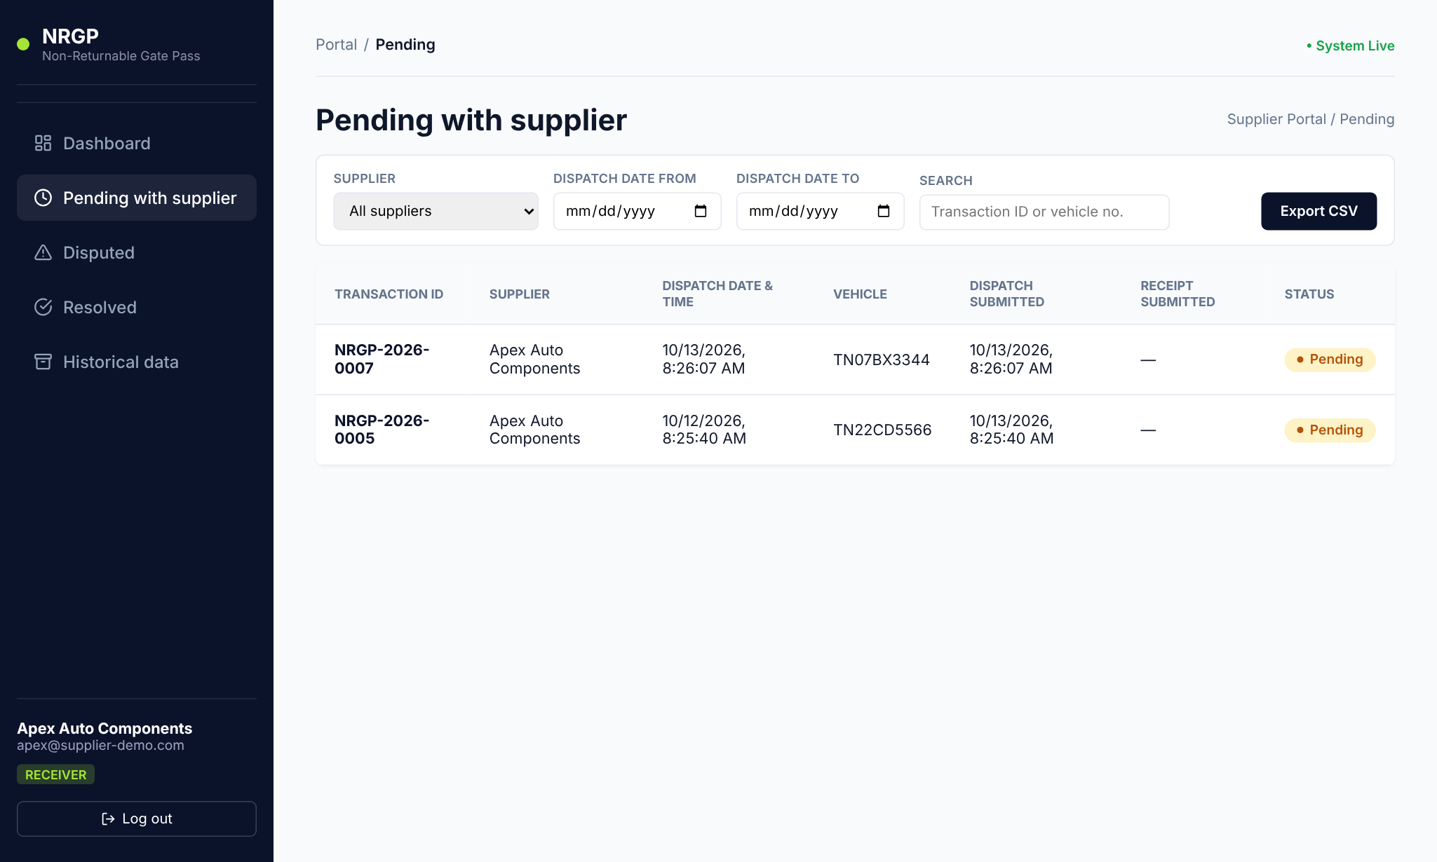
Figure 32 — Dispatches pending your confirmation

5.3 Confirm a receipt
The dispatch page shows what NX sent. The Received column is pre-filled with the dispatched quantity, so if everything arrived correctly you only need to check and submit.
- Check Receiving date & time. It defaults to now — change it if the goods physically arrived earlier.
- Count what arrived and compare it with the Dispatched column.
- If a line matches, leave Received as it is. Confirmation shows Accepted. A remark is optional (e.g. Nil).
- If a line does not match, type the quantity you actually received (see section 5.4).
- Click Confirm & submit entry.
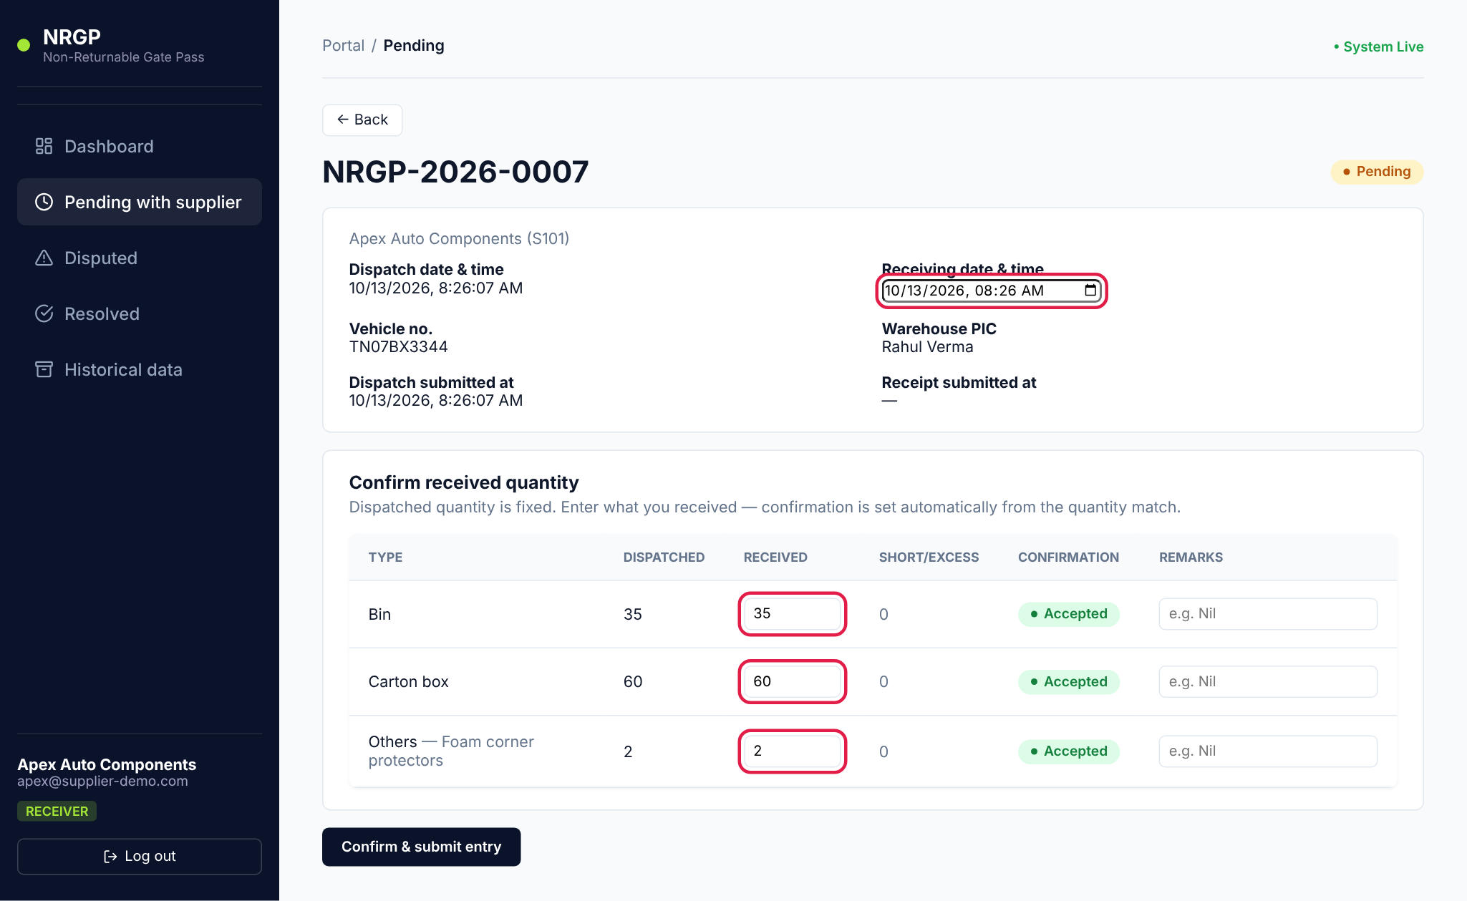
Figure 33 — Confirm received quantity — receiving date and Received column highlighted
If every line was accepted, the dispatch becomes Confirmed and is complete. No further action is needed.
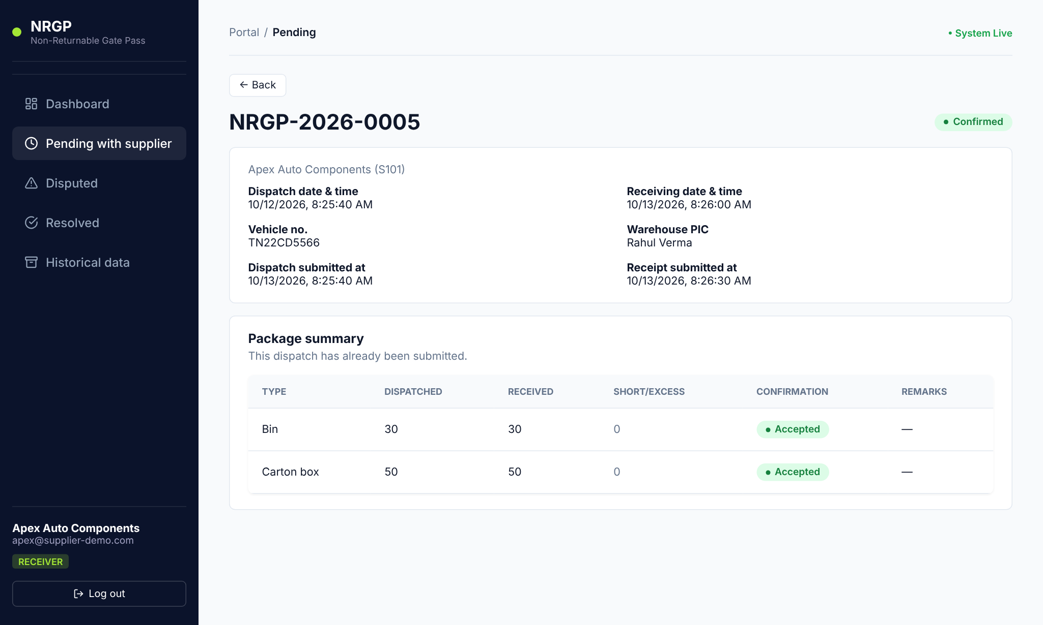
Figure 34 — A dispatch confirmed with all lines accepted
Important: You can submit a receipt once. After submission the quantities are locked, so count carefully before clicking Confirm & submit entry.

5.4 Report a shortage or excess
- In the Received column, enter the quantity you actually received on the line that does not match.
- The Short/Excess column shows the difference automatically, and Confirmation changes to Disputed.
- A red message appears: "Quantity mismatch detected…". A remark is mandatory for every disputed line — explain what was wrong (e.g. "2 carton boxes missing — vehicle checked on arrival").
- Click Confirm & submit entry.
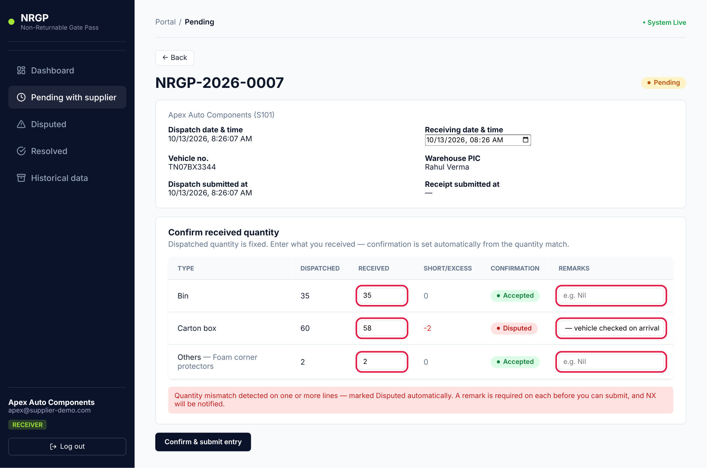
Figure 35 — Carton box received 58 of 60 — line marked Disputed and remark entered
The dispatch status becomes Disputed and it moves to your Disputed list. A yellow message explains that the dispute is now with the NX dispatch team.
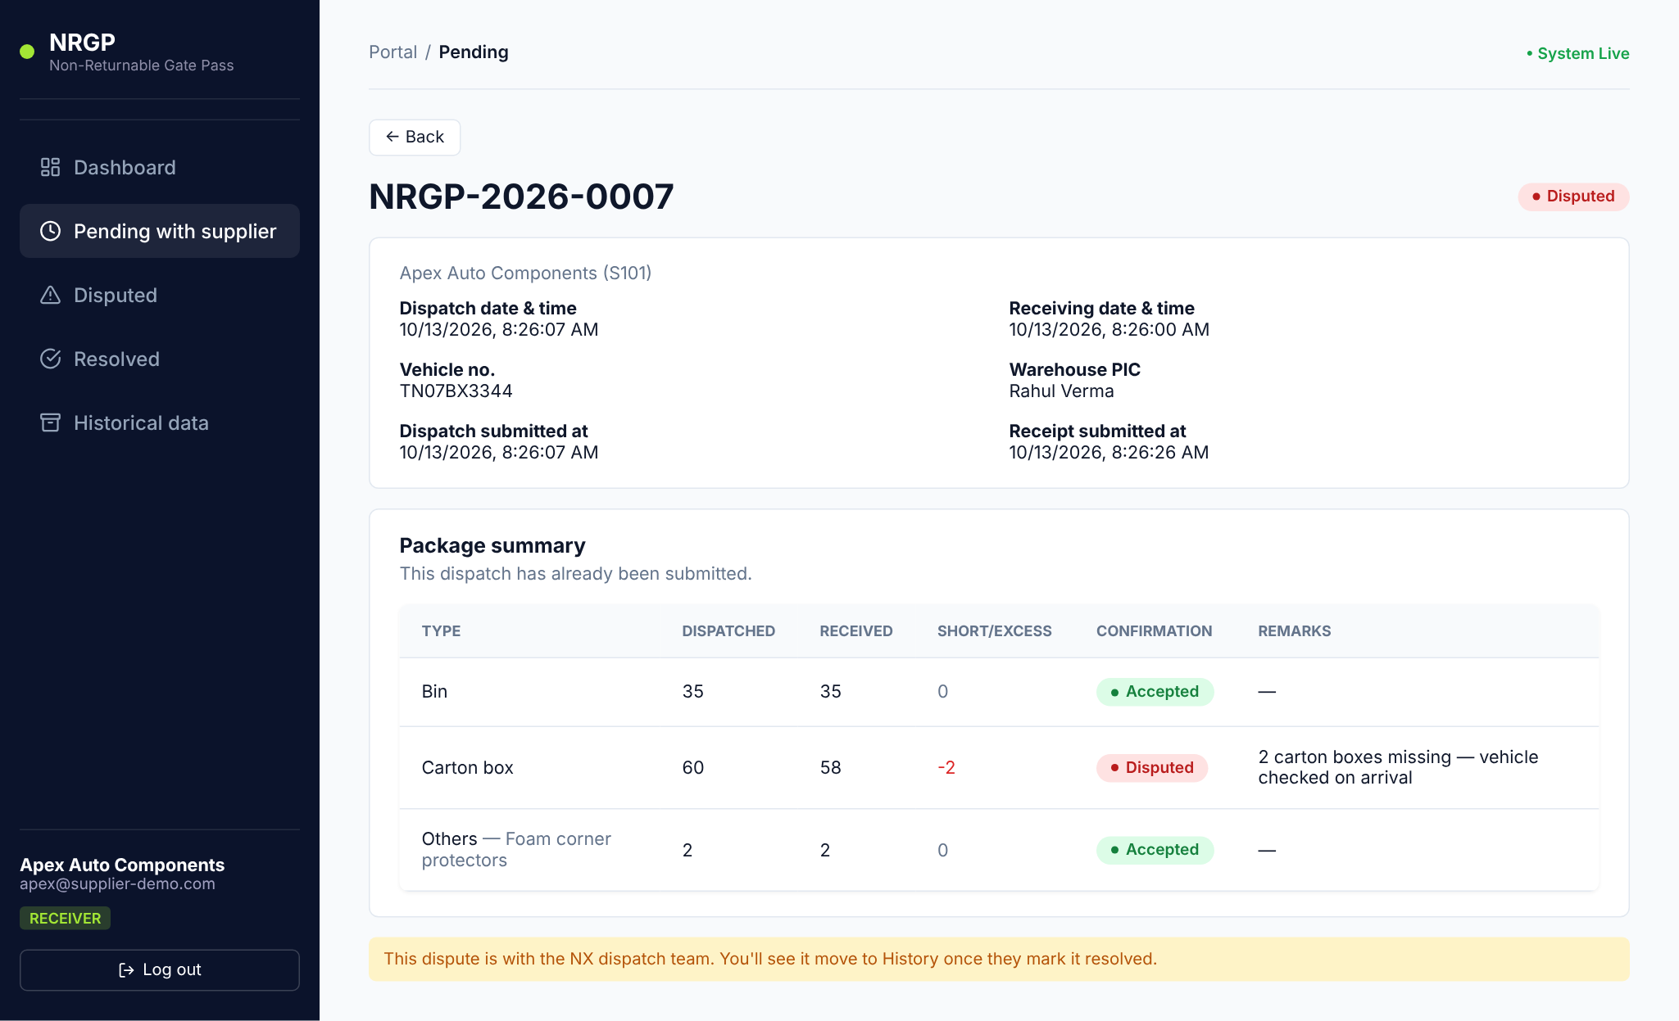
Figure 36 — After submitting — the dispute is with NX
Tip: If you try to submit a disputed line without a remark you will see "Add a remark for every disputed line before submitting."

5.5 After NX resolves the dispute
When NX closes the dispute, the dispatch moves to Resolved. Open it to read NX's resolution note. Historical data lists all your dispatches in every status, and Export CSV downloads them for your own records.
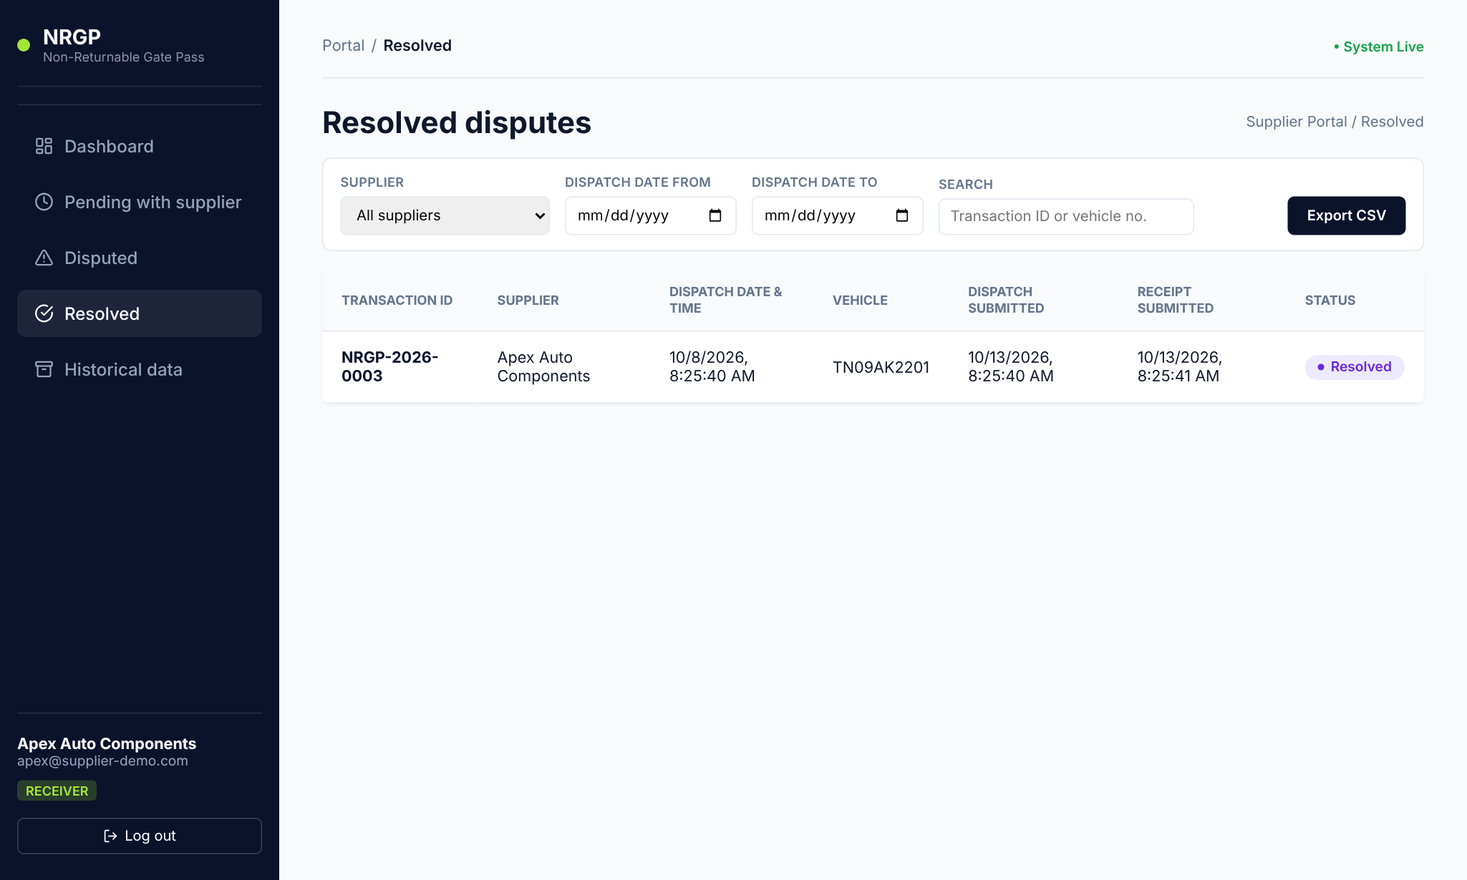
Figure 37 — Resolved disputes for the supplier
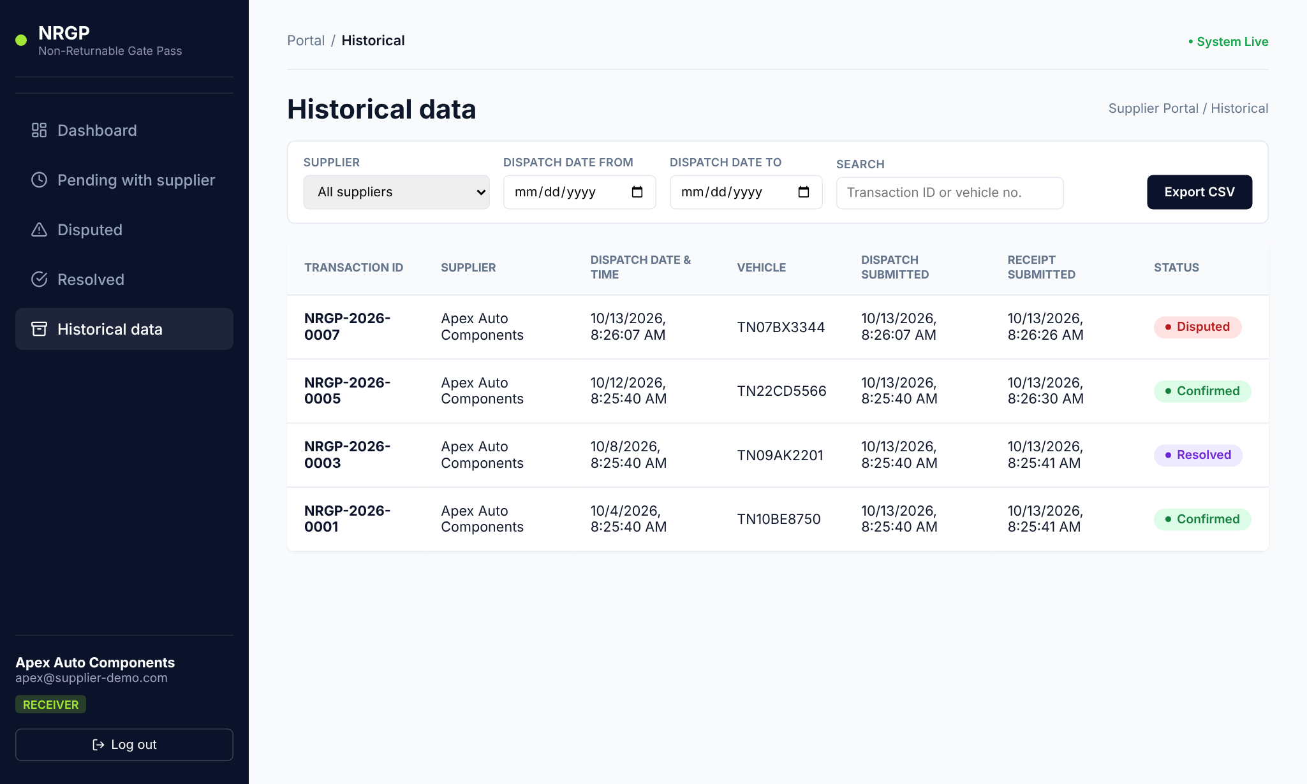
Figure 38 — Supplier historical data

6. Quick reference

Portal Admin
I want to… | Go to
Add one NX employee or admin | NX employees → + Add NX employee
Add many employees | NX employees → Bulk upload
Add a supplier | Suppliers → + Add supplier
Reset someone's password | NX employees / Suppliers → Reset password on their row
Remove someone's access | NX employees / Suppliers → Deactivate
Create or resolve dispatches | Same as NX Employee below

NX Employee
I want to… | Go to
Send goods to a supplier | New dispatch → fill in → Submit & notify supplier
See what suppliers haven't confirmed | Pending with supplier
Handle a quantity mismatch | Disputed → open dispatch → Resolve dispute → Mark resolved
Find an old dispatch | Historical data → Search by transaction ID or vehicle no.
Download a report | Any list → filters → Export CSV

Supplier
I want to… | Go to
Confirm a load that arrived | Pending with supplier → open dispatch → Confirm & submit entry
Report missing or extra items | Change the Received quantity, add a remark → Confirm & submit entry
See how NX settled a dispute | Resolved → open dispatch → Resolution note
Download my records | Historical data → Export CSV

