Market based Ecom to increase profit with Deep Learning on Neural Networks
First Author#, Second Author*, Third Author#
#First-Third Department, First-Third University
Address
¹first.author@first-third.edu
²second.author@second.com

Abstract— Mining high beneficial item sets from a transactional database means to identify the item sets with high utility as profits. Although a number of Algorithms have been invented but there is a problem as it generate large set of candidate Item sets for High Beneficial Item sets also require large number of times scan the database. The unit profits and purchased quantities of the items are not taken into considerations in frequent item set mining and weighted mining only weight is to be considered but not consider the profit. This situation may worse when database contains a large number of Transactions.
With the help of Deep Learning on Neural Networks, candidate item sets generated with only two scans of the database. Proposed algorithms not only reduce a number of candidate item sets but also work efficiently when database has lots of long transactions. This work will be finding the highest sales of the products in the online web ecom applications. It helps to find the combination of products sold in the online sales web sites. It helps the organization to find out the customer requirements in the market and to further improve the higher sold out products in the websites. The existing methods of the finding the top profit selling items in the market is very difficult. The accuracy levels of the identification of the products are also not good. The deep learning on neural network will provide the better solution to solve the problem of identification of the profit selling products in the real world data. The Convolutional Neural Network algorithm will check the data in more compact with training and testing the data. It will provide more accuracy as compared with the other type of techniques. The online ecommerce dataset will be taken as the input to the application and the dataset will be passed into the Convolutional Neural Network algorithm and the data will be analysed with the different visual graphs

Keywords— Candidate Item set, Neural Networks, Transactions, Market Item set, Mining.
- Introduction
Successive examples are designs which show up often inside a dataset mining. An incessant item set is one which is comprised of one of these examples, which the reason continuous example is mining is frequently on the other hand alluded to as successive item set mining. Regular data mining is generally effectively made sense of by presenting market crate examination, a run of the mill utilization for which it is notable. Market bin examination endeavours to distinguish affiliations, or examples, between the different things that have been picked by a specific customer and put in their market container (be it genuine or virtual) and relegates backing and certainty measures for correlation. The worth of this lies in cross-promoting and client conduct examination.

The speculations of market container examination are successive example mining and are entirely like characterization aside from that any quality, or blend of properties, can be anticipated in an affiliation. As affiliation doesn't need the pre-naming of classes, it is a type of unaided learning.

Information mining is cycle of separating helpful data according to alternate points of view. Regular Thing set mining is broadly utilized in monetary, retail and media transmission industry. The main pressing issue of these ventures is quicker handling of an exceptionally huge measure of information. Continuous thing sets are those things which are often happened. So we can involve various kinds of calculations for this reason. The dissected calculations for tracking down successive examples fully intent on finding how these calculations can be utilized to acquire regular examples over huge value-based data sets. This has been introduced as a relative investigation of the accompanying calculations: Affiliation Rule Mining and successive example mining calculations. This concentrate likewise centres on every one of the calculation's benefits, drawbacks and constraints for finding designs among huge thing sets in data set frameworks.
- MOTIVATION
The primary motivation of market based Ecom analysis with Deep Learning on Neural Networks is to detect the find out the highly sold product in the market. In this work, the dataset containing the online sales will be taken into consideration. The pre-processing will be applied in to the dataset and the noisy and null value data will be removed from the dataset. After the data will be analysed and visualized for further processing. The Convolutional Neural Networks algorithm will be chosen to make the market based prediction of highest sales of group of products. The project evaluation can be tested with the machine learning algorithm prediction results. Since the Convolutional Neural Networks algorithm along with high utility pruning will be used to predict the highest sales rate of products, the accuracy of the algorithm result will be helpful to evaluate the results. The accuracy score of the algorithm in the market based helps to evaluate the dataset.
Frequent item sets rules can be utilized for various tasks like market container analysis, strategically pitching and proposal frameworks. Notwithstanding, it ought to be noticed that affiliation rule mining can produce an enormous number of rules, a considerable lot of which might be insignificant or tiresome. Hence, it is critical to utilize fitting measures, for example, lift and conviction to assess the intriguing quality of the created rules. Affiliation Digging looks for continuous things in the informational index. In continuous mining normally, fascinating affiliations and connections between item sets in value-based and social data sets are found. To put it plainly, Successive Mining shows which things show up together in an exchange or relationship.

- CONTRIBUTION & OBJECTIVE
- The objective of market based Ecom analysis with machine learning is to detect the find out the highly sold product in the market.
- In this work, the dataset containing the online sales will be taken into consideration.
- The primary contribution is to apply the deep learning to find out the top selling profit items.
- The pre-processing will be applied in to the dataset and the noisy and null value data will be removed from the dataset.
- After the data will be analysed and visualized for further processing.
- The Deep Learning neural network algorithm will be chosen to make the market based prediction of highest sales of group of products.
- It will be helpful in all the Ecom online sales web applications to find out the highest sales of the products.

- RELATEDWORK
The author Hamrouni [1] fostered a calculation for mining affiliation rules between sets of things in enormous data sets. Affiliation rule mining is an in the event that/proclamation that assists with revealing connections between apparently irrelevant information in a social data set or other data vault. Affiliation rule mining strategy utilizes a two stage process. The initial step is to recognize all the continuous item sets in view of the help count worth of the item sets. It utilizes the download conclusion property of item sets to eliminate the rare item sets. The subsequent step is the age of affiliation rules from the continuous item sets utilizing the help and certainty.

B.-E. Shie, H.-F. Hsiao[2] fostered a calculation for mining successive examples without lower and higher threshold value. In this system of successive item set mining, the significance of things, benefit and bought amounts of things are not thought of. Successive item set in mobile may just contribute a little piece to the general benefit, and non-continuous item set may contribute an enormous part to the benefit. The data mining development works on the proficiency of incessant mining as it doesn't produce applicant item sets during the mining system. The downside of this approach is that it considers just the significant things in the continuous market analysis .

Y.Liu, W.K. Liao and A. Choudhary[3] proposed a two stage calculation which was created to find high utility item sets, utilizing the download conclusion property of apriori. The calculations have characterized the exchange weighted usage while keeping up with the download conclusion property. In this paper they characterized two data set examines. In the principal data set check, the calculation finds all the one element exchange weighted use item sets and its outcomes structure the reason for two component exchange weighted usage item sets .In the subsequent data set filter, the calculation finds all the two component exchange weighted use item sets and it brings about three component exchange weighted use item sets. The disadvantage of this calculation is that it experiences level wise applicant age and test system.

J.Hu, A. Mojsilovic[4] fostered a calculation for continuous thing set mining that distinguish high utility thing blends. The objective of this calculation is to track down portions of information, characterized through mixes of certain things, which fulfil specific circumstances collectively and expand a predefined objective capability. The high utility example mining issue considered is not quite the same as previous methodologies, as it conducts rule revelation as for individual credits as well similarly as for the general basis for the mined set, endeavouring to find gatherings of such examples that together add to the most to a predefined objective capability.

Y.-C. Li,j,-s. Yeh, and C.-C. Chang[5] proposed a segregated thing disposing of procedure. In this paper, they found high utility item sets and furthermore decreased the quantity of applicants in each data set filter. They recovered productive high utility item sets utilizing the mining calculation called FUM and DCG+. In this procedure they showed a preferred exhibition over the entire past high utility example mining strategy. Notwithstanding, their calculations actually endure with the issue of level wise age and test issue of apriori and it require various data set checks.

Liu Jian-ping, Wang Ying, Yang Fan-ding et al[6] proposed a calculation called tree based UP-Development affiliation rule mining calculation (Pre-Fp). It depends on a high utility mining technique. The significant objective of FUFP is the re-utilization of recently mined successive things while moving onto UP-Development mining. The upside of high utility is that it diminishes the quantity of competitor set in the refreshing strategy. In high utility, all connections are bidirectional though in FP-tree, joins are just unidirectional. The benefit of bidirectional is that it is not difficult to add, eliminate the kid hub absent a lot of recreation. The high utility structure is utilized as a contribution to the pre-enormous tree which gives positive count distinction at whatever point little information is added to unique data set. It manages not many changes in data set in the event of embedding new exchange. In this paper the calculation groups the things into three classes: continuous, rare and pre-huge. Pre-enormous item sets has two backings edge esteem for example upper and lower edge. The disadvantage of this approach is that it is tedious.

- PROPOSED SYSTEM

The proposed methods aim to find the top profit selling items in the market dataset. The accuracy levels of the identification of the products will be improved with the proposed system. The deep learning on neural network will provide the better solution to solve the problem of identification of the profit selling products in the real world data. The Convolutional Neural Network algorithm will check the data in more compact with training and testing the data. It will provide more accuracy as compared with the other type of techniques. The online ecommerce dataset will be taken as the input to the application and the dataset will be passed into the Convolutional Neural Network algorithm and the data will be analysed with the different visual graphs.

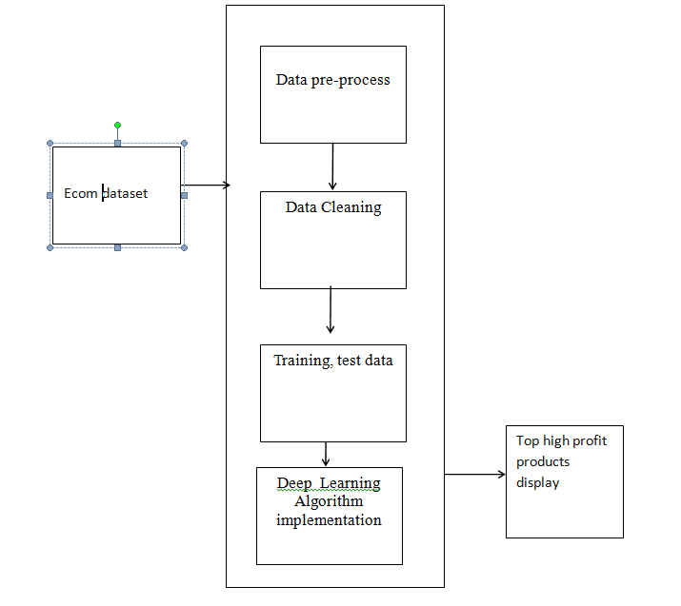

Fig 1 System diagram

Top 10 profit products will be getting the results which will be useful for the client point of view in monitoring the product which provides the highest profit. The top finding value also can be increased based on the situation which makes the accuracy level higher. The Proposed possibility of the venture is examined in this stage and strategic plan is advanced with an extremely broad arrangement for the undertaking and a few quotes. During framework examination the plausibility investigation of the proposed framework is to be completed. This is to guarantee that the proposed framework isn't a weight to the improve in findings of top profit selling items of the organization. For practicality examination, some comprehension of the significant prerequisites for the framework is fundamental.

This work will be to check the monetary effect that the framework will have on the association. How much asset that the organization can fill the innovative work of the framework is restricted. The uses should be legitimate. Consequently the created framework also reasonably affordable and this was accomplished in light of the fact that the vast majority of the advancements utilized are openly accessible. Just the altered items must be bought. Any framework created should not have popularity on the accessible specialized assets. This will prompt high requests on the accessible specialized assets. This will prompt high requests being put on the client. The created framework should have an unassuming necessity, as just insignificant or invalid changes are expected for carrying out this framework.
This proposed algorithm provides numerous benefits to users, including two essential algorithms: the Model-based Collaborative Filtering Algorithm and the Product Recommendation Model with Singular Value Decomposition with neural networks. Additionally, it incorporates the Utility Pattern Tree, a compact tree structure that assists in identifying high utility item sets and maintaining crucial information related to utility patterns within databases.

Organization and preparation of functional tests is focused on requirements, key functions, or special test cases. In addition, systematic coverage pertaining to identify Business process flows; data fields, predefined processes, and successive processes must be considered for testing. Before functional testing is complete, additional tests are identified and the effective value of current tests is determined.

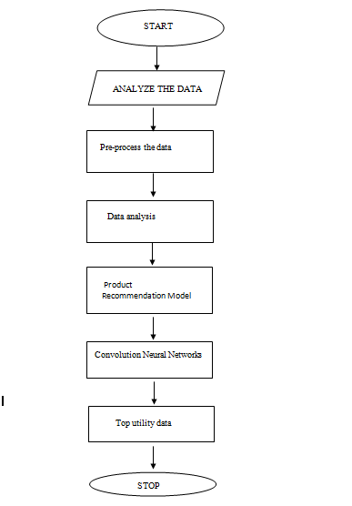

Fig 2 Proposed Architecture

In this algorithm will provide a comprehensive and intelligent solution for discovering high utility item sets, enabling users to access important information and streamline their search processes.
The application will be developed with Google Colab Python Tool as the project can be directly executed in any type computer systems with internet connection. There is no need of any specific software to be installed in the user system. The Colab Tool helps to develop and run the application directly inside the cloud server where the Python library files are installed. The deep learning algorithm libraries are built inside the Colab.

- DATA DESCRIPTION

The dataset for the market based analysis is taken from the source of kaggle dataset. This dataset contain the fields needed for the analysing of the amazon dataset. Exploratory examination is a cycle to investigate and comprehend the information and information relationship in a total profundity with the goal that it makes highlight designing and deep learning demonstrating steps smooth and smoothed out for expectation. Exploratory examination assists with validating our presumptions or misleading. Most of the image in a dataset are noisy and contain lots of information. But with feature engineering do, will get more good results. The first step is to import the libraries and load data. After that will take a basic understanding of data like its shape, sample, is there are any NULL values present in the dataset. Understanding the data is an important step for prediction or any deep learning project. It is good that there are no NULL values.

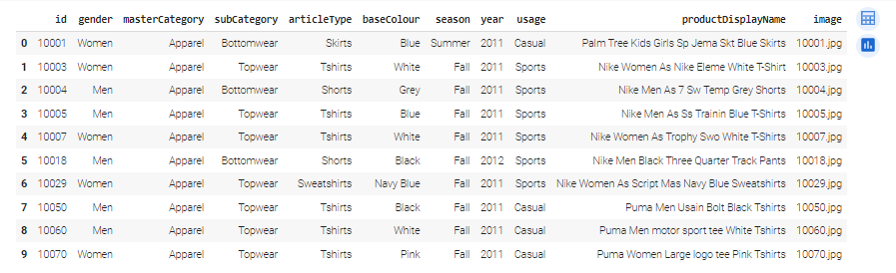

Fig. 3 Market dataset

The information about the dataset with different types of attributes is collected from online Ecom kaggle data. The dataset total contains of image dataset and json files and style.csv and image.csv file. The style.csv dataset contains the attributes which match the image data. Below are the attributes of style.csv dataset:
Id, gender, master Category, subcategory, article Type, base Colour, season, year, usage, and product display Name.
It will begin from the principal segment and investigate every section and comprehend what influence it makes on the objective segment. At the necessary step, we will likewise perform pre-processing and include designing undertakings. The point in acting top to bottom exploratory examination is to get ready and clean information for better Deep Learning demonstrating to accomplish elite execution and summed up models. So it should begin with breaking down and setting up the dataset for expectation.

- EXPERIMENTAL ANALYSIS
The Initial process of loading the dataset into the Google Colab into the drive is the first step in execution process. The image data with json file containing the information of the image with respect to the path and the description of the image location and the image related style are linked with the mapping of the image with the json file.
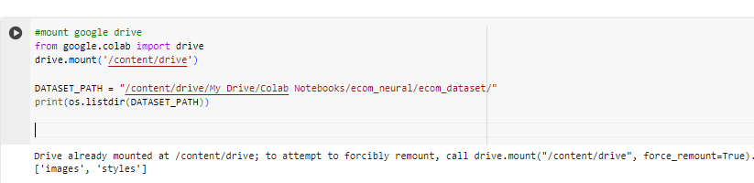

Fig. 4 Load dataset

The pre-processing is applied to the dataset where all the noisy data are removed and the image is reshaped as per the mapping of 255pixel.
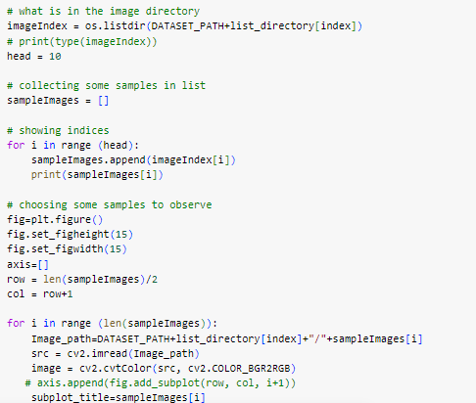

Fig. 5 Image re-shape

The sample image files after pre-processing is given below
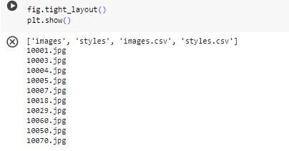
Fig. 6 Sample images layout

The image dataset is mapped with the dataset style.csv and image.csv files. The relationship between the image and the json files are mapped like a data cube.
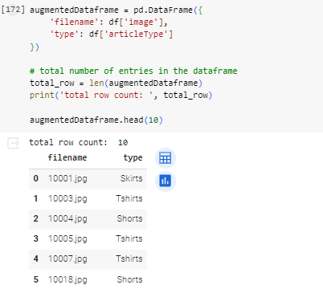

Fig. 7 Image Mapping

The products are categorized based on the product ID with respect to the number of sales items in the market dataset.
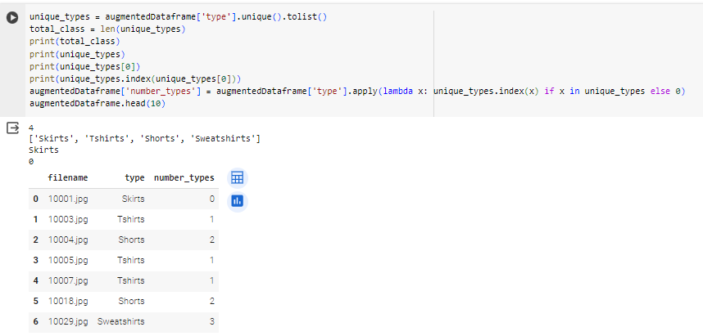Fig. 8 Unique items information

Based on the type of the product and count values are calculated in the product wise sales in the online ecommerce application.
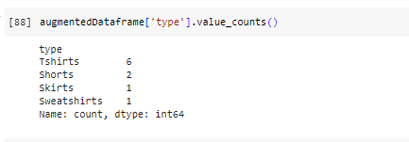
Fig. 9 Product with sales count

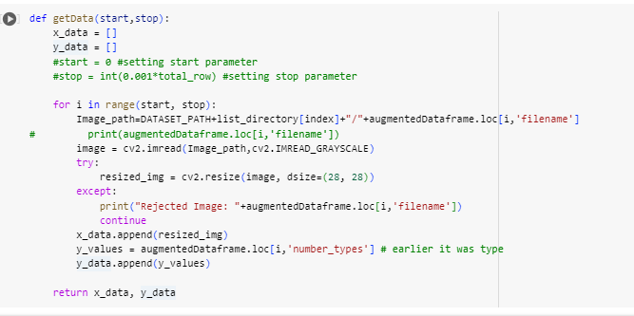

Fig. 10 Image Get data

The image dataset is divided into testing and training to pass in to the neural network model.
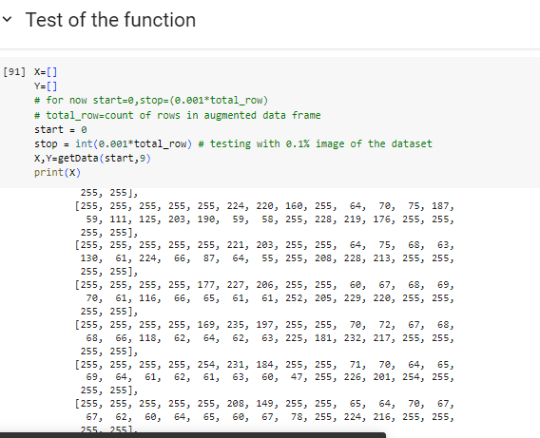

Fig. 11 Getdata list

The image dataset is converted into the array format and the data is added into the dataset as the large dataset will help in finding the clarity of the application.
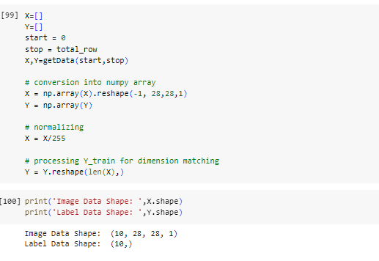
Fig.12 Image re-shape

The attributes of input data is been trained and tested then the model is been build, trained and tested and the predicted output is displayed.

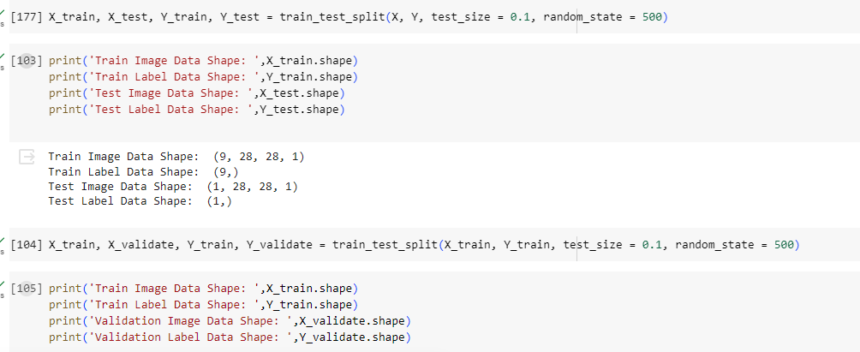

Fig.13: Train and test data
The Convolutional Neural Networks algorithm is applied with creating the sequential model. The output of the sequential model with layers is displayed.
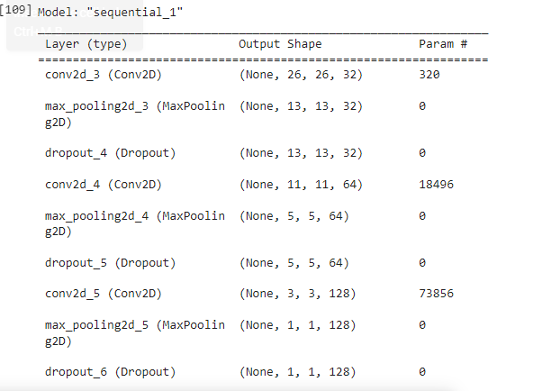

Fig. 14 Sequential output model layer

The profit and loss of the model were evaluated and the accuracy is calculated.
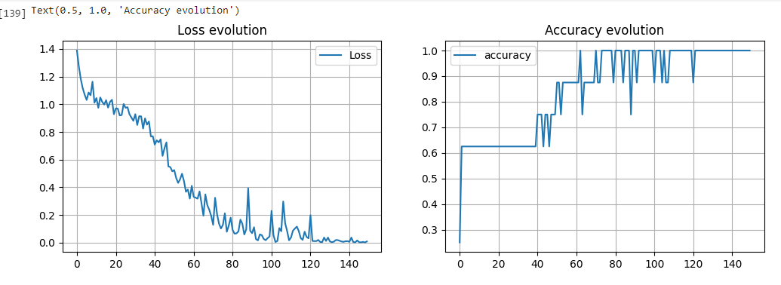
Fig. 15 Loss and accuracy evaluation

The market based analysis is computed with the convolutional neural networks and the top high utility market based items are identified.

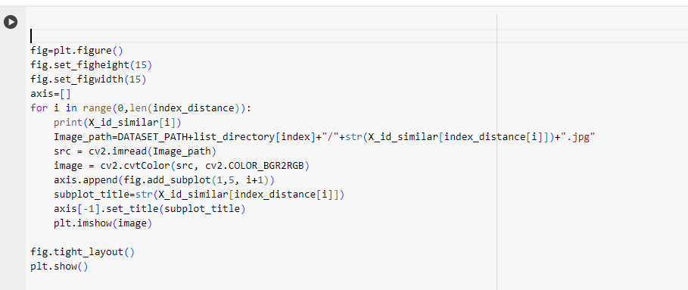
Fig 16 Top high utility based on cnn

The final results based on the similarity and top utility items based on the profit are displayed.

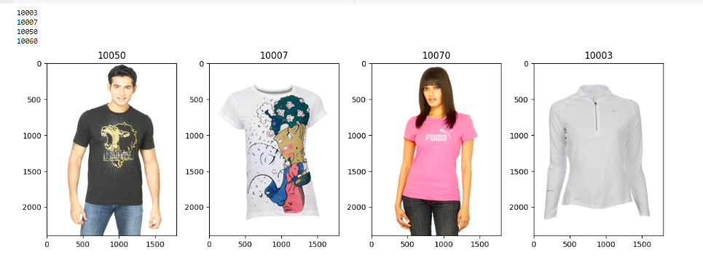

Fig 17: Top 10 high utility products

Data visualization helps to see how the data looks like and what kind of correlation is held by the attributes of data. It is the fastest way to see how the features correspond to the output.

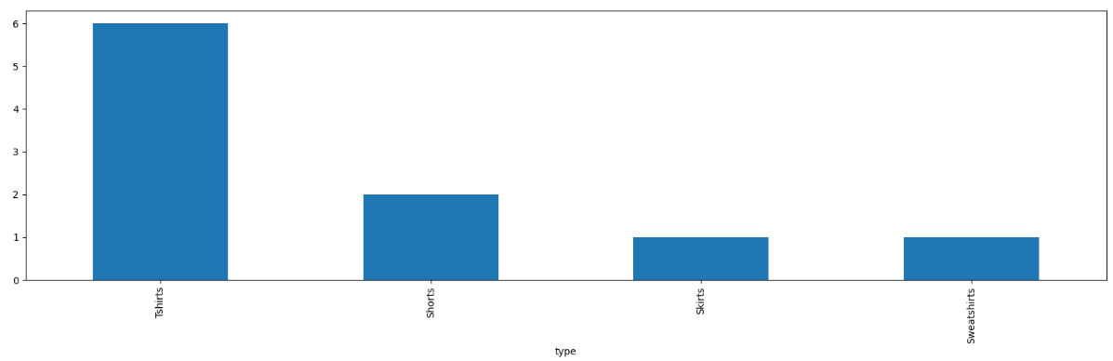
Fig 18: Top high utility products

The high profit supporting items are identified with the convolutional neural networks.
- CONCLUSION

The Proposed framework has utility example calculations, digging for finding High valuable item sets from data sets.
The convolutional neural network calculations are applied to figure out the top high utility item things from the amazon dataset. Future work in this field can include, a distributed and dynamic method. It generates complete set of high utility item sets from large databases. Mining high utility item sets from databases refers to finding the item sets with high profit. In distributed, it disposes the unpromising items based on the minimum utility item sets from transactions database. This approach creates distributed environment with one master node and two slave nodes scans the database once and counts the occurrence of each item. The large database is distributed to all slave nodes. The global table has the final resultant. UP- Growth Mining Algorithm is used where continuous updating goes on appearing in a database. Finally UP- Growth database is rearranged and the high utility item sets is discovered. Hence, it provides faster execution, that is reduced time and cost.
References
- T. Hamrouni, S. Yahia, and E. M. Nguifo, “Sweeping the disjunctive search space towards mining new exact concise representations of frequent item sets ,” Data Knowl. Eng., vol. 68, no. 10, pp. 1091–1111, 2009.
- B.-E. Shie, H.-F. Hsiao, V. S. Tseng, and P. S. Yu, “Mining high utility mobile sequential patterns in mobile commerce environments,” in Proc. Int. Conf. Database Syst. Adv. Appl., 2011, vol. 6587, pp. 224–238..
- Y.Liu, W.K. Liao and A. Choudhary, ―A two phase algorithm for fast discovery of high utility itemset‖, Cheng, D. and Liu. H. PAKDD, LNCS. PP: 689-695, 2005.
- J.Hu, A. Mojsilovic, ―High utility pattern mining: A method for discovery of high utility itemssets‖, in: pattern recognition. PP: 3317-3324, 2007.
- Y.-C. Li,j,-s. Yeh, and C.-C. Chang, ―Isolated Items Discarding Strategy for Discovering High Utility Item sets ,‖ Data and Knowledge engg., pp: 198-217, 2008.
- Liu Jian-Ping, Wang Ying Fan-Ding, ‖UP- Growth Mining algorithm Pre-FP in Association Rule Based on FP-tree‖, Networking and Distributed Computing, International Conference, pp: 199-203, 2010.
- Ahmed CF,Tanbeer SK,Jeong B-S, Lee Y-K (2011) ―HUC-Prune: An Efficient Candidate Pruning Technique to mine high utility patterns‖ Appl Intell PP: 181–198, 2011.
- Shih-Sheng Chen, Tony Cheng-Kui Huang, Zhe-Min Lin, ―New and efficient knowledge discovery of partial periodic patterns with multiple minimum supports‖, The Journal of Systems and Software 84, pp. 1638–1651, 2011, ELSEVIER.
- Chowdhury Farhan Ahmed, Syed Khairuzzaman Tanbeer, Byeong-Soo Jeong, Young-Koo Lee a,Ho-Jin Choi(2012) ―Single-pass UP- Growth and interactive mining for weighted frequent patterns‖, Expert Systems with Applications 39 pp.7976– 7994, ELSEVIER 2012.
- Vincent S Tseng, Bai-En Shie, Cheng-Wu, Philip S,‖ Efficient algorithms for mining high utility item sets from transactional databases‖, IEEE Transactions on knowledge and data engineering, 2013.
- T. Hamrouni, S. Yahia, and E. M. Nguifo, “Sweeping the disjunctive search space towards mining new exact concise representations of frequent item sets ,” Data Knowl. Eng., vol. 68, no. 10, pp. 1091–1111, 2009.
- H.-F. Li, H.-Y. Huang, Y.-C. Chen, Y.-J. Liu, and S.-Y. Lee, “Fast and memory efficient mining of high utility item sets in data streams,” in Proc. IEEE Int. Conf. Data Mining, 2008, pp. 881–886.
- C.-W. Lin, T.-P. Hong, and W.-H. Lu, “An effective tree structure for mining high utility item sets ,” Expert Syst. Appl., vol. 38, no. 6, pp. 7419–7424, 2011.
- G.-C. Lan, T.-P. Hong, and V. S. Tseng, “An efficient projection based indexing approach for mining high utility item sets ,” Knowl. Inf. Syst, vol. 38, no. 1, pp. 85–107, 2014.
- H. Li, J. Li, L. Wong, M. Feng, and Y. Tan, “Relative risk and odds ratio: A data mining perspective,” in Proc. ACM SIGACT-SIGMOD- SIGART Symp. Principles Database Syst., 2005, pp. 368–377.
- B. Le, H. Nguyen, T. A. Cao, and B. Vo, “A novel algorithm for mining high utility item sets ,” in Proc. 1st Asian Conf. Intell. Inf. Database Syst., 2009, pp. 13–17.
- Y. Liu, W. Liao, and A. Choudhary, “A fast high utility item sets mining algorithm,” in Proc. Utility-Based Data Mining Workshop, 2005, pp. 90–99.
] C. Lucchese, S. Orlando, and R. Perego, “Fast and memory efficient mining of frequent closed item sets ,” IEEE Trans. Knowl. Data Eng., vol. 18, no. 1, pp. 21–36, Jan. 2006.
- Y.-C. Li, J.-S. Yeh, and C.-C. Chang, “Isolated items discarding strategy for discovering high utility item sets ,” Data Knowl. Eng., vol. 64, no. 1, pp. 198–217, 2008.
- [20] N. Pasquier, Y. Bastide, R. Taouil, and L. Lakhal, “Efficient mining of association rules using closed itemset lattice,” J. Inf. Syst., vol 24, no. 1, pp. 25–46, 1999.
- J. Pei, J. Han, H. Lu, S. Nishio, S. Tang, and D. Yang, “H-mine: Fast and space-preserving frequent pattern mining in large databases,” IIE Trans., vol. 39, no. 6, pp. 593–605, Jun. 2007.
- https://www.kaggle.com/paramaggarwal/fashion-product-images-dataset
- https://www.kaggle.com/code/nickken253/fashion-products-recommendation-system/input

