Host Software

Customizing The Firmware Updater

Version 1.4
11/17/2008

Copyright © 2008 Freescale Semiconductor, Inc. All rights reserved.
All contents of this document are protected by copyright law and may not be reproduced without the express written consent of Freescale Semiconductor, Inc.
Freescale, the Freescale logo, and combinations thereof are trademarks of Freescale Semiconductor, Inc. Other product names used in this publication are for identification purposes only and may be trademarks or registered trademarks of their respective companies. The contents of this document are provided in connection with Freescale, Inc. products. Freescale, Inc. has made best efforts to ensure that the information contained herein is accurate and reliable. However, Freescale Semiconductor, Inc. makes no warranties, express or implied, as to the accuracy or completeness of the contents of this publication and is providing this publication "AS IS". Freescale, Semiconductor Inc. reserves the right to make changes to specifications and product descriptions at any time without notice, and to discontinue or make changes to its products at any time without notice. Freescale Semiconductor, Inc. does not assume any liability arising out of the application or use of any product or circuit, and specifically disclaims any and all liability, including without limitation special, consequential, or incidental damages.

Table of Contents
1. Revision History 3
2. Scope 3
3. Features 3
3.1. Updating Firmware Without a Host Installer 3
3.2. Easy Product Specific Customization 3
3.3. Protected Firmware Files 3
3.4. Updating Options For Localized Firmware 4
4. Binding Options And Resources 4
4.1. StBinder 4
4.1.1. Using StBinder 5
4.1.1.1. Selecting The Target Executable 5
4.1.1.2. Loading An Existing Configuration Profile 5
4.1.1.3. Customizing The Updater 6
4.1.1.4. Selecting Resource Types 12
4.1.1.5. Adding Resources 13
4.1.1.6. Existing Bound Resources 14
4.1.1.7. Editing The Resource List 14
4.1.1.8. Extracting Bound Resources 15
4.1.1.9. Saving The Configuration 15
4.1.1.10. Applying The Resources 16
5. Using The Updater Application 16
5.1. Firmware resource selection 16
5.2. User Interface Dialogs 18
5.2.1. Default Interface Selection 18
5.2.2. Minimal 18
5.2.3. Standard 19
5.2.4. Advanced 20
5.2.4.1. Detailed Information Groups 21

Revision History

REVISION | DATE | DESCRIPTION
1.0 | 05/11/2007 | Initial pubic release.
1.1 | 05/17/2007 | Updated images, added dialog selection to binder, default recovery mode drivers
1.2 | 09/30/2008 | Renamed to Customizing The Firmware Updater, added updater configuration options
1.3 | 10/03/2008 | Minor corrections
1.4 | 11/17/2008 | Addition of profile load/save feature, default drive label

Scope

This document describes features of the Freescale Semiconductor, Inc. STMP resource binder application that allows customization and resource loading of the firmware update application.

- A single update executable image with all required resources.
- Application can be customized with device IDs, descriptive strings, icons, and other customer specific resources.
- Multiple localized firmware versions can be included.

Features

Updating Firmware Without a Host Installer

The firmware updater executable provides all required components such as recovery mode driver and firmware bound to the updater application as resources. This creates a single executable with everything it needs to update the device.

For the end consumer, there is no need to have software installed to the Program Files area of the target system other than copying the updater executable to anywhere the end user selects. The recovery mode driver is installed in the normal system location if none is currently installed. The firmware updater executable may be saved and executed from anywhere on the target system.

For example, the end user may be able to select to download the appropriate updater on the manufacturer’s support page, and select Run to execute the update from the Temporary Internet Files folder.

Easy Product Specific Customization

Use the StBinder application to customize a pre-built SDK specific copy of the firmware update application to include company and product specific strings, identifiers, execution options, and other resources.

Protected Firmware Files

By binding the firmware files to the updater executable, the firmware files are protected from being deleted or replaced. This ensures that the appropriate firmware is being applied by the end consumer.

Updating Options For Localized Firmware

Multiple localized versions of firmware can be bound to the updater. The updater can then select the version to update based on the locale of the system being used to perform the update.

This allows a single firmware update executable image to support multiple locales.

Binding Options And Resources

Resources are bound to an existing updater application using a utility application, StBinder, that is available for customer download from the host application download site at http://www.freescale.com/go/192888830.

StBinder

This application is used to specify customer specific data identifiers and strings, icons, images, and execution options for the updater. It is also used to bind the customer’s compiled firmware files to the SDK specific host updater executable downloaded from the host application download site at http://www.freescale.com/go/192888830.

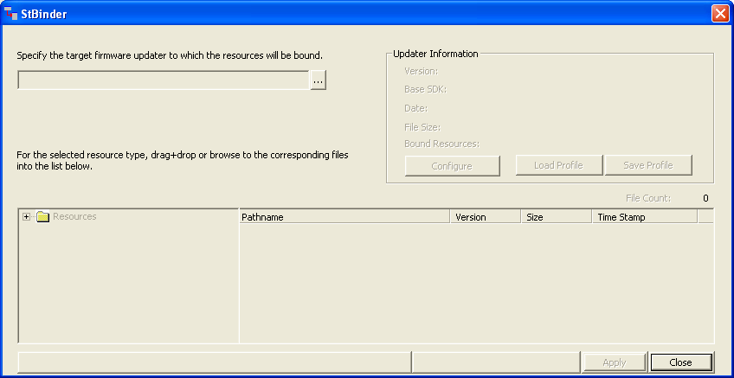

The application is not specific to the STMP SDK and may be used with STMP35xx, STMP36xx, or STMP37xx based firmware and host updater applications v1.800.0.000 or later.

The application is localized for the following languages:

- Chinese (Simplified)
- Chinese (Traditional)
- English
- Japanese
- Korean
NOTE: Additional languages can be supported if requested.

Using StBinder

Selecting The Target Executable

The targeted host update executable is specified by browsing to an existing updater executable. The executable may be renamed, but the original filename must be “stupdaterapp.exe”.

A “Browse” button next to the target specification launches an “Open File” dialog for browsing. Information about the targeted updater is displayed in the upper right corner of the dialog. Any existing resources already bound to the executable are listed in the appropriate resource group.

Once the target updater executable is specified, the Configure button is enabled along with the current resource lists. Configuration options and resources may be added, replaced, or removed.

By default, the updater application selects any resources found in the folder from which it executes. This feature allows resources such as firmware files to be dropped in to replace those resources bound to the application. This feature can be disabled with the “Uses local file resources by default” checkbox. When the resources are then applied, the updater will use only those resources for firmware updating.

Loading An Existing Configuration Profile

If a previous configuration profile has been saved, the Load Profile will be enabled and the user can select a pre-defined profile to load. The profile includes all product data, file specifications, and update options.

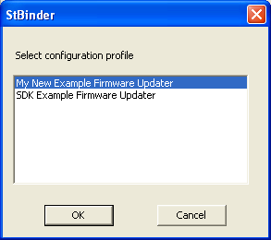

The profile must have been saved before applying resources to the updater application to preserve file path specifications for items such as firmware files, icons, or images. Those file specifications must exist to load the profile correctly.

Customizing The Updater

Selecting the Configure button displays a tabbed page control for the various options for customizing the updater application to a customer’s specification.

Changes may be made on multiple pages before selecting OK or Cancel at the bottom of the tabbed control. No changes are saved until the OK button is selected. Changes are not applied to the updater until the Apply button is selected on the main page.

The originally downloaded STMP Firmware Update application will have the default STMP identifiers and string. The user changes those values to match that of the customer product.

Customer Data

The Customer Data page contains strings and other resources specific to the customer product.

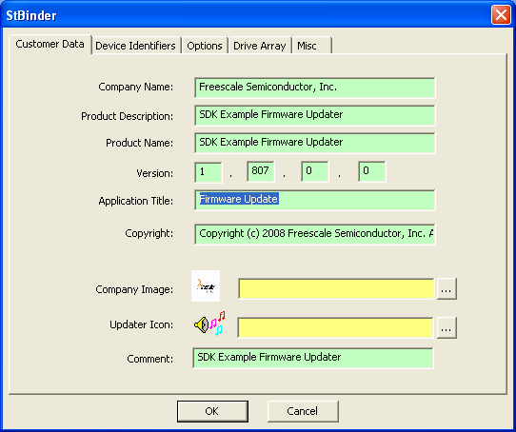

Company Name – The name of the customer company.

Product Description – A descriptive statement of the product.

Product Name – The product name, usually a model number or name.

Version – Specify customer specific version, if desired. This will be the version displayed in the About window. The original version is still retained in file version resource for reference.

Application Title - The updater application’s main window title.

Copyright – Text displayed in the About window for copyright protection. Change to a customer specific message.

Company Image – This may be either a Windows bitmap (.bmp), or an icon (.ico) file With the bitmap, a splash screen type About is used. With an icon, the more traditional About window is displayed.

Updater Icon – Icon to be used by the firmware updater. This will be used in explorer windows, etc…

Device Identifiers

This page contains the identifiers that uniquely identify the device in the Windows operating system. These identifiers must match exactly those used in building the STMP firmware.

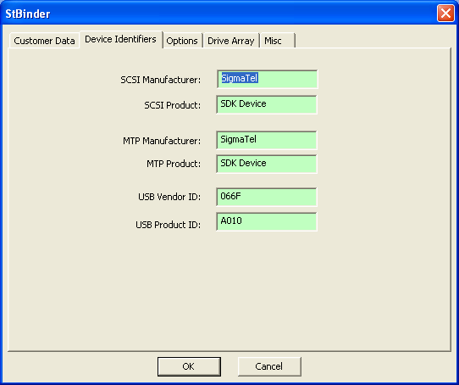

SCSI Manufacturer – Used to identify the device in MSC mode.

SCSI Product - Used to identify the device in MSC mode.

MTP Manufacturer - Used to identify the device in MTP mode.

MTP Product - Used to identify the device in MTP mode.

USB Vendor ID – The customer USB vendor ID

USB Product ID – The customer US product ID.

Options

This page sets the various execution options for the firmware update application. The default options are seen below.

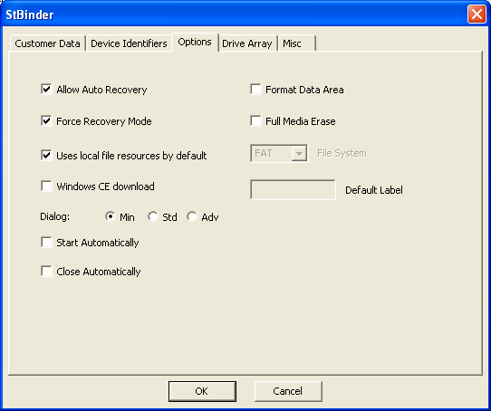

Allow Auto Recovery – If needed, allow the updater to reset the device into recovery mode prior to updating.

Force Recovery Mode – The updater can always force the device into recovery mode before updating.

Use Local File Resources By Default – Selecting this option causes the updater application to check for firmware files in the local directory and loading those rather than any resource bound firmware files.

Windows CE Download – Select this option if downloading to a Windows CE device.

Dialog – Select from three different user interfaces for the updater application.

Min—Typically, the Minimal interface is used by the end consumer for updating. This simplified interface depends on default settings with minimal user input.
Std—The Standard interface performs as it has traditionally with the user able to format the data area.
Adv—The Advanced interface is primarily used for development and troubleshooting. This interface is not typically used by the end consumer.

Format Data Area – Selecting this option causes the data area to be formatted wiping out any user, or device data stored there.

Erase Media – This option causes the entire media to be erased and re-allocated.

File System – Select the file system for formatting the data drive.

Default Label – If desired, specify a drive label for the data drive.

Drive Array

The Drive Array page lists the current drive allocation to be written to the device. Like the device identifiers, it is critical to match this data with that of the firmware files.

Using the provided example updater drive array as a guide for a particular base SDK modify the table, if needed, to match that expected by firmware.

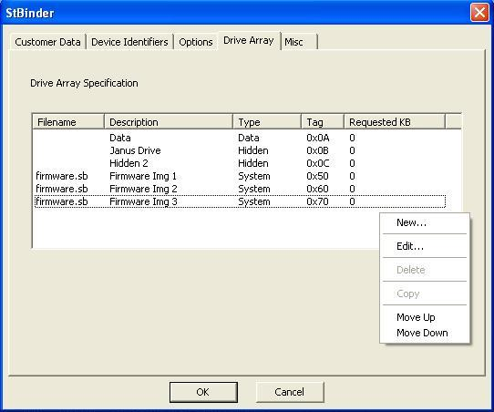

To add, edit, copy, move or remove drive entries right click in the drive control to bring up the context menu.

New – Create a new drive. Opens the Drive Edit dialog to allow the user to specify the details of the new drive.
Edit – Edit the existing drive. Opens the Drive Edit dialog to allow the user to change details of the existing drive.
Delete – Deletes the drive form the table.
Copy – If another drive of this type is available, use this option to
automatically create the next available drive of this type.
Move Up – Moves the drive up in the table.
Move Down – Moves the drive down in the table.

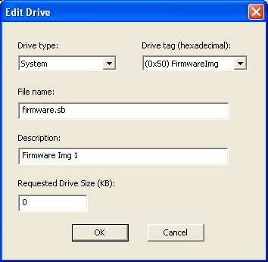

The Edit Drive window allows a new drive to be added, or an existing drive to the modified. It uses a pre-requisite scheme to prevent drive tags from being duplicated or entered out of order.

Misc

The Misc page contains miscellaneous firmware updater options which are not commonly used, or specific to a particular SDK version. If the option is specific to a particular SDK and the updater is not based on that SDK, the option is disabled as below.

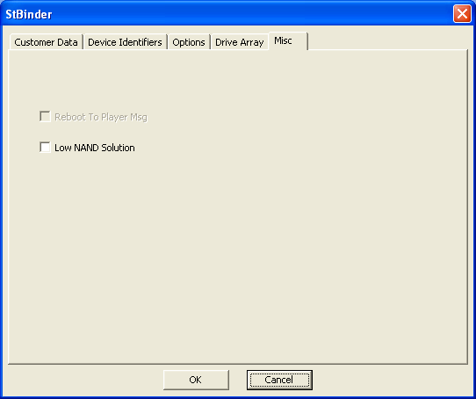

Reboot To Player Msg – This is an SDK35xx option which requires the device to be booted into player mode after updating to complete the update process. A message is displayed by the updater at completion to instruct the user.

Low NAND Solution – Select only if the device uses only an external media for data storage.

Selecting Resource Types

Resources are specified in resource types. The resource types are Recovery Mode Driver, Language Invariant, or language-specific firmware.

Several default language resources are listed. Any other supported language can be specified by selecting the “Firmware – Other” resource group.

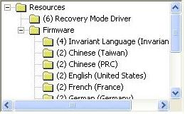

The “Firmware – Invariant Language” type is for default firmware where the locale of the host system is not supported by the other language firmware resources, or for non-localized firmware binaries. The updater attempts to load resources from this group if no other firmware resources match the locale of the host system.

Selecting the “Firmware – Other” resource group displays an additional interface that allows the user to specify a new firmware resource group.

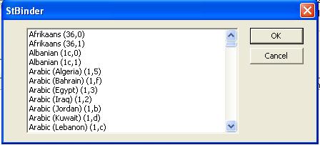

Selecting any language listed adds that language group to the list of resource groups. Firmware resources may then be added to the new group.

Adding Resources

StBinder supports drag and drop, as well as file browsing to include a specific resource type. The user adds as many localized firmware resources types as they wish.

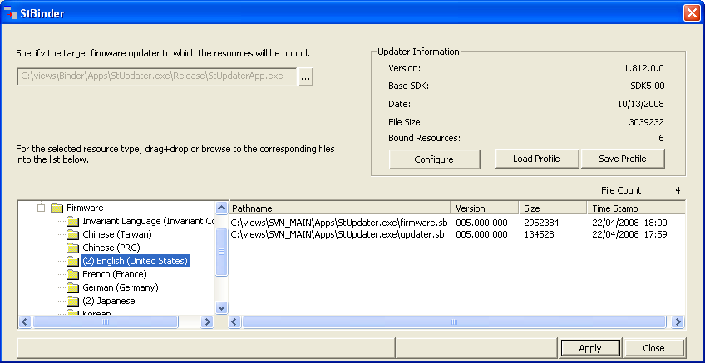

The list of resources for each resource group displays the path name, version, size, and time stamp of the resources.

To browse for files to add, right-click either the resource group or in the resource list to launch the “Open File” dialog.

Existing Bound Resources

If the targeted updater has existing resources bound to it already, those resources are listed in the resource list and displayed in brackets (for example, <resource>) rather than a path name to indicate their presence in the executable.

The updater application has existing digitally signed recovery mode drivers bound to it as resources by default. These can be replaced with drivers with the customer’s own digital signatures.

If a file that is added already has a resource in the executable, the bound resource will be marked for replacement.

Editing The Resource List

Any resource listed can be deleted from the list by selecting that item (or items), pressing the right mouse button, and selecting Delete (or pressing the Del key on the keyboard).

If that resource is already bound to the executable, it is marked for deletion when the resources are applied to the target.

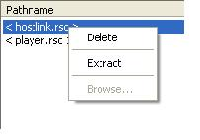

Extracting Bound Resources

Any resource currently bound to the executable can be extracted from the executable by selecting that item (or items), pressing the right mouse button, and selecting Extract. The application displays the Save As dialog box in which the user specifies the location to save the extracted resources.

NOTE: Extracting a resource does not delete the resource from the executable.

Saving The Configuration

After making any changes, save the configuration to the registry using the Save Profile button for easy configuration of any new updater application. This saves time in configuring new firmware updater releases, and adds reliability in always being able to load correct configuration data.

A Save As dialog will allow the profile to be saved under a descriptive name. By default, on a new profile the profile name will be the product name. However, the user can specify any profile name in the Save Profile dialog. The profile is stored in the registry under this key name.

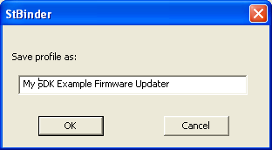

Note: Once resources are applied, the configuration is no longer that of the profile, but of the executable itself. Therefore, it is important to save any profile changes, particularly file specifications before applying the changes to the executable.

Applying The Resources

No changes are made to the executable until the changes are applied by selecting the Apply button. If there are resources listed to be replaced or deleted, the application requests confirmation from the user before starting the binding process.

With the target executable selected and resources specified, the user selects Apply. The application disables the Apply button and displays a progress bar to indicate progress in applying the resources.

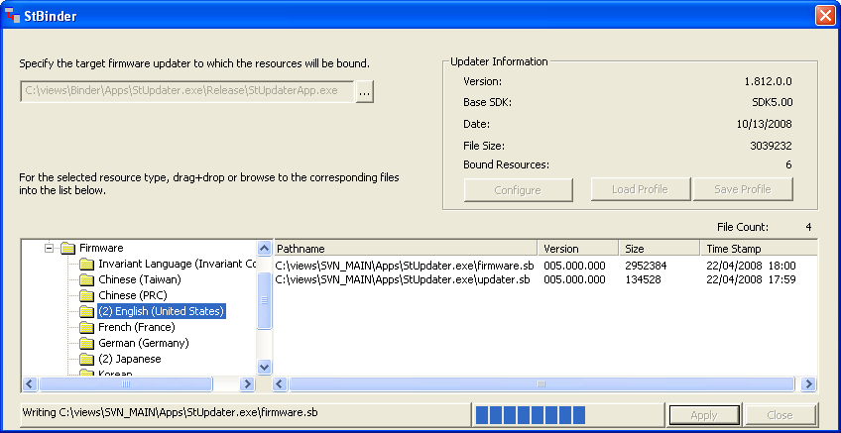

When complete, the Apply button is enabled. All new resources bound to the executable are denoted in the bracketed format to indicate their presence as a resource in the targeted executable.

At this point the user may continue to add, remove, or extract additional resources, or the user may close the application.

Using The Updater Application

By default, the updater application operates as previous versions have done when a full software installation is performed and when there are no resources bound to the updater executable.

Firmware resource selection

Firmware resource selection is made according to a specific order of precedence. The firmware updater attempts to make a best fit with the locale of the host system, but also to allow system developers to override any locale specific selections.

The firmware update application attempts to load a firmware resource in the following order:

- Instance of file in local directory

By default, a user can override the bound firmware resource by copying the firmware file into the updater’s local directory. This ability can be disabled when the resources are applied by removing the check from the “Uses local resource files by default” check box in the Updater information group in the StBinder application.

- Language ID command-line override

A language-specific ID can be specified via a command-line parameter to download specific language resources.

The language IDs are specified as a hexadecimal values in both a primary language ID and a sub-language ID. Refer to the Microsoft Windows SDK for complete language ID specification. The language option is specified as a combination of primary sub-language IDs.

/lang primary,sub-language

The primary language ID for English is 9, and the sub-language ID for the United States is 1. Therefore, to override the default system location, the option is:

/lang 9,1

- Language ID of local host system

The language ID of the host system is the default resource selection method.

- Primary language ID of host system and sub-language ID of NEUTRAL

If the updater fails to find the resource in the specific language ID of the host system, it attempts to find a resource with only the primary language ID.

- Primary language ID of Invariant with sub-language ID of NEUTRAL

For all other resources, including recovery mode driver files and non-localized firmware,
the updater looks for the resource using an invariant language ID.

If the updater fails to load a resource by all of these means, an error message is displayed.

User Interface Dialogs

Although the application utilizes three different dialog displays to the user, it is important to note that the application uses the same code for the actual update operation. The difference is in the presentation.

Default Interface Selection

The default user interface dialog can be specified using the StBinder application. This creates a resource variable in the updater application specifying which dialog interface to use by default.

The updater application uses the selected default interface whenever there is no overriding command-line option.

The default option removes the resource variable, and the updater uses the default option it was originally built for, typically the Standard interface.

Minimal

To simplify the firmware update procedure for the end consumer, an additional user interface is available with minimal information and no formatting option. The dialog display current and upgrade project versions, a single progress bar, and Start and Close buttons.

The minimal dialog does not have a data drive format option. The option is set during the customization by the StBinder application.

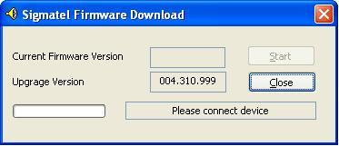

If formatting is required, but not selected by default, the user is notified that the data must be formatted in order to update the device. This is the same as the other update dialogs without the format selected.

The minimal dialog is displayed with the /min command-line option.

Standard

The default dialog is the standard dialog from previous versions. It is activated with the /std command-line option.

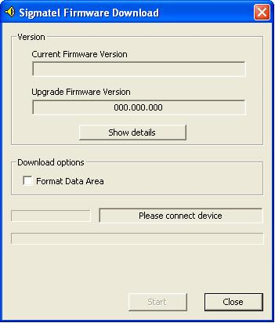

Advanced

To provide increased productivity in development and troubleshooting, an advanced interface is provided that includes more information about the device, update status, firmware resources, and download options.

This interface is activated with the /adv command-line option. This is the dialog box that is displayed with the /adv command-line option:
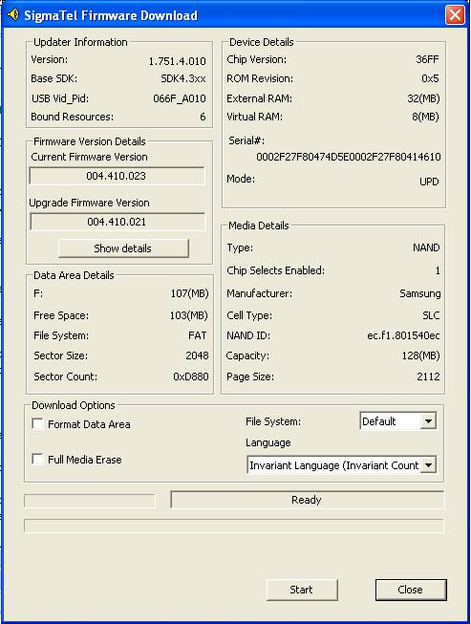

Detailed Information Groups

Updater Information

This group includes information about the firmware updater itself:

        - Version of the firmware updater
        - Base SDK on which this firmware updater supports
        - Number of resources bound to the executable, including firmware and recovery mode driver resources

Firmware Version Details

This group provides firmware version information for both current and upgrade firmware. Selecting the Show Details button displays version information of the individual firmware resources.

Device Details

This group provides information on specific details of the STMPxxxx device itself.

Chip ID – Chip ID returned by the device (3500, 3600, etc…).
ROM Revision - Revision code of the device ROM.
External RAM Size - Build time configured size of STMPxxxx external RAM in MBytes.
Virtual RAM Size – Amount of external RAM used by the upater.sb firmware build in MBytes
Serial Number – STMPxxxx device serial number (matches USB enumeration in registry).
Mode - Current mode the device is executing in, one of the following:
RCV – Recovery Mode
MTP – Media Transfer Protocol
LIM – Limited Mass Storage Class
MSC – Mass Storage Class
UPD – Update mode (updater.sb enumerated)
HID – Human Interface Device (STMP37xx)

Media Details

This group provides information about the storage media in the device.

Type – Only NAND media type is currently supported.
NAND Fields:
Chip Selects Enabled – Number of chip selects in use and detected by updater.sb (NAND1 build detects 1 CS max, NAND2 detects 2 CS max, etc…) .
Manufacturer – Media manufacturer name.
Cell Type – Can be SLC or MLC<x> where x represents the number of bits per cell.
NAND ID - Read ID command response from the physical media. Use public STMP3xxx media supported list and media data sheets to decode.
Capacity – Total capacity of the media in MB.
Page Size – Physical size of the data page in bytes + data page Redundant Area size. (eg: 2048 byte nand data page + 64 byte RA = 2112 byte total page size.)

Data Area Details

This group provides information about the data drive allocation on the media.

Drive letter and total size (MB) – Drive letter and reported drive size.
Freespace – Amount of free space on the logical data drive.
File System (FAT, FAT32) – Current file system.
Sector Size – Sector size.
Sector Count – Total number of sectors comprising the data drive.

Download Options

Format Data Area – Format data area.
Full media erase – Erase media completely before updating.
File system – Select Default, FAT or FAT32.
Language - Specifies which firmware resources to download overriding the default system locale. If there are no bound firmware resources, this option is not displayed.

