RW610 NCP User Manual

NXP Semiconductors.

Revision History
Date | Authors | Revision | Description
06/21/2022 | Qiankun Li | 1.0 | Initial draft.
02/15/2023 | Hui Bai | 1.1 | Add wlan-roaming command.

Table of Contents
1. RW610 UART 4
1.1. RW610 --- RW610(FC0 --- FC0) 4
1.2. RW610 --- PC 4
2. The format of command and response 5
3. Command Reference – WLAN Commands 6
3.1. Command Set 6
3.2. WLAN Commands 6
3.2.1. wlan-scan 6
3.2.2. wlan-version 8
3.2.3. wlan-roaming 9
3.3. wlan-connect 10
3.3.1. Usage 10
3.3.2. Command Format 10
3.4. get-connect-result 11
3.4.1. Usage 11
3.4.2. Command Format 11
3.4.3. Response Format 11
3.5. wlan-disconnect 13
3.5.1. Usage 13
3.5.2. Command Format 13
3.5.3. Response Format 13
3.6. ping 14
3.6.1. Usage 14
3.6.2. Command Format 14
3.7. get-ping-result 15
3.7.1. Usage 15
3.7.2. Command Format 15
3.7.3. Response Format 15
3.8. iperf 16
3.8.1. Usage 16
3.8.2. Command Format 17
3.9. get-iperf-result 18
3.9.1. Usage 18
3.9.2. Command Format 18
3.9.3. Response Format 19

- RW610 UART

Board | FC0 RX/TX | FC0 CTS/RTS
BGA | Y  Option 1: Remove R437  Option 2: Connect JP5 to GND, unload JP23, load JP9 | Y  - Remove R437
QFN | Y  - Connect JP30 to GND* | Not support  - GPIO0 not supported in QFN
CSP | Y  - Connect JP30 to GND* | Not work
*Note: Connecting JP30 to GND only needs to be GND once after power-on, and then it can be removed.

  - RW610 --- RW610(FC0 --- FC0)
The connection is as follows:
FC0 RX/TX:
RW610 board1 RW610 board2
HD2 2(FC0_UART_RXD) --- HD2 3(FC0_UART_TXD)
HD2 3(FC0_UART_TXD) --- HD2 2(FC0_UART_RXD)
HD2 GND --- HD2 GND
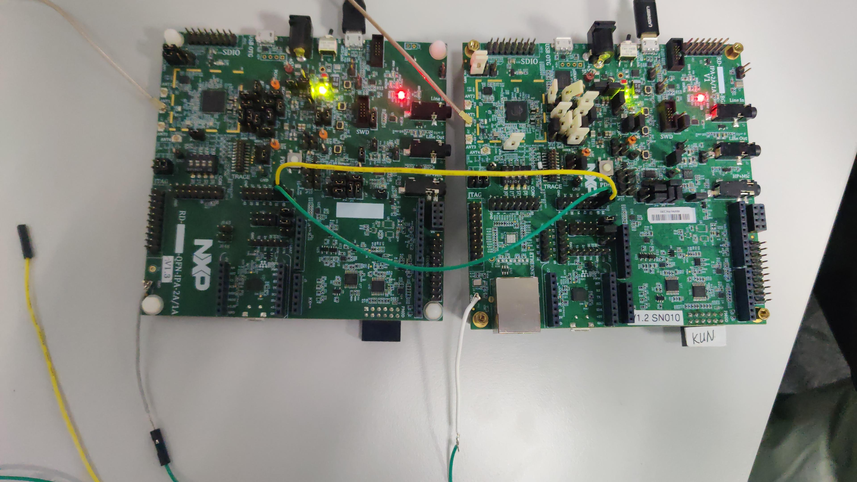

  - RW610 --- PC
The connection is as follows:
FC0 RX/TX:
HD2 2(FC0_UART_RXD) --- HD3(RX)
HD2 3(FC0_UART_TXD) --- HD3(TX)
FC0 RTS/CTS: (Only for BGA board)
HD11 0(FC0_UART_CTS) --- HD3(CTS)
HD11 5(FC0_UART_RTS) --- HD3(RTS)

And use a usb cable to connect the left uart(FC0) and PC in the figure below.

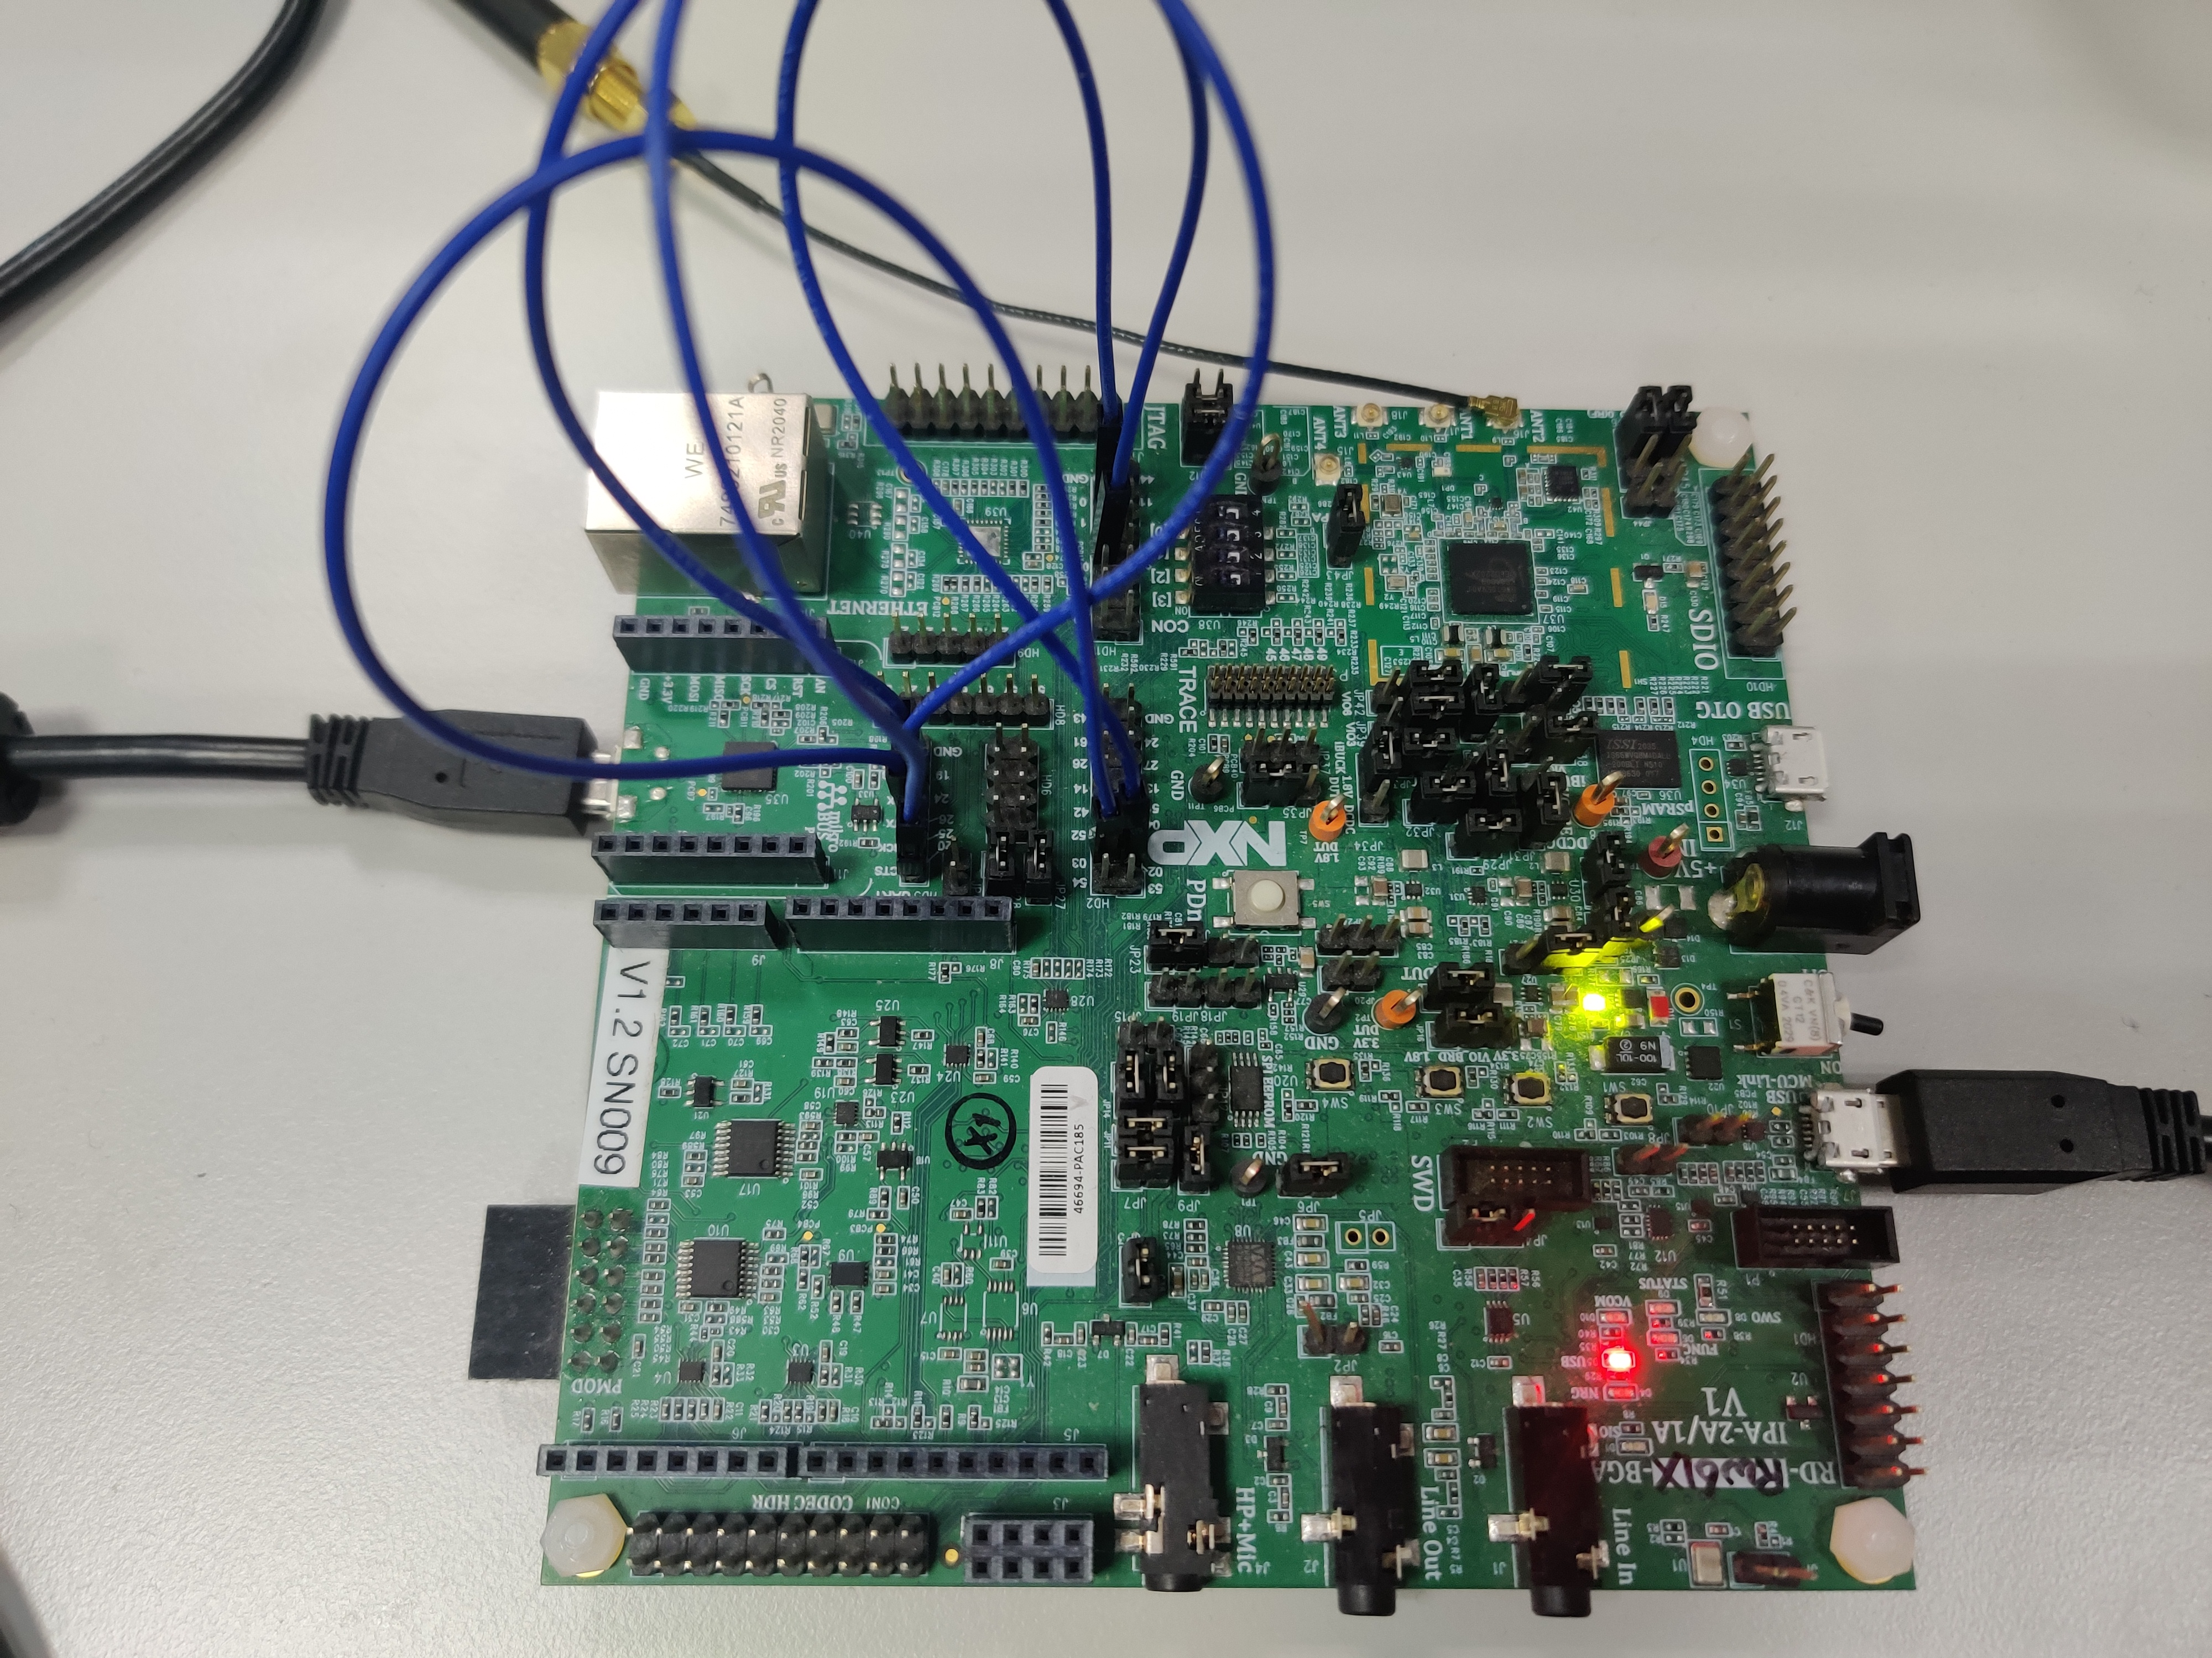

- The format of command and response

The command format looks as follows:
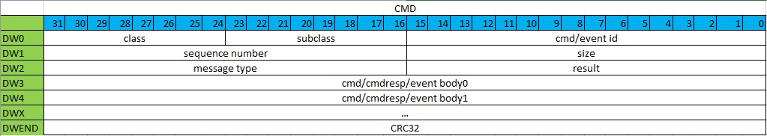
Figure 1. Command format

Filed Name | Type | Description
class | U8 | command class: Wi-Fi/BLE/15.4/Matter
subclass | U8 | command subclass
cmd/event id | U16 | command/event id
size | U16 | total bytes of command header and tlv
sequence number | U16 | command sequence number
result | U16 | Success/Fail/…
message type | U16 | 0, cmd; 1, cmd response; 2, event
cmd/cmdresp/event body | variable | /
CRC32 | U32 | command checksum

Figure 2. TLV format

Filed Name | Type | Description
type id | U16 | TLV type id
length | U16 | total bytes of the TLV header and body
value | variable

- Command Reference – WLAN Commands

  - Command Set
Instruction | Description
WLAN Commands
wlan-scan | WLAN scan
wlan-disconnect | Disconnect from network
wlan-version | Read firmware version
wlan-set-mac | Set STA and uAP mac address
wlan-get-mac | Get STA and uAP mac address
wlan-stat | Get WLAN connection status
wlan-info | Get the configured WLAN network information

  - WLAN Commands

    - wlan-scan
      - Usage
wlan-scan
      - Description
This command schedules a new scan and returns scan results of the available wlan networks.
      - Command Format
Filed Name | Type | Value | Description
class | U8 | 0x0 | NCP_BRIDGE_CMD_WLAN
subclass | U8 | 0x0 | NCP_BRIDGE_CMD_WLAN_STA
command id | U16 | 0x0001 | NCP_BRIDGE_CMD_WLAN_STA_SCAN
size | U16 | variable | total length of command buffer except for CRC
sequence number | U16 | 0x0 | command sequence number
result | U16 | 0x0 | NCP_BRIDGE_CMD_RESULT_OK
message type | U16 | 0x0 | NCP_BRIDGE_MSG_TYPE_CMD
CRC32 | U32 | variable | Command checksum
      - Response Format
Filed Name | Type | Value | Description
class | U8 | 0x0 | NCP_BRIDGE_CMD_WLAN
subclass | U8 | 0x0 | NCP_BRIDGE_CMD_WLAN_STA
command id | U16 | 0x0001 | NCP_BRIDGE_CMD_WLAN_STA_SCAN
size | U16 | variable | total length of command buffer except for CRC
sequence number | U16 | 0x0 | command sequence number
result | U16 | 0x0 if success  0x1 if fail | NCP_MPU_BRIDGE_CMD_RESULT_OK if success  NCP_MPU_BRIDGE_CMD_RESULT_ERROR if failed
command response  body | NCP_CMD_SCAN  _NETWORK_INFO | sizeof(NCP_CMD_SCAN  _NETWORK_INFO) | scan results
message type | U16 | 0x0 | NCP_BRIDGE_MSG_TYPE_RESP
CRC32 | U32 | variable | Command checksum

NCP_CMD_SCAN_NETWORK_INFO
Filed Name | Type | Description
res_cnt | uint8_t | total number of scan results
res[30] | wlan_bridge_scan_result | scan result

wlan_bridge_scan_result
Filed Name | Type | Description
ssid[33] | uint8_t | the network ssid
ssid_len | unsigned int | ssid length
bssid[6] | char | the network bssid
channel | unsigned int | the network channel
wmm:1 | unsigned | the network supports WMM
wps:1 | unsigned | the network supports WPS  (if defined CONFIG_WPS2)
wps_session | unsigned int | WPS Type PBS/PIN  (if defined CONFIG_WPS2)
wpa2_entp:1 | unsigned | WPA2 enterprise security
wep:1 | unsigned | WEP security
wpa:1 | unsigned | WPA security
wpa2:1 | unsigned | WPA2 security
wpa3_sae:1 | unsigned | WPA3 SAE security
rssi | unsigned char | the signal strength of the beacon
trans_ssid[33] | char | the network trans_ssid
trans_ssid_len | unsigned int | trans_ssid length
trans_bssid[6] | char | the network trans_bssid
beacon_period | uint16_t | beacon period
dtim_period | uint8_t | DTIM period
      - Example
#wlan-scan
4 networks found
E0:40:07:4A:45:58 [hw-2g-9177]
channel: 1
rssi: -39 dBm
security: OPEN
WMM: YES
8C:A6:DF:B2:76:99 [huibai-2g]
channel: 1
rssi: -33 dBm
security: OPEN
WMM: YES
0C:9D:92:02:2A:98 [000_ASUS_BS_wpa3]
channel: 1
rssi: -52 dBm
security: OPEN
WMM: YES
68:77:24:03:A4:86 [TPAX2G]
channel: 1
rssi: -56 dBm
security: OPEN
WMM: YES

    - wlan-version
      - Usage
wlan-version
      - Description
This command returns the Wi-Fi driver and firmware version. The command can be issued anytime once NCP bridge boots up successfully.
      - Command Format
Filed Name | Type | Value | Description
class | U8 | 0x0 | NCP_BRIDGE_CMD_WLAN
subclass | U8 | 0x0 | NCP_BRIDGE_CMD_WLAN_STA
command id | U16 | 0x0004 | NCP_BRIDGE_CMD_WLAN_STA_VERSION
size | U16 | variable | total length of command buffer except for CRC
sequence number | U16 | 0x0 | command sequence number
result | U16 | 0x0 | NCP_BRIDGE_CMD_RESULT_OK
message type | U16 | 0x0 | NCP_BRIDGE_MSG_TYPE_CMD
CRC32 | U32 | variable | Command checksum
      - Response Format
Filed Name | Type | Value | Description
class | U8 | 0x0 | NCP_BRIDGE_CMD_WLAN
subclass | U8 | 0x0 | NCP_BRIDGE_CMD_WLAN_STA
command id | U16 | 0x0004 | NCP_BRIDGE_CMD_WLAN_STA_VERSION
size | U16 | variable | total length of command buffer except for CRC
sequence number | U16 | 0x0 | command sequence number
result | U16 | 0x0 if success  0x1 if fail | NCP_MPU_BRIDGE_CMD_RESULT_OK if success  NCP_MPU_BRIDGE_CMD_RESULT_ERROR if failed
command response body | NCP_CMD_FW_VERSION | sizeof(NCP_CMD_FW_VERSION) | driver and firmware version
message type | U16 | 0x0 | NCP_BRIDGE_MSG_TYPE_RESP
CRC32 | U32 | variable | Command checksum

NCP_CMD_FW_VERSION
Filed Name | Type | Description
driver_ver_str[16] | char | Driver version
fw_ver_str[128] | char | Firmware version
      - Example
#wlan-version
WLAN Driver Version :v1.3.r34.p40
WLAN Firmware Version :rw610w-V0, RF878X, FP91, 18.91.1.p175, PVE_FIX 1, RF878X, FP91, 18.91.1.p175

    - wlan-roaming
      - Usage
wlan-roaming <enable> <rssi_threshold>
      - Description
This command is used to enable or disable roaming and configure RSSI threshold value to firmware. It will take effect after connecting to Ext-AP.
      - Parameters
No. | Description | Values | Mandatory
1 | enable | 0 – disable roaming  1 – enable roaming | YES
2 | rssi_threshold | Default value is 70 if not specified(absolute value). This setting is valid only when enable = 1. | NO
      - Command Format
Field | Type | Value | Description
class | U8 | 0x0 | NCP_BRIDGE_CMD_WLAN
Subclass | U8 | 0x0 | NCP_BRIDGE_CMD_WLAN_STA
Command ID | U16 | 0x0008 | NCP_BRIDGE_CMD_WLAN_STA_ROAMING
Size | U16 | variable | Total length of command buffer except for CRC
Sequence Number | U16 | 0x0 | Command sequence number
Result | U16 | 0x0 | NCP_BRIDGE_CMD_RESULT_OK
Message Type | U16 | 0x0 | NCP_BRIDGE_MSG_TYEP_CMD
Command Body | MPU_NCP_CMD_ROAMING | sizeof(MPU_NCP_CMD_ROAMING) | Roaming configuration.
CRC32 | U32 | variable | Command checksum

MPU_NCP_CMD_ROAMING
Field | Type | Description
enable | U32 | 0 – disable roaming  1 – enable roaming
rssi_threshold | U32 | Rssi threshold. If RSSI is lower than this value, firmware will report RSSI_LOW event to host.
      - Response Format
Field | Type | Value | Description
class | U8 | 0x0 | NCP_BRIDGE_CMD_WLAN
Subclass | U8 | 0x0 | NCP_BRIDGE_CMD_WLAN_STA
Command ID | U16 | 0x0008 | NCP_BRIDGE_CMD_WLAN_STA_ROAMING
Size | U16 | variable | Total length of command response buffer except for CRC
Sequence Number | U16 | 0x0 | Command sequence number
Result | U16 | 0x0 if success  0x1 if fail | NCP_BRIDGE_CMD_RESULT_OK if success  NCP_BRIDGE_CMD_RESULT_ERROR if failed
Message Type | U16 | 0x1 | NCP_BRIDGE_MSG_TYPE_RESP
CRC32 | U32 | variable | Command checksum
      - Example
# wlan-roaming 1 50 -- Enable roaming and set rssi threshold to 50dBm
# wlan-roaming 0 -- Disable roaming

    - wlan-reset
      - wlan-reset
      - Usage
wlan-reset action
      - Description
This command is used to enable, disable and reset wlan driver.
      - Parameters
No. | Description | Values | Mandatory
1 | action | 0 – disable wlan  1 – enable wlan  2 – reset wlan | YES
      - Command Format
Field | Type | Value | Description
class | U8 | 0x0 | NCP_MPU_BRIDGE_CMD_WLAN
Subclass | U8 | 0x1 | NCP_MPU_BRIDGE_CMD_WLAN_BASIC
Command ID | U16 | 0x00000001 | NCP_MPU_BRIDGE_WLAN_BASIC_WLAN_RESET
Size | U16 | variable | Total length of command buffer except for CRC
Sequence Number | U16 | 0x0 | Command sequence number
Result | U16 | 0x0 | NCP_MPU_BRIDGE_CMD_RESULT_OK
Message Type | U16 | 0x0 | NCP_MPU_BRIDGE_MSG_TYEP_CMD
Command Body | MPU_NCP_CMD_WLAN_RESET_CFG | sizeof(MPU_NCP_CMD_WLAN_RESET_CFG) | Wlan reset.
CRC32 | U32 | variable | Command checksum

MPU_NCP_CMD_WLAN_RESET_CFG
Field | Type | Description
action | U32 | 0 – disable wlan  1 – enable wlan  2 – reset wlan
      - Response Format
Field | Type | Value | Description
class | U8 | 0x0 | NCP_MPU_BRIDGE_CMD_WLAN
Subclass | U8 | 0x1 | NCP_MPU_BRIDGE_CMD_WLAN_BASIC
Command ID | U16 | 0x00000001 | NCP_MPU_BRIDGE_WLAN_BASIC_WLAN_RESET
Size | U16 | variable | Total length of command response buffer except for CRC
Sequence Number | U16 | 0x0 | Command sequence number
Result | U16 | 0x0 if success  0x1 if fail | NCP_MPU_BRIDGE_CMD_RESULT_OK if success  NCP_MPU_BRIDGE_CMD_RESULT_ERROR if failed
Message Type | U16 | 0x1 | NCP_MPU_BRIDGE_MSG_TYPE_RESP
CRC32 | U32 | variable | Command checksum
      - Example
# wlan-reset 0 – Disable the wlan
External host console result:
wlan-reset 0
Sent command successfully!
wlan_reset is ok!
# wlan-reset 1 – Enable the wlan
wlan-reset 1
Sent command successfully!
wlan_reset is ok!
# wlan-reset 2 – Reset the wlan
wlan-reset 2
Sent command successfully!
wlan_reset is ok!

    - wlan-disconnect
      - Usage
wlan-disconnect
      - Description
This command disconnects from a WLAN network it is connected to. The connection status can be checked using “wlan-stat” command.
      - Command Format
Filed Name | Type | Value | Description
class | U8 | 0x0 | NCP_BRIDGE_CMD_WLAN
subclass | U8 | 0x0 | NCP_BRIDGE_CMD_WLAN_STA
command id | U16 | 0x0003 | NCP_BRIDGE_CMD_WLAN_STA_DISCONNECT
size | U16 | variable | total length of command buffer except for CRC
sequence number | U16 | 0x0 | command sequence number
result | U16 | 0x0 | NCP_BRIDGE_CMD_RESULT_OK
message type | U16 | 0x0 | NCP_BRIDGE_MSG_TYPE_CMD
CRC32 | U32 | variable | Command checksum
      - Response Format
Filed Name | Type | Value | Description
class | U8 | 0x0 | NCP_BRIDGE_CMD_WLAN
subclass | U8 | 0x0 | NCP_BRIDGE_CMD_WLAN_STA
command id | U16 | 0x0003 | NCP_BRIDGE_CMD_WLAN_STA_DISCONNECT
size | U16 | variable | total length of command buffer except for CRC
sequence number | U16 | 0x0 | command sequence number
result | U16 | 0x0 if success  0x1 if fail | NCP_MPU_BRIDGE_CMD_RESULT_OK if success  NCP_MPU_BRIDGE_CMD_RESULT_ERROR if failed
message type | U16 | 0x0 | NCP_BRIDGE_MSG_TYPE_RESP
CRC32 | U32 | variable | Command checksum
      - Example
#wlan-disconnect -- Disconnect from the current network it is connected to.

    - wlan-stat
      - Usage
wlan-stat
      - Description
This command provides the WLAN connection status.
      - Command Format
Filed Name | Type | Value | Description
class | U8 | 0x0 | NCP_BRIDGE_CMD_WLAN
subclass | U8 | 0x0 | NCP_BRIDGE_CMD_WLAN_STA
command id | U16 | 0x0007 | NCP_BRIDGE_CMD_WLAN_STA_ CONNECT_STAT
size | U16 | variable | total length of command buffer except for CRC
sequence number | U16 | 0x0 | command sequence number
result | U16 | 0x0 | NCP_BRIDGE_CMD_RESULT_OK
message type | U16 | 0x0 | NCP_BRIDGE_MSG_TYPE_CMD
CRC32 | U32 | variable | Command checksum
      - Response Format
Filed Name | Type | Value | Description
class | U8 | 0x0 | NCP_BRIDGE_CMD_WLAN
subclass | U8 | 0x0 | NCP_BRIDGE_CMD_WLAN_STA
command id | U16 | 0x0007 | NCP_BRIDGE_CMD_WLAN_STA_ CONNECT_STAT
size | U16 | variable | total length of command buffer except for CRC
sequence number | U16 | 0x0 | command sequence number
result | U16 | 0x0 if success  0x1 if fail | NCP_MPU_BRIDGE_CMD_RESULT_OK if success  NCP_MPU_BRIDGE_CMD_RESULT_ERROR if failed
message type | U16 | 0x0 | NCP_BRIDGE_MSG_TYPE_RESP
command response  body | NCP_CMD_  CONNECT_STAT | sizeof(NCP_CMD_  CONNECT_STAT) | wlan connnection state
CRC32 | U32 | variable | Command checksum

NCP_CMD_CONNECT_STAT
Field | Type | Description
ps_mode | U8 | station power save mode
uap_conn_stat | U8 | WLAN uAP connection status
sta_conn_stat | U8 | WLAN station connection status
      - Example
#wlan-stat
Station disconnected (Active)
uAP stopped

    - wlan-info
      - Usage
wlan-info
      - Description
This command returns the configured WLAN network information.
      - Command Format
Filed Name | Type | Value | Description
class | U8 | 0x0 | NCP_BRIDGE_CMD_WLAN
subclass | U8 | 0x0 | NCP_BRIDGE_CMD_WLAN_NETWORK
command id | U16 | 0x0001 | NCP_BRIDGE_CMD_WLAN_NETWORK_INFO
size | U16 | variable | total length of command buffer except for CRC
sequence number | U16 | 0x0 | command sequence number
result | U16 | 0x0 | NCP_BRIDGE_CMD_RESULT_OK
message type | U16 | 0x0 | NCP_BRIDGE_MSG_TYPE_CMD
CRC32 | U32 | variable | Command checksum
      - Response Format
Filed Name | Type | Value | Description
class | U8 | 0x0 | NCP_BRIDGE_CMD_WLAN
subclass | U8 | 0x0 | NCP_BRIDGE_CMD_WLAN_NETWORK
command id | U16 | 0x0001 | NCP_BRIDGE_CMD_WLAN_NETWORK_INFO
size | U16 | variable | total length of command buffer except for CRC
sequence number | U16 | 0x0 | command sequence number
result | U16 | 0x0 if success  0x1 if fail | NCP_MPU_BRIDGE_CMD_RESULT_OK if success  NCP_MPU_BRIDGE_CMD_RESULT_ERROR if failed
message type | U16 | 0x0 | NCP_BRIDGE_MSG_TYPE_RESP
command response  body | NCP_CMD_  NETWORK_INFO | sizeof(NCP_CMD_  NETWORK_INFO) | wlan network info
CRC32 | U32 | variable | Command checksum

NCP_CMD_NETWORK_INFO
Field | Type | Description
uap_conn_stat | U8 | WLAN uAP connection status
sta_conn_stat | U8 | WLAN station connection status
uap_network | wlan_bridge_network | WLAN uAP Network Profile
sta_network | wlan_bridge_network | WLAN station Network Profile

wlan_bridge_network
Field | Type | Description
name[32] | char | The name of this network profile.
ssid[33] | char | ssid of the AP to which NCP Bridge is connected
bssid[6] | char | bssid of the AP to which NCP Bridge is connected
channel | unsigned int | channel no. of the AP to which NCP Bridge is connected
acs_band | uint16_t | The ACS band if set channel to 0.
rssi_threshold | short | Rssi threshold(if defined  CONFIG_SCAN_WITH_RSSIFILTER)
type | uint8_t | BSS type
role | uint8_t | Set this to specify what type of wlan network mode to use. (uAP or STA)
security_type | uint8_t | Type of network security to use specified
enable_11ax:1 | uint8_t | enable 802.11ax
enable_11ac:1 | uint8_t | enable 802.11ac
enable_11n:1 | uint8_t | enable 802.11n
ipv6[3] | wlan_bridge_ipv6_config | The network IPv6 address configuration (if defined CONFIG_IPV6)
ipv4 | wlan_bridge_ipv4_config | The network IPv4 address configuration
is_sta_ipv4_connected | uint8_t | whether ipv4 is connected
identity[256] | char | (if defined CONFIG_WPA2_ENTP)
ssid_specific:1 | unsigned | If set to 1, the ssid field contains the specific SSID for this network.
bssid_specific:1 | unsigned | If set to 1, the bssid field contains the specific BSSID for this network.
channel_specific | unsigned | If set to 1, the channel field contains the specific channel for this network.
security_specific | unsigned | If set to 0, any security that matches is used.
wps_specific | unsigned | This indicates this network is used as an internal network for WPS. (if defined CONFIG_WPS2)
beacon_period | uint16_t | Beacon period of associated BSS
dtim_period | uint8_t | DTIM period of associated BSS
wlan_capa | uint8_t | (if defined CONFIG_WIFI_CAPA)

wlan_bridge_ipv6_config
Field | Type | Description
address[4] | unsigned | The system's IPv6 address in network order.
addr_type_str[16] | unsigned char | The address type string: linklocal, site-local or global.
addr_state_str[32] | unsigned char | The state string of IPv6 address (Tentative, Preferred, etc).

wlan_bridge_ipv4_config
Field | Type | Description
addr_type:2 | uint32_t | use DHCP to obtain the IP address or to use a static IP.
address | uint32_t | The system's IP address in network order.
gw | uint32_t | The system's default gateway in network order.
netmask | uint32_t | The system's subnet mask in network order.
dns1 | uint32_t | The system's primary dns server in network order.
dns2 | uint32_t | The system's secondary dns server in network order.

      - Example
#wlan-info
Station not connected
uAP started as:
"testuAP"
SSID: ncp
BSSID: 00:50:43:99:FF:11
channel: 1
role: uAP
security: WPA3 SAE
wifi capability: 11ax
user configure: 11ax

IPv4 Address
address: STATIC
IP: 192.168.1.1
gateway: 192.168.1.1
netmask: 255.255.255.0
dns1: 192.168.1.1
dns2: 0.0.0.0

IPv6 Addresses
Link-Local : fe80::250:43ff:fe99:ff11 (Tentative)

rssi threshold: 0

    - wlan-set-mac
      - Usage
wlan-set-mac <mac_address>
      - Description
This command sets the MAC address.
      - Parameters
No. | Description | Values | Mandatory
1 | mac_address | xx:xx:xx:xx:xx:xx | YES
      - Command Format
Filed Name | Type | Value | Description
class | U8 | 0x0 | NCP_BRIDGE_CMD_WLAN
subclass | U8 | 0x0 | NCP_BRIDGE_CMD_WLAN_STA
command id | U16 | 0x0005 | NCP_BRIDGE_CMD_WLAN_STA_ SET_MAC
size | U16 | variable | total length of command buffer except for CRC
sequence number | U16 | 0x0 | command sequence number
result | U16 | 0x0 | NCP_BRIDGE_CMD_RESULT_OK
message type | U16 | 0x0 | NCP_BRIDGE_MSG_TYPE_CMD
command body | NCP_CMD_MAC  _ADDRESS | sizeof(NCP_CMD_  MAC_ADDRESS) | MAC address
CRC32 | U32 | variable | Command checksum

NCP_CMD_MAC_ADDRESS
Field | Type | Description
mac_addr[6] | uint8_t | MAC address
      - Response Format
Filed Name | Type | Value | Description
class | U8 | 0x0 | NCP_BRIDGE_CMD_WLAN
subclass | U8 | 0x0 | NCP_BRIDGE_CMD_WLAN_STA
command id | U16 | 0x0005 | NCP_BRIDGE_CMD_WLAN_STA_ SET_MAC
size | U16 | variable | total length of command buffer except for CRC
sequence number | U16 | 0x0 | command sequence number
result | U16 | 0x0 if success  0x1 if fail | NCP_MPU_BRIDGE_CMD_RESULT_OK if success  NCP_MPU_BRIDGE_CMD_RESULT_ERROR if failed
message type | U16 | 0x0 | NCP_BRIDGE_MSG_TYPE_RESP
CRC32 | U32 | variable | Command checksum
      - Example
#wlan-set-mac 00:50:43:99:FE:11 --- Set MAC address to “00:50:43:99:FE:11”.

    - wlan-get-mac
      - Usage
wlan-get-mac
      - Description
This command gets the MAC address of station and uAP.
      - Command Format
Filed Name | Type | Value | Description
class | U8 | 0x0 | NCP_BRIDGE_CMD_WLAN
subclass | U8 | 0x0 | NCP_BRIDGE_CMD_WLAN_STA
command id | U16 | 0x0006 | NCP_BRIDGE_CMD_WLAN_STA_GET_MAC
size | U16 | variable | total length of command buffer except for CRC
sequence number | U16 | 0x0 | command sequence number
result | U16 | 0x0 | NCP_BRIDGE_CMD_RESULT_OK
message type | U16 | 0x0 | NCP_BRIDGE_MSG_TYPE_CMD
CRC32 | U32 | variable | Command checksum
      - Response Format
Filed Name | Type | Value | Description
class | U8 | 0x0 | NCP_BRIDGE_CMD_WLAN
subclass | U8 | 0x0 | NCP_BRIDGE_CMD_WLAN_STA
command id | U16 | 0x0005 | NCP_BRIDGE_CMD_WLAN_STA_ SET_MAC
size | U16 | variable | total length of command buffer except for CRC
sequence number | U16 | 0x0 | command sequence number
result | U16 | 0x0 if success  0x1 if fail | NCP_MPU_BRIDGE_CMD_RESULT_OK if success  NCP_MPU_BRIDGE_CMD_RESULT_ERROR if failed
message type | U16 | 0x0 | NCP_BRIDGE_MSG_TYPE_RESP
command response  body | NCP_CMD_GET_  MAC_ADDRESS | sizeof(NCP_CMD_GET  _MAC_ADDRESS) | Get MAC address
CRC32 | U32 | variable | Command checksum

NCP_CMD_GET_MAC_ADDRESS
Field | Type | Description
uap_mac [6] | uint8_t | uAP MAC address
sta_mac [6] | uint8_t | Station MAC address
      - Example
#wlan-get-mac
MAC Address
STA MAC Address: 00:50:43:99:FE:11
UAP MAC Address: 00:50:43:99:FF:11

  - wlan-connect

    - Usage
wlan-connect <ssid>
(Only supports connecting to unencrypted APs.)

    - Command Format

wlan_connect_command(char *arg)(wifi_bridge_command.c) processes ‘wlan-connect <ssid>’ command and converts it the specified command format.
Para arg points to the ssid to be connected. The characters in ssid are converted to corresponding ASCII.

typedef struct SSID_ParaSet
{
TypeHeader_t header;
uint8_t ssid[1];
}SSID_tlv;

SSID_tlv ssid_tlv;
ssid_tlv.header.type = 0x02;
ssid_tlv.header.size = strlen(ssid);
ssid_tlv.ssid = the ASCII of ssid(char*);

0 8 16 24 31
|-+-+-+-+-+-+-+-|-+-+-+-+-+-+-+-|-+-+-+-+-+-+-+-|-+-+-+-+-+-+-+-|
| Command code | Size |
|-+-+-+-+-+-+-+-|-+-+-+-+-+-+-+-|-+-+-+-+-+-+-+-|-+-+-+-+-+-+-+-|
| SeqNum | BSS | Result |
|-+-+-+-+-+-+-+-|-+-+-+-+-+-+-+-|-+-+-+-+-+-+-+-|-+-+-+-+-+-+-+-|
| Action | type | size |
|-+-+-+-+-+-+-+-|-+-+-+-+-+-+-+-|-+-+-+-+-+-+-+-|-+-+-+-+-+-+-+-|
| ssid
|-+-+-+-+-+-+-+-|-+-+-+-+-+-+-+-|-+-+-+-+-+-+-+-|-+-+-+-+-+-+-+-|

Filed Name | Type | Description
Command Code | UINT16 | 0x02
Size | UNIT16 | BRIDGE_COMMAND_LEN + TLV_HEADER_LEN + ssid_tlv.header.size
SeqNum | UINT8 | 0x00
BSS | UINT8 | 0x00
Result | UINT16 | 0x00
Action | UINT8 | 0x01
SSID_Tlv | UINT8 | ssid tlv

Function wlan_bridge_connect(t_u8 *cmd)(MCU bridge_app) processes the connect command sent by LINUX APP. Para cmd points to the received command.
  - get-connect-result

    - Usage
get-connect-result

Use this command to get the connected network info. Because it takes some time to connect AP, it’s best to wait at least 10s to get network info after entering ‘wlan-connect <ssid>’.

    - Command Format

wlan_get_connect_res_command()(wifi_bridge_command.c) processes this command and converts it the specified command format.

Filed Name | Type | Description
Command Code | UINT16 | 0x02
Size | UINT16 | BRIDGE_COMMAND_LEN
SeqNum | UINT8 | 0x00
BSS | UINT8 | 0x00
Result | UINT16 | 0x00
Action | UINT8 | 0x00

    - Response Format
wlan_bridge_get_connect()(MCU bridge_app) processes the command and returns the connected network info to the LINUX APP in the specified command format.

typedef struct CONNECT_RES
{
TypeHeader_t header;
uint8_t ip[16];
uint8_t ssid[32];
}CONNECT_res_tlv;

#define BRIDGE_CONNECT_RES_TLV_LEN 48

The format of connected result response:
0 8 16 24 31
|-+-+-+-+-+-+-+-|-+-+-+-+-+-+-+-|-+-+-+-+-+-+-+-|-+-+-+-+-+-+-+-|
| Command code | Size |
|-+-+-+-+-+-+-+-|-+-+-+-+-+-+-+-|-+-+-+-+-+-+-+-|-+-+-+-+-+-+-+-|
| SeqNum | BSS | Result |
|-+-+-+-+-+-+-+-|-+-+-+-+-+-+-+-|-+-+-+-+-+-+-+-|-+-+-+-+-+-+-+-|
| Action | type | size |
|-+-+-+-+-+-+-+-|-+-+-+-+-+-+-+-|-+-+-+-+-+-+-+-|-+-+-+-+-+-+-+-|
| ip address |
|-+-+-+-+-+-+-+-|-+-+-+-+-+-+-+-|-+-+-+-+-+-+-+-|-+-+-+-+-+-+-+-|
| ip address |
|-+-+-+-+-+-+-+-|-+-+-+-+-+-+-+-|-+-+-+-+-+-+-+-|-+-+-+-+-+-+-+-|
| ip address |
|-+-+-+-+-+-+-+-|-+-+-+-+-+-+-+-|-+-+-+-+-+-+-+-|-+-+-+-+-+-+-+-|
| ip address |
|-+-+-+-+-+-+-+-|-+-+-+-+-+-+-+-|-+-+-+-+-+-+-+-|-+-+-+-+-+-+-+-|
| ssid |
|-+-+-+-+-+-+-+-|-+-+-+-+-+-+-+-|-+-+-+-+-+-+-+-|-+-+-+-+-+-+-+-|
| ssid |
|-+-+-+-+-+-+-+-|-+-+-+-+-+-+-+-|-+-+-+-+-+-+-+-|-+-+-+-+-+-+-+-|
| ssid |
|-+-+-+-+-+-+-+-|-+-+-+-+-+-+-+-|-+-+-+-+-+-+-+-|-+-+-+-+-+-+-+-|
| ssid |
|-+-+-+-+-+-+-+-|-+-+-+-+-+-+-+-|-+-+-+-+-+-+-+-|-+-+-+-+-+-+-+-|
| ssid |
|-+-+-+-+-+-+-+-|-+-+-+-+-+-+-+-|-+-+-+-+-+-+-+-|-+-+-+-+-+-+-+-|
| ssid |
|-+-+-+-+-+-+-+-|-+-+-+-+-+-+-+-|-+-+-+-+-+-+-+-|-+-+-+-+-+-+-+-|
| ssid |
|-+-+-+-+-+-+-+-|-+-+-+-+-+-+-+-|-+-+-+-+-+-+-+-|-+-+-+-+-+-+-+-|
| ssid |
|-+-+-+-+-+-+-+-|-+-+-+-+-+-+-+-|-+-+-+-+-+-+-+-|-+-+-+-+-+-+-+-|

Filed Name | Type | Description
Command Code | UINT16 | 0x02
Size | UINT16 | BRIDGE_COMMAND_LEN + TLV_HEADER_LEN + BRIDGE_CONNECT_RES_TLV_LEN
SeqNum | UINT8 | 0x00
BSS | UINT8 | 0x00
Result | UINT16 | 0:Success !0:Failed
Action | UINT8 | 0x00
SSID_res_tlv | UINT8 | IPv4 address ssid

Function wlan_process_con_response()(wifi_bridge_command.c) processes the response sent by bridge_app.
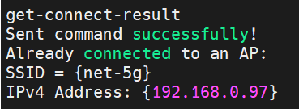
  - ping

    - Usage
ping [c <packet_count>] <ip address>

    - Command Format
wlan_ping_command()(wifi_bridge_command.c) processes this command and converts it the specified command format.

typedef struct PING_ParaSet
{
TypeHeader_t header;
uint16_t packet_count;
uint8_t ping_ip[1];
}PING_tlv;

PING_tlv ping_tlv;
ping_tlv.header.type = 0x04;
ping_tlv.header.size = strlen(ping_ip) + sizeof(packet_count);
ping_tlv.packet_count = the count of ping packets;
ping_tlv.ping_ip = <IP Address>

0 8 16 24 31
|-+-+-+-+-+-+-+-|-+-+-+-+-+-+-+-|-+-+-+-+-+-+-+-|-+-+-+-+-+-+-+-|
| Command code | Size |
|-+-+-+-+-+-+-+-|-+-+-+-+-+-+-+-|-+-+-+-+-+-+-+-|-+-+-+-+-+-+-+-|
| SeqNum | BSS | Result |
|-+-+-+-+-+-+-+-|-+-+-+-+-+-+-+-|-+-+-+-+-+-+-+-|-+-+-+-+-+-+-+-|
| Action | type | size |
|-+-+-+-+-+-+-+-|-+-+-+-+-+-+-+-|-+-+-+-+-+-+-+-|-+-+-+-+-+-+-+-|
| packet_count | ping_ip
|-+-+-+-+-+-+-+-|-+-+-+-+-+-+-+-|-+-+-+-+-+-+-+-|-+-+-+-+-+-+-+-|

Filed Name | Type | Description
Command Code | UINT16 | 0x04
Size | UNIT16 | BRIDGE_COMMAND_LEN + TLV_HEADER_LEN + ping_tlv.header.size
SeqNum | UINT8 | 0X00
BSS | UINT8 | 0X00
Result | UINT16 | 0X00
Action | UINT8 | 0X01
PING_Tlv | UINT8 | The tlv of ping parameters

Function wlan_bridge_ping(t_u8 *cmd)(MCU bridge_app) processes ‘ping’ command sent by LINUX APP. Para cmd points to the received command.

  - get-ping-result

    - Usage
get-ping-result

Use this command to get the ping statistics info. Because it takes some time to ping, it’s best to wait at least 10s(If the packet count is 10.) to get ping info after entering ‘ping <ip address>’.

    - Command Format
wlan_get_ping_res_command()(wifi_bridge_command.c) processes ‘get-ping-result’ command and converts it the specified command format.

Filed Name | Type | Description
Command Code | UINT16 | 0x04
Size | UINT16 | BRIDGE_COMMAND_LEN
SeqNum | UINT8 | 0X00
BSS | UINT8 | 0X00
Result | UINT16 | 0X00
Action | UINT16 | 0X00

    - Response Format
wlan_bridge_get_ping()(MCU bridge_app) processes the command and returns the ping statistics info to the LINUX APP in the specified command format.

typedef struct PING_RES
{
TypeHeader_t header;
uint8_t status;
uint32_t packet_transmit;
uint32_t packet_received;
}PING_res_tlv;

#define PING_RES_INFO 9

0 8 16 24 31
|-+-+-+-+-+-+-+-|-+-+-+-+-+-+-+-|-+-+-+-+-+-+-+-|-+-+-+-+-+-+-+-|
| Command code | Size |
|-+-+-+-+-+-+-+-|-+-+-+-+-+-+-+-|-+-+-+-+-+-+-+-|-+-+-+-+-+-+-+-|
| SeqNum | BSS | Result |
|-+-+-+-+-+-+-+-|-+-+-+-+-+-+-+-|-+-+-+-+-+-+-+-|-+-+-+-+-+-+-+-|
| Action | type | size |
|-+-+-+-+-+-+-+-|-+-+-+-+-+-+-+-|-+-+-+-+-+-+-+-|-+-+-+-+-+-+-+-|
| status | packet_trans |
|-+-+-+-+-+-+-+-|-+-+-+-+-+-+-+-|-+-+-+-+-+-+-+-|-+-+-+-+-+-+-+-|
|packet_trans | packet_recv |
|-+-+-+-+-+-+-+-|-+-+-+-+-+-+-+-|-+-+-+-+-+-+-+-|-+-+-+-+-+-+-+-|
| packet_recv |
|-+-+-+-+-+-+-+-|-+-+-+-+-+-+-+-|-+-+-+-+-+-+-+-|-+-+-+-+-+-+-+-|

Filed Name | Type | Description
Command Code | UINT16 | 0x04
Size | UNIT16 | BRIDGE_COMMAND_LEN + TLV_HEADER_LEN + PING_RES_INFO
SeqNum | UINT8 | 0X00
BSS | UINT8 | 0X00
Result | UINT16 | 0:Success !0:Failed
Action | UINT8 | 0X00
PING_Tlv | UINT8 | The tlv of ping parameters

Function wlan_process_ping_response()(wifi_bridge_command.c) processes the response sent by bridge_app.
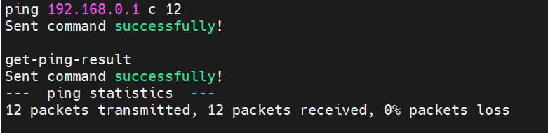

  - iperf

    - Usage
iperf s TCP Server
iperf su UDP Server
iperf c <IP address> t <time> TCP Client <time is optional, the default time is 10s>
iperf cu <IP address> t <time> UDP Client <time is optional, the default time is 10s>
iperf a Abort current iperf mode

    - Command Format
wlan_iperf_command()(wifi_bridge_command.c) processes ‘iperf’ command and converts it the specified command format.

typedef struct IPERF_ParaSet
{
TypeHeader_t header;
uint16_t time;
uint8_t iperf_ip [1];
}IPERF_tlv;

IPERF_tlv iperf_tlv;

TCP Server:
iperf_tlv.header.type = 0x51;
iperf_tlv.header.size = 0;

UDP Server:
iperf_tlv.header.type = 0x52;
iperf_tlv.header.size = 0;

TCP Client:
iperf_tlv.header.type = 0x53;
iperf_tlv.header.size = strlen(<IP Address>) + sizeof(iperf_tlv.time);
iperf_tlv.time = the time of throughput test(default time is 10s);
iperf_tlv.iperf_ip = <IP Address>

UDP Client:
Iperf_tlv.header.type = 0x54;
iperf_tlv.header.size = strlen(<IP Address>) + sizeoof(iperf_tlv.time);
iperf_tlv.time = the time of throughput test(default time is 10s);
iperf_tlv.iperf_ip = <IP Address>

Iperf Abort
perf_tlv.header.type = 0x55;
iperf_tlv.header.size = 0;

0 8 16 24 31
|-+-+-+-+-+-+-+-|-+-+-+-+-+-+-+-|-+-+-+-+-+-+-+-|-+-+-+-+-+-+-+-|
| Command code | Size |
|-+-+-+-+-+-+-+-|-+-+-+-+-+-+-+-|-+-+-+-+-+-+-+-|-+-+-+-+-+-+-+-+
| SeqNum | BSS | Result |
|-+-+-+-+-+-+-+-|-+-+-+-+-+-+-+-|-+-+-+-+-+-+-+-|-+-+-+-+-+-+-+-|
| Action | type | size |
|-+-+-+-+-+-+-+-|-+-+-+-+-+-+-+-|-+-+-+-+-+-+-+-|-+-+-+-+-+-+-+-|
| time | iperf_ip
|-+-+-+-+-+-+-+-|-+-+-+-+-+-+-+-|-+-+-+-+-+-+-+-|-+-+-+-+-+-+-+-|

Filed Name | Type | Description
Command Code | UINT16 | 0x05
Size | UNIT16 | BRIDGE_COMMAND_LEN + TLV_HEADER_LEN + iperf_tlv.header.size
SeqNum | UINT8 | 0x00
BSS | UINT8 | 0x00
Result | UINT16 | 0x00
Action | UINT8 | 0x01
IPERF_Tlv | UINT8 | iperf parameter

Function wlan_bridge_iperf(t_u8 *cmd)(MCU bridge_app) processes ‘iperf’ command sent by LINUX APP. Para cmd points to the ‘iperf’ command.

  - get-iperf-result

    - Usage
get-iperf-result

Use this command to get the iperf statistics info. Because it takes some time to test throughput, it’s best to wait until the throughput test is over.

    - Command Format
Filed Name | Type | Description
Command Code | UINT16 | 0x05
Size | UINT16 | BRIDGE_COMMAND_LEN
SeqNum | UINT8 | 0x00
BSS | UINT8 | 0x00
Result | UINT16 | 0x00
Action | UINT16 | 0x00

wlan_bridge_get_iperf()(MCU bridge_app) processes the command and returns ‘iperf’ statistics info to the LINUX APP in the specified command format.

    - Response Format

typedef struct IPERF_INFO
{
uint8_t role;
uint8_t local_addr[4];
uint16_t local_port;
uint8_t remote_addr[4];
uint16_t remote_port;
uint64_t bytes_transferred;
uint32_t ms_duration;
uint32_t bandwidth_Mbitpsec;
}IPERF_info;

typedef struct IPERF_RES
{
TypeHeader_t header;
IPERF_info iperf_info;
}IPERF_res_tlv;

#define IPERF_INFO_LEN 29

0 8 16 24 31
|-+-+-+-+-+-+-+-|-+-+-+-+-+-+-+-|-+-+-+-+-+-+-+-|-+-+-+-+-+-+-+-|
| Command code | Size |
|-+-+-+-+-+-+-+-|-+-+-+-+-+-+-+-|-+-+-+-+-+-+-+-|-+-+-+-+-+-+-+-|
| SeqNum | BSS | Result |
|-+-+-+-+-+-+-+-|-+-+-+-+-+-+-+-|-+-+-+-+-+-+-+-|-+-+-+-+-+-+-+-|
| Action | type | size |
|-+-+-+-+-+-+-+-|-+-+-+-+-+-+-+-|-+-+-+-+-+-+-+-|-+-+-+-+-+-+-+-|
| role | local_addr |
|-+-+-+-+-+-+-+-|-+-+-+-+-+-+-+-|-+-+-+-+-+-+-+-|-+-+-+-+-+-+-+-|
| local_addr | local _port | remote_addr |
|-+-+-+-+-+-+-+-|-+-+-+-+-+-+-+-|-+-+-+-+-+-+-+-|-+-+-+-+-+-+-+-|
| remote_addr | remote_port |
|-+-+-+-+-+-+-+-|-+-+-+-+-+-+-+-|-+-+-+-+-+-+-+-|-+-+-+-+-+-+-+-|
| remote_port | bytes_transfer |
|-+-+-+-+-+-+-+-|-+-+-+-+-+-+-+-|-+-+-+-+-+-+-+-|-+-+-+-+-+-+-+-|
| bytes_transfer |
|-+-+-+-+-+-+-+-|-+-+-+-+-+-+-+-|-+-+-+-+-+-+-+-|-+-+-+-+-+-+-+-|
|bytes_transfer| ms_duration |
|-+-+-+-+-+-+-+-|-+-+-+-+-+-+-+-|-+-+-+-+-+-+-+-|-+-+-+-+-+-+-+-|
| ms_duration | bandwidth_Mp |
|-+-+-+-+-+-+-+-|-+-+-+-+-+-+-+-|-+-+-+-+-+-+-+-|-+-+-+-+-+-+-+-|
|bandwidth_Mp|
|-+-+-+-+-+-+-+-|-+-+-+-+-+-+-+-|-+-+-+-+-+-+-+-|-+-+-+-+-+-+-+-|

Filed Name | Type | Description
Command Code | UINT16 | 0x05
Size | UNIT16 | BRIDGE_COMMAND_LEN + TLV_HEADER_LEN + IPERF_INFO_LEN
SeqNum | UINT8 | 0x00
BSS | UINT8 | 0x00
Result | UINT16 | 0x00
Action | UINT8 | 0x00
IPERF_res_tlv | UINT8 | iperf throughput test info

Function wlan_process_iperf_response()(wifi_bridge_command.c) processes ‘iperf’ response sent by bridge_app.
