NXP Semiconductors | Document Number: AN00000000000000
Application Notes | Rev. 1 | , | 03/2020

LPC55Sxx PSA Secure Boot, Debug Authentication, Provisioning

Contents
Stanislav Jancik – Optional
1. Introduction 1
2. Software Requirements 2
3. Secure Boot 2
3.1. Private Key Generation 2
3.2. Certification Signing Request 2
3.3. Self-Signed Certificate 3
3.4. Prepare Binary Files 3
3.5. Signed Images Preparation 6
3.6. Erasing a Device 8
3.7. Loading Signed Images (only when PRINCE is not used) 8
3.8. CFPA Page Preparation 8
3.9. CMPA Page Preparation 9
3.10. Flash Encryption Using PRINCE 10
4. Debug Authentication 11
5. Provisioning 11

Introduction
The LPC55xx/LPC55Sxx is an Arm Cortex® M33-based microcontroller for embedded applications:
- App to 320KB of on-chip SRAM
- App to 640KB of on-chip flash
- High-speed and full-speed USB host
- Device interface with crystal-less operation for full-speed
- Five general-purpose timers
- One SCTimer/PWM
- One RTC/alarm timer
- One 24-bit Multi-Rate Timer (MRT)
- Windowed Watchdog Timer (WWDT)
- Eight flexible serial communication peripherals, each of it is a USART, SPI, I2C, or I2S interface
- One 16-bit 1.0 Msamples/sec ADC, temperature sensor
LPC55xx/LPC55Sxx devices offer support for real-time encryption and decryption for on-chip flash using the PRINCE encryption engine. The following sections

explain the use of LPC55Sxx PRINCE for data encryption of on-chip flash.

Software Requirements
OpenSSL 1.1.1
- Download

elftosb-gui, blhost

- Download
- Board LPCxpresso55S69
- Choose All toolchains or MCUXpresso IDE in Toolchain / IDA list
- The checkbox mcu-boot has to be checked (use select all)
- Generate SDK package
- The elftosb-gui and blhost are located here: SDK_2.7.0_LPCXpresso55S69\middleware\mcu-boot\bin\Tools\
- To run elftosb-gui use elfosb-gui(win).cmd script

MCUXpresso IDE v11.1.0_3209 or later

Dokumentation: UM11126_LPC556x_v.1.7.pdf
AN12283.pdf
Attached files: CustomerManufacturingFactoryConfigurationArea_0x9e400.bin
InFieldROMAPIScratch_0x9de00.bin

Secure Boot

Private Key Generation
The four private keys need to be generated:

openssl genrsa -out rotk1.pem 4096
openssl genrsa -out rotk2.pem 4096
openssl genrsa -out rotk1_2048.pem 2048
openssl genrsa -out rotk2_2048.pem 2048

Certification Signing Request
After creation of private keys, certificate signing request (csr) is created:

openssl req -new -key rotk1.pem -out certificate_rotk1.csr -extensions v3_ca
openssl req -new -key rotk2.pem -out certificate_rotk2.csr -extensions v3_ca
openssl req -new -key rotk1_2048.pem -out certificate_rotk1_2048.csr -extensions v3_ca
openssl req -new -key rotk2_2048.pem -out certificate_rotk2_2048.csr -extensions v3_ca
After this command, the user has to fill the following data:

Country Name:
State or Province Name:
Locality Name:
Organization Name:
Organization Unit Name:
Common Name:
Email address:
Password:
Company Name:

Self-Signed Certificate
openssl x509 -req -days 365 -in certificate_rotk1.csr -signkey rotk1.pem -sha256 -outform der -out certificate_rotk1.der.crt -extfile x509_v3.ext -set_serial 0x3cc30000abababab

openssl x509 -req -days 365 -in certificate_rotk2.csr -signkey rotk2.pem -sha256 -outform der -out certificate_rotk2.der.crt -extfile x509_v3.ext -set_serial 0x3cc30000abababab

openssl x509 -req -days 365 -in certificate_rotk1_2048.csr -signkey rotk1_2048.pem -sha256 -outform der -out certificate_rotk1_2048.der.crt -extfile x509_v3.ext -set_serial 0x3cc30000abababab

openssl x509 -req -days 365 -in certificate_rotk2_2048.csr -signkey rotk2_2048.pem -sha256 -outform der -out certificate_rotk2_2048.der.crt -extfile x509_v3.ext -set_serial 0x3cc30000abababab

The x509_v3.ext file has to be created to follow x509v3_config -X509 V3 certificate extension configuration format. In this case, the file should contain:

authorityKeyIdentifier=keyid,issuer
basicConstraints=CA:FALSE
keyUsage = digitalSignature, nonRepudiation, keyEncipherment, dataEncipherment

Prepare Binary Files
- Open MCUxpresso IDE
- Move generated SDK package to the Installed SDKs list (See figure 1)
- Click on Quickstart Panel -> Create or import a project -> Import SDK example(s) (See figure 1)
- Choose lpcxpresso55s69 board and click on next (See figure 2)
- Choose examples tfm_examples/tfm_psatest_s and tfm_examples/tfm_psatest_ns and click on finish button (See figure 3)
- In the project explorer are located two projects
- Right click on lpcxpresso55s69_tfm_psate_ns and choose build project (both projects will be built)
- Right click on lpcxpresso55s69_tfm_psate_ns.axf in lpcxpresso55s69_tfm_psate_ns/Debug and choose Binary Utilities/Create binary (do the same for secure project) and binary files will be created (See figure 4)
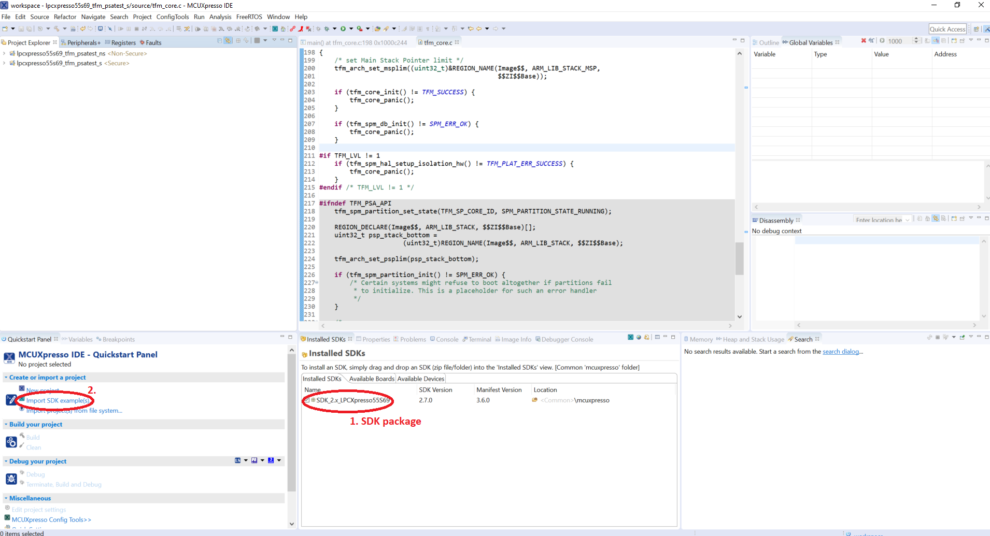
- MCUxpresso IDE
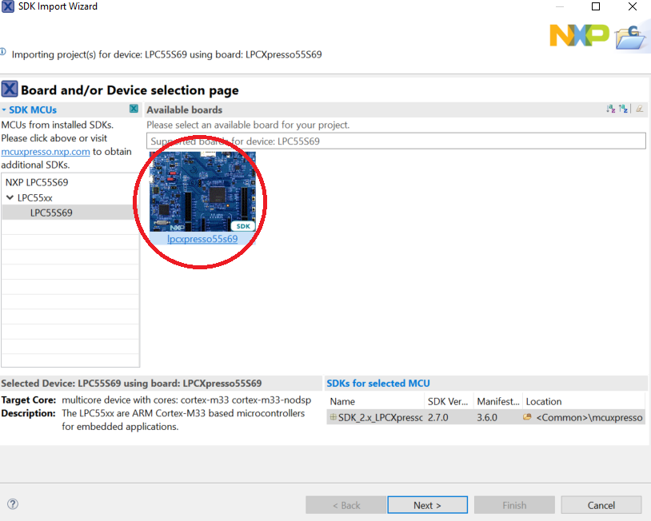
- SDK Import Wizard – step 1
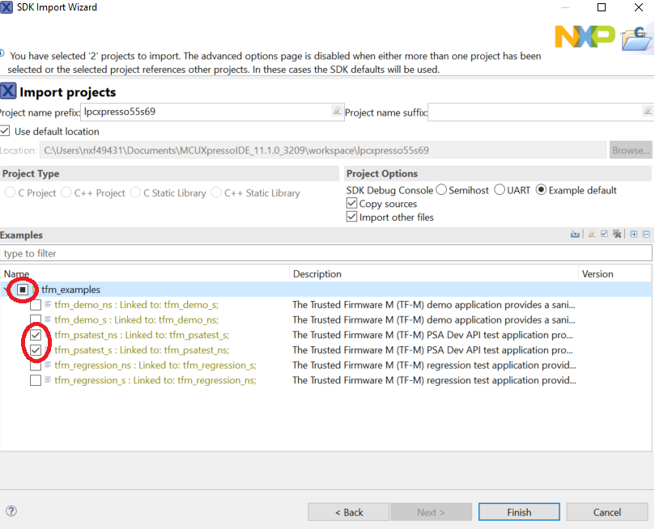
- SDK Import Wizard – step 2

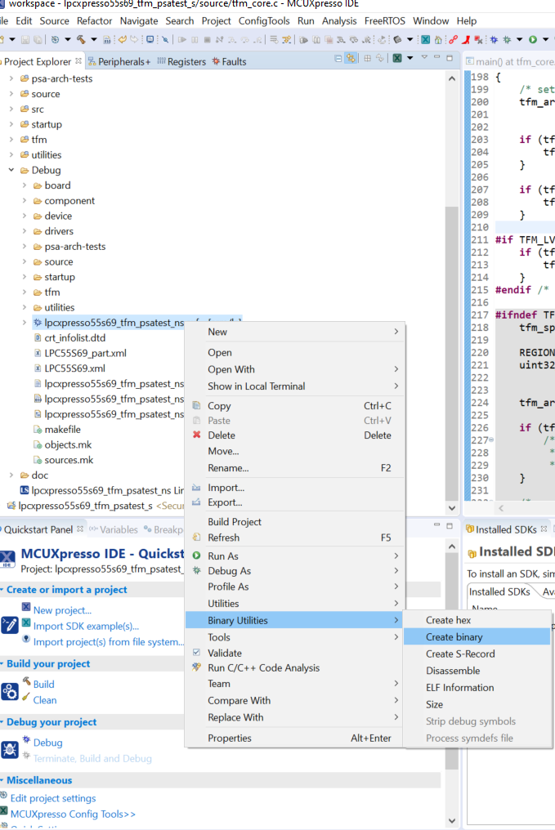
- Create binary file

Signed Images Preparation
- Select LPC55Sxx device
- Set all settings according to figures 5 and 6.

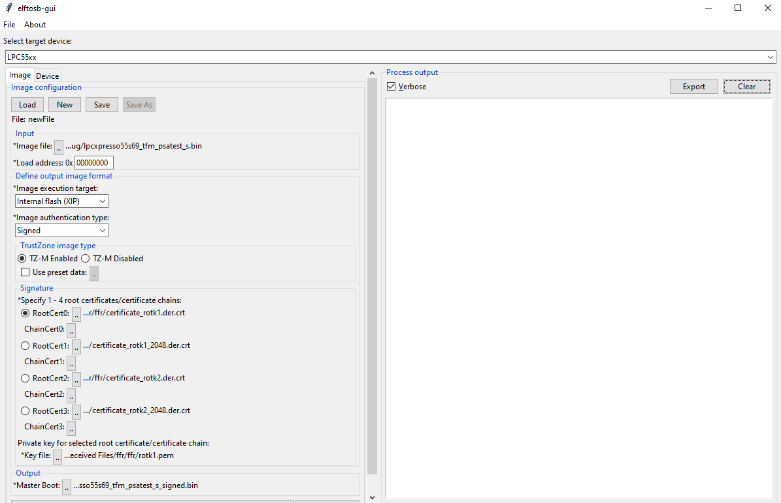
- Elftosb-gui setup for signed image (secure)
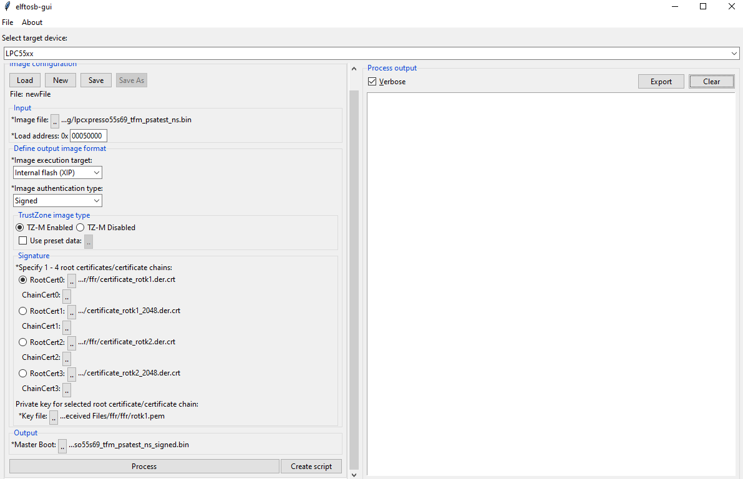
- Elftosb-gui setup for signed image (nonsecure)

Erasing a Device
Before signed images are loaded to the device, the internal flash memory should be erased:
blhost -p COMxx flash-erase-region 0x00000 0x9ddfc

CFPA Page Preparation
By default, the CFPA is cleared. There are registers related to secure boot which is set up.

ROTKH_REVOKE field at CFPA page address 0x9DE18 has to be setup to accept signed images with created certificates. See Protected Flash Region v1.0.xlsx in attachments in UM11126_LPC55x_v.1.7.pdf reference manual.

Enter UART ISP mode

- Press and hold the ISP button (Switch S1) on the LPC55Sxx development board while pressing the RESET button (Switch S4) to enter ISP mode
Test communication through BLHOST tool

blhost -p COMxx get-property 1

*if ping failure show it has got wrong connection
Prepare CFPA page in .bin file (example with RoT key 0-3 enabled and Version set to 1 is attached – InFieldROMAPIScratch_0x9de00.bin)

Write images into flash memory

blhost -p COMxx write-memory 0x9DE00 <path to the CFPA(.bin)>

NOTE: Never restart the device before both pages (CFPA and CMPA) are loaded, otherwise you will increase a probability of lock the device.

CMPA Page Preparation
The CMPA page is configured to boot the signed image.

The Root Key Table Hash (RKTH) is counted by elftosb-gui (see figure 7). This RTKH field at CMPA page address 0x9e450 has to be setup. See Protected Flash Region v1.0.xlsx in attachments in UM11126_LPC55x_v.1.7.pdf reference manual.

Enter UART ISP mode

- Press and hold the ISP button (Switch S1) on the LPC55Sxx development board while pressing the RESET button (Switch S4) to enter ISP mode
Test communication through BLHOST tool

blhost -p COMxx get-property 1

*if ping failure show it has got wrong connection

Prepare CMPA page in .bin file (example is attached CustomerManufacturingFactoryConfigurationArea_0x9e400.bin – when the attached file is used, the RKTH has to be updated according to hash value counted by elftosb-gui (figure 7))

Write images into flash memory

blhost -p COMxx write-memory 0x9E400 <path to the CMPA(.bin)>

NOTE: Never restart the device before both pages (CFPA and CMPA) are loaded, otherwise you will increase a probability of lock the device.
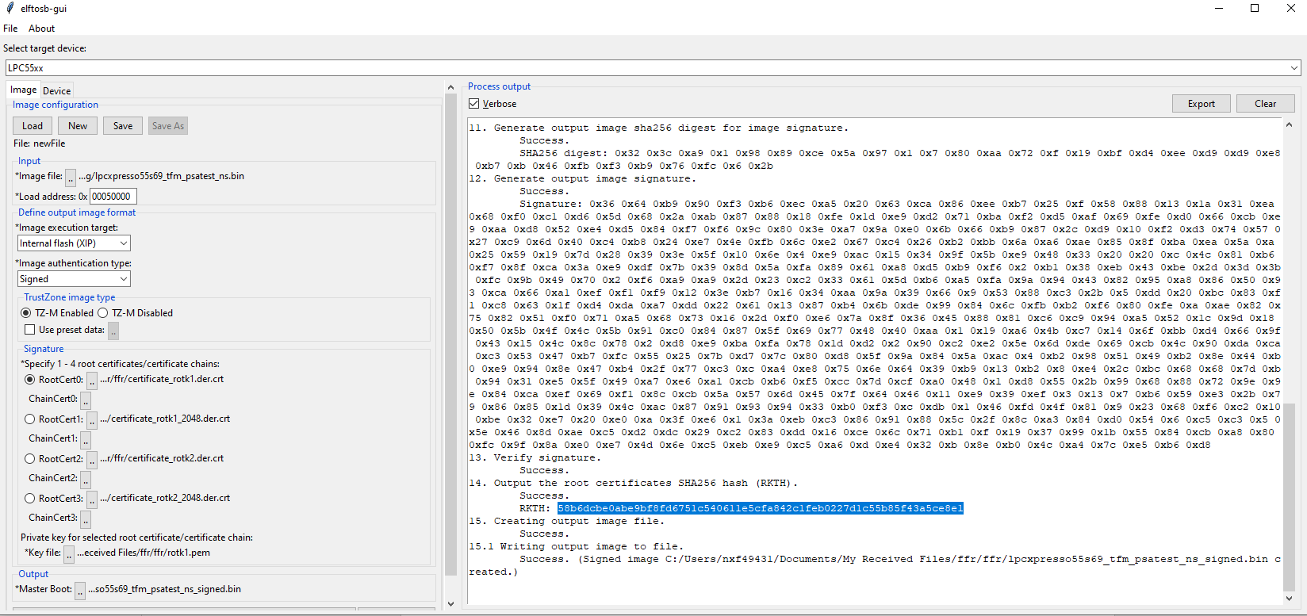
- Root of Trust Keys Table Hash

Loading Signed Images without Flash Encryption

Loading Signed Images
The signed images are programmed into the device by means of BLHOST utility in ISP mode. For more information, see the BLHOST manual.

Enter UART ISP mode

- Press and hold the ISP button (Switch S1) on the LPC55Sxx development board while pressing the RESET button (Switch S4) to enter ISP mode
Test communication through BLHOST tool

blhost -p COMxx get-property 1

*if ping failure show it has got wrong connection

Write images into flash memory

blhost -p COMxx write-memory 0 <path to the signed secure image(.bin)>
blhost -p COMxx write-memory Y <path to the signed nonsecure image(.bin)>

*Y The value is taken from map file (0x00050000 for this example)

After these steps, the signed images are loaded in the flash.

Loading Signed Images with Flash Encryption Using PRINCE

PRINCE related PUF key store setup
The keys used for PRINCE encryption/decryption are generated in the device using on-chip SRAM PUF and they are delivered to the PRINCE engine through internal hardware bus.
The proper PRINCE enabled Key Store needs to be generate via blhost application.
- generate device activation code and store it into key store structure
blhost -p COMxx key-provisioning enroll
- generate random PRINCE region 0, key type = 7
blhost -p COMxx key-provisioning set_key 7 16
- generate random PRINCE region 1, key type = 8
blhost -p COMxx key-provisioning set_key 8 16
- generate random PRINCE region 2, key type = 9
blhost -p COMxx key-provisioning set_key 9 16
- save the key store into PFR page of Flash memory
blhost -p COMxx key-provisioning write_key_nonvolatile 0

PRINCE region configuration with blhost
For PRINCE encryption and decryption the regions and sub-regions for the crypto operation needs to be configured. This can be done with ISP command “configure-memory”. This command have to be called with following data structure.

Table 1. Structure of configure-memory command
Offset | Size | Description
0 | 4 | PRINCE Configuration
4 | 8 | PRINCE Region Info

Table 2. PRINCE configuration register for configure-memory command
Bit | Symbol
1:0 | 0x00 – PRINCE Region 0  0x01 – PRINCE Region 1  0x10 – PRINCE Region 2
25:2 | Reserved
31:8 | 0x50 (‘P’) – Configure PRINCE

Table 3. PRINCE region info register for configure-memory command
Bit | Symbol
31:0 | PRINCE Region X Start
63:32 | PRINCE Region X Size
Load structure into RAM memory and call “configure-memory” command with this structure:
- Region selection (Region 0)
blhost -p COMxx fill-memory 0x20034000 4 0x50000000
- Start address of encrypted area
blhost -p COMxx fill-memory 0x20034004 4 0
- Length of the encrypted area
blhost -p COMxx fill-memory 0x20034008 4 0x40000
- Call configure-memory with prepared structure in RAM
blhost -p COMxx configure-memory 0 0x20034000
- Region selection (Region 1)
blhost -p COMxx fill-memory 0x2003400c 4 0x50000001
- Start address of encrypted area
blhost -p COMxx fill-memory 0x20034010 4 0x40000
- Length of the encrypted area
blhost -p COMxx fill-memory 0x20034014 4 0x40000
- Call configure-memory with prepared structure in RAM
blhost -p COMxx configure-memory 0 0x2003400c
- Region selection (Region 2)
blhost -p COMxx fill-memory 0x20034018 4 0x50000002
- Start address of encrypted area
blhost -p COMxx fill-memory 0x2003401C 4 0x80000
- Length of the encrypted area
blhost -p COMxx fill-memory 0x20034020 4 0x1ddfc
- Call configure-memory with prepared structure in RAM
blhost -p COMxx configure-memory 0 0x20034018

Loading Signed Images
The signed images are programmed into the device by means of BLHOST utility in ISP mode. For more information, see the BLHOST manual.

Enter UART ISP mode

- Press and hold the ISP button (Switch S1) on the LPC55Sxx development board while pressing the RESET button (Switch S4) to enter ISP mode
Test communication through BLHOST tool

blhost -p COMxx get-property 1

*if ping failure show it has got wrong connection

Write images into flash memory

blhost -p COMxx write-memory 0 <path to the signed secure image(.bin)>
blhost -p COMxx write-memory Y <path to the signed nonsecure image(.bin)>

*Y The value is taken from map file (0x00050000 for this example)

After these steps, the signed images are loaded in the flash.

Download CFPA and CMPA pages
To check that CFPA and CMPA pages were setup correctly are used the following commands:
blhost -p COMxx read-memory 0x9de00 512 <path to the CFPA output(.bin)>
blhost -p COMxx read-memory 0x9e400 512 <path to the CMPA output(.bin)>

Debug Authentication

Provisioning

