Software reference manual for

LA9310 IQ player application

Project Name | LA9310
Version | 0.1
Date | 11/25/2024
Status | Draft
iCAP Classification

Revision history

Version | Author | Changes
0.1 | Francois Massot-Pellet | Initial draft

Table of Contents
Abbreviations 5
1. Introduction 6
1.1. Scope of the document 6
1.2. Related documentation 6
1.3. Use-Cases 6
1.4. Software and toolchain 7
1.5. Content of release package 7
2. Hardware support 8
2.1. RFNM motherboard and RF modules 8
2.2. Harware setup 9
2.3. Deployment and usage 9
3. iq-replay.sh/iq-capture.sh 11
4. lib_iqplayer/iq_app 14
5. DMA performance 18
5.1. VSPA DMA Write to host DDR 20
5.2. VSPA DMA Read from host DDR 21
5.3. Host DMA (edma) read and write 22
5.4. VSPA DMA consideration 23
5.5. How to maximize the VSPA AXI and DMEM bandwidths 24
5.6. Why not using LA9310 TCM memory to extend dmem fifo size 25
6. PCI read/write accesses to LA9310 DMEM 26
7. VSPA Firmware API/ABI , the “VSPA dmem proxy” 27
8. iq_mon : statistics monitoring 29
9. IQ data format 30
10. QEC and DC OFFSET 30
11. Decimation 32
12. Debug and trace 33
13. Known limitations 35
13.1. Full duplex 1T1R at 122.88MSPS limitation 35
13.2. 4R channel parallel operation 35
13.3. liq_iqplayer/iq_app start and stop sequence 35
14. ToDoList 36
15. Do more with LA9310… 36
16. Figure List 37

Abbreviations

API | Application Programming Interface
APP | Application
BSP | Board Support Package
BW | BandWidth
CLI | Command Line Interface
CPU | Computer Processing Unit
DAC | Digital Analog Convertor
DCS | Digital Convertor System
DL | DownLink
DMA | Direct Memory Access
DSP | Digital Signal Processor
IPC | Inter Process/Processor Communication
L1 | Layer 1, Physical Layer
VSPA | Vector Signal Processing Acceleration

Introduction

Scope of the document

The scope of this document is to present the current design of the LA9310 iq-player software developed and delivered as part of NXP LA9310 BSP. The primary target system is the RFNM board, and this code will work on any LA9310 based setup including NLM module connected to i.mx8mp-evk and imx8dxl-evk.

Related documentation

Here some additional documents and resources that you can refer to for more information on LA9310, i.mx8mp, some of the documents listed may be available only under a non-disclosure agreement (NDA). To request access to these documents, contact your local NXP field applications engineer (FAE) or sales representative.

- LA9310-iMX_BSP1.1_Guide.pdf
- LA9310RM_Rev0RH.pdf
- IMX8MPRM.pdf

Use-Cases

The main objective is to provide simple solution to exercise LA9310 baseband rx and tx path, using raw time domain I/Q sample flow. This should enable use cases such as SDR applications, RF testing and calibration, where LA9310 will do signal conditioning including Tx/Rx QEC and decimation. It intends to reach maximum capacity allowed by LA9310 hardware, in term of sampling rate , PCI throughput and number of channels.

Feature list :
- Raw continuous time domain rx/tx streaming
- Sampling rate, 61.44MSPS, 122.88MSPS and possibly 160MSPS
- Support 1T1R, 1T2R, 1T4R
- Support QEC

Software and toolchain

- VSPA toolchain , CW_VSPA_v10.3.10
- LA9310 BSP ( LA9310 iMX BSP 1.0 )

https://github.com/nxp-real-time-edge-sw/yocto-real-time-edge/tree/la93xx

Features:
- Linux Factory Real Time Edge 2.5 release based
- Kernel RT 5.15.71
- LA9310 drivers
  - LA9310 – Shiva driver (PCI RC driver)
  - LA9310 – app/demo ( tti, wdog, CDT )
  - LA9310 – RFNM (USB-IIO driver)
- FreeRTOS
  - Upgraded to 10.4.6
  - RFNM V2H and RF driver support
- ARM RAL Library
  - 24.01 added for High-phy development over i.mx

Content of release package

The iq-player package includes all source code for VSPA firmwares, linux application and i.mx8mp M7 firmware. This application si deployed by default in the LA9310 NXP BSP under /home/root/hot-utils

├── EULA.txt
└── LA9310_cal
├── Debug_IQPLAYER*
│ └── apm-iqplayer.eld
│ └── apm-iqplayer-2R.eld
│ └── apm-iqplayer-4R.eld
├── doc
│ ├── Host(CM4 or host)_VSPA_Mailbox_Communication.xlsx
├── host-utils
│ ├── iq_app
│ ├── iq_monitor
│ ├── iq-capture-ddr.sh
│ ├── iq-capture.sh
│ ├── iq-replay.sh
│ ├── iq-stop.sh
│ ├── lib_iqplayer
│ ├── load-nlm.sh
│ ├── readme.txt
│ ├── singleTone.sh
├── include
├── matlab
├── Sources
├── vspa-lib
└── vspa-sdk

30 directories, 167 files

Hardware support

RFNM motherboard and RF modules

This software has been tested on RFNM hardware and is mostly dealing with baseband traffic. For RF configuration, users should refer to LA9310 BSP which enables various RF modules such as limeRF, Granita , Yucca.

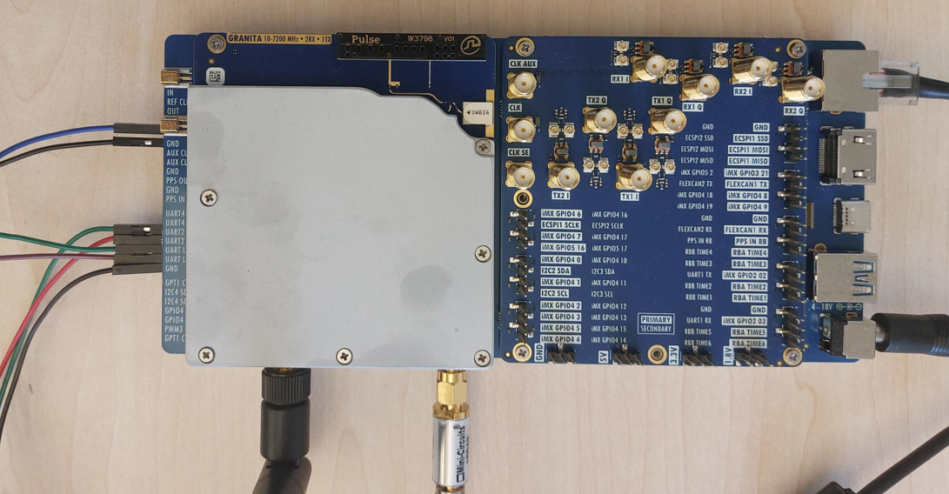

Harware setup

How to power-up RFNM/LTI SDR : Need to connect an external power supply on the jack. Could be anything between 5-22 Volt , center positive. I’m using in general 12V 5A.

How to connect linux console : If you want to see more what happen on the board.. you can connect an uart console. You need to connect uart2 , you’ll need a TTL adapter such as TTL-232R-RPI . On uart console you’ll be able to connect to linux prompt root/root.

Deployment and usage

iq-player components are deployed by default on NXP LA9310 BSP. NXP provide prebuilt sdcard images downloadable from nxp.com

Then iq-player components are located under

Here the sequence to start traffic and capture iq samples

By default ADC/DAC are configured at 61.44MSPS, in order to enable 122.88MSPS one can pass “1” as parameter to load-nlm.sh. One can also edit the script and modify “adc_mask=0xf” and “adc_rate_mask=0x1” where each bit select sampling rate dcs clock 122.88Mhz /2 divider.

iq-replay.sh/iq-capture.sh

The primary function of iq-player is to play/capture waveforms and provides the first following scripts:
- iq-replay.sh : play in loop a tx waveform from a binary file
- iq-capture.sh : single shot capture of a rx waveform into a file
- iq-capture-ddr.sh : continuous capture of rx flow into DDR buffer
- iq-stop.sh : stop traffic

The basic principle is to send vspa mailbox message to start streaming from a buffer in DDR in the DDR iqflood region. This region is declared in device tree and LA9310 PCI driver will map it over PCI by configuring the la9310 end point outbound windows so we can access that region from LA9310 and VSPA. Configuration incl host physical address (0x96400000) and associted LA9310 physical address (0xb0001000) can be retrieved in dmesg :

So LA9310 DMA reading at 0xb0001000 will reach i.MX DDR at 0x96400000

This is what iq-replay.sh script is using. It retrieves iqflood region from dmesg, and by convention is using bottom it as Tx buffer. It loads the binary waveform at beginning of iqflood , then build and issue a vspa mailbox command to VSPA to start streaming this buffer at EP side address 0xb0001000.

From that point VSPA will fill its tx DMEM FIFO which is devided in 2 parts. QEC operation is taking input in part1 in IPPU DMEM and output FIFO part 2 in VCPU DMEM. We use 2 different banks for performance reason. All this will be paced by the availability of a next command into the DAC DMA fifo command. So DAC is triggering progress of the Tx FIFO and VSPA DMA read toward DDR. DDR TX Buffer is read in loop until user issue a stop command.

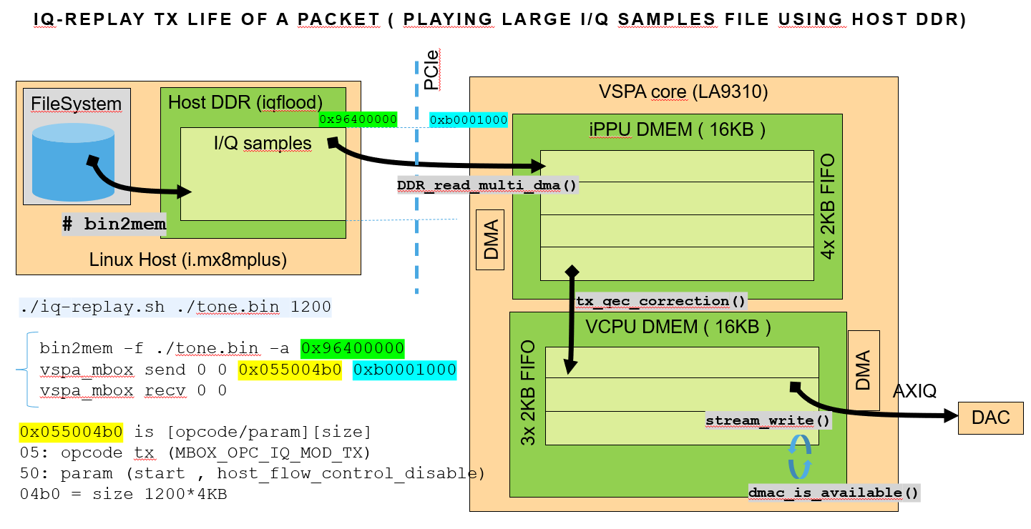
Figure 1 : iq-replay Tx life of a packet

Same principle is used for reception by iq-capture.sh (one shot capture) and iq-capture-ddr.sh (free running until stop). By convention iq-capture script will use the second half of the iqflood region, first half is reserved for tx buffer, so we can run Rx and Tx in parallel.

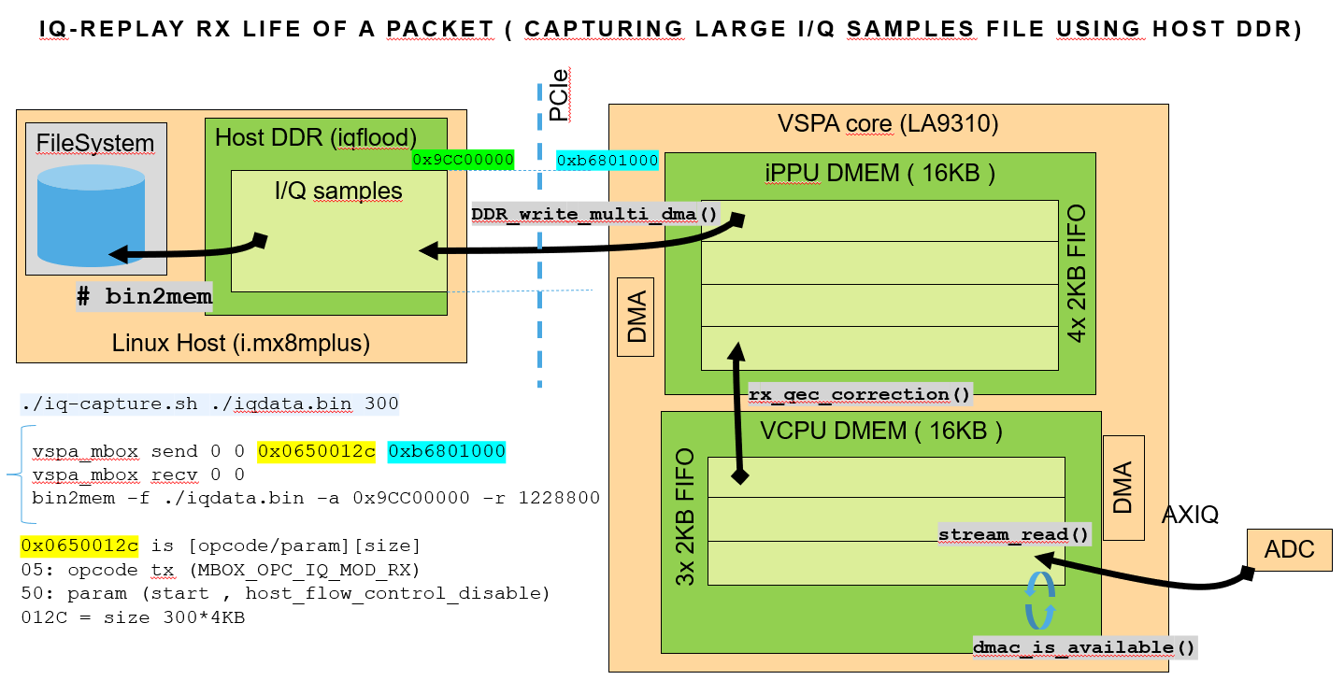
Figure 2 : iq-capture Rx life of a packet

Same principle applies to multi channel RX. When running VSPA firmware implementing 2R or 4R, user will use the exact same iq-replay.sh or iq-capture.sh scripts, and VSPA will start all channels together and will split the DDR buffer passed across channels :

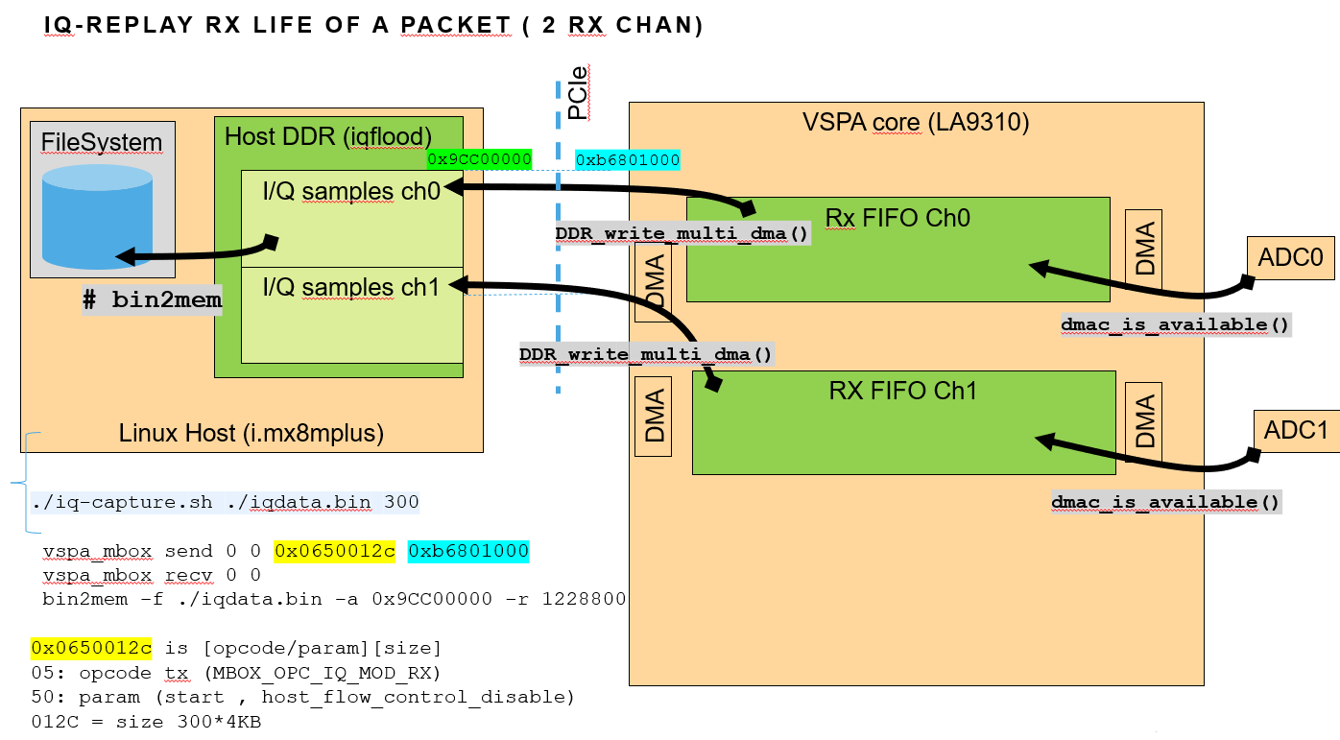
Figure 3 : iq-capture Rx life of a packet 2ch

lib_iqplayer/iq_app

iq-player is providing an application example how to send and receive data as needed to connect an upper stack or an SDR framework.

The way it works, we are using same mechanism as the single buffer replay/capture and the buffer in DDR will now play role of Rx and Tx FIFO, where app will push/pull data and VSPA firmware sill pull/push data.

Using DDR fifo allow to size the fifo according to the application real time and latency constraint. By default documented examples are using 32KB fifos which turns to be enough to sustain all use cases as far as the linux application is ran in isolated CPU with kenrel configuration reducing arch timer interrupt.

By default 2 out 4 cpu of the i.mx8mp are isolated with following linux boot arg configuration and kernel config:

The way to configure and start/stop such fifo is similar as the iq-replay.sh and iq-capture-ddr.sh i.e. simple vspa_mbox message passing address and size of the Fifo to VSPA firmware and let VSPA firmware to perform transfer from/to DDR fifo to/from DMEM fifo. The script to start continuous Tx or Rx from/to a fifo in DDR are ./iq-start-rxfifo.sh and ./iq-start-txfifo.sh.

In order to use DDR buffer as a TX/RX Fifo, the VSPA Firmware has an option to enable an additional handshake called “host flow control”. By default the flow control is disabled in iq-replay/iq-capture, so VSPA assume data is always ready in host DDR buffer. For streaming, lib_iqplayer is maintaining the size of samples produced or concumed by the app into the DDR FIFO. This control the amount of data VSPA is allowed to read or write in the DDR Fifo. This is control using the host_flow_control_disable bit in the command passed to vspa_mbox (bit 0x00400000) in the opcode, hence command used in iq-start-rxfifo.sh and iq-start-txfifo.sh are changed from opcode 0x0550 to 0x0510 as shown below :

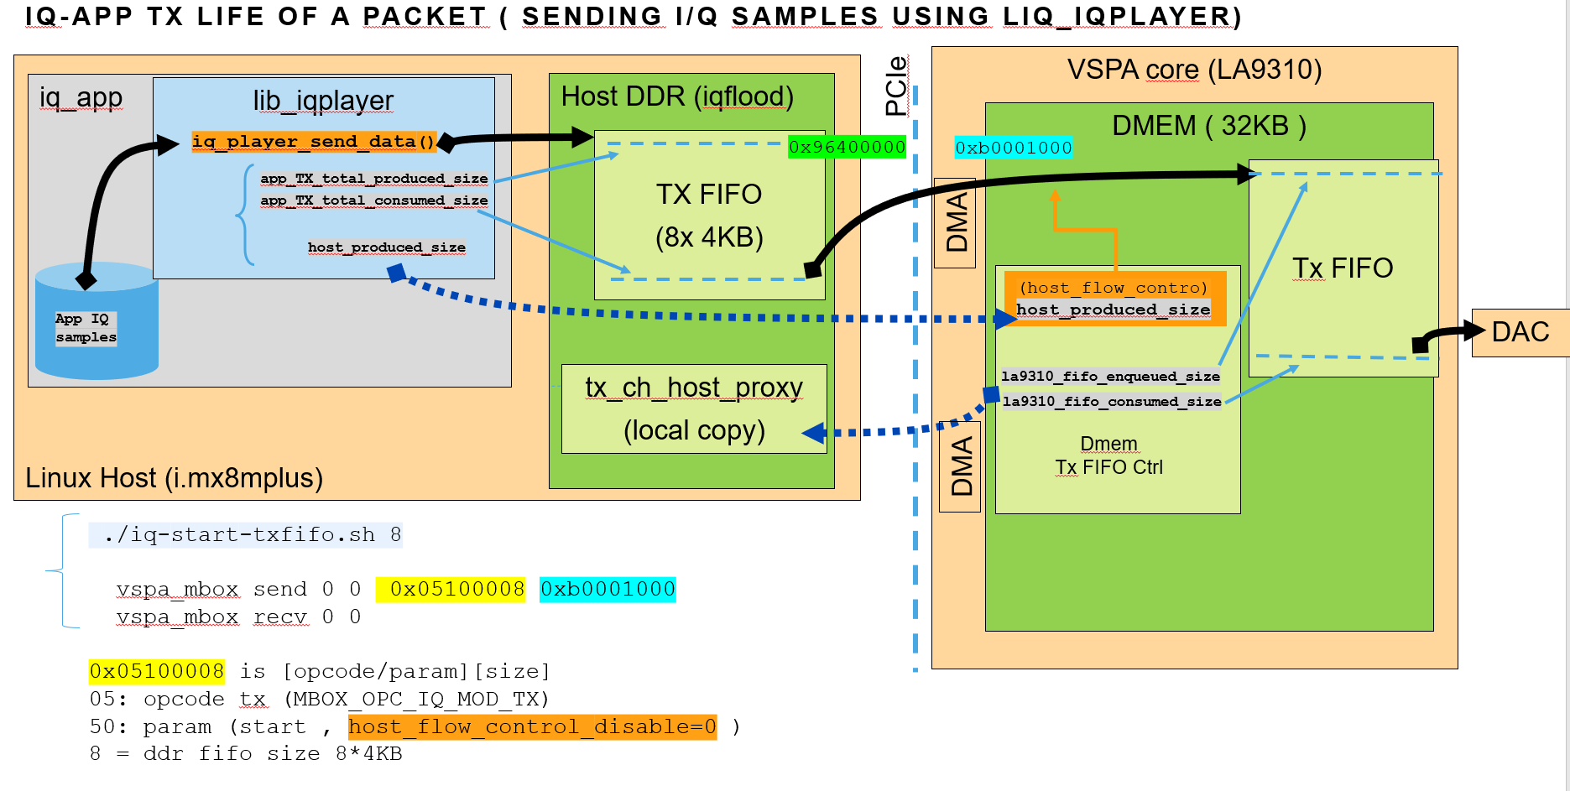

The iq_app example is a basic application streaming a large file of iq_samples loaded in iqflood DDR region and sending it using lib_iqplayer using iq_player_send_data() function. Same iq_app can receive large file of iq samples into iq_flood DDR region by using iq_player_receive_data() function.

Here how iq_app code looks like :

DMA performance

The major constraint for the iq-player application is the capability to carry iq sample over PCI bus from/to VSPA DMEM to/from host DDR.

Theoretical PCI throughput is x1 PCI Gen 3, serdes speed is 8Gbps with encoding and frame format the efficiency could be as low as 85% for 128bytes packets which means 850MB/s as realistic max theoretical throughput.

To carry IQ samples, we need 4Bytes per samples 16bits I and 16bits Q :

- 61.44MSPS 122.88 MB/s
- 122.88MSPS 491.52 MB/s
- 160MSPS 640 MB/s

In this section we will provide DMA performance as measured on RFNM platform, with VSPA DMA and host eDMA. Those measurements would help to find the right approach to support the various targeted use cases.

VSPA DMA Write to host DDR

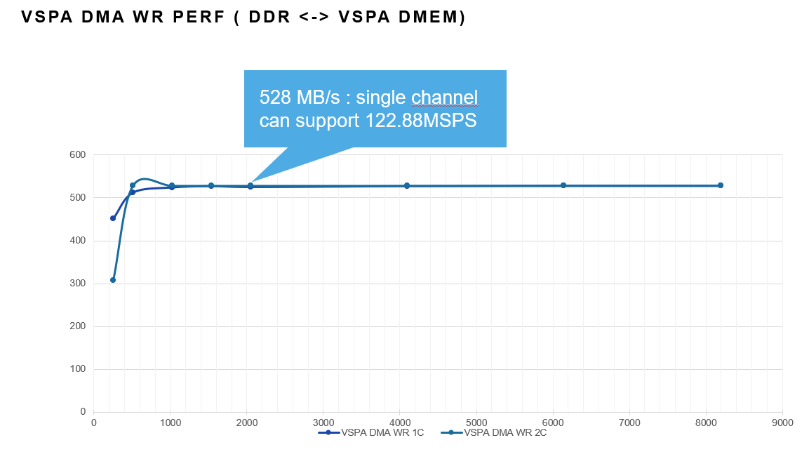
Figure 4 : LA9310 VSPA DMA Wr perf

The LA9310 AXI bus supports 2 opened WR transactions in parallel, so best throughput may be achieved by using 2x DMA channels. On RFNM (i.mx8mplus) using 2 channels doesn’t help because we reach first a limit of the host itself. As per AN13164.pdf , i.mx8mplus has an hardware limitation for inbound write transaction (inbound MWr). in our case the limit seems to be 528MB/s. This will be enough to carry out 122.88MSPS, but not enough for 160MSPS.

By default iq-player is using 1 VSPA DMA write channel.

VSPA DMA Read from host DDR

Here below performance we have measured on RFNM target :

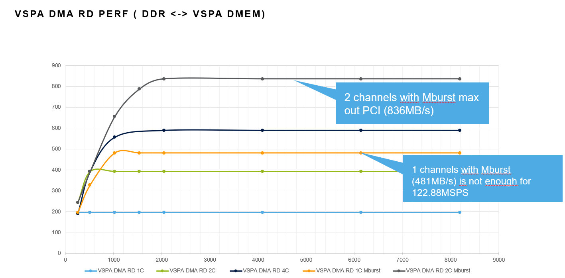
Figure 5 : LA9310 VSPA DMA Rd perf

LA9310 AXI bus supports 4 opened Rd transactions in parallel, so best throughput may be achieved by using 4x DMA channels. VSPA DMA has an option to configure Multi Burst read for a given channels to increase throughput

This measurements shows the need for a minimum of 2 channels to support 122.88MSPS with or without mBurst enabled.

By Default iq-player will use 2 channels without mBurst which gives 393MB/s good enough for 61.44MSPS.

There is an option to use 2channels with mBurst to sustain 122.88MSPS, this configuration is causing problem for full duplex operation at 61.44MSPS. Therefore, iq-player is using 2 channel without mBurst in FD 61.44MSPS mode, and 2 channel with mBurst in half duplex (tx only) 122.88MSPS. See parameter “half duplex” :

Host DMA (edma) read and write

Due to performance limitation using VSPA DMA (mostly in Write), iq-player is providing the option to use an external agent on the host performing iq samples transfer from/to dmem to/from DDR using host DMA instead of VSPA DMA. Here performance measured using eDMA :

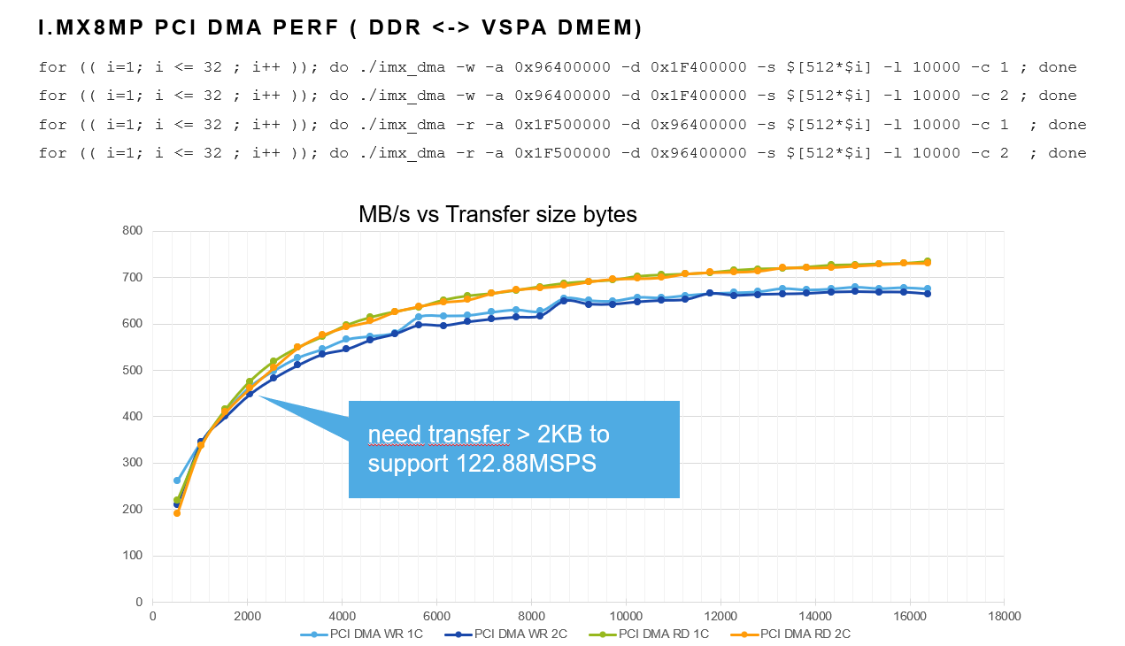
Figure 6 : i.mx8mp edma Wr/Rd perf
This measurements shows edma is able to sustain up to 700MB/s read and write with large transfer size. This requires to use transfers larger than 2KB to support 122.88MSPS and even 6KB to sustain 160MSPS.

VSPA DMA consideration

LA9310 VSPA DMA and system interface is 128-bit AXI3 interface to the system Multi-channel DMA with 3 engines servicing 16 channels
• Single burst per DMA transaction per channel
• Capable of multi-bursts (maximum of 4 consecutive 256B bursts)
• Strict priority among DMA channels (lower number gets higher priority)

LA9310 VSPA has 16 DMA channels chan0-15. Each channel has a 2 entries command fifo allowing continuous operation as soon as user ensure a transfer command is available in the second entry when first entry is running.

Amongst 16 channels,
- chan0 : DMA for High Priority SW Usage
- chan1-6 are dedicated to AXIQ ADC
- chan11 is dedicated to AXIQ DAC

all others are SW Usage here below how is-player is using DMA channels

How to maximize the VSPA AXI and DMEM bandwidths

There are 2 VSPA DMEMs, which we called VDMEM (VCPU-DMEM) and IDMEM (IPPU-DMEM).

There are separate access arbiters for each DMEM. So if you are having issues with DMEM BW, you should try spreading the BW load between the 2 DMEM instances. How you utilize the DMEM memory map can affect the DMEM BW by a factor of 2…

iq-player will try to use 2 banks in its tx and rx processing chain. The opportunity to change bank happen when performing either QEC or Decimation processing. Those VSPA kernel could be either executed “in place” and stay on same bank or use different input and output buffers which allows to change buffer location. In the 1T1R firmware bank transition will happen during QEC, in 1T2R and 1T4R transition will happen at rx decimation stage.

It’s also helpful to DMEM BW if the DMA and AXI slave data transfers are aligned to the AXI and DMEM data bus widths. Align the AXI side to AXI width and the DMEM side to DMEM width.

On the AXI side, make sure the data origin is aligned to a 4K byte boundary, which will minimize 4K boundary crossings and therefore maximize burst lengths.

If you want to boost the outstanding transactions on a DMA channel you can use multi-burst, but it would not be useful for AXIQ, just for DDR.

Also, I assume the channel FIFOs are being topped off and never allowed to fully empty…

Remember DMA channel 0 is highest priority and not subject to the round robin DMA channel arbitration. Use it if want guaranteed BW at the expense of the other requestors, avoid it if you prefer BW equality.

There is only one write engine, but there are at least 2 read engines on LA9310. You can parallelize AXI reads and writes if they are running on different channels.

In addition VSPA DMEM access priority from highest to lowest is:

- DMA writing DMEM
- DMA reading DMEM
- AXI slave ( access outside toward PCI/DDR)
- IPPU
- Debug
- VCPU

VSPA memories are single port memories
16KB VCPU Data Memory (VDMEM): 128 x 1024b - 16-bit writes
16KB IPPU Data Memory (IDMEM) 128 x 1024b - 16-bit writes

Why not using LA9310 TCM memory to extend dmem fifo size

The LA9310 M4 D-MEM 64K is a single-port 32-bit wide SRAM. It relies on 32-bit AHB interfaces which will not bring good performance when accessing it from outside the m4 complex :

The m4 TCM D-MEM could be accessed by the m4, in competition with external initiators.

m4 interface clock speed is slower than VSPA, and is using an async bridge. That increases latency and reduces BW. TCM is a 32-bit wide single port SRAM, it can only manage a peak of 4 bytes read OR 4 bytes write per m4 cycle, not both. m4 is at 245.5 MHz, the max. theoretical BW of m4 TCM is 982 Mbytes/sec. Which means 491MB/s Wr and Rd.

TCM performance is not better than direct access to host DDR across PCI, hence there is no interest for iq-player to use TCM as intermediate fifo, so transfer will be direct from/to dmem to/from DDR.

PCI read/write accesses to LA9310 DMEM

In addition to radio data transfer over PCI, there is need to expose control and statistic data.

- iq_mon : host app needs access to VSPA firmware statistics in dmem
- lib-iqplayer: host app needs access to VSPA flow control context to control tx/rx fifos

As a general principle, it is preferable to perform write accesses over PCI bus rather than reads. A PCI read transaction stay open as long as the data comes back for the far end partner. PCI read initiator has usually a limited number of transactions which can be opened in parallel, a read transaction can stall the initiator and create performance penalty. When a PCI write transaction is “posted”, it doesn’t need to stay open and will not be limited by the number of transaction the initiator is able to open in parallel. Based on this, iq-player is implementing an “VSPA dmem proxy” mechanism as described in next section.

VSPA Firmware API/ABI , the “VSPA dmem proxy”

For portability and performance reason, iq-player is implementing an “VSPA dmem proxy” mechanism, where all the information the host may need to access in VSPA dmem will be mirrored in the host DDR to remove PCI read transaction.

This vspa dmem structure is defined in vspa_dmem_proxy.h header file and it holds all needed informations needed to interface with the vspa firmware. This structure along with the vspa mailbox definition will be main API/ABI between the host utilities iq_mon, lib_iqplayer and the firmware. The utilities will be compatible with any firmware as far as those APIs stay unchanged. As we have seen lib_iqplayer also need to write control flow status into dmem, the vspa dmem proxy also provide the offset to with structure in the dmemProxyOffset field.

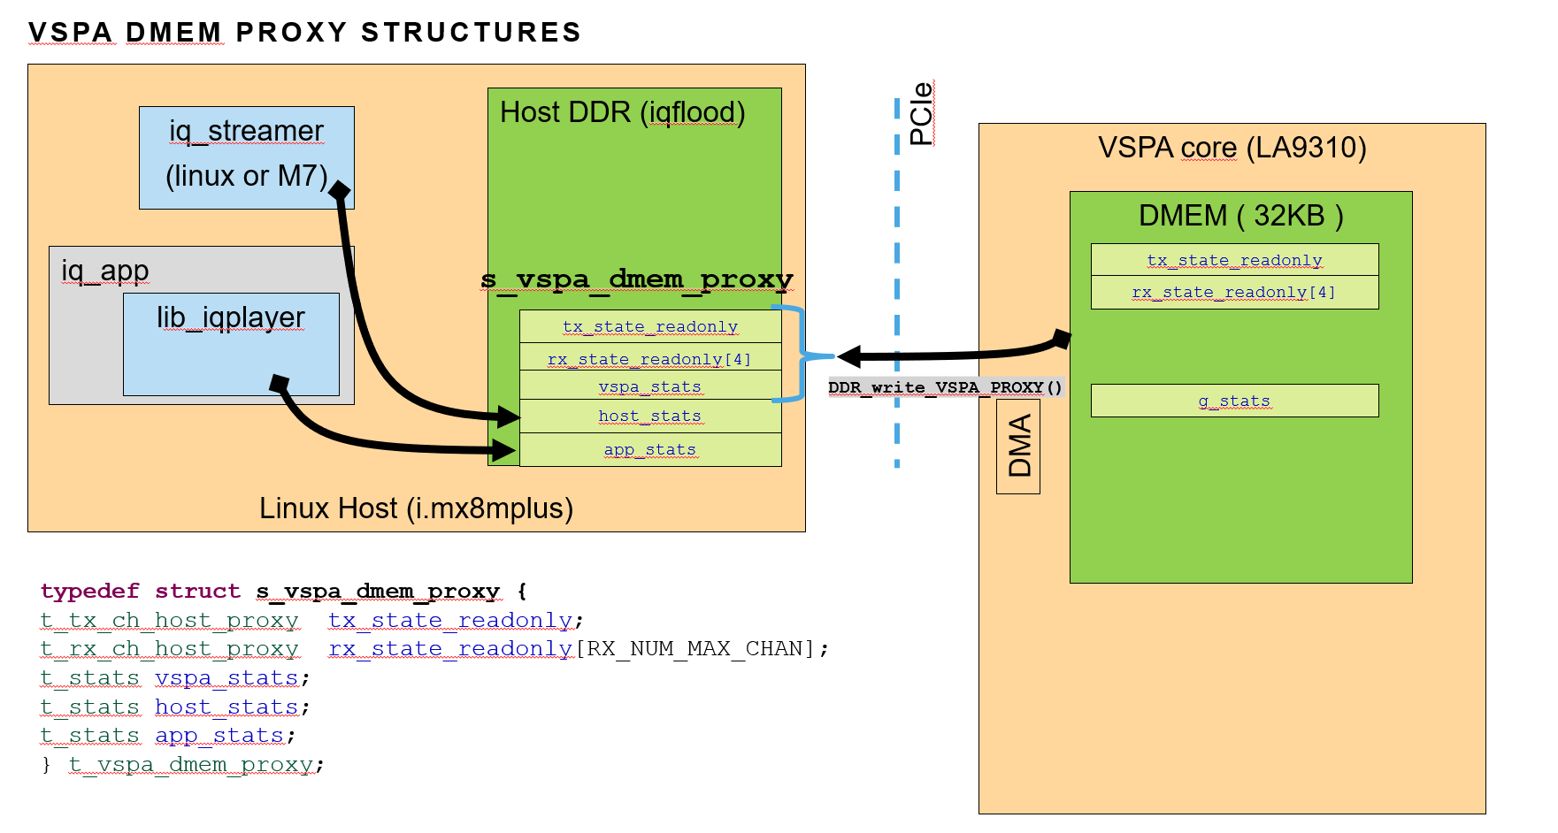
Figure 7: vspa dmem proxy structure

By convention, s_vspa_dmem_proxy structure is located at last 1KB of IQFLOOD region in host DDR.

tx_state_readonly, rx_state_readonly and vspa_stats are read only for the host sw and is by VSPA firmware at runtime using VSPA DMA to copy/mirror structures from dmem to DDR.

Some information such as host flow control or stats fetch request flag, will be accessed by liq_iqplayer or iq_mon directly in vspa dmem, location in dmem of the original structure is given is exported in dmemProxyOffset field.

iq_mon : statistics monitoring

iq-player provides an statistics monitoring utility iq_mon, this is very simple tool monitoring the t_stats structure in the vspa dmem proxy region in DDR. It captures values every second and compute bandwidth for relevant items.
iq_mon retrieve number of channels in the vspa dmem proxy to adapt the info displayed.
iq_mon can be started on a dedicated ssh shell on the target to monitor activities and checkout possible Fifo underrun/overrun.

IQ data format

The data format used by iq-player VSPA firmware is the 16 bit signed magnitude representation called half-fixed.

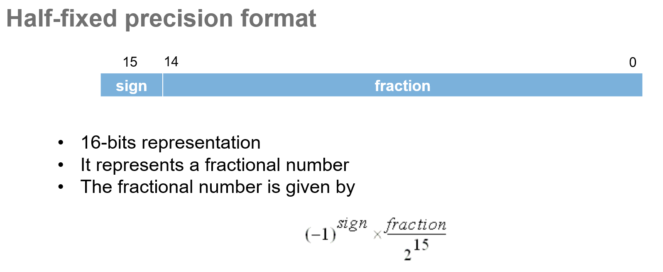
Figure 8: signed magnitude HF format

The VSPA DMA used to transfer data to/from DDR has the capability to convert this data format into a more standard 2’c complement usually expected by software running on host, value which can be simply interpreted as int16.
Hence the waveform binary files used with iq-player scripts are using 2’c complement format.

iq-player provides matlab code to generate and display iq sample binary files.

QEC and DC OFFSET

iq-player is integrating an VSPA Quadrature Error Correction (QEC) and DC offset compensation as needed for wideband Zero-IF system such as LA9310.

This support performs the following:
- IQ imbalance phase & amplitude compensation and fractional delay compensation
- DC offset compensation

Two versions of vspa kernels are integrated txiqcomp()and txiqcomp_x32chf_5t(), they are used in both Tx and Rx paths, the first one is used by default and implements :

The second one add a 5 TAPs fractional delay compensation filter :

iq-player is providing python scripts helping out computing and configuring those parameters on each channels imb2qec-rfnm.py :

A basic manual procedure to tweak QEC and DC offset parameters is as below.

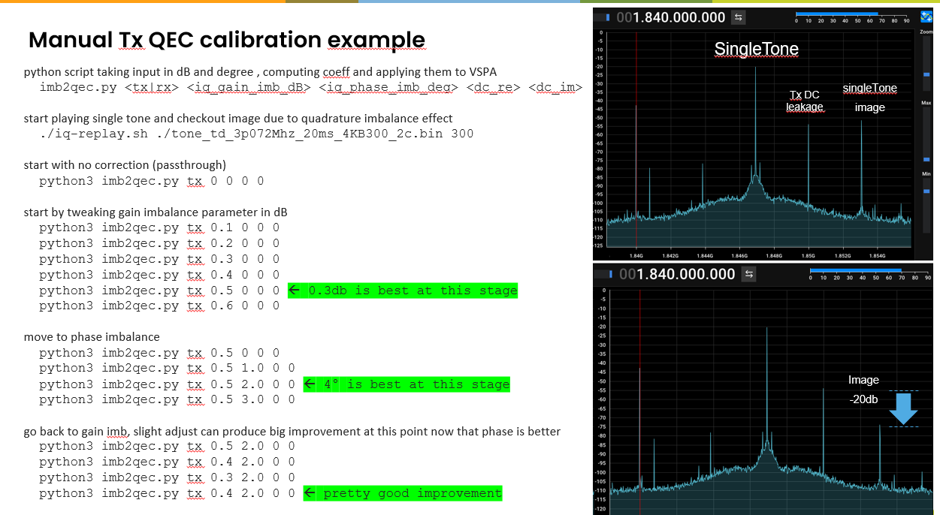

Decimation

iq-player is integrating a decimation function to enable multi rx channel operations. It provides two vspa kernels with factor 2x or 4x including a 8 TAPs FIR filter decimator_2x_8_Taps_asm() and decimator_4x_8_Taps_asm()

By default iq-player is enabling 2x version which turns to be a good compromise in term of use case supported and VSPA cycles.

Debug and trace

iq-player is providing trace capabilities in all the individual components :

- Linux applications iq_app generates debug trace in local trace buffer in the local heap. Trace can be displayed by sending USR1 signal to the app :

- VSPA firmware generates debug trace in trace buffer in DMEM. Trace can be displayed by using iq_trace app

Timestamp is local clock cycles of the hosting core A53 or VSPA, on RFNM board default clock speeds are A53 (1.6Ghz), VSPA (491.52Mhz).

Known limitations

Here are the list of known limitations and improvements

Full duplex 1T1R at 122.88MSPS limitation

With current implementation, iq-player supports only half duplex 1T or 1R operation at 122.88MSPS using VSPA DMAs.

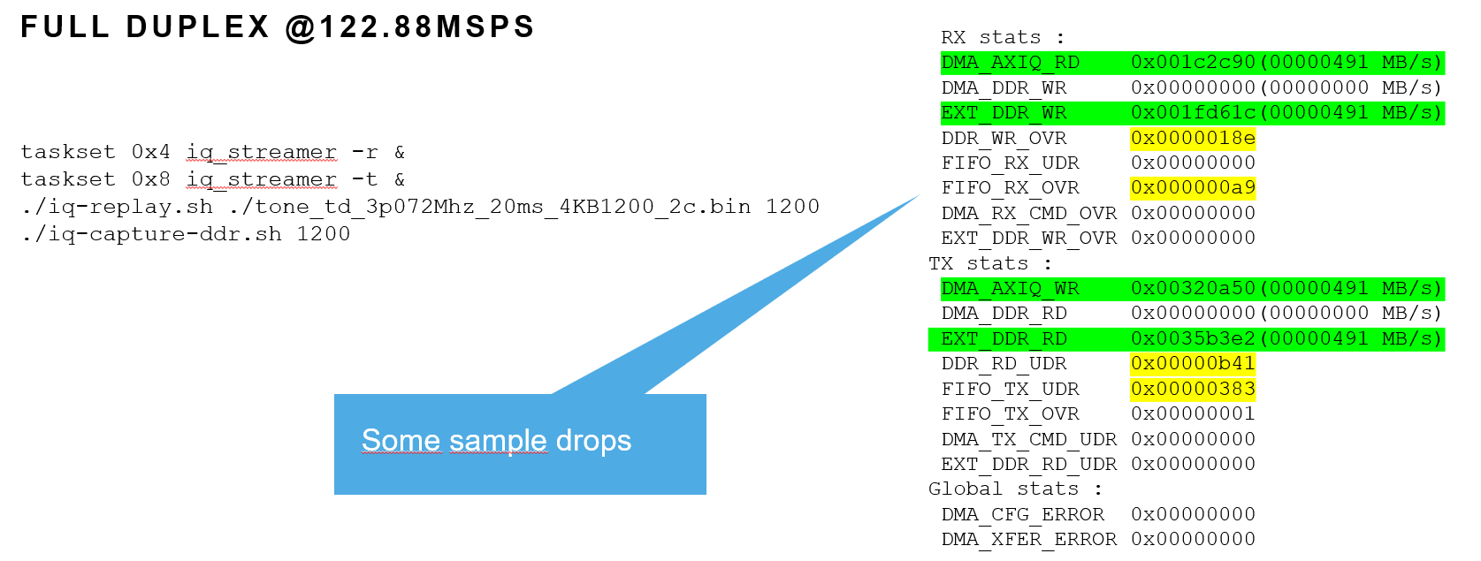

This needs further debugging and may be improved by changing FIFO placement in dmem which seems to cause rare/marginal starvation on VSPA DMA dealing with AXIQ ADC/DAC fifo tranfers.

4R channel parallel operation

iq-player implements 1T4R operation, however there is a limitation which prevents today to enable all 4 channels at same time. This would show Fifo underrun/overflow errors. User should disable 2 out of 4 channels in losd-nlm.sh to keep only 2 rx_allow signals asserted.
This requires more debugging, possible root cause is possible race condition between the 4 VSPA DMAs dealing with AXIQ fifos and/or DDRs. To be revisit with the consideration listed in the VSPA DMA chapter.

liq_iqplayer/iq_app start and stop sequence

With current limitation, lib_iqplayer as a constraint to start first the application and then the traffic. Stop and restart is not possible as well. This will be added in future releases.

ToDoList

- Use VSPA overlay instead of multiple binaries to support various use cases without need to restart la9310
- Debug the sample drop at full duplex 122.88Mhz to support 100Mhz BW usecases
- Add buffer metadata such as timestamping to enable more SDR usecases
- Replace binary file by signal processing and analyzing in iq_app. Could leverage and ARM RAL library to generate waveorm and display frequency spectrum from example
- Add 160MSPS single channel firmware
- Add userspace standard SDR API such as Soapy/GNUradio
- Port iq_player on big the high end version of layerscape access familly LA1224
- ..

Do more with LA9310…

This iq_player tool is intending to be exercise the capability of the LA9310 in term of performance (up to 122.88MSPS) and connectivity (up to 1T4R). It is also intending to be a starting point to implement custom VSPA firmware where users will implement custom signal processing chains adding functions such as FFT or filtering. A set of existing VSPA kernels is available on demand from NXP.

iq-player is limited to raw time domain streaming. For more sophisticated use cases such as 3GPP frame and symbol processing, NXP is providing an L1RefApp application implementing a full L1 5G low PHY 10/20MHz BW. Implementation approach will be different, and will leverage the LA9310 PHYTIMER capability to drive ADC/DAC fifo DMA aligned on symbol boundaries to support TDD operation. This will deal with time synchronization and cell search procedure and is intending to be a first building block to implement a full 3GPP/5G stack. NXP also propose an Network Listening application NLM performing LTE cell search operation and implementing some time synchronization algorithm.

Figure List

Figure 1 : LA9310 VSPA DMA Wr perf 20
Figure 2 : LA9310 VSPA DMA Rd perf 21
Figure 3 : i.mx8mp edma Wr/Rd perf 22
Figure 4: vspa dmem proxy strcture 27
Figure 5 : iq-replay Tx life of a packet 12
Figure 6 : iq-capture Rx life of a packet 13
Figure 7 : iq-capture Rx life of a packet 2ch 14

