DATA ANALYTICS SPECIALIZATION
LEVEL 1 — FOUNDATIONS
Level Completion Report
Day 1 – Day 3
STUDENT NAME | ___________________________________
DAY RANGE COVERED | Day 1 – Day 3
DOMAIN(S) COVERED | Environmental Analytics — Global Air Quality (AQI)
DATE OF SUBMISSION | ___________________________________

Fill in your details above before submitting. This report should be submitted only after the level's deliverable is complete.

STEP 1: WHAT YOU BUILT
Performed data integration and cleaning using Power Query in Excel, conducted comprehensive Exploratory Data Analysis (EDA) on global air quality data, and carried out SQL-based aggregation and ranking analysis in MySQL to profile pollution severity by country and city, supporting the project's goal of identifying high-risk regions for environmental decision-making.
Day | Topics Covered | Expected Deliverable
Day 1 | Power Query ETL, Data Cleaning, Star Schema Design | Cleaned Master Dataset + ETL Report
Day 2 | Descriptive Statistics, Distribution Analysis, Outlier Detection | EDA Report + Visualizations
Day 3 | SQL-Based Aggregation & Ranking Analysis, Country/City Risk Profiling | Segmentation Model + Insight Report

STEP 2: APPROACH & STEPS TAKEN
- Data Integration & Cleaning (Day 1): Consolidated raw air quality source data using Power Query in Excel — removed duplicates and null records, standardized Country/City naming, and built the cleaned master dataset (Master_Environmental_Impact_Dataset_Cleaned.xlsx) used for all downstream analysis.
- Exploratory Data Analysis (Day 2): Ran descriptive statistics and distribution analysis on AQI Value and the pollutant sub-indices (CO, Ozone, NO2, PM2.5) in Python to understand spread, central tendency, and outliers across the dataset.
- Visualization (Day 2): Built AQI category distribution charts, top-10 country/city rankings, histograms, box plots, a correlation heatmap, and category-percentage breakdowns to surface pollution patterns and high-risk regions.
- SQL-Based Aggregation & Risk Profiling (Day 3): Loaded the cleaned dataset into MySQL (Environmental_DB) and wrote a series of queries to profile pollution severity — overall AQI statistics (COUNT, AVG, MAX, MIN), the AQI Category breakdown, category breakdowns for each individual pollutant (CO, Ozone, NO2, PM2.5), the top 10 most polluted cities, the top 10 countries by average AQI and average PM2.5, and a count of monitored cities per country. The full query set is included in Step 3 / Appendix.
- Insight Consolidation: Combined the SQL outputs into ranked views of the highest-risk countries and cities (by average AQI, by pollutant-specific severity, and by monitoring coverage) to flag the regions most in need of stricter environmental policy, supporting the project's dashboard and decision-making objective.

STEP 3: SCREENSHOTS OF OUTPUT
Screenshot 1
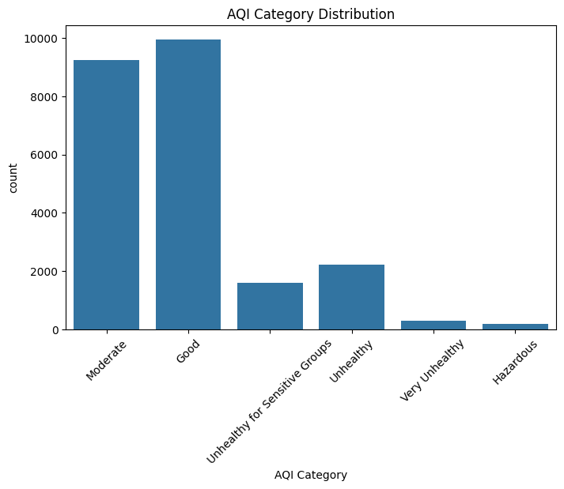
Caption / what this shows: AQI category distribution (Python/EDA) — Good and Moderate categories account for the majority of records, while Hazardous and Very Unhealthy are comparatively rare.
Screenshot 2
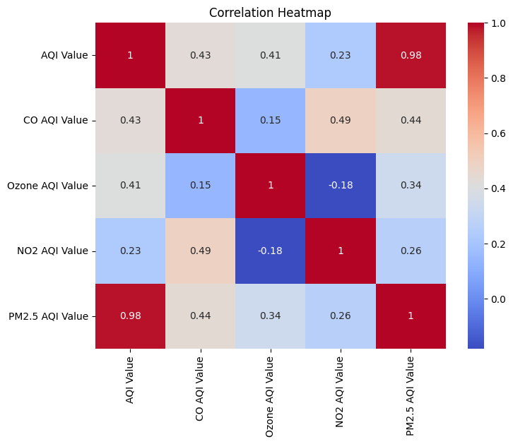
Caption / what this shows: Correlation heatmap of pollutant AQI measurements — pollutant values are generally positively correlated with one another.
Screenshot 3
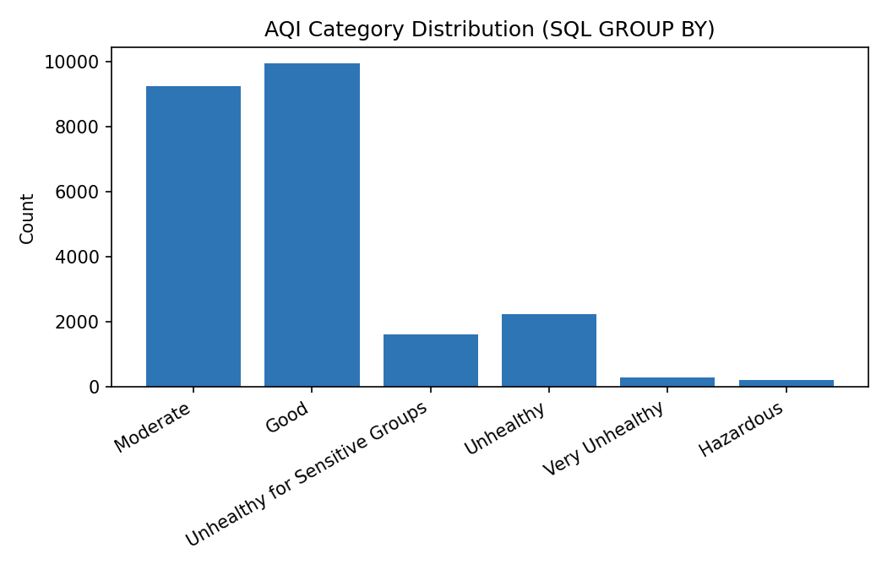
Caption / what this shows: MySQL: AQI Category distribution via GROUP BY — confirms the same pattern seen in the EDA, validating the cleaned dataset (9,936 Good, 9,231 Moderate, 191 Hazardous records).
Screenshot 4
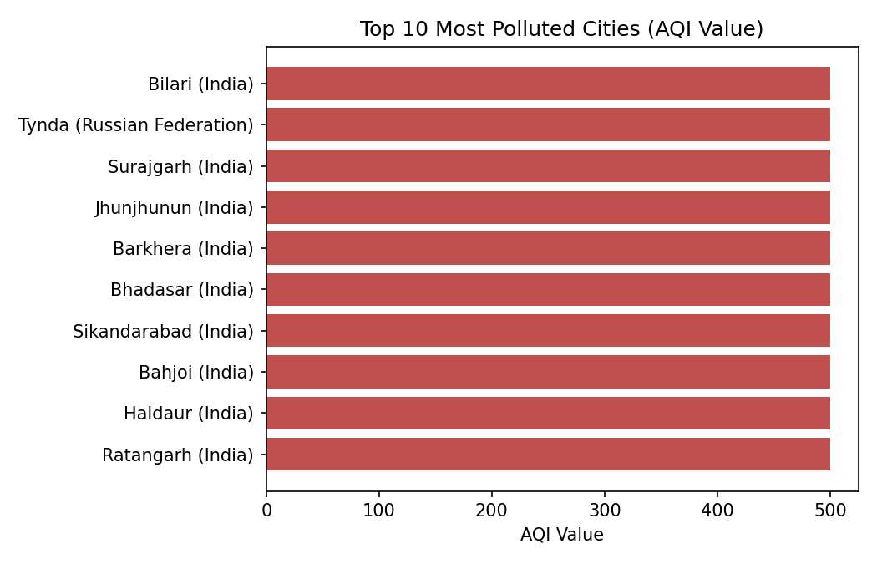
Caption / what this shows: MySQL: Top 10 most polluted cities by AQI Value, dominated by cities in India and the Russian Federation, each capped at the maximum recorded AQI value of 500.
Screenshot 5
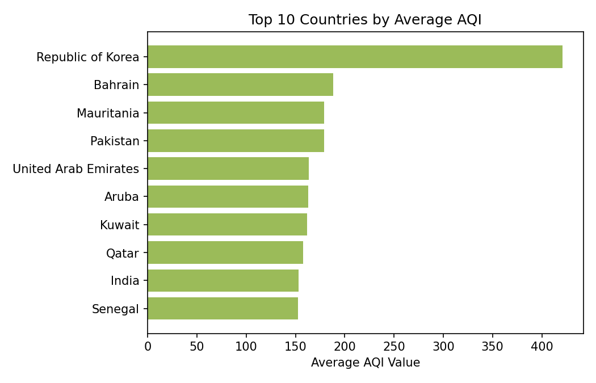
Caption / what this shows: MySQL: Top 10 countries by average AQI Value — Republic of Korea, Bahrain, and Mauritania show the highest average pollution levels.
Screenshot 6
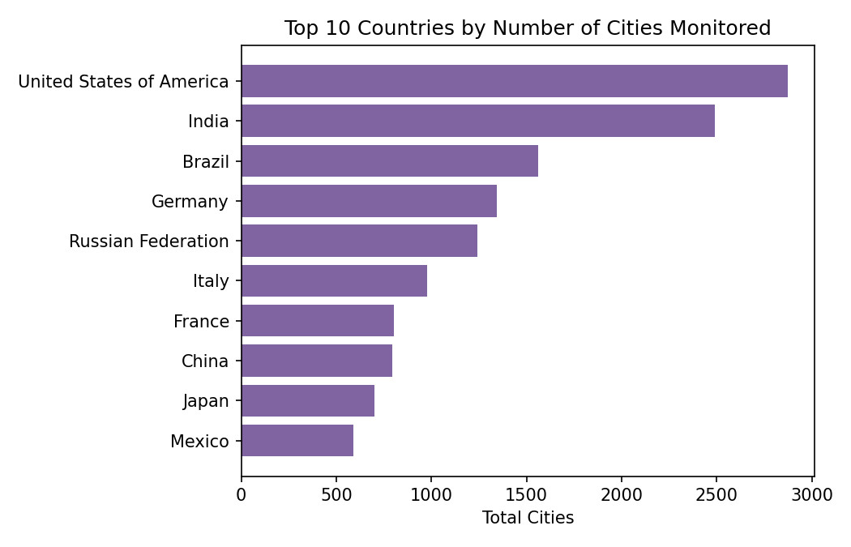
Caption / what this shows: MySQL: Top 10 countries by number of monitored cities — the United States and India have by far the widest monitoring coverage in the dataset.

STEP 4: AI TOOLS USED
List the AI tools used during this level:
- ChatGPT — used for project development support.
- Claude — used to compile and structure this Level 1 completion report.

STEP 5: GITHUB REPOSITORY
GITHUB REPOSITORY LINK: https://github.com/____________________

STEP 6: DELIVERABLE CHECKLIST
- Code runs successfully without errors
- Output matches the expected deliverable described above
- Screenshots above clearly show the working result
- GitHub repository is linked and accessible
- Report is filled completely before submission

STEP 7: CHALLENGES FACED
The dataset has no customer ID or date/timestamp field, so classic behavioral segmentation techniques (like RFM) don't map onto it directly. This was addressed by using SQL-based aggregation and ranking (by country, city, and individual pollutant) as the Day 3 profiling method instead — grouping and ordering records to surface the highest-risk countries and cities. Handling inconsistent country name encoding (e.g., a UTF-8 BOM prefix appearing on the Country column in some query outputs) also required attention when writing and grouping by that column.

STEP 8: REVIEWER SECTION
Reviewer Comments:

STUDENT SIGNATURE: ____________________ Date: _______________
REVIEWER APPROVAL — LEVEL 1: ____________________ Date: _______________

APPENDIX: SQL QUERIES USED (Day 3)
Environmental_DB — cleaned_master_environmental_impact_dataset
CREATE DATABASE Environmental_DB;
USE Environmental_DB;
SELECT * FROM cleaned_master_environmental_impact_dataset;
SELECT Country, City FROM cleaned_master_environmental_impact_dataset;
SELECT COUNT(*) AS Total_Records FROM cleaned_master_environmental_impact_dataset;
SELECT AVG(`AQI Value`) AS Average_AQI FROM cleaned_master_environmental_impact_dataset;
SELECT Country, City, `AQI Value` FROM cleaned_master_environmental_impact_dataset ORDER BY `AQI Value` DESC LIMIT 10;
SELECT `AQI Category`, COUNT(*) AS Total FROM cleaned_master_environmental_impact_dataset GROUP BY `AQI Category`;
SELECT Country, AVG(`AQI Value`) AS Average_AQI FROM cleaned_master_environmental_impact_dataset GROUP BY Country ORDER BY Average_AQI DESC;
SELECT MAX(`AQI Value`) AS Highest_AQI FROM cleaned_master_environmental_impact_dataset;
SELECT MIN(`AQI Value`) AS Lowest_AQI FROM cleaned_master_environmental_impact_dataset;
SELECT Country, City, `AQI Value` FROM cleaned_master_environmental_impact_dataset WHERE `AQI Value` > 100;

SELECT Country, COUNT(DISTINCT City) AS Total_Cities
FROM cleaned_master_environmental_impact_dataset
GROUP BY Country
ORDER BY Total_Cities DESC;

SELECT Country, AVG(`PM2.5 AQI Value`) AS Avg_PM25
FROM cleaned_master_environmental_impact_dataset
GROUP BY Country
ORDER BY Avg_PM25 DESC;

SELECT `CO AQI Category`, COUNT(*) AS Total
FROM cleaned_master_environmental_impact_dataset
GROUP BY `CO AQI Category`;

SELECT `Ozone AQI Category`, COUNT(*) AS Total
FROM cleaned_master_environmental_impact_dataset
GROUP BY `Ozone AQI Category`;

SELECT `NO2 AQI Category`, COUNT(*) AS Total
FROM cleaned_master_environmental_impact_dataset
GROUP BY `NO2 AQI Category`;

SELECT `PM2.5 AQI Category`, COUNT(*) AS Total
FROM cleaned_master_environmental_impact_dataset
GROUP BY `PM2.5 AQI Category`;

SELECT Country, AVG(`AQI Value`) AS Average_AQI
FROM cleaned_master_environmental_impact_dataset
GROUP BY Country
ORDER BY Average_AQI DESC
LIMIT 10;

