- AQI Category Distribution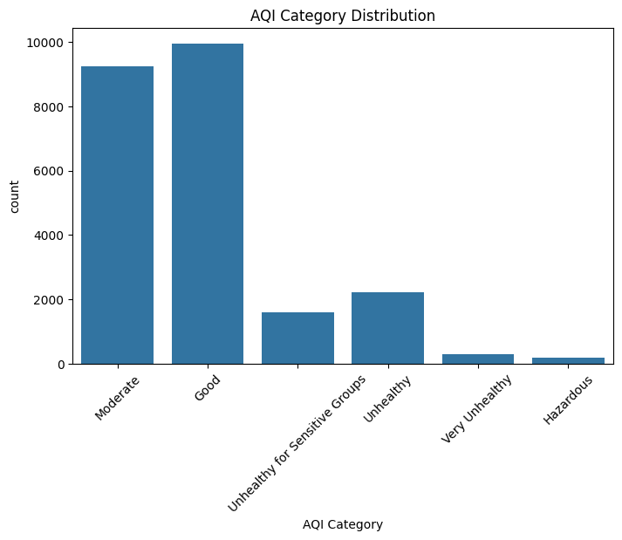
Observation:
- Good and Moderate categories have the highest number of records.
- Hazardous and Very Unhealthy categories are comparatively rare.

2. Top 10 Countries
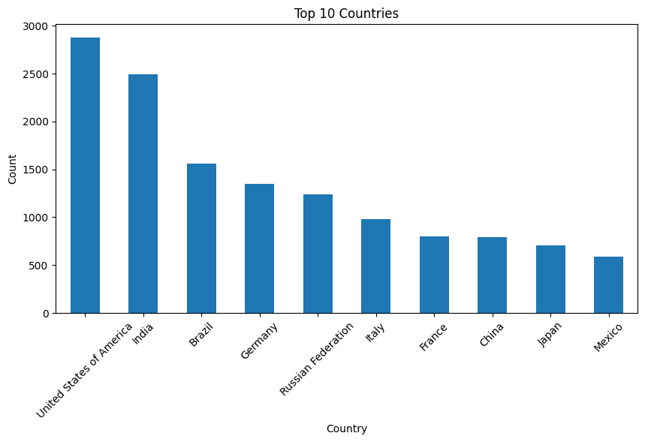

Observation:
- United States has the highest number of city records.
- India is the second highest.

3. Distribution of AQI Values

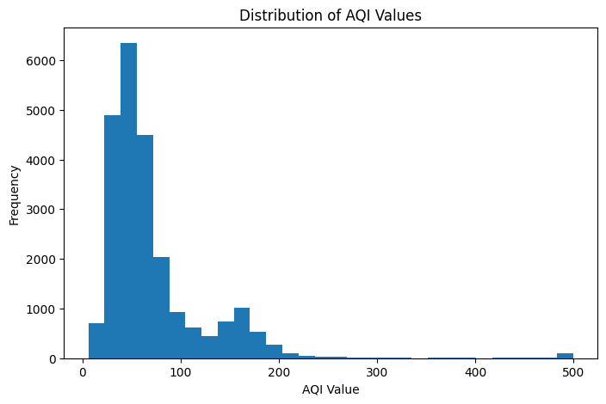

Observation:
- Most AQI values lie between 30 and 100.
- Very high AQI values occur less frequently.

4. Box Plot of AQI Value

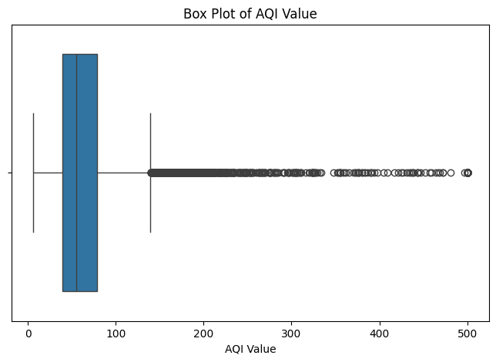

Observation:
- There are several outliers with extremely high AQI values.
- Most observations fall within the normal AQI range.

5. Top 10 Most Polluted Cities
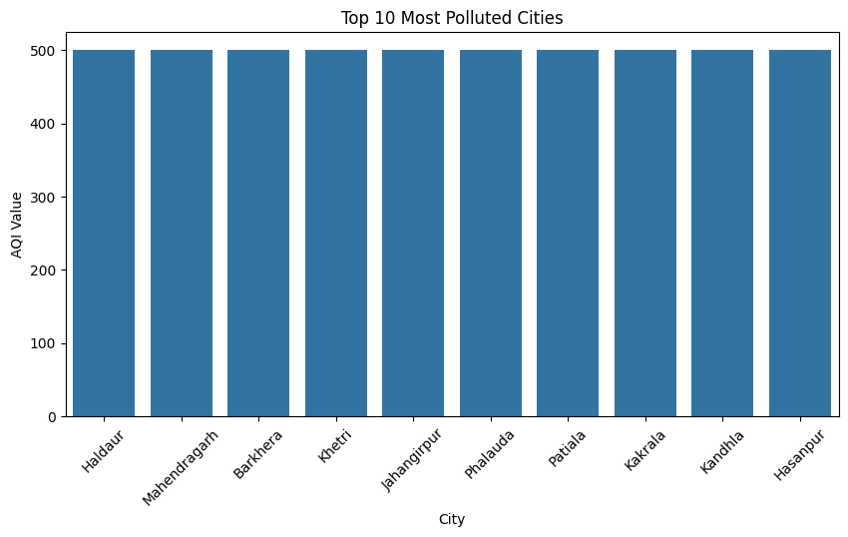

Observation:
- These cities have the highest AQI values in the dataset.
- They may require stricter pollution control measures.

6. AQI Category Percentage

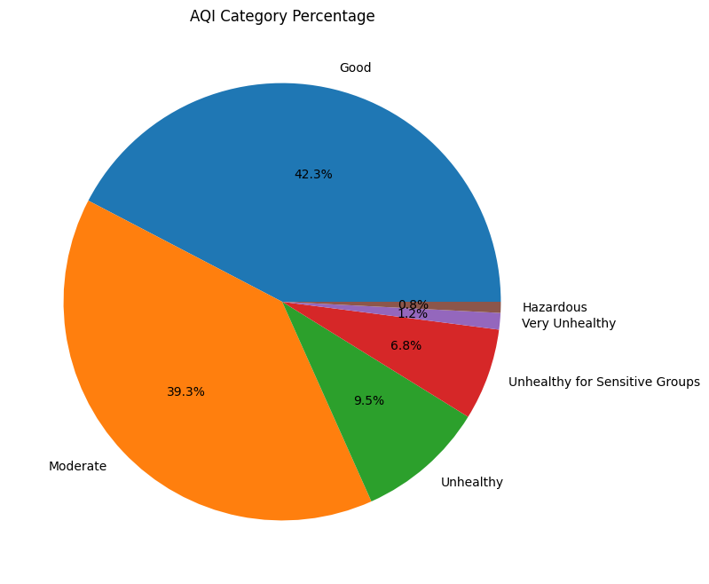
Observation:
- Good and Moderate categories make up the majority of the dataset.
- Hazardous category represents only a small percentage.

7. Correlation Heatmap
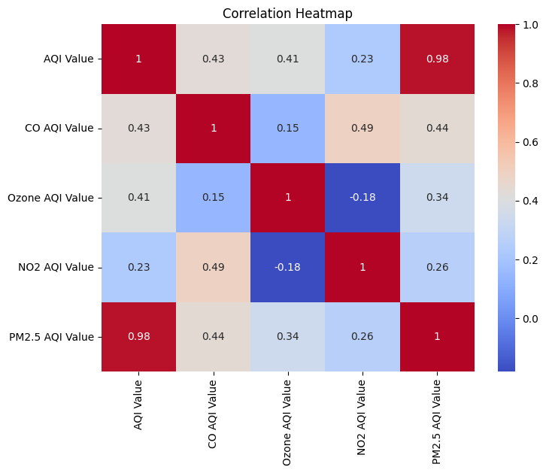

Observation:
- AQI measurements are positively correlated.
- Pollutant values generally increase together.

8. Top 10 Countries by Average AQI
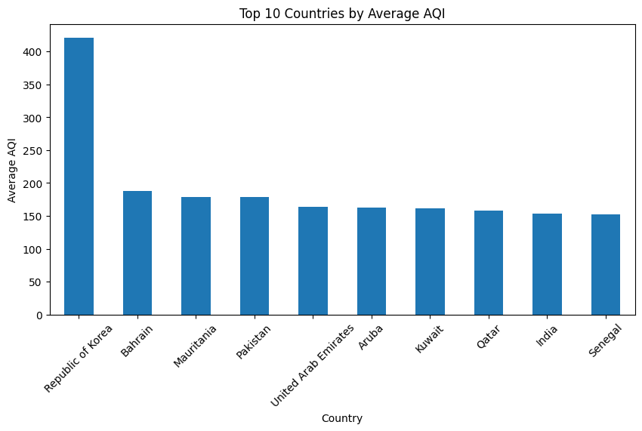

Observation:
- The graph shows the top 10 countries with the highest average AQI values.
- Countries with higher average AQI experience poorer air quality and higher pollution levels.
- These countries may require stricter environmental policies and pollution control measures to improve air quality.

