mtc.R

ken

Mon Jul 18 10:00:00 2016

R has many built-in data sets, such as mtcars, which contains information about a number of cars:

mtcars

## mpg cyl disp hp drat wt qsec vs am gear carb  
## Mazda RX4 21.0 6 160.0 110 3.90 2.620 16.46 0 1 4 4  
## Mazda RX4 Wag 21.0 6 160.0 110 3.90 2.875 17.02 0 1 4 4  
## Datsun 710 22.8 4 108.0 93 3.85 2.320 18.61 1 1 4 1  
## Hornet 4 Drive 21.4 6 258.0 110 3.08 3.215 19.44 1 0 3 1  
## Hornet Sportabout 18.7 8 360.0 175 3.15 3.440 17.02 0 0 3 2  
## Valiant 18.1 6 225.0 105 2.76 3.460 20.22 1 0 3 1  
## Duster 360 14.3 8 360.0 245 3.21 3.570 15.84 0 0 3 4  
## Merc 240D 24.4 4 146.7 62 3.69 3.190 20.00 1 0 4 2  
## Merc 230 22.8 4 140.8 95 3.92 3.150 22.90 1 0 4 2  
## Merc 280 19.2 6 167.6 123 3.92 3.440 18.30 1 0 4 4  
## Merc 280C 17.8 6 167.6 123 3.92 3.440 18.90 1 0 4 4  
## Merc 450SE 16.4 8 275.8 180 3.07 4.070 17.40 0 0 3 3  
## Merc 450SL 17.3 8 275.8 180 3.07 3.730 17.60 0 0 3 3  
## Merc 450SLC 15.2 8 275.8 180 3.07 3.780 18.00 0 0 3 3  
## Cadillac Fleetwood 10.4 8 472.0 205 2.93 5.250 17.98 0 0 3 4  
## Lincoln Continental 10.4 8 460.0 215 3.00 5.424 17.82 0 0 3 4  
## Chrysler Imperial 14.7 8 440.0 230 3.23 5.345 17.42 0 0 3 4  
## Fiat 128 32.4 4 78.7 66 4.08 2.200 19.47 1 1 4 1  
## Honda Civic 30.4 4 75.7 52 4.93 1.615 18.52 1 1 4 2  
## Toyota Corolla 33.9 4 71.1 65 4.22 1.835 19.90 1 1 4 1  
## Toyota Corona 21.5 4 120.1 97 3.70 2.465 20.01 1 0 3 1  
## Dodge Challenger 15.5 8 318.0 150 2.76 3.520 16.87 0 0 3 2  
## AMC Javelin 15.2 8 304.0 150 3.15 3.435 17.30 0 0 3 2  
## Camaro Z28 13.3 8 350.0 245 3.73 3.840 15.41 0 0 3 4  
## Pontiac Firebird 19.2 8 400.0 175 3.08 3.845 17.05 0 0 3 2  
## Fiat X1-9 27.3 4 79.0 66 4.08 1.935 18.90 1 1 4 1  
## Porsche 914-2 26.0 4 120.3 91 4.43 2.140 16.70 0 1 5 2  
## Lotus Europa 30.4 4 95.1 113 3.77 1.513 16.90 1 1 5 2  
## Ford Pantera L 15.8 8 351.0 264 4.22 3.170 14.50 0 1 5 4  
## Ferrari Dino 19.7 6 145.0 175 3.62 2.770 15.50 0 1 5 6  
## Maserati Bora 15.0 8 301.0 335 3.54 3.570 14.60 0 1 5 8  
## Volvo 142E 21.4 4 121.0 109 4.11 2.780 18.60 1 1 4 2

Perhaps better is to display the structure:

str(mtcars)

## 'data.frame': 32 obs. of 11 variables:  
## $ mpg : num 21 21 22.8 21.4 18.7 18.1 14.3 24.4 22.8 19.2 ...  
## $ cyl : num 6 6 4 6 8 6 8 4 4 6 ...  
## $ disp: num 160 160 108 258 360 ...  
## $ hp : num 110 110 93 110 175 105 245 62 95 123 ...  
## $ drat: num 3.9 3.9 3.85 3.08 3.15 2.76 3.21 3.69 3.92 3.92 ...  
## $ wt : num 2.62 2.88 2.32 3.21 3.44 ...  
## $ qsec: num 16.5 17 18.6 19.4 17 ...  
## $ vs : num 0 0 1 1 0 1 0 1 1 1 ...  
## $ am : num 1 1 1 0 0 0 0 0 0 0 ...  
## $ gear: num 4 4 4 3 3 3 3 4 4 4 ...  
## $ carb: num 4 4 1 1 2 1 4 2 2 4 ...

how about plotting gas mileage mpg against number of cylinders cyl?

library(ggplot2)  
ggplot(mtcars,aes(x=cyl,y=mpg))+geom_point()+geom_smooth(method="lm")

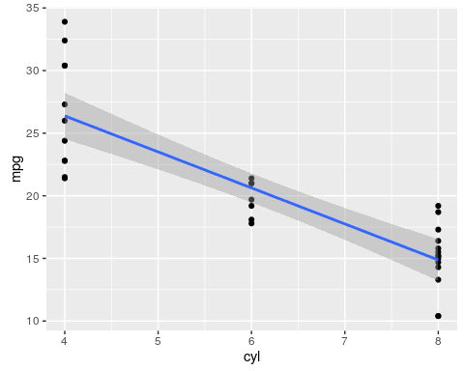

The gas mileage goes down as the number of cylinders goes up that is, a bigger engine uses more gas.