xcode.R

ken

Mon Jul 18 13:45:33 2016

1. Enter the values as shown:

x=c(10,11,13,15,16,17,19,24,32)  
x

## [1] 10 11 13 15 16 17 19 24 32

This demonstrates that the values entered were indeed correct.

1. This gets both mean and median in one go:

summary(x)

## Min. 1st Qu. Median Mean 3rd Qu. Max.   
## 10.00 13.00 16.00 17.44 19.00 32.00

The mean is 17.44, and the median is 16. The mean is noticeably bigger. This suggests that the data are right-skewed.

boxplot(x)

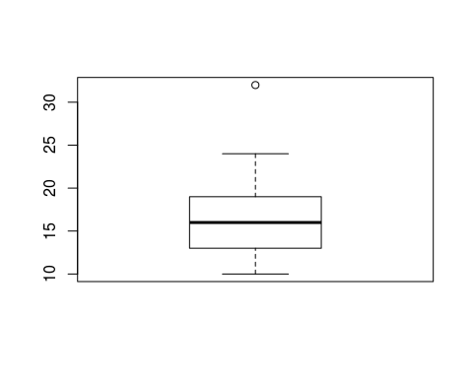

On the boxplot, the upper whisker is a little longer and there is an upper outlier. This supports our conclusion that the data are right-skewed.