Effect of exercise type and diet on pulse rates

- 18 subjects in study to assess effects of exercise type and diet on pulse rate.
- Each subject randomly assigned to one of three types of exercise:
  - racquetball,
  - aerobic stair climbing,
  - weights.
- Each subject also classified as a meat-eater or a vegetarian (with 3 meat-eaters and 3 vegetarians doing each type of exercise.)
- Response variable: pulse rate.
- So far, two-factor ANOVA with 3 replicates per combo of exercise- type and diet.
- But: 3 responses for each subject: pulse rate at low, moderate, high intensity in their exercise. Makes it repeated measures.
- 3 factors:
  - diet and exercise type “between subjects”,
  - intensity-of-exercise “within subjects”.
- MANOVA to assess within-subjects factors and their interactions with all else
- ordinary ANOVA to assess between-subjects factors & interactions with each other. (Based on response averaged over the repeated measures.)
Data:

stairs 112 166 215 meat
stairs 111 166 225 meat
stairs 89 132 189 meat
stairs 95 134 186 veg
stairs 86 109 150 veg
stairs 89 119 177 veg
racquetball 105 177 241 meat
racquetball 85 117 186 meat
racquetball 97 137 185 meat
racquetball 93 151 197 veg
racquetball 77 122 178 veg
racquetball 78 119 173 veg
weights 81 134 205 meat
weights 88 133 180 meat
weights 88 157 224 meat
weights 58 99 131 veg
weights 85 132 186 veg
weights 78 110 164 veg

SAS code:

options ls=70;

data ex;
infile "exercise.dat";
input exercise $ pulse1 pulse2 pulse3
diet $;

proc means;
class exercise diet;
var pulse1--pulse3;

proc glm data=ex;
class exercise diet;
model pulse1 pulse2 pulse3 =
exercise diet / nouni;
repeated intensity;

Would normally do “exercise|diet” on model line, but interaction turns out non-significant, so removed from here.

Proc means output:
exercise diet NObs Variable N Mean Std Dev
-----------------------------------------------------------------
racquetb meat 3 pulse1 3 95.6666667 10.0664459
pulse2 3 143.6666667 30.5505046
pulse3 3 204.0000000 32.0468407

veg 3 pulse1 3 82.6666667 8.9628864
pulse2 3 130.6666667 17.6729549
pulse3 3 182.6666667 12.6622799

stairs meat 3 pulse1 3 104.0000000 13.0000000
pulse2 3 154.6666667 19.6299092
pulse3 3 209.6666667 18.5831465

veg 3 pulse1 3 90.0000000 4.5825757
pulse2 3 120.6666667 12.5830574
pulse3 3 171.0000000 18.7349940

weights meat 3 pulse1 3 85.6666667 4.0414519
pulse2 3 141.3333333 13.5769412
pulse3 3 203.0000000 22.0680765

veg 3 pulse1 3 73.6666667 14.0118997
pulse2 3 113.6666667 16.8027775
pulse3 3 160.3333333 27.6827263
-----------------------------------------------------------------

- Must be intensity-of-exercise effect
- Might be diet effect
- Probably not a type-of-exercise effect.
Test for intensity-of-exercise effect:

MANOVA Test Criteria and Exact F Statistics
for the Hypothesis of no intensity Effect
H = Type III SSCP Matrix for intensity
E = Error SSCP Matrix

S=1 M=0 N=5.5

Statistic Value F Value Num DF Den DF Pr > F

Wilks' Lambda 0.01778139 359.05 2 13 <.0001
Pillai's Trace 0.98221861 359.05 2 13 <.0001
Hotelling-Lawley Trace 55.23856418 359.05 2 13 <.0001
Roy's Greatest Root 55.23856418 359.05 2 13 <.0001

Strongly significant as expected.

Intensity-of-exercise by exercise type interaction:

MANOVA Test Criteria and F Approximations for
the Hypothesis of no intensity*exercise Effect
H = Type III SSCP Matrix for intensity*exercise
E = Error SSCP Matrix

S=2 M=-0.5 N=5.5

Statistic Value F Value Num DF Den DF Pr > F

Wilks' Lambda 0.88850421 0.40 4 26 0.8098
Pillai's Trace 0.11235730 0.42 4 28 0.7952
Hotelling-Lawley Trace 0.12451746 0.40 4 14.623 0.8079
Roy's Greatest Root 0.11617098 0.81 2 14 0.4633

NOTE: F Statistic for Roy's Greatest Root is an upper bound.
NOTE: F Statistic for Wilks' Lambda is exact.

Nothing here. Whatever effect of exercise type is same at all intensity levels.

Intensity-of-exercise by diet interaction:

MANOVA Test Criteria and Exact F Statistics for
the Hypothesis of no intensity*diet Effect
H = Type III SSCP Matrix for intensity*diet
E = Error SSCP Matrix

S=1 M=0 N=5.5

Statistic Value F Value Num DF Den DF Pr > F

Wilks' Lambda 0.64025576 3.65 2 13 0.0551
Pillai's Trace 0.35974424 3.65 2 13 0.0551
Hotelling-Lawley Trace 0.56187584 3.65 2 13 0.0551
Roy's Greatest Root 0.56187584 3.65 2 13 0.0551

Marginally significant. The effect of exercise intensity in pulse rates is different for each diet type. Investigate later.

Effect of diet and exercise type on pulse rate (averaged over intensity-of-exercise):

The GLM Procedure
Repeated Measures Analysis of Variance
Tests of Hypotheses for Between Subjects Effects

Source DF Type III SS Mean Square F Value

exercise 2 1524.77778 762.38889 1.03
diet 1 7800.01852 7800.01852 10.51
Error 14 10390.70370 742.19312

Source Pr > F

exercise 0.3835
diet 0.0059
Error

- Exercise type has no effect, but diet does have an effect on pulse rates overall.
- Diet by intensity interaction significant, so effect of diet on pulse rate differs by intensity as well.
- Look back at PROC MEANS output (over):

exercise diet NObs Variable N Mean Std Dev
-----------------------------------------------------------------
racquetb meat 3 pulse1 3 95.6666667 10.0664459
pulse2 3 143.6666667 30.5505046
pulse3 3 204.0000000 32.0468407

veg 3 pulse1 3 82.6666667 8.9628864
pulse2 3 130.6666667 17.6729549
pulse3 3 182.6666667 12.6622799

stairs meat 3 pulse1 3 104.0000000 13.0000000
pulse2 3 154.6666667 19.6299092
pulse3 3 209.6666667 18.5831465

veg 3 pulse1 3 90.0000000 4.5825757
pulse2 3 120.6666667 12.5830574
pulse3 3 171.0000000 18.7349940

weights meat 3 pulse1 3 85.6666667 4.0414519
pulse2 3 141.3333333 13.5769412
pulse3 3 203.0000000 22.0680765

veg 3 pulse1 3 73.6666667 14.0118997
pulse2 3 113.6666667 16.8027775
pulse3 3 160.3333333 27.6827263
-----------------------------------------------------------------

- Meat pulse rates a little higher than corresponding veg pulse rates eg:
weights meat 3 pulse1 3 85.6666667 4.0414519
pulse2 3 141.3333333 13.5769412
pulse3 3 203.0000000 22.0680765

veg 3 pulse1 3 73.6666667 14.0118997
pulse2 3 113.6666667 16.8027775
pulse3 3 160.3333333 27.6827263

  - significant diet main effect
- Difference in pulse rates between meat and veg increases as intensity increases: for weights, means differ by 12, 28, 43 for three intensities. This pattern consistent across exercise types.
  - significant diet by intensity interaction.

Looking at means is one way to assess how groups differ; discriminant analysis is another.

First make a variable with all combos of exercise and diet:

data ex;
infile "exercise.dat";
input exercise $ pulse1 pulse2 pulse3 diet $;
gp=cat(diet,"-",exercise);
one=pulse1/pulse1;

(variable “one” explained later)
Then see what it is about pulse1 pulse2 pulse3 that explains differences among groups:

proc discrim can out=fred;
class gp;
var pulse1--pulse3;

Output (edited):
Generalized Squared Distance to gp

meat meat meat veg veg
From gp -racquetb -stairs -weights -racquetb -stairs

meat 0 1.16623 3.41757 3.41347 2.93105
-racquetb
meat -stairs 1.16623 0 7.38962 6.45912 3.17538
meat 3.41757 7.38962 0 1.23812 9.55256
-weights
veg 3.41347 6.45912 1.23812 0 6.12220
-racquetb
veg -stairs 2.93105 3.17538 9.55256 6.12220 0
veg 7.33211 11.27939 3.86302 1.06346 7.79109
-weights

veg
From gp -weights

meat 7.33211
-racquetb
meat -stairs 11.27939
meat 3.86302
-weights
veg 1.06346
-racquetb
veg -stairs 7.79109
veg 0
-weights
Where generalized squared distance is large, groups are very different (in pulse rate profile) – eg. meat-stairs and veg-weights. Most similar groups: meat-racquetball & stairs; veg-racquetball & weights; meat-weights and veg-racquetball & meat-weights (!)
Canonical variables are combinations of original variables that explain differences among groups. How many do we need?

Test of H0: The canonical correlations in the
current row and all that follow are zero

Likelihood Approximate
Ratio F Value Num DF Den DF Pr > F

1 0.14954639 1.85 15 28.007 0.0778
2 0.47530543 1.24 8 22 0.3236
3 0.89044735 0.49 3 12 0.6943

Only 1 near significance.

Raw Canonical Coefficients

Variable Can1 Can2 Can3

pulse1 0.1965980326 -.0565263460 0.0251750782
pulse2 -.0834670872 0.0092799901 -.1315596602
pulse3 0.0109568453 0.0533423277 0.0875031123

Can1 mostly pulse1 with a little (negative) pulse2 (pulse3 near 0). But pulse2 and pulse3 more variable than pulse1, so might be more influential than they look:

Pooled Within-Class Standardized Canonical Coefficients

Variable Can1 Can2 Can3

pulse1 1.940143588 -0.557834818 0.248442296
pulse2 -1.618486870 0.179945685 -2.551036460
pulse3 0.250534283 1.219701610 2.000806707

Pulse2 more influential than appears.
How do groups differ on canonical variables?

Class Means on Canonical Variables

gp Can1 Can2 Can3

meat -racquetb 0.759973767 0.519620228 0.281658046
meat -stairs 1.542241535 0.452920427 -0.459854929
meat -weights -1.022206867 1.009888050 0.249376692
veg -racquetb -0.944474555 -0.004146803 -0.202075451
veg -stairs 1.204085362 -1.133800397 0.277268748
veg -weights -1.539619242 -0.844481506 -0.146373106

Meat values generally more positive than veg ones on Can1 (comparing like exercise). Pattern for exercise not so clear (exercise wasn't significant).

Next part of discriminant analysis: see how well data were classified into correct groups.

Number of Observations and Percent Classified into gp

meat meat meat veg veg veg
From gp -racquetb -stairs -weights -racquetb -stairs -weights Total

meat 1 0 1 0 1 0 3
-
racquetb
33.33 0.00 33.33 0.00 33.33 0.00 100.00

meat 1 2 0 0 0 0 3
-stairs
33.33 66.67 0.00 0.00 0.00 0.00 100.00

meat 0 0 2 1 0 0 3
-weights
0.00 0.00 66.67 33.33 0.00 0.00 100.00

veg 0 0 0 3 0 0 3
-
racquetb
0.00 0.00 0.00 100.00 0.00 0.00 100.00

veg 0 0 0 0 3 0 3
-stairs
0.00 0.00 0.00 0.00 100.00 0.00 100.00

veg 0 0 0 2 0 1 3
-weights
0.00 0.00 0.00 66.67 0.00 33.33 100.00

Total 2 2 3 6 4 1 18
11.11 11.11 16.67 33.33 22.22 5.56 100.00

Error Count Estimates for gp

meat meat meat veg veg veg
-racquetb -stairs -weights -racquetb -stairs -weights
Rate 0.6667 0.3333 0.3333 0.0000 0.0000 0.6667
Priors 0.1667 0.1667 0.1667 0.1667 0.1667 0.1667

Total
Rate 0.3333
Priors
Overall 33% of 18 observations misclassified – meat-racquetball and veg-weights hardest to get right.
Was classification clear-cut or a close call? Look at output data set (2 parts here):

Obs gp pulse1 pulse2 pulse3 Can1 _INTO_

1 meat -stairs 112 166 215 2.22750 meat -stairs
2 meat -stairs 111 166 225 2.14047 meat -stairs
3 meat -stairs 89 132 189 0.25875 meat -racquetb
4 veg -stairs 95 134 186 1.23853 veg -stairs
5 veg -stairs 86 109 150 1.16138 veg -stairs
6 veg -stairs 89 119 177 1.21234 veg -stairs
7 meat -racquetb 105 177 241 0.21806 meat -weights
8 meat -racquetb 85 117 186 0.69149 meat -racquetb
9 meat -racquetb 97 137 185 1.37037 veg -stairs
10 veg -racquetb 93 151 197 -0.45308 veg -racquetb
11 veg -racquetb 77 122 178 -1.38628 veg -racquetb
12 veg -racquetb 78 119 173 -0.99407 veg -racquetb
13 meat -weights 81 134 205 -1.30566 meat -weights
14 meat -weights 88 133 180 -0.11993 veg -racquetb
15 meat -weights 88 157 224 -1.64104 meat -weights
16 veg -weights 58 99 131 -3.71687 veg -weights
17 veg -weights 85 132 186 -0.56051 veg -racquetb
18 veg -weights 78 110 164 -0.34147 veg -racquetb

Some groups very consistent on Can1 (eg. veg-stairs), some not.

Now look at “posterior probabilities” of group membership given pulse rates:

m v
e m e v
a m e g v e
t e a _ e g
_ a t _ g _
_ t _ _ _ _
_ _ _ _ _ _
_ _ _ _ _ _
_ _ _ _ _ _
r _ _ r _ _
a _ w a _ w
c s e c s e
q t i q t i
u a g u a g
O e i h e i h
b g t r t t r t
s p b s s b s s

1 meat -stairs 0.13770 0.77947 0.00180 0.00467 0.07608 0.00028
2 meat -stairs 0.25337 0.68596 0.00503 0.00485 0.05059 0.00020
3 meat -stairs 0.34811 0.13063 0.11847 0.19098 0.15494 0.05687
4 veg -stairs 0.25831 0.28436 0.01226 0.04113 0.39391 0.01003
5 veg -stairs 0.03924 0.04843 0.00096 0.01759 0.87601 0.01778
6 veg -stairs 0.24437 0.12467 0.01025 0.02856 0.58268 0.00948
7 meat -racquetb 0.32225 0.20603 0.37332 0.09132 0.00322 0.00386
8 meat -racquetb 0.48368 0.07753 0.06972 0.06051 0.29235 0.01620
9 meat -racquetb 0.20082 0.34074 0.00714 0.03384 0.40909 0.00837
10 veg -racquetb 0.12599 0.09311 0.19375 0.43418 0.02208 0.13090
11 veg -racquetb 0.04244 0.00423 0.27034 0.37524 0.00911 0.29863
12 veg -racquetb 0.06944 0.00977 0.18520 0.38139 0.03172 0.32249
13 meat -weights 0.06891 0.00348 0.70775 0.17292 0.00171 0.04523
14 meat -weights 0.16749 0.09678 0.09419 0.34370 0.12551 0.17232
15 meat -weights 0.02769 0.00245 0.80732 0.14137 0.00015 0.02102
16 veg -weights 0.00003 0.00000 0.00630 0.07856 0.00004 0.91506
17 veg -weights 0.14777 0.03807 0.22633 0.37720 0.04105 0.16958
18 veg -weights 0.13810 0.02505 0.08622 0.27658 0.21368 0.26036

Obs 1 clearcut meat-stairs, obs 2 less so, obs 3 misclassified as meat-racquetball. Obs 4 correct but very close call. Obs 14 totally wrong!
Plotting 1st 2 canonical variables gives nice 2-dimensional picture of data & how well groups are separated:

goptions reset=all;
symbol1 c=red v=x;
symbol2 c=blue v=o;
symbol3 c=green v=triangle;
symbol4 c=black v=diamond;
symbol5 c=purple v=plus;
symbol6 c=cyan v=square;

proc gplot;
plot can2*can1=gp;

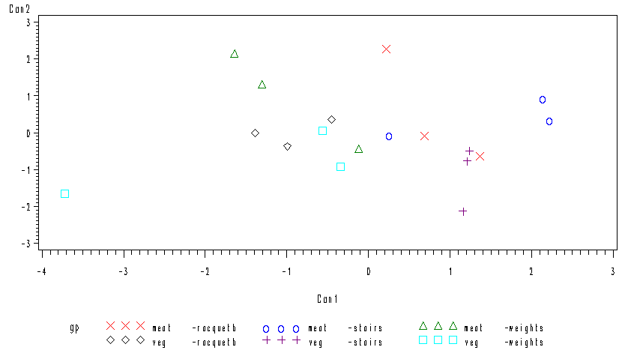
Groups rather mixed up. Can2 sometimes helps (racquetball) but not significant.
Actually exercise type not significant, so really only need discriminant analysis by diet:

proc discrim data=ex can out=ginger;
class diet;
var pulse1--pulse3;

proc print;
var diet pulse1 pulse2 pulse3 can1 meat veg _into_;

proc gplot;
plot one*can1=diet;

output:

Test of H0: The canonical correlations in the
current row and all that follow are zero

Likelihood Approximate
Ratio F Value Num DF Den DF Pr > F

1 0.56370159 3.61 3 14 0.0404

Only one canonical variable (2 groups), which is significant. (With 2 groups, same test as MANOVA.)

What does canonical variable depend on?

Raw Canonical Coefficients

Variable Can1

pulse1 0.0199203412
pulse2 -.0305445631
pulse3 0.0631215151

Mainly pulse3 now. (Different.)
How are groups distinguished on Can1?

Class Means on Canonical Variables

diet Can1

meat 0.8294513579
veg -.8294513579

Meat-eaters +, veg-eaters -.

How well can observations be classified back into groups?

Number of Observations and Percent Classified into diet

From
diet meat veg Total

meat 7 2 9
77.78 22.22 100.00

veg 1 8 9
11.11 88.89 100.00

Total 8 10 18
44.44 55.56 100.00

Priors 0.5 0.5

Error Count Estimates for diet

meat veg Total

Rate 0.2222 0.1111 0.1667
Priors 0.5000 0.5000

About as well as before, though simpler to see.
On a graph:

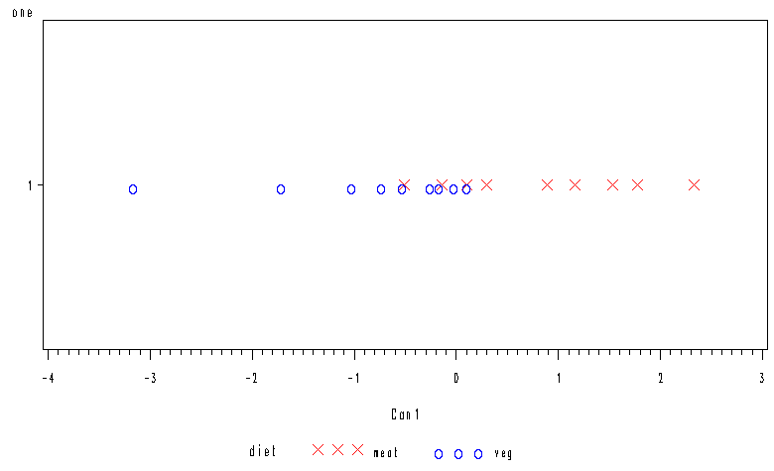
Now see purpose of “one”. Shows distinction difficult in middle but easy at the ends.

Output data set:

Obs diet pulse1 pulse2 pulse3 Can1 meat veg _INTO_

1 meat 112 166 215 1.16811 0.87411 0.12589 meat
2 meat 111 166 225 1.77940 0.95035 0.04965 meat
3 meat 89 132 189 0.10730 0.54438 0.45562 meat
4 veg 95 134 186 -0.02363 0.49020 0.50980 veg
5 veg 86 109 150 -1.71168 0.05523 0.94477 veg
6 veg 89 119 177 -0.25308 0.39656 0.60344 veg
7 meat 105 177 241 2.33384 0.97960 0.02040 meat
8 meat 85 117 186 0.29642 0.62051 0.37949 meat
9 meat 97 137 185 -0.13855 0.44279 0.55721 veg
10 veg 93 151 197 0.11160 0.54615 0.45385 meat
11 veg 77 122 178 -0.52064 0.29657 0.70343 veg
12 veg 78 119 173 -0.72469 0.23109 0.76891 veg
13 meat 81 134 205 0.89679 0.81573 0.18427 meat
14 meat 88 133 180 -0.51126 0.29982 0.70018 veg
15 meat 88 157 224 1.53302 0.92711 0.07289 meat
16 veg 58 99 131 -3.16331 0.00523 0.99477 veg
17 veg 85 132 186 -0.16175 0.43332 0.56668 veg
18 veg 78 110 164 -1.01788 0.15596 0.84404 veg

- Sometimes classification clear (obs 1, 2, 5);
- sometimes very unclear (obs 3, 4, 9)
- when pulse3 high, “meat”,
- when low, “veg”,
- when middling, hard to tell
- but look at obs 8 and 10

