R Notebook
List all my files in this folder beginning with cu:
ls cu*
## cube.aux
## cube.dat
## cube-dos.dat
## cube.log
## cube.pdf
## cube.png
## cube.sas
## cube.sas~
## cube-SASEngine.log
## cube.swv
## cube.tex
## cube.txt
## cube.txt~
## curvy.dat
## curvy.dat~
## curvy-resid2.png
## curvy-residual.png
## curvy-scatter.png
## curvy.txt
Load up the Tidyverse:
library(tidyverse)
## ── Attaching packages ───────────────────────────────────────────────────────────────────── tidyverse 1.2.1 ──
## ✔ ggplot2 2.2.1.9000 ✔ purrr 0.2.4
## ✔ tibble 1.4.1 ✔ dplyr 0.7.4
## ✔ tidyr 0.7.2 ✔ stringr 1.2.0
## ✔ readr 1.1.1 ✔ forcats 0.2.0
## ── Conflicts ──────────────────────────────────────────────────────────────────────── tidyverse_conflicts() ──
## ✖ dplyr::filter() masks stats::filter()
## ✖ dplyr::lag() masks stats::lag()
Read in and display the sleep data:
my_url="http://www.utsc.utoronto.ca/~butler/d29/sleep.txt"
sleep=read_delim(my_url," ")
## Parsed with column specification:
## cols(
## atst = col_double(),
## age = col_double()
## )
sleep
## # A tibble: 13 x 2
## atst age
## <dbl> <dbl>
## 1 586 4.40
## 2 462 14.0
## 3 491 10.1
## 4 565 6.70
## 5 462 11.5
## 6 532 9.60
## 7 478 12.4
## 8 515 8.90
## 9 493 11.1
## 10 528 7.75
## 11 576 5.50
## 12 532 8.60
## 13 530 7.20
Make a scatterplot for predicting atst from age, with a smooth trend:
ggplot(sleep,aes(x=age,y=atst))+geom_point()+geom_smooth()+
ggtitle("Scatterplot of average total sleep time against age","Sleep time in minutes")
## `geom_smooth()` using method = 'loess' and formula 'y ~ x'
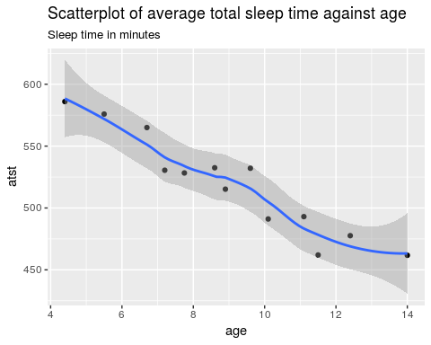
The trend is downward, fairly strong and more or less linear.

