R Notebook

List all my files in this folder beginning with cu:

ls cu*

## cube.aux  
## cube.dat  
## cube-dos.dat  
## cube.log  
## cube.pdf  
## cube.png  
## cube.sas  
## cube.sas~  
## cube-SASEngine.log  
## cube.swv  
## cube.tex  
## cube.txt  
## cube.txt~  
## curvy.dat  
## curvy.dat~  
## curvy-resid2.png  
## curvy-residual.png  
## curvy-scatter.png  
## curvy.txt

Load up the Tidyverse:

library(tidyverse)

## ── Attaching packages ───────────────────────────────────────────────────────────────────── tidyverse 1.2.1 ──

## ✔ ggplot2 2.2.1.9000 ✔ purrr 0.2.4   
## ✔ tibble 1.4.1 ✔ dplyr 0.7.4   
## ✔ tidyr 0.7.2 ✔ stringr 1.2.0   
## ✔ readr 1.1.1 ✔ forcats 0.2.0

## ── Conflicts ──────────────────────────────────────────────────────────────────────── tidyverse_conflicts() ──  
## ✖ dplyr::filter() masks stats::filter()  
## ✖ dplyr::lag() masks stats::lag()

Read in and display the sleep data:

my_url="http://www.utsc.utoronto.ca/~butler/d29/sleep.txt"  
sleep=read_delim(my_url," ")

## Parsed with column specification:  
## cols(  
## atst = col_double(),  
## age = col_double()  
## )

sleep

## # A tibble: 13 x 2  
## atst age  
## <dbl> <dbl>  
## 1 586 4.40  
## 2 462 14.0   
## 3 491 10.1   
## 4 565 6.70  
## 5 462 11.5   
## 6 532 9.60  
## 7 478 12.4   
## 8 515 8.90  
## 9 493 11.1   
## 10 528 7.75  
## 11 576 5.50  
## 12 532 8.60  
## 13 530 7.20

Make a scatterplot for predicting atst from age, with a smooth trend:

ggplot(sleep,aes(x=age,y=atst))+geom_point()+geom_smooth()+  
 ggtitle("Scatterplot of average total sleep time against age","Sleep time in minutes")

## `geom_smooth()` using method = 'loess' and formula 'y ~ x'

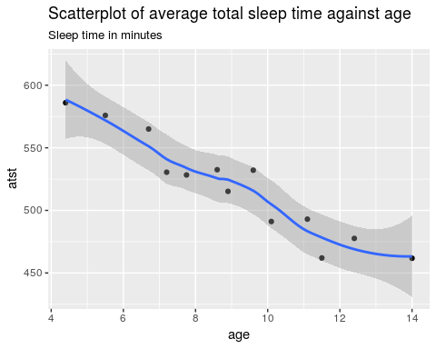

The trend is downward, fairly strong and more or less linear.