ST. XAVIER’S COLLEGE
MAITIGHAR, KATHMANDU, NEPAL
Phone: 01-5321365, 01-5344636
Email: ktm@sxc.edu.np



LAB/WRITTEN ASSIGNMENT NUMBER:

“SPREADSHEET SOFTWARE”

Submitted By | Submitted To | Signature
Name: Drona Bhandari  Roll No: 753  Class:11  Section:G | Department of Computer Science,  NEB (Plus Two)  St. Xavier’s College

Submission Date: 7th August, 2026

Table of Contents
Theoritical question…………………………………………………………………….1-4
Gradesheet samples ……………………………………………………………………6-10
Screenshots of formulas…………………………………………………………………11-15
Lab activity reflections and conclusion…………………………………………………..16

LIST OF FIGURES

Figure 1:Structural Blueprint of Microsoft Excel Interface…………………………………….2
Figure2: Screenshots of sheet 1:Student Mark Sheet calculation……………………………….5
Figure 3-7:Screenshot of Gradesheet of 5 students………………………………………………6-10
Figure 8:Screenshot of total marks…………………………………………………………………11
Figure 9:Screenshot of Remarks ………………………..................................................................12
Figure 10:Screenshot of Percentage………………………………………………………………….13
Figure 11:Screenshot of Rank………………………………………………………………………..14
Figure 12:Screenshot of Grade………………………………………………………………………..15
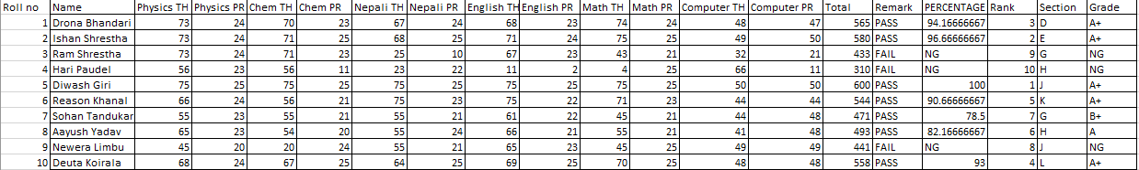
Fig 2 :Screenshot of sheet1:Student marksheet calculation

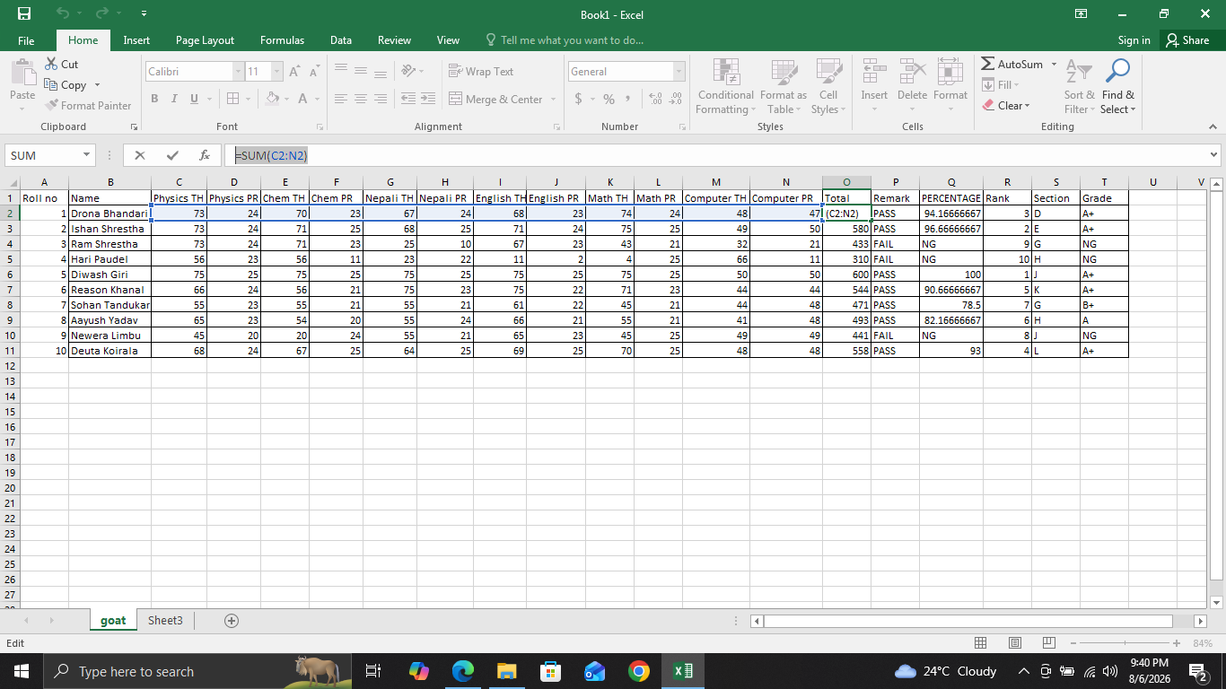

FIG 8: SCREENSHOT OF TOTAL MARKS

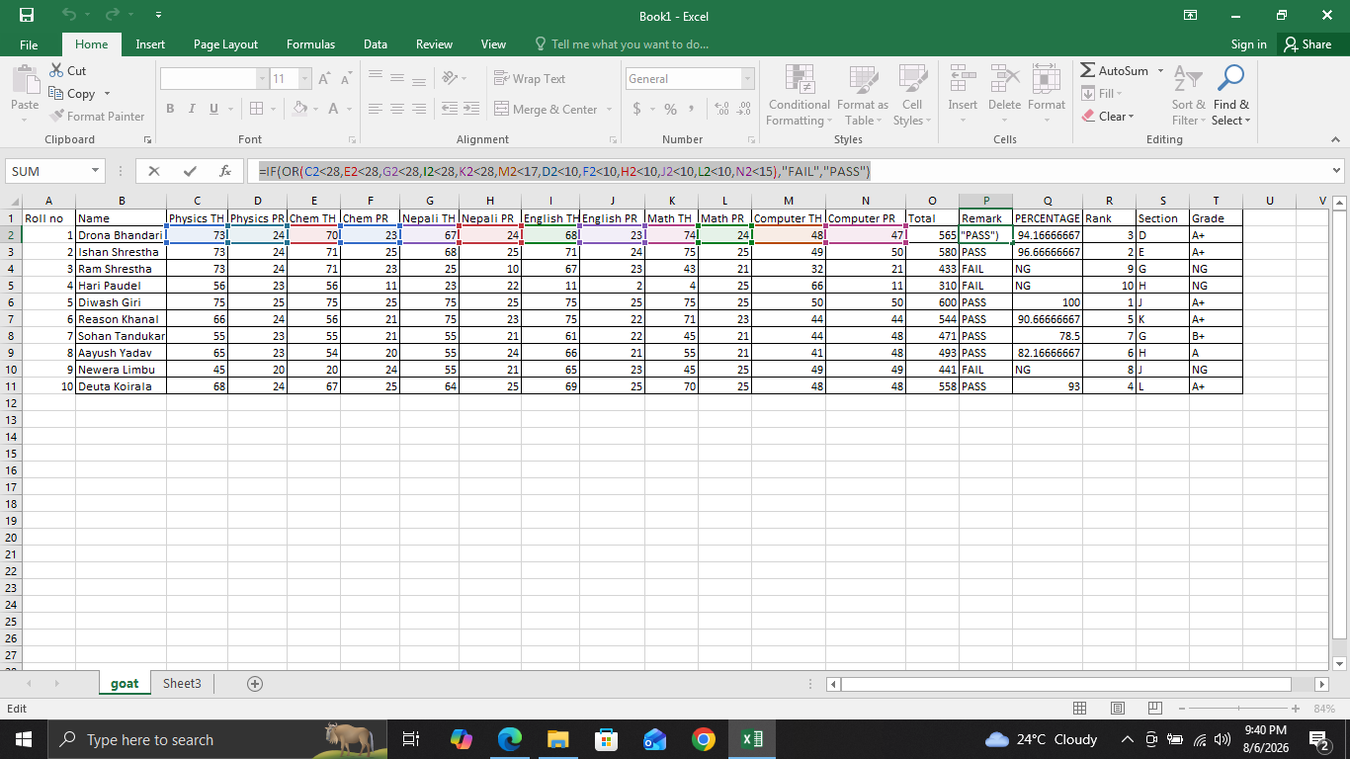
Figure 8:Screenshot of total marks
FIG 9: SCREENSHOT OF REMARKS
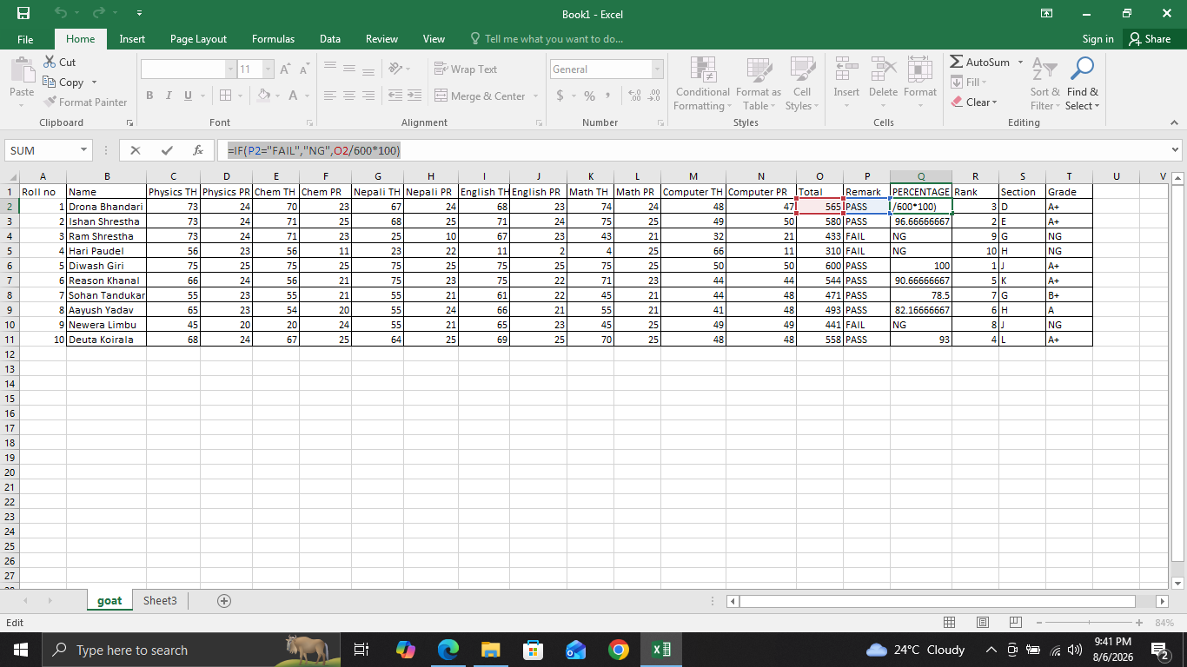
FIG 10: SCREENSHOT OF PERCENTAGE

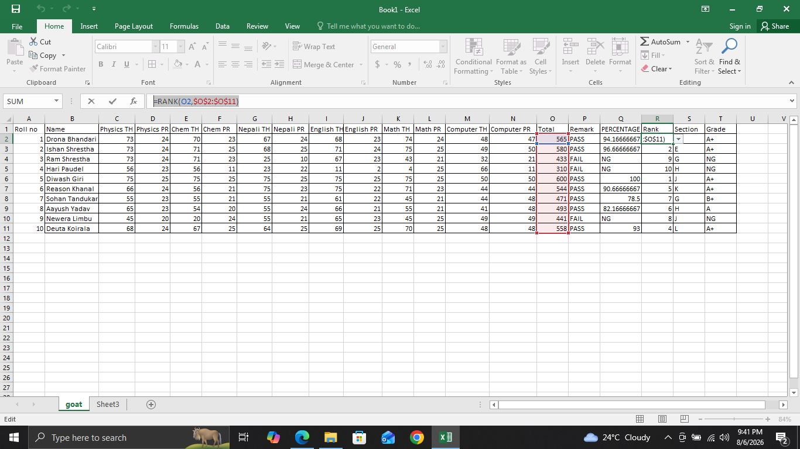
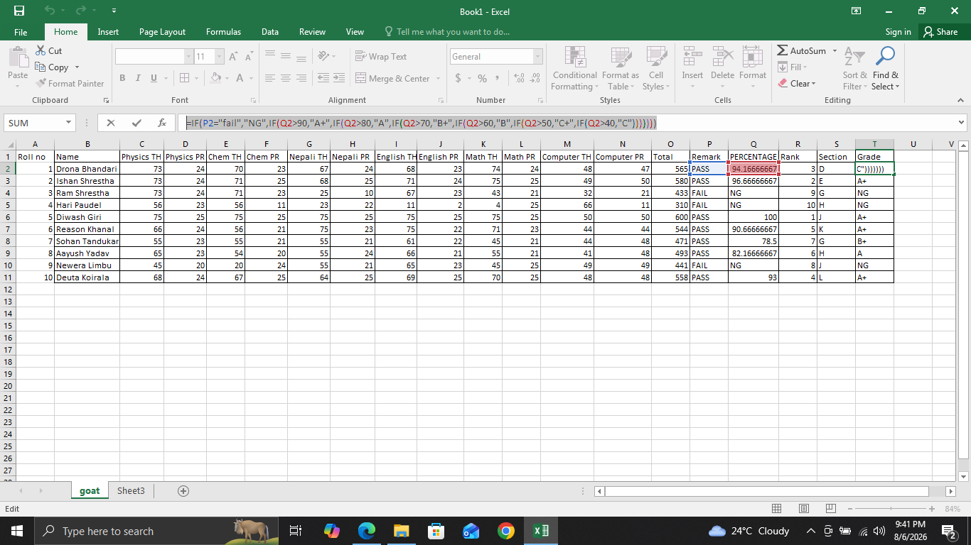
FIG 11:SCREENSHOT OF RANK
FIG 12:SCREENSHOT OF GRADE
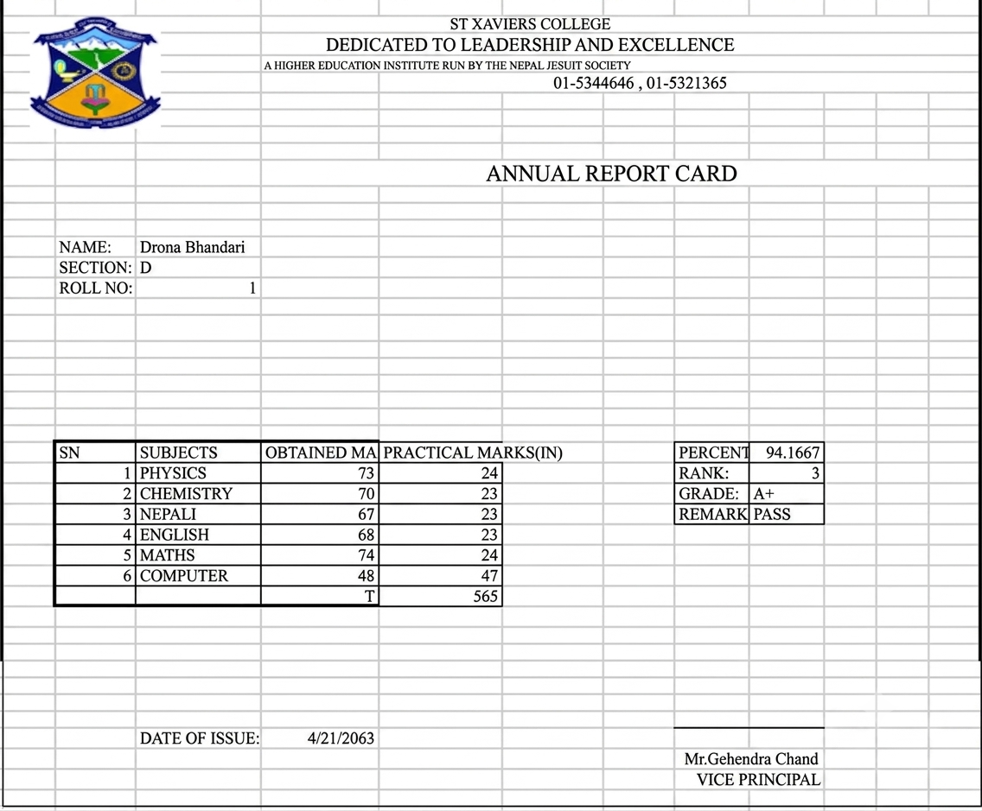
FIG 3:SCREENSHOT OF GRADESHEET OF ROLL NO 1
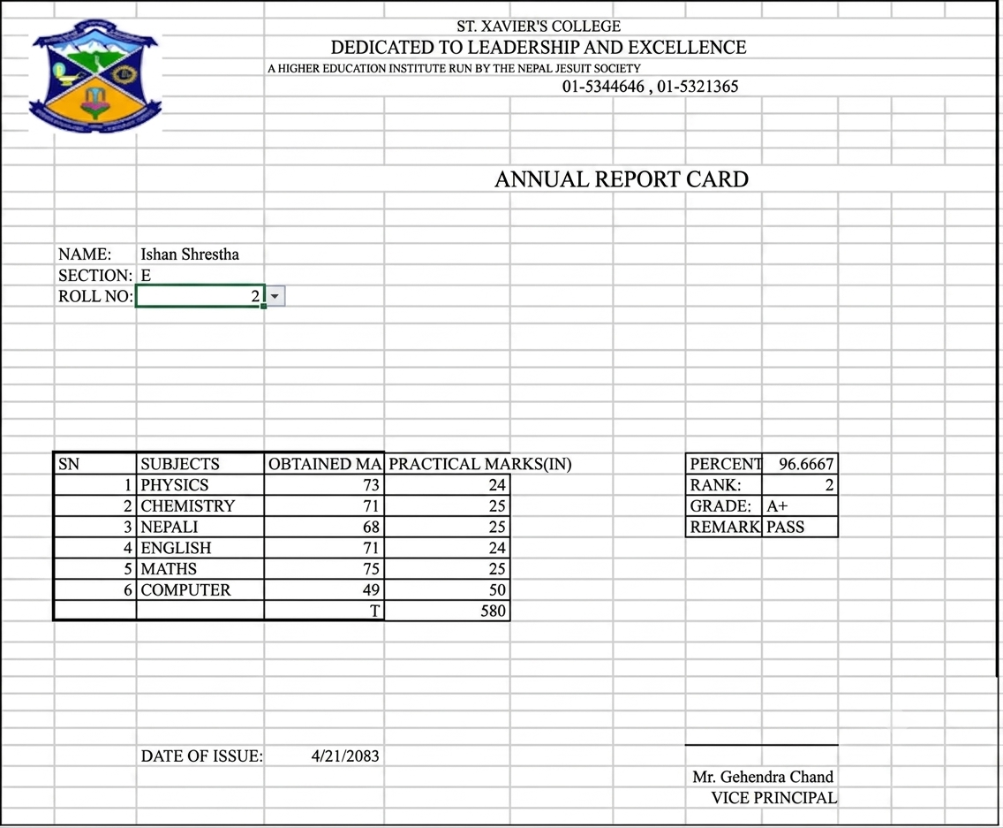
FIG 4: SCREENSHOT OF GRADESHEET OF ROLL NO 2
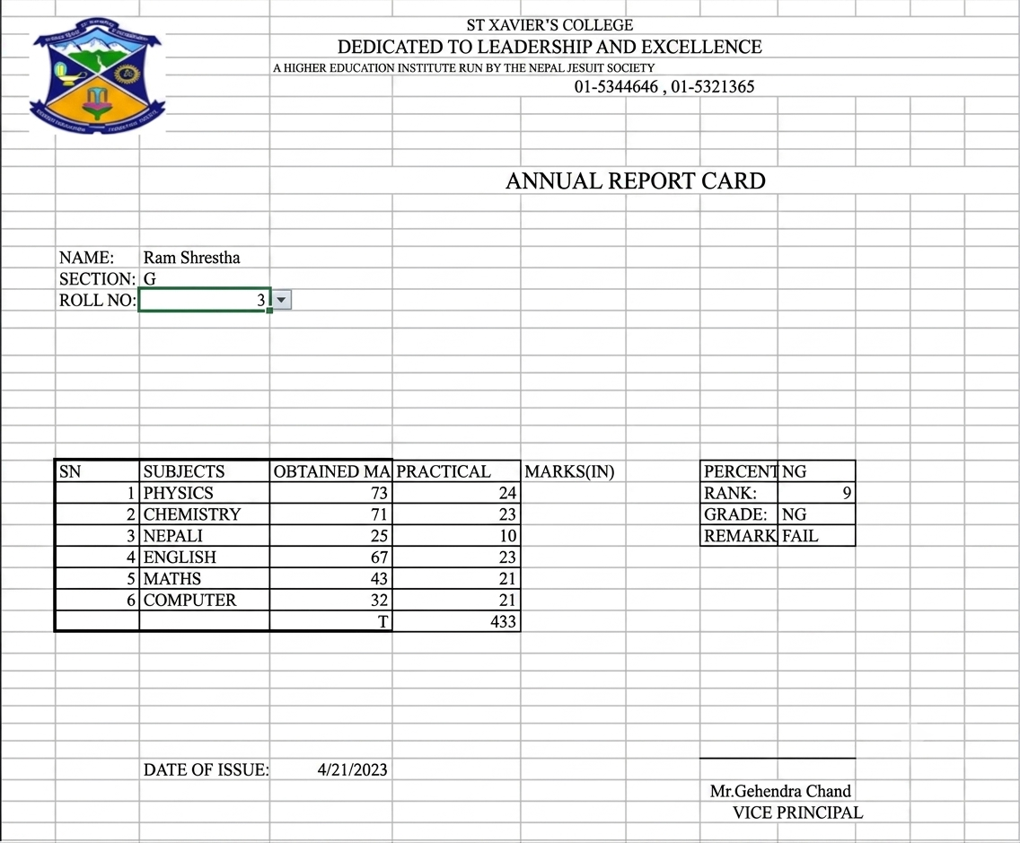
FIG 5:SCREENSHOT OF GRADESHEET OF ROLL NO 3

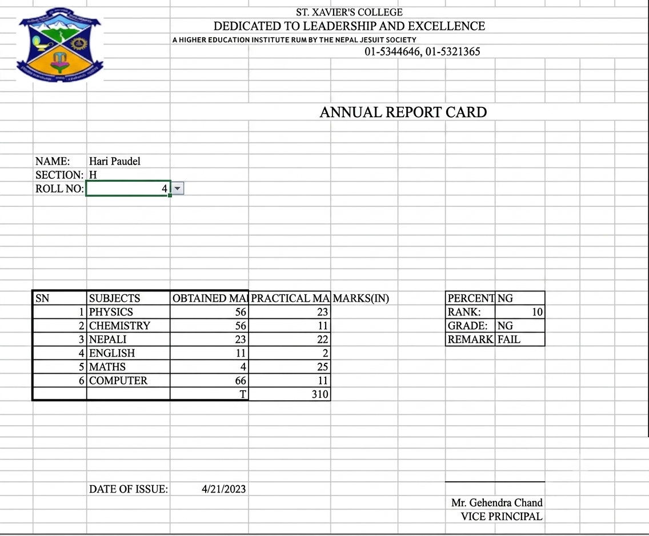
FIG 6: SCREENSHOT OF GRADESHEET OF ROLL NO 4
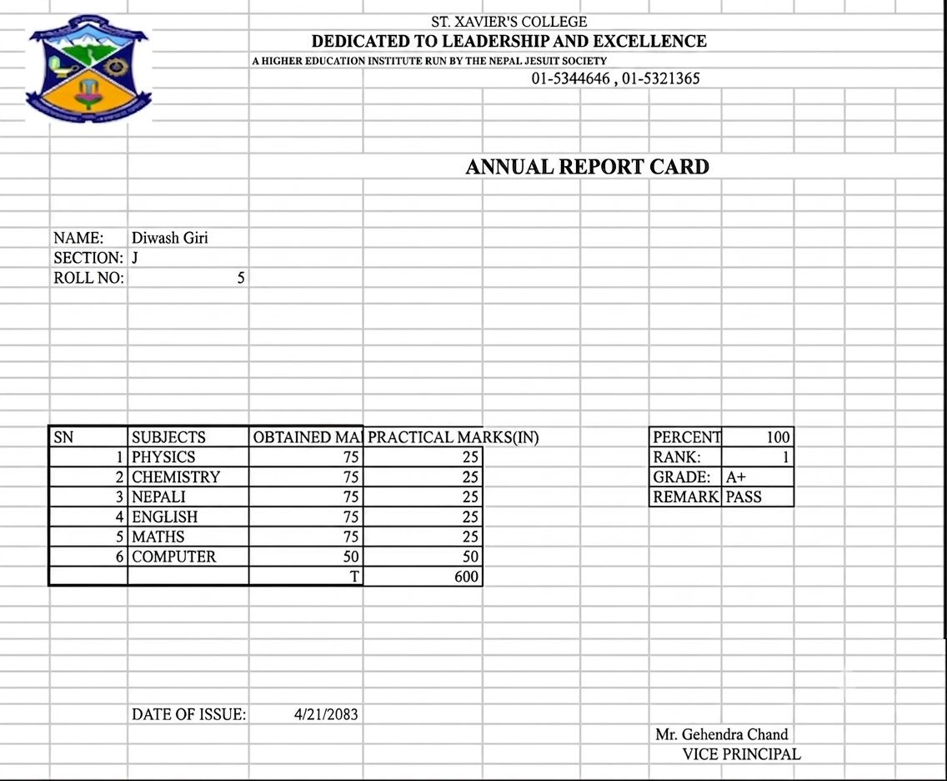
FIG 7: SCREENSHOT OF GRADESHEET OF ROLL NO 5

