SMART INDIA HACKATHON 2026 · PROBLEM STATEMENT SIH26002
RASTA AI
Day 1 Task 3 — Functional Frontend & Backend Development
NER-AI LOGISTICS · Team 17 · 18 September 2026

Problem statement | SIH26002 — AI-Based Smart Logistics and Accessibility Intelligence Platform for the North Eastern Region (MDoNER)
Team | NER-AI LOGISTICS, Team 17
Product | RASTA AI — a fleet console for dispatchers and a driver app for the cab
Date | 18 September 2026
Code state | main at 8561f46 when we started. Our changes were committed later the same afternoon inside 985db6d; main was at 5dcc608 when we finished this write-up
What this report rests on | Test suites we ran today, a local copy of the whole stack started from this checkout, 40 API calls we made by hand, 21 screenshots taken from that stack, and one read-only health check of the hosted deployment
A note on how we wrote this. Everything below was either run by us today or is quoted from an earlier certification log that we name. Where we could not verify something in the time we had, we say so and mark it needs testing. Nothing has been rounded up.

Contents

1. What Task 3 asked of us, and how we went about it
Task 3 is the "does it actually work" checkpoint. The brief lists the major screens, the REST endpoints those screens depend on, sign-in and permissions, business rules, input validation, error handling, the states a page can be in (loading, empty, error, success) and, bluntly, "broken buttons, forms, routes and API calls". It also says: use the existing project, do not rebuild working features.
That last line mattered, because RASTA AI was not a blank page on the morning of Day 1. The repository already had a manager console, a driver app, a FastAPI backend with more than a thousand tests, and a hosted deployment that had been certified end to end two days earlier (docs/terrain/HANDOFF.md, sections 17 to 19). So we treated Task 3 as an audit rather than a build:
- Read the code and the previous certification logs, screen by screen and endpoint by endpoint.
- Run every test suite from a clean state and record what it said.
- Start the whole stack locally from the current checkout and drive it in a real browser, at three screen widths, with a real login.
- Fix whatever we found, add a test that fails without the fix, and re-run.
- Write down exactly what we saw, including the awkward bits.
We found two genuine gaps (section 6). Both were small, both were real, and both are now covered by tests. Everything else in the brief we were able to verify without changing code.

2. The system in one page
RASTA AI has two clients and one backend.
The manager console (React, in a browser) is where a dispatcher creates drivers and trucks, pairs them, plans a shipment and its trip in one step, checks the road conditions on the candidate routes, approves a route, dispatches, and then watches the truck move on a map. The driver app (Expo / React Native, the same code on Android and on the web) is where the driver signs in with a phone number, verifies the truck they are sitting in, accepts and starts the trip, follows turn-by-turn guidance, works through the stops, and can reach emergency numbers and offline first-aid guidance without a signal.
Both talk to a FastAPI backend over HTTPS. That backend owns every rule that matters: who may do what, whether a truck can carry the cargo, whether a road is eligible, whether a trip may move from one state to the next. Neither client holds a database credential.
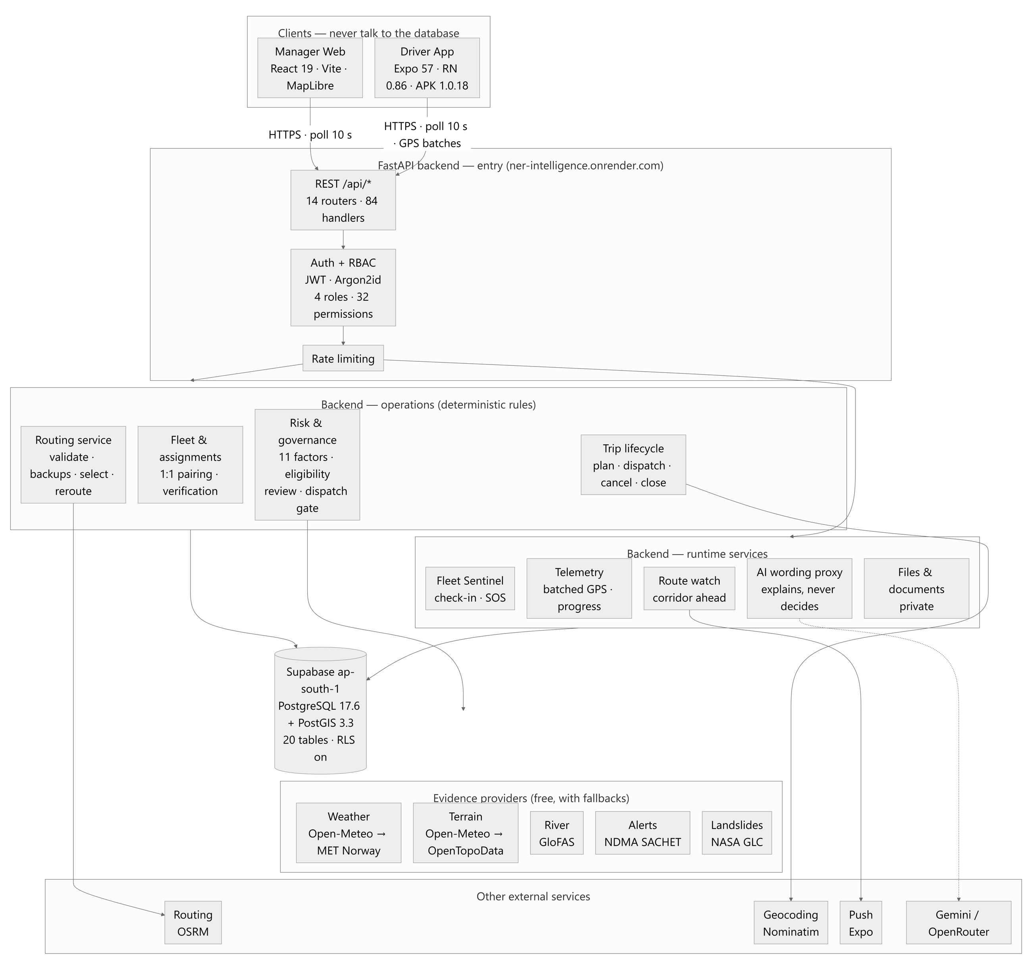
Figure 1. The high-level architecture, reused from our Task 1 document. Both clients talk only to FastAPI; FastAPI talks to Supabase PostgreSQL/PostGIS and, behind interfaces, to the routing, weather and terrain providers.
There are two ways to run it, and we used both today.
- Local REST mode. Everything goes through FastAPI, which talks to a PostgreSQL/PostGIS cluster on the laptop. This is the mode we verified in this report, because it exercises the full backend path: authentication, permissions, validation, business logic, database.
- Hosted mode. The console and the app authenticate against Supabase and read operational state through its Data API, while the FastAPI "intelligence" service (routing, risk, weather, terrain, navigation packages) runs on Render. This was certified on 18 September in the handoff log; today we only checked that all three hosted services answer, which they do (section 12).
The split exists because the intelligence service holds no state of its own. If it is down, routes report their accessibility as unassessed and every other workflow keeps working. That property is what let us host the tested Python engine instead of porting it to something else in a hurry.

3. What it is built with
We read the versions off the installed environment rather than off a wishlist.
Part | Technology | Version | Notes
Backend runtime | Python | 3.11.9 | Deliberately not 3.14; some ML dependencies have no wheels for it yet
Web framework | FastAPI on Uvicorn | 0.115.6 / 0.34.0 | 84 routes at 8561f46
Validation | Pydantic | 2.10.4 | Every request body and path parameter
Database access | SQLAlchemy (async) with psycopg | 2.0.36 / 3.2.3 | Parameterised SQL only; no string formatting anywhere near PostGIS
Migrations | Alembic | 1.14.0 | 12 versions; row-level security enabled on every table
Passwords and tokens | argon2-cffi, PyJWT | 23.1.0 / 2.10.1 | Argon2id hashes; signed access tokens
Hosted database | Supabase PostgreSQL + PostGIS | 17.6 / 3.3 | Mumbai region; primary for the running product
Local database | PostgreSQL + PostGIS | 18.2 / 3.6 | An isolated cluster on 127.0.0.1:55432, used by every test and by today's local stack
Manager console | React, TypeScript, Vite | 19.2 / 6.0 / 8.2
Manager UI | Tailwind CSS, lucide-react, MapLibre GL | 4.3 / 1.45 / 6.6 | Fleet map on OpenStreetMap tiles
Client routing | react-router-dom | 7.18 | Per-role guards on every screen (section 6.1)
Driver app | Expo SDK, React Native, react-native-web | 57 / 0.86.3 / 0.21 | One codebase for the Android APK and the web build
Driver map | Leaflet inside a WebView | 1.9.4 | OSM tiles, no API key
Tests | pytest, Vitest, Testing Library | — | See section 12
Hosting | Render (API, manager, driver web) and Supabase | — | Declared in render.yaml

4. How the code is laid out

4.1 Manager console — `manager-web/src`
The console is organised so that a page never touches fetch directly. Pages compose components, components call the API layer, and the API layer is the only thing that knows about tokens, timeouts and the error envelope.
Pages. One file per screen: LoginPage, FleetPage (the dispatcher's home, with the map), TripsPage (plan, review, dispatch), DriversPage, TrucksPage, AssignmentsPage, ReviewPage (the optional second-level reviewer) and SystemPage (diagnostics). A control the signed-in role cannot use is simply not rendered; we never draw a disabled button that would 403 if you could click it.
Components. ui.tsx holds the primitives everyone uses: Button, Field, StatusPill, Card, and the three state components LoadingState, EmptyState and ErrorState. The bigger pieces are FleetMap and FleetKpiBar; the route work in TripRouteReview, RouteCandidateCards and RouteApprovalDialog; AddressPicker (Google Places, "choose on map", or paste a Maps link); AssignTruckDialog; and two side drawers for driver and truck context.
API layer. api/client.ts is the REST client: ApiError and NetworkError, an in-memory access token, a single-flight token refresh that is also serialised across browser tabs, a 15-second timeout (90 s for route assessments, which fan out to several providers), and since today a fieldErrors() helper (section 6.2). api/supabaseManagerApi.ts is the hosted-mode implementation of the same interface. api/connectivity.ts decides whether the console is online from whether the last request succeeded, not from navigator.onLine.
Hooks. useResource is the data-fetch state machine (idle, loading, success, error) with a stale-while-revalidate cache in localStorage and optional polling that pauses when the tab is hidden. useMutation guards against double submits and hands the error back synchronously so a form can map a 422 onto its fields.
Utilities. Pure functions with their own tests: track.ts (splits the GPS track where the truck was not actually sampled), terrain.ts, focusTrap.ts, planValidation.ts, googleMapsUrl.ts, i18n/reasonCodes.ts.
Auth. AuthProvider.tsx restores the session on reload, exposes can(permission), and refuses a driver's credentials at the console with one sentence.

4.2 Driver app — `driver-app/src`
Four tabs: Trip, Navigate, Safety, More. The screens are LoginScreen, TripScreen, AssignmentScreen (truck verification), MapScreen, SafetyScreen, MoreScreen, MyDetailsScreen, AssistantScreen and PhrasebookScreen.
Under them: api/ (backend selection and the same error model as the console), tracking/ (GPS batching with an idempotent replay queue, so a reconnecting phone cannot duplicate rows), notify/ (push), offline/ (the corridor package and bundled guidance), map/ (manoeuvre cards, navigation state, spoken guidance — muted by default), trip/TripProvider.tsx (the trip state, and the connection status derived from the last successful poll), and i18n/ (English plus the 22 scheduled languages selectable; some translations are still drafts and fall back to English).

4.3 Backend — `backend/app`
Package | What lives there
api/ | The routers: auth, driver (everything under /api/driver/me), fleet (drivers, trucks, assignments), trips (shipments, trips, routes, fleet positions), emergencies, geocoding, ai, files, documents, health. Each route declares its permission with require_permission(...).
core/ | config; errors (the one error envelope, and the boundary that keeps stack traces and connection strings out of responses); permissions (the RBAC catalogue); security (hashing, JWT); rate_limit; event_loop (a Windows-specific fix without which async psycopg fails).
services/ | 33 modules. The only layer that talks to the database. Transactions and business rules: auth, drivers, trucks, assignments, shipments, trips, driver_trips, telemetry, routes, route_risk, route_review, reroute, navigation, sentinel and so on.
domain/ | 20 pure modules with no I/O: trip_state, route_eligibility, route_risk, telemetry_policy, fuel_model, reroute, sentinel… Deterministic rules with published constants, which is why the tests around them are cheap and numerous.
models/, schemas/ | SQLAlchemy tables; Pydantic request and response contracts. schemas/domain.py is where every validation rule in section 11 comes from.
alembic/versions/ | 12 migrations. History is history; nothing is edited in place.
tests/ | 82 files, 1,144 test functions at 8561f46. The suite refuses to run against any database other than the isolated cluster, a guard added after a test run once wrote into the shared project.

5. Our verification checklist
This is the list we worked through. Each item names where its evidence is.
Requirement from the brief | What we did | Where
Major frontend screens | Signed in and captured all 8 manager screens and all 6 driver screens from a stack started from this checkout | Section 7
Usability and responsiveness | Emulated 1440×900, 768×1024 and 390×844 in headless Chrome; measured horizontal overflow on every screen | Section 7
REST APIs | Dumped the route table from the running app (84 routes); made 40 calls by hand and recorded every status code and body | Section 9
Authentication | Exercised no token, bad token, wrong password, unknown user, web and mobile clients, and the rate limiter | Section 10
Authorization | Called manager endpoints with a driver token and driver endpoints with a manager token; checked the client-side guards too | Section 10
Business logic | Ran the full backend suite (1,183 tests), which pins the trip state machine, capacity, the dispatch gate, route eligibility and the reroute rules | Section 12
Input validation | Sent bad bodies to five endpoints; checked the 422 envelope and how the form displays it | Section 11
Error handling | Checked the client's handling of network loss, timeouts, 401, 403, 404, 409, 422 and 503 | Section 11
Frontend ↔ backend | Every screenshot in section 7 shows live data from the API, not fixtures | Sections 7 and 8
Loading / empty / error / success | Confirmed the state machine in useResource and photographed each state | Sections 7 and 11
Broken buttons, forms, routes, calls | Found two defects and fixed both with regression tests; the earlier zero-dead-control audit is in docs/INTERACTION_CERTIFICATION.md | Section 6

6. Two things we found and fixed

6.1 A screen you could reach by URL but not use
The console hides navigation links that the signed-in role lacks. The shell's own comment went further and promised that a screen "is not mounted" if you type its URL directly, so that an operator who lands on the wrong page sees a redirect rather than a page whose every request fails with 403. That promise was kept for /fleet and for nothing else.
The role this bites is the authorised reviewer, who holds only trip:read, route:read and route:review_authorize. Type /drivers and you got a mounted Drivers page with a red "Not permitted" card. Honest, but it reads like a broken system rather than a missing permission.
The fix was five lines: /trips, /drivers, /trucks, /assignments and /review now use the same Guarded element that /fleet already used, keyed on the permission the navigation table already declares. The redirect target is the first screen the role can use, so it cannot loop.
We added App.test.tsx with two cases: a reviewer opening /drivers lands on /trips; a manager still reaches every workflow screen. We ran the test against the old App.tsx first — it failed, as it should — and then against the new one.

6.2 A validation message that quoted a regular expression at the operator
Create a driver with the phone number 12345 and the field lit up red with: String should match pattern '^\+?[0-9]{10,15}$'. That is Pydantic's own wording, passed straight through. It is correct and it is useless to a dispatcher.
Looking at why, we found the same fifteen lines that map a 422 onto form fields copied into both DriversPage.tsx and TrucksPage.tsx, so the truck registration field had the same problem. We replaced both copies with one helper in the API layer:
export function fieldErrors(error: unknown): Record<string, string> {
const out: Record<string, string> = {}
if (!(error instanceof ApiError) || error.code !== 'VALIDATION_ERROR') return out
const details = error.details as { errors?: { loc?: unknown[]; msg?: string; type?: string }[] }
for (const item of details.errors ?? []) {
const field = String(item.loc?.[item.loc.length - 1] ?? '')
if (!field) continue
out[field] = item.type === 'string_pattern_mismatch' ? 'Not in the expected format' : (item.msg ?? 'Invalid value')
}
return out
}
Only the pattern-mismatch case is reworded. The other Pydantic messages ("String should have at least 8 characters") are already fine and we left them alone. The phone field's hint now says it wants a 10-digit mobile number. There is a test for the helper in client.test.ts, and the corrected screen is Figure 11.

6.3 What we deliberately did not touch
Three lint warnings about React hooks in FleetPage.tsx and TripsPage.tsx predate today. They are not defects and they are outside the brief, so we left them. We also did not remove the optional reviewer page even though a manager no longer needs it to dispatch: it is still the audit trail of who accepted what evidence and why, and that is worth keeping.

7. The screens
Everything in this section was captured today from a backend started from this checkout (port 8000, the demo database), the Vite dev server (port 5174) and the Expo web build (port 8123). The sign-in is a real one with the demo manager account; the driver screens are the demo driver's. Widths were emulated with Chrome's device metrics. On every screen we also measured scrollWidth − clientWidth, which is zero when nothing spills off the right edge. It was zero at all three widths.

7.1 Signing in
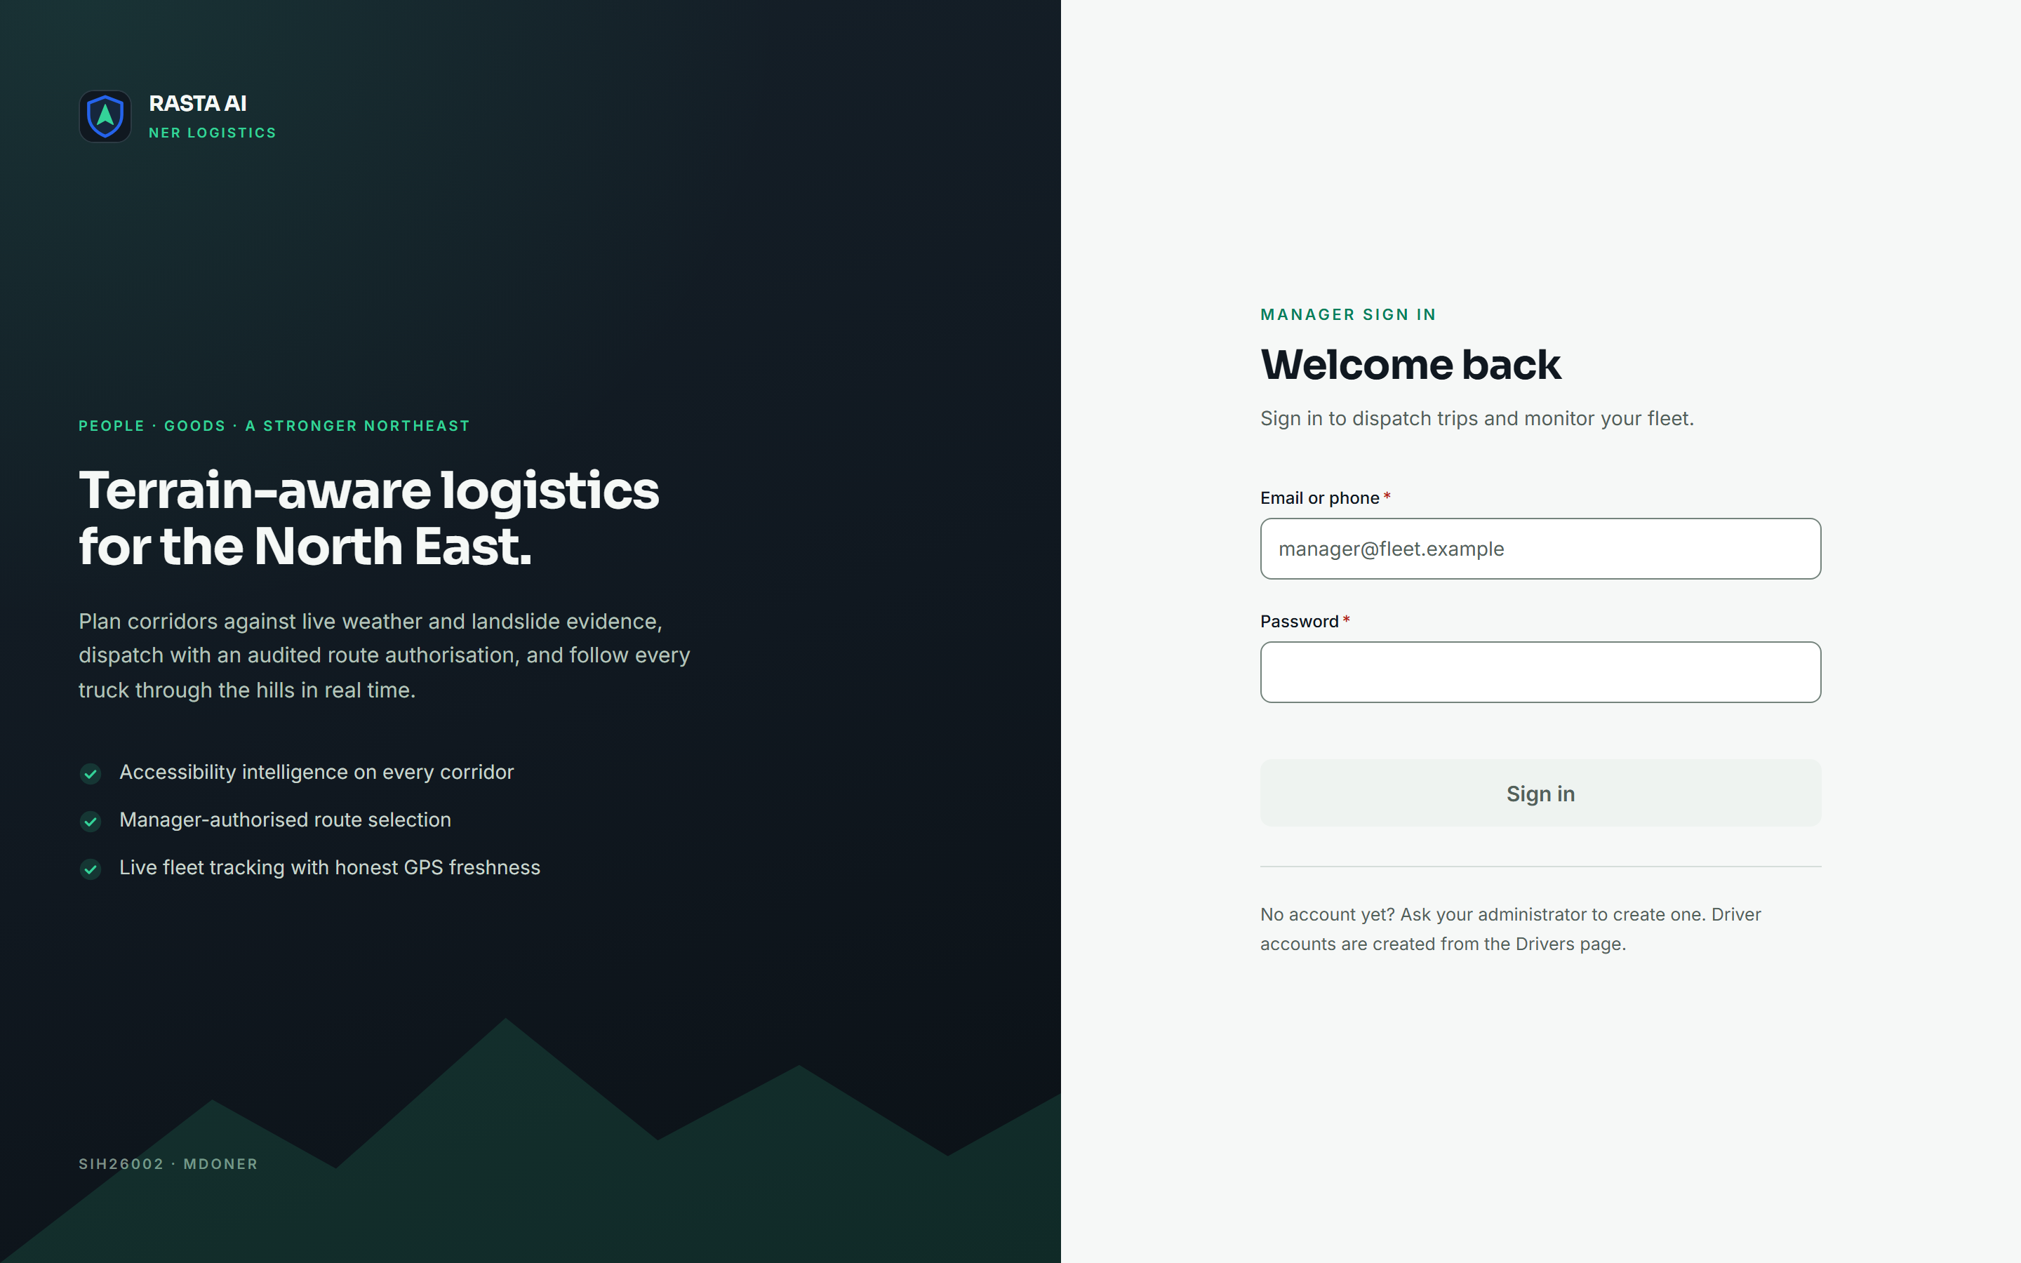
Figure 2. Manager login at 1440×900. The left panel is the one place the console says what the product is; it has no interactive elements.
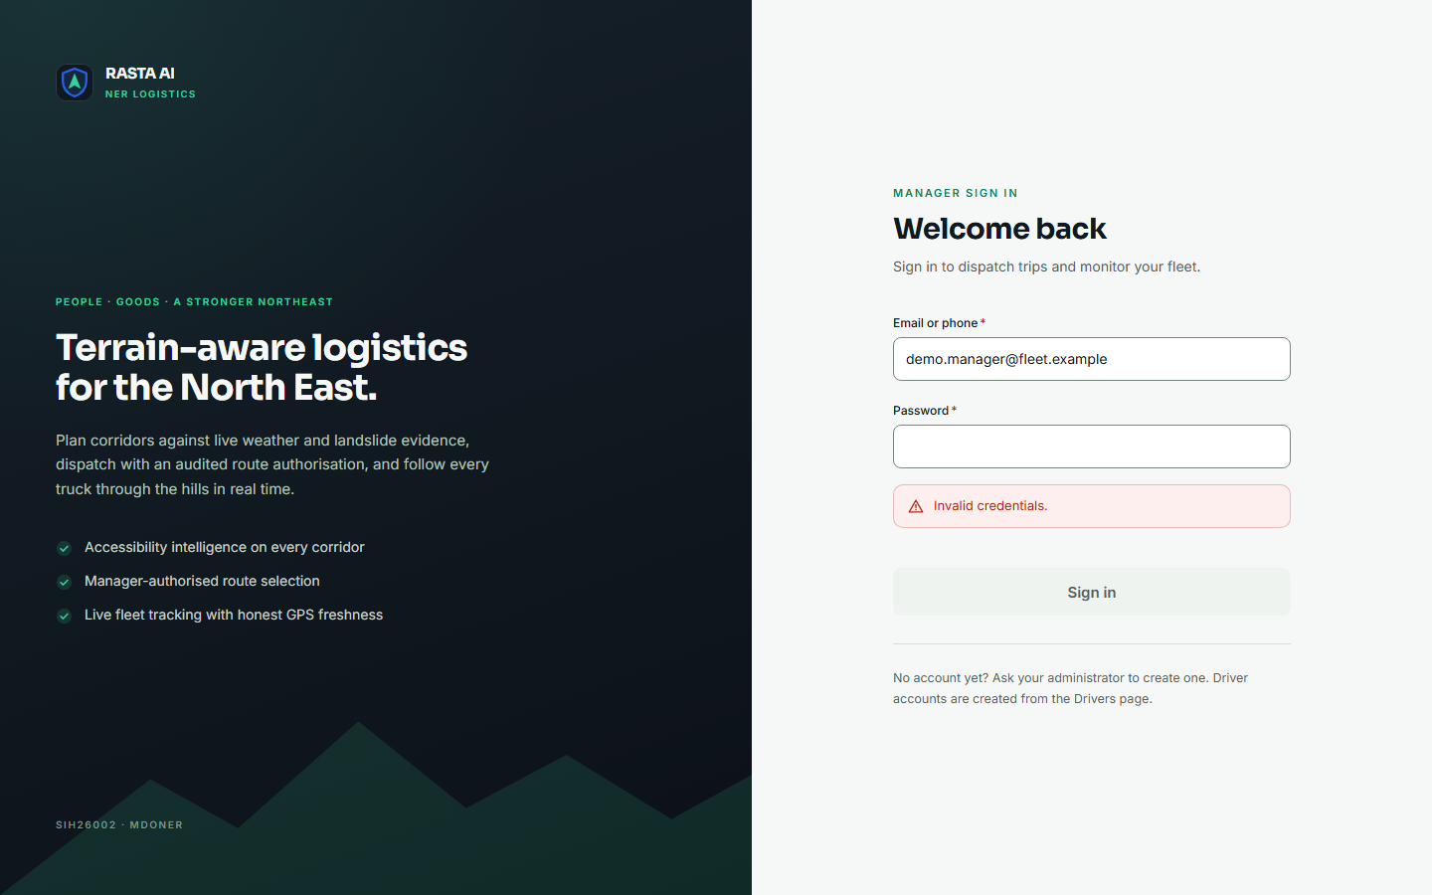
Figure 3. The same screen with a wrong password. The backend returns one message whether the account exists or not, and the password field is cleared.
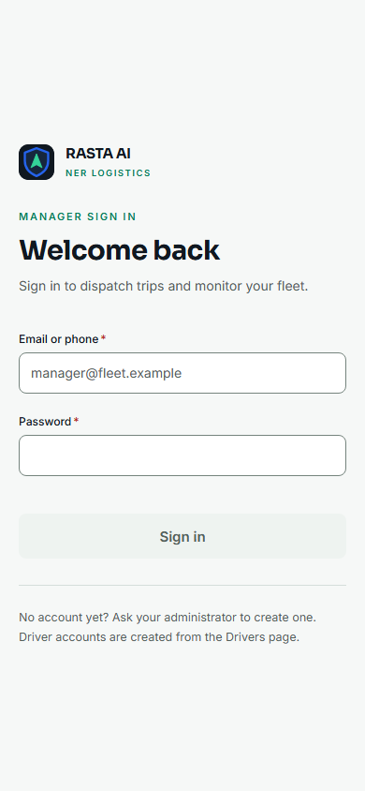 | Figure 4. Login at 390×844. Below 900 px the brand panel is dropped rather than stacked, so the password field does not fall under the fold on a small screen.

7.2 Fleet command
This is the screen a dispatcher keeps open. The demo database had no trips on the road when we took these, which is a useful thing to show: the tiles say 0 with the word dispatched next to it, and "none transmitting". Nothing is padded with a plausible-looking number.
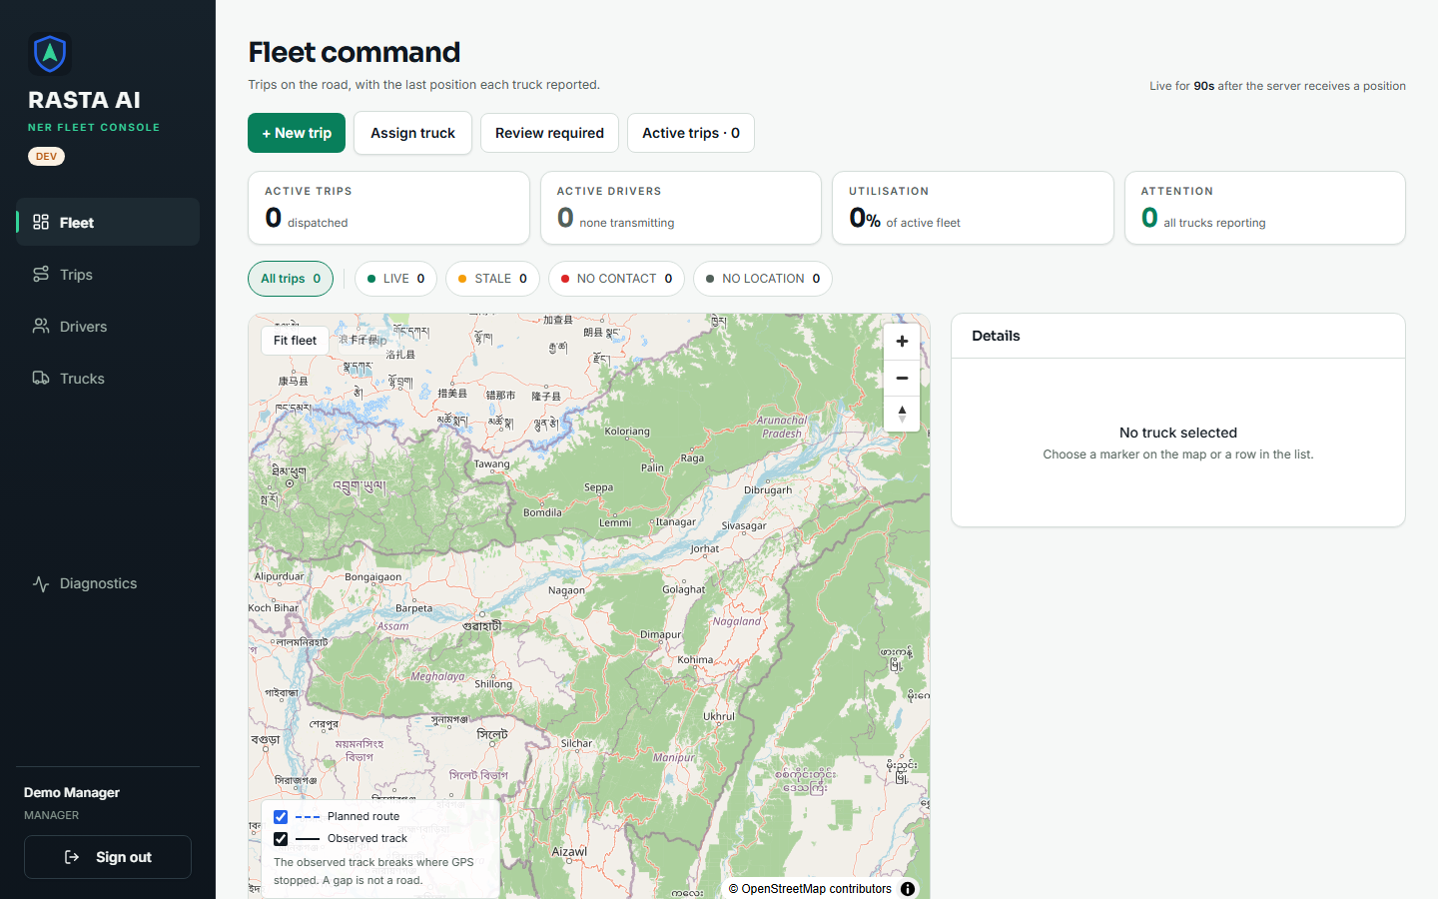
Figure 5. Fleet command, desktop. Quick actions, the four KPI tiles, freshness filters, the map with its legend, and the detail panel on the right. The legend explains that a gap in the observed track is a gap in the data, not a road.
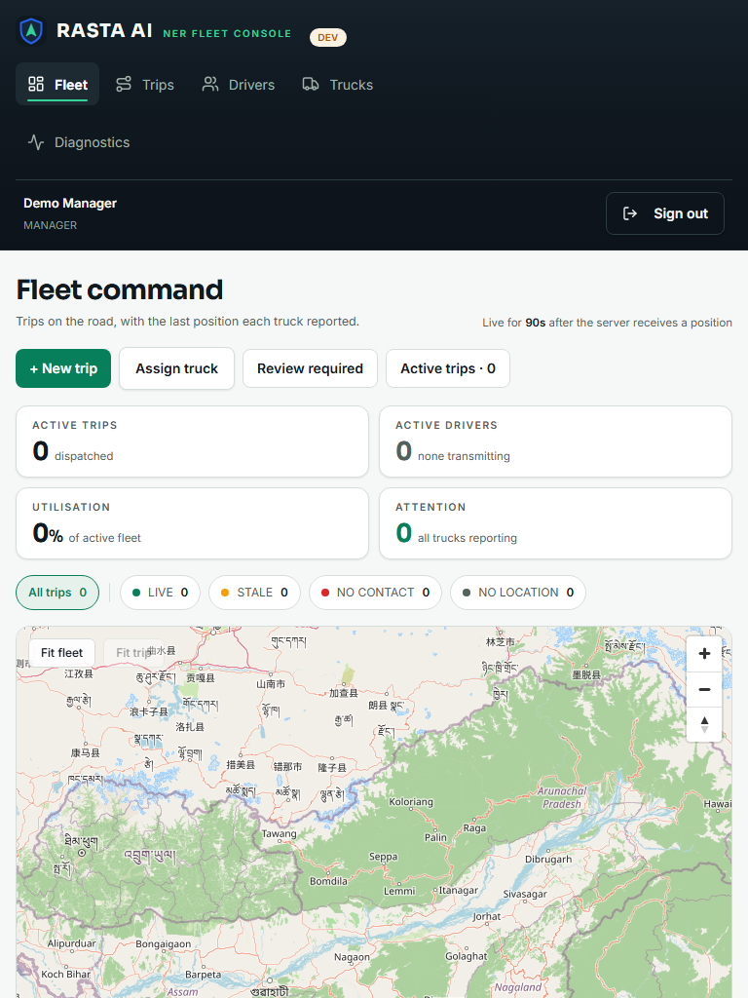  Figure 6. Fleet command at 768×1024. The rail stays, the content uses the full width, the map keeps its controls. | 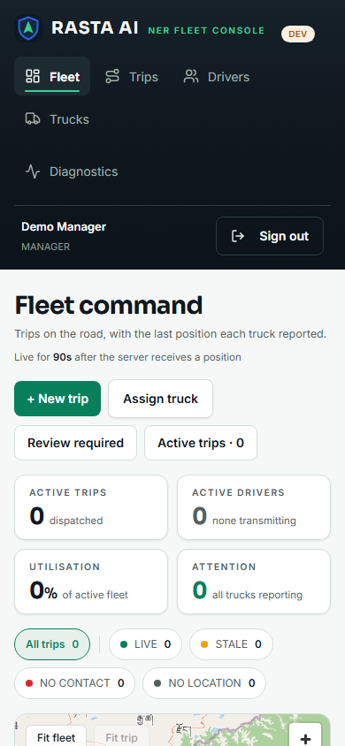  Figure 7. Fleet command at 390×844. The tiles reflow to two columns and the filter chips wrap.

7.3 Dispatch workspace
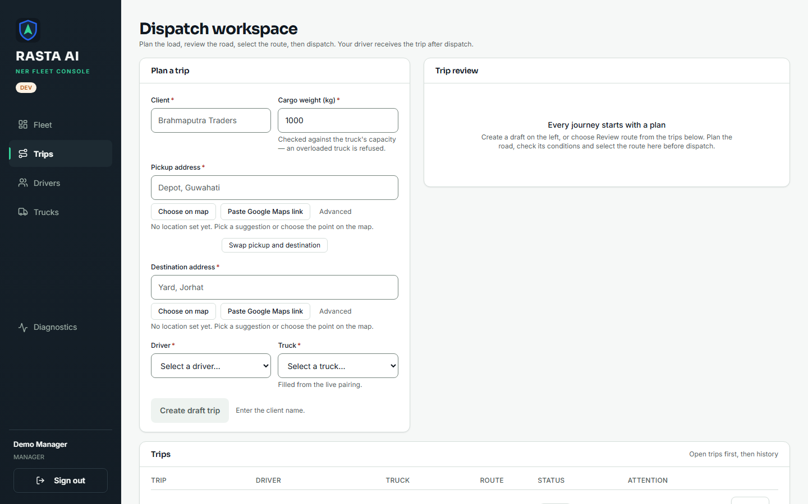
Figure 8. Dispatch workspace (Trips), desktop. Plan a trip on the left — client, cargo weight (checked against the truck's capacity on the server), pickup and destination through the address picker, driver and truck — review the road on the right, and the trip list below.
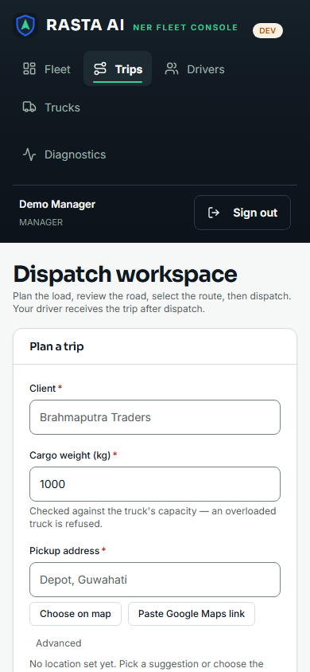 | Figure 9. The same workspace at 390×844. The two panels stack and the form stays usable.

7.4 Drivers, trucks and assignments
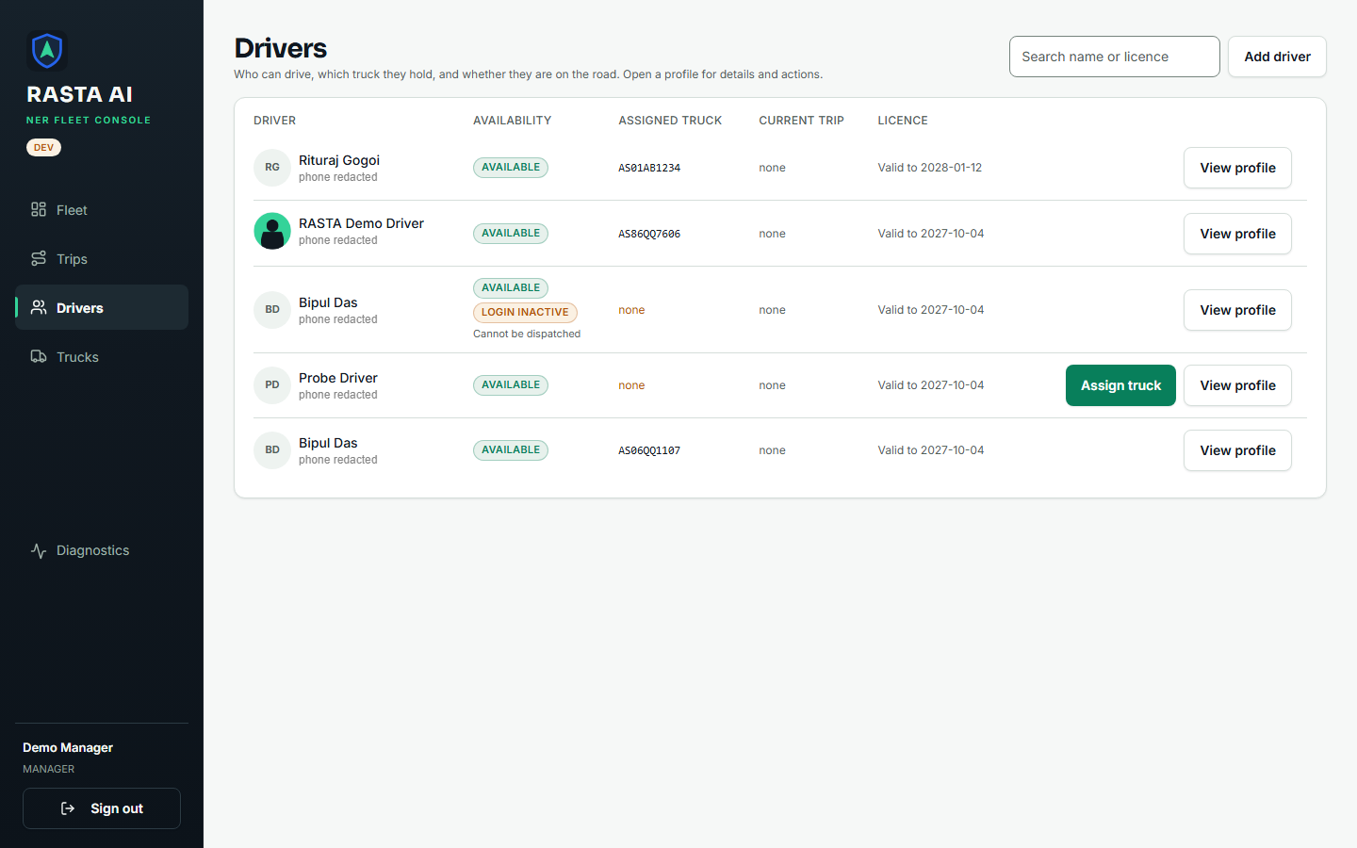
Figure 10. Drivers. Availability, the assigned truck, the current trip and licence validity all come from the API. "Assign truck" is offered only for a driver the server would actually accept.
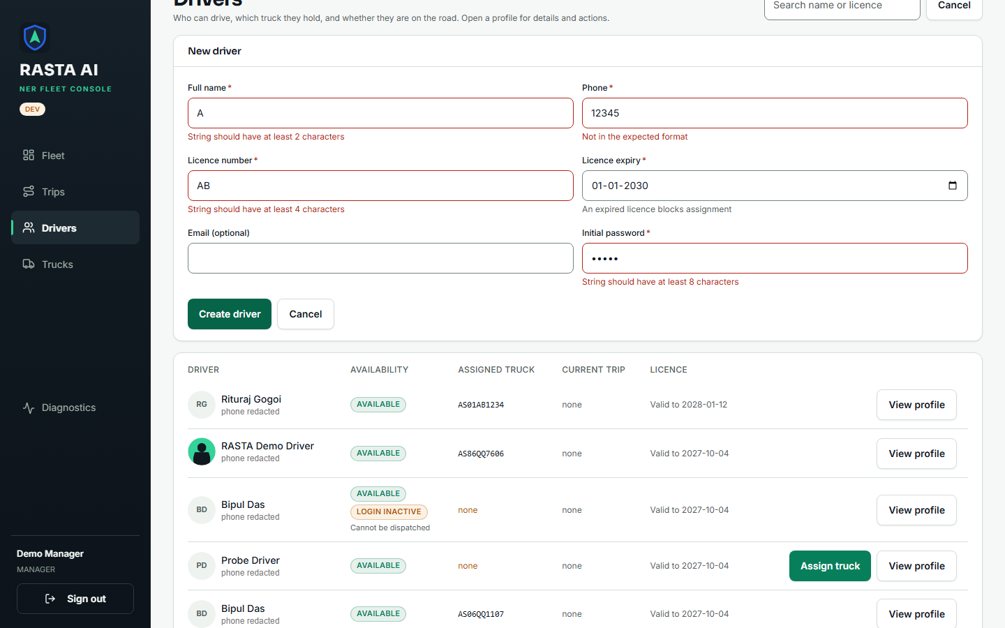
Figure 11. The "New driver" form after the server refused it. Four fields carry the server's own 422 messages; the phone field now reads "Not in the expected format" instead of a regular expression (section 6.2). Nothing was written to the database.
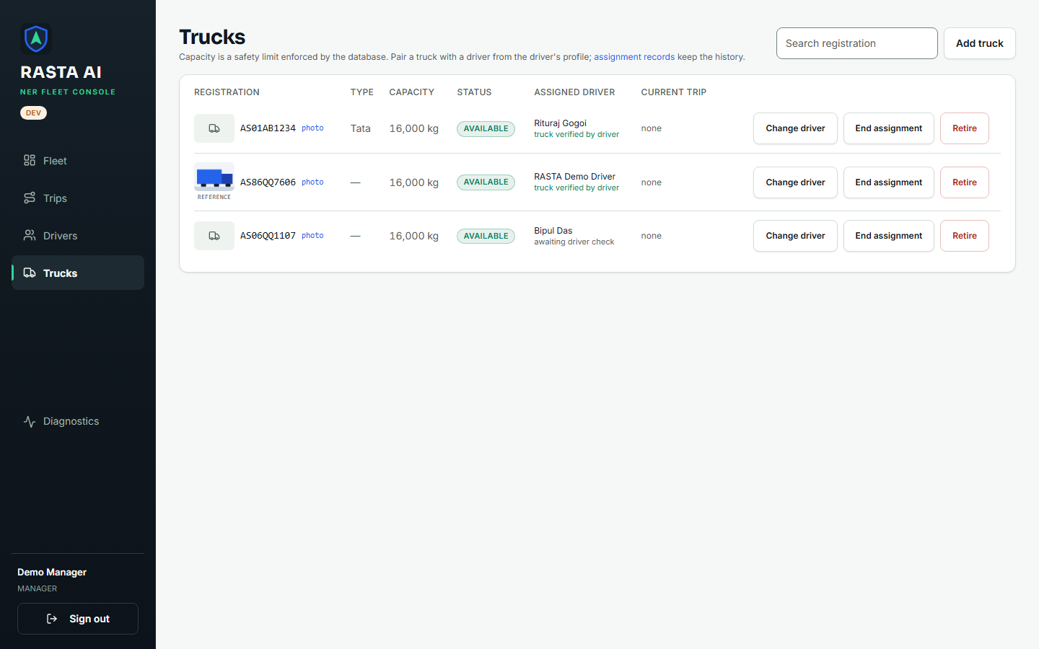
Figure 12. Trucks. Capacity is a hard limit the server enforces; the driver's verification of the physical truck is shown beside it.
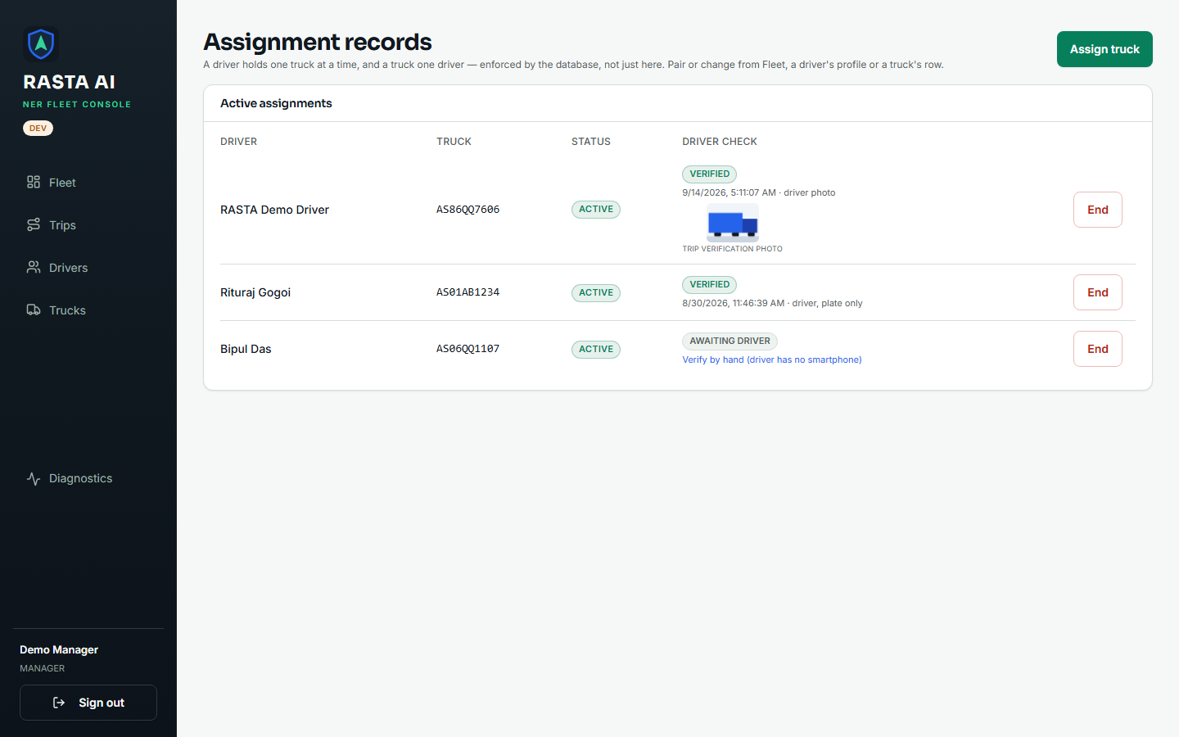
Figure 13. Assignment records, with the driver's verification result: photo, time, and whether a mismatch was flagged.

7.5 Review and diagnostics
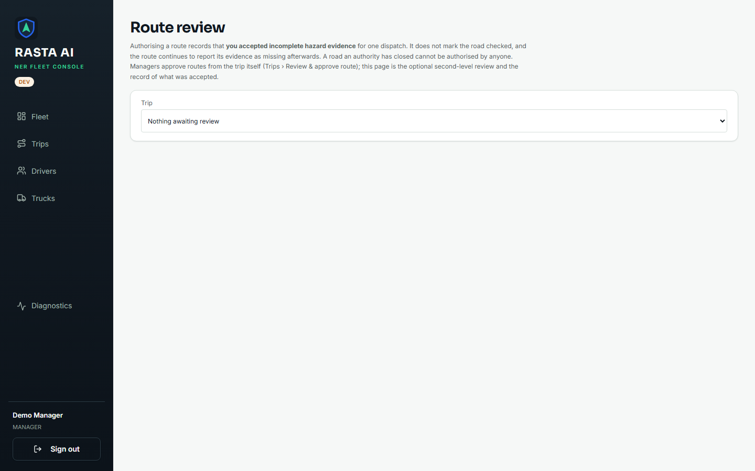
Figure 14. Route review, the optional second-level reviewer page, in its empty state: "Nothing awaiting review".
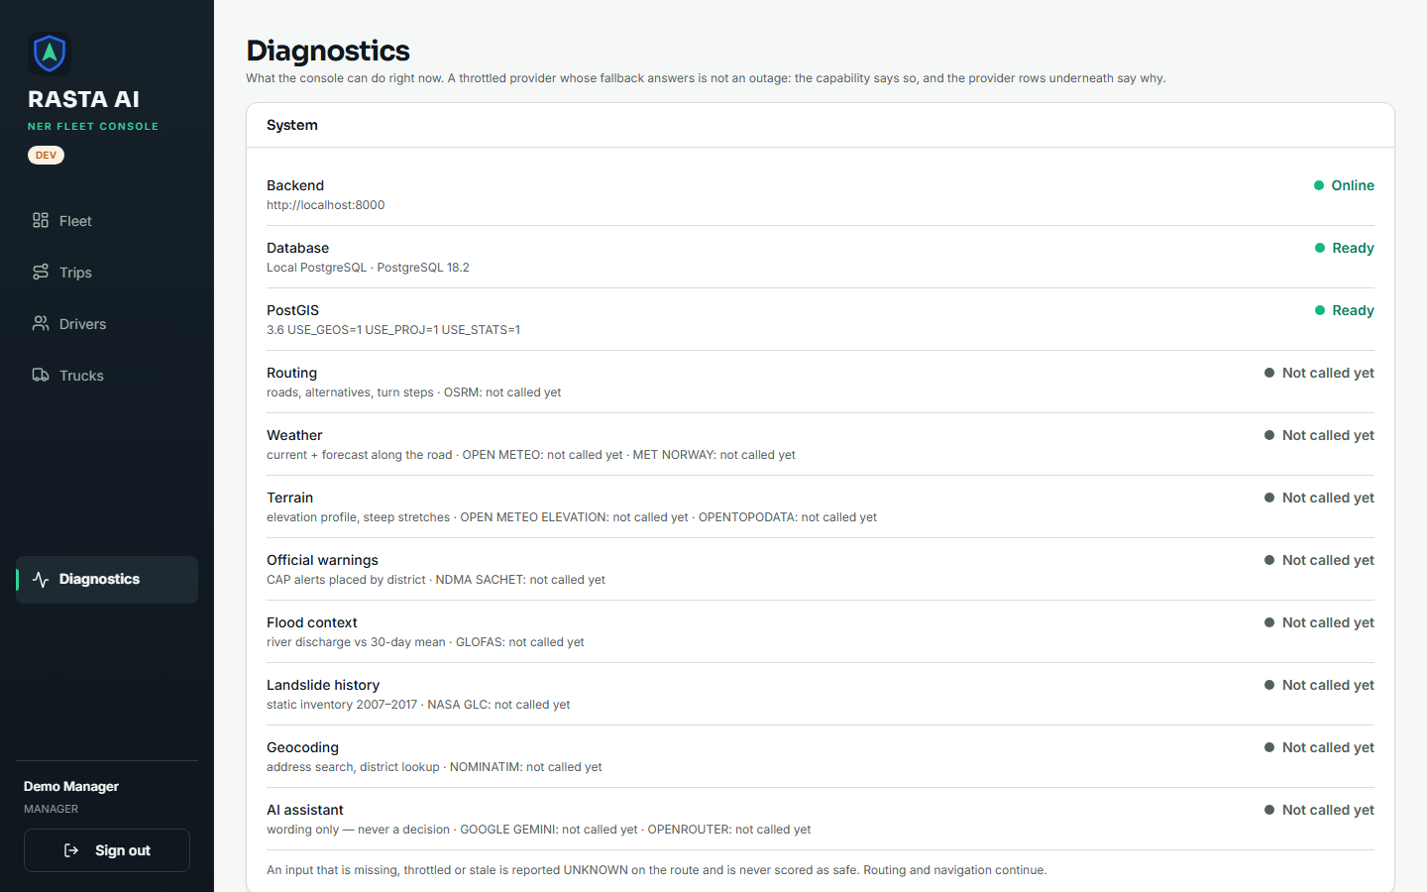
Figure 15. Diagnostics. The backend is Online, the database and PostGIS are Ready, and each external provider shows its real state — "not called yet" for a provider nobody has asked anything of. A throttled provider is reported as throttled, not as an outage.
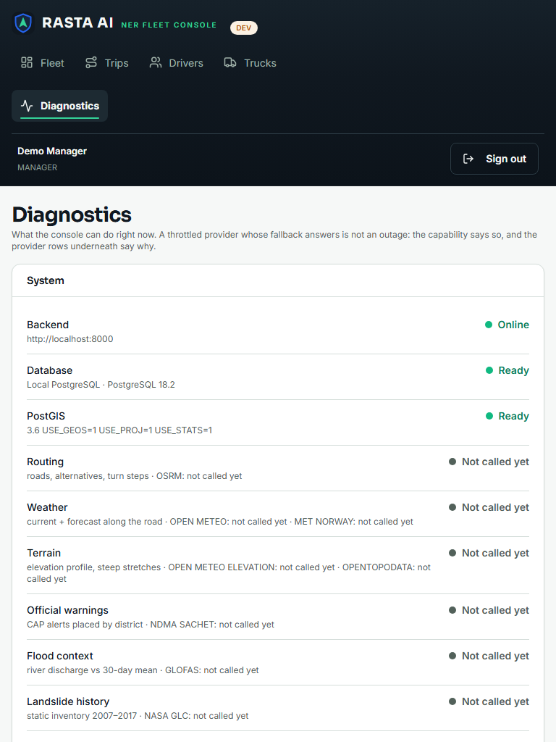 | Figure 16. Diagnostics at 768×1024.

7.6 The driver app
The driver web build is the same code as the Android APK, rendered by react-native-web. We used it here because it can be driven by a script; the physical-phone certification from 14 and 16 September is in the handoff log and we did not repeat it today.
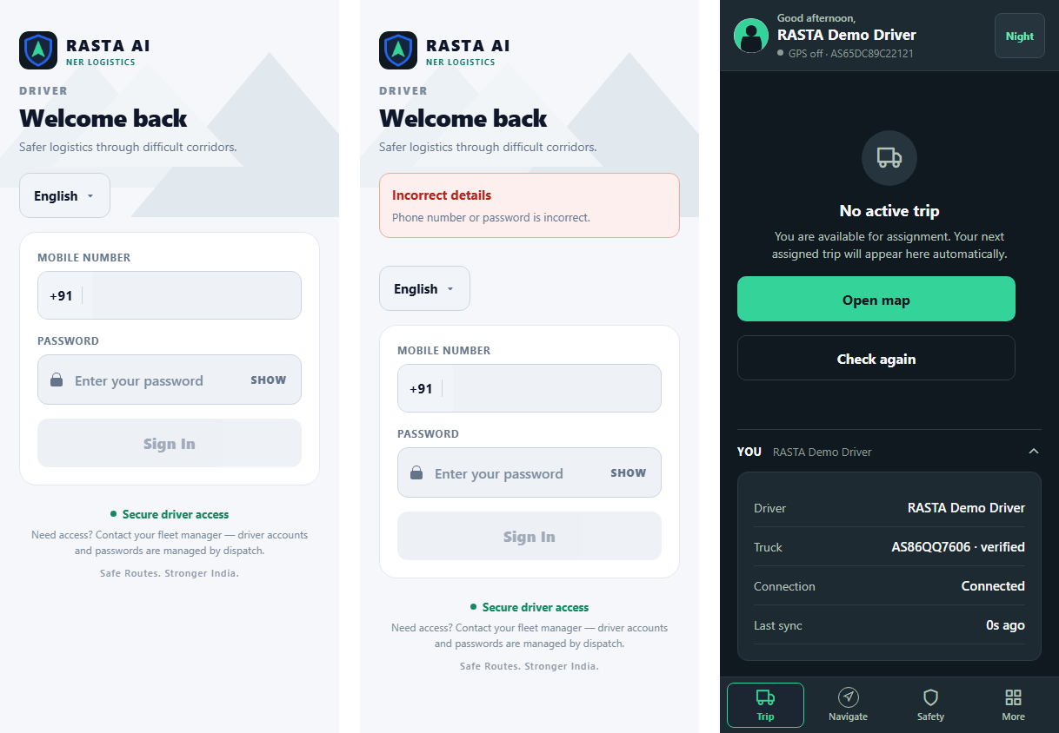
Figure 17. Left to right: the driver login with its language selector; a wrong password refused with one message; and the Trip tab with no active trip. The truck is shown as verified, and the connection status comes from the last successful sync rather than from the phone's signal bars.
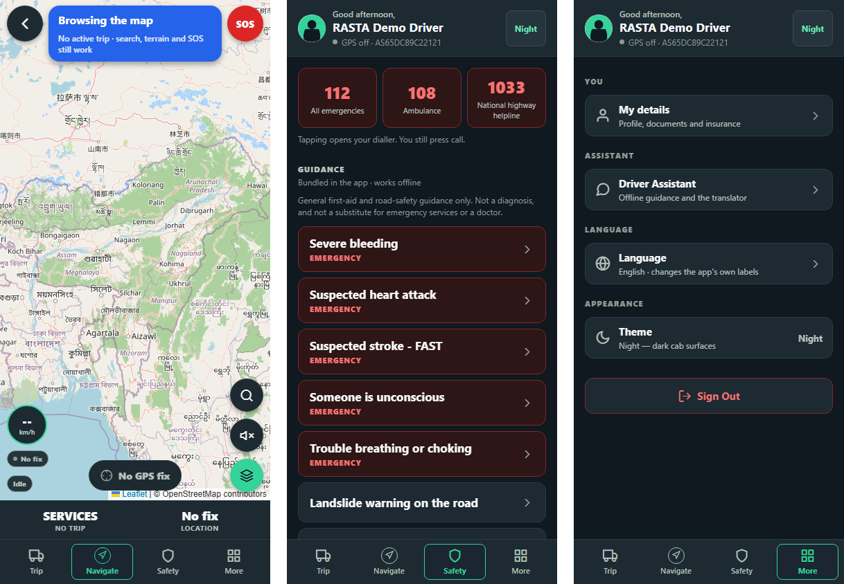
Figure 18. Left to right: Navigate (Leaflet/OSM map, SOS, speed, and "No GPS fix" stated rather than hidden); Safety (emergency numbers that open the dialler, bundled offline first-aid guidance); More (profile, offline assistant, language, theme, sign out).

8. One request, end to end
Every write in the system takes the same path. Here it is for Add driver, which is the flow behind Figure 11.
USER ACTION
the manager fills in "New driver" and presses Create driver
▼
FRONTEND STATE
useMutation refuses a second submit while one is in flight; the button shows busy
▼
API REQUEST
POST /api/drivers with a JSON body, Authorization: Bearer <access token>, credentials included
▼
AUTHENTICATION
signature and expiry checked; the role is re-read from the users table on every request
▼
AUTHORIZATION
require_permission("driver:create"); a missing permission is a 403 that names it
▼
BACKEND VALIDATION
Pydantic DriverCreate: name ≥ 2, phone ^\+?[0-9]{10,15}$, licence ≥ 4, password ≥ 8; failure is a 422 with per-field errors
▼
BUSINESS LOGIC
the service creates the users row and the drivers row in one transaction and writes an audit_logs entry
▼
DATABASE
PostgreSQL/PostGIS through parameterised SQL; a unique-constraint hit becomes a 409
▼
API RESPONSE
201 with the new DriverRead, or the one error envelope {error: {code, message, details, request_id}}
▼
UI STATE
success: form cleared, list reloaded · 422: a message under each offending field · anything else: an ErrorState card, with a retry button only when a retry could help

Two details about this path are easy to miss and worth stating.
The access token never touches localStorage. It lives in memory, so a page reload loses it — deliberately. The refresh token sits in an HttpOnly; SameSite=Strict; Path=/api/auth cookie that JavaScript cannot read, and AuthProvider calls /api/auth/refresh silently before rendering anything. From the operator's side a reload just works; from an attacker's side there is no token to steal from script.
The driver app's GPS path is the same shape with one extra rule: each fix carries a client-generated device_fix_id, and the server is idempotent on (trip_id, device_fix_id). A phone that loses signal in a valley, queues two hundred fixes and re-sends the batch twice does not produce duplicate rows. The response says how many fixes were accepted, how many were duplicates and how many were rejected, rather than a single pass or fail for the whole batch.

9. The API

9.1 Conventions
All bodies are JSON. Timestamps are ISO-8601 in UTC. Coordinates in payloads are {lat, lon}; only route geometry uses GeoJSON's [lon, lat], because that is the GeoJSON standard and swapping it would be the most common spatial bug there is. Money is a decimal string. Lists are cursor-paginated (?limit=&cursor= gives {items, next_cursor}), because GPS and audit rows are appended constantly and offset paging would skip them.
Every failure, from every route, looks like this:
{"error": {"code": "VALIDATION_ERROR",
"message": "Request failed validation.",
"details": {"errors": [{"loc": ["body", "phone"], "msg": "…", "type": "string_pattern_mismatch"}]},
"request_id": "c1d48a99-…"}}
The status codes each mean one thing. 401: no token or a bad one. 403: you may not. 404: not found, or it exists but is not yours (a driver gets 404, not 403, for another driver's trip, so the API does not leak that it exists). 409: the request is fine but the state is not. 422: a rule nobody may override. 429: slow down. 503: something we depend on is unreachable, and a retry might help.

9.2 The endpoints the screens use
Auth column: public, or the permission the caller must hold. M means a manager holds it, D a driver, R an authorised reviewer. "Own" is always resolved from the token; no driver-side route takes a driver id.
Method | Path | Purpose | Auth | Request | Response | Errors
POST | /api/auth/login | Sign in with email (manager) or phone (driver) | public | {identifier, password, client: "web" or "mobile"} | {access_token, refresh_token (mobile only), token_type, expires_at, user} and, for web, a ner_refresh cookie | 401 (same message for unknown user and wrong password), 422, 429
POST | /api/auth/refresh | Rotate the refresh token | cookie or body | {client} (+ refresh_token on mobile) | as login | 401; presenting an already-rotated token revokes the whole family
POST | /api/auth/logout | Revoke the refresh token | any token | — | 204 | —
GET | /api/auth/me | Who am I, and what may I do | any token | — | {user, permissions[]} | 401
GET | /api/drivers | List drivers | driver:read (M, D) | ?limit&cursor&status | {items[], next_cursor} | 401, 403
POST | /api/drivers | Create a driver and their login | driver:create (M) | DriverCreate | 201 DriverRead | 422, 409
PATCH | /api/drivers/{id} | Edit a driver | driver:update (M) | partial DriverUpdate | DriverRead | 404, 422
POST | /api/drivers/{id}/deactivate | Disable the login | driver:deactivate (M) | — | DriverRead | 404, 409 if on a trip
GET | /api/drivers/{id}/documents | Licence and other documents | driver:read (M) | — | list | 404
POST | /api/drivers/{id}/support-session | A short-lived, read-only "view as driver" token | driver:support_view (M) | — | {token, expires_at, driver_id} | 404
GET / POST | /api/trucks, /api/trucks/{id}, …/retire | Trucks | truck:read / create / update / retire (M) | TruckCreate (registration pattern, capacity 0–100,000 kg) | TruckRead | 422, 404, 409
GET / POST | /api/assignments, …/{id}/end, …/verify-manual | Driver–truck pairing | assignment:read / create / end / review (M) | {driver_id, truck_id} | AssignmentRead | 409 already assigned, 422 licence expired
POST | /api/assignments/{id}/verify | The driver confirms the physical truck | assignment:verify_own (D) | photo, registration, odometer, fuel % | AssignmentRead | 409, 422
POST | /api/trips/plan | Create the shipment and the trip in one transaction | trip:create (M) | {shipment: ShipmentCreate, trip: TripPlanTrip} | 201 TripRead | 422 (capacity, outside the service region, missing fields), 503 routing provider down
GET | /api/trips, /api/trips/{id} | List (with total) and detail | trip:read (M, R) | ?limit&cursor&status | {items[], next_cursor, total} / TripDetail | 404
POST | /api/trips/{id}/dispatch | DRAFT → DISPATCHED | trip:dispatch (M) | — | TripRead | 404, 409 wrong state, 422 no selected route
POST | /api/trips/{id}/cancel, …/close | Cancel / close | trip:cancel, trip:close (M) | ?reason= (≤ 200 chars) | TripRead | 409; cargo on the truck is never cancelled silently
GET | /api/trips/{id}/routes | The candidate roads | route:read (M, R) | — | TripRoute[] | 404
POST | /api/trips/{id}/routes/recalculate | Ask the routing provider again | route:plan (M) | — | RoutePlanResult | 503
GET | /api/trips/{id}/routes/recommendation | Compare the candidates | route:read (M, R) | — | RouteRecommendation (comparable, reason codes) | 404, 503
GET | /api/trips/{id}/routes/{route_id}/risk | Deterministic risk for one road | route:read (M, R) | — | RouteRisk (score, band, the datasets it lacks) | 404, 503
POST | /api/trips/{id}/routes/{route_id}/select | Choose the road, when it is eligible | route:select (M) | — | TripRoute | 422 REQUIRES_REVIEW, 409
POST | /api/trips/{id}/routes/{route_id}/approve | Accept incomplete evidence and choose the road in one audited step | route:select (M) | {rationale ≥ 20 chars, acknowledged_incomplete_evidence: true, from_route_id?} | TripRoute | 422 ROUTE_REJECTED_ACTIVE_HAZARD, 409 stale screen
GET / POST / DELETE | /api/trips/{id}/routes/{route_id}/review-authorization | The optional reviewer's single-use, 30-minute authorisation | route:review_authorize (R) | {rationale} | ReviewAuthorization | 403 for a manager
GET / POST | /api/trips/{id}/reroute, …/reroute/accept | A driver's proposed road, and the manager's answer | route:read / route:select (M) | — | RerouteAssessment / RerouteAccepted | 404, 422
GET | /api/fleet/active | Trips on the road with their last position | fleet:location_read (M) | — | {trips[], fresh_seconds: 90, stale_seconds: 600, server_time} | 403
GET | /api/trips/{id}/track | The observed GPS track | fleet:location_read (M) | — | TrackSnapshot | 404
POST / DELETE | /api/trips/{id}/simulation | Demo simulator: moves a truck along its road | trip:dispatch (M) | — | — | 404
GET | /api/driver/me, …/assignment, …/profile, …/documents, …/truck-documents, …/notices | The driver's own records | driver token | — | own rows only | 403 for a manager token
GET | /api/driver/me/trip | The driver's current trip, with route progress | driver token | — | TripRead with progress, or null when there is none | —
POST | /api/driver/me/trip/accept, …/start, …/stops/{stop}/arrive, …/stops/{stop}/complete, …/complete | Trip execution | trip:execute_own (D) | — / {position} | TripRead | 409 wrong state, 422 rule
POST | /api/driver/me/trip/reroute | "I have left the road; propose another" | trip:execute_own (D) | {position} | 201 proposal | 422
POST | /api/driver/me/trip/check-in, …/instruction/ack | Safety check-in; acknowledge a manager instruction | trip:execute_own (D) | — | — | 409
GET | /api/driver/me/trip/navigation, …/offline-package, …/route-risk, …/places | Manoeuvres, the offline corridor pack, conditions ahead, roadside services | trip:execute_own (D) | — | packages | 404 when there is no trip
POST | /api/driver/me/location | A batch of GPS fixes, idempotent on (trip_id, device_fix_id) | location:submit_own (D) | {trip_id, fixes[1..500]: {device_fix_id (UUID), location, recorded_at, speed_kmph ≤ 200, …}} | {accepted, duplicates_ignored, rejected, rejected_reasons} | 422
POST | /api/driver/me/push-token | Register the phone for push | driver token | {token} | 204 | 422
GET / POST | /api/emergencies/active, …/{id}/resolve, …/sweep | Fleet Sentinel: stationary or silent trucks | emergency:read / resolve (M) | {note} | EmergencyRead | 403, 404
GET / POST | /api/geocoding/suggest, …/details, …/resolve-link | Address search (server-side key), and pasting a Google Maps link | trip:create (M) | ?q= / {url} | suggestions / a resolved point | 503 when no key is configured
POST / GET | /api/files, /api/files/{id} | Photos and documents; ownership checked in the service | any token | bytes | {id, …} / bytes | 403, 404
GET / POST | /api/ai/status, /api/ai/ask | The optional in-cab assistant | driver token | {question, context} | an answer, or 503 AI_UNAVAILABLE | 503
GET | /api/system/providers, …/simulation | Provider health for the Diagnostics page | any token | — | {providers[14], intelligence} | —
GET | /health, /ready | Liveness; readiness with database and PostGIS checks | public | — | {status} / {status, provider, checks} | 503 when not ready

9.3 What we actually got back today
We ran these by hand against the local backend with a small Python script, then read the responses. The backend was at 8561f46.
We sent | We got
GET /api/auth/me with no token | 401, code UNAUTHENTICATED, "Authentication required."
GET /api/drivers with a garbage token | 401, "Invalid or expired token." — not a 500
Login with the right email and a wrong password | 401, "Invalid credentials."
Login with an email that does not exist | 401, "Invalid credentials." — byte-identical to the previous one
Login with client: "fax" | 422, "Input should be 'web' or 'mobile'"
Login as the manager with client: "web" | 200; no refresh_token in the body; Set-Cookie: ner_refresh=…; HttpOnly; SameSite=strict; Path=/api/auth
Login as the driver with client: "mobile" | 200; refresh_token in the body; no cookie
The eleventh wrong password from one address within a minute | 429, code RATE_LIMITED, "Too many attempts. Try again shortly.", Retry-After: 45
GET /api/auth/me as the manager | 200 with the user and the full permission list
GET /api/fleet/active with a driver token | 403, details.required_permission = "fleet:location_read"
GET /api/trips with a driver token | 403, required trip:read
POST /api/trucks with a driver token | 403, required truck:create
GET /api/driver/me with a manager token | 403, "This endpoint is for drivers only."
POST …/review-authorization with a manager token | 403, required route:review_authorize
GET /api/drivers?limit=2, /api/trucks?limit=2, /api/trips?limit=2 | 200, two items each, an opaque next_cursor; the trips list also carries total: 70
GET /api/assignments?active_only=true, /api/fleet/active, /api/emergencies/active, /api/system/providers | 200
GET /api/driver/me as the driver | 200, the driver's own record
GET /api/driver/me/trip as the driver, with no trip on the road | 200 null — a legitimate answer, not an error
POST /api/drivers with name A, phone 12345, licence AB, password short | 422 with four entries, each with loc, msg and type
POST /api/trucks with registration hello and capacity 0 | 422, string_pattern_mismatch and greater_than
POST /api/trips/plan with an empty body | 422, shipment and trip "Field required"
POST /api/driver/me/location with a fix id that is not a UUID | 422, uuid_parsing at body.fixes.0.device_fix_id
GET /api/trips/<random uuid> and POST …/dispatch on it | 404, "Trip not found."
GET /api/trips/not-a-uuid | 422, uuid_parsing at path.trip_id
GET /api/no-such-route | 404 in the same envelope
POST /api/drivers with a body that is not JSON | 422, json_invalid, and no stack trace
POST /api/auth/logout | 204

10. Signing in, and staying in your lane
We were asked to check authentication and authorization separately, and they are separate things in this codebase.
Authentication is "prove who you are". Passwords are hashed with Argon2id and are never logged; the 422 handler strips input values from its details for exactly that reason. A successful login issues a signed JWT that lasts 15 minutes and a refresh token that lasts 30 days. The refresh token rotates on every use and, if an already-rotated token is ever presented again, the whole family is revoked; that is how a stolen token is caught. Web clients get the refresh token as an HttpOnly cookie; the mobile app gets it in the body and stores it in expo-secure-store. The client says which it is, and nothing is inferred from the User-Agent, because that would let anyone ask for the token in the body by claiming to be a phone. The login endpoint answers "Invalid credentials." with the same body whether the identifier exists or not, and it is rate-limited at 20 attempts a minute per address and 10 per identifier. We tripped that limit ourselves during the day, which is how we know the Retry-After header is there.
Authorization is "are you allowed to do this", and it lives in one place: app/core/permissions.py. Permissions are strings like trip:dispatch; roles map to sets of them; every route depends on a permission and never on a role name. There are four roles — ADMIN, MANAGER, DRIVER and AUTHORISED_REVIEWER — and the interesting one is the reviewer, who can read trips and routes and authorise a selection but deliberately cannot make one. The person who accepts a risk should not be the person who acts on it.
Two more properties are worth knowing. The role is re-read from the database on every request rather than taken from the token, so demoting or deactivating someone takes effect immediately, not at token expiry. And no driver-side route takes a driver id: require_current_driver() resolves the driver from the token, which is the shape that makes a whole class of "change the id in the URL" bugs impossible to write.
On the client, the same permission strings drive what is rendered. The navigation only shows screens the role can use, buttons the role cannot use are not drawn, and since today (section 6.1) arriving at a screen's URL directly redirects instead of mounting a page that would fail. The console also refuses a driver's valid credentials outright, with one sentence, on login and on the silent restore a reload performs.
For the hosted deployment the backend verifies Supabase-issued tokens instead of its own (ES256/RS256 against the project's JWKS, with issuer, audience and expiry checked, and an unreachable JWKS reported as a 5xx rather than as "your session expired"). That path has 17 tests of its own and was exercised on the hosted stack in the 18 September certification; we did not re-run it today.
Finally, secrets. No .env file is tracked (we checked with git ls-files). Every VITE_ and EXPO_PUBLIC_ variable is a URL or a public tile key, because those prefixes are inlined into the client bundle. The API's /docs and /openapi.json are switched off outside development so the endpoint inventory is not handed to anyone who asks for it.

11. Validation, and what the user sees when things go wrong

11.1 The rules the server enforces
All of these come from backend/app/schemas/domain.py and schemas/auth.py. The client does not duplicate them; it shows what the server says.
Field | Rule | An input we tried | What the form shows
full_name | 2 to 120 characters | A | String should have at least 2 characters
phone | ^\+?[0-9]{10,15}$ | 12345 | Not in the expected format
licence_number | 4 to 40 characters, upper-cased on the way in | AB | String should have at least 4 characters
initial_password | 8 to 200 characters | short | String should have at least 8 characters
registration_number | ^[A-Z]{2}[ -]?\d{1,2}[ -]?[A-Z]{1,3}[ -]?\d{1,4}$, spacing and case normalised | hello | Not in the expected format
max_capacity_kg | more than 0, at most 100,000 | 0 | Input should be greater than 0
cargo_items[] | at least one; each with weight_kg > 0 and quantity 1–100,000 | [] | List should have at least 1 item
reference_code, trip_code | 3 to 32 characters | ab | String should have at least 3 characters
stops[].geofence_radius_m | 10 to 20,000 m | 5 | Input should be greater than or equal to 10
GPS fix | device_fix_id a UUID; speed_kmph 0–200; heading_deg 0 to below 360; accuracy_m up to 20,000; 1 to 500 fixes per batch | speed 999 | Input should be less than or equal to 200
client on login | exactly web or mobile | fax | Input should be 'web' or 'mobile'
rationale on approve / authorise | at least 20 characters | ok | String should have at least 20 characters (the UI keeps the button shut until this is met)

Then there are the rules that are not about the shape of a field but about the world, and those come back as 422 no matter who you are: cargo heavier than the truck's capacity; a driver whose licence has expired; a shipment endpoint outside the service region; dispatching a trip that has no selected route; rerouting onto a road with a verified closure (ROUTE_REJECTED_ACTIVE_HAZARD). State conflicts are 409: dispatching a trip that is already moving, assigning a truck that is on a trip, approving a reroute from a screen that is no longer current.

11.2 What the operator sees
The console has one component for each kind of failure, and every page uses them.
When | What appears
The backend cannot be reached | A "Cannot reach the backend" card on the page, and a banner across the top of the shell: Offline · showing last known data · last synced N min ago · reconnecting… Pages keep whatever they last loaded.
A request takes longer than 15 s (90 s for a route assessment) | "The backend took too long", with a retry
The session is really gone (401 after a failed silent refresh) | The login screen, with the session state cleared
403 | "Not permitted", with the server's message and no retry button, because retrying cannot help
404 / 409 | "Not found" / "Conflict", with the server's message
422 | The message under each offending field (Figure 11). The request never reached the database.
503 from a routing or weather provider | "Service unavailable" with a retry; the route cards show NOT ASSESSED rather than a made-up score
Anything else | "Something went wrong". The server never sends a stack trace or a connection string: register_exception_handlers in core/errors.py is the boundary, and psycopg's habit of putting the full DSN into its exceptions is the reason it exists.

Loading and empty states are components too — LoadingState with a label, EmptyState with a title, a hint and an optional action — and useResource guarantees a page cannot confuse "no data yet" with "the request failed". That distinction sounds pedantic until an outage renders as an empty list and someone concludes the fleet is idle.

12. Test results
Every number here was produced by a command we ran today. None were copied from earlier documents.
Suite | Command | Result
Backend, full suite | pytest against the isolated cluster, armed with .runtime/use-isolated-db.sh | 1,183 passed, 5 skipped, 0 failed in 7 min 00 s. The skips are four destructive migration tests gated behind an environment variable, and one non-Windows case.
Manager console, tests | vitest run on a clean checkout of 8561f46 plus our changes | 231 passed, 0 failed across 22 files (228 before today, 3 new)
Manager console, types | tsc -b --noEmit | 0 errors
Manager console, build | vite build | Built in 0.8 s; one chunk-size warning
Manager console, lint | oxlint src | 0 errors, 3 pre-existing warnings
Driver app, tests | vitest run | 624 passed, 0 failed across 54 files
Driver app, types | tsc --noEmit | 0 errors
API by hand | 40 requests (section 9.3) | Every status code and body as documented
Browser, manager console | .runtime/task3/evidence.mjs — headless Chrome, real login | 8 of 8 checks: login error shown, session established, zero overflow at three widths on Fleet and at 390 px on Trips, the 422 mapped onto four fields, an unknown URL redirected home; no uncaught exceptions
Browser, driver app | .runtime/task3/evidence_driver.mjs | 3 of 3: wrong password refused, session established, zero overflow
Regression test for section 6.1 | App.test.tsx against the old App.tsx, then the new | 1 failed, then 2 passed
Hosted deployment, read-only | GET /health and /ready on the API; the manager and driver sites | 200 / ready (PostgreSQL 17.6, PostGIS 3.3) / 200 / 200
Re-run on main at 5dcc608, after the parallel session's commits | backend pytest; manager tsc -b, vitest run, vite build; driver tsc, vitest run | Backend 1,199 passed, 5 skipped (3 min 42 s). Manager 246 passed, vite build fine, but tsc -b reports 2 errors in files from those commits (an unused import in TripsPage.tsx; a tuple index in a new test in client.test.ts), so npm run build, which type-checks first, fails on main right now. Driver 624 passed, types clean.

The backend suite is where the business rules live. The files a mentor might want to open are test_trip_lifecycle, test_dispatch_route_gate, test_assignment_invariant, test_route_eligibility, test_route_review_authorization (which now includes the hard-block reroute case), test_driver_reroute_api, test_authorization, test_auth, test_rate_limit, test_telemetry and test_golden_path_e2e, which walks a trip from creation to closure through the real API.
One caution about "clean checkout". While we were working, another session was editing files in the same working copy (section 13). To make sure our numbers were about our code and not theirs, we made a fresh git worktree of 8561f46, copied only our six files into it, and ran the manager suite, type-check and build there. Those are the numbers above.

13. What we could not verify, and what is still open
We would rather list these ourselves than have them found.
The hosted console in Supabase-direct mode. Certified end to end on 18 September (handoff log, sections 18 and 19), including a live reroute approved by a manager while a simulated truck was moving. Today we only confirmed that the three hosted services answer. In that mode, twenty operations are deliberately switched off with the reason shown on the control itself — creating, editing and deactivating drivers; adding, editing and retiring trucks; cancelling and closing trips; address lookup; and a few more — because they need the API service rather than the Data API. All of them work through the FastAPI path this report is about.
Which backend the driver screenshots came from. Figures 17 and 18 were taken from a driver web build that was already running on port 8123 and points at a demo backend on port 8010, started at 09:58, before one of the day's earlier commits. Nothing on those screens depends on that commit, but strictly they were not captured against the port-8000 backend the rest of this report uses. Needs testing, if that distinction matters to the reviewer.
A physical phone. The APK (1.0.18) was certified on a handset on 14 and 16 September. We did not repeat that today.
The reviewer redirect in a real browser. Section 6.1 is covered by a unit test. There is no reviewer account in the local demo database, so we did not also click through it.
Trip history and the `ROUTE_CHANGED` event. At 8561f46 the backend wrote the event when a manager approved a reroute, but nothing listed it and there was no endpoint for it. During the afternoon a parallel session added GET /api/trips/{id}/events and POST /api/trips/{id}/stops (commit 24986f0) and then a manager-side journey history and trip export (985db6d). We did not run or exercise any of that; it is outside the numbers in section 12. Needs testing.
Concurrent work in the same checkout. This deserves a plain statement. While we were auditing, another session was editing TripsPage.tsx, TripRouteReview.tsx, supabaseManagerApi.ts, the driver's TripScreen.tsx and several new files in the same working copy. It later committed its work and, in doing so, swept our six files into its commit 985db6d. So our changes are on main, but under a commit message that is not ours. We have not touched that commit. Everything we measured was measured on a clean copy of 8561f46 plus our files, and Figures 8 and 9 show the Trips page as it was at 8561f46.
`main` does not type-check at `5dcc608`. The two TypeScript errors above are in the parallel session's files, not in ours (our six files type-checked clean in the worktree run), but anyone pulling main this evening and running npm run build in manager-web will hit them. Tests and the Vite build itself pass. We have left the fix to the session that owns those changes rather than editing its work under it.
No accuracy figure for any model. The route risk is a deterministic weighted rule with published constants and is labelled as such on screen. No predictive model has been evaluated on a held-out set (docs/AI_MODELS.md), so this report claims no percentage, and neither should anyone quoting it.

14. Files we changed
File | What changed
manager-web/src/App.tsx | /trips, /drivers, /trucks, /assignments and /review wrapped in the existing Guarded element
manager-web/src/App.test.tsx | New. Two tests for the route guard
manager-web/src/api/client.ts | New fieldErrors() helper, 18 lines
manager-web/src/api/client.test.ts | A test for the helper, including the pattern-mismatch rewording
manager-web/src/pages/DriversPage.tsx | Its copy of the 422 mapping replaced by the helper; the phone hint now names the format
manager-web/src/pages/TrucksPage.tsx | Its copy of the 422 mapping replaced by the helper
docs/submission/day1/task3/ | This report and its Markdown source, 21 screenshots, and the two JSON files the browser scripts wrote
docs/submission/day1/build_docs.py | The document builder we already had for Task 1, taught to take a source path, place screenshots and draw an editable table flowchart

Fifty-one lines added and thirty-one removed in application code. We did not commit, push or deploy anything ourselves, and the hosted database was only read.

15. Appendix A — running our checks yourself
From the repository root on Windows, each block in its own terminal. The backend must be started with run.py; starting Uvicorn directly skips an event-loop fix and every database call then fails.
# backend tests (about 7 minutes; refuses any database but the isolated cluster)
source .runtime/use-isolated-db.sh
cd backend && .venv/Scripts/python.exe -m pytest -q
# manager console: types, tests, build
cd manager-web && npm run typecheck && npm test && npm run build
# driver app: types, tests
cd driver-app && npm run typecheck && npm test
# the local stack we used for the screenshots
cd backend && .venv/Scripts/python.exe run.py # http://127.0.0.1:8000
cd manager-web && npm run dev # http://localhost:5173
cd driver-app && npm run web # http://localhost:8081
# the browser evidence scripts: headless Chrome, a real login, screenshots into docs/submission/day1/task3/screenshots
node .runtime/task3/evidence.mjs
node .runtime/task3/evidence_driver.mjs
The demo manager and driver credentials are in .runtime/demo-credentials.private.json, which is not tracked. The API smoke in section 9.3 is a 70-line stdlib Python script; the responses are quoted in that section as we received them.

16. Appendix B — the afternoon, in order
We kept the timestamps because they answer the question "how long did this actually take".
Time (IST) | What happened
15:30 | Started reading: AGENTS.md, the README, the last three handoff sections, the route table, the permission catalogue
15:33 | Kicked off the full backend suite against the isolated cluster
15:40 | Manager console: type-check clean, 228 tests green. Driver app: type-check clean, 624 tests green
15:41 | Backend suite finished: 1,183 passed, 5 skipped
15:45 | Route guard gap confirmed by reading App.tsx; fix written; App.test.tsx written and shown to fail on the old code
16:05 | A backend started from this checkout on port 8000, Vite on port 5174
16:07–16:11 | First browser evidence run. One script bug: we looked for a button called "Create"; it is called "Create driver"
16:13 | The second run reused the headless profile and the session restore let us straight in. A feature, but not the screenshot we wanted; fixed the script
16:15 | The regex-in-the-error-message defect noticed in Figure 11; helper written, both pages switched to it, test added
16:16 | Third evidence run, 8 of 8. Driver app run, 3 of 3 after fixing the "Sign In" capitalisation in the script
16:20 | 40 API calls by hand. Noticed our own probing had tripped the login rate limiter, which is how the Retry-After: 45 line got into section 9.3
16:25 | Found the other session's uncommitted edits in the same checkout; made a clean worktree of 8561f46 and re-ran the manager checks there: 231 tests, types and build green
16:30 onwards | Wrote this report, built the Word document, and checked every page of it as rendered by Word

