SMART INDIA HACKATHON 2026 · PROBLEM STATEMENT SIH26002
RASTA AI
Day 2 — Task 2
Web Application Vulnerability Testing & Security Assessment
NER-AI LOGISTICS · Team 17 · 19 September 2026

Problem statement | SIH26002 — AI-Based Smart Logistics and Accessibility Intelligence Platform for the North Eastern Region
Team | NER-AI LOGISTICS (Team 17)
Task | Day 2 · Task 2 — Web Application Vulnerability Testing & Security Assessment (software track, page 1 of the task sheet)
Date | 19 September 2026
Repository | nxtlucifer/ner-ai-logistics, branch main, HEAD 5b5e474 plus the uncommitted working tree of 19 September
Evidence base | docs/DAY2_TASK2_SECURITY_TEST_PLAN.md, docs/submission/day2/task2/DAY2_TASK2_SECURITY_RESULTS.md, evidence/results.json, evidence/*.txt, evidence/*.png, backend/tests/test_security_assessment.py
Every result in this report was produced on 19 September 2026 by running the real application: a local backend built from the working tree, bound to an isolated clone of the demo database, plus read-only checks of our own hosted services. Findings are stated with the evidence that produced them; where a control was not exercised (OWASP ZAP, pip-audit, the hosted rate limiter) the report says so rather than claiming it. No statement of the form "fully secure" is made anywhere in this document: the honest claim is that no exploitable issue was reproduced within the defined scope after the fixes below.

Contents
1. Executive summary
2. Testing scope
3. Testing environment
4. Security methodology
5. Vulnerability assessment summary
6. SQL injection assessment
7. XSS assessment
8. Security misconfiguration
9. File upload security
10. Security headers
11. Session management
12. API security
13. Excessive / improper API access
14. Issues found & remediation
15. Test results
16. Evidence gallery
17. Residual risks
18. Final security assessment
19. Conclusion

1. Executive summary
The Day 2 Task 2 sheet asks for a basic security assessment of the developed web application across eight vulnerability classes, each finding documented with evidence, impact, severity and remediation. This assessment covered the RASTA AI FastAPI backend (86 operations over 75 paths), the Manager Web console and the Driver App's API surface, using a written test plan of 63 cases, a 49-case runtime probe against an isolated environment, a headless-browser stored-XSS check, static code review, a repository and bundle secret scan, dependency audits, and the project's own test suites.
Overall posture. The application was designed with security boundaries that held under test: every database query is parameterised through SQLAlchemy (no SQL injection reproduced on login, three search endpoints, cursors, path and enum parameters); React and the two hand-written HTML writers escape user text (stored <img onerror> / <svg onload> payloads rendered as literal text in the manager console, with zero live handlers and zero dialogs); refresh tokens rotate, replay revokes the whole family, logout invalidates, forged and expired JWTs are refused, a deactivated account is cut off on its next request; uploads are typed by magic bytes and never by name; the SSRF surface refuses every non-Google host before contacting anything; every one of the 81 non-public operations answers 401 without a token; and the login limiter returned 429 with Retry-After on the eleventh wrong password.
What was found and fixed today. Five real defects, none Critical or High: one Medium — a broken object-level authorisation on GET /api/drivers/{id}/documents that let any driver read another driver's document types, expiry dates and masked numbers — and four Low: no security headers on API responses, the DRIVER role able to read the whole truck register, uploads buffered in full before the 5 MB check, and clickjacking/referrer headers missing from the hosted static sites. All five are fixed in the working tree with regression tests that fail when the fix is reverted (6 of 8 backend cases fail without it). The backend suite passed in full afterwards (1,246 passed, 5 skipped), as did the Manager Web (261 tests, typecheck, build) and Driver App (624 tests, typecheck) suites.
What remains. (Updated 20 September 2026: SEC-006 and SEC-008 have since been closed — see `docs/submission/day2/task3/RASTA_AI_DAY2_TASK3_MITIGATION.md`. The paragraph below records the position as it stood at the end of Task 2.) One Low finding is open by choice — the login rate limiter keys on the TCP peer, which on Render is the platform proxy, so the per-address budget is shared fleet-wide (the per-account budget still holds). Seven informational observations are recorded. Two hosted checks still show the pre-fix headers until the working tree is deployed. Residual risks are listed in section 17.
Headline numbers (measured 19 Sep 2026) | Value
Test plan cases / runtime probe cases | 63 / 49 (46 PASS · 1 INFO · 2 FINDING pending deploy)
Operations checked without a token | 81 of 81 → 401
Findings | 0 Critical · 0 High · 1 Medium · 5 Low · 7 Informational
Fixed today with regression tests | 5 (SEC-001 … SEC-005) — 8 new backend tests, 1 new manager test
Backend / Manager / Driver suites after the fixes | 1,246 passed 5 skipped · 261 passed + tsc + build · 624 passed + tsc

2. Testing scope
In scope | What was exercised
Backend (FastAPI, backend/app) | all 86 mounted operations: authentication, drivers, trucks, assignments, shipments, trips, routes, fleet location, driver self-service, telemetry, emergencies, files, documents, geocoding, AI proxy, system
Manager Web (manager-web) | stored-XSS rendering of Drivers, Trips and Trucks pages in headless Chrome; the printable report writer (tripExport.ts); built bundle contents; hosted response headers
Driver Web / App (driver-app) | API surface exercised with driver tokens; WebView map HTML reviewed; token storage reviewed; hosted web build headers; unit tests and typecheck
REST APIs | authentication, authorisation (role and object level), input validation, pagination limits, method restrictions, SSRF, error containment, CORS
Authentication & session management | login (web and mobile contracts), refresh rotation and reuse detection, logout, token forgery, expiry, disabled accounts, support-view tokens, rate limiting
Database-facing inputs | login identifier, three ILIKE searches, opaque cursors, UUID path parameters, enum filters; code review of every raw SQL use
File uploads | POST /api/files (all six kinds) and GET /api/files/{id}
Security headers | local API before and after the fix; hosted API, manager and driver web sites
Configuration | Settings, render.yaml, vercel.json, netlify.toml, .env handling, docs exposure, secrets in the repository and in the built bundle, RLS test suite, dependency advisories

Out of scope (deliberately) | Reason
Supabase infrastructure, Render, MapTiler, Google, OSRM, Open-Meteo, NDMA feed, Nominatim | third-party services; only our own application was tested
Denial-of-service and high-volume brute force | the limiter was proven with 11 requests; nothing more was sent
Writes against the shared/production database | every write went to a disposable local clone
Page 2 of the task sheet (hardware, sensors, actuators, power) | RASTA AI ships no hardware in this repository
OWASP ZAP active scan, pip-audit | not installed on the assessment machine; recorded as not run rather than claimed

3. Testing environment
Item | Value
Git branch / commit | main @ 5b5e474 (working tree carried uncommitted Day 2 Task 1 work; nothing was committed or pushed by this assessment)
Local backend | FastAPI from the working tree, .runtime/start-sec-backend.sh, http://127.0.0.1:8020, APP_ENV=development (docs open, cookie without Secure — both by design for local http)
Local test database | PostgreSQL 18.2 + PostGIS 3.6 on the isolated cluster 127.0.0.1:55432; database ner_logistics_sec created with CREATE DATABASE … TEMPLATE ner_logistics_demo, migrated to 0013, dropped after the assessment
Backend test suite | the same cluster, database ner_logistics_test, guarded by tests/db_target.py (refuses any other target before a socket is opened)
Manager URL | Vite dev server http://localhost:5175 → API :8020
Driver URL | the driver web build was not started; its API surface was exercised with driver tokens and its hosted build's headers were read
Hosted (read-only) | https://ner-intelligence.onrender.com (API), https://ner-manager.onrender.com, https://ner-driver-web.onrender.com — HEAD/GET of public pages, one login/logout with the team's own account to read cookie flags
Accounts | seeded demo manager and two seeded demo drivers on the clone; one throwaway driver created and deactivated on the clone per run; one driver, truck and trip carrying XSS payloads created on the clone per probe run (Figure 3 shows the four from the runs before the final one)
Tools | security_probe.py (httpx 0.28, PyJWT), xss_browser_check.mjs and render_evidence.mjs (Chrome DevTools Protocol, headless Chrome), pytest 8, vitest, tsc, vite build, npm audit, scripts/secret_scan.py plus a full tracked-file pattern scan, curl
Redaction | tokens, cookies and passwords were replaced with <REDACTED> at capture time by the probe; no credential appears in any evidence file or figure

4. Security methodology
CODE REVIEW
routers, dependencies, services, models, config, deployment descriptors, both clients; grep for raw SQL, eval/exec/subprocess/pickle/yaml.load, dangerouslySetInnerHTML/innerHTML/document.write, localStorage tokens
▼
STATIC CHECK
secret scan of untracked+modified files (project tool) and of all 590 tracked text files; built-bundle scan; npm audit for both clients; permission matrix review
▼
RUNTIME TEST
49 probe cases against the isolated backend: sessions, SQLi, XSS storage, misconfiguration, headers, uploads, API and object boundaries, pagination, rate limit
▼
NEGATIVE SECURITY TEST
forged tokens, replayed refresh tokens, other users' ids, SSRF hosts, polyglot files, oversized bodies, tautology payloads, tampered cursors
▼
FIX
minimum safe change at the layer that owns the boundary: one middleware, one scoped lookup, one scoped query, one bounded read, one deployment header block
▼
REGRESSION
new tests written first and shown to fail with the fix reverted (6 of 8), then the full backend, manager and driver suites
▼
RETEST
the probe re-run on the fixed backend; the browser XSS check re-run; hosted checks repeated to record what is pending deployment

The order matters: code review first, so that runtime tests target real sinks rather than guesses; fixes only after a failing regression test exists, so that no test was weakened to pass.

5. Vulnerability assessment summary
ID | Vulnerability | Severity | Status
SEC-001 | API responses carried no security headers (X-Content-Type-Options, X-Frame-Options/frame-ancestors, Referrer-Policy, Cache-Control: no-store, HSTS) | Low | FIXED (hosted: pending deploy)
SEC-002 | BOLA: any driver could read another driver's document metadata via GET /api/drivers/{id}/documents | Medium | FIXED
SEC-003 | DRIVER role could list and read the whole truck register (GET /api/trucks, GET /api/trucks/{id}) | Low | FIXED
SEC-004 | POST /api/files buffered the entire body before the 5 MB check (authenticated memory amplification) | Low | FIXED
SEC-005 | Hosted static sites (Render) lacked X-Frame-Options / frame-ancestors, Referrer-Policy, Permissions-Policy | Low | FIXED (pending deploy)
SEC-006 | Login rate limiter keys on the TCP peer; behind Render's proxy the per-address budget is shared by every client | Low | CLOSED 20 Sep — trusted-proxy handling implemented and tested (12 cases). See Day 2 Task 3 §2.
SEC-007 | Swagger UI and /openapi.json are open when APP_ENV=development | Informational | ACCEPTED (404 on the hosted service, verified)
SEC-008 | Leaflet loaded from unpkg inside the driver's map WebView without Subresource Integrity | Informational | CLOSED 20 Sep — sha384 digests pinned on both assets, crossorigin set, 5 tests. See Day 2 Task 3 §3.
SEC-009 | Dependency advisories: 2 moderate dev-only (vitest) in Manager Web; 10 moderate in the Driver App's Expo build toolchain (xcode → uuid) | Informational | OPEN (build-time only; 0 in either production dependency set)
SEC-010 | % and _ are not escaped in ILIKE searches (a search for % lists every row the caller may already list) | Informational | ACCEPTED
SEC-011 | Supabase anon (publishable) key inlined in the manager bundle | Informational | ACCEPTED (public by design; RLS proven by tests/test_rls_boundary.py)
SEC-012 | Web login response body contains a "refresh_token": null key | Informational | ACCEPTED (the value is never present for web clients)
SEC-013 | A JPEG/PNG polyglot containing <script> is accepted as an image | Informational | MITIGATED by SEC-001 (nosniff; served as image/jpeg only)

Everything else in the eight required areas passed: see sections 6–13 and the compliance matrix in section 18.

6. SQL injection assessment
Code review. Every database access goes through SQLAlchemy 2 Core/ORM with bound parameters. The only text() calls in the application are two constant strings in the readiness probe (SELECT version(), SELECT postgis_version()); there is no f-string or concatenated SQL, no dynamic ORDER BY and no dynamic table or column name anywhere under backend/app. Searches use Column.ilike(pattern) with the pattern bound as a parameter; cursors are base64 JSON decoded into a typed (datetime, UUID) pair and rejected as 400 INVALID_CURSOR when malformed; UUID path parameters and enum filters are validated by Pydantic before any query is built.
Runtime tests (payloads: ', '', ' OR '1'='1, " OR "1"="1, '; SELECT 1 --, ') OR ('1'='1, admin'--, %' OR 1=1 --):
Endpoint | Payload placement | Observed | Result
POST /api/auth/login | identifier (8 payloads) and password (3 payloads) | 401 UNAUTHENTICATED for every request, identical envelope, no driver text | PASS
GET /api/drivers?search= | 8 payloads | 200, 0 rows each (literal match); the unfiltered page returned rows | PASS
GET /api/trucks?search= | 8 payloads | 200, 0 rows each | PASS
GET /api/trips?search= (trip code + client-name sub-select) | 8 payloads | 200, 0 rows each | PASS
GET /api/trips?cursor= | raw SQL, base64-wrapped SQL in t and in i, AAAA, empty | 400 INVALID_CURSOR for every malformed value; empty = first page | PASS
GET /api/trips/' OR 1=1-- | UUID path parameter | 422 VALIDATION_ERROR | PASS
GET /api/trips?trip_status=' OR 1=1-- | enum filter | 422 VALIDATION_ERROR | PASS

No authentication bypass, no database error text and no unexpected rows were observed. The login endpoint additionally verifies against a dummy Argon2 hash when no user matches, so the response time does not reveal whether the identifier exists. Evidence: Figure 2 (section 16).

7. XSS assessment
Sinks reviewed. Both clients are React; the only non-React HTML writers are the printable trip report (manager-web/src/pages/tripExport.ts, written with document.write into a print window) and the driver's Leaflet map page (driver-app/src/map/DriverRouteMap.native.tsx, a WebView). Both escape & < > " before interpolating any user text (escapeHtml() and esc() respectively); tooltips go through esc() before bindTooltip. There is no dangerouslySetInnerHTML, no innerHTML assignment and no Markdown-to-HTML renderer in either client. AI answers are rendered as text. The one window.open in the manager builds its URL from an encoded server token, never from user text.
Stored payloads through the API. <img src=x onerror=alert(1)> and "><svg onload=alert(1)> were stored as a driver's name and emergency contact, a truck's make, and a shipment's client name, both addresses and a cargo name via POST /api/drivers, POST /api/trucks and POST /api/trips/plan. The API accepted them as plain strings (201) and returned them verbatim as JSON — correct, since escaping belongs at the rendering boundary, not in storage.
Rendering in the Manager Web (headless Chrome, alert/confirm/prompt replaced by counters before every document loaded): the Drivers page, the Trips page and the Trucks page each showed the payload as literal text, with 0 live img[onerror]/svg[onload] nodes in the DOM and 0 dialog calls. The printable report escapes an attribute-breaking payload in every one of its twelve columns and in its title, filters, timestamp and note (new vitest case).
Reflected. A payload in a path parameter returns a 404 JSON envelope that does not echo the input; in a query parameter it returns 200 application/json with no reflection. Every error envelope is application/json, so a browser never interprets it as HTML.
Test | Observed | Result
Store <img onerror> / <svg onload> via three POST endpoints | 201 / 201 / 201, echoed as JSON strings | PASS (storage is not the boundary)
Drivers page renders the driver name | shown as text; live handlers 0; alerts 0 | PASS
Trips page renders client name and addresses | shown as text; live handlers 0; alerts 0 | PASS
Trucks page renders the make | live handlers 0; alerts 0 | PASS
reportHtml() with "><img src=x onerror=alert(1)><svg onload=alert(1)> in every column and header | no <img / <svg tag in the output; &lt;img …&gt; appears 11 times | PASS (unit test)
Reflected in path / query | JSON envelope, not echoed | PASS

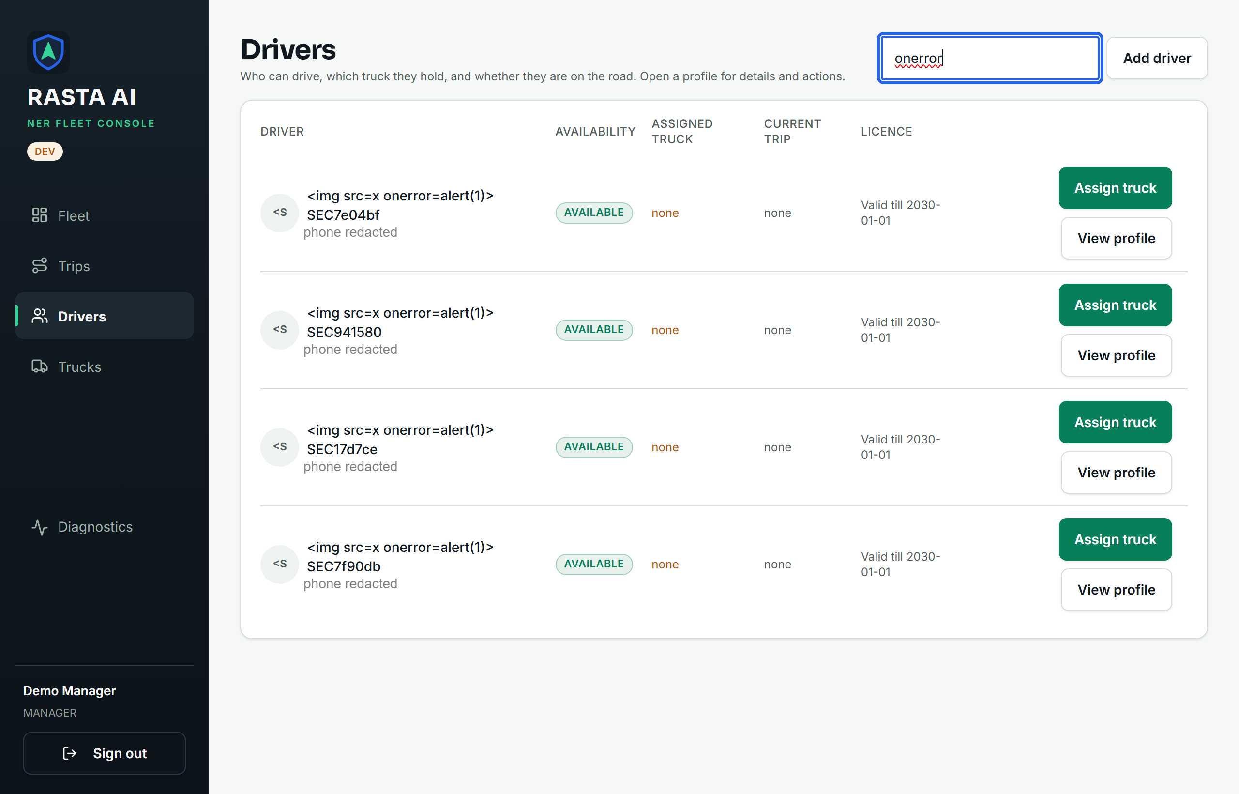
Figure 3. Manager Web Drivers page rendering four stored drivers whose names are the payload: literal text, no image element, no dialog.
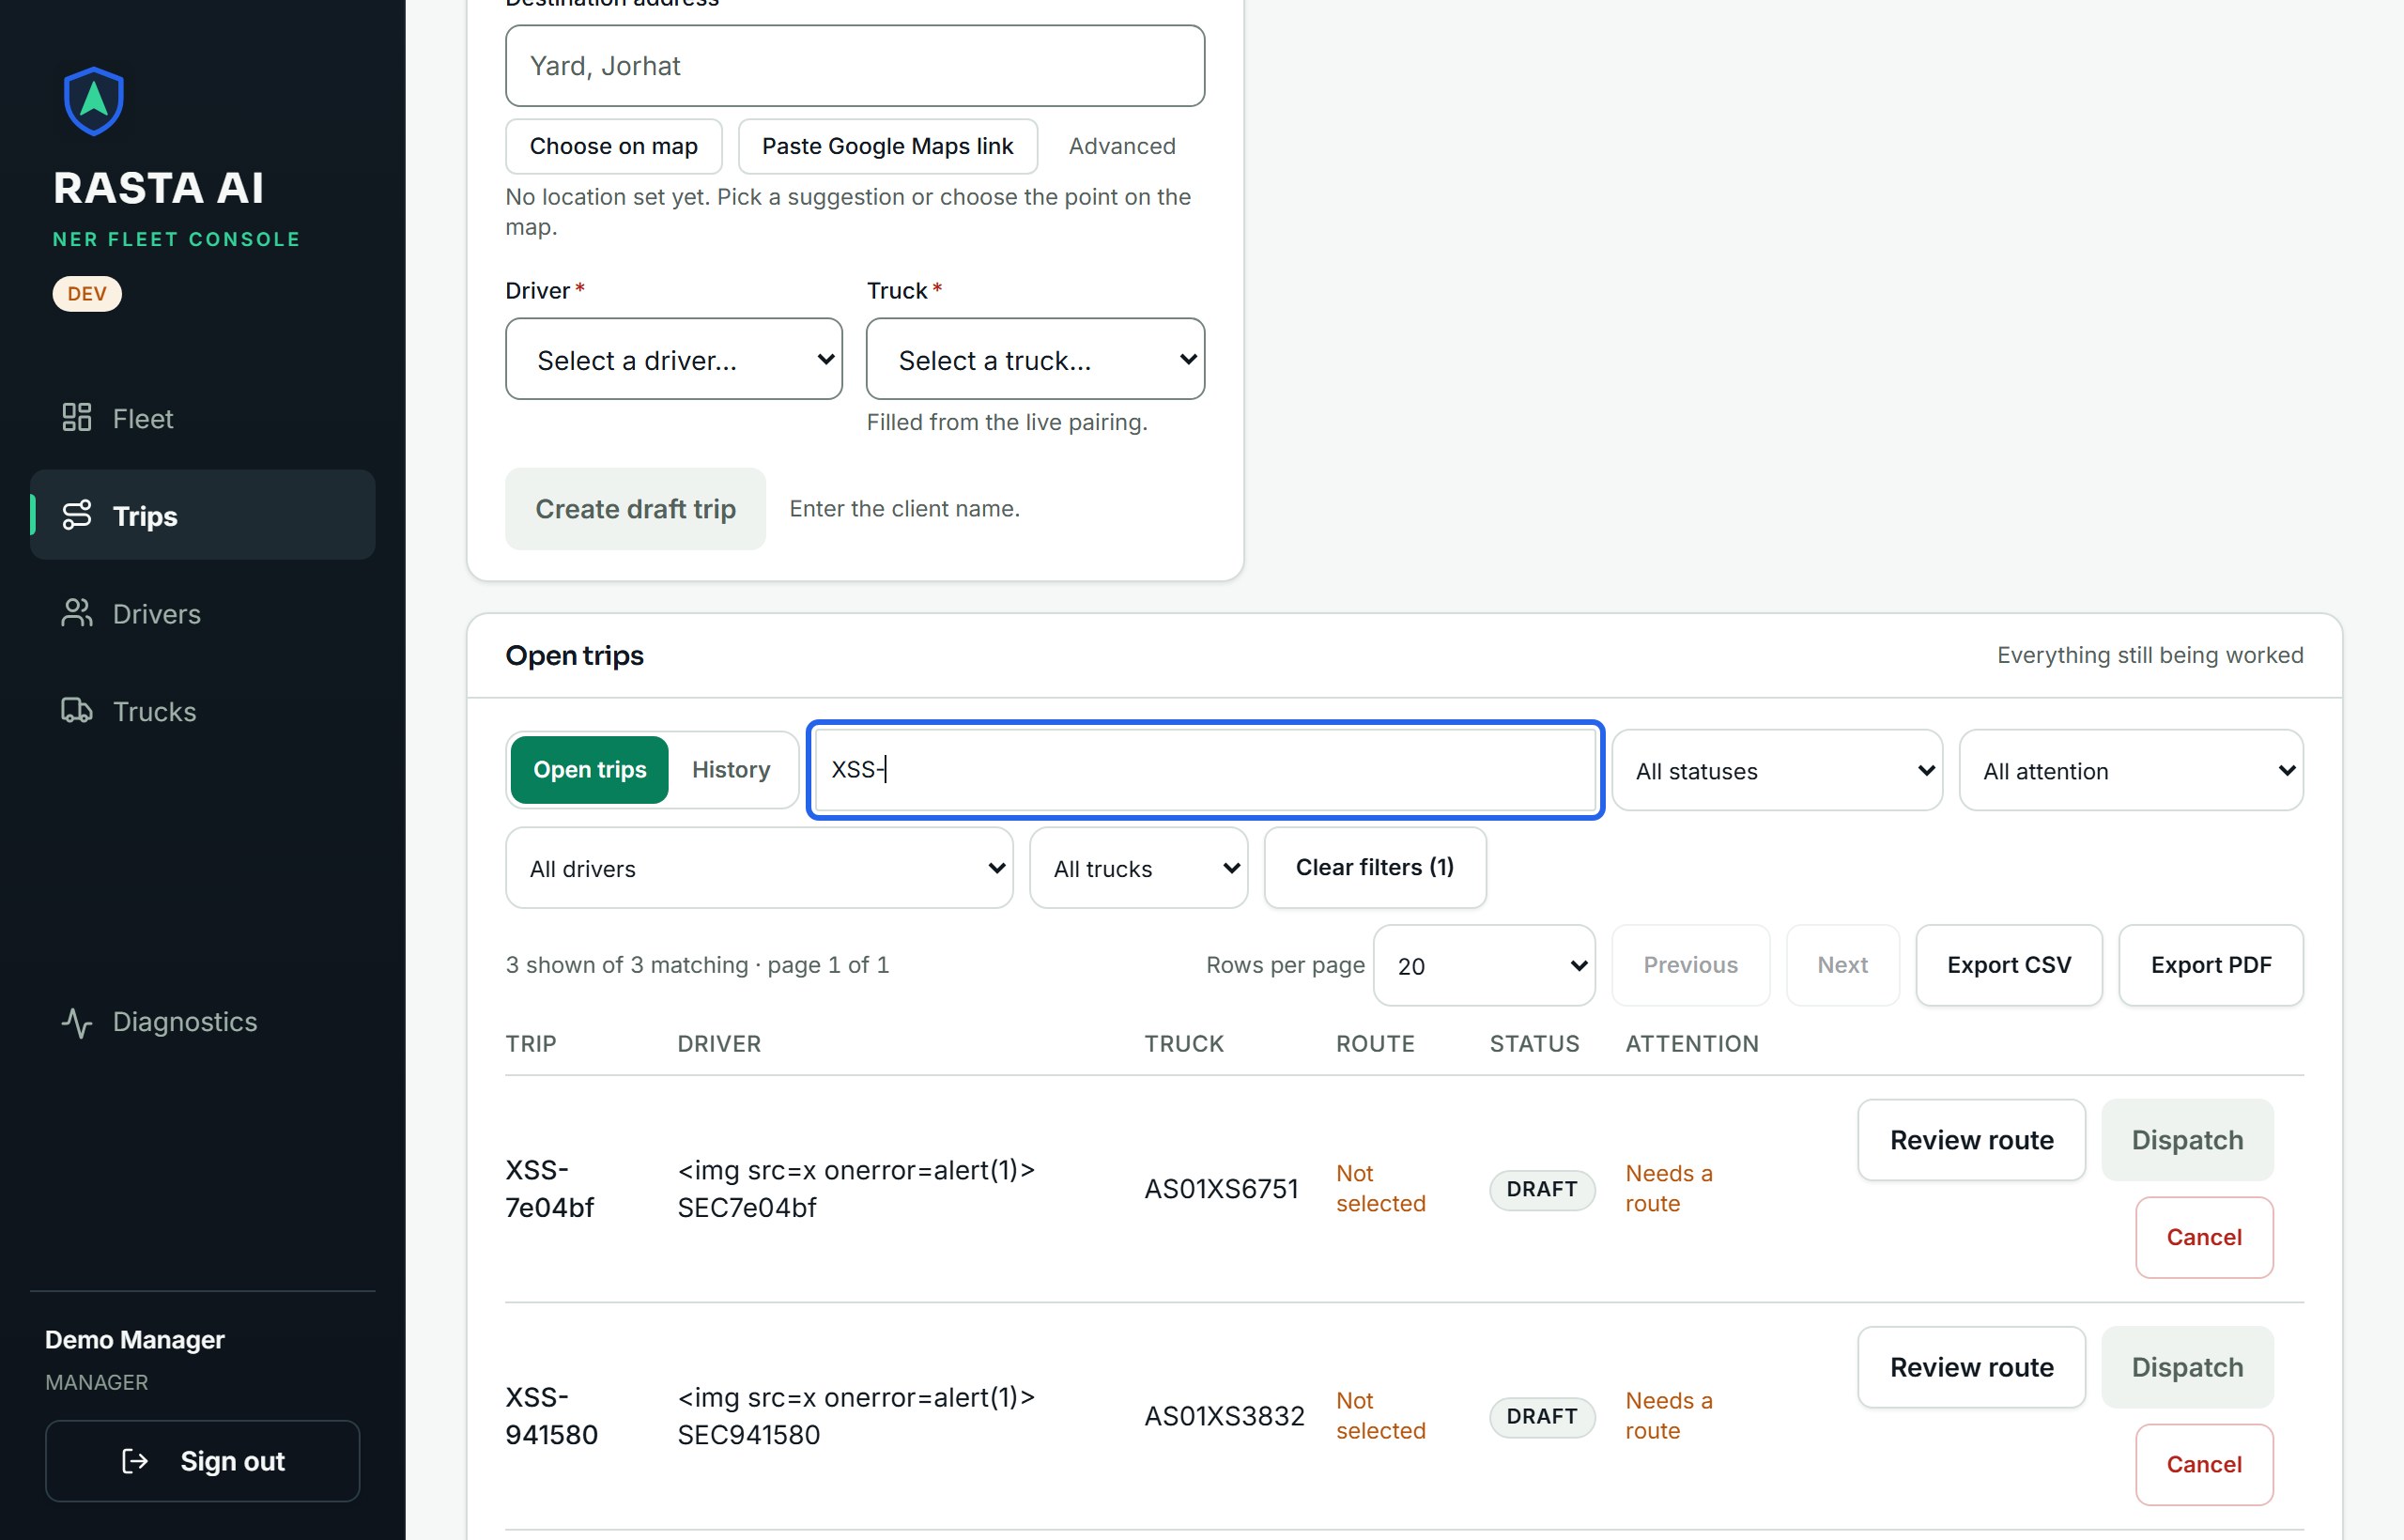
Figure 4. Manager Web Trips page filtered to the XSS trip: client name and addresses rendered as text.

8. Security misconfiguration
Check | Observed | Result
Debug mode / environment | DEBUG=False default; render.yaml sets APP_ENV=production; Settings refuses the placeholder SECRET_KEY outside development (tests/test_config.py) | PASS
Swagger / OpenAPI exposure | hosted /docs, /openapi.json, /redoc → 404 / 404 / 404; local development /docs → 200 (intended) | PASS (SEC-007 informational)
CORS | preflight from https://evil.example → no Access-Control-Allow-Origin; from http://localhost:5173 → exact origin with credentials, never *; hosted allow-list is the two static sites only | PASS
.env in version control | tracked: backend/.env.example, driver-app/.env.example, manager-web/.env.example only; every real .env is git-ignored | PASS
Secrets in the repository | project scanner over 75 untracked/modified files: 0 matches; full scan of 590 tracked text files: 15 DSN-pattern hits, all placeholders, .invalid hosts or localhost/CI throwaways (triage in evidence/secret_scan.txt) | PASS
Secrets in the built manager bundle | 0 service-role keys, 0 API keys, 0 DSNs, 0 source maps; the one JWT is the Supabase anon key (role=anon), the one sb_secret_ string is a prefix check inside the supabase-js library | PASS (SEC-011 informational)
Error responses / stack traces | malformed JSON → 422 envelope; a real database error seen during setup (clone lacked migration 0013) → 503 DATABASE_UNAVAILABLE with the traceback only in the server log; unhandled exceptions → 500 INTERNAL_ERROR by handler | PASS
/ready disclosure | reports provider: local and version strings only; no host, DSN or credential | PASS
Default credentials | none in source; seeded demo accounts live in git-ignored .runtime/ files | PASS
Supabase RLS | tests/test_rls_boundary.py (6 tests, in the passing suite): RLS enabled on every application table, no permissive policy, refresh tokens not exposed | PASS
Server header | local server: uvicorn (no version); hosted Server: cloudflare + x-render-origin-server: uvicorn | INFO
Test-only endpoints | demo simulation endpoints require trip:dispatch and DEMO_SIMULATION_ENABLED; no test-only route is reachable unauthenticated | PASS

Evidence: Figures 5, 6 and 7 (section 16) and evidence/secret_scan.txt.

9. File upload security
POST /api/files takes raw bytes (no multipart, no filename) and stores them in PostgreSQL by UUID, so there is no filesystem path for a name to traverse and no extension for a browser to trust. The type is decided by magic bytes only (JPEG FF D8 FF, PNG 89 50 4E 47…, PDF %PDF); anything else is 415.
Case | Observed | Result
Valid PNG (profile photo), PDF (document) as a driver | 201 image/png, 201 application/pdf | PASS
Text, HTML, SVG, GIF, empty body, MZ executable header, "JPEG but really text" | 415 UNSUPPORTED_FILE_TYPE for all seven | PASS
PDF uploaded as PROFILE_PHOTO | 415 | PASS
5 MB + 1 document; 600 KB profile photo | 413 FILE_TOO_LARGE; 413 PROFILE_PHOTO_TOO_LARGE | PASS
JPEG polyglot with <script> inside, then GET | stored as image/jpeg; served with Content-Type: image/jpeg, X-Content-Type-Options: nosniff (after SEC-001), Cache-Control: private, max-age=3600 | PASS (SEC-013 informational)
Driver A uploads with ?driver_id=<driver B> | 201; B's photo_url unchanged; the file is owned by A | PASS
Upload without a token | 401 | PASS
Driver B reads A's photo / manager reads it / A reads it / anonymous | 404 / 200 / 200 / 401 | PASS
Whole body buffered before the size check | reproduced by code review (await request.body()); fixed — Content-Length over the cap is refused before a byte is read, a chunked body is cut off at 5 MB + 1 (tests pull 0 and ≤ 6 of 20 offered chunks) | FIXED (SEC-004)

Evidence: Figure 8 (section 16).

10. Security headers
Before the assessment the API set no hardening headers at all (locally and on the hosted service), and the hosted static sites relied on Render's defaults (nosniff, HSTS) with nothing against framing. The fix adds one middleware in backend/app/main.py and a headers: block for both static services in render.yaml. A full script-src Content-Security-Policy for the manager was deliberately not added blind: the console loads Google Fonts, MapLibre workers and map tiles, and a wrong policy would blank the map during a demo; it is listed as a residual improvement.
Header | API before | API after (local, fixed) | Manager / driver web (hosted, before) | Manager / driver web (after deploy) | Status
X-Content-Type-Options | absent | nosniff | nosniff (Render default) | nosniff | FIXED / PASS
X-Frame-Options | absent | DENY | absent | DENY | FIXED
Content-Security-Policy | absent | frame-ancestors 'none' | absent | frame-ancestors 'none' | FIXED (frame-ancestors only)
Referrer-Policy | absent | no-referrer | absent | strict-origin-when-cross-origin | FIXED
Cache-Control on /api/* | absent (files: private, max-age=3600) | no-store (files keep private, max-age=3600) | public, max-age=0, s-maxage=300 (static, fine) | unchanged | FIXED
Strict-Transport-Security | absent | set outside development (max-age=31536000; includeSubDomains) | present (Render default) | present | FIXED
Permissions-Policy | not applicable to a JSON API | not set | absent | manager: camera=(), microphone=(), payment=(); driver web: camera=(self), microphone=(self), geolocation=(self), payment=() (it captures photos, speech and GPS) | FIXED

Hosted verification: the API at ner-intelligence.onrender.com and both static sites still answered with the pre-fix headers at the time of writing because the working tree has not been deployed; the probe records these two rows as FINDING (pending deploy) rather than PASS. Evidence: Figure 9 (section 16) and evidence/headers_before_after.txt.

11. Session management
Control | Observed | Result
Web login cookie (local, development) | ner_refresh=<REDACTED>; HttpOnly; Max-Age=2592000; Path=/api/auth; SameSite=strict; body refresh_token absent (null) | PASS
Web login cookie (hosted, production) | HttpOnly; Secure; SameSite=none; Path=/api/auth; Max-Age=2592000 (cross-site static host, so none+Secure by configuration) | PASS
Mobile login | refresh token in the body, no cookie set (stored in expo-secure-store on the phone; nothing persisted on the web target) | PASS
Access token lifetime | expires_at − now = 15.0 min; role and is_active re-read from the users row on every request | PASS
Refresh rotation and reuse detection | rotate → 200 with a different token; replay of the old token → 401; the newly issued token is then 401 too (family revoked) | PASS
Logout invalidation | 204, then refresh with the same token → 401 | PASS
Forged / broken bearer tokens | malformed, wrong signature, alg=none, expired, tampered role claim, refresh token presented as access token, random string → 401 for all seven | PASS
Disabled account | manager deactivates a driver → that driver's still-valid access token gets 401 Account is disabled. on the next request; login → 401 | PASS
Manager support-view token | GET /api/driver/me as the driver → 200; any POST with the same token → 403 Manager support view is read-only.; token lives 15 minutes and is carried in the URL fragment only | PASS
Web token storage | access token held in memory only; localStorage used solely for a non-sensitive offline page cache (connectivity.ts) | PASS (code review)

Evidence: Figure 10 (section 16).

12. API security
Authentication. All 81 operations outside /health, /ready and the three public auth routes answered 401 UNAUTHENTICATED without a token, including every POST, PATCH and DELETE with a random UUID in the path.
Authorisation and object boundaries.
Test | Observed | Result
Driver token on /api/trips, /api/shipments, /api/fleet/active, /api/emergencies/active, POST /api/drivers, POST /api/trucks, POST /api/emergencies/sweep | 403 everywhere | PASS
Driver A on GET /api/drivers/{B} | 404 (scoped getter; the id space is not an oracle) | PASS
Driver A on GET /api/drivers/{B}/documents | before: 200 with B's document rows — BOLA; after the fix: 404 Driver not found. | FIXED (SEC-002)
Driver lists GET /api/drivers / GET /api/trucks | drivers: 1 row (self); trucks before: the full register; after the fix: only the assigned truck (1 row vs 9 for the manager) | FIXED (SEC-003)
Manager token on /api/driver/me, /api/driver/me/trip, /api/driver/me/documents, /api/ai/status, POST /api/driver/me/location | 403 (a manager has no driver profile) | PASS
Driver B reads driver A's private file | 404 | PASS
Driver A acts on a stop of another driver's trip | 409 TRIP_NOT_IN_PROGRESS — the subject trip comes from the token, never from the path | PASS
Mass assignment: role, id, user_id on PATCH /api/drivers/{id}; status, id on POST /api/trips/plan | 422 (every request model is extra='forbid') | PASS
Unknown UUID / non-UUID | 404 / 422 | PASS
DELETE /api/drivers/{id}, PUT /api/trips | 405 | PASS
SSRF via POST /api/geocoding/resolve-link: loopback, 169.254.169.254, localhost, [::1], 10.0.0.1, file://, maps.google.com.evil.example, maps.google.com@evil.example | 400 NOT_A_MAPS_LINK for all eight before any request is made | PASS
Error leakage | uniform {"error":{code,message,details,request_id}} envelope; validation errors name the field, never the value | PASS
Idempotency / state transitions | covered by the existing suites (test_trip_state.py, test_concurrency.py, test_resource_reservation.py), all passing | PASS (existing tests)

Evidence: Figures 11 and 12 (section 16).

13. Excessive / improper API access
Check | Observed | Result
Page size bounds GET /api/trips?limit= | 0, -1, 999999, abc, 101 → 422; 100 → 200 (service also clamps to 100) | PASS
Track dump GET /api/trips/{id}/track?limit=100000 | 422 (max 1,000, since cursor for more) | PASS
Events GET /api/trips/{id}/events?limit= | max 200 by schema | PASS (review)
Sensitive fields | no password_hash in /api/auth/me or any list; base_salary_monthly requires driver:read_sensitive (ADMIN only); document numbers leave the API as •••• 1234 only | PASS
User enumeration | a driver's GET /api/drivers returns only their own row; POST /api/drivers → 403; login and logout answer identically for unknown and known identifiers | PASS
Another driver's trip / files / documents | 404 / 404 / 404 (after SEC-002) | PASS
Whole fleet register readable by a driver | before: yes; after SEC-003: only assigned trucks | FIXED
Mass export | CSV/PDF export is client-side over pages the manager can already list; no export endpoint exists | PASS
Rate-limit abuse | login: 20/min per address and 10/min per identifier (counted before Argon2 runs); refresh: 60/min per address; GPS ingestion deliberately unlimited (per-route limiter, never global) | PASS / SEC-006

Authentication rate limiting. Eleven wrong passwords on one identifier: ten 401 then 429 RATE_LIMITED with Retry-After: 60. Because every earlier login in the run shares the address budget, the probe waited 61 s first and the first attempt after the wait was 401 again — the fixed window recovers. Per-address limits, window arithmetic and identifier case-folding are covered by tests/test_rate_limit.py (18 tests, clock injected, passing). Evidence: Figure 13 (section 16).

14. Issues found & remediation

SEC-001 — API responses carried no security headers
Category Missing / weak security headers · Severity Low · Status FIXED (local); hosted pending deploy
Affected component FastAPI backend, every response · File backend/app/main.py
Description GET /api/auth/me (and every other route) answered without X-Content-Type-Options, X-Frame-Options/frame-ancestors, Referrer-Policy, Cache-Control or HSTS. Stored user files were served inline without nosniff.
Reproduction curl -sI http://127.0.0.1:8020/api/auth/me (baseline) and the same against https://ner-intelligence.onrender.com.
Evidence evidence/headers_before_after.txt, evidence/probe_prefix_baseline.txt (SEC-HDR-001 FAIL), Figure 9.
Impact Low: bearer tokens are never in a URL and the API returns JSON, so the practical exposure was the absence of defence in depth — a polyglot image could in principle be sniffed by an old browser, and a proxy could cache an authenticated JSON body.
Root cause No response-hardening layer existed; the project's rule against app-wide authorisation middleware had been read as a rule against any middleware.
Fix applied One @app.middleware("http") setting nosniff, X-Frame-Options: DENY, Content-Security-Policy: frame-ancestors 'none', Referrer-Policy: no-referrer, Cache-Control: no-store on /api/* (with setdefault, so /api/files keeps its avatar cache policy) and HSTS outside development.
Regression test tests/test_security_assessment.py::TestSecurityHeaders (2 tests) · Retest probe SEC-HDR-001 PASS, SEC-UP-005 PASS; hosted rows remain FINDING until deployed.

SEC-002 — Any driver could read another driver's document metadata
Category API security (BOLA / IDOR) · Severity Medium · Status FIXED
Affected endpoint GET /api/drivers/{driver_id}/documents · File backend/app/api/documents.py
Description The route required driver:read, which the DRIVER role holds for its own row, but did not resolve the target driver through the scoped getter that GET /api/drivers/{id} uses. A driver could therefore request any driver id and receive that driver's document types, issue and expiry dates, status and masked numbers (•••• 1234).
Reproduction Log in as driver A, GET /api/drivers/{B}/documents → 200 [...] (baseline probe SEC-API-005).
Evidence evidence/probe_prefix_baseline.txt line FAIL SEC-API-005 … 200; after the fix evidence/probe_postfix.txt PASS … 404; Figure 12.
Impact Medium, not High: the exposed rows are limited metadata about identity documents of other drivers (numbers masked, file bytes still protected by the file endpoint's ownership check), reachable only with a valid driver account. It is still personal data crossing an ownership boundary.
Root cause Object-level scoping was implemented in drivers.get() but this route queried DriverDocument directly by the path id.
Fix applied The route now calls driver_service.get(db, driver_id, actor=actor) first, which raises 404 for any driver the actor may not see, before selecting documents. Managers and reviewers are unaffected.
Regression test TestDriverDocumentsAreScoped (2 tests: other driver → 404, manager still 200) · Retest probe SEC-API-005 PASS.

SEC-003 — DRIVER role could read the whole truck register
Category Excessive / improper API access · Severity Low · Status FIXED
Affected endpoints GET /api/trucks, GET /api/trucks/{id} · Files backend/app/services/trucks.py, backend/app/api/fleet.py
Description DRIVER holds truck:read so it can load its own truck's photo, but list_trucks() and get() took no actor and returned every truck (registration numbers, capacity, make/model, photo URLs) to any driver.
Reproduction Driver token on GET /api/trucks → 200 with the fleet's rows (exploratory run); code review of list_trucks (no actor parameter).
Evidence Figure 12 (after: 1 row for the driver vs 9 for the manager); evidence/regression_tests.txt.
Impact Low: fleet asset data, not personal data, but well beyond what a driver needs and inconsistent with the project's own "a driver reads their own records" rule.
Root cause Scoping was written for drivers and assignments but never for trucks.
Fix applied _own_trucks(actor) — an IN (select truck_id from open assignments of this user) predicate — applied in both list_trucks and get when the actor is a DRIVER; the API passes actor through. Every other caller of get is unchanged (actor defaults to None).
Regression test TestTruckRegisterIsScopedForDrivers (2 tests) · Retest probe SEC-XS-004 PASS.

SEC-004 — Upload body buffered in full before the size check
Category Insecure file upload · Severity Low · Status FIXED
Affected endpoint POST /api/files · File backend/app/api/files.py
Description data = await request.body() read the entire request into memory and only then compared it with the 5 MB cap; the module docstring claimed "reading at most 5 MB + 1", which was not what the code did. An authenticated client could make one request cost the process hundreds of megabytes before receiving 413.
Reproduction Code review; the new tests offer a 20 MB body and count how many chunks the server pulls.
Evidence evidence/regression_tests.txt — both upload tests fail on the old code, pass on the new.
Impact Low: requires an authenticated account and the process runs one worker, so the effect is a self-inflicted slowdown rather than data exposure; Render's edge also caps request bodies.
Root cause Convenience API used where a bounded stream read was intended.
Fix applied A declared Content-Length above the cap is refused before any byte is read; otherwise the body is accumulated from request.stream() and the request is rejected the moment it exceeds 5 MB + 1.
Regression test TestUploadIsBoundedBeforeItIsBuffered (2 tests: 0 chunks pulled with a declared length; ≤ 6 of 20 pulled when chunked) · Retest probe SEC-UP-004 PASS.

SEC-005 — Hosted static sites lacked clickjacking and referrer headers
Category Missing / weak security headers · Severity Low · Status FIXED (pending deploy)
Affected components ner-manager.onrender.com, ner-driver-web.onrender.com · File render.yaml
Description manager-web/vercel.json and netlify.toml carry X-Frame-Options, Referrer-Policy and nosniff, but the Render blueprint — the deployment that is actually live — had no headers: block, so the manager console could be framed by any site.
Reproduction curl -sI https://ner-manager.onrender.com/ → HSTS and nosniff only.
Evidence evidence/headers_before_after.txt, Figure 9.
Impact Low: the console needs a live session and every mutating action is a server call, so a clickjacking page could at most trick a signed-in manager into a click; no credential is exposed.
Root cause Three deployment descriptors with different header sets; the canonical one was the incomplete one.
Fix applied headers: on both Render static services: X-Frame-Options: DENY, Content-Security-Policy: frame-ancestors 'none', Referrer-Policy: strict-origin-when-cross-origin, Permissions-Policy (manager denies camera/microphone/payment; driver web keeps camera=(self), microphone=(self), geolocation=(self) because it captures photos, speech and GPS).
Regression test none possible offline; verify after deploy with the same curl -sI (section 19, action 1) · Retest pending deploy.

SEC-006 — Login rate limiter keys on the TCP peer behind a proxy
Category Session management / API security · Severity Low · Status OPEN
Affected component backend/app/core/rate_limit.py, backend/app/api/auth.py; backend/Dockerfile (uvicorn without --forwarded-allow-ips)
Description The limiter deliberately keys on request.client.host and ignores X-Forwarded-For (which a client can forge). On Render every request arrives from the platform proxy, so the per-address budget of 20 logins per minute is shared by every user of the hosted service, and twenty junk requests a minute from anyone keep it exhausted. The per-identifier budget (10/min per account) is unaffected and still stops password guessing on any one account. The trade-off is written in the module's docstring.
Reproduction Not exercised against the hosted service on purpose: proving it would lock the team out of the demo. Established by code review and uvicorn's default of trusting forwarded headers from loopback only.
Impact Low: availability of hosted login under hostile traffic; no confidentiality impact. Also a false sense of per-address protection.
Remediation Run uvicorn with --proxy-headers --forwarded-allow-ips=<Render proxy range> or take the client address from the header Render's edge sets after stripping client-supplied copies (the rightmost trusted hop, never the leftmost value), then key the limiter on that. Keep the per-identifier limit as the primary control until then.

SEC-007 … SEC-013 — Informational
ID | Observation | Disposition
SEC-007 | Swagger and /openapi.json are served when APP_ENV=development | Intended; both are None in every other environment and the hosted service answers 404 (verified)
SEC-008 | Leaflet 1.9.4 JS/CSS loaded from unpkg inside the driver map WebView without SRI | The WebView holds no token and talks only to tile servers; add integrity attributes or vendor the 40 KB file
SEC-009 | npm audit: Manager Web 2 moderate (vitest/@vitest/mocker, dev only, 0 in production); Driver App 10 moderate, all in the Expo build toolchain (xcode → uuid), 0 in shipped code | Track upstream Expo release; npm audit fix --force would change Expo majors and was not applied
SEC-010 | %/_ unescaped in ILIKE searches | Harmless: the caller can already list the same rows; add escape='\\' if search semantics ever matter
SEC-011 | Supabase anon key inlined in the manager bundle | Publishable by design; the Data API is protected by RLS (tests/test_rls_boundary.py) and the hosted manager talks only to the FastAPI service
SEC-012 | Web login body includes "refresh_token": null | The value is never present; the key could be dropped with exclude_none
SEC-013 | A valid-magic JPEG/PNG with HTML inside is accepted | Served with the sniffed image type and nosniff (SEC-001), never as HTML; a re-encode on upload would remove the payload entirely

15. Test results
All results are from the runs of 19 September 2026 after the fixes were applied.
Suite | Command | Result
Backend | pytest on the isolated cluster (ner_logistics_test) | 1,246 passed, 5 skipped in 216.8 s (skips: 4 destructive migration tests gated by RUN_DESTRUCTIVE_MIGRATION_TESTS, 1 non-Windows event-loop test)
Backend — security regression | pytest tests/test_security_assessment.py | 8 passed; with the fixes temporarily reverted: 6 failed, 2 passed (the two "manager still sees" controls)
Manager | npm test | 261 passed (24 files), including the new tripExport XSS case
Manager | npm run typecheck (tsc -b --noEmit) | clean, exit 0
Manager | npm run build (tsc -b && vite build) | built in 0.67 s (chunk-size warning only)
Driver | npm test | 624 passed (54 files)
Driver | npm run typecheck (tsc --noEmit) | clean, exit 0
Security-specific | security_probe.py (49 cases) | 46 PASS, 1 INFO, 2 FINDING (hosted headers, pending deploy); baseline before fixes: SEC-HDR-001 FAIL, SEC-UP-005 FINDING, SEC-API-005 FAIL, trucks unscoped
Security-specific | xss_browser_check.mjs | 4/4 PASS (login, drivers, trips, trucks)
Static | scripts/secret_scan.py; full tracked scan; bundle scan | 0 / 0 real / 0
Dependencies | npm audit (prod and full) | Manager 0 prod, 2 moderate dev; Driver 10 moderate (build toolchain); pip-audit not installed — not run

Evidence: Figures 14 and 15 (section 16) and the raw captures listed there.

16. Evidence gallery
All figures are in docs/submission/day2/task2/evidence/. Cards were rendered from the run's own output files (results.json, pytest/npm/curl captures) by render_evidence.mjs; the two console screenshots were taken by xss_browser_check.mjs in headless Chrome. No credential, token or key appears in any of them.
Figure | File | Shows
1 | 01_scope_environment.png | branch/HEAD, targets, database, accounts, tools, exclusions
2 | 02_sqli_test.png | SQL injection cases SEC-SQLI-001 … 007
3, 4 | 03_xss_test.png, 03b_xss_trips.png | stored payloads rendered inert in the Manager Web
5, 6, 7 | 10_secret_scan.png, 10b_secret_scan_full.png, 10c_bundle_dependencies.png | configuration checks, repository secret scans, bundle scan, dependency audit
8 | 05_file_upload_validation.png | upload typing, caps, ownership
9 | 04_security_headers.png | header rows plus the curl before/after capture
10 | 06_session_security.png | cookie flags, rotation, replay, logout, forged tokens, disabled account
11 | 07_api_unauthorized_access.png | 81/81 → 401, wrong role, SSRF, methods
12 | 08_api_role_access.png | object boundaries after the fixes, pagination, minimisation
13 | 09_rate_limit.png | 10 × 401 then 429, Retry-After 60, window recovery
14 | 11_security_tests.png | regression tests failing without the fix, passing with it
15 | 12_final_regression.png | full backend, manager and driver results
— | probe_prefix_baseline.txt, probe_postfix.txt, results.json | raw probe output before and after the fixes
— | headers_before_after.txt, secret_scan.txt, dependency_audit.txt, regression_tests.txt, backend_full_suite.txt, manager_regression.txt, driver_regression.txt, xss_browser_results.json | raw captures behind the cards

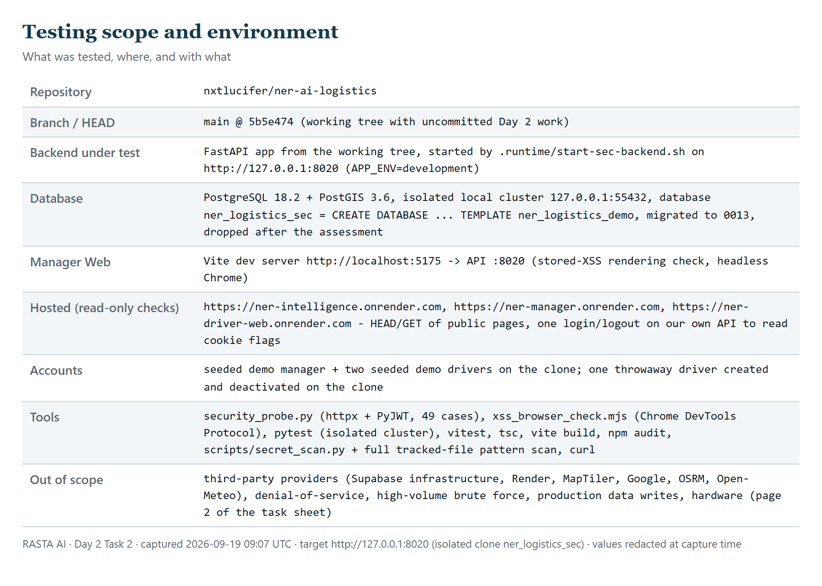
Figure 1. Testing scope and environment card generated from the run (git state, targets, database, tools, exclusions).
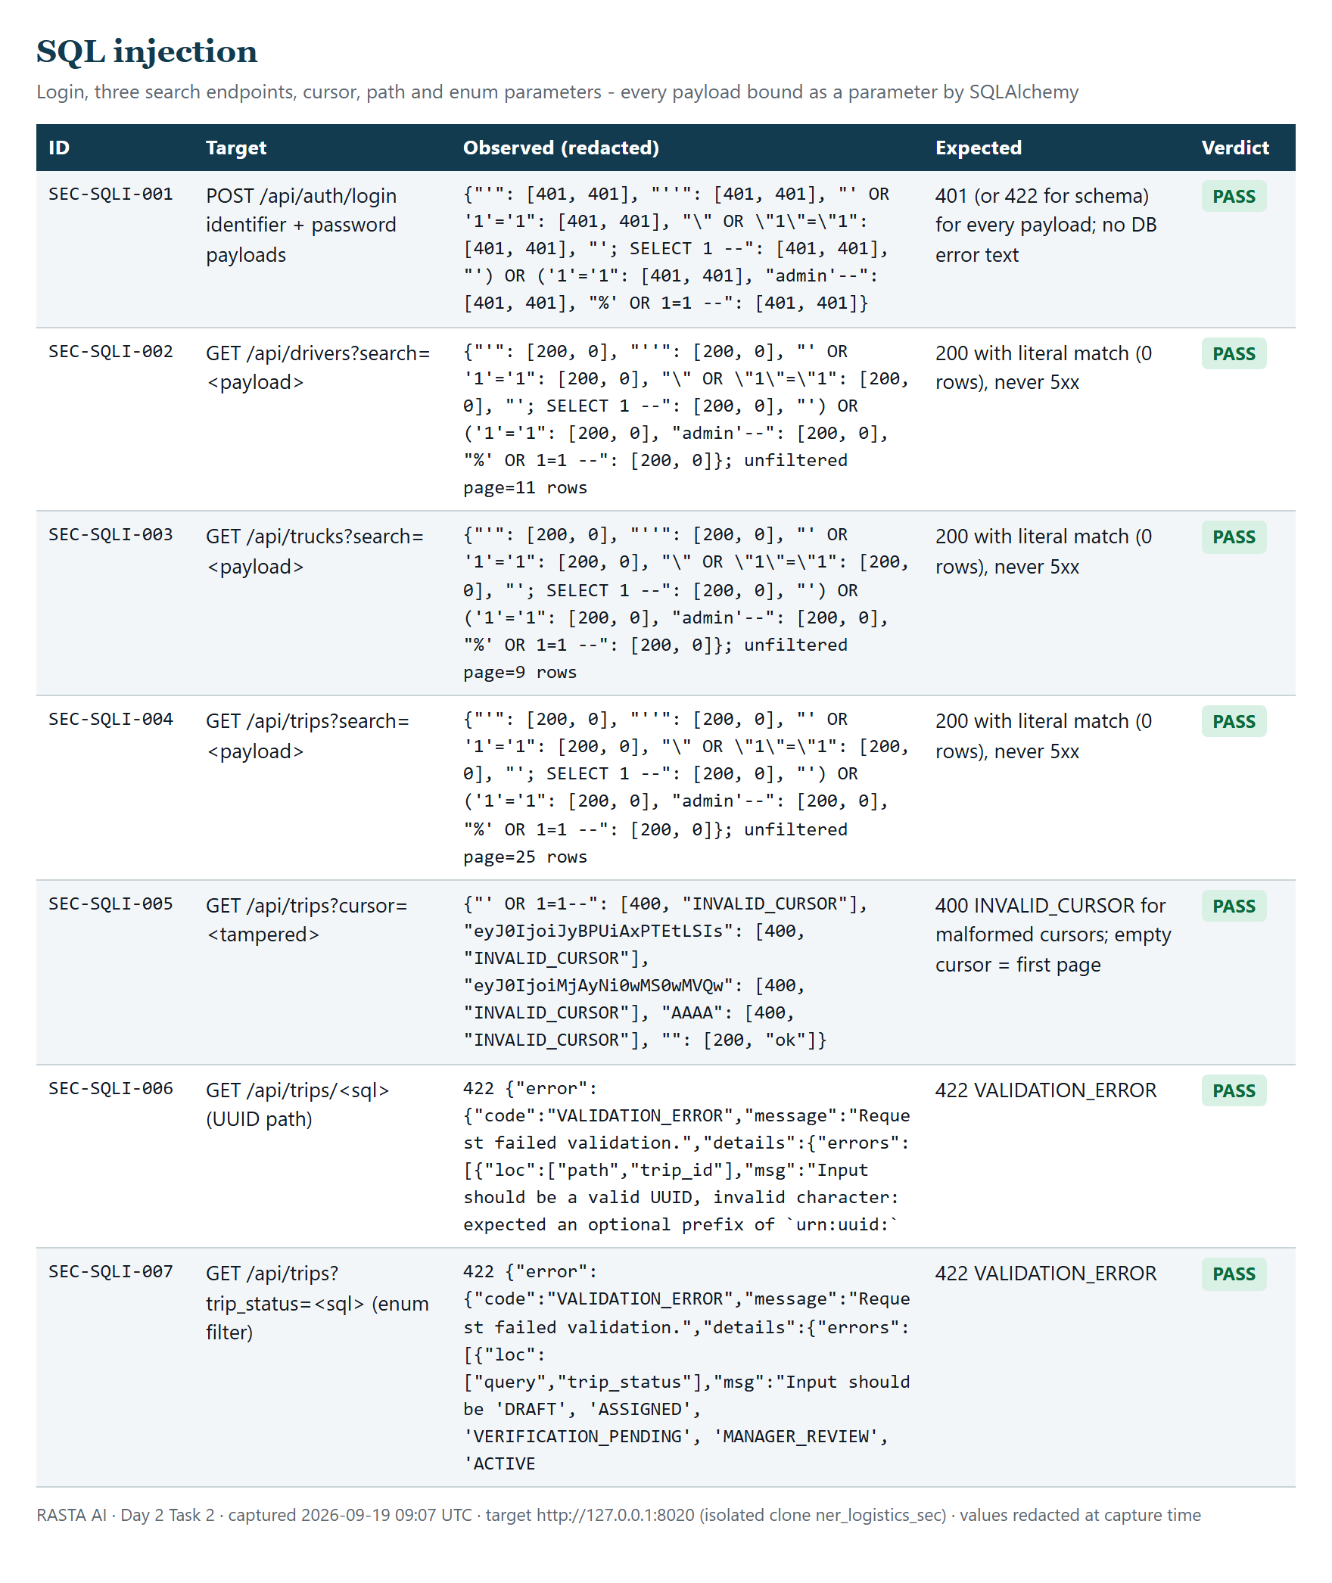
Figure 2. SQL injection probe results (SEC-SQLI-001 … 007): every payload bound as a parameter; 401/400/422 or a literal zero-row search.
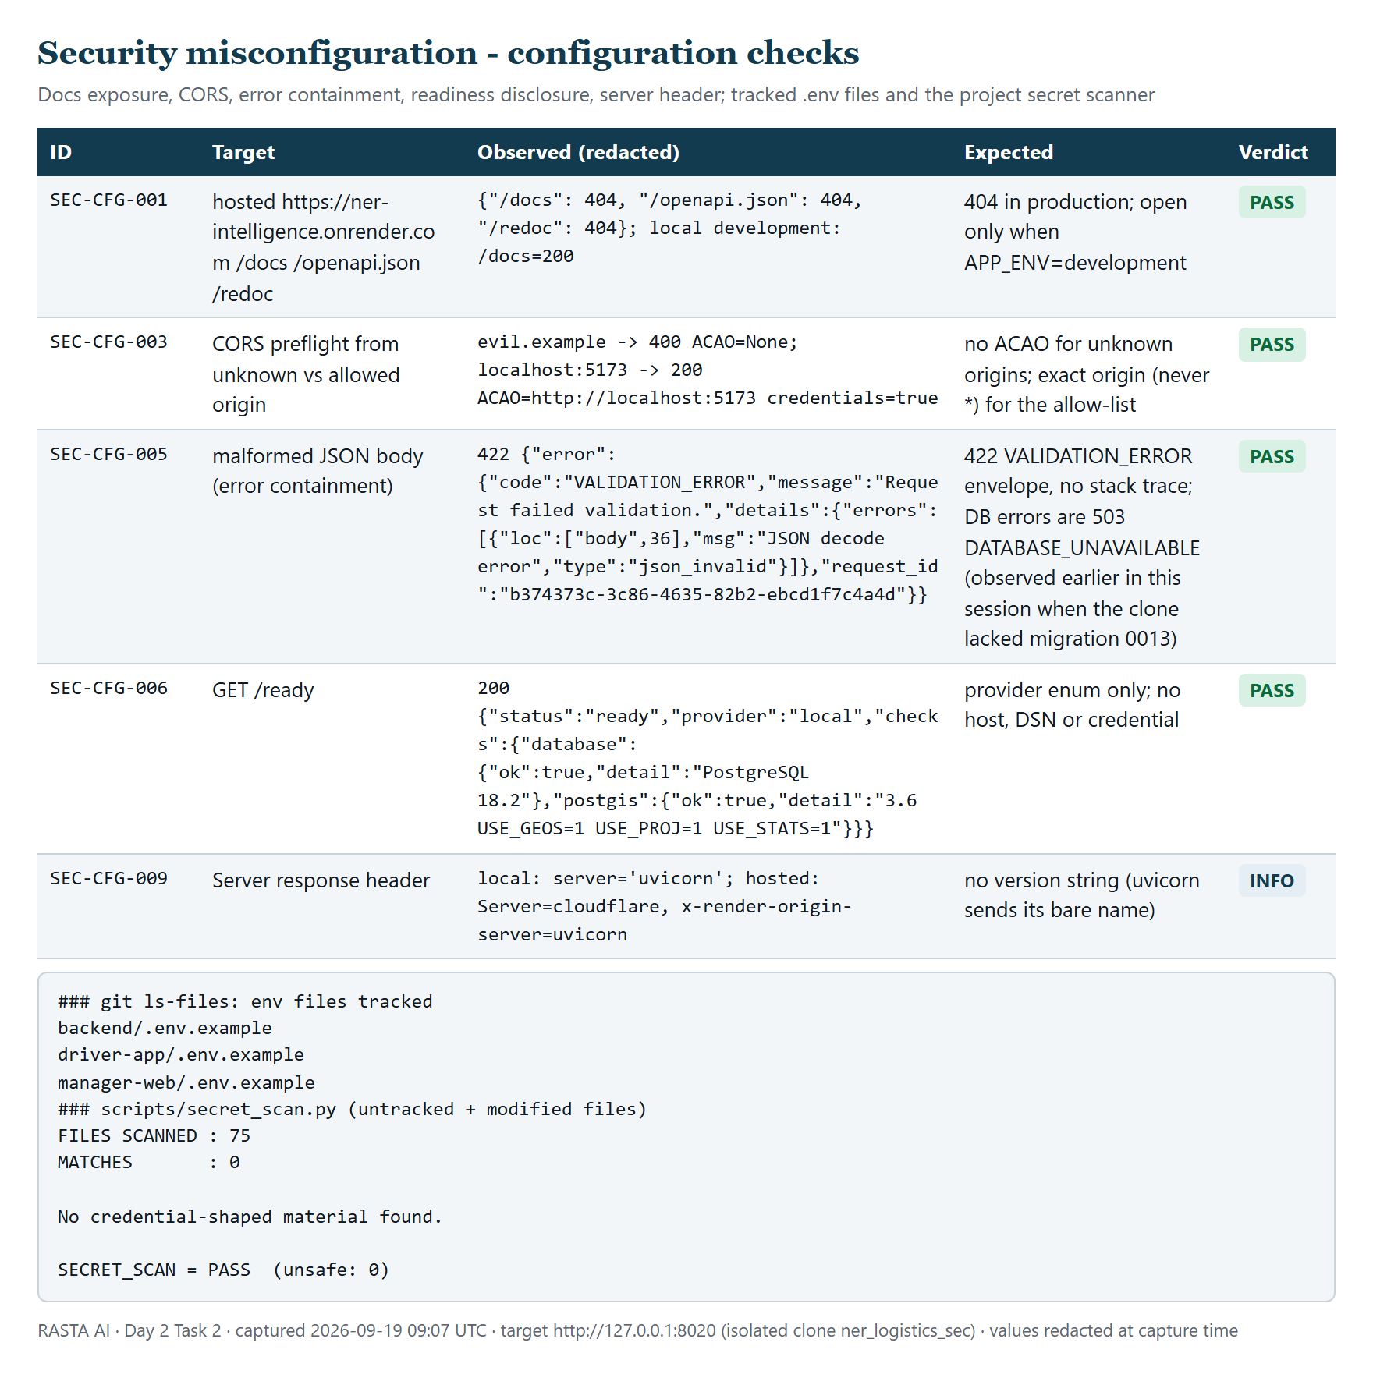
Figure 5. Configuration checks (docs exposure, CORS, error containment, readiness, server header), tracked .env files and the project secret scanner.
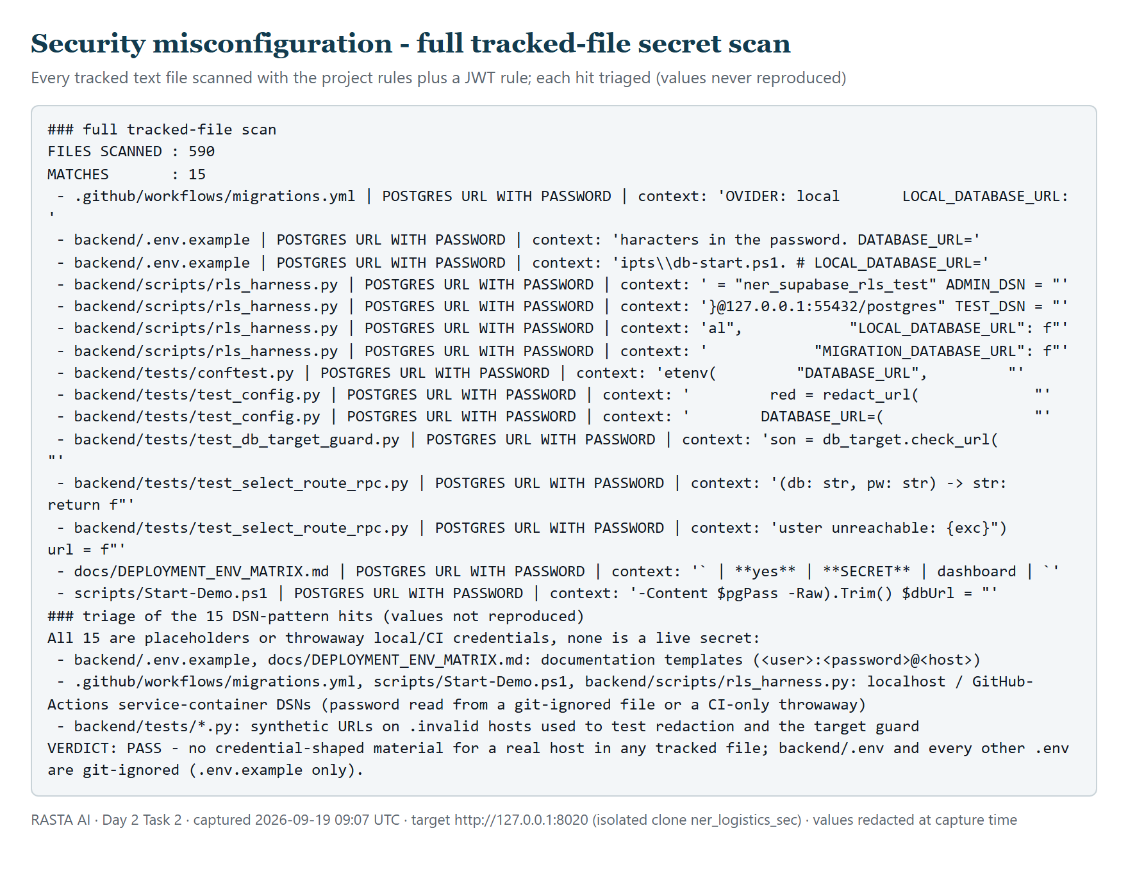
Figure 6. Full tracked-file secret scan: 590 files, 15 pattern hits, every one a placeholder, an .invalid host or a localhost/CI throwaway.
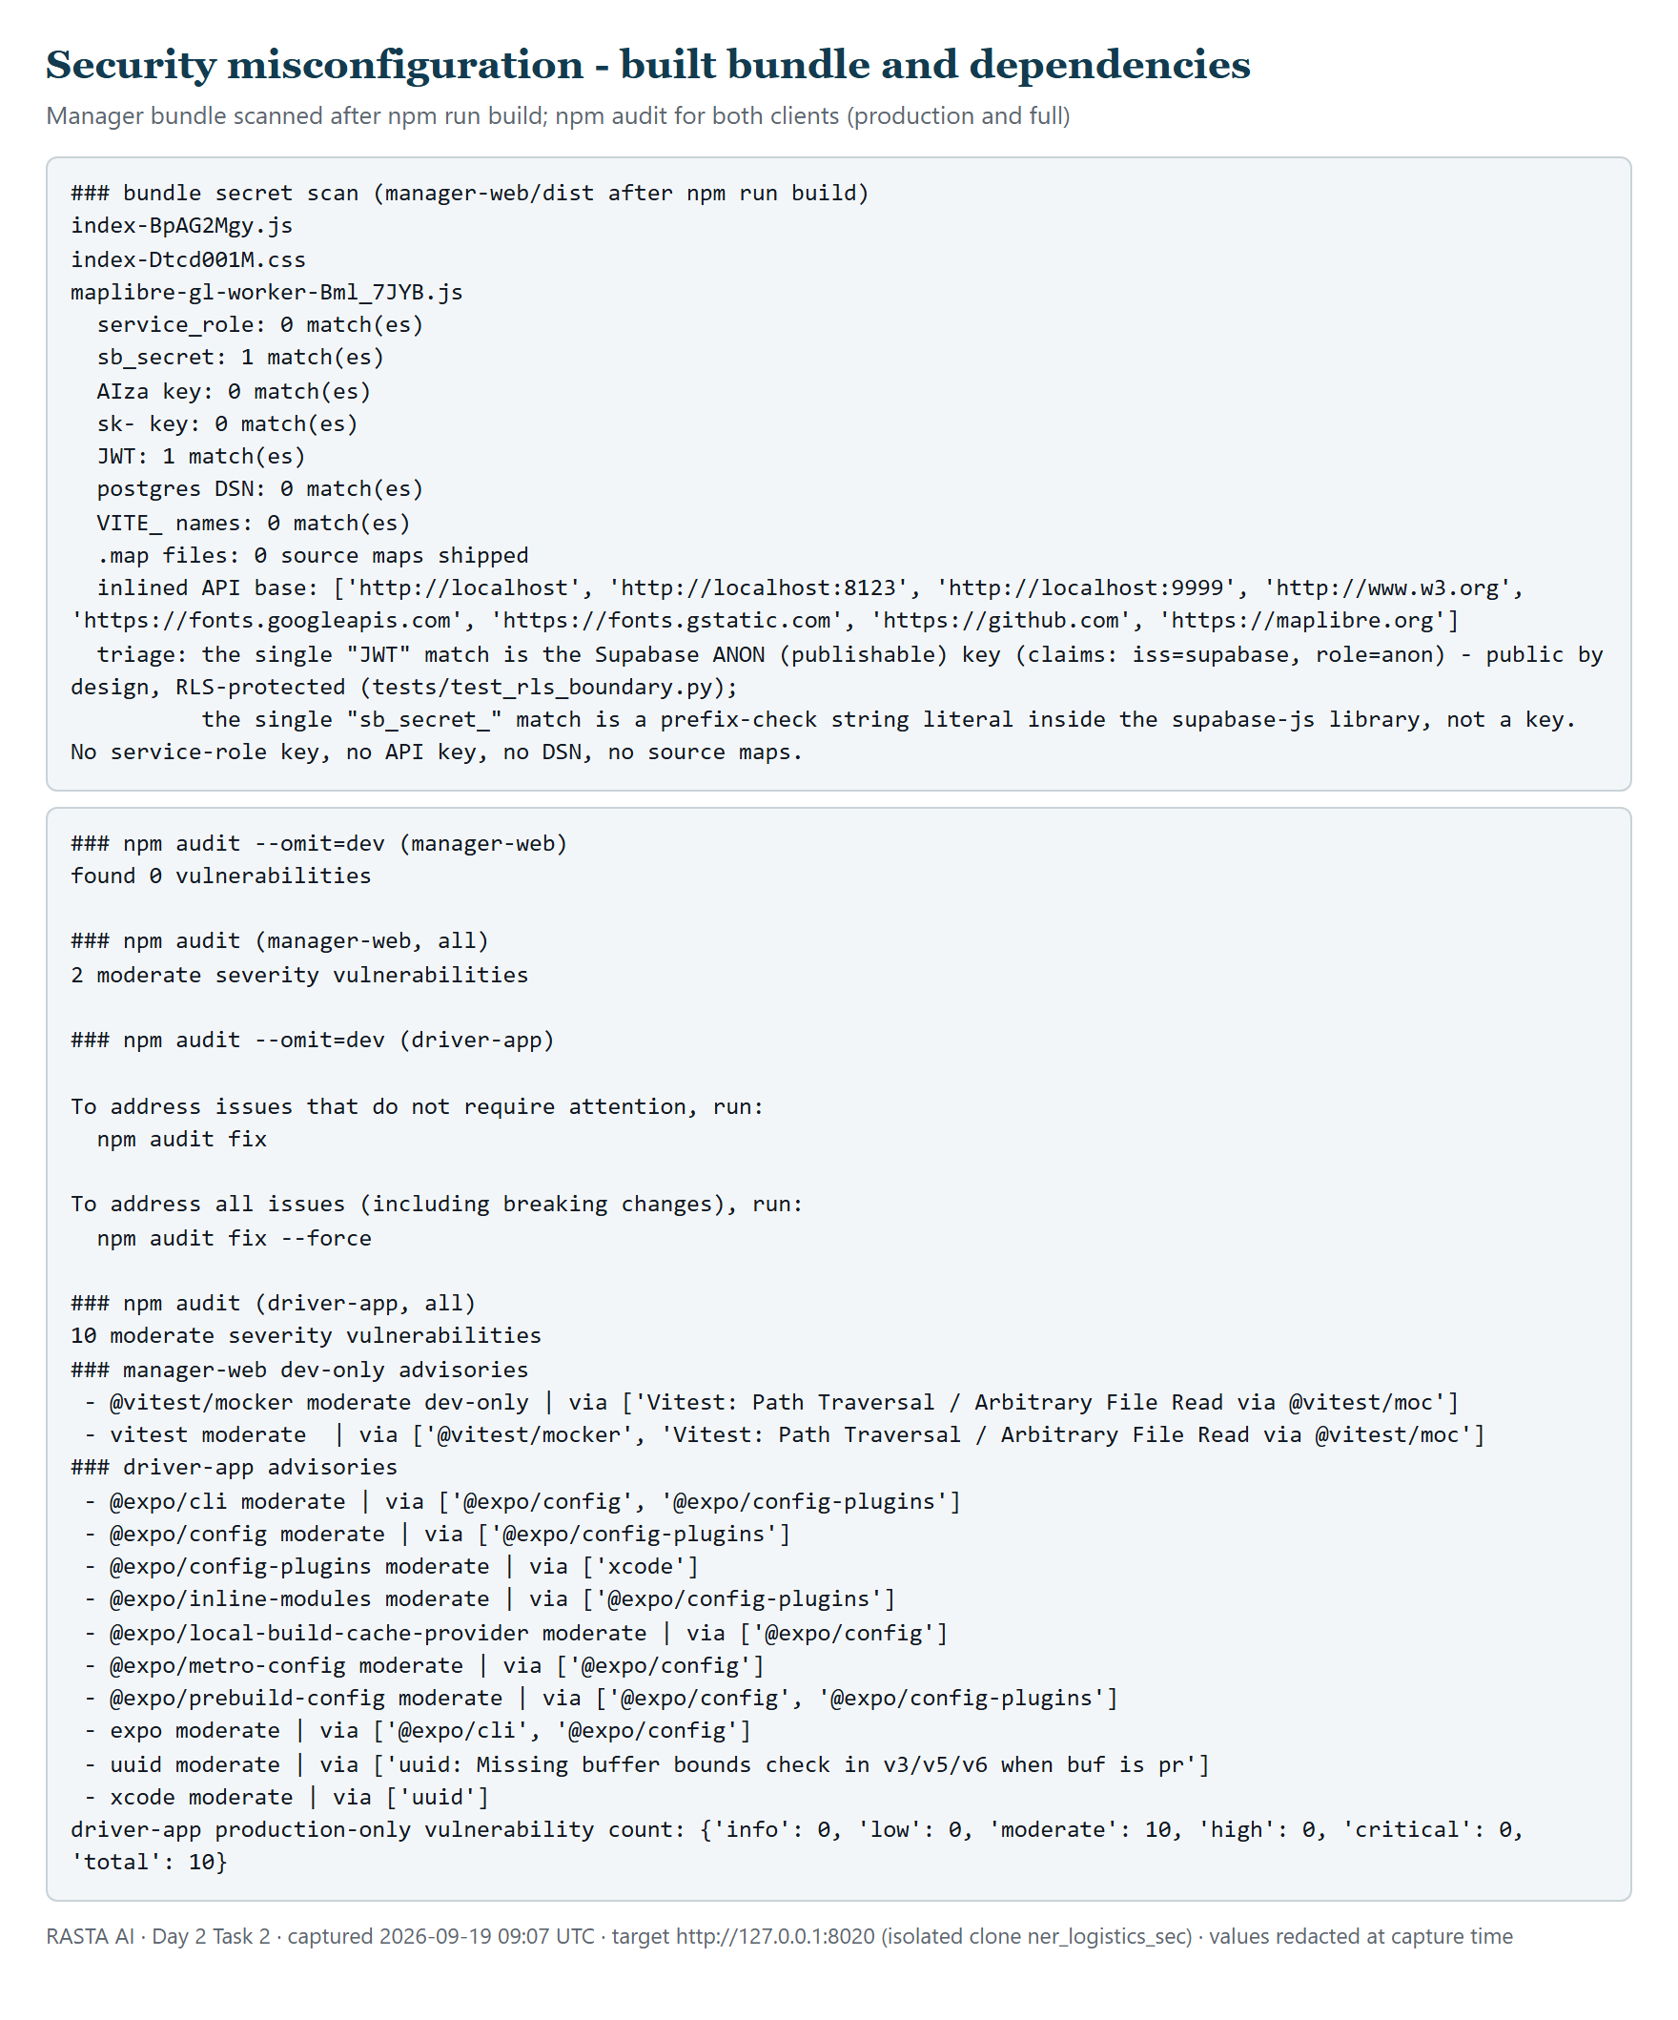
Figure 7. Built manager bundle scan and npm audit for both clients.
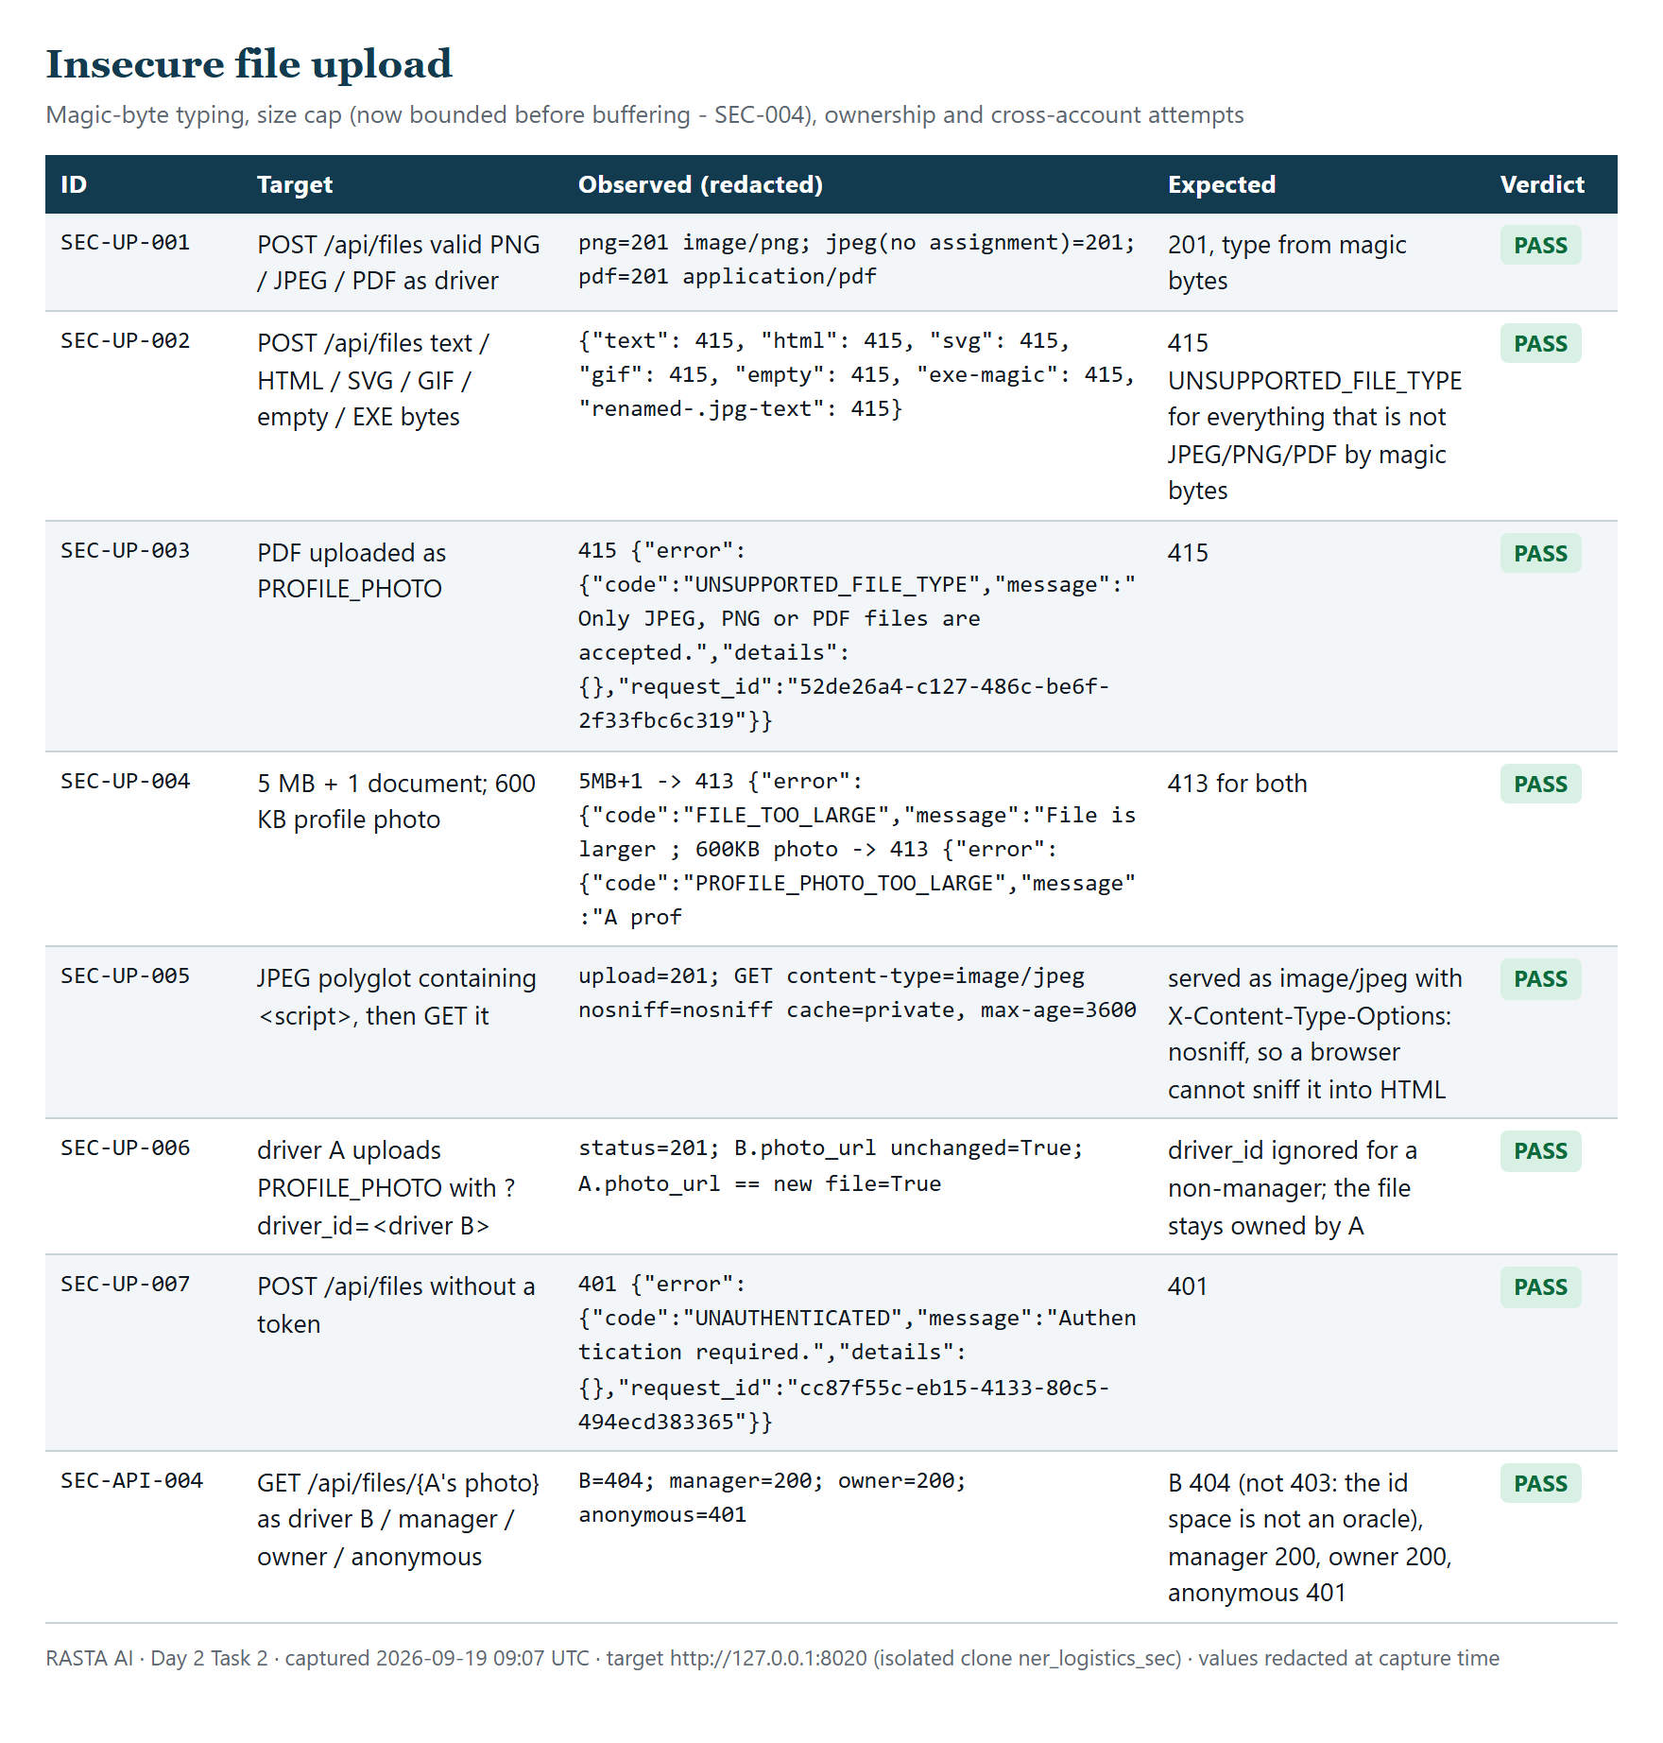
Figure 8. File upload probe results: magic-byte typing, size caps, ownership and cross-account attempts.
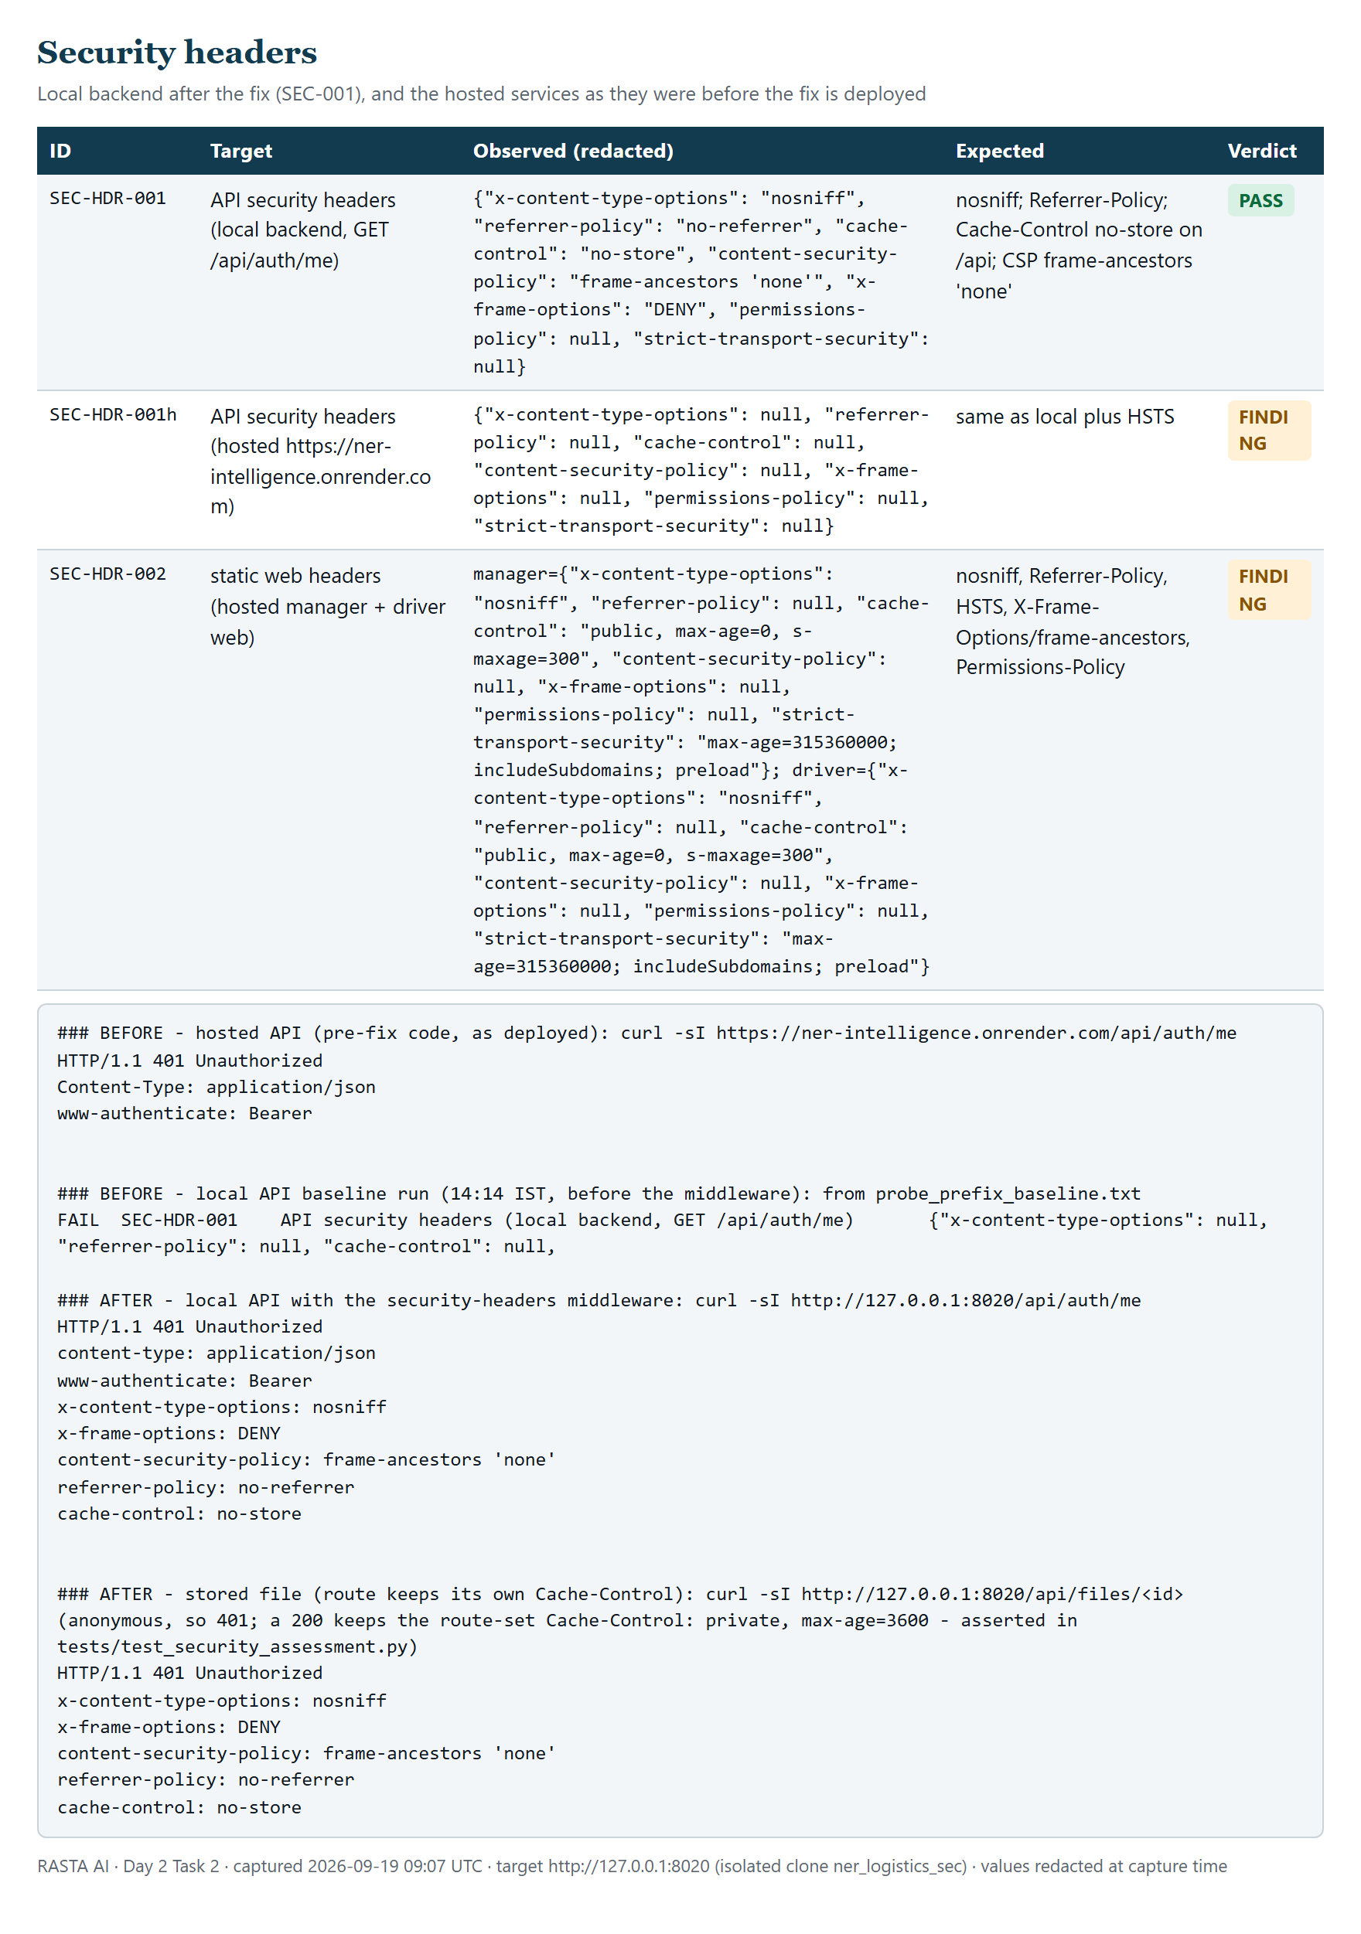
Figure 9. Security header matrix: probe rows for the fixed local API and the hosted services, with the curl before/after capture.
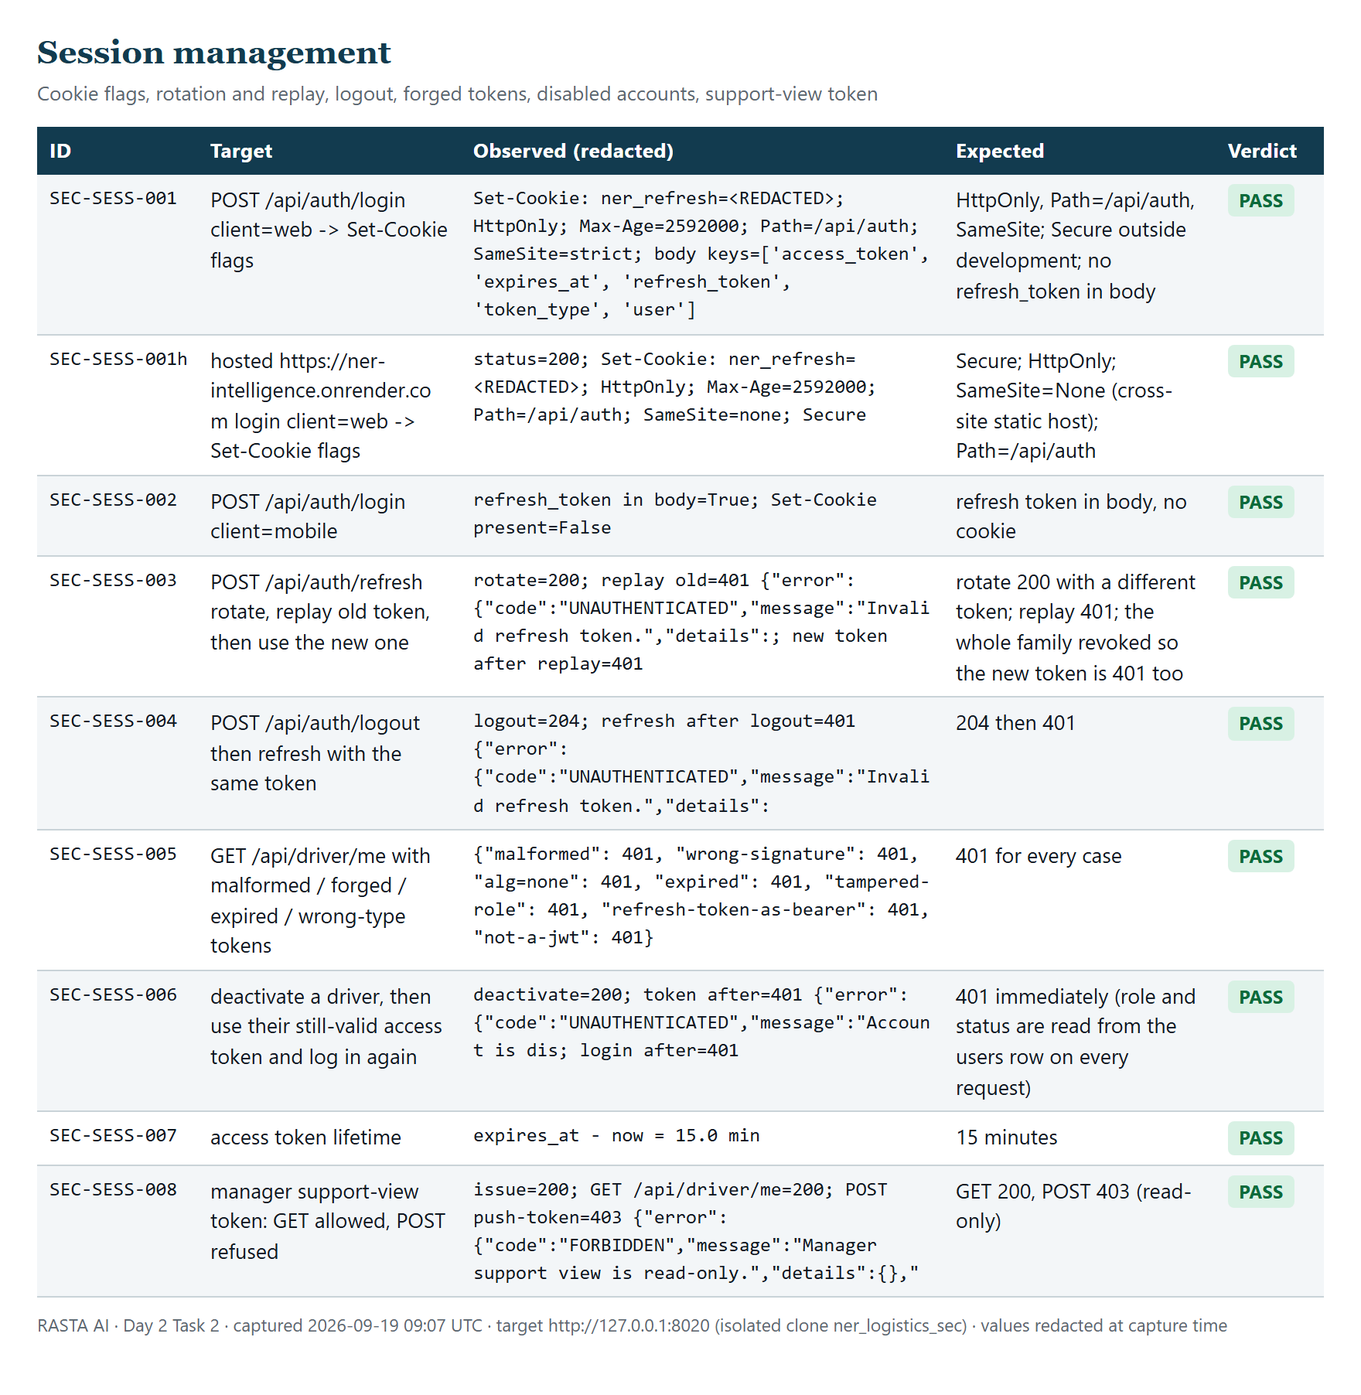
Figure 10. Session management probe results: cookie flags (local and hosted), rotation/replay, logout, forged tokens, disabled account, support-view token.
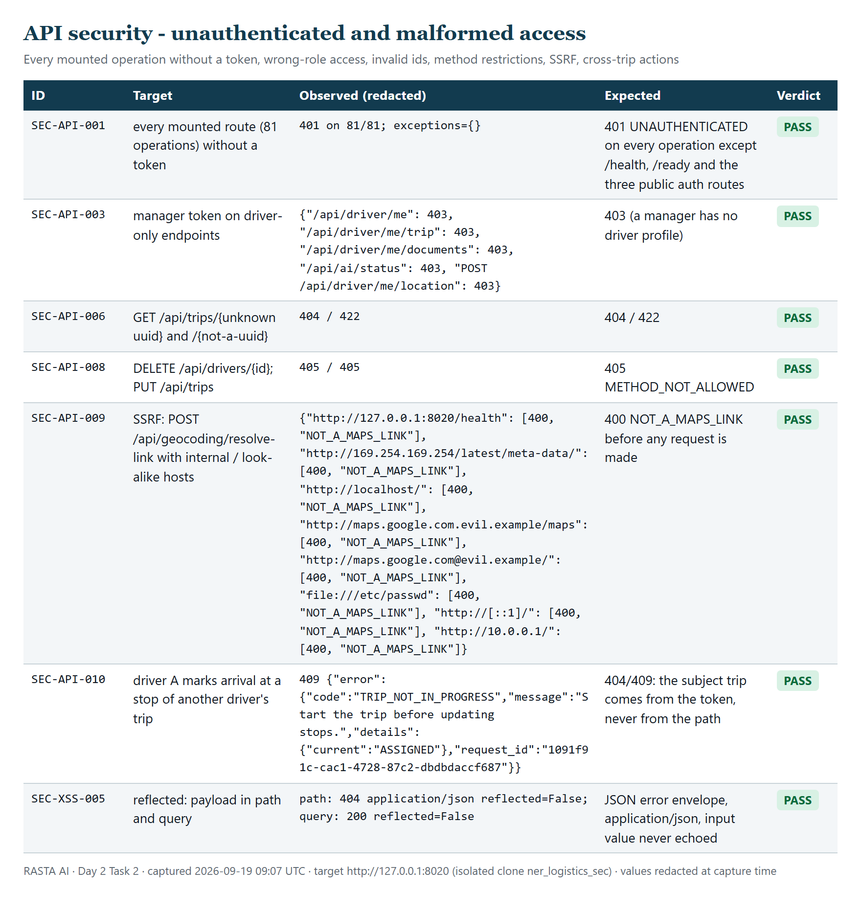
Figure 11. Unauthenticated and malformed access: 81/81 operations → 401; wrong role → 403; SSRF hosts refused; method restrictions.
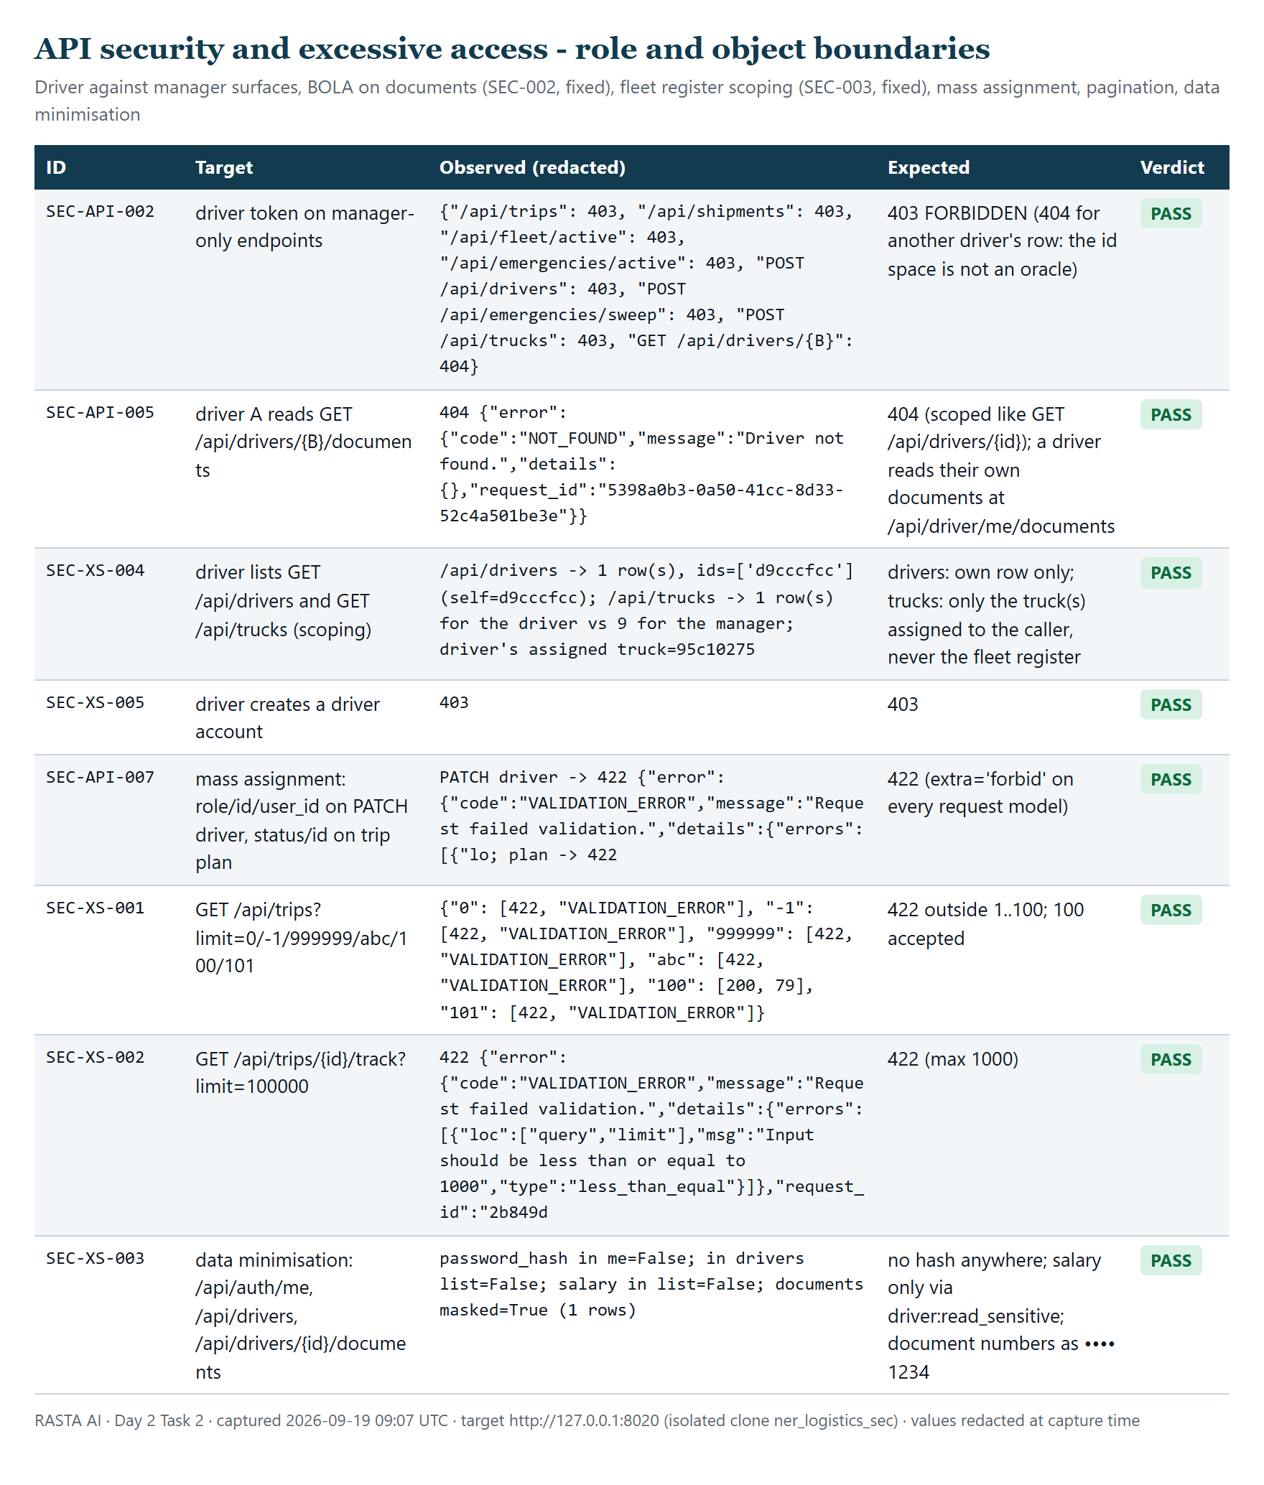
Figure 12. Role and object boundaries after the fixes: scoped lists, documents BOLA closed, mass assignment refused, pagination bounds, data minimisation.
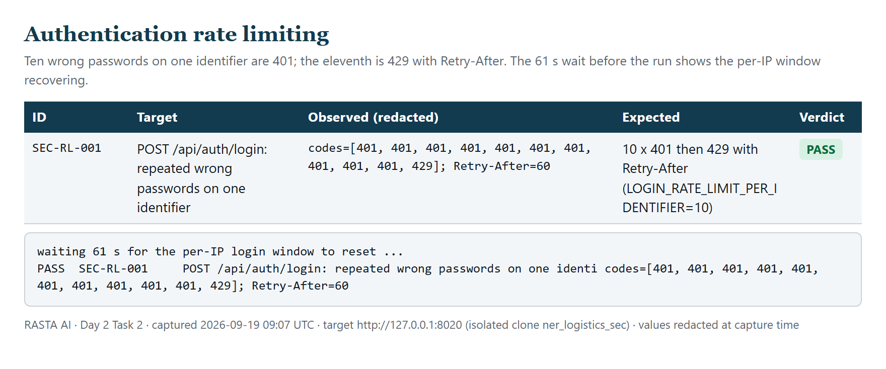
Figure 13. Rate limit: codes [401 ×10, 429], Retry-After 60, after a 61 s window recovery.
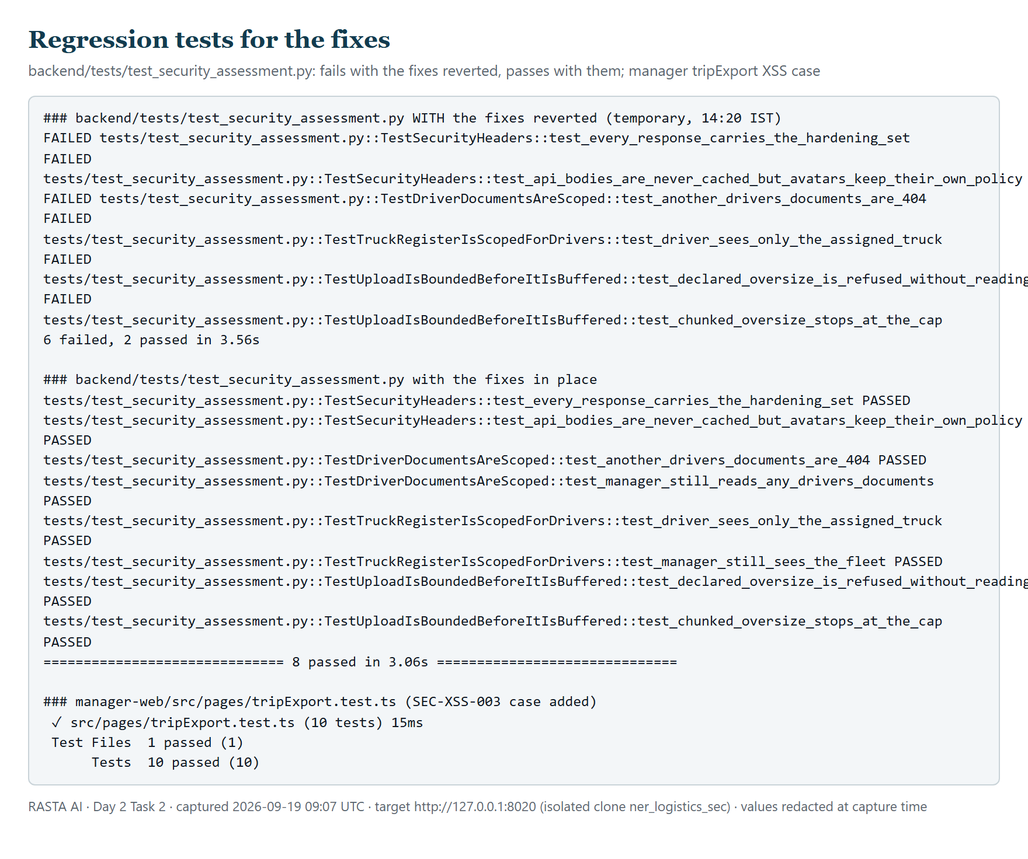
Figure 14. Regression tests: the new backend cases fail with the fixes reverted and pass with them; the manager export test.
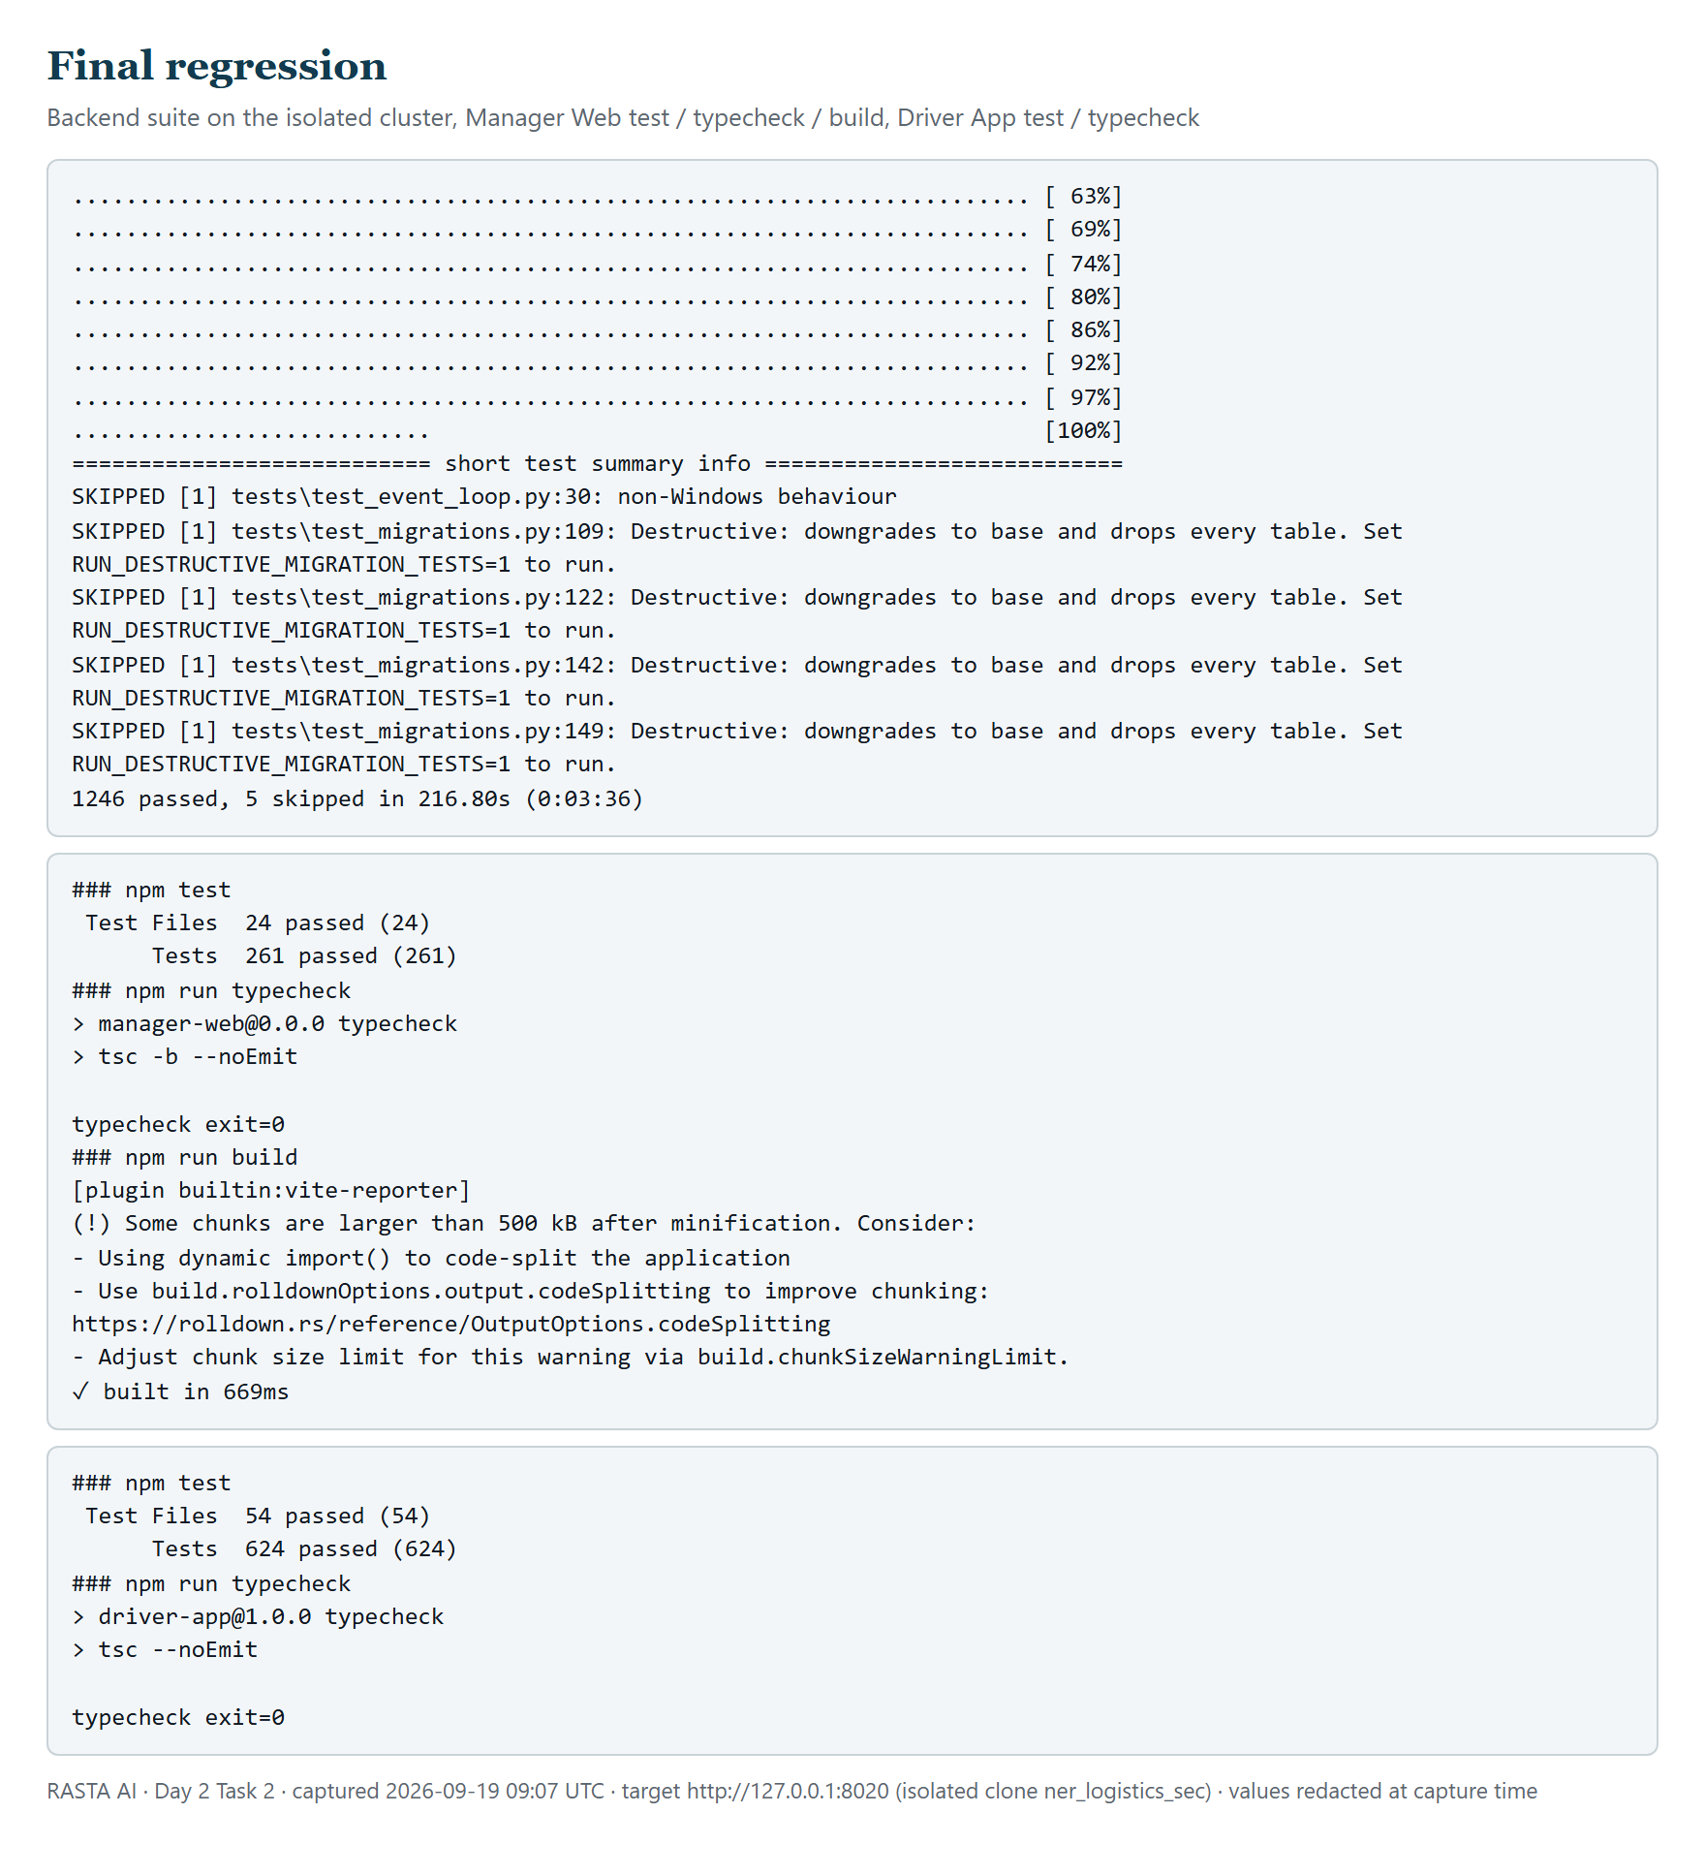
Figure 15. Final regression: backend suite tail, Manager Web test/typecheck/build, Driver App test/typecheck.

17. Residual risks
- Deployment lag. SEC-001 and SEC-005 are fixed in the working tree only; the hosted API and both static sites keep serving the old headers until main is pushed and Render rebuilds. Verify with curl -sI afterwards (section 19).
- Rate limiting behind the platform proxy (SEC-006). Per-address login limiting is effectively global on Render; the per-account limit is the control that holds. State is in-process, so a restart clears it and a second worker would double it.
- No full Content-Security-Policy on the clients. Only frame-ancestors is set. A script-src policy would blunt any future XSS but must be tested against the map, fonts and worker loads before it ships.
- Dependency advisories. Ten moderate advisories in the Driver App's Expo build toolchain and two dev-only ones in the manager's test runner; none in production dependency sets; no Python audit was run (pip-audit unavailable offline).
- Third-party providers. Routing, weather, terrain, flood, warnings and geocoding come from public providers over HTTPS with time-outs and health tracking; their availability and the integrity of the public OSRM demo server are outside our control (the code treats "unknown" as "not safe", never as "safe").
- No web application firewall in front of the hosted service beyond Cloudflare's defaults on Render's free tier.
- Isolated-clone limits. Tests ran against a local clone of the demo database, so Supabase-specific behaviour (pooler limits, its own RLS enforcement for the Data API) was covered by the existing test suites rather than re-exercised here.
- Physical devices. The Driver App was exercised through its API and its web build's headers; secure-store behaviour on a real phone was reviewed in code, not re-tested on a device today.

18. Final security assessment
Required task | Result | Evidence
SQL Injection | PASS — no injection reproduced; all queries parameterised | §6, Figure 2, SEC-SQLI-001…007
XSS | PASS — stored and reflected payloads inert; escaping at every raw-HTML sink; new unit test | §7, Figures 3–4, tripExport.test.ts
Security Misconfiguration | PASS — docs closed in production, exact-origin CORS, no secrets tracked or bundled, errors contained, RLS proven | §8, Figures 5–7, secret_scan.txt
Insecure File Upload | FINDING → FIXED — magic-byte typing, caps and ownership held; unbounded buffering fixed (SEC-004) | §9, Figure 8, TestUploadIsBoundedBeforeItIsBuffered
Missing / Weak Security Headers | FINDING → FIXED — API headers added (SEC-001), Render static headers added (SEC-005); hosted verification pending deploy | §10, Figure 9, TestSecurityHeaders
Session Management | PASS — cookie flags, rotation, replay revocation, logout, forgery, disabled accounts, support token all correct; SEC-006 open (limiter keying) | §11, Figure 10, SEC-SESS-001…008
API Security | FINDING → FIXED — 81/81 unauthenticated → 401, roles enforced, SSRF refused; documents BOLA closed (SEC-002) | §12, Figures 11–12, TestDriverDocumentsAreScoped
Excessive / Improper API Access | FINDING → FIXED — pagination bounded, sensitive fields minimised, enumeration blocked; truck register scoped (SEC-003) | §13, Figure 12, TestTruckRegisterIsScopedForDrivers

Severity totals: Critical 0 · High 0 · Medium 1 (fixed) · Low 5 (4 fixed, 1 open) · Informational 7.

19. Conclusion
Day 2 Task 2 is ready for submission on the evidence above. All eight required areas were tested against the running application, each with captured evidence; five real defects were found, fixed with the smallest change at the owning layer, and locked in by tests that demonstrably fail without the fix; the complete backend, manager and driver suites pass afterwards. No exploitable issue was reproduced within the defined scope after the fixes. What is not claimed: that the hosted deployment already carries the fixes (it does not until the next push), that the clients ship a full CSP, or that any automated scanner beyond the ones named was run.
Three actions follow this report, in order: (1) commit and push the working tree so the hosted API and static sites pick up SEC-001 and SEC-005, then re-run curl -sI against the three hosted URLs and security_probe.py with SEC_BASE pointed at the hosted API for the read-only rows; (2) decide on SEC-006 — configure uvicorn's forwarded-IP trust for Render's proxy or accept the shared address budget for the demo; (3) schedule the informational items (SRI for Leaflet, Expo toolchain update, a tested script-src CSP) into the next engineering pass. The isolated database ner_logistics_sec has been dropped and .runtime/start-sec-backend.sh remains for re-running the assessment.

