Table of Contents
1 Analysis 4
1.1 Identifying the Problem 4
1.1.1. Background: 4
1.1.2. Identification 4
1.2 Identifying the End Users 4
1.3 Research 5
1.3.1. Key Insights from Research 5
1.3.1.1 Books 5
1.3.1.1.1 Building a Second Brain 5
1.3.1.1.1.1 The CODE Method 5
1.3.1.1.1.2 The PARA Method 6
1.3.1.1.2 The Bullet Journal Method 6
1.3.1.2 In-depth analysis of existing software 6
1.3.1.2.1 Notion 6
1.3.1.2.2 Google Keep: 7
1.3.1.2.3 Evernote: 7
1.3.1.2.4 Apple Notes: 8
1.3.2. Survey results 8
1.3.2.1 How do you currently organise your tasks and notes? 9
1.3.2.2 What features do you value most in a notetaking app? (Multiple choices allowed) 9
1.3.2.3 What are the biggest challenges with your current notetaking method? 10
1.3.2.4 How likely are you to use an app that combines notetaking and statistics? 10
1.3.2.5 Conclusion 11
1.4 Interview with Anton Kogun 11
1.5 Modelling the problem 12
1.6 Coding objectives 13
1.6.1. Database 13
1.6.1.1 Configuration and Security 13
1.6.1.2 Create tables for: 14
1.6.2. Design the backend functionality: 14
1.6.3. User Interface 14
1.6.4. Validation 15
1.6.4.1 Frontend Validation 15
1.6.4.2 Backend Validation 15
1.7 Proposed solution 15
2 Documented Design 16
2.1 User data flow 16
2.1.1. Determining frontend-backend communication 16
2.1.1.1 Optimistic updating 16
2.1.1.2 Pessimistic updating 16
2.1.1.3 Why I chose optimistic updating 16
2.1.2. Creating data flow diagrams 17
2.1.2.1 Note creation 17
2.1.2.2 Editing a note 18
2.1.2.3 Fetch all notes of a specific type 19
2.1.2.4 Fetch one note 20
2.1.2.5 Delete a note 21
2.1.2.6 Searching for a note 22
2.1.2.7 Tag workflow 24
2.1.2.8 Registering and logging users in 25
2.2 Backend 25
2.2.1. Designing the database 25
2.2.1.1 Detecting patterns in data representation 25
2.2.1.2 Choosing the database 25
2.2.1.3 Efficiency 25
2.2.1.4 Data Types and Functions: 26
2.2.1.5 Why use UUID? 26
2.2.1.6 Performance: 26
2.2.1.7 Security: 26
2.2.2. Database relationships 27
2.2.2.1 User data 27
2.2.2.2 Notes 28
2.2.2.3 Tagging 30
2.2.2.4 Statistics 30
2.2.2.5 Conclusion 31
2.2.3. Backend file structure 31
2.2.4. OOP 32
2.2.4.1 Constructing note processing code 33
2.2.4.2 Simplifying validation schemas 34
2.3 Frontend 34
2.3.1. User data on the frontend 34
2.3.2. Frontend file structure 35
2.4 User Interface 37
2.4.1. The 10 principles of good design 37
2.4.2. Design as an iterative process 37
2.4.3. Creating wireframes 38
2.4.3.1 A generic note viewing and editing page, which supports organization by tagging, additional form fields and timestamps. 39
2.4.3.1.1 Viewing all notes 39
2.4.3.1.2 Editing a note 39
2.4.3.2 An account page where the user can edit their details 40
2.4.3.3 A sidebar and other popups, such as alerts or search widgets 41
2.4.3.4 A note statistics page 41
2.4.3.4.1 Charts 42
2.4.3.4.2 Numbers 43
2.4.3.4.3 Progress Bars 43
2.4.3.4.4 Streaks 44
2.4.3.4.5 Mobile design 44
2.4.4. Choosing the color and fonts 47
2.4.4.1 Core color palette 47
2.4.4.2 Typeface: Open Sans 49
2.4.4.2.1 Introduction 49
2.4.4.2.2 Character set support 49
2.4.4.2.3 Licensing 49
2.4.4.2.4 Performance 49
2.4.4.2.5 A 50
3 Technical solution 50
3.1 Backend 50
3.1.1. app.py 50
3.1.1. modules/universal.py 51
3.1.1.1 BaseNote class 52
3.1.1.2 Universal note functionality 53
3.1.1.3 Searching 54
3.1.1.4 Recents 56
3.1.2. modules/notes.py 59
3.1.2.1 Create Note 61
3.1.2.2 Update Note 62
3.1.2.3 Delete Note 63
3.1.2.4 Get a specific note 63
3.1.2.5 Get Note previews 64
3.1.3. modules/tasks.py 66
3.1.3.1 Initialization 66
3.1.3.2 Task creation 67
3.1.3.3 Updating tasks 69
3.1.3.4 Deleting a task 71
3.1.3.5 Toggling task fields 72
3.1.3.6 Task Previews 74
3.1.3.7 Retrieving a single task 76
3.1.4. modules/archive.py 77
3.1.4.1 Archive and Restore 78
3.1.4.2 GetAll 79
3.1.5. modules/tags.py 80
3.1.5.1 CRUD tags 81
3.1.5.2 Linking Tags 84
3.1.6. modules/widgets.py 85
3.1.7. modules/users.py 85

- Analysis
  - Identifying the Problem
    - Background:
Anton is an A-level student who does not have much time on his hands. With tasks and life goals snowballing around him, he needs to keep track of his progress on everything all at once. His current methods, which are paper-based or reliant on scattered digital tools, are inefficient and make it difficult to:
- Centralise and organise his tasks, goals, and habits in one place.
- Visualise his progress towards short-term and long-term objectives.
- Stay motivated by tracking his habits and achievements.
- Access his information across different devices (e.g., laptop, smartphone).
    - Identification
Anton’s requirements for a notetaking app include:
- An all-in-one solution for both short-term and long-term tasks and goals.
- Easy organisation and accessibility of notes.
- Features to motivate and track progress, such as habit tracking.
- A user-friendly, cross-platform experience.
  - Identifying the End Users
The primary end users of this notetaking app include:
- Students: Students like Anton who juggle multiple tasks, assignments, and projects can use the app to organise their workload, set goals, maintain habits, and track progress.
- Professionals: Busy professionals can benefit from managing their tasks, projects, and goals to improve productivity.
- Individuals Seeking Personal Organisation: People aiming to enhance their daily routines and achieve personal goals can utilise features like habit tracking and progress visualisation.
- Individuals with Specific Needs: Those with conditions like ADHD or difficulties with time management can use the app’s features (e.g., summarisation, advanced lookup, and sorting) to stay productive.

  - Research
Research Methodology:
To thoroughly understand the problem and design a suitable solution, I:
- Explored existing notetaking apps (e.g., Notion, Obsidian, Evernote, Google Keep) to identify their strengths and weaknesses.
- Read notable books on notetaking systems, such as Building a Second Brain by Tiago Forte and The Bullet Journal Method by Ryder Carroll.
- Conducted interviews with potential users, including Anton and other students, to gather insights into their preferences and pain points.
- Analysed feedback from online communities and forums discussing productivity tools.
- Created prototypes and tested them with users to refine the app’s features.
My app was greatly inspired by books such as Building a Second Brain by Tiago Forte and The Bullet Journal Method by Ryder Caroll. However, such systems as one were too complex to me and I could not make myself use my physical Bullet journal for long enough due to the objective superiority of note taking apps, that were always in my pocket or my computer. As a result, I took some ideas from these two books and implemented them in my app.

    - Key Insights from Research
      - Books
        - Building a Second Brain
          - The CODE Method
One of the concepts in this book is the four-step CODE method, which is an acronym for Capture, Organise, Distill, Express.
- The first step in the Building a Second brain method is seeing the recurring themes and determining which knowledge does one want to interconnect. This information, most importantly, must be kept in one place. This is why my app must have different types of notes for various use cases.
- According to the author, an approach with folders may look good, but is not practical. Therefore, in the Organise part of the CODE method, a flexible organisation method is more preferable. As a result, using a tagging system would be more flexible and would allow a note to be shared across multiple categories. Finally, adding tags such as “Active” or “Inactive” would help organise projects by their urgency.
- Distilling notes into bite-sized summaries would significantly speed up the process of obtaining and retrieving valuable knowledge. One possible solution for summarising notes would be to use AI language models, such as ChatGPT or Gemini to quickly summarise the notes based on a predetermined and optimised prompt. The prompt could automatically:
  - Highlight key terms
  - Retain links to websites
  - Insert placeholders if the initial note is incomplete
By using the following summarization feature, the notes can be readable for the user even in a long time

          - The PARA Method
Using tags for the Organise step will aid with organising data from most actionable to the least actionable using the Projects->Areas->Resources->Archive. Additionally, to separate forgotten notes and automatically clean them up, a separate archive section should be introduced, which will also delete unused notes after some period of time.
        - The Bullet Journal Method
Even though the author is against the digital approach and bases their book on an analogue notebook, it is impossible to deny that digital is the future. Some concepts in this book are very specific to the Bullet Journal method and would be complicated to understand for users that haven’t read the book prior to opening the app. However, some concepts, such as Collections and Migration can be implemented, keeping the app usable for everyone. Just like in the previous example, Collections can be solved by sorting notes by types and using tags to group them together. Meanwhile, migrating tasks to the future or present would require a changeable due date on a note.

      - In-depth analysis of existing software
        - Notion
Notion is a cross-platform tool developed by Notion Labs, Inc. It allows the user to create their own note templates and organise their data in databases, tables. Advanced users can create completely custom solutions that can be considered their own websites.
Advantages:
- Notion is customizable
- Has AI tools to summarise notes and generate text
- Has support for organising entries in tables by tags
- Is cross platform

Disadvantages:
- Notion is very complicated to set up, so base users cannot use most of these features fully. Customization is very time consuming, so most users rely on paid templates to get any advanced functionality.
- From my experience, and experience of other Notion users I interviewed, the cross-platform experience is mediocre. The app is not optimised for touchscreens.
- The AI features are a paid subscription. Some users may underutilize the features and overpay for services they never use.

        - Google Keep:
Advantages:
- Simple and intuitive to use, making it accessible to users of all technical levels.
- Well-integrated with Google’s ecosystem, allowing seamless synchronisation across devices.
- Offers dedicated apps for Android, iOS, and WearOS, ensuring availability on most platforms.
Disadvantages:
- Limited to basic note types, which restricts functionality for advanced users.
- Lacks features for tracking statistics, such as task completion or habit trends.
- Minimal options for customisation or organisation, making it less suitable for complex workflows.
        - Evernote:
Advantages:
- Offers robust organisational tools, including notebooks, tags, and advanced search capabilities.
- Supports multimedia notes, allowing users to attach images, audio, and files.
- Cross-platform support with apps for desktop, mobile, and web.
- Allows integration with third-party apps and services, enhancing functionality.
Disadvantages:
- Free version has significant limitations, such as device restrictions and reduced storage capacity.
- Interface can feel cluttered and overwhelming for new users.
- Features, like AI tools and offline access, are locked behind a premium subscription.
        - Apple Notes:
Advantages:
- Seamlessly integrated into Apple’s ecosystem, providing excellent synchronisation across iPhone, iPad, and Mac devices.
- Simple and straightforward interface, ideal for quick note-taking.
- Supports rich text formatting, drawing tools, and file attachments.
- Includes collaborative features, allowing multiple users to edit notes in real time.
Disadvantages:
- Limited to Apple devices, restricting cross-platform usability.
- Organisation features are basic compared to competitors like Notion or Evernote.
- Lacks advanced capabilities, such as tagging or detailed analytics for tracking progress.
    - Survey results
To gather direct input from end users, I conducted a survey with around 50 respondents among my friends, their parents and my classmates. I tried to include people of various age groups to be able to account for the needs of as many users as possible. Below are the results of some conducted surveys:
      - How do you currently organise your tasks and notes?

      - What features do you value most in a notetaking app? (Multiple choices allowed)

      - What are the biggest challenges with your current notetaking method?

      - How likely are you to use an app that combines notetaking and statistics?

      - Conclusion
This small survey reveals key insights into users current task and note organization habits, and favourite features in notetaking tools. The data suggests a strong preference for digital solutions, with 50% of respondents utilizing digital tools, compared to 40% relying on paper-based methods and only 10% employing a hybrid approach. The findings of the survey confirmed my ideas regarding the importance of usability and efficiency for modern-day users. The most valued feature among respondents was a simple and intuitive interface (85%), indicating a search for user-friendly tools that minimize friction and maximize productivity. Finally, a combined 90% of respondents expressed at least some level of likelihood (70% very likely, 20% somewhat likely) to use an app that combines notetaking and progress tracking in a simple way. This response suggests a significant market opportunity for such a tool.
To sum up, the survey results point to a clear demand for efficient, user-friendly, and digitally accessible notetaking solutions. Users prioritize easy organization, cross-platform accessibility, and intuitive interfaces.

  - Interview with Anton Kogun
Having concluded the survey on a wider potential customer base, I decided to probe deeper into the wants of potential users, so I conducted a short interview with the A-level student, Anton Kogun, from 1.1. Below, will be the results of this interview in a question-answer format:

What's the biggest problem you face with managing your schoolwork digitally?

Definitely the organization. I have notes scattered everywhere – some in Word docs, some in Google Docs, others in random note-taking apps. Plus, I use different task management apps, so I end up forgetting deadlines and losing track of what I've actually done.

If you had a magic wand and could create the perfect app for yourself, what's the one feature it absolutely must have?

A way to bring it all together. Notes, assignments, to-do lists, even my habit tracker – all in one place. And it needs to be easy to find what I need, fast.

And what about accessing your notes and assignments? Do you use multiple devices?

All the time! I use my laptop at home, my tablet at school, and sometimes even my phone. It needs to work seamlessly across all of them, without any ssues or syncing problems.

What would be your preferred way of accessing the application?

On PC, it would probably be a website. Web apps are fast and I can use my browser plugins to customize them to my liking. It is also to switche between tabs than multiple screens if I need to jor something down quickly. On the other hand, on my phone I would rather have an app, since some websites are not optimized for the smaller phone screens.

Imagine you've got hundreds of notes and tasks in this app. How would you quickly find the one you need?

Search is crucial, of course. But it needs to be smart. Searching by keywords is good, but what if I can't remember the exact words? Maybe something that understands the context of my notes. That would be amazing.
  - Modelling the problem
Here's how each objective addresses specific issues and integrates research findings:
- Provide a tagging system to categorise notes flexibly: Helps users with easy organization (80% in the survey) and aligns with the "Building a Second Brain" emphasis on tags over folders. This also addresses Anton's need for centralization.
- Support multiple note types (e.g., text notes, checklists, habit trackers): Addresses the need for an all-in-one solution for tasks, goals, and habits (Anton's requirement) and directly responds to the 90% survey interest in combined habit tracking and notetaking.
- Record and display metadata (e.g., creation dates, due dates): Supports task management and progress tracking, addressing the challenges identified in the survey (40% difficulty tracking progress) and the Bullet Journal concept of migration (managing tasks over time).
- Allow summarisation of notes using AI to highlight key information: Helps users perform the "Distill" step of the CODE method from "Building a Second Brain" and helps with quick lookup and long-term readability of notes.
- Enable quick and advanced note lookup based on context and keywords: Addresses the need for easy accessibility of notes (Anton's requirement) and improves upon the limitations of basic search in some existing apps.
- Ensure cross-platform compatibility with automatic interface adjustments: From the surveys conducted, (70% value cross-platform accessibility, 35% cite poor cross-device support as a challenge) and Anton's need for access across devices.
- Display user statistics, such as note completion rates and habit trends: Directly addresses the need for progress visualization (Anton's requirement) and the survey results (40% difficulty tracking progress, 60% desire habit tracking/goal visualization).
- Allow users to customise the app’s appearance and preferences: While not a primary pain point, this improves user experience and lets users
- Include an archive feature to manage unused or outdated notes: Directly addresses the "Archive" component of the PARA method from "Building a Second Brain" .
- Implement security measures to protect user data: Users will have an expectation of privacy while using the app to store their personal data
Keeping these 10 main objectives in mind, I formulated a list of tasks that I will need to complete in order to successfully implement this application.
  - Coding objectives
    - Database
      - Configuration and Security
    - Create algorithms to generate unique IDs.
    - Configure usage access by limiting permissions of clients that will be used with the databases.
    - Ensure that the database is encrypted and adheres to modern security standards.
    - Have a hashing algorithm to further encrypt user passwords.
    - Implement input sanitization to prevent attacks, such as SQL injection.
    - Use HTTPS for all communication.
    - Upon login, provide users with an identity token to keep them logged in.
    - Create functions to search notes by their vector representation instead of text.
      - Create tables for:
    - Users
    - Notes
    - Tags
    - Habits
    - Statistics
    - Goals
    - Tasks
    - Design the backend functionality:
    - Have functionality to retrieve, create, update and delete various note types and tags, using filters and pagination where needed.
    - Be able to authentify and register new users.
    - Link and unlink tags to and from notes.
    - Complete/uncomplete tasks.
    - Retrieve user statistics for several note types.
    - Be able to save user preferences.
    - Communicate with other APIs, such as one from Google or OpenAI to be able to pass submitted notes for AI summarization and return the result to the user.
    - Implement an archiving function.
    - Create algorithms to vectorize notes for context-based searches
    - User Interface
    - Design the overall layout of the app.
    - Have a screen to view all notes for a selected note type with pagination and filter controls, along with the titles and tags of the notes displayed
    - Have a rich text editor for creating and editing notes (support for checklists and habit trackers).
    - Design a navigation bar, searching screens and alerts.
    - Have an account page where the user can edit their details.
    - Design the statistics page and unique widgets with information for each note type.
    - Ensure that the designs will adhere to accessibility standards.
    - Make the application cross-platform compatible by choosing a technology that supports such development natively, such as React.
    - Have error handling in place to prevent the app from crashing and communicate any errors to the user.

    - Validation
      - Frontend Validation
    - Form validation on the UI to provide immediate feedback to users if data was incorrectly entered.
    - Validate passwords and emails to avoid unnecessary requests.
      - Backend Validation
    - Input validation for all API endpoints.
    - Authentication and authorization checks to ensure users can only access their own data.
    - Ensure that new entries have unique IDs before inserting them to the database.
    - Impose a limit on the character length of submitted notes.

  - Proposed solution
My solution this feature-rich note-taking application leverages a robust and scalable technology stack. For the user interface, I will utilize ReactJS, a powerful JavaScript library for building dynamic and responsive single-page applications. To speed up design, I will use a component library called shadcn, which is open source, modern, adheres to acceccibility guidelines such as WCAG and is highly customizable. This choice ensures a smooth and intuitive user experience across various platforms. The backend will be constructed using Python and Flask, a lightweight and flexible microframework that allows for rapid development and efficient API creation. This combination provides a strong foundation for handling complex logic, data processing, and communication with the database. Data persistence and management will be handled by PostgreSQL, a powerful and reliable relational database system known for its data integrity, scalability, and support for complex queries. This technology stack offers a balanced approach, combining a modern frontend framework with a robust backend and database, enabling us to deliver a performant, scalable, and maintainable application that effectively addresses all the specified requirements above.
  - A
- Documented Design
  - User data flow
    - Determining frontend-backend communication
      - Optimistic updating
Optimistic updating is a design pattern where a user interface is immediately updated based on the user's actions, assuming that the backend operation will succeed. This gives a more responsive user experience by avoiding unnecessary delays, especially when it comes to saving or creating notes. However, it will need careful error handling to prevent inconsistencies between the frontend and backend in case of errors.
      - Pessimistic updating
Pessimistic updating is a design pattern where the user interface is not updated until the backend operation has been successfully completed. This approach ensures data consistency but can lead to perceived delays, especially in scenarios with slow network connections or complex backend processing, which, for tasks such as vectorization, may take significant time and can be left for later.
      - Why I chose optimistic updating
With optimistic updating, changes made by the user are immediately reflected in the app's interface, providing a seamless and responsive experience. This is very beneficial for notetaking, where the user does not want to be concerned with the processing of their notes and just needs to write them down as quickly as possible. Pessimistic updating, on the other hand, requires the backend to process and validate the changes before they are displayed, leading to delays, amplified by poor connectivity. However, most of the benefits of pessimistic updating such as data validation can be addressed on the frontend too. For example, input text can be firstly validated on the frontend, displaying a message to the user if some values are missing or of wrong datatype. Using a type safe language such as TypeScript would ensure that the data types passed within the frontend are also correct. Finally, data can be additionally validated on the backend, which would allow for more complicated validation algorithms, as there is no longer a time constraint.
    - Creating data flow diagrams
      - Note creation
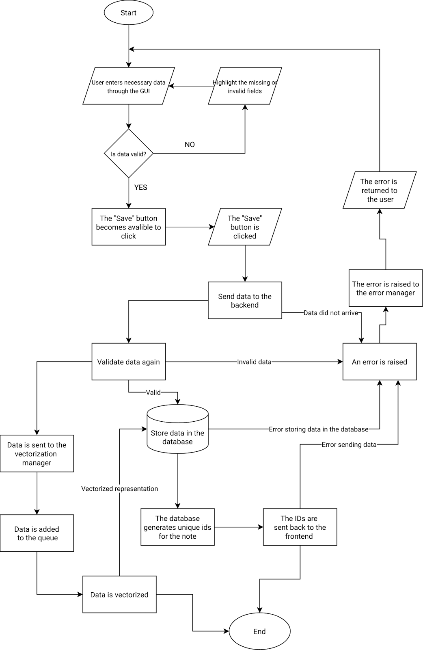
When the user clicks on “Create” button on the home page for a note type, a screen should be opened with the necessary fields, such as title, content, etc. Once the user enters all the details for a note to be considered valid by the validation script and all the validation errors have been resolved, the “Save” button is enabled allowing the user to click it and send the data to the backend. If the data gets to the backend successfully, it is again validated using and stored in the database. Additionally, meaningful parts of the note, such as its content, title and information from any additional fields are added to the queue to be vectorized. At the same time, the unique IDs, generated by the database, are returned to the frontend and, along the data entered by the user, are stored in a corresponding array for fast retrieval. The gui changes necessary elements from “Create” to “Edit” to mirror the success of the process and a success toast is displayed and the user can continue editing the note using the process mentioned below. Finally, when the server has the resources, data is vectorized and stored in the Notes table along the non-vectorized parts of the note.
      - Editing a note
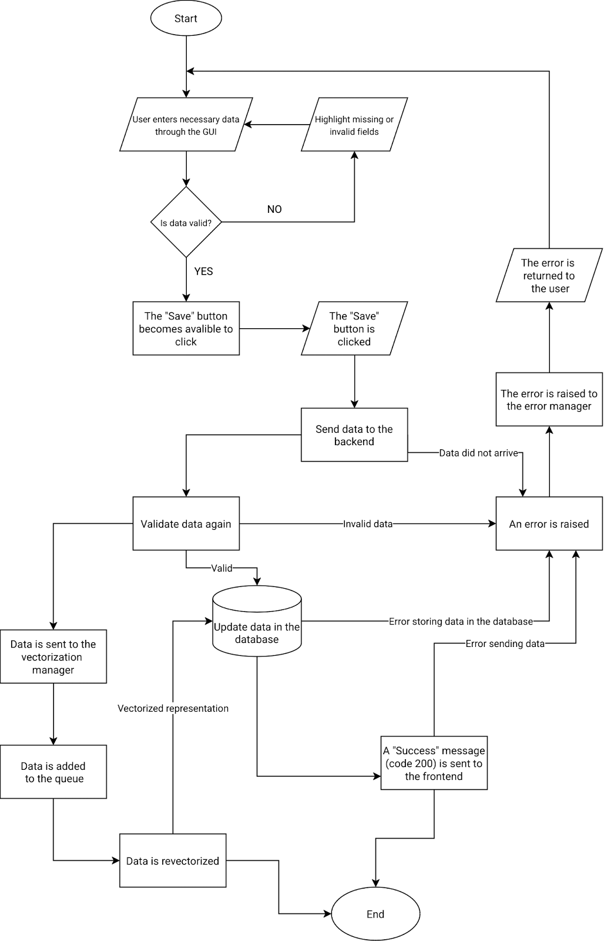
Generally, the note editing data flow is similar to creation, apart from first few details. To begin with, the “Save” button will not be enabled if no additional data was entered into the note. This is done to prevent unnecessary edit requests to the backend. In addition, if the database was updated correctly, instead of the IDs, a simple https code is sent to the frontend to indicate the success of the program. No additional toasts are shown to the user and the process can be repeated indefinitely as long as the saved note is valid.
      - Fetch all notes of a specific type
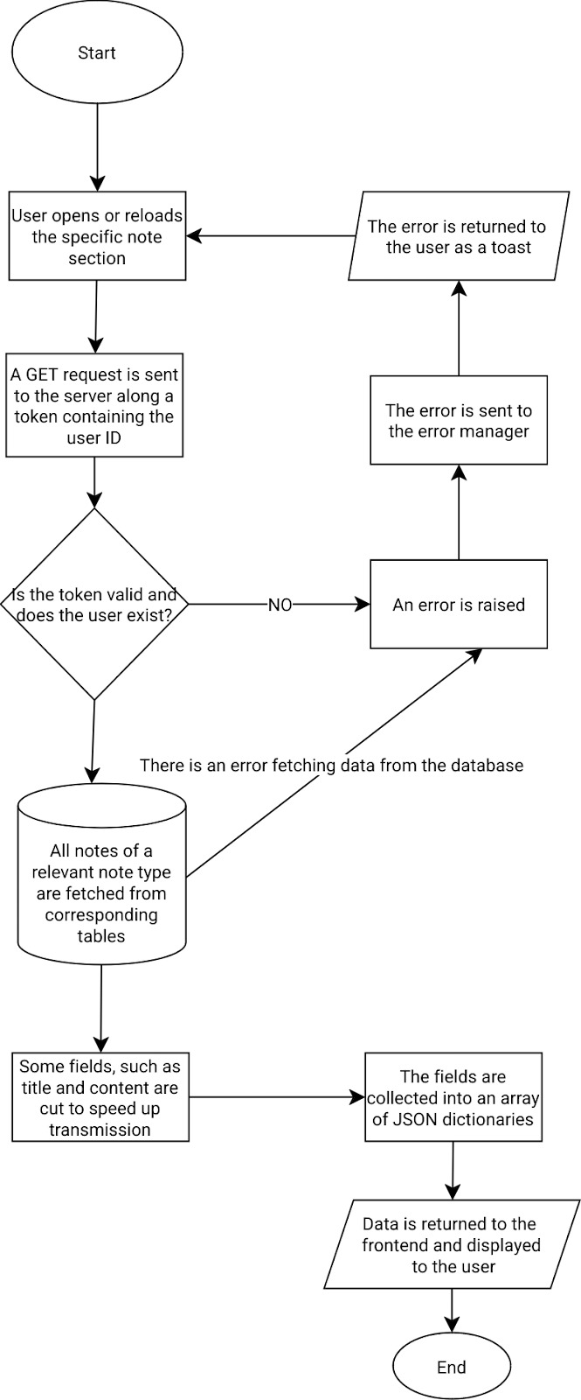
Every time a user loads a page of a specific note type, such as Tasks or Goals, a GET request is sent to the server alongside a JSON Web Token containing encoded user Id and information about the session. If the token is valid and the user exists in the database, all notes from a specific note type are fetched from the main Notes table and connected tables, such as Tasks and Subtasks for a Tasks note type. If the retrieval is successful. Since this page would only be used to find the correct note and then click on it to open a note editing page, there is no need to fetch the whole note, it makes more sense to fetch the first n characters from each field that would fit on the user’s screen and then fetch the rest once the note is clicked. Therefore, before sending the data back to the frontend, some fields' contents are cut. Finally, data is returned as an array of JSON dictionaries and notes are displayed to a user.
      - Fetch one note

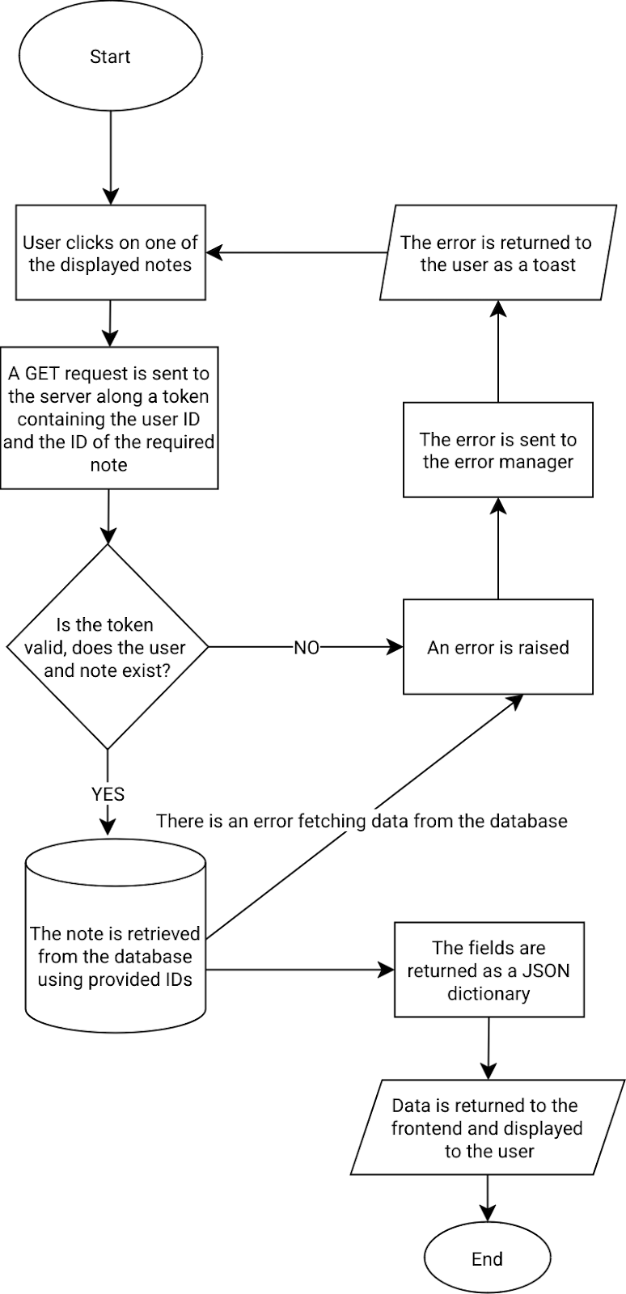
When the user chooses the note to edit, when they click, the GUI changes into an editing mode and a GET request is sent to the backend containing the ID of the clicked note along the JWT mentioned above. The main difference between fetching all notes and one note is that the fields are not shortened and only one note is returned. When the request succeeds, the user can continue to edit the note.
      - Delete a note
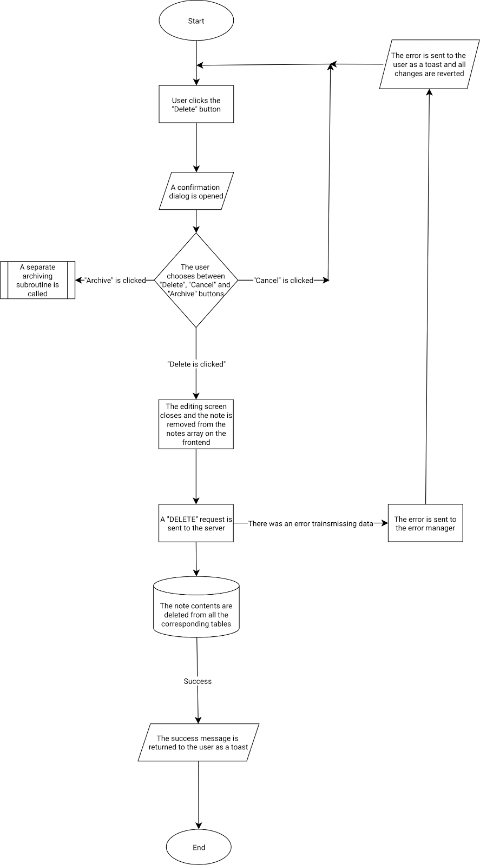
When a user attempts to delete a note, they should be first greeted by a dialogue which allows them to either cancel the deletion, continue with it or put the note into an archive instead. If the user chooses to proceed with the deletion, the note is removed from the corresponding notes array on the frontend and the DELETE request with a token, containing a user id and the ID of the note to be deleted. If the token is valid and the user is the owner of the note, its data is deleted from all corresponding tables. Finally, the success or error message is returned to the user as a toast.
      - Searching for a note
To search for a note, the user will have to click a search icon that will always be present in the header of the page. Upon clicking, a popup will appear over the page with the search bar alongside a toggle. The user is provided with an option to choose between “Approximate” and “Exact” searching modes, the latter of which is toggled by default and stored in the component state. Then, the user enters their query and presses the enter key or a corresponding button. The query, user token and the search mode are sent to the server. If the token is valid, the server reads the value of the search mode and processes the query accordingly:
- “Exact” search mode. The query will be used to look up title or content fields in the database using SQL querying
- “Approximate” search mode. The query will be vectorized with a pretrained model and its vector representation will be compared to the stored vector representations of notes in the database using a function such as cosine similarity.
Once the notes have been retrieved, they are split into pages of 5 or 10 notes and, along with its pagination data, are sent to the user to be displayed. The user can use a selector on the window to switch pages of notes.

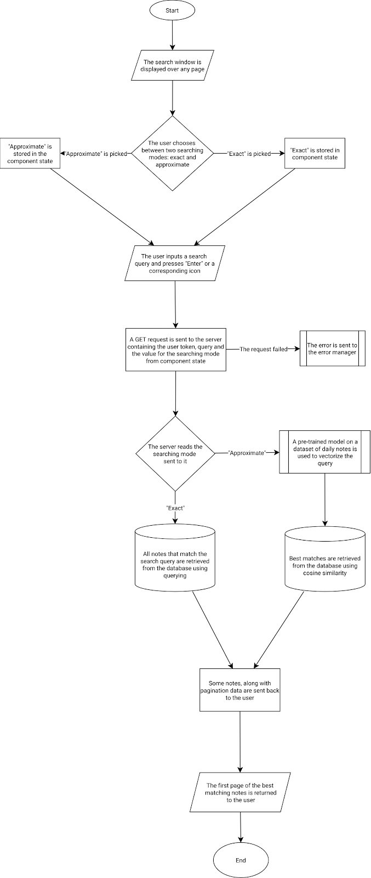

      - Tag workflow
In general, the workflow associated with tags is similar to notes. Tags can be created, edited, viewed and deleted. Tags come with an additional field, which has their colour to be distinguishable not only by name. More differences start when notes need to be linked to tags. One way to do so is to have a state which stores the selected tags when a note is opened or created. Then, the ids are passed to the backend whenever the note is saved and then linked to their note id in a separate table, which will be stored in the database.
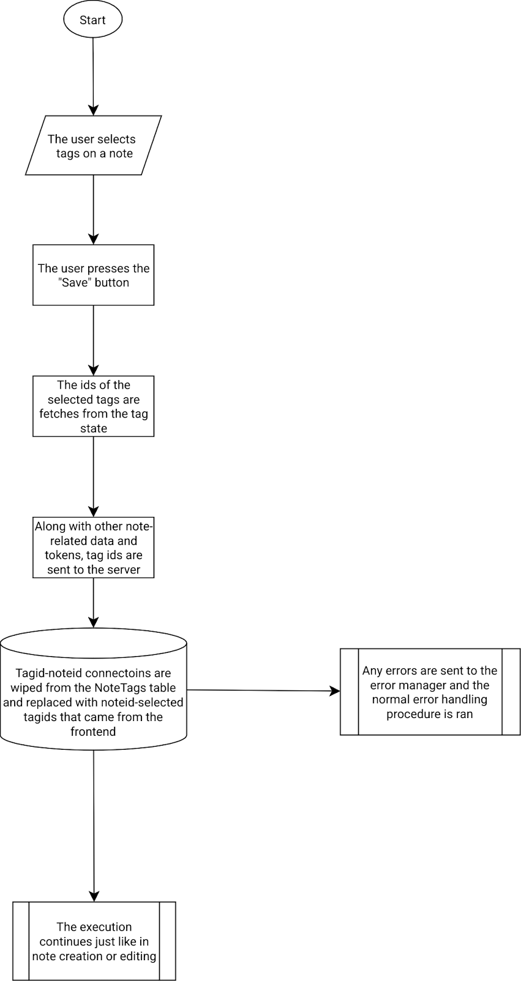
This procedure is executed alongside any note creation or editing procedure whenever the selected tag ids differ from the fetched ones.

      - Registering and logging users in
One way to ensure that users are correctly logged in, we can store a JWT (Json web token) in the browsers cookies. The token will be passed alongside any user request to the server, would include the user identity and expire after a set time period. This will cause the user to log in again, which would protect their personal information from being accesses by third parties.
The user data will be stored in the Users table. This may include their username, email and encrypted password to prevent it from being compromised in case of a data breach. Additionally, each user field in the table may store their preferences, such as dark or light themes and any additional information.
  - Backend
    - Designing the database
      - Detecting patterns in data representation
In order for my database to accommodate multiple note types without wasting space, we can use multiple tables to split the data from one note into multiple parts. Since any note can have a title, some basic content, an owner and tags, information, concerning the note, can be put into a table called Notes. Then, any other task types will pass the id of the note further into the database into note type specific tables, which will contain additional fields for a note.
Since the same tag can be used for many notes, it is unnecessary to store all the tags for each note in the Notes table. As a result, a Tags table needs to be created and connected to the Notes table with a one to many relationship.
      - Choosing the database
There are many different databases available with their own pros and cons. However, after trying multiple databases, such as MySQL and MongoDB, which had their own pros and cons, I finally landed on PostgreSQL, which satisfied all of my requirements for the notetaking app due to its robust features and capabilities:
      - Efficiency
It efficiently handles complex relationships between tables, such as one-to-many, many-to-many, and hierarchical structures, which will be useful in my app. Moreover, Postgres offers numerous built-in functions for data manipulation, aggregation, and analysis, simplifying tasks like searching, filtering, and sorting notes.
      - Data Types and Functions:
Postgres supports a wide range of data types such as UUID for primary keys, which will accommodate various note content formats and use cases.
      - Why use UUID?
UUIDs (Universally Unique Identifiers) are highly beneficial for generating unique IDs. UUID ensures that no two IDs will ever be the same, even across different systems or networks. UUIDs are also generated randomly, making it extremely difficult to predict or guess their values, which can improve security. Finally, they can be generated efficiently, making them suitable for high-performance applications.
      - Performance:
The database is designed to scale efficiently, handling large volumes of data and supporting high-performance queries, which will speed up note loading and retrieval.
      - Security:
Postgres supports user authentication, role based access control and encryption, which will encrypt sensitive user information in the notes and limit the extent to which the server can access the database to stop potentially malicious requests.
    - Database relationships
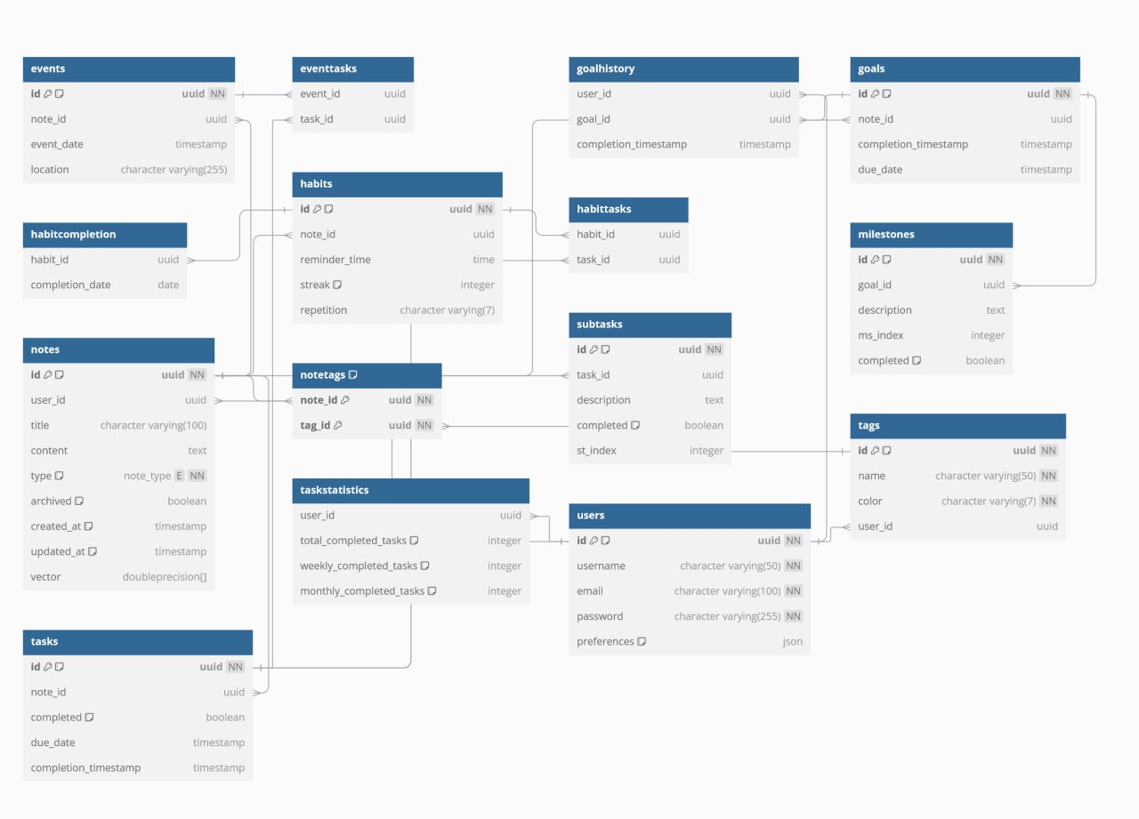
It is important to note that tables, such as events, eventtasks, and goalhistory were later removed from the design during the creation of the program as they were found redundant. For example, goalhistory would simply copy the completion timestamp of a goal, which is unnecessary repetition. In addition, several tables to store widgets were added

After picking the appropriate database, I started planning the tables that could be possibly useful for storing note and user data.
      - User data
Firstly, the user must be able to create their account. In order to keep records of users, each account must have a unique id, which will be generated using the UUIDv4 module of the UUID library in the database whenever a user is created. Each user must have a unique username, an email and an encrypted password. Additionally, each user table may also store their preferences and other optional data which may not need its own column in the preferences field.

CREATE TABLE users (
id uuid DEFAULT uuid_generate_v4() NOT NULL,
username character varying(50) NOT NULL,
email character varying(100) NOT NULL,
password character varying(255) NOT NULL,
preferences json DEFAULT '{}'::json
);
      - Notes
The main table for each note, no matter its note type, is the Notes table. It contains the fields universal for all note types, such as the title, content, type and the vector representation of the note. Finally, each note is connected to a user using the user_id foreign key and has a few other fields, such as creation and update timestamps and whether a note is archived or not. Additionally, note type tables, such as habits, milestones, events and goals reference the note_id of a corresponding note in the notes table to store additional data specific for this note type, such as a due date, location or whether a task is completed or not. Finally, some note types may have their own little notes, such as subtasks in tasks or milestones in goals. These tables are usually similar to their parent note, as they may also have a completion boolean and a description, but they reference the corresponding Task or Goal id.
Main notes table:
CREATE TABLE notes (
id uuid DEFAULT uuid_generate_v4() NOT NULL,
user_id uuid,
title character varying(100),
content text,
type note_type NOT NULL,
archived boolean DEFAULT false,
created_at timestamp without time zone DEFAULT CURRENT_TIMESTAMP,
updated_at timestamp without time zone DEFAULT CURRENT_TIMESTAMP,
vector double precision[]
);
Tables for the “Task” note type:
CREATE TABLE tasks (
id uuid DEFAULT uuid_generate_v4() NOT NULL,
note_id uuid,
completed boolean DEFAULT false,
due_date timestamp without time zone,
completion_timestamp timestamp without time zone
);

CREATE TABLE subtasks (
id uuid DEFAULT uuid_generate_v4() NOT NULL,
task_id uuid,
description text,
completed boolean DEFAULT false,
st_index integer
);

Tables for the “Habit” note type:
CREATE TABLE habits (
id uuid DEFAULT uuid_generate_v4() NOT NULL,
note_id uuid,
reminder_time time without time zone,
streak integer DEFAULT 0,
repetition character varying(7)
);

Ability to link multiple tasks to a single habit
CREATE TABLE habittasks (
habit_id uuid,
task_id uuid
);

Tables for the “Goal” note type:
CREATE TABLE goals (
id uuid DEFAULT uuid_generate_v4() NOT NULL,
note_id uuid,
completion_timestamp timestamp without time zone,
due_date timestamp without time zone
);

A table for subgoals(checkpoints)
CREATE TABLE milestones (
id uuid DEFAULT uuid_generate_v4() NOT NULL,
goal_id uuid,
description text,
ms_index integer,
completed boolean DEFAULT false
);

      - Tagging
Tags are independent from notes, so a corresponding table containing data about tags, such as their name and color, will be connected to notes using a separate table, called NoteTags, where note and tag ids are linked together.

CREATE TABLE tags (
id uuid DEFAULT uuid_generate_v4() NOT NULL,
name character varying(50) NOT NULL,
color character varying(7) NOT NULL,user_id uuid);

CREATE TABLE notetags (
note_id uuid NOT NULL,tag_id
uuid NOT NULL
);

      - Statistics
Finally, some tables containing data, such as statistics on goal, task and habit completion, are linked to each user and a corresponding note to provide the users with a history of their progress, even if the initial note is deleted.

CREATE TABLE taskstatistics (
user_id uuid,
total_completed_tasks integer DEFAULT 0,
weekly_completed_tasks integer DEFAULT 0,
monthly_completed_tasks integer DEFAULT 0
);

CREATE TABLE goalhistory (
user_id uuid,
goal_id uuid,
completion_timestamp timestamp without time zone
);

CREATE TABLE habitcompletion (
habit_id uuid,
completion_date date
);

      - Conclusion
This database design prioritizes normalization by separating data into distinct tables, minimizing redundancy and improving data integrity. For instance, user data is stored separately from notes, and note types have their own tables, negating data duplication. This approach enhances data consistency and simplifies updates. Furthermore, the use of foreign keys establishes clear relationships between tables, enabling efficient data retrieval and querying. By optimizing table structures and utilizing appropriate indexing, this design aims to ensure efficient data storage and retrieval, providing a robust foundation for the application.

    - Backend file structure
The structure I came up with follows common Python project conventions and uses a combination of modules for separation of concerns and a utils directory for reusable utility functions:
- models
  - w2v.model
- modules
  - __init__.py
  - goals.py
  - tasks.py
  - universal.py
  - etc
- utils
  - __init__.py
  - word2vec.py
  - utils.py
  - etc
- app.py
- config.py
- validation.py

In this system, models will be used to store pre-trained models for NLP (natural language processing) tasks such as note vectorization for context-based search. The main logic will be happening in the modules folder, where the __init__.py file signifies that this directory is a Python package. Goals, Tasks and other files will handle functionality related to similarly named note types. These files contain all the CRUD (create, read,update,delete) functionality for each note type respectively and will interact with the SQL database and process request sent by the frontend. Universal.py will contain ‘universal’ endpoints such as site-wide search that are not significant enough to be put in a separate file.
On the other hand, more complicated algorithms, such as text vectorization do deserve a separate file, which will be placed in the utils folder of the root directory. Any remaining functions without an endpoint will be put in utils.py.
Additionally, app.py will host the Flask application and be the place where all the routes are defined and the Flask application is initialised. Config.py is excluded from source control as in contains confidential configuration settings, such as database connection credentials and other enviroment variables. Finally, validation.py will contain validation forms for user submitted data to sanitize the inputs in notes or to add an additional layer of type safety and security before inserting data into the database.
    - OOP
OOP (object oriented programming) is a programming paradigm that organizes software design around objects (instances of classes), rather than functions. By using OOP, we can structure the code in a modular and organized manner. This improves code reusability, maintainability, and flexibility.
      - Constructing note processing code
In the context of my note-taking app, we can apply OOP by creating classes to represent key entities like Notes, Users, and Tags. These classes would encapsulate data and methods that operate on that data.
However, I noticed that most notes share similar base characteristics, such as tags, content and title and decided to use classes to mix and match actual api components to create an object that will be able to work with a specific note type. By doing that, I will encapsulate all logic for a note type in one place and create multiple classes for any note type by inheriting some properties, such as tag functionality or data cleanup for vectorization from the base class.
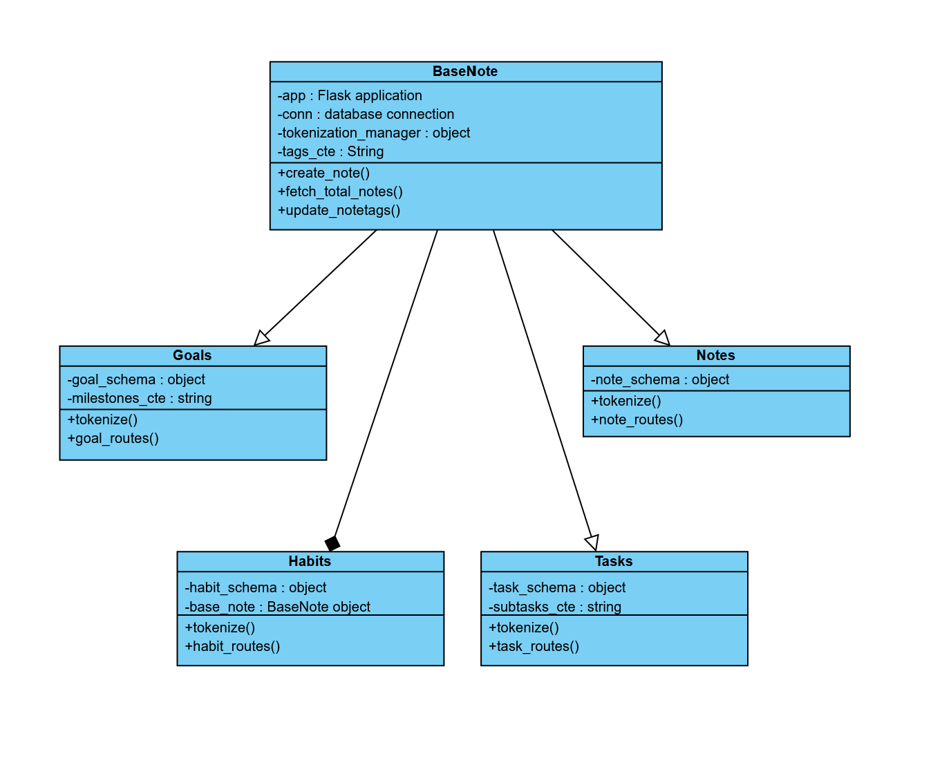

With the implementation above each note api inherits or composes all the necessary connections and managers, along with commonly used methods. In each case, a tokenization function is created that adjusts for the note type’s unique attributes (e.g. apart from note title and content on a task note type, the contents of the subtasks may also be read). All the endpoints that contain the logic are in the routes() function of each class.
      - Simplifying validation schemas
Object-Oriented Programming can also be uset so implify validation schemas by creating a base schema class. This class acts like a blueprint, defining common fields such as title, content, tags and their validation rules . Other schema classes inherit from the base class, just like in the processing part of the backend, reusing the common field definitions and validations. This reduces code duplication and makes it easier to maintain the validation rules. If a schema needs additional fields, it can simply add them to its own class definition. Based on the designed database and encapsulating any repeating fields or datastructures, here is an example of how such approach may be used to create a validation schema for an incoming request to validate and store a new Task note:
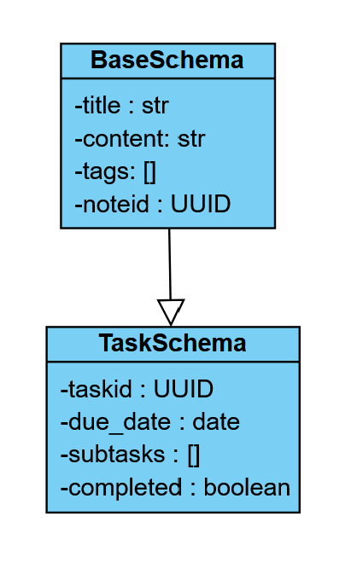

It is important to note that in this implementation the datatypes on attributes are the valid datatypes that are checked for in incoming data. In the Technical Solution, this will be expanded on further and the actual datatypes of the properties may turn out different due to the logic of the chosen validation library.
  - Frontend
    - User data on the frontend
Now that we’ve established how the data will be stored and processed on the backend, it’s time to delve deeper into how will it be collected and displayed to users.
Frontend applications often employ a state management system to efficiently handle and update data displayed to the user. This may include information about the currently selected note, a list of notes, loading status, and any validation errors.
The data flow involves these steps:
- Fetching Data: When the application starts or when the user reloads the page to view notes, the application fetches an initial set of note previews from a backend API based on the user’s pagination settings and the size of the display. Previews will have the note title and contents cut to speed up loading times and avoid loading long notes. This data is then stored in the application's state.
- User Interaction: As the user interacts with the application (e.g., creating, editing, or deleting notes), the application updates its internal state optimistically to reflect these changes. For example, when a user starts creating a new note, a new note object is created and added to the state and a request is sent to the backend to process and store the submitted data or reflect any changes, following one of the flowcharts in 2.1.2.
- Data Display: The application uses the updated state to render the user interface. For example, the list of notes is dynamically updated as new notes are created or existing ones are modified, all while the request may not have even reached the backend. Any changes are reverted if the request fails and an error message is displayed
This general data flow ensures that the user interface always reflects the latest state of the application's data, providing a seamless and responsive user experience.
    - Frontend file structure
Since the frontend of the application will be built with the React framework using JavaScript and TypeScript, the file structure will be predetermined by web application generation tools, such as Vite, unlike on the backend. Vite and similar tools provide a faster development experience for modern web projects. Running a simple command would create the basic components of a web app, such as index.html which is the default file that web servers look for on a website, along with installing NodeJS modules, creating a Git repository and providing the developer with a few sample components to start development. By some convention and from my experience, I arrived to the following file structure of the web app:

- node_modules
- components
- public
- src
  - api
  - types
    - taskTypes.ts
  - tasksApi.ts
  - Pages
    - Tasks
      - Components
      - Tasks.tsx
      - useTasks.ts
    - Account
    - Dashboard
  - index.css
  - routes.tsx
  - main.tsx
  - etc
- index.html
- .gitignore
- other configuration files

In the root directory of my app, I will have configuration files, such as package-lock.json, which will have the NodeJs libraries used in the project written down or .gitignore, which cofigures the folders that will be tracked by my source control scripts. One such folder is node_modules, which contains the actual NodeJs libraries and their files. These files are to be configured once and rarely touched during the development process.
The first folder necessarily involved with development of the app would be components, which would contain any reusable components such as buttons, cards or layout components. Public conventionally contains fonts, any images used in the website, documents or icons, so the user’s web browser would know in advance about the media it would have to load.
The most important folder of the project is src, containing files such as index.css, which would store the color codes for the main theme of the website, along with the router in routes.tsx to predetermine the routes the users would be able to follow on the website. In addition, main.tsx will act as the ‘brain’ of the application, where the most important tools such as contexts and providers will be imported and the core of the React app is set up. This will also be the file which renders the website on the webpage. The Pages folder will store the page components of the website, such as the Accounts page along with any components uniquely used in this page. Any logic involving interaction with accounts will be stored in a hook named useAccounts, which may involve api calls or changes to the state of the application. This hook can be called in other componetns or pages to retrieve some information from the Accounts state.
Finally, the api folder will contain files involved with moving data between frontend and backend. It will contain interfaces and schemas for type safety and validation, as well as CRUD (create, read, update, delete) methods on predetermined backend endpoints.

  - User Interface
    - The 10 principles of good design
Design is more than aesthetics—it's a philosophy that governs how users interact with and perceive a product. Dieter Rams' 10 principles of good design, though originally conceived for physical products, are still used in the web design industry. Here are the 10 principles that will be used during the design of the user interface of the app:
- Good design is innovative
- Good design makes a product useful
- Good design is aesthetic
- Good design makes a product understandable
- Good design is unobtrusive
- Good design is honest
- Good design is long-lasting
- Good design is thorough down to the last detail
- Good design is environmentally friendly
- Good design is as little design as possible
Even though not all of these principles can apply to digital designs or this specific scenario, they will still be referred to throughout the design process.
    - Design as an iterative process
Design should be an iterative process because it allows for continuous refinement and improvement, ensuring that the final product meets user needs effectively. This approach helps developers to not get tunnel visioned and obsess over their own design, but rather take advice from the end users of the product, keeping the final design as little as possible. Furthermore, iterative design is flexible, adapting to changing requirements or technologies, and ensures that the end product remains long-lasting, understandable and thorough.
    - Creating wireframes
Wireframes are an excellent first step in designing a website because they provide a clear, simplified visual blueprint of the layout and structure before investing time in detailed design or coding. By focusing on functionality and user flow, wireframes allow designers to map out where key elements like navigation, content, and receive user feedback, allowing the design of the website to quickly change without editing the code and being distracted by colors or typography. Wireframes save time and resources by laying a solid foundation for further development.
Before beginning with the wireframes, let’s establish a simple code which will be used to denote various elements on the webpage, in accordance with industry standards:
Button
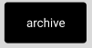
A button is denoted by a black box with or without any text inside
Icon

Icons or images are crossed wireframe boxes
Legend
The left of each wireframe is designated to the legend of the wireframe, which contains descriptions of primary components of the wireframe.
On the other hand, the right side of the screen may be used for additional notes, such as explaining the usage of buttons which were too small to have text inside.
Cards
Each different card or element which is not a button or an icon is colored in a different shade of gray to be easier to distinguish from other elements of the design.
Having considered the objectives in Analysis, I came to the following pages and elements that need to be sketched out first:

      - A generic note viewing and editing page, which supports organization by tagging, additional form fields and timestamps.
        - Viewing all notes
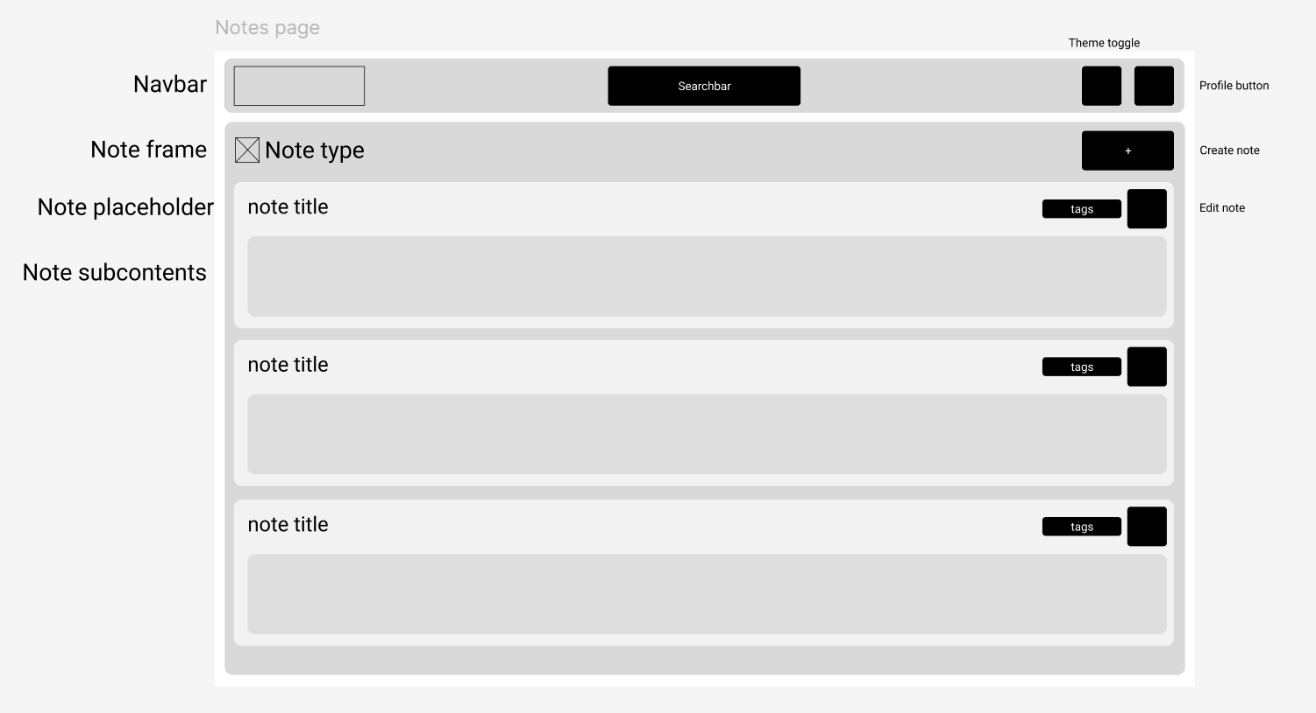
This wireframe represents the screen which will be containing all of user’s notes of a specific type, along with pagination controls, ability to create new notes, view their previews (such as a cropped title and content, if they exceed a certain character limit) and open each note in a separate screen for editing or viewing.
        - Editing a note
In the note editing page, the user will be able to alter the contents of each note, as long as organize tags, delete or archive it

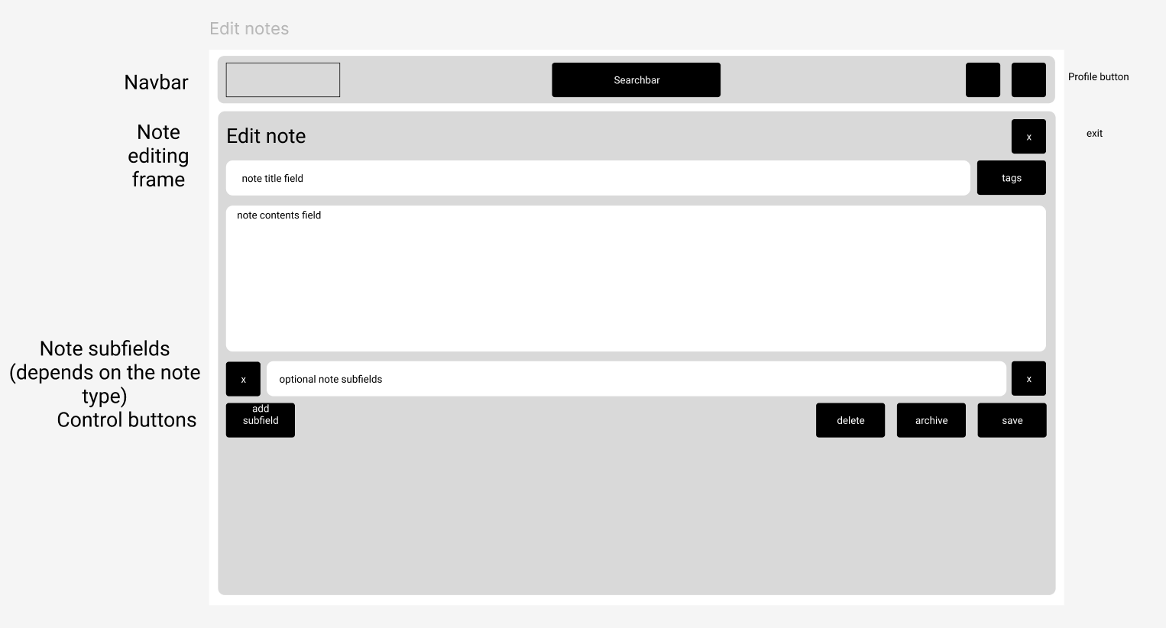
      - An account page where the user can edit their details
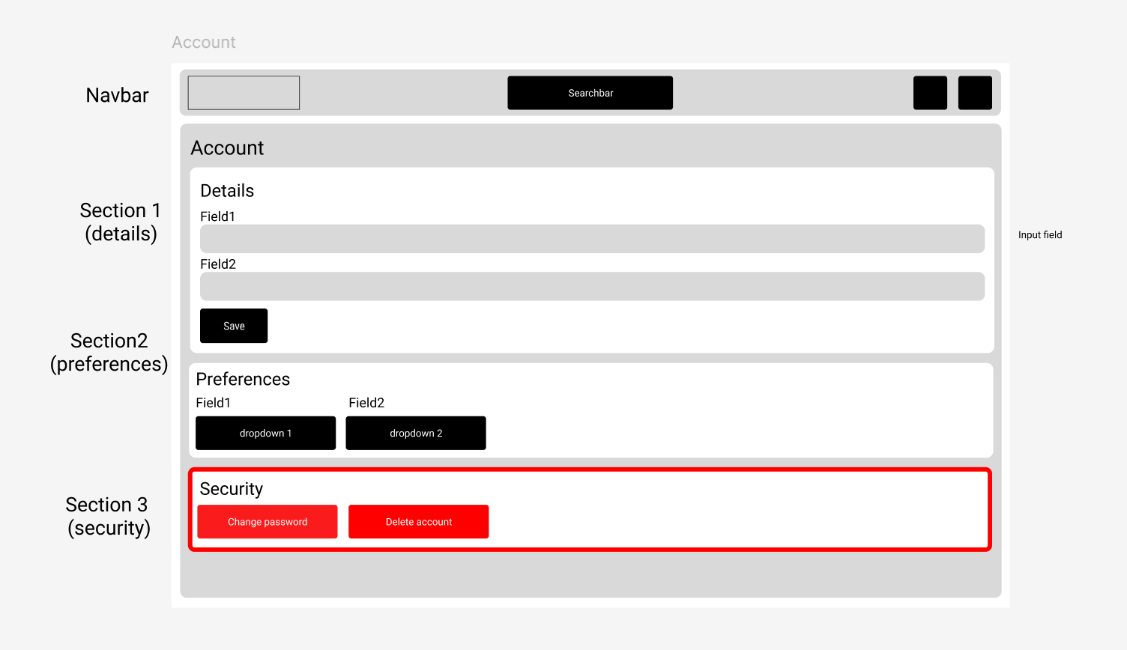
The account page will be divided into multiple sections, such as a form section (Section 1), where the user can edit text-based details such as their display name or email, Section 2 with preferences, such as font sizes or theme and finally a security section, which is outlined in red to warn users that it contains buttons such as changing the password.
      - A sidebar and other popups, such as alerts or search widgets

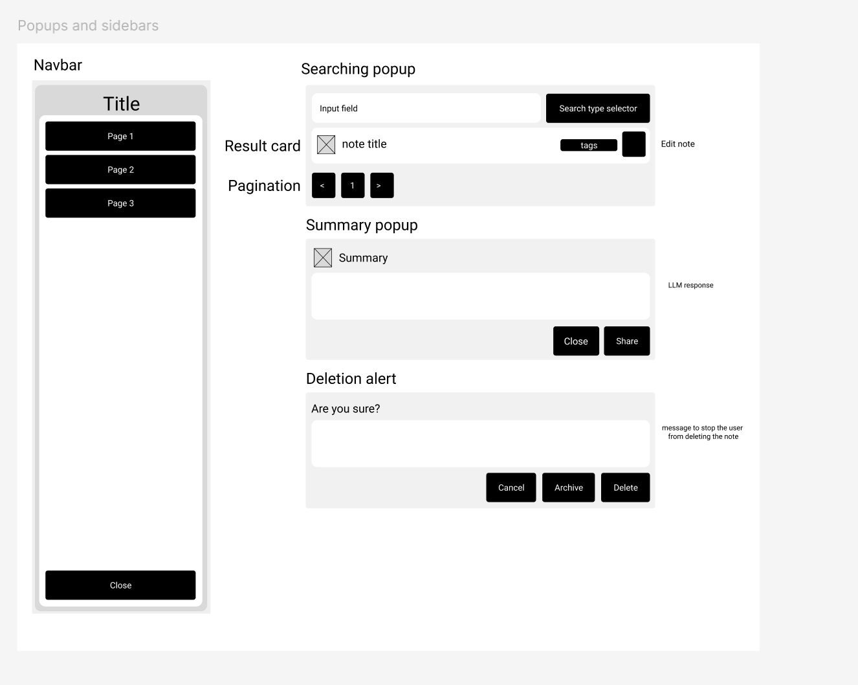

This wireframe contains reusable components, such as alerts, a searching popup with an ability to search notes, select types and edit them and a navbar, which can be used by the user at any time to navigate through the website.
      - A note statistics page
The requirement for accountability and statistics can be further expanded into a dashboard, which will contain widgets with statistics and other information. The general look for such a page should be as follows:
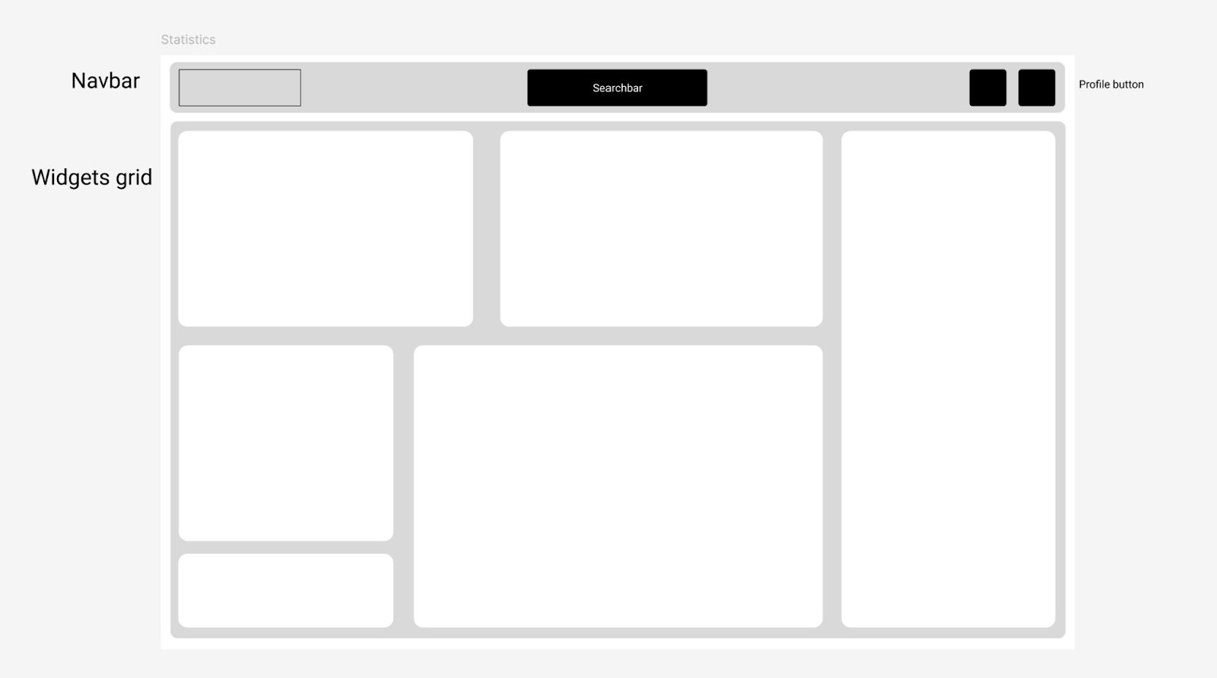
The page can be a grid with customizable widgets of various sizes. There are plenty of widget options, but most of them can be simplified to several types:
        - Charts
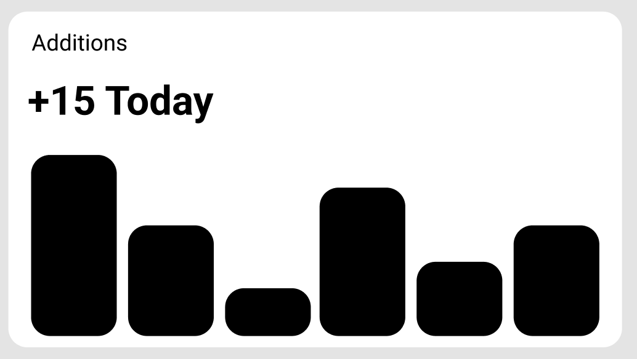
Charts can take the form of bar or graph charts and may be used to represent data such as task completion, activity, streaks etc. Depending on the size of the widget, several key features such as the scale may be dynamically added as the user scales the widget.
        - Numbers
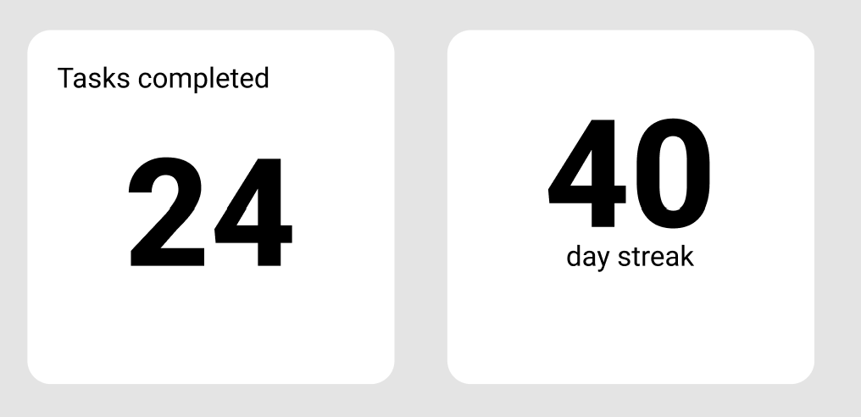
The smallest possible gridcell may be used to store a simple numerical value, such as the numbers provided above. In the examples, the widgets represent the total of tasks completed for a user and the length of their streak of using the app or a specific habit
        - Progress Bars
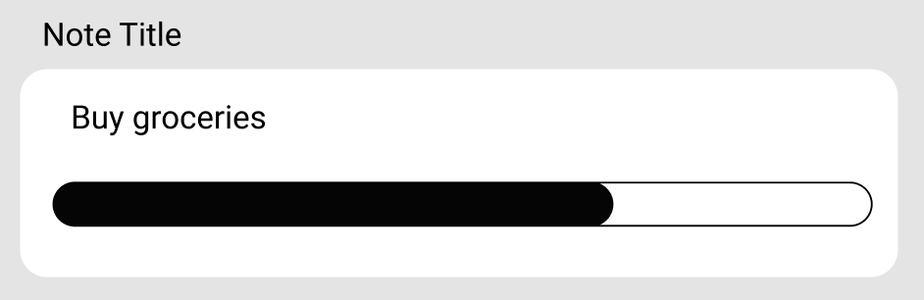
Such a simple thing as a progress bar may motivate users to continue with their commitments and provide gratification when they see their progress move after successfully completing a task.
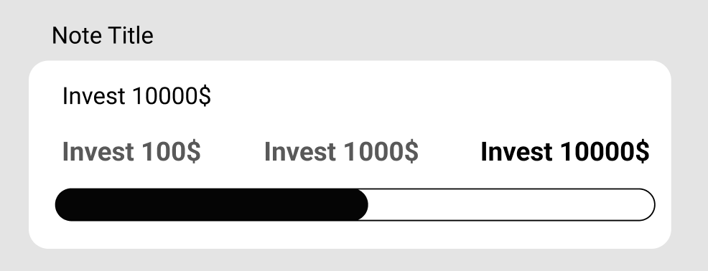
This idea may be expanded with the addition of milestones for goals, which may further motivate the user. Additionally, this example maybe used to highlight the ease of adapting these components for different sizes by stacking the milestones vertically:
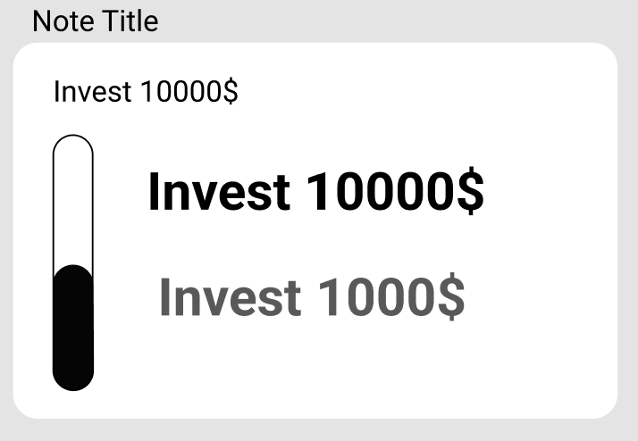
It is also important to remember that these widgets are drafts/wireframes and will look differently after being implemented in code.
        - Streaks
The following type can only be used to very specific notes that require daily commitment, allowing the user to visualise their progress in a simple way.
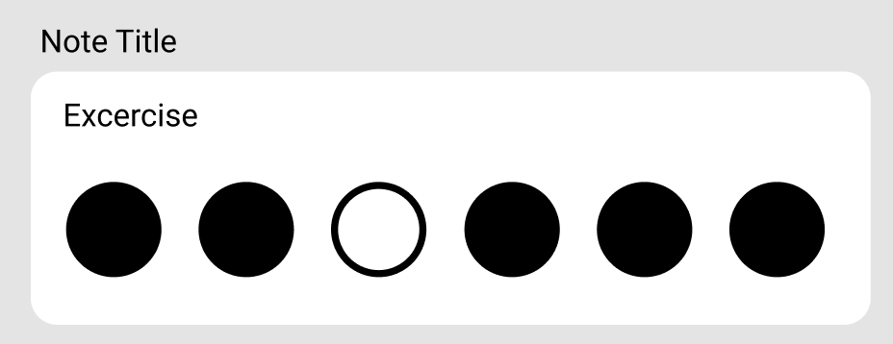
        - Mobile design
In addition, there should be design options for devices of different display sizes, to ensure that the products is long-lasting and thorough. Even though the app should be able to auto-adapt to various display sizes, some components must be moved around or replaced to accommodate for smaller screens.
Several elements of the interface have to be rearranged in order to keep everything readable. The biggest change was done to the navbar, where the theme toggle and account buttons have been moved to the sidebar to make more space for the logo on the narrower navbar.
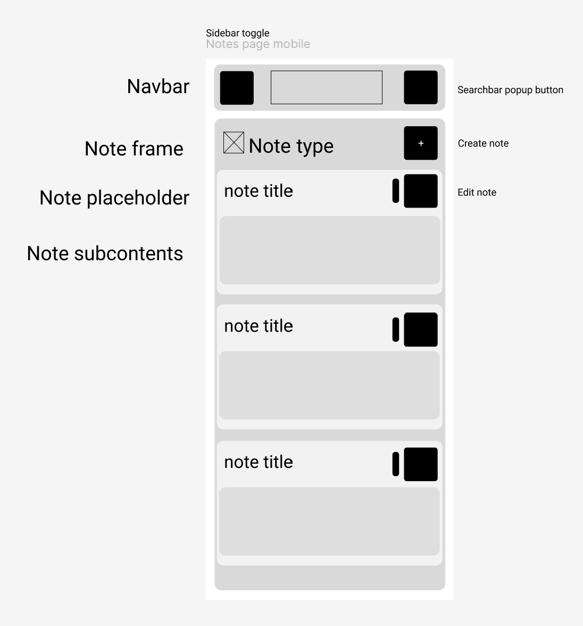
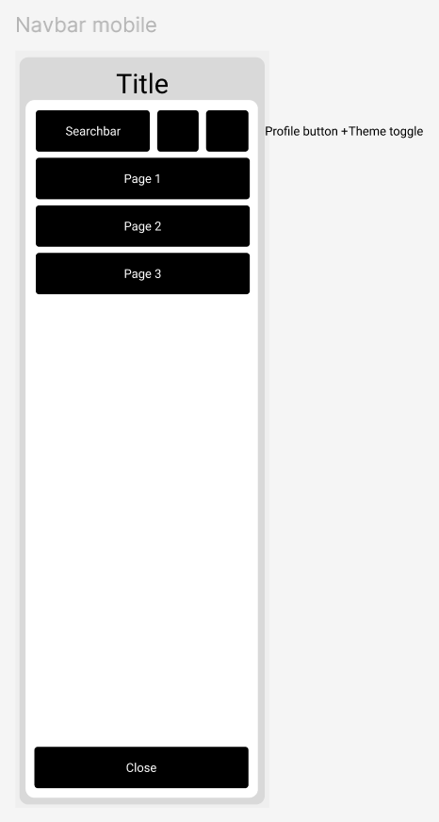
A similar refactoring happened to the note cards themselves. For example, there are less characters displayed per line as the screen shrinks to make the note cards grow in height instead of width. Moreover, additional whitespace can be found by shrinking the tag labels and just leaving small colored badges, with the actual tag titles being accessible only on click or hover:
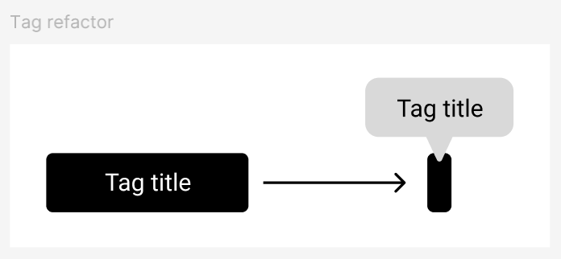
Other components such as widgets, editing screens or other pages without moving components or popups can be dynamically resized by the software or rearranged using adjustable grids for various display sizes
Finally, some components, that were previously used as popups on wider screens, such as search popups or alerts now can take the full width of the device
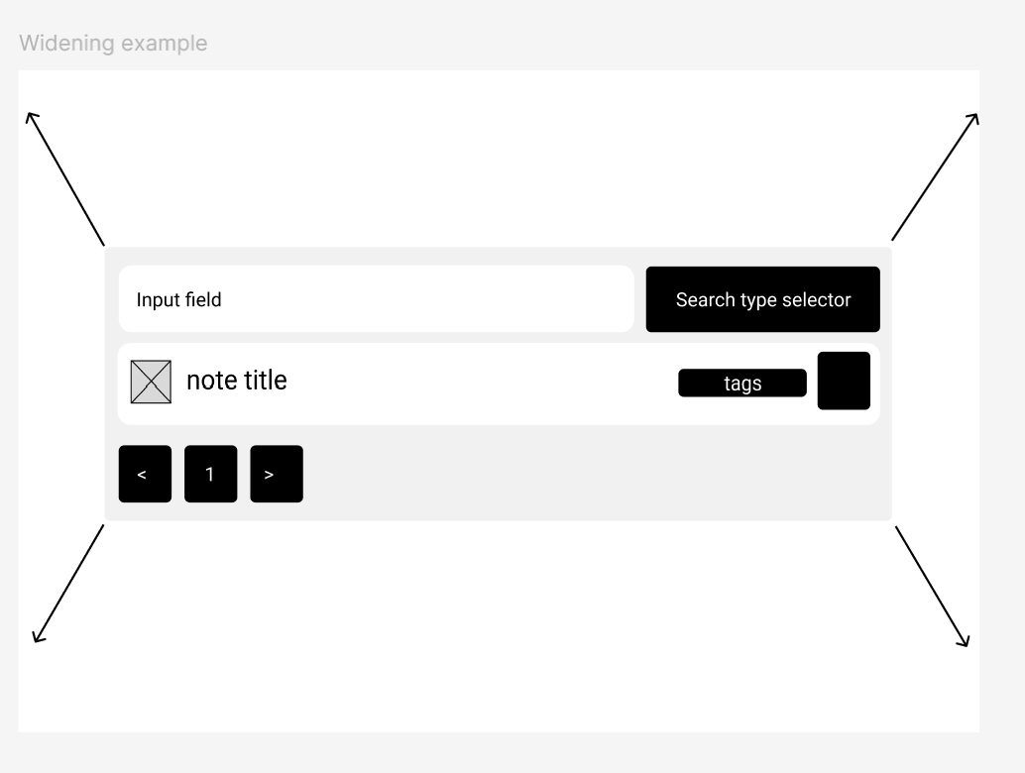
    - Choosing the color and fonts
      - Core color palette
Foreground, background, primary, and other colors are essential components of any visual design, serving crucial roles in creating a functional, visually appealing, and accessible user experience.
Foreground typically represents the text or content that users need to read or interact with. It's crucial for it to have a high contrast with the background color, making the text easily legible and reducing eye strain. Meanwhile, background sets the overall tone and provides a visual foundation for the design. The most prominent color in the design is called the primary color, often used for buttons, calls to action, and brand elements. It helps guide the user's attention to important areas of the interface.
There are a few optional colors that may be included in the color palette of a design. These colors are used to add visual interest and distinguish different elements within the design. They might include secondary colors for less prominent elements, accent colors for highlighting specific features, and neutral colors for borders or subtle background elements.
Since the users will have an ability to edit the colors of the tags that they create, I opted for a simple black and white color theme for light mode, and dark blue-light gray for the dark mode, to avoid the colors of the design from interfering with user’s note tag colors. In addition to that, the colors were chosen based on the following guidelines:
- Contrast: The color choices ensure contrast between foreground and background elements for readability and accessibility by all users.
- Accessibility: The color palette adheres to accessibility guidelines, aiming to meet WCAG contrast ratios to ensure sufficient color differentiation for users with visual impairments.
- Aesthetics: The colors were selected to create a visually appealing and cohesive aesthetic. The colors allow for a clean and relaxed look, without any attention-grabbing hues that would interfere with user’s focus.
- User Experience: The inclusion of a dark mode option provides users with greater flexibility to customize the interface to their preferences or in dark environments, which would improve their overall experience.
The following colors will be provided using the HSL color model (Hue, Saturation, Lightness), which would allow me to intuitively tweak the color palette, ensuring harmony and flexubility during the design process.
Background:
- Light Mode: 0 0% 100% (white)
- Dark Mode: 222.2 84% 4.9% (dark gray)
Foreground:
- Light Mode: 222.2 84% 4.9% (dark gray)
- Dark Mode: 210 40% 98% (light gray)
Primary: 222.2 47.4% 11.2% (a dark blue/purple hue)
Secondary:
- Light Mode: 210 40% 96.1% (light gray)
- Dark Mode: 217.2 32.6% 17.5% (darker gray)
Muted:
- Light Mode: 210 40% 96.1% (light gray)
- Dark Mode: 217.2 32.6% 17.5% (darker gray)
Accent:
- Light Mode: 210 40% 96.1% (light gray)
- Dark Mode: 217.2 32.6% 17.5% (darker gray)
Destructive: (warning)
- Light Mode: 0 84.2% 60.2% (red)
- Dark Mode: 0 62.8% 50.6% (red)

      - Typeface: Open Sans
        - Introduction
Sans-serif fonts, which is the category that Open Sans is part of, is characterized by their clean lines and lack of decorative flourishes (serifs), are commonly used in web development for several key reasons:
To begin with, sans fonts easier to read quickly due to their simplicity and reduces eye strain, crucial for comfortable digital experiences. Simplicity is often associated with technology, innovation, and minimalist design, which would align well with the preferences of the target user base (students and professionals that may not have time to decypher a complex font). Finally, these fonts can be used effectively for headlines, body text, and interface elements, ensuring consistency throughout the design while adhering to modern web accessibility standards.
        - Character set support
Font's character set support is a crucial consideration for a project where users are allowed to enter their own information in their language. The chosen font must encompass a broad range of characters, including:
    - Support for all Latin characters, including accented characters and diacritics
    - Support for common special characters such as punctuation, symbols, and mathematical symbols.
    - Comprehensive Unicode support to ensure accurate rendering across different platforms and operating systems and allowing users to write non-latin characters.
Luckily, Open Sans supports 586 languages at the time of writing and alphabets, such as Greek, Cyrillic, Latin, Hebrew with many math operators and punctuation signs. As a result, it is safe to say that most is not all of the characters that users write will be supported.
        - Licensing
Open Sans is an open-source font, licensed under the OFL (Open Font License), so I can use use it for free for both personal and commercial projects, completely eliminating any licensing costs.
        - Performance
One more consideration when picking a font for a project may be performance, as complex fonts may take a longer time to render, resulting in a worse user experience. On most modern computers this change in performance may be negligible, but this decision may be impactful on mobile phones or old computers.
        - A
- Technical solution
  - Backend
    - app.py

backend/app.py: This file is the main entry point for the backend application, built using the Flask framework in Python. It sets up the core application instance, configures middleware, initializes database connections, loads models, and defines the application's routes. The file starts by importing necessary modules and classes.

app = Flask(__name__)
app.config.from_object(Config)

This creates the Flask application instance and loads configuration settings from the `Config` class.

CORS(app, resources={r"/api/*": {"origins": ["http://localhost:5173"]}} , supports_credentials=True)

This configures CORS to allow requests from `http://localhost:5173`, which is the default port for the React frontend during development. The `supports_credentials=True` allows sending cookies and authorization headers.

jwt = JWTManager(app)

conn = psycopg2.connect(
host=Config.host,
database=Config.database,
user=Config.user,
password=Config.password,
port=Config.port
)

This initializes the JWT manager for handling authentication and establishes a connection to the PostgreSQL database using credentials from the configuration file

model = load_or_train_model()
tokenization_manager = TokenizationTaskManager(Config,model)
recents_manager = RecentNotesManager()

This section loads the vectorization model and initializes the `TokenizationTaskManager` and `RecentNotesManager`, modules that will encapsulate logic, concerning note vectorization and recent notes manaers.

notes = NoteApi(app, conn, tokenization_manager, recents_manager)
tasks = TaskApi(app, conn, tokenization_manager, recents_manager)
habits = HabitApi(app, conn, tokenization_manager, recents_manager)
goals = GoalApi(app, conn, tokenization_manager, recents_manager)

tag_routes(app, conn, tokenization_manager)
user_routes(app, conn)
archive_routes(app, conn, tokenization_manager)
universal_routes(app, conn, model, recents_manager)

API endpoints for different resources (notes, tasks, habits, goals, tags, users, archive, and universal routes) are initialised. It passes the Flask app instance, the database connection, and other managers to the route handlers.

@app.errorhandler(Exception)
def handle_exception(error):
return jsonify({'message': 'An error occurred', 'details': str(error)}), 500

@app.errorhandler(429)
def ratelimit_handler(e):
return jsonify({'message': 'An error occurred', 'details' : "Rate limit exceeded"}), 429

These define global error handlers for catching exceptions and rate limit errors, providing consistent JSON error responses.

if __name__ == '__main__':
app.run(debug=True, port=5000)

This starts the Flask development server when the script is executed directly. The `debug=True` option enables debugging features, and the development server runs on port 5000.
    - modules/universal.py
from datetime import datetime
import os
import sys
import psycopg2
from flask import g, jsonify, request
from flask_jwt_extended import jwt_required
sys.path.append(os.path.abspath(os.path.join(os.path.dirname(__file__), os.path.pardir)))
from flask import g, jsonify, request
from flask_jwt_extended import jwt_required
from formsValidation import GeminiSummarySchema
from utils.utils import process_universal_notes, token_required
from utils.word2vec import combine_strings_to_vector
```
This section imports necessary libraries. `datetime` handles dates and times. `os` and `sys` are for operating system interactions (file paths, etc.). `psycopg2` is the PostgreSQL database adapter. `flask`, `jsonify`, and `request` are from the Flask framework for building web APIs. `flask_jwt_extended` manages JWT authentication. The `sys.path` modification adds a parent directory to the Python path. `process_universal_notes` and `token_required` are custom utility functions, that will be talked about later
      - BaseNote class
class BaseNote:
def __init__(self, app, conn, tokenization_manager, recents_manager):
self.app = app
self.conn = conn
self.tokenization_manager = tokenization_manager
self.recents_manager = recents_manager
self.tags_cte = """TagsCTE AS (
SELECT
nt.note_id,
json_agg(json_build_object(
'tagid', tg.id,
'name', tg.name,
'color', tg.color
)) AS tags
FROM NoteTags nt
JOIN Tags tg ON nt.tag_id = tg.id
GROUP BY nt.note_id
)"""
def create_note(self, cur, userId, title, content, noteType, tags):
cur.execute( # Insert into Notes table
"INSERT INTO Notes (user_id, title, content, type) VALUES (%s, %s, %s, %s) RETURNING id",
(userId, title, content, noteType)
)
noteId = str(cur.fetchone()[0])
self.update_notetags(cur, noteId,tags, withDelete=False)
return noteId
def fetch_total_notes(self, cur,note_type, userId, page,offset,per_page):
cur.execute("""
SELECT COUNT(DISTINCT n.id) AS total
FROM Notes n
WHERE n.user_id = %s AND n.type = %s AND n.archived = FALSE
""", (userId,note_type,))
total = cur.fetchone()['total']
nextPage = page + 1 if (offset + per_page) < total else None
return total, nextPage
def update_notetags(self, cur, note_id, tags, withDelete=True):
if withDelete:
cur.execute("DELETE FROM NoteTags WHERE note_id = %s", (note_id,))
if tags:
tag_tuples = [(note_id, str(tagId)) for tagId in tags]
cur.executemany(
"""
INSERT INTO NoteTags (note_id, tag_id)
VALUES (%s, %s)
""",
tag_tuples
)
```
The `BaseNote` class provides core functionality for managing notes, that will be incorporated into other note types in the application. The `__init__` method initializes the class with the Flask app, a database connection (`conn`), a `tokenization_manager`, and a `recents_manager`. `tags_cte` defines a Common Table Expression (CTE) for efficiently retrieving note tags from the database, since the tag functionality is the same for all note types. `create_note` inserts a new note into the `Notes` table and then calls `update_notetags`. `fetch_total_notes` retrieves the total number of notes for a given user and note type, used for pagination. `update_notetags` updates the `NoteTags` table, associating tags with a note. It can either delete existing tags for the note before adding new ones or just add new tags.
      - Universal note functionality
def universal_routes(app, conn, model, recents_manager,genai):
@app.route('/api/search', methods=['GET'])
@jwt_required()
@token_required
def search():
# ...
@app.route('/api/recents', methods=['GET'])
@jwt_required()
@token_required
def get_recents():
# ...
@app.route('/api/calendar', methods=['GET'])
@jwt_required()
@token_required
def get_calendar_notes():
# ...
@app.route('/api/summarize', methods=['POST'])
@jwt_required()
@token_required
def summarize():
# ...
The `universal_routes` function sets up the API endpoints using Flask. It takes the Flask app instance, the database connection, a word2vec model (for note vectorization), a `recents_manager`, and a `genai` object (part of Google’s AI libraries). It defines four routes: `/api/search`, `/api/recents`, `/api/calendar`, and `/api/summarize`. Each route is decorated with `@app.route`, specifying the URL and HTTP method. `@jwt_required()` and `@token_required` ensure that the user is authenticated before accessing these routes. Here is how each function works:
      - Searching
@app.route('/api/search', methods=['GET'])
@jwt_required()
@token_required
def search():
try:
user_id = g.userId
cur = conn.cursor(cursor_factory=psycopg2.extras.DictCursor)
search_query = request.args.get('searchQuery')
search_mode = request.args.get('searchMode')
page = int(request.args.get('pageParam', 1))
per_page = int(request.args.get('perPage', 5))
offset = (page - 1) * per_page
if search_mode == "approximate":
query_vector = combine_strings_to_vector(search_query.split(),
model, False)
cur.execute("""
SELECT n.id AS note_id, n.title, n.content, n.type,
t.id AS tagid,
t.name,
t.color,
cosine_similarity(n.vector, %s) as similarity
FROM Notes n
LEFT JOIN NoteTags nt ON n.id = nt.note_id
LEFT JOIN Tags t ON nt.tag_id = t.id
WHERE n.user_id = %s AND n.archived = FALSE AND n.vector IS NOT NULL
ORDER BY similarity DESC
LIMIT %s OFFSET %s;
""", (query_vector, user_id, per_page, offset))
else:
cur.execute("""
SELECT n.id AS note_id, n.title, n.content, n.type,
t.id AS tagid,
t.name,
t.color
FROM Notes n
LEFT JOIN NoteTags nt ON n.id = nt.note_id
LEFT JOIN Tags t ON nt.tag_id = t.id
WHERE n.user_id = %s AND n.archived = FALSE
AND (n.title ILIKE %s OR n.content ILIKE %s)
LIMIT %s OFFSET %s;
""", (user_id, f"%{search_query}%", f"%{search_query}%", per_page, offset))
rows = cur.fetchall()
# Get the total number of results for pagination
if search_mode == "approximate":
cur.execute("""
SELECT COUNT(*) FROM Notes n
WHERE n.user_id = %s AND n.archived = FALSE AND n.vector IS NOT NULL;
""", (user_id,))
else:
cur.execute("""
SELECT COUNT(*) FROM Notes n
WHERE n.user_id = %s AND n.archived = FALSE
AND (n.title ILIKE %s OR n.content ILIKE %s);
""", (user_id, f"%{search_query}%", f"%{search_query}%"))

total = cur.fetchone()[0]
next_page = page + 1 if offset + per_page < total else None

if rows:
notes=process_universal_notes(rows,cur)

return jsonify({'message': 'Notes retrieved successfully', 'data': notes,
'pagination': {
'total': total,
'page': page,
'perPage': per_page,
'nextPage': next_page
}
}), 200
except Exception as e:
conn.rollback()
print(f"An error occurred: {e}")
return jsonify({'message': 'An error occurred', 'error': str(e)}), 500
finally:
cur.close()
The /api/search route handles searching for notes. It retrieves the user ID from the JWT (g.userId), gets the search query and mode (approximate or regular) from the request arguments, and sets up pagination. If the search mode is "approximate," it uses a cosine similarity search against pre-calculated note vectors (more about it later). Otherwise, it performs a standard case-insensitive search using ILIKE on the note title and content. It fetches the results, sorts them, calculates the total number of results for pagination, and calls process_universal_notes to format the data. Finally, it returns the notes and pagination information as a JSON response.
      - Recents
@app.route('/api/recents', methods=['GET'])
@jwt_required()
@token_required
def get_recents():
try:
userId=g.userId
noteIds = recents_manager.get_recent_notes_for_user(userId)
cur = conn.cursor(cursor_factory=psycopg2.extras.DictCursor)

notes = []
for note_id in noteIds:
cur.execute("""
SELECT n.id AS note_id, n.title, n.content, n.type,
t.id AS tagid,
t.name,
t.color
FROM Notes n
LEFT JOIN NoteTags nt ON n.id = nt.note_id
LEFT JOIN Tags t ON nt.tag_id = t.id
WHERE n.user_id = %s AND n.id = %s;
""", (userId, note_id))

row = cur.fetchone()
if row:
note = process_universal_notes([row], cur)[0]
notes.append(note)

return jsonify({'message': 'Recent notes retrieved successfully', 'data': notes}), 200
except Exception as e:
conn.rollback()
raise

The /api/recents route retrieves recently accessed notes. It gets the user ID, uses the recents_manager to fetch a list of recent note IDs, and then retrieves the full note details from the database for each ID. It works as an endpoint to retrieve recently accessed notes by the user from the recents_manager(more about it later), then format the notes and return them as a JSON response.
      - Calendar functionality
@app.route('/api/calendar', methods=['GET'])
@jwt_required()
@token_required
def get_calendar_notes():
try:
userId = g.userId
start_date = request.args.get('startDate')
end_date = request.args.get('endDate')

# Convert start and end dates to datetime objects
start_date = datetime.fromisoformat(str(start_date))
end_date = datetime.fromisoformat(str(end_date))

with conn.cursor(cursor_factory=psycopg2.extras.DictCursor) as cur:
# Fetch notes from goals table
cur.execute("""
SELECT n.id AS note_id, n.title, n.content, n.type, g.due_date
FROM Notes n
JOIN Goals g ON n.id = g.note_id
WHERE n.user_id = %s AND g.due_date BETWEEN %s AND %s
""", (userId, start_date, end_date))
goal_notes = cur.fetchall()

# Fetch notes from tasks table
cur.execute("""
SELECT n.id AS note_id, n.title, n.type, n.content, t.due_date
FROM Notes n
JOIN Tasks t ON n.id = t.note_id
WHERE n.user_id = %s AND t.due_date BETWEEN %s AND %s
""", (userId, start_date, end_date))
task_notes = cur.fetchall()

# Combine results
notes = []
for row in goal_notes + task_notes:
note = {
'noteid': row['note_id'],
'title': row['title'][:50] + '...' if len(row['title']) > 50 else row['title'],
'content': row['content'],
'due_date': row['due_date'],
'type': row['type'],
'tags' : []
}
#Select tags
cur.execute("""
SELECT
json_agg(json_build_object(
'tagid', tg.id,
'name', tg.name,
'color', tg.color
)) AS tags
FROM NoteTags nt
JOIN Tags tg ON nt.tag_id = tg.id
WHERE nt.note_id = %s
GROUP BY nt.note_id
""", (row['note_id'],))
note['tags'] = cur.fetchone()
notes.append(note)

return jsonify({'message': 'Notes retrieved successfully', 'data': notes}), 200

except Exception as e:
conn.rollback()
print(f"An error occurred: {e}")
return jsonify({'message': 'An error occurred', 'error': str(e)}), 500
The /api/calendar route retrieves notes associated with goals and tasks that fall within a specified date range. It gets the start and end dates from the request arguments, converts them to datetime objects, and then queries the Goals and Tasks tables to retrieve the relevant notes. It combines the results, truncates long titles, and fetches tags for each note. The notes with their due dates are then returned as a JSON response, and will be displayed on the calenar component on the website.

      - Summarization
@app.route('/api/summarize', methods=['POST'])
@jwt_required()
@token_required
def summarize():
try:

gemini_schema = GeminiSummarySchema()
data = gemini_schema.load(request.json)
title = data['title']
selection = data['selection']

model = genai.GenerativeModel("gemini-2.0-flash")
response = model.generate_content("""
Please summarize the following extract from a note titled {title}, delimeted by three backticks:

```{selection}```

Please include:

Key points: What are the most important things mentioned in the extract?

Context: How does this extract relate to the note as a whole?

Purpose: What is the purpose of this particular extract within the note?

Keep the summary concise, clear and below 1000 characters.
""".format(title=title, selection=selection),
# stream=True,
generation_config = genai.types.GenerationConfig(
temperature=0.2,
top_p=0.95,
max_output_tokens=256,
),

)
return jsonify({'message': 'Summary generated successfully', 'data': response}), 200
except Exception as e:
raise

The Summarization function is used to summarize the contents of the note a user selects on the website. It first checks whether the data is of valid type and length through the Schema, then extracts the relevant information. After that, a model is loaded from Google’s genai library. This model is a Large Language Model (LLM) called Gemini. The model is provided with a specific prompt, that was engineered to avoid prompt injection by telling the model that any text inside the backticks must be summarized. Moreover, extra instructions are given to ensure that summaries are generated with consistent formatting and the model knows maximum length of data it has to generate. Finally, the model is configured to match the task at hand with the following properties:

- temperature=0.2: Temperature controls the "randomness" of the generated text. A lower temperature (closer to 0) makes the output more deterministic and predictable, sticking closely to the most likely next words. It tends to produce more focused and conservative text.
- top_p=0.95: This is the nucleus sampling parameter. Nucleus sampling considers the most likely words whose cumulative probability exceeds top_p. In this case, it considers the words whose probabilities add up to 95%. A value of 0.95 means the model will consider a wider range of possible next tokens, but still constrain the selection to the most probable ones.
- max_output_tokens=256: This sets a hard limit on the number of tokens (roughly words or sub-words) that the model can generate. This prevents the model from running indefinitely and helps to control the length of the output. 256 tokens is a moderate length and likely corresponds to a few paragraphs of text.
When the response is generated, data returns to the user in form of a JSON object

    - modules/notes.py
Generally, most endpoints for different note types use similar logic, as each note has a create, update, edit and delete functionality. This is why the BaseNote class, and its predetermined functions to create a note in the Notes table, edit tags, etc. exists. Before we dive deeper into more complex note processing logic, I would like to first present the ‘simplest’ module, which is notes. By definition, this note type has no extra fields except for the usual title, contents and tags, to be used as a way to quickly jot down information and use advanced searching and summarization techniques that were briefly mentioned above.

from datetime import datetime
import os
import sys
from flask import Blueprint, g, jsonify, request
from flask_jwt_extended import jwt_required

from modules.universal import BaseNote
from utils.userDeleteGraph import delete_notes_with_backoff, delete_user_data_with_backoff
sys.path.append(os.path.abspath(os.path.join(os.path.dirname(__file__), os.path.pardir)))
from formsValidation import BaseSchema
from utils.utils import token_required
import psycopg2

class NoteApi(BaseNote):
def __init__(self, app, conn, tokenization_manager, recents_manager):
super().__init__(app, conn, tokenization_manager, recents_manager)
self.note_schema = BaseSchema()
self.note_routes()

def tokenize(self,noteId,title,content):
text = [title, content]
priority = sum(len(string) for string in text)
self.tokenization_manager.add_note(
text=text,
priority=priority,
note_id=noteId
)
The NoteApi class inherits the methods and properties of BaseNote and initializes them. The Tokenize function will be used for text vectorization and contains the fields that exist in this note type and will be relevant for the tokenization function

To sanitize and validate all the inputs, I am using a validation library called Marshmallow. With this library, I create schemas that validate the type, length and other properties of the input data. All the schemas are stored in a separate file named formsValidation.py. I will not explicitly mention this file, just provide relevant validation schemas along each module. For example, for notes, the following validation schemais used, which is then inherited into other schemas, that build on the BaseNote class:
from marshmallow import Schema, fields, ValidationError

# Base Schema for common fields
class BaseSchema(Schema):
title = fields.Str(required=True, validate=lambda s: 100 >= len(s) > 0)
content = fields.Str(required=False, validate=lambda s: len(s) <= 1000)
tags = fields.List(fields.UUID(), required=False)
noteid = fields.UUID(required=False)

Additionally, note_routes method defines the following API endpoints. By convention, all modules that require a token are decorated by @token_required function, and each endpoint features error handling algorithms that display the error to the user, roll back any database transactions and safely exit the function:

      - Create Note
I/api/notes/create (POST): Creates a new note. It validates the request data using self.note_schema.load(), retrieves the user ID from the JWT, creates the note in the database using the create_note method (inherited from BaseNote), adds the note text to the tokenization manager, commits the transaction, and returns the new note's ID It uses the functions from BaseNote, as there are no extra properties in the Notes type:
@self.app.route('/api/notes/create', methods=['POST'])
@jwt_required()
@token_required
def create_note():
try:
userId = str(g.userId)
data = self.note_schema.load(request.get_json())
title = data['title']
tags = data['tags']
content = data['content']
with self.conn.cursor(cursor_factory=psycopg2.extras.DictCursor) as cur:
noteId = self.create_note(cur, userId, title, content, 'note', tags)

self.tokenize(noteId,title,content)
self.conn.commit()

return jsonify({
'message': 'Note created successfully',
'data': {
'noteid': noteId,
}
}), 200
except Exception as error:
self.conn.rollback()
print('Error during transaction', error)
raise
finally:
cur.close()
      - Update Note
/api/notes/update (PUT): Updates an existing note. It validates the request data, retrieves the note ID, title, content, and tags, updates the note in the database, updates the note's tags, updates the tokenization manager, commits the transaction, and returns a success message.
@self.app.route('/api/notes/update', methods=['PUT'])
@jwt_required()
@token_required
def update_note():
try:
userId = str(g.userId) # Convert userId to string
note = self.note_schema.load(request.get_json())

note_id = str(note['noteid'])
title = note['title']
content = note['content']
tags = note.get('tags', [])

with self.conn.cursor(cursor_factory=psycopg2.extras.DictCursor) as cur:

cur.execute("""
UPDATE Notes
SET title = %s, content = %s
WHERE id = %s AND user_id = %s
""", (title, content, note_id, userId))

self.update_notetags(cur, note_id, tags)

self.tokenize(note_id, title, content)
self.conn.commit()

return jsonify({'message': 'Note updated successfully', 'data': None}), 200
except Exception as e:
self.conn.rollback()
print(f"An error occurred: {e}")
raise
finally:
cur.close()
      - Delete Note
/api/notes/delete (PUT): Deletes a note. It retrieves the note ID from the request, and uses delete_notes_with_backoff(more about it later) to attempt deletion with retries, handles NoteTags table before Notes table. It also removes the note from the tokenization manager, if it is currently awaiting tokenization. It returns a success message or an error message if deletion fails after retries.
@self.app.route('/api/notes/delete', methods=['PUT'])
@jwt_required()
@token_required
def delete_note():
try:
userId = g.userId
data = request.get_json()
note_id = data['noteId']
stack = [12,2] #NoteTags, Notes
stack.reverse()
if delete_notes_with_backoff(self.conn, note_id, stack):
self.tokenization_manager.delete_note_by_id(note_id)
return jsonify({'message': 'Note deleted successfully'}), 200
else:
return jsonify({'message': 'Failed to delete note data after multiple retries'}), 500
except Exception as e:
self.conn.rollback()
raise
      - Get a specific note
/api/note (GET): Retrieves a single note by ID. It retrieves the user ID and note ID from the request, fetches the full note details along with its tags using self.tags_cte, and adds the note to the recents_manager (for tracking recently viewed notes). It returns the note details or a 404 error if the note is not found. It also uses the self.tags_cte to efficiently retrieve tags.

@self.app.route('/api/note', methods=['GET'])
@jwt_required()
@token_required
def get_note():
try:
userId = g.userId
noteid = request.args.get('noteid')

with self.conn.cursor(cursor_factory=psycopg2.extras.DictCursor) as cur:

cur.execute(f"""
WITH {self.tags_cte}
SELECT
n.id AS note_id,
n.title AS note_title,
n.content AS note_content,
n.created_at AS note_created_at,
n.type AS note_type,
COALESCE(tags_cte.tags, '[]') AS tags
FROM Notes n
LEFT JOIN TagsCTE tags_cte ON n.id = tags_cte.note_id
WHERE n.user_id = %s AND n.id = %s AND n.type = 'note' AND n.archived = FALSE
""", (userId, noteid))

row = cur.fetchone()
if not row:
return jsonify({'message': "Note not found"}), 404

note = {
'noteid': row['note_id'],
'title': row['note_title'],
'content': row['note_content'],
'tags': row['tags']
}
self.recents_manager.add_note_for_user(userId, noteid)
return jsonify({"note": note, 'message': "Note fetched successfully"}), 200

except Exception as e:
self.conn.rollback()
print(f"An error occurred: {e}")
return jsonify({'message': 'An error occurred', 'error': str(e)}), 500

finally:
cur.close()
      - Get Note previews
/api/notes/previews (GET): Retrieves previews of notes, paginated. It retrieves the user ID, gets the page number and items per page from the request arguments, calculates the offset, retrieves the total number of notes for pagination, and then fetches note previews (truncated title and content) along with their tags. This is implemented to reduce the amount of data being transmitted when many notes are loaded, which will speed up loading time. It returns the previews and pagination information as a JSON response. The query uses a Tag CTE, self.tags_cte, defined in the BaseNote class.
@self.app.route('/api/notes/previews', methods=['GET'])
@jwt_required()
@token_required
def get_note_previews():
try:
userId = g.userId
# Pagination
page = int(request.args.get('pageParam', 1)) # Default to page 1
per_page = int(request.args.get('per_page', 5)) # Default to 10 items per page
offset = (page - 1) * per_page

with self.conn.cursor(cursor_factory=psycopg2.extras.DictCursor) as cur:
# Fetch the total count of notes for pagination metadata
total,nextPage = self.fetch_total_notes(cur, 'note', userId, page, offset, per_page)

cur.execute(f"""
WITH {self.tags_cte}
SELECT
n.id AS note_id,
n.title AS title,
n.content AS content,
n.type AS type,
COALESCE(tags_cte.tags, '[]') AS tags
FROM Notes n
LEFT JOIN TagsCTE tags_cte ON n.id = tags_cte.note_id
WHERE n.user_id = %s AND n.type = 'note' AND n.archived = FALSE
ORDER BY n.updated_at DESC
LIMIT %s OFFSET %s
""", (userId, per_page, offset))

rows = cur.fetchall()
notes = []
for row in rows:
note = {
'noteid': row['note_id'],
'title': row['title'][:100] + '...' if len(row['title']) > 100 else row['title'],
'content': row['content'][:200] + '...' if len(row['content']) > 200 else row['content'],
'tags': row['tags']
}
notes.append(note)

return jsonify({"notes": notes,
'pagination': {
'total': total,
'page': page,
'perPage': per_page,
'nextPage': nextPage
}}), 200

except Exception as e:
self.conn.rollback()
print(f"An error occurred: {e}")
return jsonify({'message': 'An error occurred', 'error': str(e)}), 500

finally:
cur.close()

    - modules/tasks.py
The tasks module combines the most techniques from other modules, building on the base provided by the notes.py files. It contains cross-table parametrized SQL, uses Common Table Expressions to simplify SQL statements and uses schemas to validate and sanitize the inputs.
      - Initialization
class TaskApi(BaseNote):
def __init__(self, app, conn, tokenization_manager, recents_manager):
super().__init__(app, conn, tokenization_manager, recents_manager)
self.task_schema = TaskSchema()
self.task_routes()

self.subtasks_cte = """SubtasksCTE AS (
SELECT
st.task_id,
json_agg(json_build_object(
'subtaskid', st.id,
'description', st.description,
'completed', st.completed,
'index', st.st_index
)) AS subtasks
FROM Subtasks st
GROUP BY st.task_id
)"""

def tokenize(self,noteId,title,content,subtasks):
text = [title, content] + [subtask['description'] for subtask in subtasks] if subtasks else [title, content]
priority = sum(len(string) for string in text)
self.tokenization_manager.add_note(
text=text,
priority=priority,
note_id=noteId
)
The taskAPI class inherits the BaseNote class mentioned previously, but some additions are made to accommodate for the new task-related tables, such as subtasks
      - Task creation
@self.app.route('/api/tasks/create', methods=['POST'])
@jwt_required()
@token_required
def create_task():
try:
userId = str(g.userId) # Convert UUID to string if userId is a UUID

data = self.task_schema.load(request.get_json())

title = data['title']
tags = data['tags']
content = data['content']
subtasks = data['subtasks']
due_date = data.get('due_date')

with self.conn.cursor(cursor_factory=psycopg2.extras.DictCursor) as cur:
noteId = self.create_note(cur, userId, title, content, 'task', tags)

cur.execute( #Insert into Tasks table
"""
INSERT INTO Tasks (note_id, completed, due_date)
VALUES (%s, %s, %s) RETURNING id
""",
(noteId, False, due_date)
)
taskId = cur.fetchone()[0]
new_subtasks = None
if subtasks:
subtask_tuples = [
(taskId, subtask['description'], False, subtask['index'])
for subtask in subtasks
]
cur.executemany(
"""
INSERT INTO Subtasks (task_id, description, completed, st_index)
VALUES (%s, %s, %s, %s)
RETURNING id, task_id, description, completed, st_index
""",
subtask_tuples
)
cur.execute(
"""
SELECT id, task_id, description, completed, st_index
FROM Subtasks
WHERE task_id = %s
""",
(taskId,)
)
new_subtasks = cur.fetchall()

self.tokenize(noteId,title,content,subtasks)
self.conn.commit()
return jsonify({
'message': 'Task created successfully',
'data': {
'noteid': noteId,
'taskid': taskId,
'subtasks': new_subtasks
}
}), 200
except Exception as error:
self.conn.rollback()
print('Error during transaction', error)
raise
finally:
cur.close()
The task creation goes as follows:
Firstly, the ID of the user that sent this request is taken and stored, along with the data that had been passed in the request. This data is validated via the following schemas, that inherit the BaseNote schema:
# Subtask Schema
class SubtaskSchema(Schema):
subtaskid = fields.UUID(required=False)
description = fields.Str(required=True, validate=lambda s: 500 >= len(s) > 0)
completed = fields.Bool(required=True)
index = fields.Int(required=True)

# Task Schema
class TaskSchema(BaseSchema):
taskid = fields.UUID(required=False)
due_date = fields.Str(required=False, allow_none=True)
subtasks = fields.List(fields.Nested(SubtaskSchema), required=False, allow_none=True)
completed = fields.Bool(required=False)

Secondly, the note is created in the Notes table of the database, with the autogenerated by the database UUID being returned. Then, this ID is passed as a foreign key into the Tasks table through an SQL statement and the subsequent TaskID as a foreign key into the Subtasks table using nested loops for simplicity, if there were any provided in the POST request.
Finally, any user-entered data is sent for tokenization and the database-generated IDs are returned in a JSON request to be used to correctly display the new notes on the frontend.

      - Updating tasks
@self.app.route('/api/tasks/update', methods=['PUT'])
@jwt_required()
@token_required
def update_task():
try:
userId = str(g.userId) # Convert userId to string
task = self.task_schema.load(request.get_json())

note_id = str(task['noteid']) # Convert note_id to string
task_id = str(task['taskid']) # Convert task_id to string
title = task['title']
content = task['content']
due_date = task.get('due_date')
subtasks = task.get('subtasks', [])
tags = task.get('tags', [])

with self.conn.cursor(cursor_factory=psycopg2.extras.DictCursor ) as cur:
if not verify_task_ownership(userId, task_id, cur):
return jsonify({'message': 'You do not have permission to update this task'}), 403

cur.execute("""
UPDATE Notes
SET title = %s, content = %s
WHERE id = %s AND user_id = %s
""", (title, content, note_id, userId))

cur.execute("""
UPDATE Tasks
SET due_date = %s
WHERE id = %s
""", (due_date, task_id))

cur.execute("DELETE FROM Subtasks WHERE task_id = %s", (task_id,))
for subtask in task.get('subtasks', []):
cur.execute("""
INSERT INTO Subtasks (task_id, description, completed, st_index)
VALUES (%s, %s, %s, %s)
""", (task_id, subtask['description'], subtask['completed'], subtask['index']))

self.update_notetags(cur, note_id, tags)

self.tokenize(note_id, title, content, subtasks)
self.conn.commit()

return jsonify({'message': 'Task updated successfully', 'data': None}), 200
except Exception as e:
self.conn.rollback()
print(f"An error occurred: {e}")
raise
finally:
cur.close()

The data is received in a similar method: the user ID is retrieved and the data is validated using a schema mentioned above. However, when updating tasks, a special function runs to verify that the task and subtask being altered indeed belong to the user that tries to alter them, to avoid any mishaps or attacks:
def verify_subtask_ownership(user_id, subtask_id, cur):
cur.execute("""
SELECT st.id
FROM Subtasks st
JOIN Tasks t ON st.task_id = t.id
JOIN Notes n ON t.note_id = n.id
WHERE st.id = %s AND n.user_id = %s
""", (subtask_id, user_id))
return cur.fetchone() is not None

def verify_task_ownership(user_id, task_id, cur):

query = """
SELECT Notes.user_id
FROM Tasks
JOIN Notes ON Tasks.note_id = Notes.id
WHERE Tasks.id = %s
"""
cur.execute(query, (task_id,))
result = cur.fetchone()

if (len(result)<1) or (result['user_id'] != user_id):
print("False")
return False
return True
The function works by checking if the task or subtask exist in the database and if the stored user id is the same as the provided user id. Similar functions exist for every note type. If the ownership is verified, SQL queries run to update the corresponding Note, Task and Subtask records for a specific note. Finally, corresponding tags are updated, user content is sent for tokenization and a success code is returned.

      - Deleting a task
@self.app.route('/api/tasks/delete', methods=['PUT'])
@jwt_required()
@token_required
def delete_task():
try:
userId = g.userId
data = request.get_json()
taskId = data['taskId']
noteId = data['noteId']
with self.conn.cursor(cursor_factory=psycopg2.extras.DictCursor) as cur:
if verify_task_ownership(userId, taskId, cur) == False:
return jsonify({'message': 'You do not have permission to update this task'}), 403

stack =[12,11,10,2] #NoteTags, Subtasks, Tasks, Notes
stack.reverse()
if delete_notes_with_backoff(self.conn, noteId, stack):
self.tokenization_manager.delete_note_by_id(noteId)
return jsonify({'message': 'Task deleted successfully'}), 200
else:
return jsonify({'message': 'Failed to delete task data after multiple retries'}), 500
except Exception as e:
self.conn.rollback()
raise
The task deletion method is similar for all the notes. However, this time a few extra tables are added to the execution stack, and user’s ownership is checked among more tables. The function ends with a success or error codes with messages returned to the frontend.
      - Toggling task fields
@self.app.route('/api/tasks/toggle', methods=['PUT'])
@jwt_required()
@token_required
def toggle_task_fields():
try:
userId = g.userId
data = request.get_json()
taskId = data.get('taskid')
subtaskId = data.get('subtaskid')

with self.conn.cursor(cursor_factory=psycopg2.extras.DictCursor) as cur:
if not verify_task_ownership(userId, taskId, cur):
return jsonify({'message': 'You do not have permission to update this task'}), 403

if not subtaskId:
toggle_task_sql = """
UPDATE Tasks
SET completed = NOT completed,
completion_timestamp = CASE
WHEN completed THEN NULL -- If the task is being uncompleted, set timestamp to NULL
ELSE CURRENT_TIMESTAMP -- If the task is being completed, set timestamp to current date and time
END
WHERE id = %s
"""
cur.execute(toggle_task_sql, (taskId,))

cur.execute("""
SELECT completed
FROM Tasks
WHERE id = %s
""", (taskId,))
task_completed = cur.fetchone()['completed']
try:
cur.execute("""
SELECT total_completed_tasks
FROM taskstatistics
WHERE user_id = %s
""", (userId,))
total_completed_tasks = cur.fetchone()['total_completed_tasks']
cur.execute("""
UPDATE taskstatistics
SET total_completed_tasks = %s
WHERE user_id = %s
""", (total_completed_tasks + 1 if task_completed else (total_completed_tasks - 1 if total_completed_tasks-1>0 else 0), userId))
except:
cur.execute("""
INSERT INTO taskstatistics (user_id, total_completed_tasks)
VALUES (%s, %s)
""", (userId, 1))

if subtaskId and verify_subtask_ownership(userId, subtaskId, cur):
toggle_subtask_sql = """
UPDATE Subtasks
SET completed = NOT completed
WHERE id = %s AND task_id = %s
"""
cur.execute(toggle_subtask_sql, (subtaskId, taskId))

self.conn.commit()
return jsonify({'message': 'Field toggled successfully', "data": None}), 200

except Exception as e:
self.conn.rollback()
print(f"An error occurred: {e}")
return jsonify({'message': 'An error occurred', 'error': str(e)}), 500

finally:
cur.close()

This section is new and specific for the Tasks note type. Tasks are made in a way that they have an extra property named completion in their tables, which shows whether the task has been completed or not. Each subtask also has the same property, which allows to track progress on a specific task. Task completion is reversible, so toggle_task_fields() can work for both completing tasks and doing the opposite. It works by first receiving two properties: taskID and subtaskID. TaskID is always received and is used to find the task that the user is trying to mark as done. If no subtaskID is received, the application assumes that the user is attempting to complete the whole task. Regardless for that, the task and/or subtask ownership is first checked by functions mentioned at 3.1.3.3. If the user has the relevant rights, a CASE SQL query is used to set the value of the completion property in the relevant task or subtask record to the opposite boolean value.
Additionally, if a task was completed, several extra queries run to update the task statistics. For example, the number of total completed tasks is fetched from the TaskStatistics table, which is then either incremented or decremented based on the action that was instigated by the user.
Lastly, as always, any changes in the database are commited and sufficient error or success codes are sent back to the user.
      - Task Previews
@self.app.route('/api/tasks/previews', methods=['GET'])
@jwt_required()
@token_required
def get_task_previews():
try:
userId = g.userId
# Pagination
page = int(request.args.get('pageParam', 1)) # Default to page 1
per_page = int(request.args.get('per_page', 5)) # Default to 5 items per page
offset = (page - 1) * per_page
with self.conn.cursor(cursor_factory=psycopg2.extras.DictCursor) as cur:
# Fetch the total count of tasks for pagination metadata
total,nextPage = self.fetch_total_notes(cur, 'task', userId, page, offset, per_page)
cur.execute(f"""
WITH {self.subtasks_cte},
{self.tags_cte}
SELECT
n.id AS note_id,
n.title AS title,
n.content AS content,
t.id AS task_id,
t.completed AS task_completed,
t.due_date AS task_due_date,
COALESCE(stc.subtasks, '[]') AS subtasks,
COALESCE(tgc.tags, '[]') AS tags
FROM Notes n
LEFT JOIN Tasks t ON n.id = t.note_id
LEFT JOIN SubtasksCTE stc ON t.id = stc.task_id
LEFT JOIN TagsCTE tgc ON n.id = tgc.note_id
WHERE n.user_id = %s AND n.type = 'task' AND n.archived = FALSE
ORDER BY n.updated_at DESC
LIMIT %s OFFSET %s
""", (userId, per_page
, offset
))
rows = cur.fetchall()
tasks = []
for row in rows:
task = {
'noteid': row['note_id'],
'taskid': row['task_id'],
'title': row['title'][:100] + '...' if len(row['title']) > 100 else row['title'],
'content': row['content'][:200] + '...' if len(row['content']) > 200 else row['content'],
'completed': row['task_completed'],
'due_date': row['task_due_date'],
'subtasks': row['subtasks'],
'tags': row['tags']
}
tasks.append(task)
return jsonify({"tasks": tasks,
'pagination': {
'total': total,
'page': page,
'perPage': per_page,
'nextPage': nextPage
}}), 200
except Exception as e:
self.conn.rollback()
print(f"An error occurred: {e}")
return jsonify({'message': 'An error occurred', 'error': str(e)}), 500
finally:
cur.close()

As stated previously in the Notes module, previews are useful to reduce the size of the notes being loaded by removing unnecessary detail, which will anyways be invisible to the user on the page where all the notes are shown.
Since each user may have many notes, pagination is used. Pagination involves sending a small chunk of the actually avalible data to again reduce loading times and avoid fetching hundreds of notes, if a single page may only have enough space to house 10 previews. To implement pagination, several extra parameters are sent to the backend. In my implementation, it is the current page and the number of tasks per page. These are arguments determined by the frontend’s settings and pickers, but default to 1 and 5 to prevent errors if for some reason such arguments are not received. Then, an inherited method fetch_total_notes is used with a ‘task’ argument to calculate the total amount of notes. With these values stored, SQL schemas are executed to fetch data from Notes, Tasks, Subtasks and Tags tables. This information is grouped together and sectioned based on the LIMIT property, with the OFFSET being calculated from the current page number and the amount of data per page. OFFSET basically moves the window of fixed length (5 by default) across the data in the database to retrieve information that should be on the specified page. Finally, long text strings are truncated and the data is sent back to the user.
      - Retrieving a single task

@self.app.route('/api/task', methods=['GET'])
@jwt_required()
@token_required
def get_task():
try:
userId = g.userId
noteid = request.args.get('noteid')

with self.conn.cursor(cursor_factory=psycopg2.extras.DictCursor) as cur:
cur.execute(f"""
WITH {self.subtasks_cte},
{self.tags_cte}
SELECT
n.id AS note_id,
n.title AS note_title,
n.content AS note_content,
n.created_at AS task_created_at,
t.id AS task_id,
t.completed AS task_completed,
t.due_date AS task_due_date,
COALESCE(stc.subtasks, '[]') AS subtasks,
COALESCE(tgc.tags, '[]') AS tags
FROM Notes n
LEFT JOIN Tasks t ON n.id = t.note_id
LEFT JOIN SubtasksCTE stc ON t.id = stc.task_id
LEFT JOIN TagsCTE tgc ON n.id = tgc.note_id
WHERE n.user_id = %s AND n.id = %s AND n.type = 'task' AND n.archived = FALSE
""", (userId, noteid))

row = cur.fetchone()
if not row:
return jsonify({'message': "Task not found"}), 404

task = {
'noteid': row['note_id'],
'taskid': row['task_id'],
'title': row['note_title'],
'content': row['note_content'],
'completed': row['task_completed'],
'due_date': row['task_due_date'],
'subtasks': row['subtasks'],
'tags': row['tags']
}

self.recents_manager.add_note_for_user(userId, noteid)
return jsonify({"task": task, 'message': "Task fetched successfully"}), 200

except Exception as e:
self.conn.rollback()
print(f"An error occurred: {e}")
return jsonify({'message': 'An error occurred', 'error': str(e)}), 500

finally:
cur.close()

This function has little difference from the function shown in 3.1.2.4, apart from the tables. There are more tables associated with the Tasks type, so more tables and Common Table Expressions are used. But in the end, data is sent to the user in JSON format.
    - modules/archive.py
Now I will pivot away from modules that are directly linked to a specific note type and continue talking about more general code. The Archive module helps complete the requirement of organization, as notes can be removed from their subsequent note page and placed into a storage without being deleted directly. This can be executed by using the archived property of the Notes table, which allows the application to filter out any notes that are not archived to display in corresponding sections. Meanwhile, all archived notes will be displayed on a separate page with options to permanently delete or restore the notes.
      - Archive and Restore
Due to this one property, the implementation is note type-agnostic, so there is no need to have a lot of cases concerning different note type-specific tables. This is because the Notes table contains the main information for any user-created note, regardless for its note type. The archiving function is called when a correct method calls the /archive API endpoint. The function just accesses the archived property of the Notes table and sets it to TRUE, subsequently removing the note from display anywhere else. Then, the connection commits and a success or error code is sent. A complete opposite SQL operation is performed when the note needs to be unarchived.
@app.route('/api/notes/archive', methods=['PUT'])
@jwt_required()
@token_required
def archive():
try:
userId = g.userId
cur = conn.cursor()
data = request.get_json()
note_id = data.get('noteId')

cur.execute(
"UPDATE Notes SET archived = TRUE WHERE id = %s AND user_id = %s",
(note_id, userId)
)
conn.commit()
return jsonify({'message': 'Note archived successfully'}), 200
except Exception as e:
conn.rollback()
raise
finally:
cur.close()
@app.route('/api/notes/restore', methods=['PUT'])
@jwt_required()
@token_required
def restore():
try:
userId = g.userId
cur = conn.cursor()
data = request.get_json()
note_id = data.get('noteId')
cur.execute(
"UPDATE Notes SET archived = FALSE WHERE id = %s AND user_id = %s",
(note_id, userId)
)
conn.commit()
return jsonify({'message': 'Note restored successfully'}), 200
except Exception as e:
conn.rollback()
raise
finally:
cur.close()
      - GetAll
The code, however, gets more complicated whenever the archived notes need to be retrieved. Since any note type can be archived, the function must work regardless for the note type.
@app.route('/api/notes/archive', methods=['GET'])
@jwt_required()
@token_required
def getAll():
try:
userId = g.userId
page = request.args.get('pageParam', 1, type=int)
per_page = request.args.get('per_page', 10, type=int)
offset = (page - 1) * per_page

cur = conn.cursor(cursor_factory=psycopg2.extras.DictCursor)

cur.execute("""
SELECT COUNT(DISTINCT n.id) AS total
FROM Notes n
WHERE n.user_id = %s AND n.archived = TRUE
""", (userId,))
total = cur.fetchone()['total']

cur.execute(
"""
SELECT n.id AS note_id, n.title, n.content, n.type,
t.id AS tagid,
t.name,
t.color
FROM Notes n
LEFT JOIN NoteTags nt ON n.id = nt.note_id
LEFT JOIN Tags t ON nt.tag_id = t.id
WHERE n.user_id = %s AND n.archived = TRUE
LIMIT %s OFFSET %s
""",
(userId, per_page + 1, offset) # Fetch one more note than the limit
)
rows = cur.fetchall()
if rows:
notes = process_universal_notes(rows,cur)

# Determine if there is a next page
if len(notes) > per_page:
next_page = page + 1
notes = notes[:per_page] # Return only the number of notes requested
else:
next_page = None

return jsonify({'message': 'Archived notes retrieved successfully', 'data': notes,
'pagination': {
'total': total,
'page': page,
'perPage': per_page,
'nextPage': next_page
}}), 200
except Exception as e:
conn.rollback()
raise
finally:
cur.close()
Firstly, the user ID and the request arguments are retrieved in a type-safe manner. Then, other pagination parameters, such as the offset, are calculated. Then, the database cursor is created and the total number of archived notes is fetched for pagination purposes. After that, note information, such as its type, title, content and their tags are fetched from the Note and Tags tables. This more simplified implementation is used to avoid returning data of different structures for notes of different type. Since the user cannot open the note in the Archive section of the application, only data necessary to display the note and make a decision to restore or delete it will be returned. Finally, a utility function is used to process such universally applicable data is used (more about it later), and pagination values, along with the requested data composed into a JSON array is returned to the user, if there are no errors on the way.
    - modules/tags.py
What differentiates tags from other notes is that apart from the CRUD functionality, there also should be a way to link the tags to other notes. For this, a link table NoteTags is used, which links tag IDs to corresponding note IDs. However, before we get to this functionality, let’s quickly go over creating, updating, retrieving and deleting tags.
      - CRUD tags
#TAG MODULE
from datetime import datetime
from flask import Blueprint, g, jsonify, request
from flask_jwt_extended import jwt_required
import psycopg2.extras

import os
import sys
sys.path.append(os.path.abspath(os.path.join(os.path.dirname(__file__), os.path.pardir)))
from utils.utils import merge_sort, token_required, verify_tag_ownership
from formsValidation import TagSchema

Firstly, all modules from libraries like datetime, flask and psycopg2 are imported. Additionaly, any custom functions and schemas are imported from other modules.

def tag_routes(app, conn, model):

@app.route('/api/tags/create', methods=['POST'])
@jwt_required()
@token_required
def create_tag():
cur = None
try:
userId = g.userId
tag_schema = TagSchema()
data = tag_schema.load(request.get_json()) #Deserialize the incoming data
tag_name = data['name']
tag_color = data['color']

cur = conn.cursor() # Create a cursor object
cur.execute(
"INSERT INTO Tags (name, color, user_id) VALUES (%s, %s, %s) RETURNING id",
(tag_name, tag_color, userId)
)
tag_id = cur.fetchone()[0]

conn.commit() # Commit the transaction
return jsonify({'message': 'Tag created successfully', 'data': {'id': tag_id}}), 200
except Exception as error:
if conn:
conn.rollback()
print('Error during transaction', error)
return jsonify({'message': 'Failed to create tag'}), 500
finally:
if cur:
cur.close()
Tag creation is similar to creating any other notes: data is retrieved from the request, broken down, validated. Then, a cursor object is created which connects to the database and performs an INSERT operation to insert the tag data, such as its name, HEX color code and the ID of the user it belonds to. Finally, connection is committed and the generated ID of the tag is returned with a success or error code.
@app.route('/api/tags/', methods=['GET'])
@jwt_required()
@token_required
def getAll_tags():
try:
userId = g.userId # Get the user id from the g object
with conn:
with conn.cursor(cursor_factory=psycopg2.extras.DictCursor) as cur: # Create a cursor object
cur.execute(
"SELECT id AS tagid, name, color FROM Tags WHERE user_id = %s", # Query to fetch all tags
(userId,)
)
rows = cur.fetchall()
sorted_tags = merge_sort(rows, key=lambda tag: tag['name']) #Mergesort to sort tags by name
tags = [{'tagid':tag['tagid'], 'name': tag['name'], 'color': tag['color']} for tag in sorted_tags]

return jsonify({'message': 'Tags fetched successfully', 'data': tags}), 200
except Exception as e:
return jsonify({'message': 'Failed to fetch tags'}), 500

This function is used on the Tags page to show the user all the tags they own, regardless of the notes they are connected to. Here, I used a mergesort (will be talked about in the utilities module) to quickly sort through the tags that were returned by the query. Finally, inline iteration is used to create an array of dictionaries of tags, which are returned along an appropriate code.
@app.route('/api/tags/<int:note_id>', methods=['GET'])
@jwt_required()
@token_required
def getTags():
try:
userId = g. userId

cur = conn.cursor(cursorclass=psycopg2.extras.DictCursor) # Create a cursor object

note_id = request.args.get('note_id')
cur.execute(
"SELECT t.id AS t.tagid, t.name, t.color FROM Tags t JOIN NoteTags nt ON t.id = nt.tag_id WHERE nt.note_id = %s AND t.user_id = %s",
(note_id, userId)
)
tags = cur.fetchall()
conn.commit() # Commit the transaction
return jsonify({'message': 'Tags fetched successfully', 'data': tags}), 200
except Exception as e:
conn.rollback()
raise
finally:
cur.close()

The getTags() function returns an array of tags that correspond to a specific note. The cursor joins Tags and NoteTags to only return tags that have the note id that was sent as arguments of the request. The retrieved tags are formed into an array and returned to the frontend.

@app.route('/api/tags/edit', methods=['PUT'])
@jwt_required()
@token_required
def editTag():
cur = None
try:
tag_schema = TagSchema()
userId = g.userId
data = tag_schema.load(request.get_json()) # Deserialize the incoming data
tag_id = str(data['tagid'])
name = data['name']
color = data['color']
cur = conn.cursor(cursor_factory=psycopg2.extras.DictCursor)# Create a cursor object
if verify_tag_ownership(userId, tag_id, cur) is False: # Check if the user has permission to update the tag
return jsonify({'message': 'You do not have permission to update this tag'}), 403

cur.execute(
"UPDATE Tags SET name = %s, color = %s WHERE id = %s", (name, color, tag_id),
)
conn.commit()
return jsonify({'message': 'Tag updated successfully', 'data': None}), 200
except Exception as e:
if cur is not None:
conn.rollback()
return jsonify({'message': 'An error occurred', 'error': str(e)}), 500
finally:
if cur is not None:
cur.close()

To edit the tag, apart from the deserialization, creation of cursor objects and other techniques like error handling, a function is used to validate that the tag indeed belongs to the user.
@app.route('/api/tags/delete', methods=['PUT'])
@jwt_required()
@token_required
def deleteTag():
try:
userId = g.userId

cur = conn.cursor()
data = request.get_json() # Deserialize the incoming data
tag_id = data['tagid']

if not verify_tag_ownership(userId, tag_id, cur):
return jsonify({'message': 'You do not have permission to update this tag'}), 403

# Perform deletion operations
cur.execute("DELETE FROM Tags WHERE id = %s AND user_id = %s", (tag_id, userId))
cur.execute("DELETE FROM NoteTags WHERE tag_id = %s", (tag_id,))
conn.commit()

return jsonify({'message': 'Tag deleted successfully', 'data': None}), 200
except Exception as e:
conn.rollback()
raise
finally:
cur.close()

Finally, deleting tags ensures that the tag belongs to a user and that all the note-tag relationships are also deleted from the NoteTags table.
      - Linking Tags
@app.route('/api/tags/add', methods=['POST'])
@jwt_required()
@token_required
def addTag():
try:
userId = g. userId
cur = conn.cursor()
data = request.get_json() # Deserialize the incoming data
note_id = data['note_id']
tag_id = data['tagid']
if verify_tag_ownership(userId, tag_id, cur) is False: # Check if the user has permission to update the tag
return jsonify({'message': 'You do not have permission to update this tag'}), 403

cur.execute (
"INSERT INTO NoteTags (note_id, tag_id) VALUES (%s, %s)", (note_id, tag_id),
)
conn.commit() # Commit the transaction
cur.close()
return jsonify({'message': 'Tag added successfully', 'data': None}), 200
except Exception as e:
conn.rollback()
cur.close()
raise

Linking tags does not even require editing the Tags table, as everything is done in the NoteTags table before verifying that the tags belong to the user trying to link them. No data needs to be sent to the user.
    - modules/widgets.py

    - modules/users.py
    - modules/ honorable mentions
    - utils...

