  - Setting up the website
The first file a browser reads when the website is loaded is index.html, which contains the title of the website, its logo, any <meta> tags that describe the contents of the website for SEO (search engine optimization), along with information that helps properly display the website using Open Graph protocol so the website can be easily embedded into any social media post. Moreover, this file allows me to mount the actual React application into the body of the webpage:
index.html
<!doctype html>
<html lang="en">
<head>
<meta charset="UTF-8" />
<link rel="icon" type="image/svg+xml" href="/logo.svg" />
<meta name="viewport" content="width=device-width, initial-scale=1.0" />

<!-- Additional meta tags -->
<meta name="description" content="Neanote - Your ultimate note-taking app for organizing and managing your tasks and ideas." />
<meta name="keywords" content="neanote, note-taking, task management, organization, productivity" />
<meta name="author" content="Roman Sasinovich" />

<!-- Open Graph meta tags for social media sharing -->
<meta property="og:title" content="Neanote - Note-taking and Task Management" />
<meta property="og:description" content="Neanote - Your ultimate note-taking app for organizing and managing your tasks and ideas." />
<meta property="og:image" content="/logo.svg" />
<meta property="og:url" content="https://www.neanote.com" />
<meta property="og:type" content="website" />
<title>neanote</title>
</head>
<body>
<div id="root"></div>
<script type="module" src="/src/main.tsx"></script>
</body>
</html>

  - Rendering the app
This file is the backbone of the whole program. It is used to mount the React app to the webpage, while also allowing me to wrap the app with context providers for key functionality:
main.tsx
import * as React from "react";
import * as ReactDOM from "react-dom/client";
import { ToastContainer } from "react-toastify";
import 'react-toastify/dist/ReactToastify.css';
import { ThemeProvider } from '../components/providers/theme-provider.tsx';
import './index.css';
import AppRouter from "./routes.tsx";
import { ScreenSizeProvider } from "./DisplayContext.tsx";

const App = () => (
<ThemeProvider defaultTheme="light" storageKey="vite-ui-theme">
<ScreenSizeProvider>
<AppRouter/>
<ToastContainer/>
</ScreenSizeProvider>
</ThemeProvider>
);

//mount the app
ReactDOM.createRoot(document.getElementById('root')!).render(
<React.StrictMode>
<App />
</React.StrictMode>,
)

Now let’s go over each provider and explain their purpose.
    - Providers
      - What is a provider?
In React, a context provider is like a shared storage space for data that you want to make accessible to multiple components in your application, without having to pass that data as props through every level of the component tree. It allows to manage global application state without engaging in prop drilling (i.e. passing same information through many and many components )
      - ThemeProvider
ThemeProvider.tsx
import React from 'react'
import { createContext, useContext, useEffect, useState } from "react"
type Theme = "dark" | "light" | "system"

type ThemeProviderProps = {
children: React.ReactNode
defaultTheme?: Theme
storageKey?: string
}

type ThemeProviderState = {
theme: Theme
setTheme: (theme: Theme) => void
}

const initialState: ThemeProviderState = {
theme: "system",
setTheme: () => null,
}

const ThemeProviderContext = createContext<ThemeProviderState>(initialState)

export function ThemeProvider({
children,
defaultTheme = "light",
storageKey = "vite-ui-theme",
...props
}: ThemeProviderProps) {
const [theme, setTheme] = useState<Theme>(
() => (localStorage.getItem(storageKey) as Theme) || defaultTheme
)

useEffect(() => {
const root = window.document.documentElement

root.classList.remove("light", "dark")

if (theme === "system") {
const systemTheme = window.matchMedia("(prefers-color-scheme: dark)")
.matches
? "dark"
: "light"

root.classList.add(systemTheme)
return
}

root.classList.add(theme)
}, [theme])

const value = {
theme,
setTheme: (theme: Theme) => {
localStorage.setItem(storageKey, theme)
setTheme(theme)
},
}

return (
<ThemeProviderContext.Provider {...props} value={value}>
{children}
</ThemeProviderContext.Provider>
)
}

export const useTheme = () => {
const context = useContext(ThemeProviderContext)

if (context === undefined)
throw new Error("useTheme must be used within a ThemeProvider")

return context
}

This code defines a React component called ThemeProvider that allows you to manage and apply a theme (dark, light, or system-defined) to your application. It uses the useState hook to store the current theme, and the useEffect hook to update the document's root element's class based on the selected theme. It also provides a useTheme hook that allows other components to easily access and utilize the current theme and its setter function. The ThemeProvider component also stores the selected theme in local storage using the storageKey prop, so the user does not need to change their theme every time they reopen the page.

      - ScreenSizeProvider
This provider adds event listeners which dynamically determine the current screen size ( small, medium, or large) based on the current window width. The current screen size is stored using a useState hook, while the useEffect hook handles window rezise events, allowing me to calculate whether certain elements of the UI will be compressed or not at the current screen width.
DisplayContext.tsx

import React, { createContext, useContext, useState, useEffect, ReactNode } from 'react';

interface ScreenSizeContextProps { //interface to ensure type safety
screenSize: 'small' | 'medium' | 'large';
isDateCollapsed: boolean;
isTagCompressed: boolean;
}

const ScreenSizeContext = createContext<ScreenSizeContextProps | undefined>(undefined);

const ScreenSizeProvider = ({ children }: { children: ReactNode }) => {
const [screenSize, setScreenSize] = useState<'small' | 'medium' | 'large'>('large');

useEffect(() => {
const handleResize = () => {
if (window.innerWidth < 650) {
setScreenSize('small');
} else if (window.innerWidth >= 650 && window.innerWidth < 1024) {
setScreenSize('medium');
} else {
setScreenSize('large');
}
};

// Set initial size
handleResize();

window.addEventListener('resize', handleResize);
return () => window.removeEventListener('resize', handleResize);
}, []);

const isDateCollapsed = screenSize === 'small';
const isTagCompressed = screenSize !== 'large';

return (
<ScreenSizeContext.Provider value={{ screenSize, isDateCollapsed, isTagCompressed }}>
{children}
</ScreenSizeContext.Provider>
);
};

const useScreenSize = () => {
const context = useContext(ScreenSizeContext);
if (context === undefined) {
throw new Error('useScreenSize must be used within a ScreenSizeProvider');
}
return context;
};

export { ScreenSizeProvider, useScreenSize };

    - App router
The last two components in the App component are AppRouter and ToastContainer. The latter is just a part of the react-toastify library and is used to show small alerts(toasts) to provide feedback to user actions. Meanwhile, AppRouter utilizes the react-router-dom library to render different components for different frontend endpoints.
routes.tsx
import React from 'react';
import Layout from "../components/Layout/Layout";

import {
BrowserRouter as Router, Routes, Route,
createBrowserRouter
} from "react-router-dom";
import Dashboard from "./Pages/Dashboard/Dashboard.tsx";
import Login from "./Pages/Login/Login.tsx";
import Register from "./Pages/Register/Register.tsx";
import withTokenCheck from '../components/providers/token-check.tsx';
import Landing from './Pages/Landing/Landing.tsx';
import Notes from './Pages/Tasks copy/Notes.tsx';
import Tasks from './Pages/Tasks/Tasks.tsx';
import Tags from './Pages/Tags/Tags.tsx';
import EditTasks from './Pages/Tasks/EditTasks.tsx';
import Habits from './Pages/Habits/Habits.tsx';
import EditHabits from './Pages/Habits/EditHabits.tsx';
import Goals from './Pages/Goals/Goals.tsx';
import EditGoals from './Pages/Goals/EditGoals.tsx';
import CreateGoal from './Pages/Goals/CreateGoal.tsx';
import CreateTask from './Pages/Tasks/CreateTask.tsx';
import CreateHabits from './Pages/Habits/CreateHabits.tsx';
import Archive from './Pages/Archive/Archive.tsx';
import Account from './Pages/Account/Account.tsx';
import CreateNote from './Pages/Tasks copy/CreateNote.tsx';
import EditNotes from './Pages/Tasks copy/EditNotes.tsx';
import Calendar from './Pages/Calendar/Calendar.tsx';

const CheckedLayout = withTokenCheck(Layout);

const AppRouter = () => (

<Router>
<Routes>
<Route path="/" element={<CheckedLayout />}>
<Route index element={<Dashboard />} />
<Route path="account" element={<Account/>} />
<Route path="calendar" element={<Calendar/>} />

<Route path="notes" element={<Notes/>} />
<Route path="notes/edit" element={<EditNotes/>} />
<Route path="notes/create" element={<CreateNote/>} />

<Route path="tasks" element={<Tasks/>} />
<Route path="tasks/edit" element={<EditTasks/>} />
<Route path="tasks/create" element={<CreateTask/>} />

<Route path="habits" element={<Habits/>} />
<Route path="habits/edit" element={<EditHabits/>} />
<Route path="habits/create" element={<CreateHabits/>} />

<Route path="goals" element={<Goals/>} />
<Route path="goals/edit" element={<EditGoals/>} />
<Route path="goals/create" element={<CreateGoal/>} />

<Route path="archive" element={<Archive/>} />
<Route path="tags" element={<Tags/>} />
</Route>
<Route path="login" element={<Login />} />
<Route path="register" element={<Register />} />
<Route path="get-started" element={<Landing/>} />
</Routes>
</Router>
);
export default AppRouter
In this file, all the endpoints of the website are defined, along with the React components that are rendered on them. However, before the user can access most of the pages, they must be authenticated.

  - User authentication
Any webpage rendered on the website is actually rendered inside the CheckedLayout component, which checks if the user has a JWT authentication token stored in cookies of their web browser. If the user does not have such a token, they are instantly rerouted to the get-started page.
token-check.tsx
import Cookies from 'js-cookie';
import React from 'react';
import { useNavigate } from 'react-router-dom';

const withTokenCheck = (WrappedComponent) => {
return (props) => {
const navigate = useNavigate();

React.useEffect(() => {
if (!Cookies.get('token')) {
navigate('/get-started');
}
}, [navigate]);

return <WrappedComponent {...props} />;
};
};

export default withTokenCheck;

    - /get-started
As previously stated, this page is the first webpage an unregistered or logged out user sees when they try to access any endpoint on the website
Landing.tsx
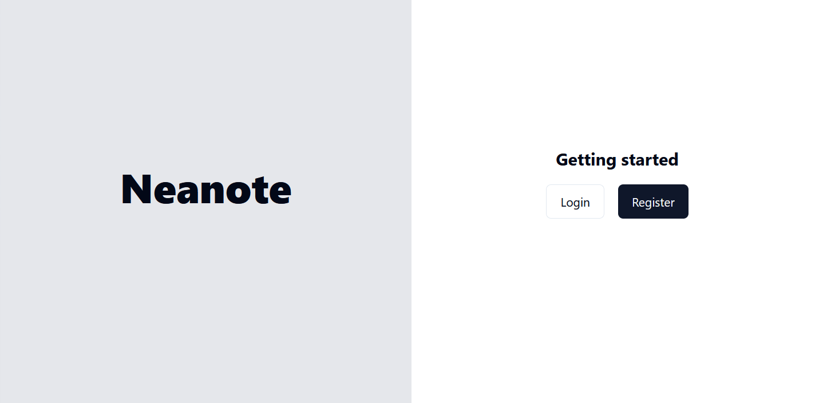
import React from 'react'
import { Link } from 'react-router-dom'
import { Button } from '../../../components/@/ui/button'

function Landing() {
return (
<div className='flex'>
<div className="w-1/2 flex justify-center items-center min-h-screen bg-gray-200">
<h1 className="text-5xl font-extrabold ">
Neanote
</h1>
</div>
<div className=" flex w-1/2 justify-center min-h-screen bg-background ">
<div className="flex flex-col justify-center items-center">
<h1 className='text-xl pt-2 font-bold'>Getting started</h1>
<div className="flex flex-row gap-4 p-4">
<Link to="/login">
<Button variant={'outline'}>Login</Button>
</Link>
<Link to="/register">
<Button>Register</Button>
</Link>
</div>
</div>
</div>
</div>
)
}

export default Landing
This page does not contain any logic, except for button-links that redirect the user to the authentication pages

