Project for SDE Backend: Restaurant

### Instructions:

You are going to design and implement RESTful web service for a restaurant in order to support menu and bill order management.

**Requirements:**

1. Menu management
   1. Implement RESTful API for CRUD operation (Create, Retrieve, Update and Delete) to manage menu in restaurant
   2. Menu item consist of
      1. Name
      2. Description
      3. Image
      4. Price
      5. Additional details (type, ingredient for example Pizza, Hot, Cold, Italian, Thai etc.)
   3. Implement RESTful API for listing menu and support pagination
   4. Implement RESTful API for searching menu by keyword that matches title, description, additional details

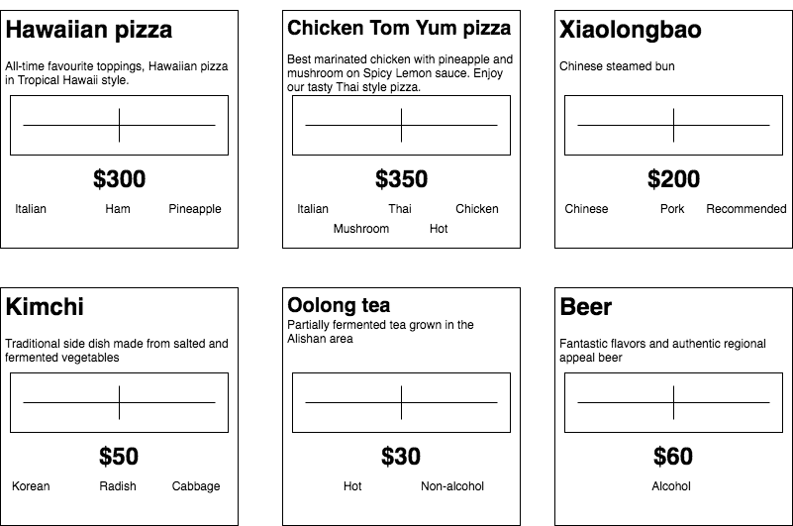

Example of menu (**No need to implement UI**)

|  |  |  |  |  |
| --- | --- | --- | --- | --- |
| **Name** | **Description** | **Image** | **Price** | **Types** |
| Hawaiian Pizza | All-time favourite toppings, Hawaiian pizza in Tropical Hawaii style. | <https://s3-ap-southeast-1.amazonaws.com/interview.ampostech.com/backend/restaurant/menu1.jpg> | $300 | Italian  Ham  Pineapple |
| Chicken Tom Yum Pizza | Best marinated chicken with pineapple and mushroom on Spicy Lemon sauce. Enjoy our tasty Thai style pizza. | <https://s3-ap-southeast-1.amazonaws.com/interview.ampostech.com/backend/restaurant/menu2.jpg> | $350 | Italian  Thai  Chicken  Mushroom  Hot |
| Xiaolongbao | Chinese steamed bun | <https://s3-ap-southeast-1.amazonaws.com/interview.ampostech.com/backend/restaurant/menu3.jpg> | $200 | Chinese  Pork  Recommended |
| Kimchi | Traditional side dish made from salted and fermented vegetables | <https://s3-ap-southeast-1.amazonaws.com/interview.ampostech.com/backend/restaurant/menu4.jpg> | $50 | Korean  Radish  Cabbage |
| Oolong tea | Partially fermented tea grown in the Alishan area | <https://s3-ap-southeast-1.amazonaws.com/interview.ampostech.com/backend/restaurant/menu5.jpg> | $30 | Hot  Non-alcohol |
| Beer | Fantastic flavors and authentic regional appeal beer | <https://s3-ap-southeast-1.amazonaws.com/interview.ampostech.com/backend/restaurant/menu6.jpg> | $60 | Alcohol |

2. Bill order management

* 1. Implement RESTful API for CRU operation (Create, Retrieve and Update) to manage bill order. Retrieval of bill order should return detail of
     1. Menu items
     2. Quantities
     3. Total price
  2. Update operation can add or remove menu items and quantities
  3. Implement an API for check operation that returns
     1. Menu items
     2. Quantities
     3. Total price

**Example of customer order**

|  |  |  |  |
| --- | --- | --- | --- |
| **Bill #** | **Menu** | **Quantity** | **Ordered time** |
| 1 | Hawaiian Pizza | 1 | 1/1/2017 10:00:00 AM |
| 1 | Kimchi | 2 | 1/1/2017 10:00:00 AM |
| 1 | Kimchi | 1 | 1/1/2017 11:00:00 AM |
| 2 | Xiaolongbao | 1 | 1/1/2017 12:00:00 PM |
| 2 | Beer | 1 | 1/1/2017 12:00:00 PM |
| 3 | Oolong tea | 1 | 1/1/2017 3:00:00 PM |
| 3 | Beer | 3 | 1/1/2017 3:00:00 PM |