IELTS Academic Writing Task 1
A step-by-step self-study guide
Learn the theory • Practise short skills • Plan the information • Write a complete report
This guide covers charts, tables, maps and processes for IELTS Academic. Task 1 is a report describing visual information. Work through the stages in order, then return to the skills that need more practice.

Your learning route
Stage | What to do | Where to check
Part 1: Theory | Learn what to select, how to organise it and which language to use. | Use the examples as reference.
Part 2: Small exercises | Complete E1–E7 before checking your answers. | Answer key: E1–E7.
Part 3: Information planning | Plan W1–W11 without writing full reports. | Answer key: W1–W11.
Part 4: Full report writing | Plan, write and revise Tasks 1–27 using the original visuals. | Answer key: Tasks 1–27.
Part 5: Complete answer key | Compare your work with the explanations, plans and model reports. | All answers are at the end.

A study routine you can repeat
Session 1: Read one theory section and complete a related short exercise. Session 2: Plan two visuals using the worksheet. Session 3: Write one complete report. Session 4: Check it, record your errors and rewrite the weakest paragraph. Begin untimed; later use the 20-minute routine in Part 4.
Keep longer responses in a notebook or separate document. The response lines are for brief notes. Suggested answers are examples of valid approaches, not scripts to memorise or examiner-awarded band scores.
Markdown navigation: Theory | Small exercises | Planning | Full writing | Answer key.

Part 1 Theory

Know the task and the report structure
Write at least 150 words in about 20 minutes. Use full sentences and connected paragraphs in a neutral or academic style. Task 2 contributes twice as much as Task 1 to the Writing score. [1]
WORKED EXAMPLE • Suppose a chart shows the proportion of commuters using buses and bicycles in two cities in 2010 and 2020. A suitable report would introduce those two modes and places, summarise the strongest overall contrast, and then give selected numbers.
HOW THE THEORY APPLIES • The job is to REPORT the information, not argue that cycling is healthier. First name the subject, place and period; next choose the two biggest patterns for the overview; finally support them with the chart values. This shows how a selective 150-word report differs from an opinion essay.

Your job: select, summarise and compare
Report what the visual shows. Include the main features and enough detail to support them. Do not add personal opinions, background knowledge or reasons that the visual does not establish. A higher birth rate and a younger population may appear together; the table alone does not prove one caused the other.
Paragraph | Purpose | What to include
Introduction | Identify the information. | Visual type, topic, place, time and units where relevant. Paraphrase accurately.
Overview | Give the big picture. | Two or three main trends, contrasts, changes or process features.
Details 1 | Support one group of features. | Selected figures, comparisons, locations or stages.
Details 2 | Support the other group. | The remaining main features, with supporting detail.
Four paragraphs are a useful starting point, not a compulsory rule. The overview can follow the introduction or come at the end. A separate opinion or argumentative conclusion is unnecessary.
WORKED EXAMPLE • Illustrative chart: in City A, cycling increases from 10% to 30%, while bus use falls from 50% to 35%. In City B, cycling stays near 15%. Overview: “Cycling became substantially more common in City A, while City B showed little change.”
HOW THE THEORY APPLIES • The example selects the standout development and the contrast rather than listing every percentage. “Became more common” is a description of the shown data; “because the council built new paths” would be an invented cause unless it appears in the visual.

Introduction versus overview
Introduction: “The chart compares the proportions of male and female teachers in six types of UK educational institution in 2010.” This identifies the task.
Overview: “Women formed the large majority in nursery and primary education, whereas men predominated at university level. College teaching staff were evenly divided.” This selects the main features.
WORKED EXAMPLE • Question: a bar chart compares renewable electricity shares in four countries in 2015 and 2025. Introduction: “The bar chart compares the proportion of electricity generated from renewable sources in four countries in 2015 and 2025.” Overview: “All four shares increased, with Country A remaining the highest in both years.”
HOW THE THEORY APPLIES • The introduction tells a reader WHAT the graphic displays: type, measure, groups and dates. The overview states the main PATTERNS and ranking. Notice that it does not require exact percentages; save the supporting values for the body paragraphs.

What the four assessment criteria mean
Task Achievement: accurate coverage, clear overview and relevant support. Coherence and Cohesion: logical grouping and clear connections. Lexical Resource: precise vocabulary. Grammatical Range and Accuracy: varied, controlled sentences. [1, 2]
Vietnamese reminder: tổng quan = bức tranh lớn; chi tiết = số liệu hoặc đặc điểm minh họa. Do not turn the overview into a list of every value.
WORKED EXAMPLE • Draft: “Bikes improved a lot. City A 10, 30. Buses were worse.” Revised: “In City A, the share of bicycle commuters rose from 10% to 30%, while bus use fell from 50% to 35%.”
HOW THE THEORY APPLIES • Task Achievement improves because both trends and values are clear; Coherence improves through the “while” contrast; Lexical Resource improves through “share” and “rose”; Grammar improves through complete, controlled clauses. A polished sentence still needs an overall overview elsewhere in the report.

Describe change accurately
Meaning | Verb pattern | Noun pattern
Upward change | Sales rose from 20 to 30. | There was a rise in sales from 20 to 30.
Downward change | Sales fell to 15. | There was a fall in sales to 15.
No change | Sales remained stable at 15. | Sales showed no change.
Variation | Sales fluctuated between 12 and 20. | There were fluctuations in sales.
Highest point | Sales peaked at 30. | Sales reached a peak of 30.
Lowest point | Sales bottomed out at 10. | Sales reached a low of 10.
Recovery | Sales recovered from 10 to 18. | There was a recovery in sales.
WORKED EXAMPLE • Illustrative line graph: online purchases account for 10%, 12%, 25% and 27% in successive years. Description: “The proportion rose slightly at first, then increased sharply before levelling off.”
HOW THE THEORY APPLIES • Match the adjective or adverb to EACH interval: 10→12 is small, 12→25 is large, and 25→27 is small again. “Rose steadily” would conceal the faster middle stage. Do not use “fluctuated” unless values actually move up and down.

Combine the direction with the size or speed
Verb + adverb: rose gradually; fell sharply. Adjective + noun: a gradual rise; a sharp fall. “Steady” describes a consistent pattern; “stable” describes little change. A series that falls once has not necessarily fluctuated.
Use strong words such as “soared” or “plummeted” only for clearly large, rapid changes. Prefer “rose” or “fell” when the pattern is ordinary. A fall from 7,000 to 5,000 is roughly 29%, so calling it “slight” may be misleading.
WORKED EXAMPLE • Values: monthly visitors rise from 2,000 in January to 2,150 in February and 5,800 in March. “Visitor numbers increased marginally in February, before rising sharply in March.”
HOW THE THEORY APPLIES • “Increased” and “rising” identify direction; “marginally” and “sharply” describe magnitude. If the time intervals are equal, speed may also be inferred, but do not claim that a small increase was “dramatic”. The word choice should be calibrated to the scale.

Keep prepositions clear
From 23% to 46% = the starting and ending values. To 46% = the ending value. By 23 percentage points = the difference between the percentages. Between 1990 and 2000 = the time span; do not write “between 1990 to 2000”.
WORKED EXAMPLE • A city’s cycling share was 18% in 2012 and 33% in 2022. Correct: “It rose FROM 18% TO 33%, an increase OF 15 percentage points, BETWEEN 2012 AND 2022.”
HOW THE THEORY APPLIES • FROM introduces the starting level; TO introduces the ending level; OF introduces the size of the rise; BETWEEN … AND … sets the time span. The share did not rise “to 15%”, and “by 15%” would wrongly suggest a relative percentage increase.

Percentage points are different from percentage change
A share rising from 23% to 46% increases by 23 percentage points. The relative increase is 100% because (46 − 23) ÷ 23 × 100 = 100. The share doubles. “It increased by 23%” would describe a different calculation.
WORKED EXAMPLE • Example data: a pass rate increases from 40% to 50%. Percentage-point rise = 50 − 40 = 10 points. Relative percentage rise = (50 − 40) ÷ 40 × 100 = 25%.
HOW THE THEORY APPLIES • The two answers are not interchangeable: “rose by 10 percentage points” discusses the gap between shares, while “rose by 25%” discusses the size of that gap relative to the original 40%. If unsure, report “rose from 40% to 50%” instead.

Combine two stages of a trend
“The number of factories rose to 120,000 in 2010 before falling to 10,000 in 2015.” Or: “After reaching 120,000 in 2010, the number of factories fell to 10,000 five years later.” Keep the subject clear after an introductory phrase.
Avoid unnatural phrases such as “recorded with 23%” or “the quantity witnessed a wild oscillation”. Clear alternatives are “The figure stood at 23%” and “The number fluctuated considerably”.
WORKED EXAMPLE • Values: app users total 15,000 in 2018, 45,000 in 2021 and 30,000 in 2023. “User numbers tripled between 2018 and 2021, before declining to 30,000 in 2023.”
HOW THE THEORY APPLIES • The sentence compresses two genuine stages into one readable comparison: expansion followed by contraction. “Tripled” is justified because 45,000 equals three times 15,000. The final 30,000 is lower than the peak but still above the initial figure.

Compare quantities without changing the meaning
Use | Example | Avoid
Number + countable noun | the number of people / cars / factories | the amount of people
Amount + uncountable noun | the amount of water / money | the number of water
Share or percentage | the percentage of time spent online | the number of users, if only time shares are shown
Comparable categories | The figure for Australia was higher than that for Spain. | Australia was higher than Spain.
Fewer / less | fewer teachers; less water; a lower percentage | less teachers
Rank and proportion | the largest share; 39% was the largest category | the majority, when the share is below 50%
WORKED EXAMPLE • Illustrative table: 60% of adults drink tea daily, against 45% who drink coffee daily. “Tea was consumed daily by 15 percentage points more adults than coffee.”
HOW THE THEORY APPLIES • The subjects remain comparable (shares of adults). The difference is 60−45 = 15 percentage points. Do not write “15% more people” if you mean percentage points, or say tea was “twice as popular” when the ratio is only 60:45.

Four useful comparison patterns
- Australia received about 41,000 British emigrants, compared with 35,000 in Spain.
- About 41,000 people moved to Australia, while around 35,000 chose Spain.
- The figure for Australia was about 6,000 higher than that for Spain.
- Around 41,000 and 35,000 British people moved to Australia and Spain respectively.
“While” and “whereas” introduce contrasting clauses. They do not require a comparative adjective. “Compared with” is followed by a noun phrase or figure; it also does not require “higher” or “lower”.
WORKED EXAMPLE • City X has 80 public parks and City Y has 50. (1) “City X had 80 parks, compared with 50 in City Y.” (2) “City X had 30 more parks than City Y.” (3) “While X had 80, Y had 50.” (4) “X and Y had 80 and 50 parks, respectively.”
HOW THE THEORY APPLIES • Each sentence preserves the same comparison while changing grammar. “More … than” requires an explicit comparable noun; “while” connects two complete clauses; “respectively” works only when the noun and number orders correspond.

Use ratios carefully
“Twice as many people” describes counts; “twice as much water” describes an amount. “Three times as high” is clearer than the ambiguous “three times higher”. If two values are 20 and 60, say “60 was three times the figure of 20”.
WORKED EXAMPLE • A table shows 40 buses and 80 taxis. Correct: “There were twice as many taxis as buses.” A second table shows 60 litres of water versus 20 litres: “The first system used three times as much water as the second.”
HOW THE THEORY APPLIES • Countable items use “many”; uncountable quantity uses “much”. Always compute the ratio before using “twice” or “three times”. “80 taxis were twice higher” is grammatically misleading; repeat the thing counted so readers know exactly what is doubled.

Paraphrase precisely
Visitors are people; visits are occasions. Applicants are not necessarily enrolled students. Population is not population density. Income, revenue and profit are not automatically interchangeable. Keep the chart’s meaning even if you repeat a key word.
Prefer “accounted for”, “represented”, “stood at” and “was higher than”. Avoid “domineering”, “outperformed” or “outnumbered” when simply comparing percentages or hours.
WORKED EXAMPLE • Source title: “Average number of visits to museums per resident”. Safe introduction: “The chart shows the average number of museum visits made by each resident.” Unsafe: “The chart shows how many residents visited a museum.”
HOW THE THEORY APPLIES • Visits and visitors are different units: one resident can make several visits. Preserve that distinction even when the rewritten sentence repeats “visits”. Precision is more important than replacing every phrase with a new synonym.

Read charts and choose the main features
WORKED EXAMPLE • Imaginary bar chart: four countries have recycling rates of 70%, 68%, 30% and 28%. Overview: “The first two countries recycled a markedly larger share of waste than the other two.”
HOW THE THEORY APPLIES • Rather than listing all four figures in an overview, spot the two clear clusters. In the body, group the high-rate pair and the low-rate pair and cite their values. This turns observation into a coherent report structure.

First decide whether time changes
Visual | Ask yourself | Useful grouping
Dynamic chart | What rose, fell or changed rank? What were the main turning points? | Rising versus falling series; or earlier versus later periods.
Static chart | What was highest or lowest? Where were the biggest contrasts or similarities? | Higher group versus lower group; or related categories.
Pie chart | What does each whole represent? Which shares dominate? | Compare the same category across pies, then other important shares.
Table | Which rows and columns share the same units and meaning? | Group similar measures; keep money, years and percentages distinct.
Mixed visuals | What is the main message of each visual? Can they be compared directly? | Often one details paragraph per visual. Cover both in the overview.
WORKED EXAMPLE • A bar chart showing spending on food, housing and leisure in 2022 is a static comparison. A line chart showing the same spending from 2010 to 2022 is a time series.
HOW THE THEORY APPLIES • For the first, compare categories and rank the shares: “Housing accounted for the largest share.” For the second, describe change and dates: “Housing spending rose over the period.” Do not invent a trend from a single snapshot.

A chart-reading checklist
- Read the title, legend and all labels before looking at the values.
- Identify the unit: people, thousands, millions, percentages, money, hours or volume.
- Read the dates and distinguish measured figures from forecasts.
- Find two or three main features, then choose supporting details.
- Check whether the graphic supports exact values or only estimates.
Use “about”, “approximately”, “just over” or “just under” for values read from a scale. Exact labels in a table can be reported directly. Do not give invented precision such as 34.73% when the axis only supports about 35%.
WORKED EXAMPLE • A vertical axis says “thousands of passengers”, with a bar at 35 for 2019. The defensible statement is “about 35,000 passengers in 2019”, not “35 passengers” or “35 million”.
HOW THE THEORY APPLIES • Read the title and unit BEFORE forming a sentence. Next check legend, dates, and whether numbers are exact labels or estimates from the scale. These checks prevent errors in Task Achievement even when the grammar sounds fluent.

Do not force a total or a causal story
Selected categories may not add up to 100%. Report the values shown; do not invent missing categories or adjust the data. Two mixed visuals may show related changes without proving a cause. Write “Spending and participation both increased”, rather than “Participation caused spending to increase”.
WORKED EXAMPLE • A survey reports 55% using streaming services and 40% using radio. It permits overlap: respondents may use both. Safe: “Streaming was more widely used than radio.” Unsupported: “Only 5% used neither platform.”
HOW THE THEORY APPLIES • The two percentages do not necessarily form parts of a single whole because categories may overlap. Similarly, if sales rise when advertising rises, report the parallel trends rather than asserting advertising caused the increase.

Choose tenses from the task
Finished dates: “rose”, “accounted for”. No date: “shows”, “accounts for”. A series ending at the chart’s “present day”: present perfect can summarise the whole period. Forecasts: “is projected to reach”. A forecast made in 1990 for 2000: “was predicted to reach”, followed by the actual past result.
Do not reinterpret a source’s “present day” as today’s calendar date or change a forecast into a measured fact just because time has passed.
WORKED EXAMPLE • One table reports 2015 values; another column predicts 2035. “In 2015, solar power provided 12% of the total; it is projected to account for 35% in 2035.”
HOW THE THEORY APPLIES • Use past simple for completed observations and a projection verb for future estimates. The tense follows the information status in the chart, not today’s date. Avoid writing “rose to 35% in 2035” as if the projected outcome had already been measured.

Describe maps and proposed changes
WORKED EXAMPLE • Two maps show a riverside park in 2000 and its proposed redesign. A playground will replace a car park, but the river and entrance will remain. Overview: “The proposal replaces vehicle space with recreation while retaining the main access and riverfront.”
HOW THE THEORY APPLIES • Group changed and unchanged features before describing locations. Use proposal language (“is planned to”, “will be built”) rather than factual past change, and mention north/south only if the map establishes direction.

Read the place before describing the changes
Find the compass, dates, entrances, roads, rivers and other fixed landmarks. Identify additions, removals, replacements, relocations and features that remain. Group details by area or by type of development.
Meaning | Useful language
Position | in the north-west; south of the river; opposite the school; beside the road
Replacement | The factory was replaced by a car park.
Conversion | The office was converted into a museum.
Relocation | The school was moved to the north of the river.
Expansion / reduction | The housing area was expanded; the woodland was reduced in size.
Unchanged feature | The railway station remained in the same position.
Proposed development | The airfield is to be replaced by an industrial estate.
WORKED EXAMPLE • On a north-oriented map, the railway runs across the southern edge. A warehouse north of it is replaced by apartments, while the station to the east remains.
HOW THE THEORY APPLIES • Anchor the description to stable landmarks: “North of the railway, the warehouse was replaced by housing, whereas the station in the east remained unchanged.” This is more accurate than describing items solely as “left” and “right” without checking orientation.

Write a meaningful overview
Weak: “There were many changes and the general layout stayed the same.” Stronger: “The former mining site was converted into a visitor attraction, with museums and recreational facilities replacing most working facilities.”
Only say the layout remained unchanged if the maps actually support that claim. Be specific about stable features, such as a river or a main road. Do not assume a beach had no previous use or that a new road will reduce congestion unless the task states it.
WORKED EXAMPLE • Illustrative before-and-after maps: a former industrial island gains hotels and footpaths, while a central dock stays. Overview: “The island was transformed into a tourist destination, although the central dock remained in place.”
HOW THE THEORY APPLIES • The overview tells readers what TYPE of transformation occurred and identifies a major exception. It does not catalogue each hut, path and bench. “The island became more modern” is too vague and subjective to count as a strong overview.

Choose a sensible body structure
For a town divided by a road: describe the west first, then the east. For an island: describe buildings and accommodation, then paths, access and swimming facilities. For a current plan and a proposal: compare each existing feature with its proposed replacement.
WORKED EXAMPLE • Map: a central road separates a western housing area from an eastern business area. Western changes: houses and a playground. Eastern changes: offices and a new car park.
HOW THE THEORY APPLIES • Write one paragraph about the west and one about the east, referring to the road as the boundary. This stops the reader mentally jumping between locations. If the task instead shows an old map versus a proposal, you could organise by replaced feature.

Use tenses naturally
Two finished dates can both use the past simple: “In 2000 there was an open space; by 2011 it had been replaced by flats.” Past perfect helps show an earlier past event, but is not required for every sentence about the earlier map. For proposals use “will be built”, “is planned” or “is proposed”.
Vietnamese reminder: vị trí → thay đổi → đặc điểm thay thế. Check the direction before choosing “north”, “south”, “left” or “right”.
WORKED EXAMPLE • Map A (1995): a field near the river. Map B (2015): a sports centre in its place. A proposed map for 2030: an extension east of that centre. “The field was replaced by a sports centre by 2015, and an extension is planned to its east.”
HOW THE THEORY APPLIES • The first change is a completed fact, so past passive “was replaced” fits. The extension is a proposal, so “is planned” avoids presenting it as completed. A past-perfect construction is optional, not a requirement for describing earlier maps.

Describe processes, cycles and anatomy
WORKED EXAMPLE • Simplified glass-bottle process: used bottles are collected, cleaned, melted, shaped and cooled. Overview: “The process converts collected glass into new bottles through cleaning, melting and remoulding.”
HOW THE THEORY APPLIES • This overview identifies the input, output and core transformation. Body details can group preparation (collection and washing) and manufacture (melting to cooling). Only mention machines, temperatures or durations if the diagram shows them.

Follow arrows rather than inventing stages
Identify the input, output, main stages, branches and any repeated cycle. An overview should describe the process as a whole: its start and end, or its main transformation. Count stages only when the diagram supports a clear count.
Type | Main focus | Typical language
Manufacturing | What happens to the material? | Tomatoes are sorted, crushed and boiled.
Natural cycle | How does the organism develop? | Eggs hatch; larvae grow; adults lay eggs.
Energy system | How is energy or fuel transferred? | Gas fuels an engine, which drives a generator.
Branching process | Where do different routes begin? | Some juice is packaged directly; the rest is concentrated.
Anatomy / object | Where are the parts, and what is shown? | The wings lie beneath the red elytra.
WORKED EXAMPLE • Diagram: harvested beans → drying → roasting → grinding → packaging. Appropriate line: “After drying, the beans are roasted and ground before they are packaged.”
HOW THE THEORY APPLIES • Read arrows as evidence for SEQUENCE. Do not describe grinding before roasting or add fermentation if absent. If a diagram splits into two production lines, describe the branch rather than pretending that all products follow one route.

Use the passive when the material is the focus
Active: “Workers remove the seeds.” Passive: “The seeds are removed.” Form: be + past participle. Use the present simple for a general process unless the prompt gives another time frame.
Join stages clearly: “After being sorted, the paper is transported to a mill.” The paper is both sorted and transported, so the subject matches. A relative clause can identify a place: “The paper is sent to a mill, where it is cleaned and pulped.”
WORKED EXAMPLE • Active: “A machine washes the bottles and workers sort them by colour.” Passive: “The bottles are washed and then sorted by colour.”
HOW THE THEORY APPLIES • The report focuses on bottles, not who operates each stage. The passive follows “be + past participle” and maintains the same material as subject. Do not make every sentence passive if an active subject such as “water” or “the machine” is useful and shown.

Sequence and alternatives
Useful links: initially; next; after this; once; subsequently; finally. Avoid starting every sentence with “then”. For alternatives: “The photographs can be developed at a pharmacy or by a professional photographer. Alternatively, they can be developed at home.”
For a closed cycle, explain how the final stage leads back to the beginning when this is shown. For a production diagram, do not invent recycling loops, temperatures, machinery or timings.
WORKED EXAMPLE • Two branches after washing: bottles may go directly to filling, or they can be melted and remade. “Once the bottles have been washed, some are refilled directly, whereas others are melted and reshaped.”
HOW THE THEORY APPLIES • “Once” establishes the shared first stage; “whereas” signals two alternative routes. Do not use “finally” for a branch that does not end the whole process. Likewise, describe a loop only if the final arrow actually returns to the beginning.

Plan the details in two groups
Paper recycling: collection, sorting and transport / cleaning, de-inking and paper manufacture. Ketchup: preparing and processing tomatoes / bottling, checking and distribution. Orange juice: shared opening steps and direct packaging / the concentration and reconstitution route.
Now complete E1–E7. Keep the answer key closed until you have attempted each exercise.
WORKED EXAMPLE • Diagram: milk production has six stages: feeding cows, milking, cooling, transport, pasteurisation and bottling. Body 1 covers obtaining and storing raw milk; Body 2 covers processing and packaging.
HOW THE THEORY APPLIES • Grouping by function makes a six-stage description easier to follow and reduces repeated “then”. The overview can say that raw milk is processed into packaged milk, while the body paragraphs retain the precise order within each group.

Part 2 Small exercises

E1 · Rewrite trend sentences
Aim: change the grammar while keeping the figures and meaning. Write one sentence for each item using the required opening. Answers are in Part 5, E1.
- The share of electricity generated rose from 23% in 1990 to 46% in 2000. Begin: “There was …”
- The number of people commuting by car fell from 7,000 in 1990 to 5,000 in 2000. Begin: “A fall …”
- The number of website visitors fluctuated between 12,000 and 20,000 from 1990 to 1995. Begin: “There were …”
- Household spending on shoes remained at $320 in each of the last two years. Begin: “There was no …”
- The annual income of Burney’s Bakery peaked at $3 million in 1988. Use: “reached a peak of”.
- The number of university applicants fell to 8,000 in 2005, then recovered to 16,000 in 2015. Begin: “After …”
- The number of factories rose to 120,000 in 2010, then fell sharply to 10,000 in 2015. Use: “before”.

E1 follow-up: quantify the change
For item 1, give (a) the increase in percentage points, (b) the relative percentage increase, and (c) one verb describing the ratio between the final and initial values.
Notes: __________________________________________________________________
Notes: __________________________________________________________________

E2 · Choose precise words and comparisons
Choose the correct option. Then correct the four comparison sentences. Answers are in Part 5, E2.
- The (number / amount) of teachers rose.
- The (number / amount) of water used fell.
- At 39%, housing was the (largest category / majority of all spending).
- A chart of visits to a website directly measures (visits / individual visitors).
- The share rose from 20% to 30%, an increase of (10% / 10 percentage points).
- The number of applicants is necessarily the same as the number enrolled: (true / false).
- Water use was (twice as much as / twice as many as) the previous level.
- The table gives the population, so it directly shows population density: (true / false).

Correct these sentences
- The percentage of men was 60,000.
- Housing accounted for 26%, outnumbering the 21% figure for Canada.
- While 40% of men watched television, whereas 30% of women did so.
- The figures for Spain and Australia were 35,000 and 41,000 respective.

Explain your choice
Why is “fewer teachers” correct, but “less water” correct? Write one sentence explaining the difference.
Notes: __________________________________________________________________

E3 · Rank and compare destinations
Use the 2004 chart. Values read from bars are approximate. Complete the nine gaps with the word bank, using each item once. Then write two comparison sentences. Answers are in Part 5, E3.
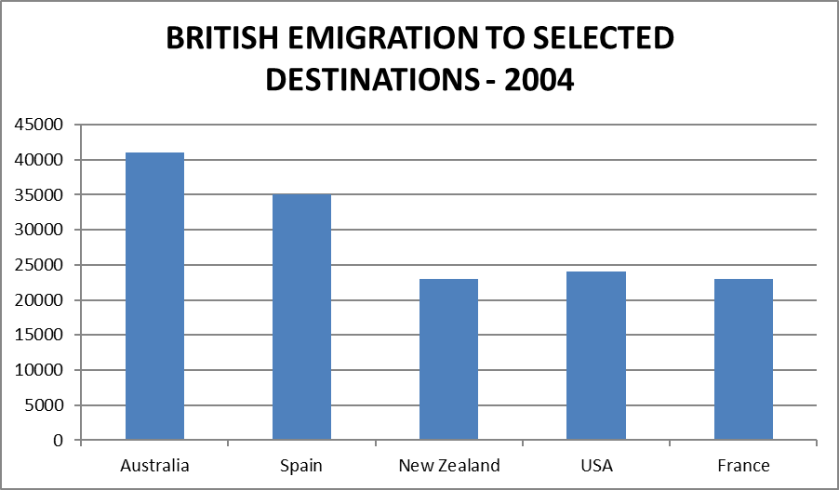
British emigration to five destinations in 2004
Word bank: largest; followed; contrast; fewer; lower; than; respectively; twice; similar.
- Australia received the ___ number of British emigrants.
- It was ___ by Spain.
- In ___, the figure for France was only about 23,000.
- ___ people moved to Spain than to Australia.
- The figure for Spain was about 6,000 ___ than Australia’s.
- More people chose Australia ___ Spain.
- Spain and the USA received about 35,000 and 24,000 emigrants ___.
- Australia’s total was less than ___ that of New Zealand.
- France and New Zealand recorded ___ totals.

Write independently
A. Compare Australia and Spain using “while”. B. Compare France and New Zealand using “approximately the same”.
Notes: __________________________________________________________________

E4 · Separate an overview from unsupported claims
For each statement, mark it: O = useful overview; D = supporting detail; U = unsupported or inaccurate. Correct every U statement. Answers are in Part 5, E4.
Use these facts: annual primary teaching hours are about 600 in Japan, Spain and Iceland, and 900 in the USA; upper-secondary hours are about 650, 1,000, 800 and 1,100 respectively. In a separate survey, parental sports spending and children’s swimming participation both rise. A population table shows the birth rate falling while the over-65 share rises.
- The USA had the highest teaching hours at both levels described.
- Primary teachers in Japan taught for about 600 hours per year.
- American teachers taught more because their schools were better funded.
- Increased swimming participation caused parents to spend more.
- The declining birth rate caused the over-65 share to rise.
- Teaching hours were higher at upper-secondary than primary level in all four countries.

E4 follow-up: organise the facts
Using only the teaching-hour facts above, write a two-sentence overview and name two sensible detail-paragraph groups. Do not add reasons for the differences.
Notes: __________________________________________________________________
Notes: __________________________________________________________________

Keep this distinction clear
An overview identifies a pattern; detail illustrates it. A claim about why a pattern exists needs evidence. When the task gives only values, describe the values and comparisons.

E5 · Build passive process sentences
The diagram shows how black-and-white photographs are produced. Convert the eight notes into present-simple passive sentences. Then join sentences 2 and 3 with “After”. Answers are in Part 5, E5.
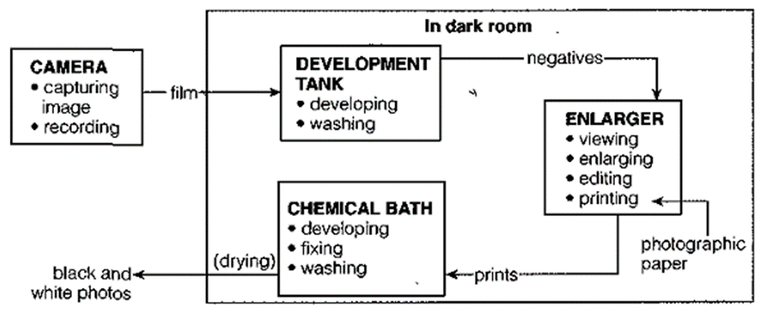
Black-and-white photographic development process
- camera / capture images and record them on film
- remove / film / from camera
- develop and wash / film / in development tank in darkroom
- remove / negatives / from tank
- view / negatives / in enlarger; enlarge and edit / images
- print / images / on photographic paper
- develop, fix and wash / prints / in chemical bath
- dry / prints / to produce finished black-and-white photographs
Alternatives task: Write two sentences explaining that photographs may be developed (a) at a pharmacy, (b) by a professional photographer, or (c) at home. Use “either … or” and “Alternatively”.

E6 · Correct and sequence an energy process
Check sentences A–H for language or factual problems. Correct any errors; one sentence is already correct. Put the sentences in order and divide them into three paragraphs. Answers are in Part 5, E6.
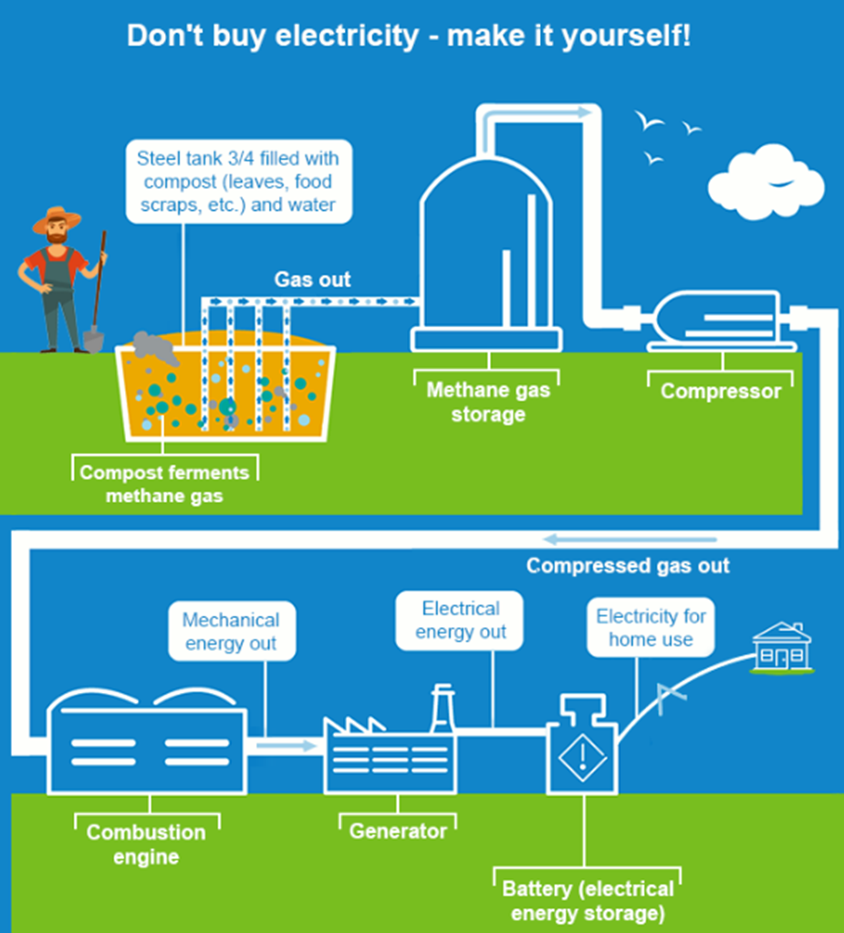
Home electricity generation using compost, methane, an engine, a generator and a battery
A. Finally, the electricity is sent to the national grid before reaching the home. B. The diagram show a method of generating electricity for domestic use. C. Mechanical energy are converted into electrical energy by a generator, and the electricity is stored in a battery. D. Overall, the system converts compost into fuel and then electricity, using a tank, gas storage, a compressor, an engine and an generator. E. The methane flows through a pipe into a storage unit, where they is collected. F. After being compressed, the gas fuel a combustion engine, which produces mechanical energy. G. The stored gas provides the fuel for the later energy conversion stage. H. First, a steel tank is filled to three-quarters of its capacity with compost and water; the compost ferment to produce methane.
Sequence: ___ → ___ → ___ → ___ → ___ → ___ → ___ → ___

E7 · Complete a life cycle and anatomy description
Fill the eleven gaps using the word bank. Use each word once. Then identify which paragraph gives the overview. Answers are in Part 5, E7.
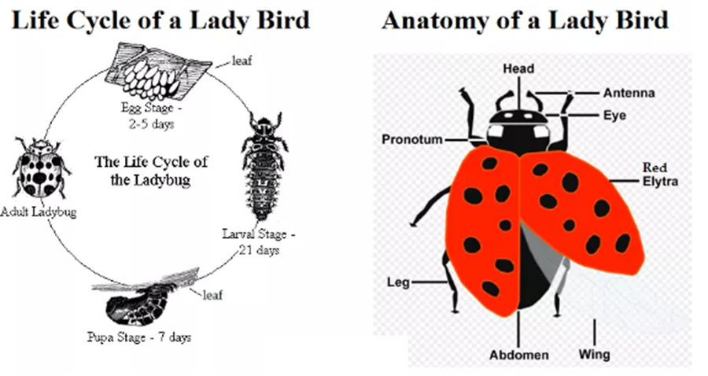
Ladybird life cycle and labelled anatomy
Word bank: stages; structure; eggs; elytra; laid; remain; emerge; pupa; end; spots; behind.
Paragraph 1: The first diagram illustrates the (1) ___ in a ladybird’s life, while the second shows its body (2) . Overall, the cycle has four stages, from (3) to adult insect. The adult has red (4) ___ marked with black spots.
Paragraph 2: Initially, eggs are (5) ___ on the underside of a leaf and (6) ___ there for two to five days. Larvae then (7) ___ and spend 21 days in this stage. The next stage is the (8) , which lasts seven days. At the (9) of this stage, an adult appears, and the cycle continues.
Paragraph 3: The adult’s red elytra have black (10) ___ and cover its wings and abdomen. It has six legs, eyes and antennae. The pronotum is immediately (11) ___ the head.

Part 3 Information planning

Plan information before writing
In Task 1, planning means selecting and grouping what is shown. You do not need to brainstorm opinions or invent examples. Use this worksheet for W1–W11 and for every full writing task.
Step | Write these notes
1. Identify | Topic: ___ Place: ___ Time: ___ Unit(s): ___
2. Classify | Dynamic / static / mixed / map / process / cycle / anatomy
3. Select | Main feature 1: ___ Main feature 2: ___
4. Group | Details paragraph 1: ___ Details paragraph 2: ___
5. Support | Key figures, dates, positions or stages for each group: ___
6. Check | Tenses: ___ Approximate values: ___ Possible traps: ___

The planning task for W1–W11
For each visual, complete the six worksheet steps. Write a one-sentence introduction and a one- or two-sentence overview. List the two detail-paragraph groups and the main evidence for each. Do not write a full report yet.
Each workshop has a specific focus below. Suggested introductions, overviews, grouping and supporting evidence are all in Part 5. Other accurate groupings are possible.

Progression
W1–W4: charts and comparable tables. W5: a table with different units. W6–W8: maps. W9–W10: mixed visuals. W11: a process. Then use Part 4 to turn the same planning skills into complete reports.
Choose one workshop at a time. Move on when your overview captures the biggest features and each detail group has a clear reason for being together.

W1 · British emigration
The chart compares British emigration to five destinations from 2004 to 2007.
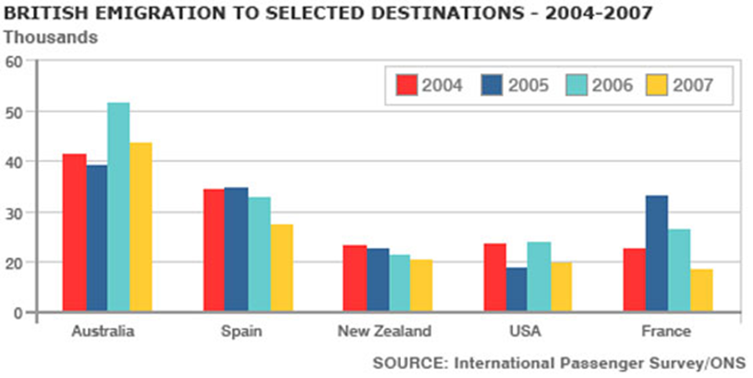
British emigration
Focus: distinguish overall direction from short-term rises and falls.
Complete the planning worksheet: introduction; overview; two detail groups; supporting evidence; units and tenses. Check Part 5 only after your attempt.
Notes: __________________________________________________________________

W2 · Leisure activities
The chart compares the percentages of men and women taking part in eight leisure activities.
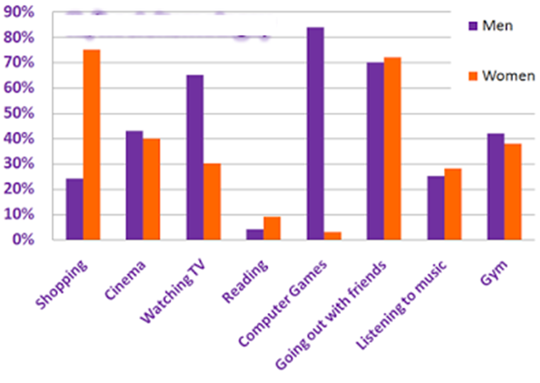
Leisure activities
Focus: group the larger gender gaps separately from the closer figures.
Complete the planning worksheet: introduction; overview; two detail groups; supporting evidence; units and tenses. Check Part 5 only after your attempt.
Notes: __________________________________________________________________

W3 · Housing preferences
The chart shows housing preferences in three UK cities in 2009.
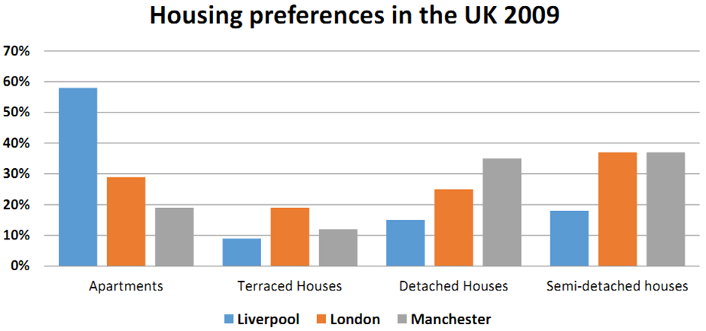
Housing preferences
Focus: compare the cities with the most similar patterns, then the remaining city.
Complete the planning worksheet: introduction; overview; two detail groups; supporting evidence; units and tenses. Check Part 5 only after your attempt.
Notes: __________________________________________________________________

W4 · Consumer spending
The table gives percentages of consumer spending in four countries in 2008.
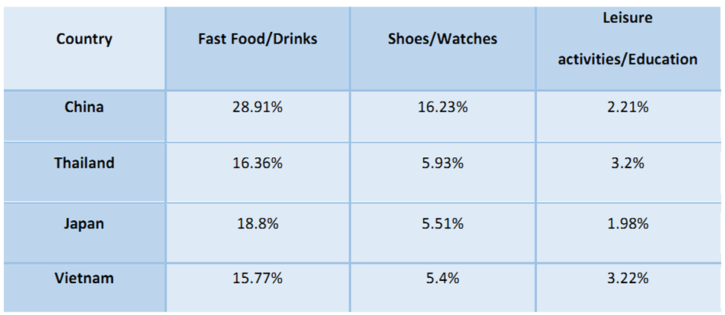
Consumer spending
Focus: identify the largest and smallest category in each country.
Complete the planning worksheet: introduction; overview; two detail groups; supporting evidence; units and tenses. Check Part 5 only after your attempt.
Notes: __________________________________________________________________

W5 · Australian water charges
The table compares water charges and average household bills in five Australian cities.
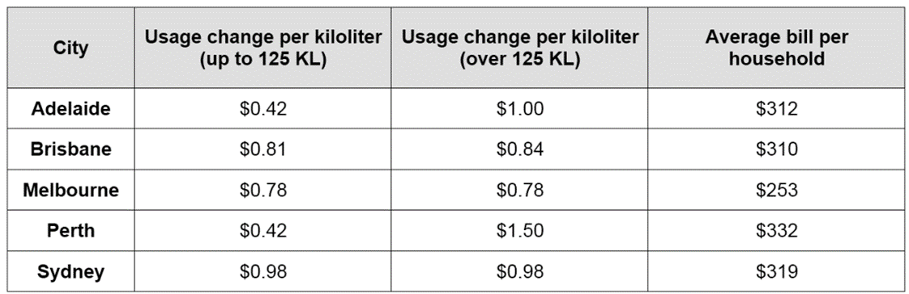
Australian water charges
Focus: separate charges per kilolitre from average bills; the two tariff columns are usage bands, not dates.
Complete the planning worksheet: introduction; overview; two detail groups; supporting evidence; units and tenses. Check Part 5 only after your attempt.
Notes: __________________________________________________________________

W6 · Eastminster village
The maps show changes in Eastminster from 1999 to 2009.
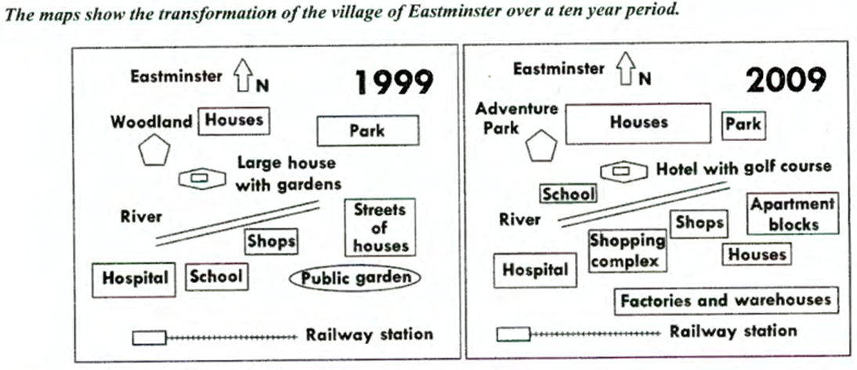
Eastminster village
Focus: group changes north and south of the river, and identify stable landmarks.
Complete the planning worksheet: introduction; overview; two detail groups; supporting evidence; units and tenses. Check Part 5 only after your attempt.
Notes: __________________________________________________________________

W7 · An island developed for tourism
The maps show an island before and after tourism facilities were built.
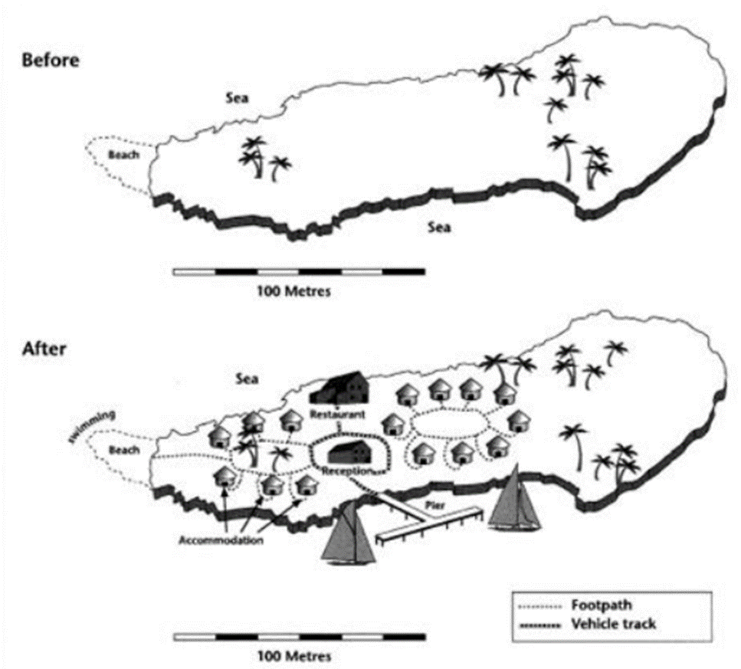
An island developed for tourism
Focus: distinguish buildings, access routes and natural features.
Complete the planning worksheet: introduction; overview; two detail groups; supporting evidence; units and tenses. Check Part 5 only after your attempt.
Notes: __________________________________________________________________

W8 · A mine becomes a visitor attraction
The maps show a working mine before and after redevelopment as a visitor attraction.
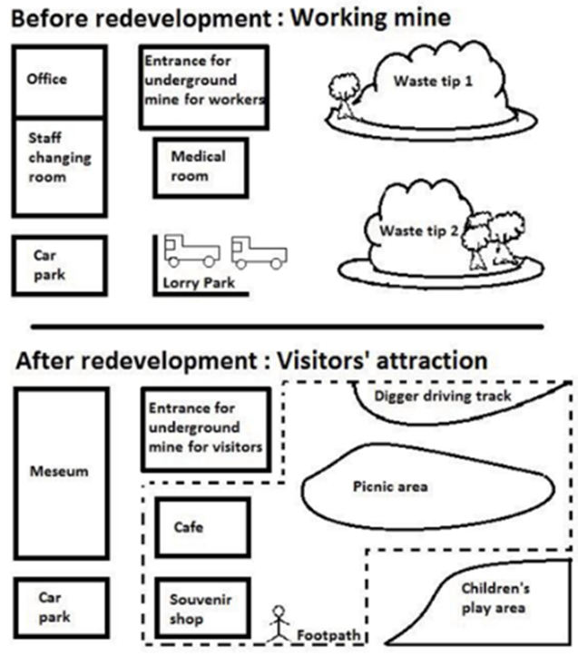
A mine becomes a visitor attraction
Focus: pair each old facility with its new use; do not infer compass directions where none are given.
Complete the planning worksheet: introduction; overview; two detail groups; supporting evidence; units and tenses. Check Part 5 only after your attempt.
Notes: __________________________________________________________________

W9 · Global water use and two countries
The graph shows global water use from 1900 to 2000; the table compares Brazil and the Democratic Republic of Congo in 2000.
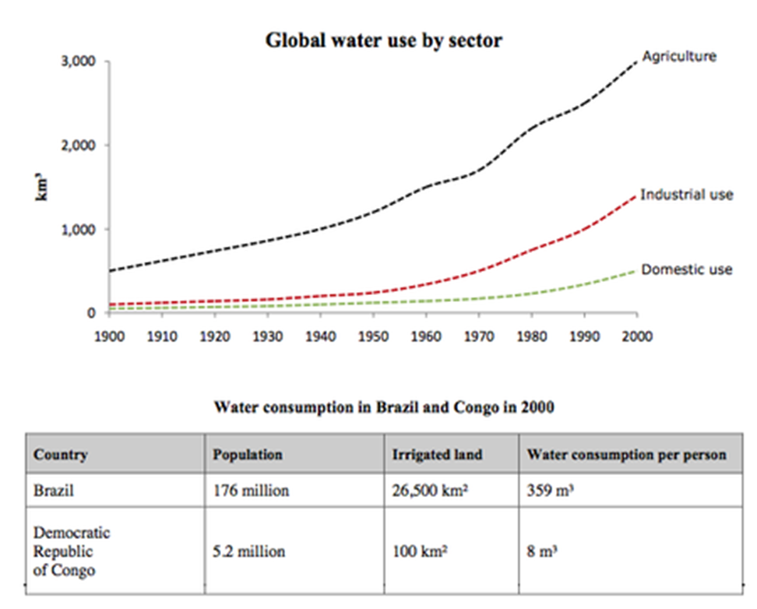
Global water use and two countries
Focus: include both visuals in the overview without claiming that one proves the cause of the other.
Complete the planning worksheet: introduction; overview; two detail groups; supporting evidence; units and tenses. Check Part 5 only after your attempt.
Notes: __________________________________________________________________

W10 · Family income and spending
The table and pie charts show income and spending on food and clothes for an average family in a UK city in 2010 and 2013.
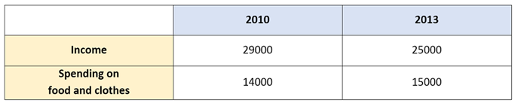
Family income and spending — image1.png
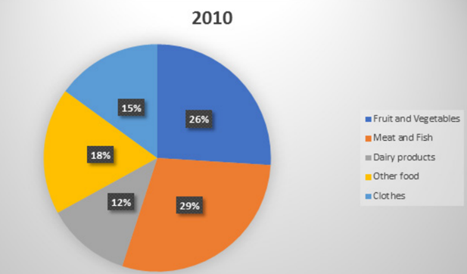
Family income and spending — image7.png
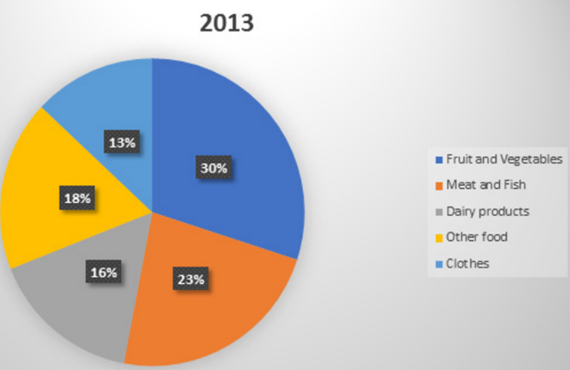
Family income and spending — image4.png
Focus: distinguish total spending from the percentage distribution of that spending.
Complete the planning worksheet: introduction; overview; two detail groups; supporting evidence; units and tenses. Check Part 5 only after your attempt.
Notes: __________________________________________________________________

W11 · Waste paper recycling
The diagram shows how waste paper is recycled.
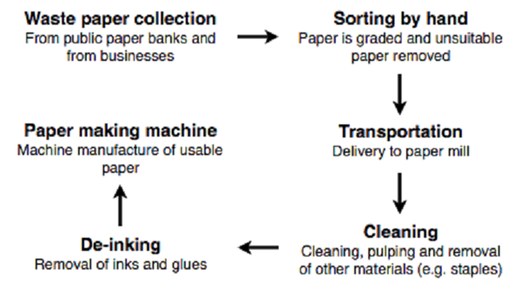
Waste paper recycling
Focus: group collection and preparation separately from cleaning and manufacture.
Complete the planning worksheet: introduction; overview; two detail groups; supporting evidence; units and tenses. Check Part 5 only after your attempt.
Notes: __________________________________________________________________

Part 4 Full report writing

Write and review a complete report
Use Tasks 1–27 on the following pages. Each includes its original visual. Write at least 150 words, summarising the main features and making comparisons where relevant. Use full sentences and paragraphs; do not copy the planning labels into your report.

A 20-minute routine
Time | Action | Result
0–3 minutes | Read labels, find the main features and group the details. | A brief plan and a clear overview.
3–17 minutes | Write the introduction, overview and two detail paragraphs. | A connected report of at least 150 words.
17–20 minutes | Check values, units, tenses, comparisons and grammar. | A revised final response.
This is a practice routine, not a required allocation. Learn the method untimed before trying to finish within 20 minutes.

Your task on every practice page
- Complete the six-step planning worksheet. Write an overview and a two-part body plan.
- Write a complete report without looking at the answer key.
- Use the checklist below to revise it. Then compare with the suggested plan and sample report in Part 5.
- Record one data-selection mistake and one language mistake, if present; rewrite the affected sentences. If a category is already accurate, record that result.

Final checklist
- Does the introduction identify the topic and time correctly?
- Does the overview capture the most important features of every visual?
- Are the details grouped logically and supported with relevant evidence?
- Are values, units, categories and directions accurate?
- Have I distinguished percentages, percentage points and actual counts?
- Are forecasts and proposed developments clearly identified?
- Have I avoided unsupported explanations and personal opinions?
- Is the response at least 150 words and written in connected paragraphs?
The answer key supplies a possible plan and a complete report for all 27 tasks. Your grouping or wording may differ if the content is accurate and well organised.

Task 1 · Three London bakeries
The graph shows the annual earnings of three bakeries in London from 2000 to 2010.
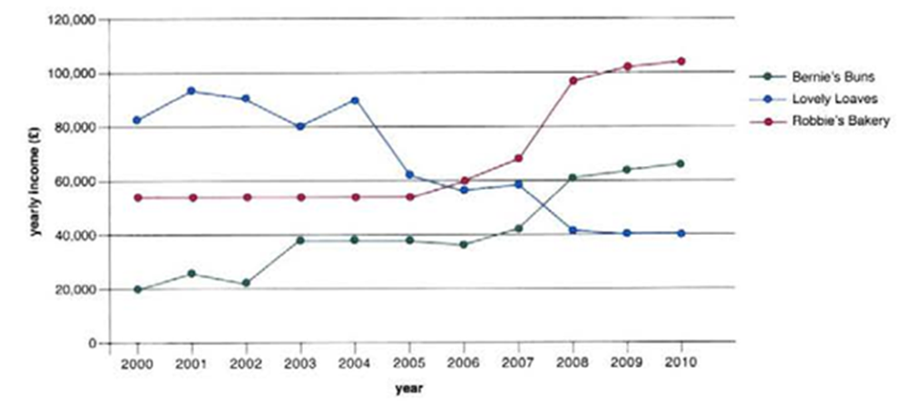
Three London bakeries

1 Plan first
Complete the six-step worksheet in Part 3. Select two or three main features and divide the details into two logical groups. Note the evidence and tenses you will use.

2 Write a complete report
Write at least 150 words in connected paragraphs. Summarise the main features and make comparisons where relevant. Use the visual as your evidence.

3 Review and compare
Use the Part 4 checklist, then read the suggested plan and model for Task 1. Record a data-selection correction and a language correction if needed.
Notes: __________________________________________________________________

Task 2 · Outdoor sports
The chart shows the percentage of young people taking part in different outdoor sports in the South West of England from 1975 to the chart’s present day.
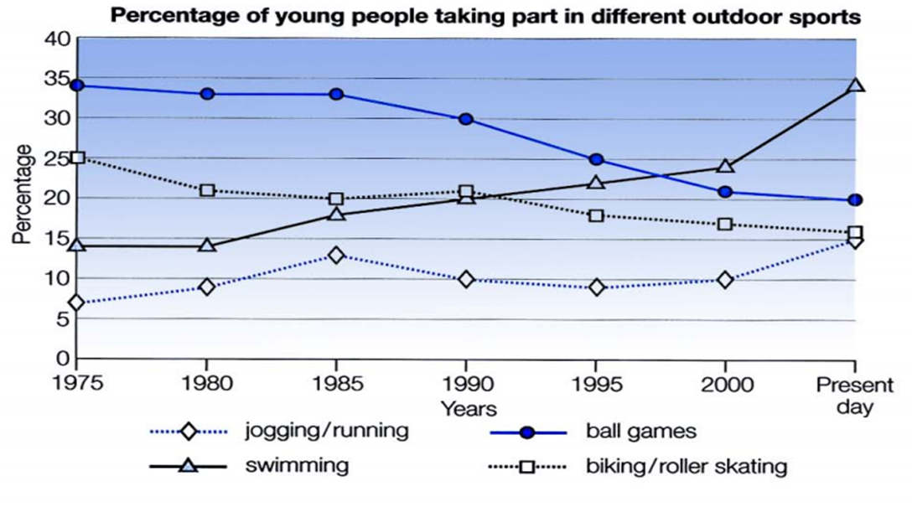
Outdoor sports
Reading note: “Present day” belongs to the source chart. Do not assign it a new calendar year.

1 Plan first
Complete the six-step worksheet in Part 3. Select two or three main features and divide the details into two logical groups. Note the evidence and tenses you will use.

2 Write a complete report
Write at least 150 words in connected paragraphs. Summarise the main features and make comparisons where relevant. Use the visual as your evidence.

3 Review and compare
Use the Part 4 checklist, then read the suggested plan and model for Task 2. Record a data-selection correction and a language correction if needed.
Notes: __________________________________________________________________

Task 3 · Places of Internet access
The chart shows the places where people mostly accessed the Internet in the UK in 1998, 2000, 2002 and 2004.
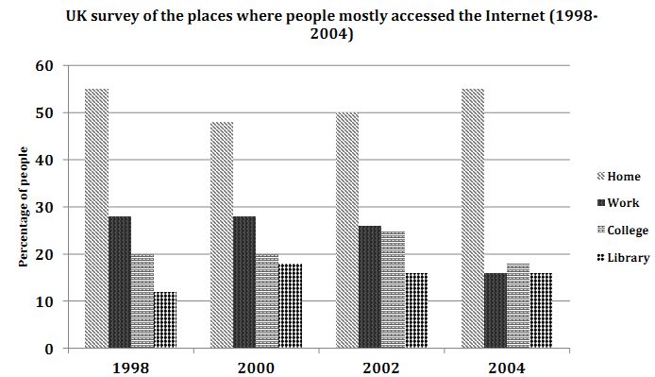
Places of Internet access

1 Plan first
Complete the six-step worksheet in Part 3. Select two or three main features and divide the details into two logical groups. Note the evidence and tenses you will use.

2 Write a complete report
Write at least 150 words in connected paragraphs. Summarise the main features and make comparisons where relevant. Use the visual as your evidence.

3 Review and compare
Use the Part 4 checklist, then read the suggested plan and model for Task 3. Record a data-selection correction and a language correction if needed.
Notes: __________________________________________________________________

Task 4 · Male and female teachers
The chart shows the percentages of male and female teachers in six types of educational setting in the UK in 2010.
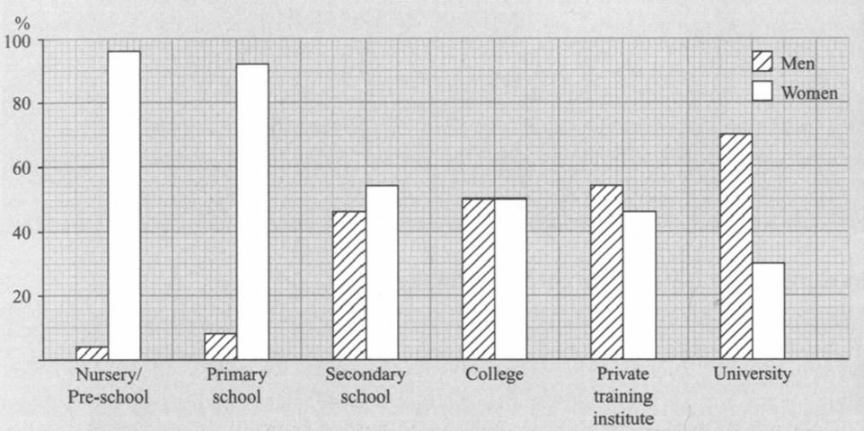
Male and female teachers

1 Plan first
Complete the six-step worksheet in Part 3. Select two or three main features and divide the details into two logical groups. Note the evidence and tenses you will use.

2 Write a complete report
Write at least 150 words in connected paragraphs. Summarise the main features and make comparisons where relevant. Use the visual as your evidence.

3 Review and compare
Use the Part 4 checklist, then read the suggested plan and model for Task 4. Record a data-selection correction and a language correction if needed.
Notes: __________________________________________________________________

Task 5 · Watching and participating in sport
The chart compares the percentages of males in a country who prefer watching different sports with those who prefer participating in them.
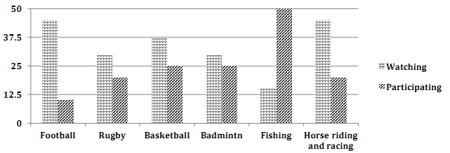
Watching and participating in sport

1 Plan first
Complete the six-step worksheet in Part 3. Select two or three main features and divide the details into two logical groups. Note the evidence and tenses you will use.

2 Write a complete report
Write at least 150 words in connected paragraphs. Summarise the main features and make comparisons where relevant. Use the visual as your evidence.

3 Review and compare
Use the Part 4 checklist, then read the suggested plan and model for Task 5. Record a data-selection correction and a language correction if needed.
Notes: __________________________________________________________________

Task 6 · Annual teaching hours
The chart shows annual teaching hours per teacher at three educational levels in four countries in 2001.
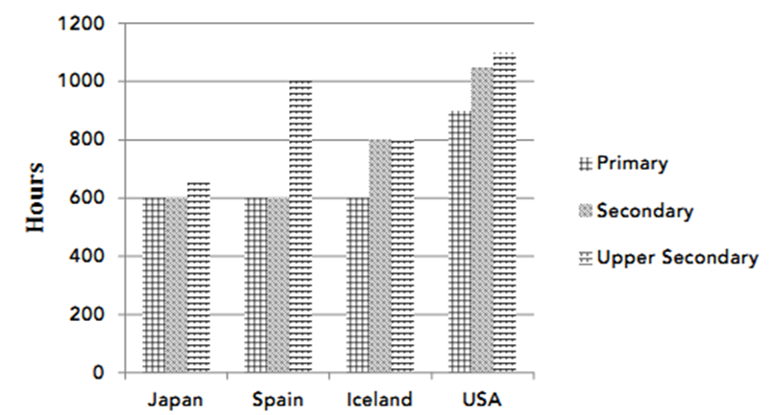
Annual teaching hours

1 Plan first
Complete the six-step worksheet in Part 3. Select two or three main features and divide the details into two logical groups. Note the evidence and tenses you will use.

2 Write a complete report
Write at least 150 words in connected paragraphs. Summarise the main features and make comparisons where relevant. Use the visual as your evidence.

3 Review and compare
Use the Part 4 checklist, then read the suggested plan and model for Task 6. Record a data-selection correction and a language correction if needed.
Notes: __________________________________________________________________

Task 7 · Household expenditure
The chart compares shares of expenditure in five categories in the United States, Canada, the United Kingdom and Japan in 2009.
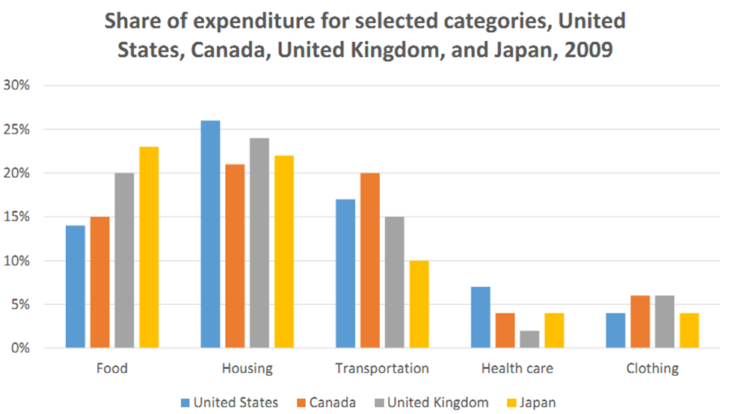
Household expenditure

1 Plan first
Complete the six-step worksheet in Part 3. Select two or three main features and divide the details into two logical groups. Note the evidence and tenses you will use.

2 Write a complete report
Write at least 150 words in connected paragraphs. Summarise the main features and make comparisons where relevant. Use the visual as your evidence.

3 Review and compare
Use the Part 4 checklist, then read the suggested plan and model for Task 7. Record a data-selection correction and a language correction if needed.
Notes: __________________________________________________________________

Task 8 · Time spent on Internet activities
The pie charts show the percentages of online leisure time spent on six activities by people aged 18–26 and 60–70.
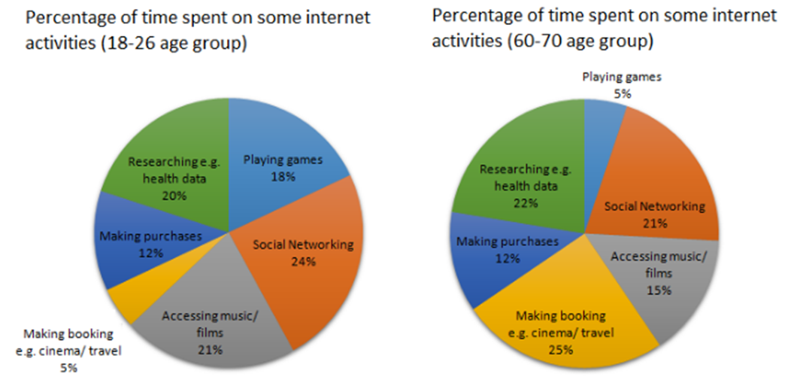
Time spent on Internet activities

1 Plan first
Complete the six-step worksheet in Part 3. Select two or three main features and divide the details into two logical groups. Note the evidence and tenses you will use.

2 Write a complete report
Write at least 150 words in connected paragraphs. Summarise the main features and make comparisons where relevant. Use the visual as your evidence.

3 Review and compare
Use the Part 4 checklist, then read the suggested plan and model for Task 8. Record a data-selection correction and a language correction if needed.
Notes: __________________________________________________________________

Task 9 · Water use in three areas
The pie charts compare water use in San Diego County, California and worldwide.
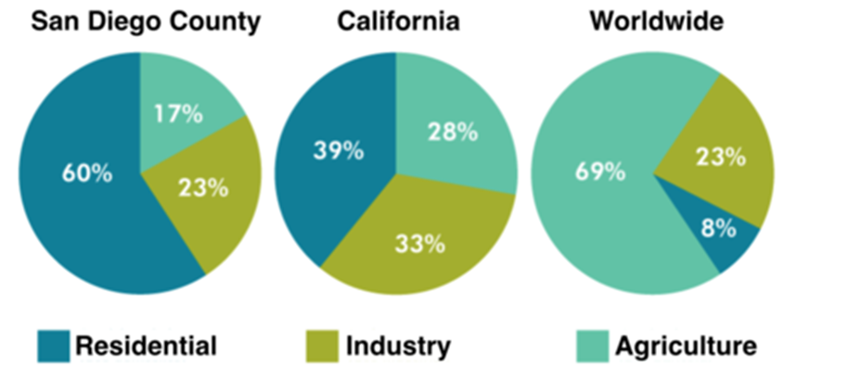
Water use in three areas

1 Plan first
Complete the six-step worksheet in Part 3. Select two or three main features and divide the details into two logical groups. Note the evidence and tenses you will use.

2 Write a complete report
Write at least 150 words in connected paragraphs. Summarise the main features and make comparisons where relevant. Use the visual as your evidence.

3 Review and compare
Use the Part 4 checklist, then read the suggested plan and model for Task 9. Record a data-selection correction and a language correction if needed.
Notes: __________________________________________________________________

Task 10 · Sources of electricity
The pie charts show sources of electricity production in India, Sweden, Morocco and Vietnam during 2003–2008.
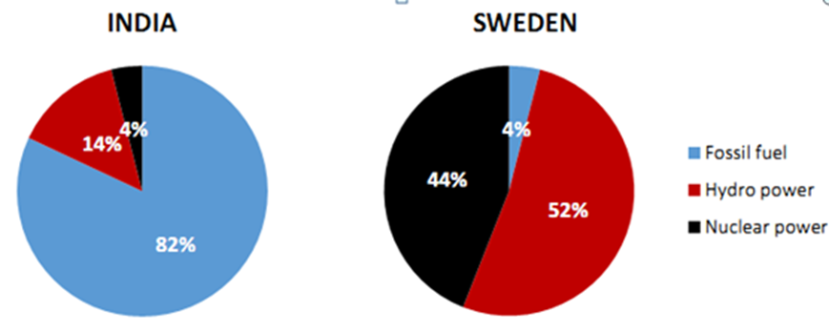
Sources of electricity
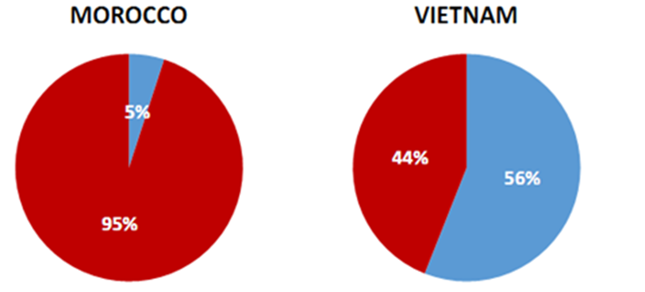
Sources of electricity

1 Plan first
Complete the six-step worksheet in Part 3. Select two or three main features and divide the details into two logical groups. Note the evidence and tenses you will use.

2 Write a complete report
Write at least 150 words in connected paragraphs. Summarise the main features and make comparisons where relevant. Use the visual as your evidence.

3 Review and compare
Use the Part 4 checklist, then read the suggested plan and model for Task 10. Record a data-selection correction and a language correction if needed.
Notes: __________________________________________________________________

Task 11 · Car production
The table shows the number of cars made in Argentina, Australia and Thailand in 2003, 2005 and 2009.
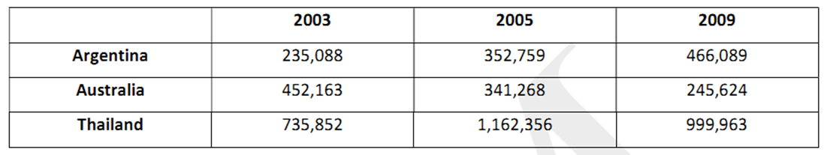
Car production

1 Plan first
Complete the six-step worksheet in Part 3. Select two or three main features and divide the details into two logical groups. Note the evidence and tenses you will use.

2 Write a complete report
Write at least 150 words in connected paragraphs. Summarise the main features and make comparisons where relevant. Use the visual as your evidence.

3 Review and compare
Use the Part 4 checklist, then read the suggested plan and model for Task 11. Record a data-selection correction and a language correction if needed.
Notes: __________________________________________________________________

Task 12 · People aged over 60
The table gives the percentage of people aged over 60 in six regions and worldwide in 2000, with projections for 2050.
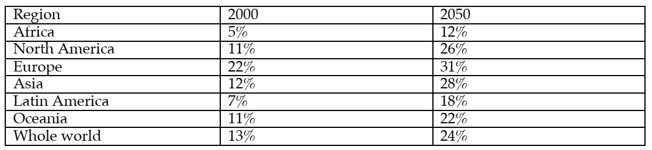
People aged over 60

1 Plan first
Complete the six-step worksheet in Part 3. Select two or three main features and divide the details into two logical groups. Note the evidence and tenses you will use.

2 Write a complete report
Write at least 150 words in connected paragraphs. Summarise the main features and make comparisons where relevant. Use the visual as your evidence.

3 Review and compare
Use the Part 4 checklist, then read the suggested plan and model for Task 12. Record a data-selection correction and a language correction if needed.
Notes: __________________________________________________________________

Task 13 · Population forecasts and actual results
The table gives actual populations in three cities in 1990, forecasts made in 1990 for 2000, and actual populations in 2000.
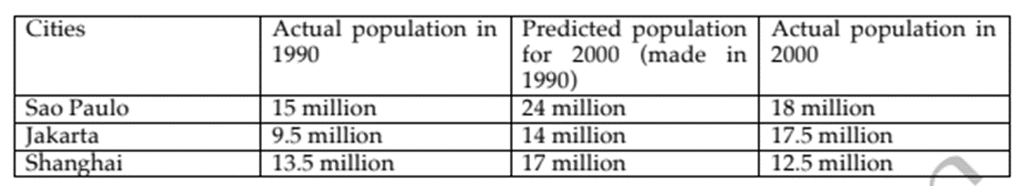
Population forecasts and actual results

1 Plan first
Complete the six-step worksheet in Part 3. Select two or three main features and divide the details into two logical groups. Note the evidence and tenses you will use.

2 Write a complete report
Write at least 150 words in connected paragraphs. Summarise the main features and make comparisons where relevant. Use the visual as your evidence.

3 Review and compare
Use the Part 4 checklist, then read the suggested plan and model for Task 13. Record a data-selection correction and a language correction if needed.
Notes: __________________________________________________________________

Task 14 · Australia and Malaysia: population
The table gives population indicators for Australia and Malaysia in 1980 and 2002.
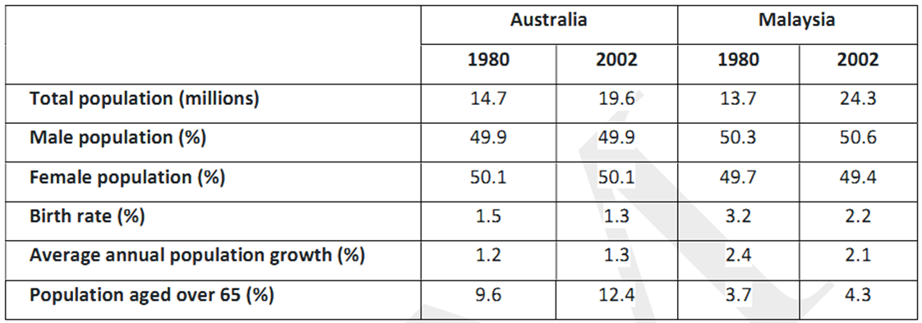
Australia and Malaysia: population

1 Plan first
Complete the six-step worksheet in Part 3. Select two or three main features and divide the details into two logical groups. Note the evidence and tenses you will use.

2 Write a complete report
Write at least 150 words in connected paragraphs. Summarise the main features and make comparisons where relevant. Use the visual as your evidence.

3 Review and compare
Use the Part 4 checklist, then read the suggested plan and model for Task 14. Record a data-selection correction and a language correction if needed.
Notes: __________________________________________________________________

Task 15 · Advertising expenditure
The table shows shares of companies’ advertising expenditure in four media sectors in Australia, Vietnam and Japan in 2005.
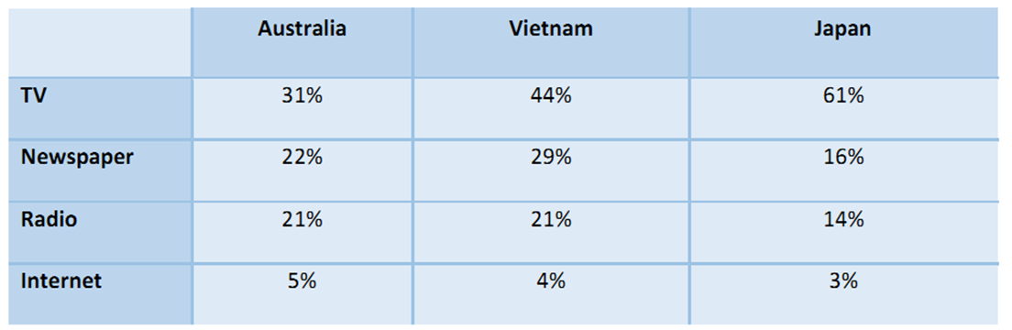
Advertising expenditure

1 Plan first
Complete the six-step worksheet in Part 3. Select two or three main features and divide the details into two logical groups. Note the evidence and tenses you will use.

2 Write a complete report
Write at least 150 words in connected paragraphs. Summarise the main features and make comparisons where relevant. Use the visual as your evidence.

3 Review and compare
Use the Part 4 checklist, then read the suggested plan and model for Task 15. Record a data-selection correction and a language correction if needed.
Notes: __________________________________________________________________

Task 16 · High-school teachers’ salaries
The table shows high-school teachers’ salary figures in five countries in 2009, including starting pay, pay after 15 years, maximum pay and years needed to reach the maximum.
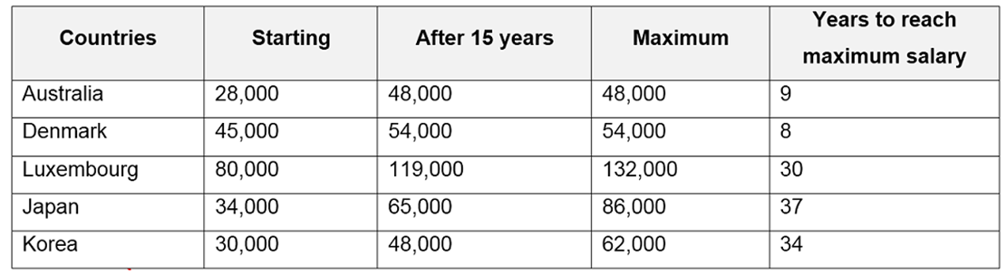
High-school teachers’ salaries
Reading note: Use the salary scale given. The reproduced table does not label a currency, so do not add a currency symbol unless the task specifies one.

1 Plan first
Complete the six-step worksheet in Part 3. Select two or three main features and divide the details into two logical groups. Note the evidence and tenses you will use.

2 Write a complete report
Write at least 150 words in connected paragraphs. Summarise the main features and make comparisons where relevant. Use the visual as your evidence.

3 Review and compare
Use the Part 4 checklist, then read the suggested plan and model for Task 16. Record a data-selection correction and a language correction if needed.
Notes: __________________________________________________________________

Task 17 · Age, income and poverty in US states
The table compares age groups, average income per person and the percentage below the poverty line in California, Utah and Florida.
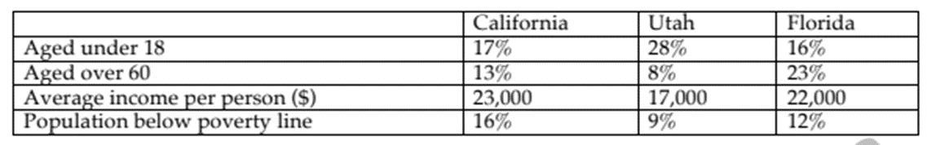
Age, income and poverty in US states

1 Plan first
Complete the six-step worksheet in Part 3. Select two or three main features and divide the details into two logical groups. Note the evidence and tenses you will use.

2 Write a complete report
Write at least 150 words in connected paragraphs. Summarise the main features and make comparisons where relevant. Use the visual as your evidence.

3 Review and compare
Use the Part 4 checklist, then read the suggested plan and model for Task 17. Record a data-selection correction and a language correction if needed.
Notes: __________________________________________________________________

Task 18 · Changes in Westerling
The maps show changes in Westerling between 2000 and 2011.
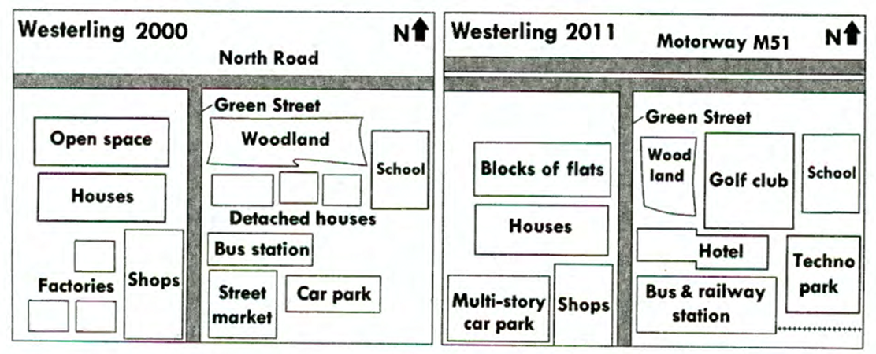
Changes in Westerling

1 Plan first
Complete the six-step worksheet in Part 3. Select two or three main features and divide the details into two logical groups. Note the evidence and tenses you will use.

2 Write a complete report
Write at least 150 words in connected paragraphs. Summarise the main features and make comparisons where relevant. Use the visual as your evidence.

3 Review and compare
Use the Part 4 checklist, then read the suggested plan and model for Task 18. Record a data-selection correction and a language correction if needed.
Notes: __________________________________________________________________

Task 19 · A town’s proposed redevelopment
The maps show the current layout of a town and a proposed future plan.
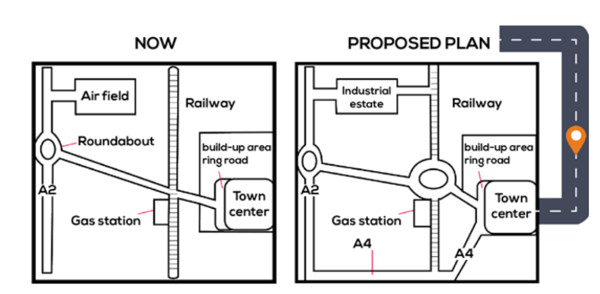
A town’s proposed redevelopment

1 Plan first
Complete the six-step worksheet in Part 3. Select two or three main features and divide the details into two logical groups. Note the evidence and tenses you will use.

2 Write a complete report
Write at least 150 words in connected paragraphs. Summarise the main features and make comparisons where relevant. Use the visual as your evidence.

3 Review and compare
Use the Part 4 checklist, then read the suggested plan and model for Task 19. Record a data-selection correction and a language correction if needed.
Notes: __________________________________________________________________

Task 20 · World water stocks and use
The charts show the types of water in the world, the composition of fresh water, and water use in Egypt, Saudi Arabia and Canada.
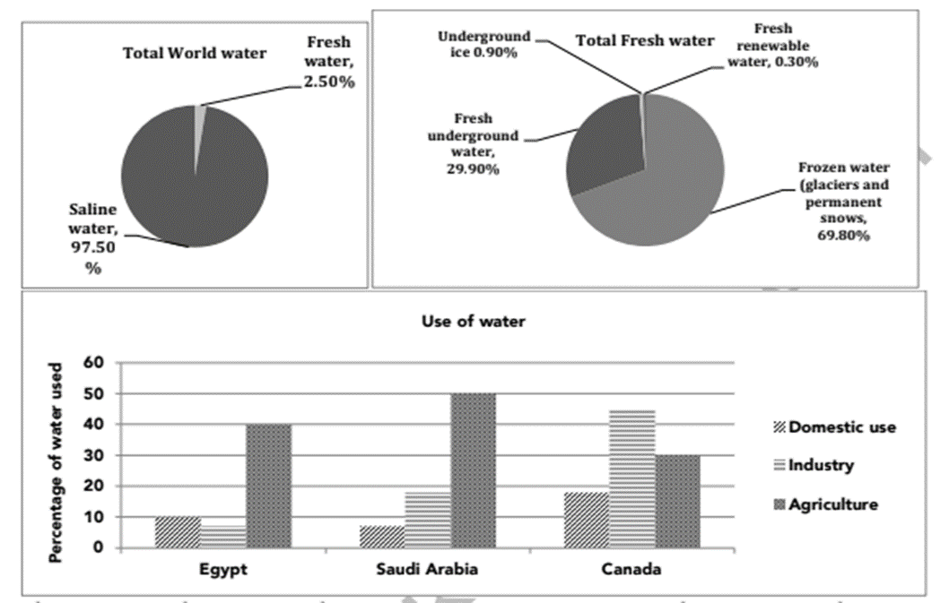
World water stocks and use
Reading note: Read each bar from its own height. The displayed bars and fresh-water labels do not form exact 100% totals; report the printed values without adjusting them.

1 Plan first
Complete the six-step worksheet in Part 3. Select two or three main features and divide the details into two logical groups. Note the evidence and tenses you will use.

2 Write a complete report
Write at least 150 words in connected paragraphs. Summarise the main features and make comparisons where relevant. Use the visual as your evidence.

3 Review and compare
Use the Part 4 checklist, then read the suggested plan and model for Task 20. Record a data-selection correction and a language correction if needed.
Notes: __________________________________________________________________

Task 21 · Parents’ spending and children’s sport
The charts show average monthly spending by British parents on children’s sport and participation in football, athletics and swimming from 2008 to 2014.
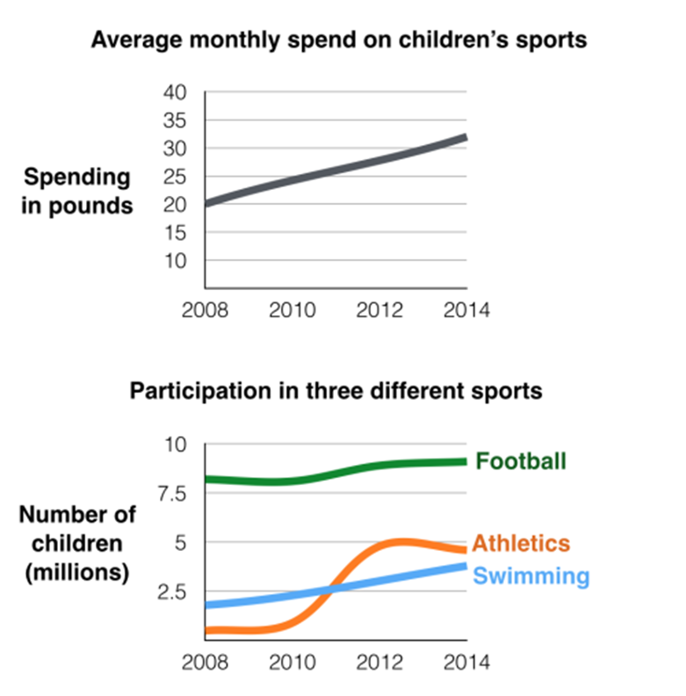
Parents’ spending and children’s sport

1 Plan first
Complete the six-step worksheet in Part 3. Select two or three main features and divide the details into two logical groups. Note the evidence and tenses you will use.

2 Write a complete report
Write at least 150 words in connected paragraphs. Summarise the main features and make comparisons where relevant. Use the visual as your evidence.

3 Review and compare
Use the Part 4 checklist, then read the suggested plan and model for Task 21. Record a data-selection correction and a language correction if needed.
Notes: __________________________________________________________________

Task 22 · Tomato ketchup production
The diagram shows the process of producing tomato ketchup.
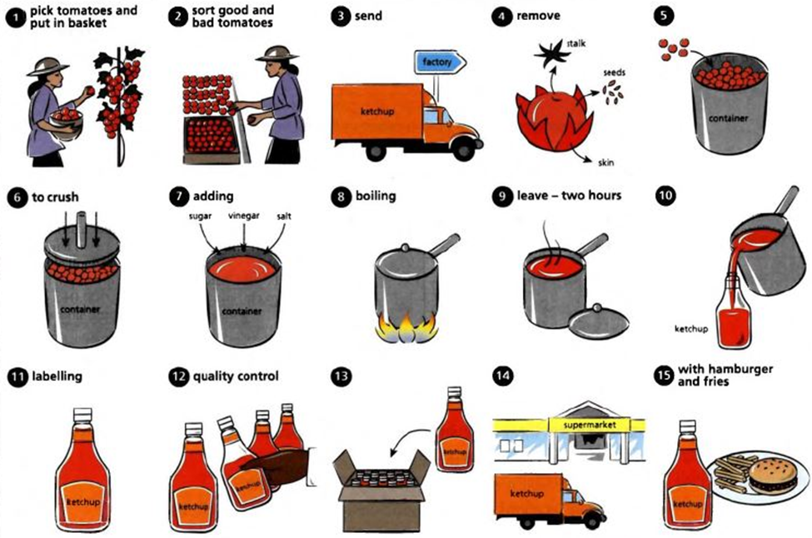
Tomato ketchup production

1 Plan first
Complete the six-step worksheet in Part 3. Select two or three main features and divide the details into two logical groups. Note the evidence and tenses you will use.

2 Write a complete report
Write at least 150 words in connected paragraphs. Summarise the main features and make comparisons where relevant. Use the visual as your evidence.

3 Review and compare
Use the Part 4 checklist, then read the suggested plan and model for Task 22. Record a data-selection correction and a language correction if needed.
Notes: __________________________________________________________________

Task 23 · Energy from coal
The diagram shows how energy is produced from coal.
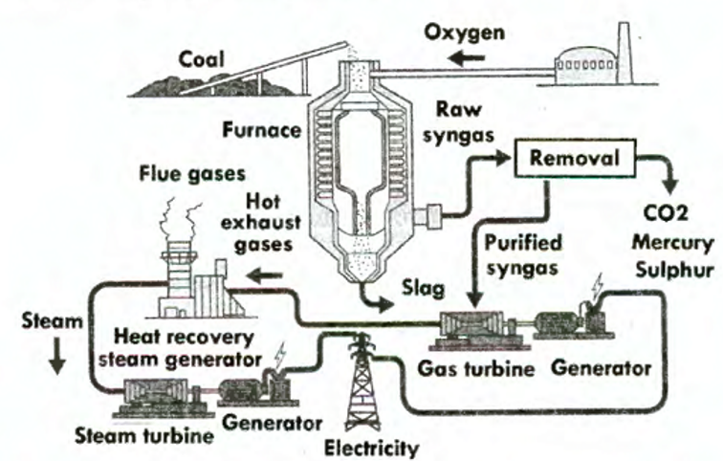
Energy from coal

1 Plan first
Complete the six-step worksheet in Part 3. Select two or three main features and divide the details into two logical groups. Note the evidence and tenses you will use.

2 Write a complete report
Write at least 150 words in connected paragraphs. Summarise the main features and make comparisons where relevant. Use the visual as your evidence.

3 Review and compare
Use the Part 4 checklist, then read the suggested plan and model for Task 23. Record a data-selection correction and a language correction if needed.
Notes: __________________________________________________________________

Task 24 · Silkworms and silk cloth
The diagrams show the life cycle of the silkworm and the production of silk cloth.
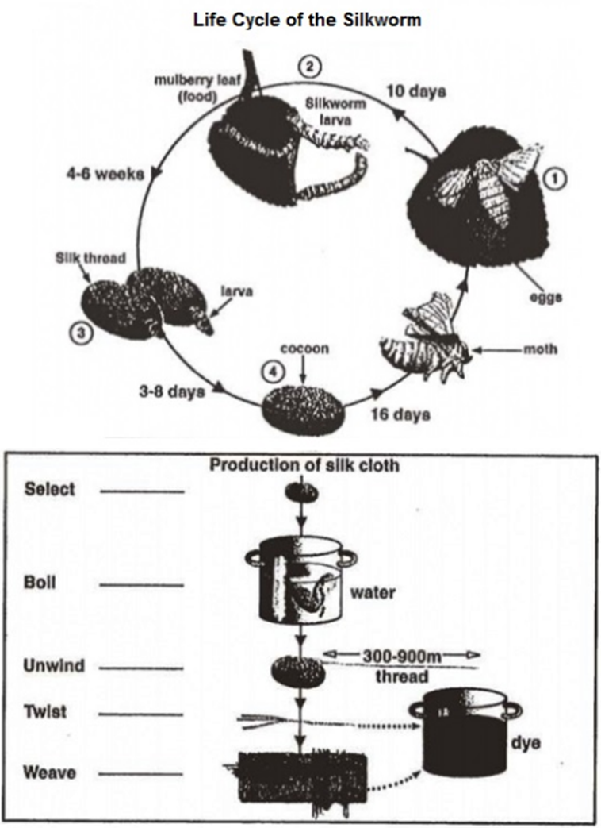
Silkworms and silk cloth

1 Plan first
Complete the six-step worksheet in Part 3. Select two or three main features and divide the details into two logical groups. Note the evidence and tenses you will use.

2 Write a complete report
Write at least 150 words in connected paragraphs. Summarise the main features and make comparisons where relevant. Use the visual as your evidence.

3 Review and compare
Use the Part 4 checklist, then read the suggested plan and model for Task 24. Record a data-selection correction and a language correction if needed.
Notes: __________________________________________________________________

Task 25 · Orange juice production
The diagram shows how orange juice is produced.
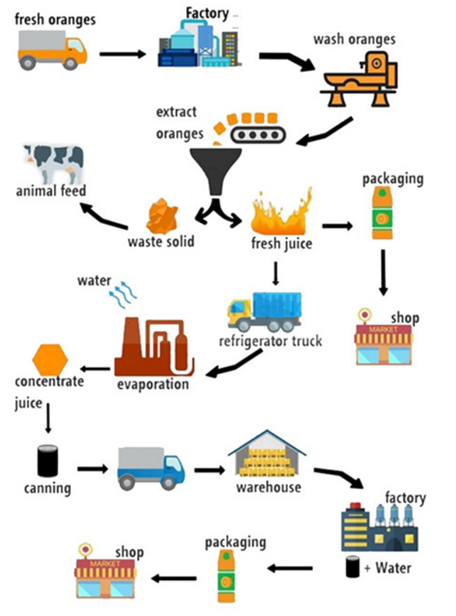
Orange juice production

1 Plan first
Complete the six-step worksheet in Part 3. Select two or three main features and divide the details into two logical groups. Note the evidence and tenses you will use.

2 Write a complete report
Write at least 150 words in connected paragraphs. Summarise the main features and make comparisons where relevant. Use the visual as your evidence.

3 Review and compare
Use the Part 4 checklist, then read the suggested plan and model for Task 25. Record a data-selection correction and a language correction if needed.
Notes: __________________________________________________________________

Task 26 · Japan’s population by age
The chart shows Japan’s population shares by age group from 1960 and includes projections to 2040.
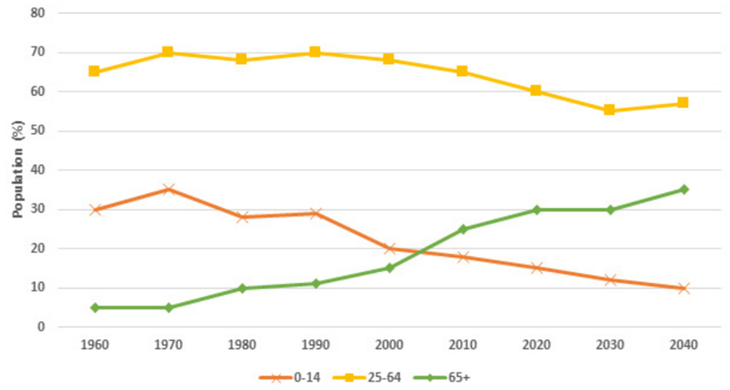
Japan’s population by age
Reading note: Retain the age-band label “25–64” as printed. No exact observed/forecast boundary is marked; identify the projected endpoint without inventing a cut-off year or correcting the source’s totals.

1 Plan first
Complete the six-step worksheet in Part 3. Select two or three main features and divide the details into two logical groups. Note the evidence and tenses you will use.

2 Write a complete report
Write at least 150 words in connected paragraphs. Summarise the main features and make comparisons where relevant. Use the visual as your evidence.

3 Review and compare
Use the Part 4 checklist, then read the suggested plan and model for Task 26. Record a data-selection correction and a language correction if needed.
Notes: __________________________________________________________________

Task 27 · TV preferences by age
The table shows percentages expressing preferences for six types of TV programme across three age groups in a European country in 2012.
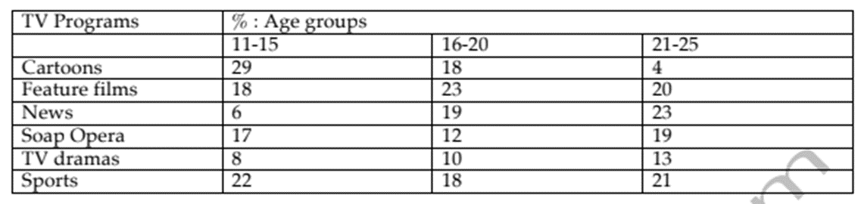
TV preferences by age

1 Plan first
Complete the six-step worksheet in Part 3. Select two or three main features and divide the details into two logical groups. Note the evidence and tenses you will use.

2 Write a complete report
Write at least 150 words in connected paragraphs. Summarise the main features and make comparisons where relevant. Use the visual as your evidence.

3 Review and compare
Use the Part 4 checklist, then read the suggested plan and model for Task 27. Record a data-selection correction and a language correction if needed.
Notes: __________________________________________________________________

Part 5 Complete answer key

Complete answer key
Task 1 | Task 2 | Task 3 | Task 4 | Task 5 | Task 6 | Task 7 | Task 8 | Task 9 | Task 10 | Task 11 | Task 12 | Task 13 | Task 14 | Task 15 | Task 16 | Task 17 | Task 18 | Task 19 | Task 20 | Task 21 | Task 22 | Task 23 | Task 24 | Task 25 | Task 26 | Task 27
Attempt the exercises before reading this section. Sentence rewrites, introductions, overviews and paragraph groups can have more than one correct answer. Judge alternatives by accuracy, relevance and clarity.

E1 · Suggested rewrites
- There was a rise in the share of electricity generated from 23% in 1990 to 46% in 2000.
- A fall from 7,000 to 5,000 was recorded in the number of people commuting by car between 1990 and 2000.
- There were fluctuations in the number of website visitors between 12,000 and 20,000 from 1990 to 1995.
- There was no change in household spending on shoes, which remained at $320 in each of the last two years.
- The annual income of Burney’s Bakery reached a peak of $3 million in 1988.
- After falling to 8,000 in 2005, the number of university applicants recovered to 16,000 in 2015.
- The number of factories rose to 120,000 in 2010 before falling sharply to 10,000 in 2015.
E1 follow-up: (a) 23 percentage points. (b) 100%. (c) Doubled. The final share is twice the initial share. Do not replace “applicants” with “enrolled students” or “visitors” with “visits”.

E2 · Word choices
1 number; 2 amount; 3 largest category; 4 visits; 5 10 percentage points; 6 false; 7 twice as much as; 8 false.

E2 · Corrected comparisons
- The number of men was 60,000. Alternatively, if the unit is genuinely a percentage, use a percentage value supported by the source.
- Housing accounted for 26%, compared with 21% in Canada. Alternatively: “The housing share was five percentage points higher than Canada’s.”
- While 40% of men watched television, 30% of women did so. Alternatively: “40% of men watched television, whereas 30% of women did so.”
- The figures for Spain and Australia were 35,000 and 41,000 respectively.
Explanation: “teachers” is countable, so use “fewer”; “water” is uncountable, so use “less”. Percentages are higher or lower, rather than “outnumbering” each other.

Answers · Comparisons and overviews

E3 · Gap-fill answers
1 largest; 2 followed; 3 contrast; 4 Fewer; 5 lower; 6 than; 7 respectively; 8 twice; 9 similar.

E3 · Independent sentences
A. About 41,000 British people emigrated to Australia in 2004, while approximately 35,000 chose Spain. B. France and New Zealand received approximately the same number of British emigrants, at around 23,000 each.
Other accurate versions are possible. “While” does not require a comparative adjective, and a small estimated difference should not be described as a dramatic contrast.

E4 · Classification and correction
Item | Answer | Explanation or corrected statement
1 | O | It summarises the cross-country ranking at both levels.
2 | D | It gives one supporting value.
3 | U | The chart does not show school funding. Write: “American teachers recorded higher teaching hours than the other countries.”
4 | U | The charts do not prove causation. Write: “Parental spending and swimming participation both increased.”
5 | U | The table does not establish a cause. Write: “The birth rate fell while the over-65 share increased.”
6 | O | It identifies a consistent contrast between the two levels.

E4 · Suggested overview and grouping
Overview: “The USA recorded the highest annual teaching hours at both levels, while primary hours were identical in the other three countries. Upper-secondary teachers taught more hours than primary teachers in every country described.”
Details paragraph 1: primary hours — about 600 in Japan, Spain and Iceland, compared with 900 in the USA. Details paragraph 2: upper-secondary hours — approximately 650 in Japan, 800 in Iceland, 1,000 in Spain and 1,100 in the USA.
A country-based grouping is also possible if it produces clear comparisons and covers both levels accurately.

Answers · Passive sentences and sequence

E5 · Eight passive sentences
- Images are captured by a camera and recorded on film.
- The film is removed from the camera.
- The film is developed and washed in a development tank in a darkroom.
- The negatives are removed from the tank.
- The negatives are viewed in an enlarger, where the images can be enlarged and edited.
- The images are printed on photographic paper.
- The prints are developed, fixed and washed in a chemical bath.
- The prints are dried to produce the finished black-and-white photographs.
Joined version: “After being removed from the camera, the film is developed and washed in a development tank in a darkroom.” The film is the subject of both actions.
Alternatives: “The photographs can be developed either at a pharmacy or by a professional photographer. Alternatively, they can be developed at home.”

E6 · Order and paragraph groups
Order: B → D → H → E → G → F → C → A. Paragraph 1: B and D, introducing the system and its overall transformation. Paragraph 2: H, E and G, describing fuel production and storage. Paragraph 3: F, C and A, describing electricity generation and home use.

E6 · Corrected sentences
B. The diagram shows a method of generating electricity for domestic use. D. Overall, the system converts compost into fuel and then electricity, using a tank, gas storage, a compressor, an engine and a generator. H. First, a steel tank is filled to three-quarters of its capacity with compost and water; the compost ferments to produce methane. E. The methane flows through a pipe into a storage unit, where it is collected. G. The stored gas provides the fuel for the later energy conversion stage. F. After being compressed, the gas fuels a combustion engine, which produces mechanical energy. C. Mechanical energy is converted into electrical energy by a generator, and the electricity is stored in a battery. A. Finally, the stored electricity is supplied to the home for domestic use.
A contains a factual problem: the national grid is not shown. G is already correct and functions as a transition. The other corrections concern agreement or the article before “generator”.

Answers · Life cycle and planning workshops

E7 · Gap-fill answers
1 stages; 2 structure; 3 eggs; 4 elytra; 5 laid; 6 remain; 7 emerge; 8 pupa; 9 end; 10 spots; 11 behind.
Paragraph 1 contains the overview after its introductory sentence. Paragraph 2 describes the life cycle; paragraph 3 describes anatomy. The elytra are the protective wing cases, so they should not simply be renamed “wings”.

E7 · Completed description
The first diagram illustrates the stages in a ladybird’s life, while the second shows its body structure. Overall, the cycle has four stages, from eggs to adult insect. The adult has red elytra marked with black spots.
Initially, eggs are laid on the underside of a leaf and remain there for two to five days. Larvae then emerge and spend 21 days in this stage. The next stage is the pupa, which lasts seven days. At the end of this stage, an adult appears, and the cycle continues.
The adult’s red elytra have black spots and cover its wings and abdomen. It has six legs, eyes and antennae. The pronotum is immediately behind the head.

W1 · British emigration
Introduction: The chart compares the numbers of British people emigrating to five destinations between 2004 and 2007. Overview: Australia remained the leading destination. New Zealand declined steadily, while Spain ended lower after a small initial increase; France and the USA varied over the period.
Details 1: Australia and Spain — about 41,000 to 44,000 for Australia, with a 2006 peak near 52,000; Spain around 35,000 to 28,000. Details 2: the smaller destinations — New Zealand about 23,000 to 20,000; France peaking near 33,000 in 2005 before falling below 20,000; the USA varying around 20,000–24,000. Unit: people, with the axis in thousands. Tense: past simple.

W2 · Leisure activities
Introduction: The chart compares the percentages of men and women taking part in eight leisure activities. Overview: Computer games were the most common male activity, while shopping led among women. Going out with friends was popular with both groups, whereas reading had low figures.
Details 1: large gaps — games about 84% of men versus 3% of women; shopping about 24% versus 75%; television about 65% versus 30%. Details 2: closer figures — friends around 70% for both; cinema and gym about 40%; music about 25–28%; reading below 10%. Unit: percentages, not counts. Tense: present simple is also valid because no date is specified; keep the choice consistent.

Answers · Planning workshops

W3 · Housing preferences
Introduction: The chart compares preferences for four types of housing in Liverpool, London and Manchester in 2009.
Overview: Flats were clearly the leading choice in Liverpool, while semi-detached houses were most popular in London and Manchester. Terraced houses had the lowest share in all three cities.
Details 1: London and Manchester — semi-detached about 37% each; detached 25% versus 35%; flats 29% versus 19%; terraced 19% versus 12%. Details 2: Liverpool — flats about 58%; semi-detached 18%; detached 15%; terraced 9%. Percentages; past simple. Do not force the city totals to add to 100%.

W4 · Consumer spending
Introduction: The table compares the proportions of consumer spending allocated to three categories in four countries in 2008.
Overview: Fast food and drinks attracted the largest share in every country, and leisure activities and education the smallest. China had the highest shares in the first two categories.
Details 1: fast food/drinks — China 28.91%, Japan 18.8%, Thailand 16.36%, Vietnam 15.77%. Details 2: shoes/watches — China 16.23%, others below 6%; leisure/education — Vietnam 3.22% and Thailand 3.2%, compared with China 2.21% and Japan 1.98%. Percentages; past simple.

Answers · Planning workshops

W5 · Australian water charges
Introduction: The table compares water charges per kilolitre and average household bills in five Australian cities.
Overview: Perth has the steepest difference between the two usage bands and the highest average bill. Melbourne has the lowest bill; Melbourne and Sydney have unchanged unit charges across the bands.
Details 1: rates — Adelaide $0.42/$1.00; Perth $0.42/$1.50; Brisbane $0.81/$0.84; Melbourne $0.78 in both bands; Sydney $0.98 in both. Details 2: bills — Perth $332, Sydney $319, Adelaide $312, Brisbane $310, Melbourne $253. Dollars per kilolitre versus dollars per household; present simple. These are usage bands, not a time trend.

W6 · Eastminster village
Introduction: The maps illustrate the transformation of Eastminster between 1999 and 2009.
Overview: The village became more developed, gaining commercial, industrial and tourist facilities. The school moved north of the river, while the river, hospital and railway station remained.
Details 1: north of the river — woodland to adventure park; houses expanded; park reduced; large house with gardens to hotel with golf course; school relocated here. Details 2: south — shopping complex on the former school site; streets of houses replaced by apartment blocks and housing; factories and warehouses on the former public-garden area; shops and hospital retained. Dates and positions; past simple, with past perfect optional where helpful.

Answers · Planning workshops

W7 · Island tourism
Introduction: The maps show an island before and after the construction of tourist facilities.
Overview: The island gained accommodation, visitor facilities and boat access, while its coastline and much of the eastern natural area were retained.
Details 1: buildings — two accommodation clusters; central reception; restaurant to its north. Details 2: movement and leisure — southern pier and vehicle track connecting the reception and restaurant; footpaths connecting accommodation and the western beach; designated swimming area. Positions rather than invented dates; past simple for the earlier state and present perfect for completed development, or a consistent before/after description.

W8 · Mine redevelopment
Introduction: The maps compare a working mine with its layout after conversion into a visitor attraction.
Overview: Industrial facilities were replaced or adapted for tourism, while the car park and underground entrance remained in their original positions.
Details 1: left and centre — office and changing room to museum; medical room to café; lorry park to souvenir shop; car park retained; mine entrance opened to visitors. Details 2: right — waste-tip areas replaced by a digger-driving track, picnic area and children’s play area, connected by footpaths. Use left/right because no compass is provided. Past simple plus present perfect is suitable for before and after.

Answers · Planning workshops

W9 · Global water use
Introduction: The graph shows worldwide water use by sector from 1900 to 2000, and the table compares Brazil and the Democratic Republic of Congo in 2000.
Overview: Water use rose in all sectors, with agriculture consistently the largest. Brazil had much higher water consumption per person than the Congo.
Details 1: graph — agriculture about 500 to 3,000 km³; industry about 100 to 1,400 km³; domestic use below 100 to about 500 km³. Details 2: table — Brazil 176 million people, 26,500 km² irrigated land, 359 m³ per person; Congo 5.2 million, 100 km², 8 m³. Keep the units distinct. Past simple. The irrigated area is 265 times as large in Brazil, but the chart does not prove it caused the per-person difference.

W10 · Family finances
Introduction: The table and pie charts compare income and spending on food and clothes for an average family in a UK city in 2010 and 2013.
Overview: Income declined while spending on food and clothes rose. Fruit and vegetables replaced meat and fish as the largest spending category.
Details 1: table — income 29,000 to 25,000; food/clothes spending 14,000 to 15,000. Details 2: pies — fruit/vegetables 26% to 30%; dairy 12% to 16%; meat/fish 29% to 23%; clothes 15% to 13%; other food 18% in both. Use the money scale as given because the reproduced table has no currency label. Past simple. A lower share does not automatically mean lower absolute spending; calculate only when useful.

Answers · Planning workshops

W11 · Paper recycling
Introduction: The flow chart shows how waste paper is recycled into usable paper.
Overview: There are six main stages, beginning with collection and ending with paper manufacture. The material is sorted and cleaned before being made into new paper.
Details 1: collection from paper banks or businesses; manual sorting by grade and rejection of unsuitable paper; transport to a mill. Details 2: cleaning and pulping, including staple removal; de-inking to remove ink and glue; production of usable paper in a paper-making machine. Present simple, mainly passive; no numerical unit or date is needed.

Model reports · Tasks 1–2

Task 1 · Three London bakeries
Suggested plan: Details 1: the overall increases at Robbie’s Bakery and Bernie’s Buns. Details 2: the decline at Lovely Loaves and the change in ranking.
The line graph compares the yearly income of three London bakeries, Bernie’s Buns, Lovely Loaves and Robbie’s Bakery, between 2000 and 2010. The figures are given in pounds.
Overall, income increased at Robbie’s Bakery and Bernie’s Buns, whereas Lovely Loaves experienced an overall decline. Lovely Loaves earned the most at the beginning, but Robbie’s became the leading bakery from 2006 onwards.
Robbie’s income remained at approximately £55,000 from 2000 to 2005. It then rose to about £60,000 in 2006 before increasing much more rapidly, reaching roughly £105,000 by 2010. Bernie’s Buns started considerably lower, at around £20,000. After some early variation, its earnings stayed close to £38,000 from 2003 to 2005, dipped slightly in 2006 and then climbed to about £65,000 at the end.
By contrast, Lovely Loaves began at just over £80,000 and peaked at approximately £93,000 in 2001. Following further fluctuations, its income fell sharply after 2004. It dropped to around £40,000 in 2008 and remained near that level for the final two years.

Task 2 · Outdoor sports
Suggested plan: Details 1: swimming and jogging/running, which end higher. Details 2: ball games and biking/roller skating, which end lower.
The line graph shows changes in the proportions of young people participating in four outdoor sports in the South West of England, from 1975 to the present day shown on the chart.
Overall, swimming and jogging or running have become more popular, while participation in ball games and biking or roller skating has declined. Swimming has overtaken ball games to become the most popular activity by the end of the period.
Swimming accounted for about 14% of young people in 1975 and 1980. Its share then rose steadily to approximately 24% in 2000 before reaching around 34% at the final point. Jogging and running began at about 7%, increased to 13% in 1985 and then fell to roughly 9% in 1995. The figure has subsequently recovered to approximately 15%.
In contrast, ball games started at around 34%, the highest initial proportion, but fell to about 20% by the end. Biking and roller skating also lost participants in percentage terms, declining from 25% to approximately 16%, despite a small recovery around 1990.

Model reports · Tasks 3–4

Task 3 · Places of Internet access
Suggested plan: Details 1: home and work. Details 2: college and library. Compare changes rather than adding the categories to a total.
The bar chart compares the percentages of people who mostly accessed the Internet at home, at work, at college or in a library in the UK in four years between 1998 and 2004.
Overall, home was the leading location in every year, despite an initial fall. Access at work became less common, while the figures for colleges and libraries fluctuated and remained well below the home figure.
In 1998, approximately 55% of people used the Internet mainly at home. This proportion fell to about 48% in 2000, recovered to 50% in 2002 and returned to roughly 55% in 2004. The workplace figure was much lower, at around 28% in both 1998 and 2000, before declining to approximately 26% in 2002 and 16% in 2004.
College access accounted for about 20% in the first two years, rose to approximately 25% in 2002 and then fell to around 18%. Library use increased from roughly 12% to 18% between 1998 and 2000, before settling at approximately 16% in the final two years.

Task 4 · Male and female teachers
Suggested plan: Details 1: nursery, primary and secondary education. Details 2: college, private training institutes and university.
The bar chart compares the proportions of male and female teaching staff in six types of educational institution in the UK in 2010.
Overall, women were much more strongly represented in nursery and primary education, whereas men formed the majority at university level. The difference between the sexes was smaller in the middle categories, with an equal distribution at colleges.
Women accounted for approximately 96% of nursery and pre-school teachers, leaving only about 4% for men. A similar pattern appeared in primary schools, where the female share was just over 90% and the male share was below 10%. At secondary level, the gap narrowed substantially: women represented roughly 55% of teachers, compared with about 45% for men.
College staff were divided equally, with each sex accounting for 50%. Men had a modest lead in private training institutes, at approximately 55%, against 45% for women. The male proportion was considerably higher at universities, reaching about 70%, while women made up the remaining 30%. Thus, the strongest male and female majorities occurred at opposite ends of the educational range.

Model reports · Tasks 5–6

Task 5 · Watching and participating in sport
Suggested plan: Details 1: football, fishing, and horse riding and racing, with large gaps. Details 2: rugby, basketball and badminton.
The bar chart compares the percentages of males who prefer watching six types of sport with the percentages who prefer participating in them in a particular country.
Overall, watching was more popular than participation in every category except fishing. Fishing had the highest participation figure, while football and horse riding and racing attracted the largest proportions of viewers.
Around 45% preferred watching football, compared with only about 10% who preferred playing it. Horse riding and racing showed a similar contrast, with approximately 45% choosing to watch and 20% choosing to participate. Fishing displayed the opposite pattern: participation reached 50%, the highest figure on the chart, whereas watching accounted for just 15%.
The gaps were smaller for the remaining sports. Basketball attracted about 37.5% as viewers and 25% as participants. For rugby, the corresponding figures were approximately 30% and 20%. Badminton also had a viewing figure of around 30%, but its participation figure was slightly higher than rugby’s, at about 25%. Consequently, badminton had the smallest difference between the two preferences.

Task 6 · Annual teaching hours
Suggested plan: Details 1: primary and secondary hours. Details 2: upper-secondary hours, comparing the four countries.
The bar chart compares the number of hours taught annually by primary, secondary and upper-secondary teachers in Japan, Spain, Iceland and the USA in 2001.
Overall, American teachers had the highest annual teaching hours at all three levels. Upper-secondary teachers taught at least as many hours as those at the other levels in every country, although the difference was particularly small in Japan.
Primary teachers in Japan, Spain and Iceland each taught for approximately 600 hours per year. The corresponding figure in the USA was considerably higher, at about 900 hours. At secondary level, Japan and Spain remained at around 600 hours, while Iceland rose to approximately 800 and the USA to just over 1,000.
Upper-secondary teaching hours varied more widely between countries. Japan recorded the lowest figure, at approximately 650 hours, only slightly above its primary and secondary totals. Iceland’s upper-secondary figure was about 800 hours, the same as its secondary figure. Spain reached roughly 1,000 hours, while the USA again had the highest total, at approximately 1,100 hours.

Model reports · Tasks 7–8

Task 7 · Household expenditure
Suggested plan: Details 1: food, housing and transportation. Details 2: health care and clothing. Note that Japan spends a slightly larger share on food than housing.
The bar chart compares the shares of expenditure allocated to five categories in the United States, Canada, the United Kingdom and Japan in 2009.
Overall, housing accounted for the largest share in the first three countries, while food was slightly higher than housing in Japan. Health care and clothing represented relatively small proportions in all four countries.
Housing expenditure reached 26% in the United States, compared with 24% in the United Kingdom, 22% in Japan and 21% in Canada. Food showed a different ranking: Japan had the highest share, at 23%, followed by the United Kingdom at 20%. Canada and the United States recorded lower figures of 15% and 14% respectively. Transportation was most prominent in Canada, at 20%, and least prominent in Japan, at 10%.
The remaining two categories each accounted for less than 10% everywhere. Health care represented 7% of expenditure in the United States, 4% in Canada and Japan, and only 2% in the United Kingdom. Clothing stood at 6% in Canada and the United Kingdom, compared with 4% in the other two countries.

Task 8 · Time spent on Internet activities
Suggested plan: Details 1: large contrasts in bookings, games and music/films. Details 2: social networking, research and purchases.
The pie charts compare how people aged 18–26 and 60–70 distribute their online leisure time among six activities.
Overall, social networking takes the largest share of the younger group’s time, whereas making bookings is the leading activity among older users. The greatest differences concern bookings and games, while the two groups allocate identical shares to online purchases.
People aged 60–70 spend 25% of their online time making bookings, such as travel or cinema reservations, compared with just 5% among those aged 18–26. The younger group, however, devotes 18% to playing games, against only 5% for older users. Accessing music and films also occupies a larger share among younger people, at 21%, compared with 15% in the older group.
The differences in the other categories are less pronounced. Social networking accounts for 24% of younger users’ time and 21% of older users’ time. Researching information such as health data represents 20% and 22% respectively. Finally, making purchases takes up 12% of online time in both age groups.

Model reports · Tasks 9–10

Task 9 · Water use in three areas
Suggested plan: Details 1: contrast residential and agricultural shares. Details 2: compare industrial use. California’s largest category is below 50%.
The three pie charts compare the proportions of water used for residential, industrial and agricultural purposes in San Diego County, California and the world as a whole.
Overall, residential use accounts for the largest share in San Diego and California, while agriculture dominates worldwide consumption. Industrial use is more similar across the three areas than either of the other two categories.
In San Diego County, residential consumption represents 60% of water use, considerably higher than California’s figure of 39%. The worldwide residential proportion is much smaller, at only 8%. Agriculture shows the reverse pattern. It accounts for 69% of global water consumption but just 28% in California and 17% in San Diego. Thus, the largest worldwide category is the smallest category in both American areas.
Industrial consumption stands at 23% in San Diego, which is exactly the same as the worldwide figure. California allocates a larger proportion to industry, at 33%. Its distribution is also relatively balanced: the difference between its largest and smallest categories is only 11 percentage points, compared with much wider gaps in the other two charts.

Task 10 · Sources of electricity
Suggested plan: Details 1: India and Vietnam, dominated by fossil fuels. Details 2: Sweden and Morocco, dominated by hydro power. These are country breakdowns, not a year-by-year trend.
The pie charts compare the proportions of electricity generated from fossil fuels, hydro power and nuclear power in four countries during the period 2003–2008.
Overall, fossil fuels were the main source in India and Vietnam, whereas hydro power contributed the largest share in Sweden and Morocco. Nuclear electricity was shown only in India and Sweden, with a much larger proportion in the latter.
India relied most heavily on fossil fuels, which accounted for 82% of its electricity production. Hydro power supplied 14%, while nuclear power contributed the remaining 4%. Vietnam also generated most of its electricity from fossil fuels, although the proportion was lower, at 56%. Its other 44% came from hydro power, with no nuclear contribution shown.
Sweden had a contrasting distribution. Hydro power represented 52% of production and nuclear power a further 44%, leaving only 4% for fossil fuels. Morocco was even more dependent on hydro power, which supplied 95% of its electricity. Fossil fuels accounted for the remaining 5%, and nuclear power was absent from its electricity mix.

Model reports · Tasks 11–12

Task 11 · Car production
Suggested plan: Details 1: Thailand’s consistently high output and its intermediate peak. Details 2: the opposite overall trends in Argentina and Australia.
The table compares car production in Argentina, Australia and Thailand in three years between 2003 and 2009.
Overall, Thailand produced the most cars in every year, despite a decline after 2005. Argentina’s output increased throughout the period, while Australia’s fell, allowing Argentina to overtake Australia by 2005.
Thailand manufactured 735,852 cars in 2003, substantially more than either of the other countries. Production then rose sharply to 1,162,356 in 2005 before decreasing to 999,963 in 2009. Although the final figure was below the intermediate peak, it remained well above the 2003 level and exceeded the combined output of Argentina and Australia in 2009.
Argentina began with the lowest production, at 235,088 cars, but its total increased to 352,759 in 2005 and 466,089 in 2009. This represented an almost twofold rise over the period. Australia showed the opposite trend, falling from 452,163 cars in 2003 to 341,268 in 2005 and then to 245,624 in 2009. By the final year, Argentina was producing almost twice as many cars as Australia.

Task 12 · People aged over 60
Suggested plan: Details 1: the 2000 ranking. Details 2: the projected 2050 ranking and the main increases, expressed in percentage points.
The table compares the proportions of people aged over 60 in six world regions in 2000 and gives projections for 2050, together with the worldwide figures.
Overall, the elderly share is projected to rise in every region. Europe had the highest proportion in 2000 and is expected to retain that position in 2050, while Africa is forecast to remain the lowest.
In 2000, 22% of Europe’s population was over 60, considerably above the worldwide figure of 13%. Asia followed at 12%, while North America and Oceania each recorded 11%. The corresponding shares were lower in Latin America and Africa, at 7% and 5% respectively.
By 2050, Europe’s figure is projected to reach 31%, with Asia close behind at 28% and North America at 26%. Oceania is expected to reach 22%, while Latin America and Africa are forecast to rise to 18% and 12%. The global proportion is predicted to increase to 24%. Asia and North America show the largest projected increases, at 16 and 15 percentage points respectively, compared with a seven-point rise in Africa.

Model reports · Tasks 13–14

Task 13 · Population forecasts and actual results
Suggested plan: Details 1: actual changes from 1990 to 2000. Details 2: compare the forecasts with the actual results. Use past prediction language.
The table compares actual populations in São Paulo, Jakarta and Shanghai in 1990 and 2000 with forecasts for 2000 that were made in 1990. All figures are given in millions.
Overall, São Paulo remained the largest city, although Jakarta experienced much stronger growth and almost caught up. The forecasts overestimated the populations of São Paulo and Shanghai but underestimated Jakarta’s.
In 1990, São Paulo had 15 million inhabitants, compared with 13.5 million in Shanghai and 9.5 million in Jakarta. By 2000, São Paulo’s population had risen to 18 million, an increase of three million. Jakarta grew more sharply, reaching 17.5 million after an increase of eight million. Shanghai, in contrast, fell to 12.5 million and became the smallest of the three.
São Paulo had been predicted to reach 24 million in 2000, six million above its actual result. Shanghai’s forecast of 17 million was also too high, exceeding the actual figure by 4.5 million. Jakarta had been expected to reach only 14 million, but its actual population was 3.5 million higher than this prediction.

Task 14 · Australia and Malaysia: population
Suggested plan: Details 1: population totals and gender shares. Details 2: birth rates, annual growth and over-65 shares. Avoid turning these associations into causes.
The table compares six population indicators in Australia and Malaysia in 1980 and 2002, including total population, gender distribution, birth rates, growth and the proportion aged over 65.
Overall, both populations increased, but Malaysia grew more strongly and became the larger country. Gender shares remained close to equal, while Australia had a substantially higher elderly proportion in both years.
Australia’s population rose from 14.7 million to 19.6 million, whereas Malaysia’s increased from 13.7 million to 24.3 million. In Australia, males and females consistently represented 49.9% and 50.1% respectively. Malaysia’s male share edged up from 50.3% to 50.6%, accompanied by an equivalent fall in the female share to 49.4%.
Birth rates declined in both countries, from 1.5% to 1.3% in Australia and from 3.2% to 2.2% in Malaysia. Average annual population growth changed less, rising from 1.2% to 1.3% in Australia but falling from 2.4% to 2.1% in Malaysia. Meanwhile, the over-65 share increased from 9.6% to 12.4% in Australia and from 3.7% to 4.3% in Malaysia.

Model reports · Tasks 15–16

Task 15 · Advertising expenditure
Suggested plan: Details 1: television and its large differences. Details 2: newspapers, radio and the Internet. Do not assume the selected categories account for all expenditure.
The table compares the percentages of companies’ advertising expenditure allocated to television, newspapers, radio and the Internet in Australia, Vietnam and Japan in 2005.
Overall, television received the largest share in all three countries, especially Japan. Internet advertising accounted for the smallest proportion everywhere, while Australia had the most balanced distribution among television, newspapers and radio.
Television represented 61% of advertising expenditure in Japan, almost twice Australia’s figure of 31%. Vietnam occupied an intermediate position, at 44%. The difference between Japan and Australia was therefore 30 percentage points, much larger than the cross-country differences in the other media sectors.
Newspapers attracted the second-largest share in each country. Vietnam recorded the highest figure, at 29%, followed by Australia at 22% and Japan at 16%. Radio accounted for 21% in both Australia and Vietnam, compared with 14% in Japan. Internet advertising was considerably less prominent, representing only 5% in Australia, 4% in Vietnam and 3% in Japan. Thus, Japan’s strong concentration on television contrasted with relatively low shares for all three other listed media.

Task 16 · High-school teachers’ salaries
Suggested plan: Details 1: starting pay and pay after 15 years. Details 2: maximum pay and years to reach it. Keep salary figures separate from years.
The table compares high-school teachers’ salaries in five countries in 2009 at different career stages and shows how many years were required to reach the maximum salary.
Overall, Luxembourg offered the highest salaries at every listed stage. Australia and Denmark reached their maximum levels much sooner than the other countries, although their maximum pay was comparatively low.
Starting salaries ranged from 28,000 in Australia to 80,000 in Luxembourg. Denmark ranked second at 45,000, followed by Japan at 34,000 and Korea at 30,000. After 15 years, Luxembourg’s figure had risen to 119,000, while Japan’s had increased to 65,000. Denmark reached 54,000, and Australia and Korea both recorded 48,000.
The highest maximum salary was again in Luxembourg, at 132,000, followed by Japan at 86,000 and Korea at 62,000. These levels required 30, 37 and 34 years respectively. By contrast, Denmark reached its maximum of 54,000 after only eight years, while Australia reached 48,000 after nine. Consequently, the salary shown after 15 years was already the maximum in both of these countries.

Model reports · Tasks 17–18

Task 17 · Age, income and poverty in US states
Suggested plan: Details 1: under-18 and over-60 shares. Details 2: income and poverty figures. Higher average income does not prove lower poverty.
The table compares California, Utah and Florida in terms of their population age profiles, average income per person and the proportion living below the poverty line.
Overall, Utah has the largest share of children and the smallest share of older people, while Florida shows the opposite pattern. California records the highest average income, but it also has the highest poverty percentage.
People aged under 18 account for 28% of Utah’s population, substantially above the figures for California and Florida, at 17% and 16% respectively. Only 8% of Utah residents are over 60, compared with 13% in California and 23% in Florida. Florida is therefore the only state where the older group is larger than the under-18 group.
Average income per person stands at $23,000 in California, slightly higher than Florida’s $22,000. Utah has the lowest figure, at $17,000. However, Utah also has the lowest poverty rate, with 9% of its population below the poverty line. The corresponding shares are 12% in Florida and 16% in California, showing that the income and poverty rankings are not opposites.

Task 18 · Changes in Westerling
Suggested plan: Details 1: west of Green Street. Details 2: east of Green Street and the transport changes along the northern and southern edges.
The maps show how Westerling changed between 2000 and 2011.
Overall, the town gained more housing, visitor facilities and transport infrastructure. North Road became the M51 motorway, while a combined bus and railway station replaced the former bus station and street market area. Green Street and the school remained in place.
West of Green Street, the open space in the north was replaced by blocks of flats. The existing houses remained immediately to their south. Farther south, the factories were removed and a multi-storey car park was built in their place, while the shops continued to occupy the south-eastern corner of this western section.
East of Green Street, the woodland was reduced in size, and a golf club occupied much of the area between the remaining trees and the school. The detached houses were replaced by a hotel. A larger bus and railway station appeared below the hotel, covering the former bus station and market area. The original car park in the south-east was replaced by a techno park, with a railway line shown along the southern edge.

Model reports · Tasks 19–20

Task 19 · A town’s proposed redevelopment
Suggested plan: Details 1: airfield replacement and access from the A2. Details 2: the new roundabout and A4 connection around the railway and town centre.
The maps compare the present layout of a town with a proposed plan for its future development.
Overall, the main changes involve replacing the airfield with an industrial estate and reorganising road access near the railway and town centre. A new roundabout and an A4 road are proposed, while the existing A2, railway and town centre are retained.
At present, the airfield lies in the north-west of the area, east of the A2. Under the proposal, an industrial estate will occupy this site, with a road extending towards the railway. The roundabout on the A2 will remain, but the road leading east from it will connect to a new, larger roundabout close to the railway.
Currently, a road runs from the A2 across the railway towards the town centre, passing near a gas station. The plan retains the gas station but changes the nearby junction arrangement. From the new roundabout, a route will continue towards the centre, while the proposed A4 will run south alongside the railway before turning towards the southern side of the town centre.

Task 20 · World water stocks and use
Suggested plan: Details 1: saline versus fresh water and the fresh-water breakdown. Details 2: compare the three sectors in the three countries.
The charts show the composition of the world’s water supplies and compare the percentages of water used for domestic, industrial and agricultural purposes in Egypt, Saudi Arabia and Canada.
Overall, almost all the world’s water is saline, and most fresh water is frozen. In the country comparison, agriculture has the highest figure in Egypt and Saudi Arabia, whereas industry is the leading user in Canada.
Saline water represents 97.5% of the world total, leaving only 2.5% as fresh water. Within the fresh-water category, nearly 70% is shown as glaciers and permanent snow, while fresh underground water accounts for 29.9%. Underground ice and fresh renewable water make up very small proportions, at 0.9% and 0.3% respectively.
Agricultural use is approximately 40% in Egypt and 50% in Saudi Arabia, compared with around 30% in Canada. Industrial use follows the opposite ranking: it is about 45% in Canada, roughly 18% in Saudi Arabia and only around 7% in Egypt. Domestic use is lower, at approximately 10% in Egypt, 7% in Saudi Arabia and 18% in Canada.

Model reports · Tasks 21–22

Task 21 · Parents’ spending and children’s sport
Suggested plan: Details 1: the spending trend. Details 2: participation and changes in ranking. Describe the association without inventing causation.
The two line charts show average monthly spending by British parents on their children’s sports and the numbers of children participating in football, athletics and swimming between 2008 and 2014.
Overall, parental spending rose throughout the period. Participation also ended higher in all three sports, although athletics fell slightly after its peak. Football remained the most popular sport by a substantial margin.
Average monthly spending increased from £20 in 2008 to approximately £25 in 2010. It continued to rise over the following four years, reaching about £28 in 2012 and roughly £32 in 2014. The overall increase was therefore approximately £12 per month.
Football participation stood at around eight million children in 2008, dipped slightly in 2010 and then climbed to about nine million by 2014. Swimming grew steadily from approximately two million to four million participants. Athletics began with only around half a million children and changed little initially, before rising sharply to about five million in 2012. Its figure then eased to roughly 4.5 million in 2014, remaining above swimming but well below football.

Task 22 · Tomato ketchup production
Suggested plan: Details 1: picking, sorting, factory preparation, crushing, seasoning and boiling. Details 2: resting, bottling, checks, packing, delivery and consumption.
The diagram illustrates the stages involved in producing tomato ketchup, from harvesting tomatoes to serving the finished product with food.
Overall, the process contains fifteen illustrated stages. It begins with picking and sorting tomatoes, continues through factory processing and bottling, and ends with distribution to supermarkets and consumption.
First, tomatoes are picked and placed in baskets. They are then sorted so that the good tomatoes are separated from the bad ones. The selected tomatoes are transported by lorry to a factory, where their stalks, skins and seeds are removed. The prepared tomatoes are placed in a container and crushed. Sugar, vinegar and salt are added to the mixture, which is then boiled.
After boiling, the mixture is left for two hours before being poured into bottles. Labels are attached to the bottles, and the ketchup undergoes quality control. The finished bottles are packed into cartons and loaded onto a lorry for delivery to supermarkets. At the final stage, the ketchup is shown being consumed with a hamburger and fries.

Model reports · Tasks 23–24

Task 23 · Energy from coal
Suggested plan: Details 1: coal and oxygen, gas production and purification. Details 2: gas-turbine electricity and heat recovery through the steam turbine.
The diagram shows how coal is used to produce electricity through a system involving gas purification, a gas turbine and a steam turbine.
Overall, coal is converted into a gas that is cleaned before powering a turbine. Heat from the system is also recovered to generate steam, allowing electricity to be produced through a second turbine as well.
Initially, coal and oxygen are supplied to a furnace. Raw syngas is produced, while slag leaves the bottom of the furnace. The gas then passes through a removal stage, where carbon dioxide, mercury and sulphur are separated from it. The resulting purified syngas is directed to a gas turbine, which drives a generator to produce electricity.
Hot exhaust gases are passed to a heat recovery steam generator. This equipment produces steam, which flows to a steam turbine connected to another generator. Electricity is therefore supplied from both generator units. After heat recovery, flue gases leave through the outlet shown above the steam-generating equipment. The diagram thus combines gas-powered generation with the recovery of heat for further electricity production.

Task 24 · Silkworms and silk cloth
Suggested plan: Details 1: the life cycle, including timings and food. Details 2: cocoon selection, boiling, unwinding, twisting, weaving and the two possible dyeing stages.
The diagrams illustrate the life cycle of the silkworm and the stages involved in manufacturing silk cloth.
Overall, the natural cycle runs from eggs to larvae, cocoons and moths, before returning to eggs. Cloth production uses the cocoons as its raw material and involves several processing stages, with dyeing possible at either the thread or cloth stage.
The cycle begins with eggs, which develop into silkworm larvae after about ten days. The larvae feed on mulberry leaves for four to six weeks before producing silk thread. Over the next three to eight days, this thread forms a cocoon. After a further sixteen days, a moth emerges, and eggs are subsequently laid to begin the cycle again.
For silk manufacture, suitable cocoons are first selected and then boiled in water. The silk is unwound from each cocoon, producing a thread approximately 300 to 900 metres long. This thread is twisted and can then be woven into cloth. The diagram also shows that dye can be applied to the twisted thread or to the fabric after weaving.

Model reports · Tasks 25–26

Task 25 · Orange juice production
Suggested plan: Details 1: shared preparation and direct fresh-juice packaging. Details 2: concentration, storage, reconstitution and final packaging.
The diagram illustrates the production of orange juice, showing both a direct route to shops and a longer route involving concentration and storage.
Overall, both routes begin with transporting and washing oranges before extracting their juice. Some juice is packaged immediately, while the rest is concentrated, stored and later mixed with water before being sold.
First, fresh oranges are delivered by truck to a factory, where they are washed. The juice is then extracted, and the solid waste is separated for use as animal feed. At this point, one part of the fresh juice is packaged and sent directly to shops.
The alternative route begins with transporting fresh juice in a refrigerated truck to an evaporation facility. Water is removed to create concentrated juice, which is then canned and delivered to a warehouse. After storage, the concentrate is taken to a factory, where water is added again. Finally, the reconstituted juice is packaged and transported to shops, joining the fresh juice that followed the shorter production route.

Task 26 · Japan’s population by age
Suggested plan: Details 1: earlier values and the shift between children and older people. Details 2: projected endpoints and the continuing lead of the middle age group.
The line graph shows the percentages of Japan’s population in three age groups from 1960, with projections extending to 2040.
Overall, the group labelled 25–64 remains the largest throughout the chart. The share aged 65 and over rises considerably, while the proportion aged 0–14 declines after an early peak. The older group overtakes children during the middle part of the series.
In 1960, approximately 65% belonged to the 25–64 group, compared with 30% aged 0–14 and only 5% aged at least 65. The middle group fluctuated around 65–70% over the following decades. The children’s share reached about 35% in 1970, then fell to around 20% in 2000. Meanwhile, the elderly proportion rose gradually to approximately 15% by 2000.
Later in the series, the older group moves above the children’s group. By 2040, its share is projected to reach roughly 35%, against just 10% for children. The 25–64 figure is expected to fall to about 55% in 2030 before recovering slightly to approximately 57% at the final point.

Model report · Task 27

Task 27 · TV preferences by age
Suggested plan: Details 1: cartoons, news and dramas, which show clear age gradients. Details 2: films, soap operas and sports, whose patterns are less consistent.
The table compares preferences for six types of television programme among three age groups in a European country in 2012.
Overall, cartoons were most popular among those aged 11–15 but much less popular in the older groups. News and television dramas showed the opposite pattern. Feature films led among 16–20-year-olds, while news ranked first among those aged 21–25.
Cartoons accounted for 29% in the youngest group, compared with 18% among 16–20-year-olds and only 4% among 21–25-year-olds. News increased across the same groups, from 6% to 19% and then 23%. Television dramas also became more popular with age, although their figures were lower, at 8%, 10% and 13% respectively.
The remaining categories showed less consistent patterns. Feature films rose from 18% in the youngest group to 23% in the middle group, before falling to 20% in the oldest. Soap operas recorded 17%, 12% and 19% respectively. Sports attracted similar proportions across all three groups, at 22%, 18% and 21%, making them the second most popular category among the youngest and oldest viewers.

Reference and next practice cycle

An error log you can reuse
Task / date | My sentence or selection | Correction | Rule for next time
___ | ___ | ___ | ___
___ | ___ | ___ | ___
___ | ___ | ___ | ___
This is a personal record, so it has no fixed answer. If your work is already accurate in a category, note that and choose a different improvement goal. Review repeated errors before your next timed report.

Choose the next skill to practise
If your overview is weak, redo W1, W4 and W9 without writing the details. If figures are inaccurate, redo E2 and compare units in W5. If paragraphs are disorganised, redo the grouping stage for Tasks 14, 18 and 25. If process grammar is weak, redo E5 and rewrite Task 22 using passive verbs.

Official test guidance
The study methods and sample reports are instructional examples. For the test format and assessment criteria, consult the official IELTS resources below. Checked 19 October 2026.
[1] IELTS. “IELTS Academic: Writing test format.” https://ielts.org/take-a-test/test-types/ielts-academic-test/ielts-academic-format-writing
[2] IELTS. “IELTS Writing test preparation resources.” https://ielts.org/take-a-test/preparation-resources/writing-test-resources
Original charts, maps and diagrams: retained from the supplied instructional guide. Keep the source labels and units when practising. Some reproduced graphics use approximate values or contain inconsistent totals; read the relevant task note and describe what is shown.

