E-COMMERCE FAQ CHATBOT
Implementation Using LangChain and LLM
Assignment Report
Date: February 2026

1. Name and Purpose of the Chatbot

This is a E-commerce FAQ Virtual Assistant, and it is designed to answer instant accurate questions such as the following to customers
1. Account creation and management
2. Payment methods and security
3. Order tracking and management
4. Shipping and delivery policies
5.Return and refund policies
6.Customer support contact information

2. NLP/LLM Methods Used
This chatbot is powered by advanced AI by using natural language processing (NLP) and large language model (LLM) that helps it understand your questions and respond in a way that makes sense

2.1 Retrieval-Augmented Generation (RAG)
It employes RAG which is Retrieval-Augmented Generation to searches through a database of FAQs to find the most relevant information. Then it uses the information to craft a clear and natural response

2.2 Semantic Embeddings
The chatbot uses a lightweight AI model sentence-transformers/all-MiniLM-L6-v2 to understand the meaning behind your questions.
Here's what it does:
- It understands meaning, can recognize that how do I track my order and how do I monitor my shipment
- It translates text into something a computer can compare
- It processes your question almost instantly

2.3 Vector Similarity Search
ChromaDB will search through all the stored FAQ to find the most similar answer based on what you ask. It match score and rank- if a scoe close to 1 means it is a very strong match, if close to 0 means its not very relevant, if close to -1 means its completely unreleted.

2.4 Large Language Model: Anthropic Claude
The chatbot uses Claude Sonnet 4 to generate responses.
- Temperature 0.3 make Claude stays focused and gives consistent reliable answers
- Max Tokens 1024 means the word limit for each response
- Context Window means clause can read how much information at once

2.5 Prompt Engineering
There are some rules set for claude before it answer anything
- Always act as a helpful ecommerce customer support assistant
- Only answer based on the FAQ information
- Be honest if it doesn’t have answer
- Direct user to contact customer support when they need

3. Dataset Information

3.1 Dataset Source
Dataset: E-commerce FAQ Dataset
Source: Public domain FAQ collection (Kaggle/Custom)
File Format: JSON
File Name: Ecommerce_FAQ_Chatbot_dataset.json

3.2 Number of Records
The dataset contains 79 question-answer pairs, each representing a unique customer inquiry and its corresponding official response.
  - Number of Features
Each record in the dataset has 2 features — the customer question and the answer to that question.

3.4 Dataset Statistics
Feature Name | Description | Data Type
question | The customer's question or inquiry (e.g. "How do I track my order?") | String (Text)
answer | The official response or information provided to the customer | String (Text)

  - Preprocessing Steps

Before the data is used by the chatbot:

- Load json file
- Combine each question and answer to single text
- Convert combined document to a vector using sentence transformer model
- Stored vectors to chromaDB with original question and answer to ready to be serach

4. Libraries, Toolkits, and Framework
The chatbot is built using a modern Python technology stack optimized for NLP and LLM applications.
Library/Framework | Version | Purpose
LangChain | 0.3.13 | Core framework for LLM orchestration
LangChain-Anthropic | 0.3.3 | Anthropic Claude API integration
Anthropic | ≥0.41.0 | Claude API client library
ChromaDB | 0.5.23 | Vector database for semantic search
Sentence Transformers | 3.3.1 | Generate text embeddings
Pandas | 2.2.3 | Data manipulation and analysis
Python-dotenv | 1.0.1 | Environment variable management

4.1 Key Framework: LangChain
LangChain connect claude, chromaDB and the Sentence Transformer
- It has structured templates for consistent LLM interactions
- The chain links the searching part and answering part into a smooth process
- It reads and process the json file and make it get ready to be used
- It connects everything to chromaDB, so the chatbot can store and search through the FAQ date smoothly

5. Application Design and Implementation

5.1 System Architecture
The chatbot has data layer which handle to the json data, then is the embedding layer which use sentence transformers to coverts text to semantic vector. Then the storage layer have the vector database in chromaDB, and retrieval layer do the searching part to find relevant answer. The generation layer use LLM to generate responses and interface layer provides command-line interface for user interaction

5.2 How the chatbox works

5.3 Model Training

This chatbot use two powerful pre-trained models:

sentence transformer(all-MiniLM-L6-v2) trained by hugging face to understand the meaning of text

Claude sonnet 4 trained by anthropic and it is accessed via API and use prompt engineering to behave like a customer support assistant

5.2.3 Prediction — How the chatbot generates an answer

When a user ask a question, it start with finding the most semantically similar answer from database. And pass them to clause clearly, claude will generate a response

6. Instructions for Running the Chatbot

6.1 Prerequisites
- Python 3.8 or higher installed on your system
- pip package manager
- Anthropic API key (obtain from https://console.anthropic.com/)

6.2 Installation Steps

Step 1: Clone or Download Project Files
Ensure you have the following files in your project directory:
- faq_chatbot.py
- requirements.txt
- Ecommerce_FAQ_Chatbot_dataset.json
- .env.example

Step 2: Install Dependencies
Open a terminal in the project directory and run:
pip install -r requirements.txt
This will install all required packages including LangChain, ChromaDB, and Sentence Transformers.

Step 3: Configure API Key
Create a .env file in the project directory:
cp .env.example .env
Edit the .env file and add your Anthropic API key:
ANTHROPIC_API_KEY=your_actual_api_key_here

Step 4: Run the Chatbot
Execute the main script:
On Windows:
python faq_chatbot.py
On Mac/Linux:
python3 faq_chatbot.py

6.3 Using the Chatbot

Demonstration Mode
Upon startup, the chatbot will automatically:
- Display initialization progress
- Run 5 sample queries to demonstrate functionality
- Export FAQ data to CSV
- Enter interactive chat mode

Interactive Mode Commands
- Ask questions naturally: Type your question and press Enter
- Find similar FAQs: Type 'similar [your question]'
- Exit: Type 'quit', 'exit', or 'bye'

7. Results

Example Interactions

Question: how I can track my order?

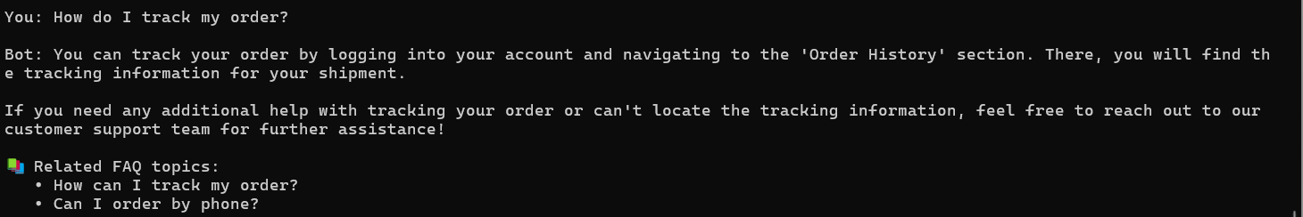

Question: What is the meaning of life?

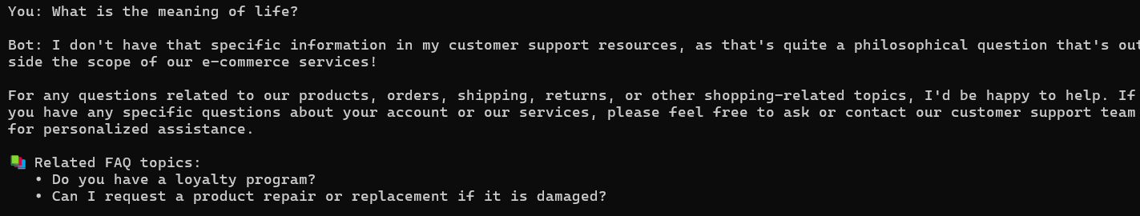

Key Achievements
- It retrieves very relevant FAQs
- It generates very human like content appropriate answers
- It responds time is around 2-3 seconds which is pretty good for user experience

8. Discussion and Insights

8.1 Technical Insights
1.RAG works well in this chatbot because it has more accurate answers since claude will only respond based on the FAQ json file. And its easy to maintain since you only need to update the data file if the FAQ content need to be changed.

8.1.2 ChromaDB vs FAISS
ChromaDB was chosen over FAISS for this implementation because:
- Simpler setup and API - no manual index management
- Built-in metadata support for storing FAQ question-answer pairs
- Persistent storage without additional configuration
- Better integration with LangChain ecosystem

8.1.3 LLM Selection: Claude Sonnet 4
Claude Sonnet 4 was selected for several reasons:
- High Quality: Excellent instruction following and natural language generation
- Speed: Faster response times compared to larger models
- Context Length: Large enough context window for multiple FAQ entries
- Cost-Effective: Balanced performance-to-cost ratio for production use

8.2 Limitation
1.user questions can be too vague to match specific FAQs
2.the embedding model might retrieves very related but not perfectly match one for specific questions
3. it might take some time to initial run requires for the first time
4. initial need to install compatible versions, sometime dependency version might have conflicts if it does not satisfy all package dependencies

8.3 Potential Improvements
- Add conversation memory to handle follow-up questions like 'What about international?' after asking about shipping.
- Can implement more functions like thumbs up /down to identify and improve poor response
- Expanse FAQ
- Can have a better UI interface if time allows

