Perform CTC Tasks after Deployment

# Perform CTC Task: SAP ME NetWeaver Engine Configuration

1.1 Log on to SAP NetWeaver Administrator using the following URL(**Chrome** browser is recommended):

<http://localhost:50000/nwa>

Choose **Configuration->Scenarios->Configuration Wizard**, find **SAP ME NetWeaver Engine Configuration**.

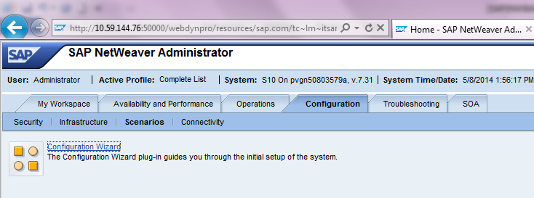

1.2 Choose “**SAP ME NetWeaver Engine Configuration**”and choose **Start**to run the CTC wizard

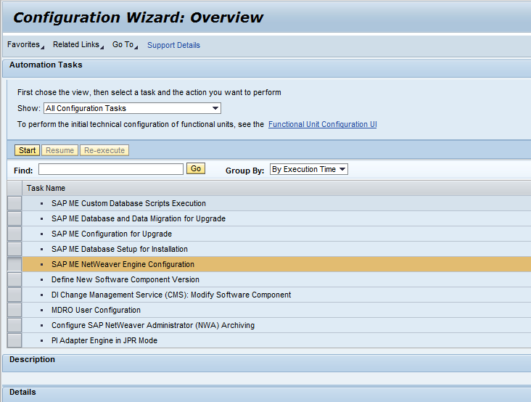

1.3 Enter correct values in the fields described in the following table, then click **Next**

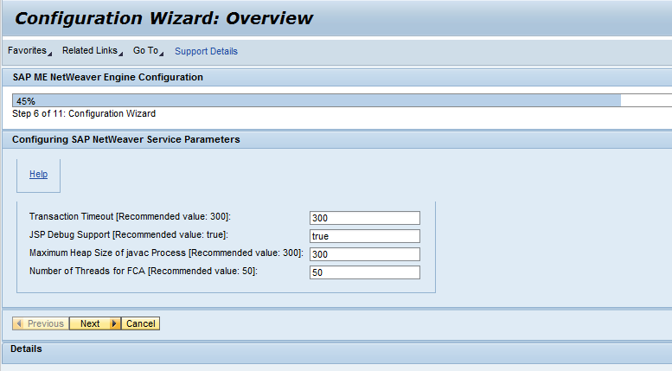

1.4 Prompt “**The Last Configuration Step**”, click **Next**

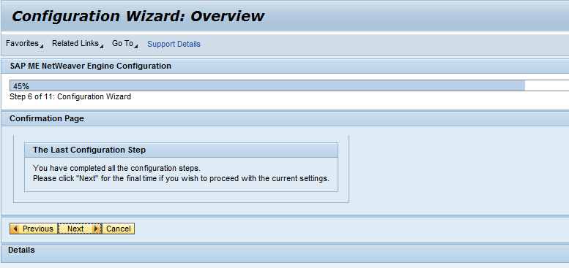

1.5 Finish

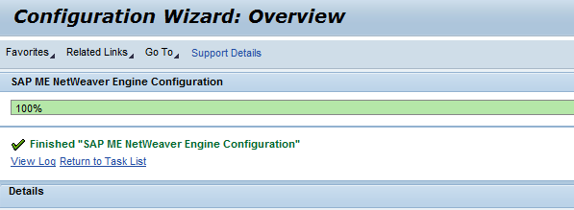

# Perform CTC Task: SAP ME Database Setup for Installation

2.1 Choose **Configuration->Scenarios->Configuration Wizard**, choose “**SAP ME Database Setup for Installation**” to **Start**the CTC wizard.

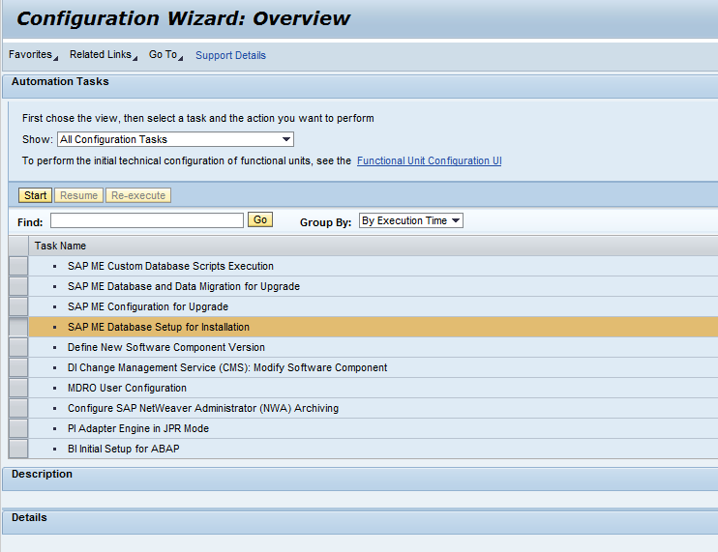

2.2 Upload JDBC driver. If you use driver C as destination, you can find your **sqljdbc4.jar**file (**C:\MFG_INST\rawfiles\sqljdbc_2.0\enu\sqljdbc4.jar**)in **Microsoft SQL Server JDBC Driver 2.0**extracted folder and upload it. Then **Upload**. Then **Next**.

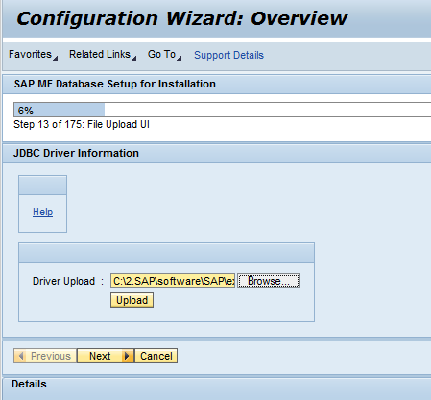

2.3 Input the WIP, ODS database information as following table, Then **Next.**

Tips:

**Host** is your computer name, it might be fetched automatically, however, you can simply input ‘localhost’

**User** and **Database** should be **{SID}_ME_{WIP/ODS/INT},**for example: MFG_ME_WIP, MFG_ME_ODS, MFG_ME_INT, they are not same as in screenshot

Passwords are master password, for example **MFG123456**, you can alsosimply leave Instance field as empty.

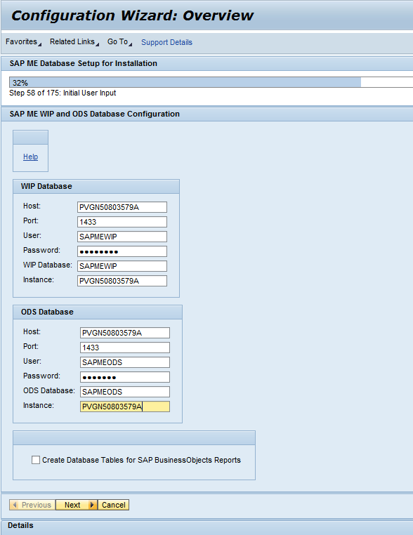

2.4 Input the INT database information as following table, Then **Next.**

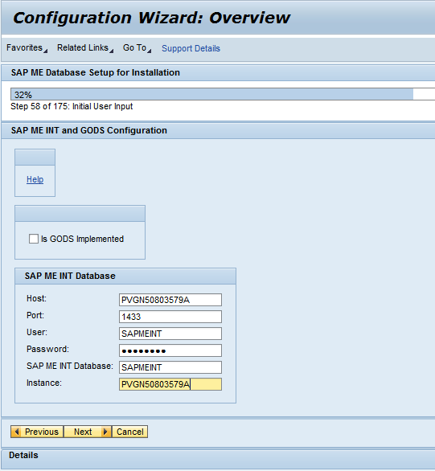

2.5 Deselect “**WIP and ODS are on Different Instances**”

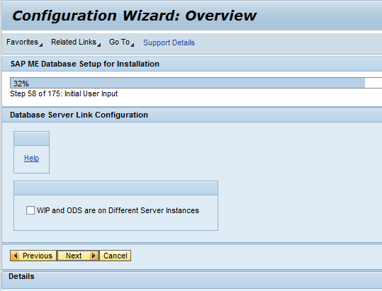

In real scenario, WIP and ODS might be in different server instances, thus a warning will popup, you can choose ‘Skip’ to continue.

2.6 Provide “SITE_ADMIN” password same as master password, for example: **MFG123456**

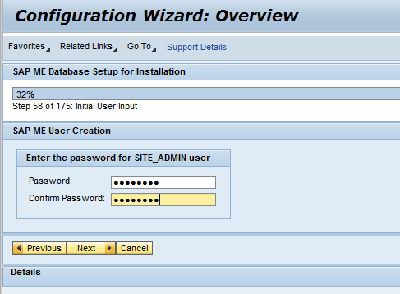

2.7 Prompt “**The Last Configuration Step**”

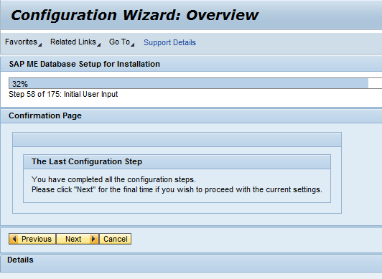

There will be a popup warning dialog, click ‘Skip Step’ to continue.

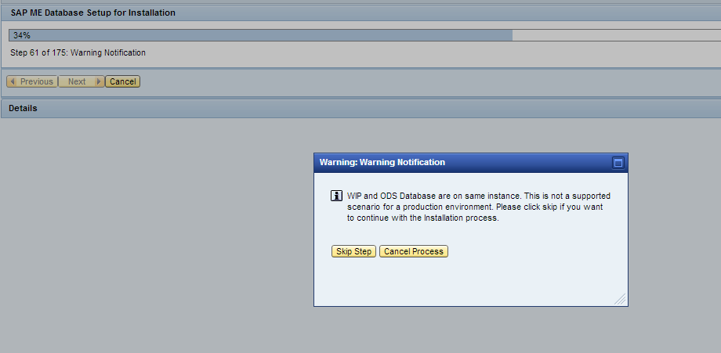

2.8 Done.

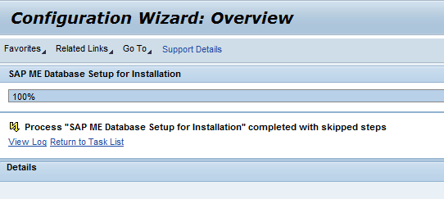

# Restart NetWeaver

Start SAP Management Console, Choose the System you want to restart, right Click and Click ‘Restart’, you might need to input your login password.

You can also run the generated script Restart_{SID}.bat in your desktop **as Administrator**without password input.

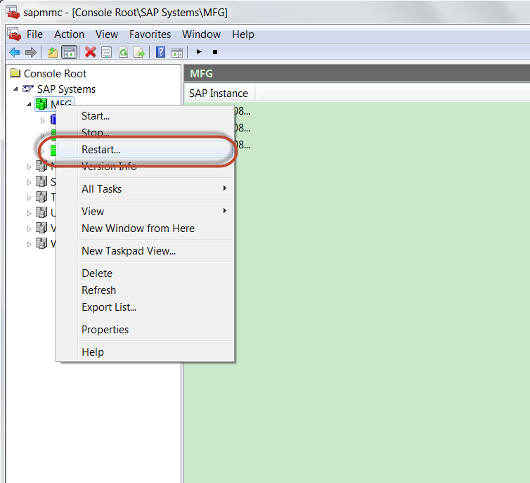

# Perform CTC Task: SAP ME Configuration for Installation

4.1 Choose **Configuration->Scenarios->Configuration Wizard**, choose “**SAP ME Configuration for Installation**” to **Start**the CTC wizard.

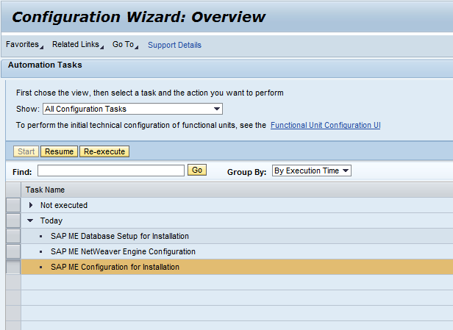

4.2 Create the global site.

Language select **English**, and Time Zone select **Asia/Shanghai**

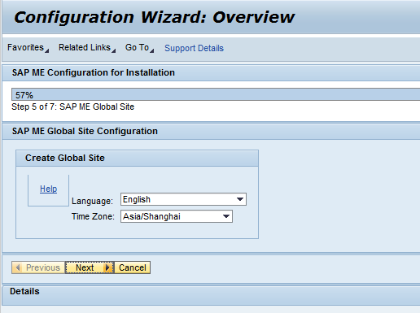

4.3 Prompt “The SAP ME Configuration is completed”, click Next.

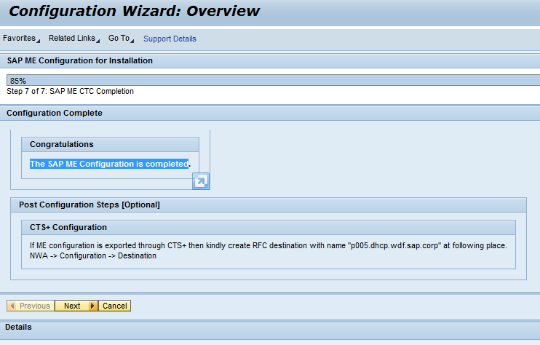

4.4 Done.

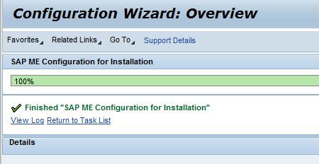

# Perform CTC Task: SAPMEINT Standard Interfaces

5.1Choose**Configuration->Scenarios->Configuration Wizard** as usual.

5.2 On the **Configuration Wizard**screen, find and select the **SAPMEINT Standard Interfaces**CTC task and choose **Start**or **Re-Execute**to begin the configuration.

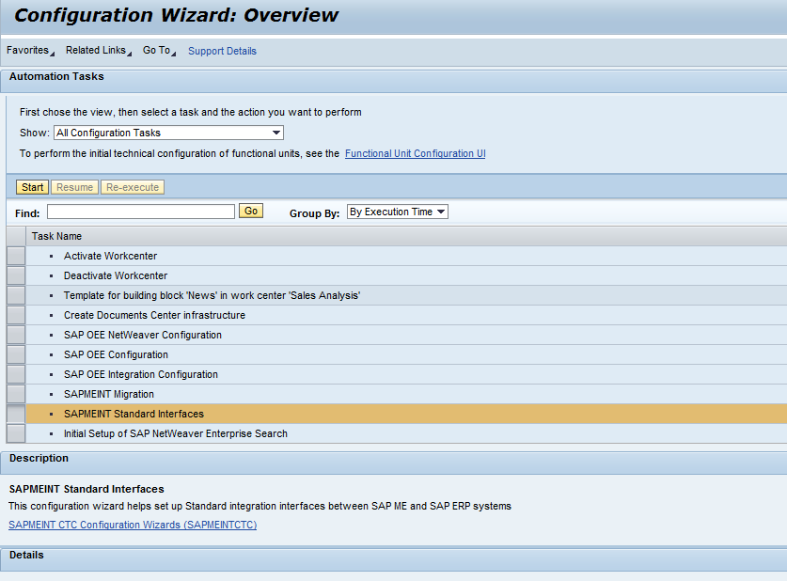

5.3Enter correct values in the fields described in the following table, You should create a site in ME system first. Then click **Next**

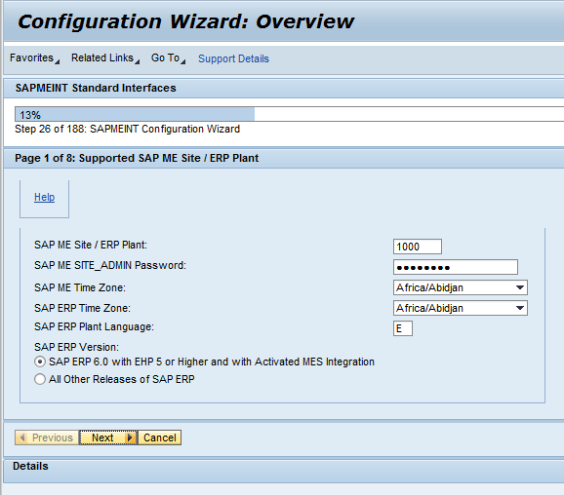

5.4 Enter **SAP Netweaver Instance for SAP MII information**, then **Next**.

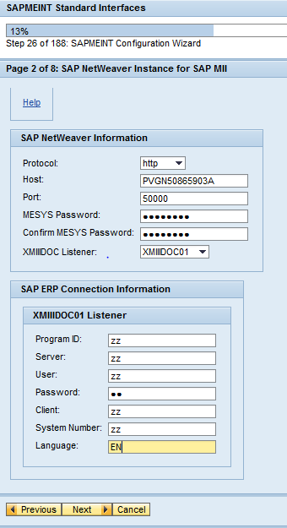

5.5 Enter **SAP NetWeaver Instance for SAP ME** information, then **Next**.

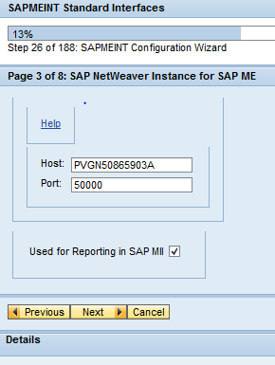

5.6 Config “**SAP ME Integration to SAP Quality Management Notification**”. Then **Next**.

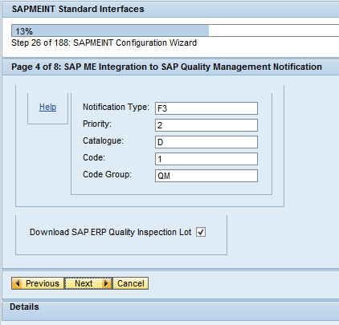

5.7 Config “**SAP MII Settings**”, then **Next**.

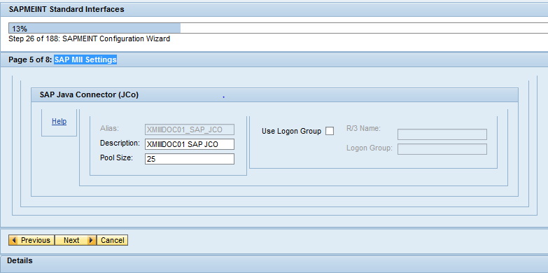

5.8 Config “**SAP MII Schedulers**”. Then **Next**.

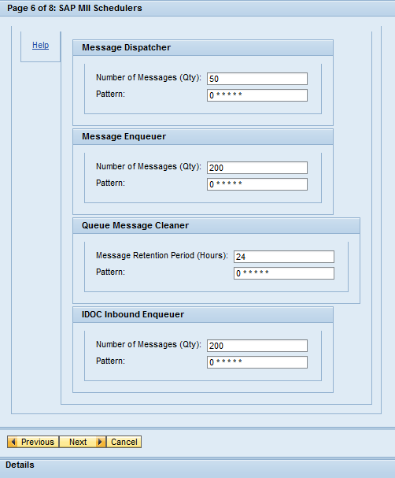

5.9 Config “**Database Configuration**”. Then **Next**.

**Make sure**you select Microsoft SQL Server as Database Vendor, because **the default choice is Oracle**!

Tips:

**Host** is your computer name, it might be fetched automatically, however, you can simply input ‘localhost’

**User** and **Database** should be **{SID}_ME_{WIP/ODS/INT},**for example: MFG_ME_WIP, MFG_ME_ODS, MFG_ME_INT, they are not same as in screenshot

Passwords are master password, for example **MFG123456**, you can also simply leave Instance field as empty.

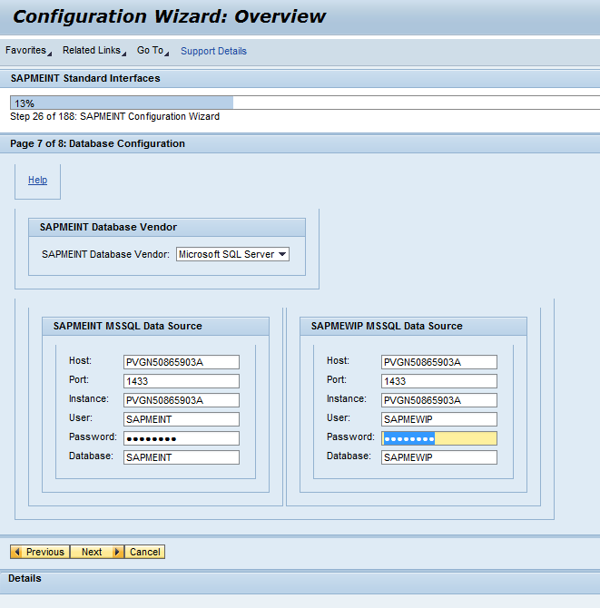

5.10 Confirmation.

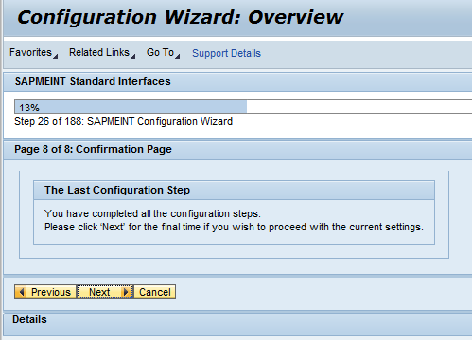

5.11 Last step confirmation. And there are also short guideline how to configure OEE reporting and how to active IDOC message listener.

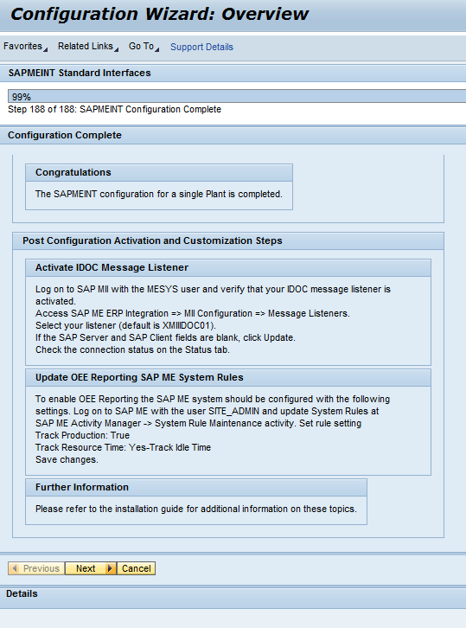

5.12 Complete.

