Implementation Details of Unattended Installation Batch Command Scripts

# Copy and extract

XCOPY {source file/folder} {target folder} (/d) /y (/e)

set PATH=%PATH%;C:\Program Files\WinRAR;C:\WINDOWS;

RAR x -o-- {self-extracted file/rar }

WINRAR x -o-- {zip/tgz} *.* {target folder}

SAPCAR -xvf {SAR file} -R {directory}

# Install JDK in silent mode

start /wait jdk-{version info}.exe /s

# Unattended Installation/Uninstallation OfNetweaver

## 3.1 Prepare templateinifile.xml, once for all

Start sapinst.exe in GUI mode, input parameter as you want to set as template, the in Summary step, we won’t click ‘Next’ but ‘Cancel’.

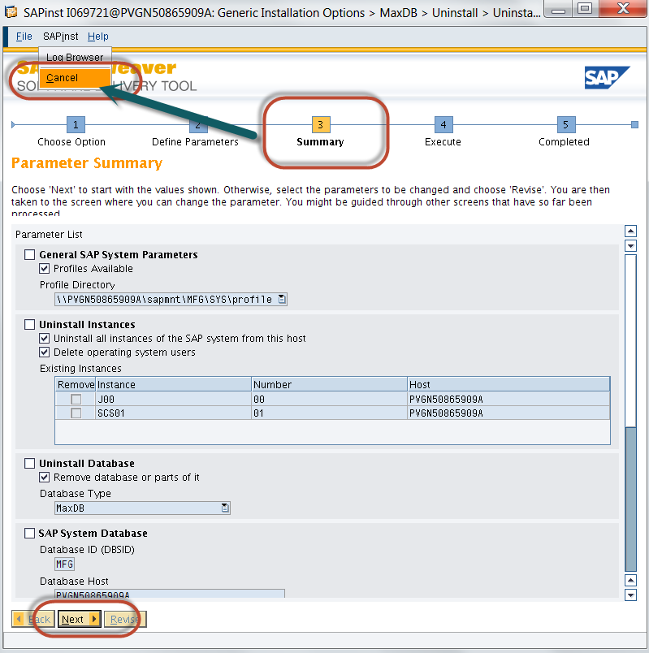

Then we will go to the folder where inifile.xml located, as you see, all the parameters we set are stored in this configuration file.

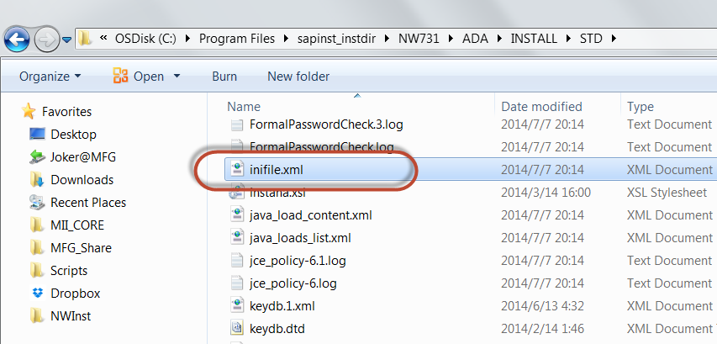

Unattended installation or system copy on Windows platforms: Open the inifile.xml and search for "startMMC". Make sure this property is set to "false", so the section in the infile.xml looks as below:

<fld name="startMMC">

<properties>

<property name="doc-long" value="true: start the SAP MMC. false: no MMC start. "/>

</properties>

<strval><![CDATA[**false**]]></strval>

</fld>

However, there are some configuration values need to be adjusted, for example: hostname, sid, instance no.

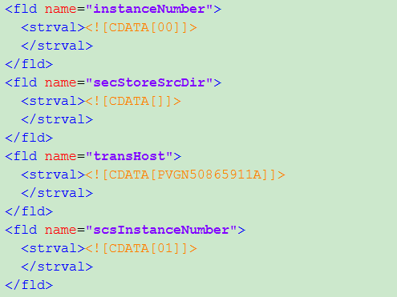

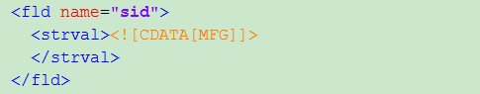

Hostname needs to be adjusted to current computer name, SID and instance no is optional, however, you may choose to customize according to your requirement, please notice that the instance no should be determined correctly, or there might be unpredictable error occur.

Thus a class was created to perform these tasks: MFGInstHelper. It will accept parameters as main scenario, sub scenario, arguments. For example, we will adjust inifile.xml in installation scenario, and we want to customize our sid not same as MFG.

java -classpath mfginst.jar com.ny83427.zorro.MFGInstHelperINST,%SID%,%NR1%,%NR2%,%PASSWORD%,%DRIVER%,%MFG_DIR%  
java -classpathmfginst.jar com.ny83427.zorro.MFGInstHelperUNINST,%SID%,%NR1%,%NR2%,%PASSWORD%,%DRIVER%,%MFG_DIR%

Meanwhile, this class will also adjust SapNetweaverDeveloperStudio.ini and add vm information to it.

java –classpath mfginst.jar com.ny83427.zorro.MFGInstHelperNWDS,%DEV_DIR%  
java -classpath mfginst.jar com.ny83427.zorro.MFGInstHelperPROFILE,%DRIVER%:\usr\sap\%SID%\SYS\profile

## 3.2 Prepare install directory and start_dir.cd

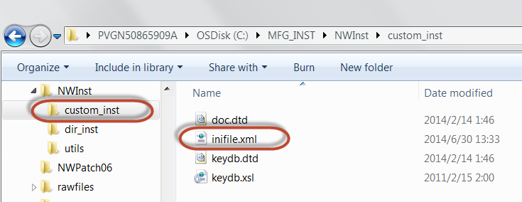

In this folder, the other 3 files are needed to parse inifile.xml, they are located in same folder in step 3.1 as screenshot 2 shows.

Then we need to prepare the start directory cd description file sapinst.exe needed

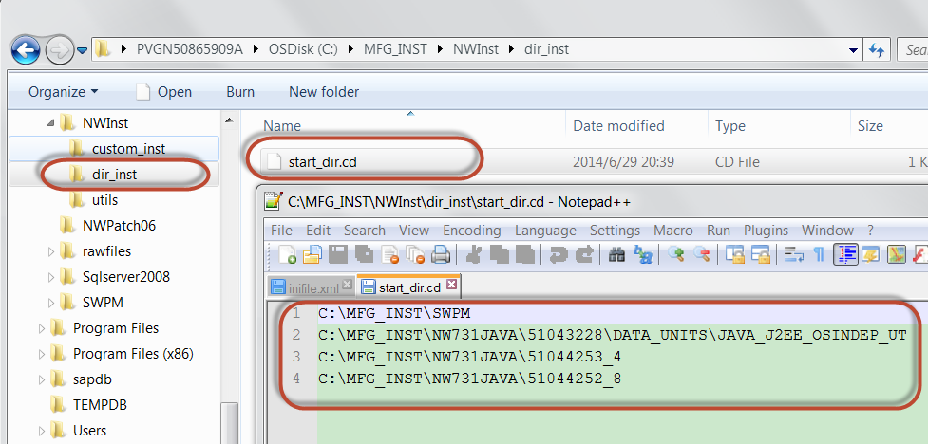

You might have found that in start_dir.cd, the contents are the directories which you input in the process of install nw, for example, sapinst.exe folder(SWPM), java components, kernel, maxdbrdbms. They must be input correctly, or you will fail.

## 3.3 Start unattended installation

start /wait /d "C:\MFG_INST\SWPM\" sapinst.exe SAPINST_PARAMETER_CONTAINER_URL=C:\MFG_INST\NWInst\custom_inst\inifile.xml SAPINST_CWD=C:\MFG_INST\NWInst\dir_inst SAPINST_EXECUTE_PRODUCT_ID=NW_Java_OneHost:NW731.ADA.PD SAPINST_SKIP_DIALOGS=true -nogui–noguiserver

The value of parameter SAPINST_EXECUTE_PRODUCT_ID can be retrieved in file keydb.xml (in the same folder of inifile.xml), then search ‘PRODUCT_ID’ you will find content like this

<property name ="PRODUCT_ID_FROM_CATALOG_FILE" value ="NW_ABAP_OneHost:NW700.ADA.CP" />

As in our case, install standard java server of maxdb is **NW_Java_OneHost:NW731.ADA.PD**, uninstall nw java server instance is **NW_Uninstall:GENERIC.IND.PD**.

Wait for 20-30mins, nw is ready. Then we will stop NW, using SAPCAR to overwrite kernel and start NW, then apply JSPM SP06 and NW BASIS SP06 and XMII and etc…

Obviously we can prepare template for NW based on sqlserver and etc.

# Apply Support Packages via JSPM

set JSPM=C:\usr\sap\%SID%\J%NR1%\j2ee\JSPM  
set AUTH=2@@Administrator@@MFG123456@@J2EE  
set INBOX=C:\\usr\\sap\\trans\\EPS\\in

xcopy %MFG_DIR%\NWPatch06\JSPM06_0-10009492.SCA %TRANS_DIR% /d /y

call %JSPM%\**jspm_cmd.bat** inbox -locationpath=%INBOX% -credentials=%AUTH% -install=true -patch=true -upgrade=false -errorOnMultiple=false  
@echo off

We will call jspm_cmd.bat to apply support packages in command line mode, we will provide locationpath, credentials and other control parameters, among them we need to set errorOnMultiple=false, because currently in our share folder, there are more than 1 SCA file of same software component.

However, the sequence will always be apply JSPM first, then apply NW BASIS, XMII, MII_ADMIN, then apply ME, MECTC, MEINT, MEINTCTC and etc. To reduce the scan and select time, we can copy jspm first, then copy other scas.

# Stop and Start NW

set KERNEL="C:\usr\sap\%SID%\SYS\exe\uc\NTAMD64"  
set PATH=%PATH%;C:\Program Files\WinRAR;C:\WINDOWS;%KERNEL%;

stopsap name=%SID% nr=%NR1% SAPDIAHOST=%computername%  
stopsap name=%SID% nr=%NR2% SAPDIAHOST=%computername%

startsap name=%SID% nr=%NR2% SAPDIAHOST=%computername% pf=C:\usr\sap\%SID%\SYS\profile\%SID%_J%NR1%_%computername%  
startsap name=%SID% nr=%NR1% SAPDIAHOST=%computername% pf=C:\usr\sap\%SID%\SYS\profile\%SID%_J%NR1%_%computername%

For example, java server instance is 00, message server instance is 01.

If we want to stop, then we will stop 00 first, then stop 01.  
If we want to start, then we will start 01 first, then start 00.

# Before install NW for the first time

There is another **BIG** limitation currently I found yesterday: when a user tries to install netweaver for the **first** time, it will require a log off to continue. However, unattended installation cannot skip this step right now; we need to find a solution.

Before that solution workaround is to run **BEFORE_INST.bat** and click anything to trigger this log off event, then when we go back, cancel sapinst.exe and run **MFG_INST.bat**. YOU JUST NEED TO RUN BEFORE_INST.BAT AND LOG OFF ONLY ONCE!

# ME Database related settings

Enable XaTransaction via powershell:  
powershell Set-ItemProperty -Path HKLM:\Software\Microsoft\MSDTC\Security -Name **XaTransactions** -Value **1**

Change authentication mode to Mixed  
sqlcmd -s localhost\ -i %SQL_DIR%\Change_To_Mixed_Mode.sql

Create databases, logins, users and configure user mappings:  
sqlcmd -s localhost\ -i %SQL_DIR%\Create_DB_Logins_%SID%.SQL

Database and logins naming convention: {SID}_ME_{WIP/INT/ODS}  
Password of logins are same as master password  
  
Restart SQLSERVER:  
net stop SQLSERVERAGENT  
net stop MSSQLSERVER  
  
net start MSSQLSERVER  
net start SQLSERVERAGENT

# Assign SAP_XMII_Administrator Role to NWA Administrator

java –classpath mfginst.jar com.ny83427.zorro.MFGInstHelperASSIGN_XMII_ADMIN_ROLE,%SID%,%NR1%,%NR2%,%PASSWORD%,%DRIVER%,%MFG_DIR%

This class will submit http request to assign role SAP_XMII_Administrator, SAP_XMII_Super_Administrator to NWA admin.