Software | Version | Usage
HCImage | 5.0.2.2 | Control sCMOS camera and image acquisition for one-photon calcium imaging
Labview | 2021 | Control behavioral devices and recordings
Pylon viewer | 7.2.1.25747 | Control machine vision cameras and video acquisition
MATLAB | 2022b | Behavioral data processing (filtering, event detection, lick-rate calculation, temporal down-sampling to synchronize for calcium imaging data)
NoRMCorre | 0.1.1 | Motion correction for calcium image stacks
Python | 3.10.14 | Data processing pipeline for packaging into NWB files
Conda | 24.3.0 | Python environment management
NumPy | 1.24.3 | Numeric array handling
SciPy | 1.14.0 | ΔF/F signal processing
Scikit-learn | 1.5.1 | ΔF/F signal processing
OpenCV (python binding) | 4.10.0 | Image processing
Pandas | 2.2.2 | Data storage
h5py | 3.11.0 | Data storage
imageio | 2.34.2 | Reading from and writing to images
Tensorflow | 2.12.1 | Training and running of deep neural networks
DeepLabCut | 2.3.10 | Keypoint estimation from behavior videos
imgaug | 0.4.0 | Data augmentation for training DeepLabCut models
ks-pupilfitting(*) | 0.1.2 | Pupil tracking based on the results of DeepLabCut inference
bdbc-atlas-registration(*) | 0.2.0 | Alignment of the reference atlas to calcium imaging data
ks-mesoscaler(*) | 0.1.0 | Alignment of the reference atlas to calcium imaging data
ks-affine-aligner(*) | 0.1.0 | Alignment of calcium imaging data across sessions of the same animal
ks-affine2d(*) | 0.1.0 | Procedures related to affine transformation
PyNWB | 2.8.1 | NWB file handling
bdbc-nwb-packager(*) | 0.5.1 | Packaging data into NWB files
Table S1 | Version and usage information of representative software and libraries. *These libraries are part of our code repository.
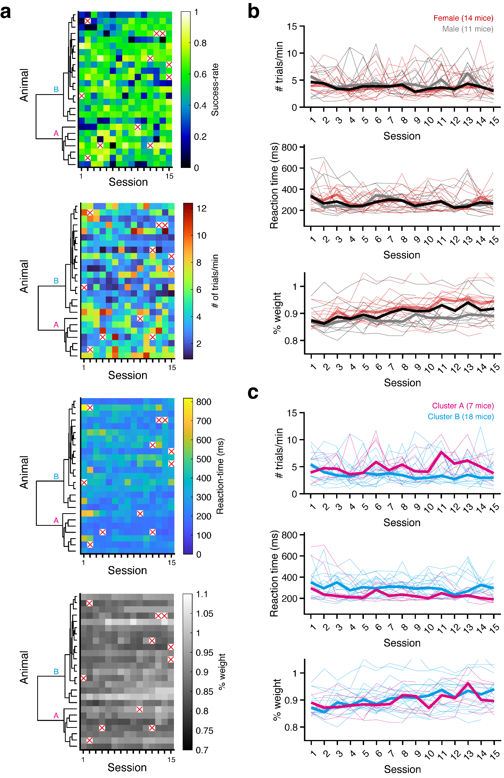
Figure S1 | Behavioral performance in task training sessions. a, Four different obtained behavioral parameters are color-coded. b, The trial number/min (top panel), reaction time in all lever-pulled trials (middle panel), and body weight normalized to the weight before starting water restriction (bottom panel) across sessions. Thin lines denote individual animals (red, female; gray, male), whereas thick lines denote the median across the population (red, female; gray, male; black, all). c, Behavioral parameters of individuals in clusters A (magenta; n = 7) and B (cyan; n = 18), identified in Fig. 3d. These plots are shown similarly as in (b).
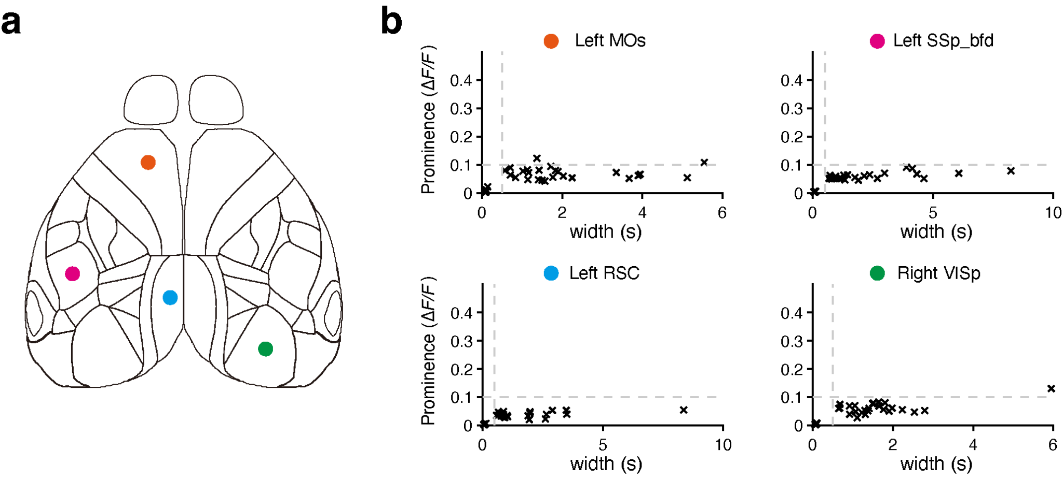Figure S2 | The validation of aberrant activity in the transgenic mouse was used in this study. a, The following positions for considering aberrant activities were selected for analyses: the left side of the frontal, barrel, retrosplenial, and right side of visual regions. b, Prominences and widths of calcium activities were detected in each first resting-state recording of each animal. These were clustered with K-means clustering (k = 2) in each animal and region, and then the centers of mass of two clusters were obtained. High prominence (> 0.1 in ∆F/F) and narrow width (< 0.5 s) of the transients were not detected in each animal.

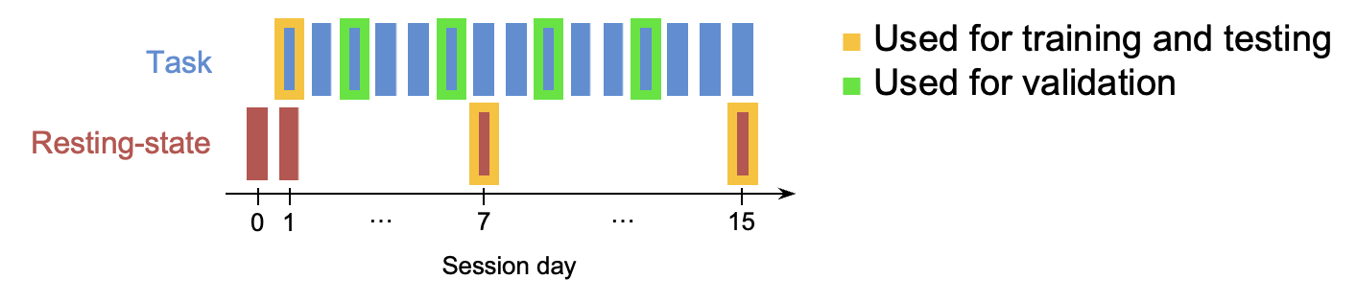
Figure S3 | Schematic of frame extraction strategy for training and validating DeepLabCut models. Task training session 1 and resting-state recording sessions 7 and 15 (including the day-8 resting-state session from one animal) were used to extract video frames for training and testing. Validation frames, for comparison with manual annotation, were extracted from task training sessions 3, 6, 9, and 12.

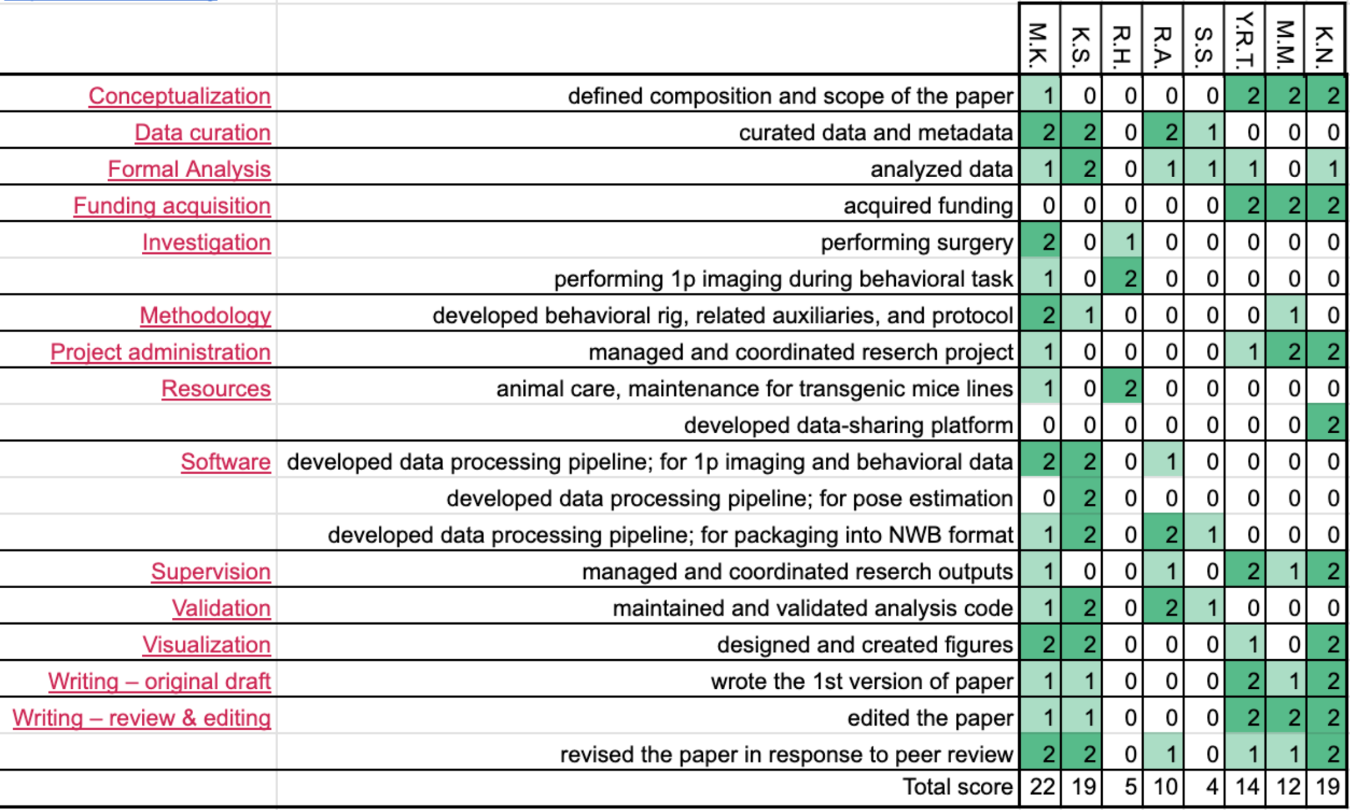
Figure S4 | Contribution diagram. The following diagram illustrates the contributions of each author, based on CRediT taxonomy (Brand et al., 2015). For each type of contribution, two levels are color-indicated: ‘support’ (light green) and ‘lead’ (dark green).

