CSE4020

Lab-1

Routu Venkat Sai Sampath

19BCE0238

Data

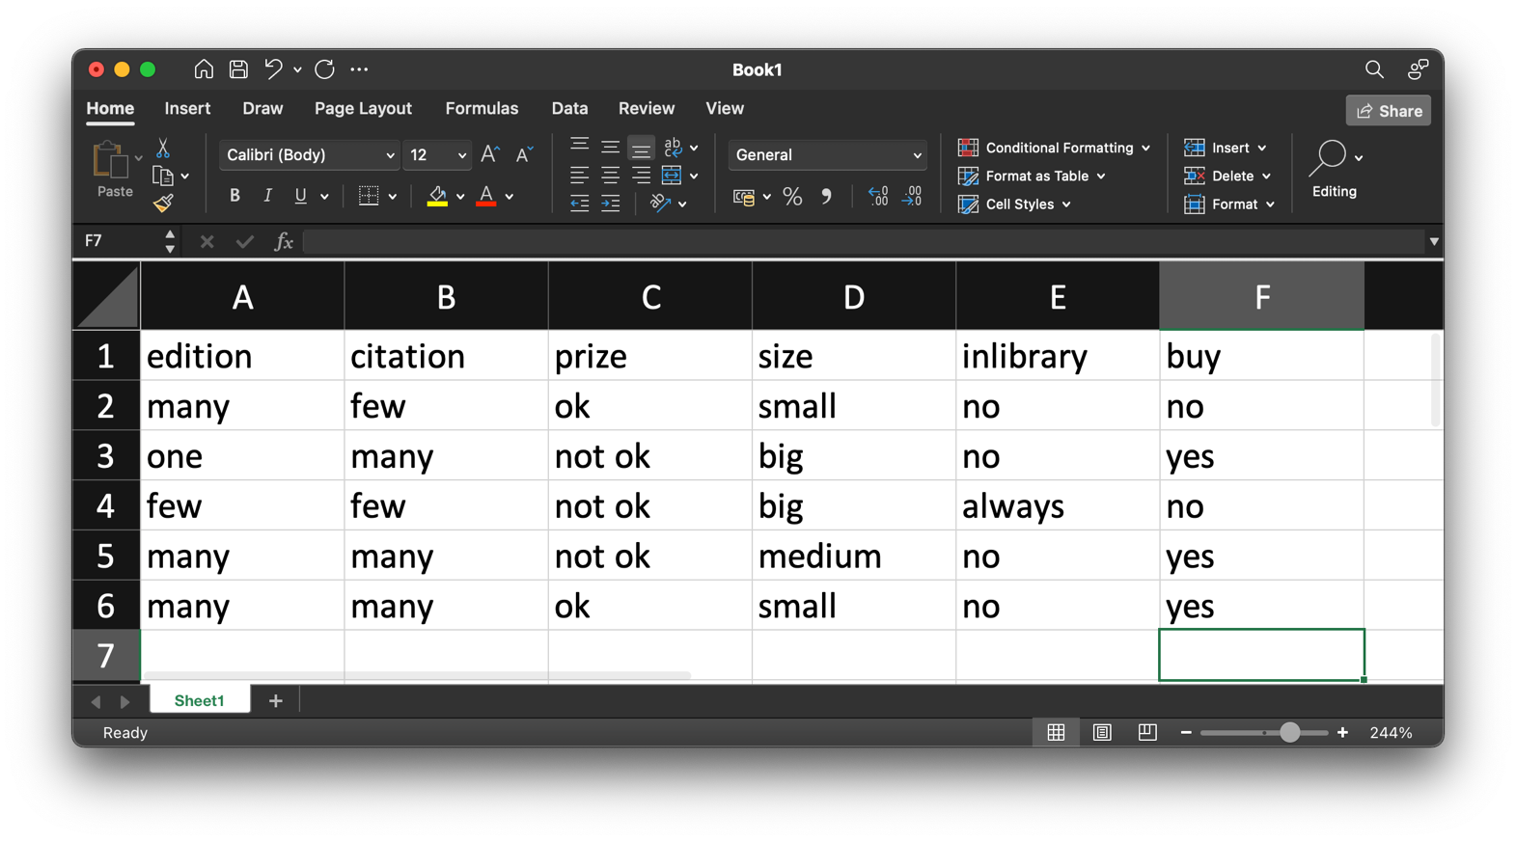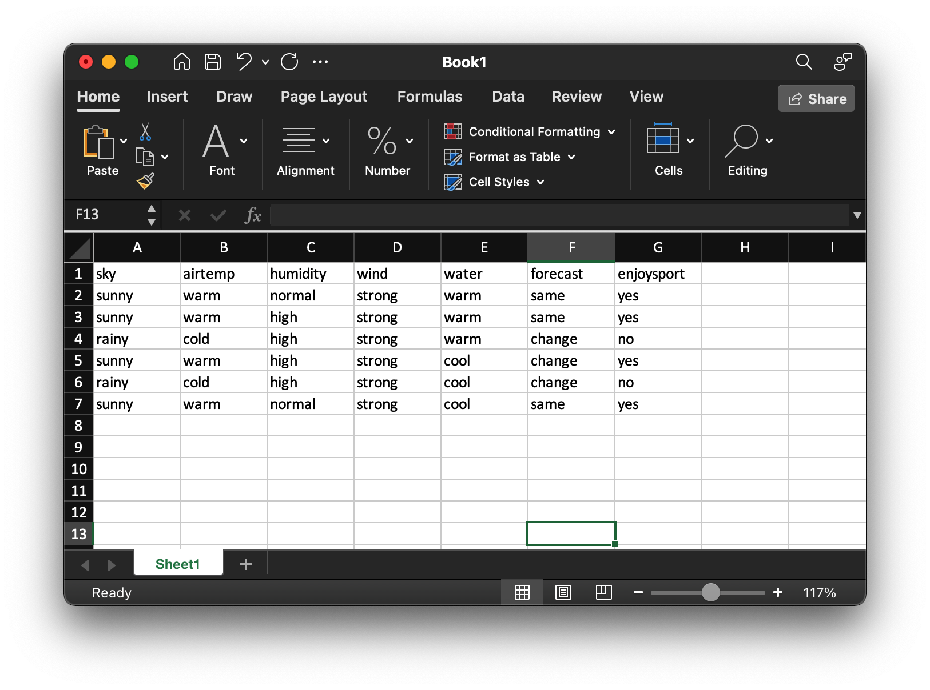The data used for the experiments will be attached below.

Experiment 1A

Aim: Implement Find S algorithm

Procedure:

1. Get the data ready
2. Form a general hypothesis as [“Φ”…]
3. Since Φ will not be matched with any row, put the first row as the general hypothesis
4. Now compare the general hypothesis to each positive row of the dataset.
5. If any column in the hypothesis does not match with the data on the row, replace it with “?”.
6. Finally, we will obtain the general hypothesis

Code, Output and Results

Experiment 1B

Aim: Implement list then eliminate algorithm

Procedure:

1. Get the data ready
2. Get the hypothesis ready
3. Now run the function of item eliminate on the hypothesis
   1. First each hypothesis will get iterated over the data to find matches with same target value
   2. After matching, the hypothesis will be compared with values from the dataset.
   3. The hypothesis will be segregated into consistent and inconsistent sets.
4. The function will return the inconsistent hypothesis set first and then the consistent set.

Code, Output and Results

Experiment 1C

Aim: Implement list then eliminate algorithm

Procedure:

1. Get the data ready
2. Get the hypothesis ready
3. Iterate over the values of the dataset
   1. If the target variable is positive then iterate over the specific hypothesis such that if any inconsistency is found between the values and specific hyp then change the hypothesis value to “?” on both general and specific.
   2. If the target is negative then iterate over the specific hypothesis such that if any inconsistency is found between the values and specific hyp then change the general hypothesis value to specific hypothesis. Else change the general hypothesis value to “?”.
4. Print the general hypothesis bounds and the specific hypothesis.

Code, Output and Results

All the code is original and can be verified from the following repository

<https://github.com/nyac-1/cse4020-ML>