CSE4020

LAB-2

Sampath Routu

19BCE0238

Data

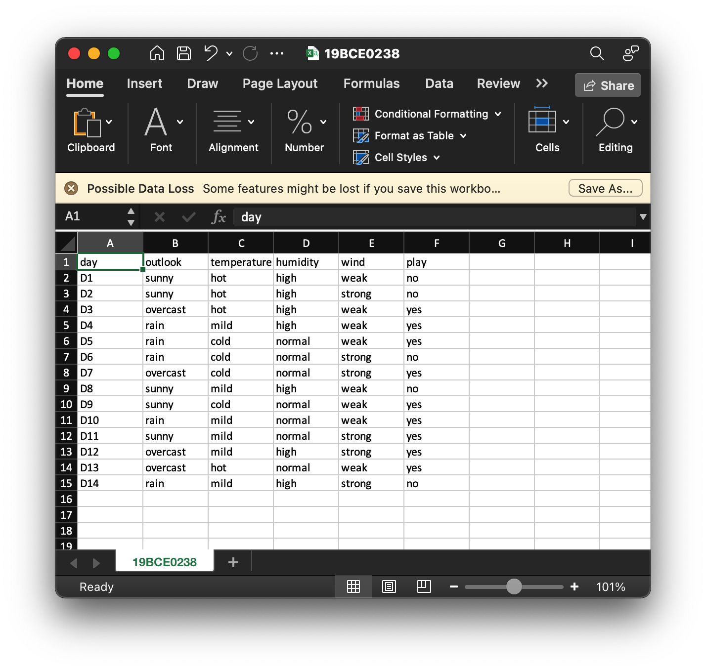

Aim: To implement the ID3 algorithm

Procedure:

1. Calculate the Information Gain of each feature.
2. Considering that all rows don’t belong to the same class, split the dataset **S**into subsets using the feature for which the Information Gain is maximum.
3. Make a decision tree node using the feature with the maximum Information gain.
4. If all rows belong to the same class, make the current node as a leaf node with the class as its label.
5. Repeat for the remaining features until we run out of all features, or the decision tree has all leaf nodes.