CAPSTONE PROJECT: CRISP DM REPORT
TeleConnect Customer Service Analysis
Role: Junior Data Analyst

Report by Monica Achieng Nyagaya
5/12/2025

Contents
1. BUSINESS UNDERSTANDING 2
1.1 Business Objectives 2
1.2 Key Variables: 2
1.3 Success criteria 2
1.4 Project Plan 3
1.4.1 Business Understanding 3
1.4.2 Data Understanding 3
1.4.3 Data Preparation 3
1.4.4 Exploratory Data Analysis (EDA) 3
1.4.5 Pattern Discovery 3
1.4.6 Statistical Summary 4
1.4.7 Visualizations 4
1.4.8 Business Insights & Recommendations 4
1.4.9 Documentation & Project Deliverables 4
2. DATA UNDERSTANDING 5
2.1 The dataset structure 5
2.2 The Data Types 5
2.3 Statistical Summary for Numerical Colum 5
2.3.1 Central tendency 5
2.3.2 Distribution 5
2.4 Data Quality Issues 7
3. DATA PREPARATION 7
3.1 Checking Data Quality 7
3.1.1 Handling missing values 7
3.1.2 Correcting data types 8
3.1.3 Feature Engineering 8
3.2 Exploratory Data Analysis 9
3.2.1 Customer demographics 9
3.2.2 Services subscription details 9
3.2.3 Payment Methods 10
3.2.4 Customer churn status 10
3.3 Pattern Discovery 10
3.4 Sample Visualizations 13
3.5 Business Insights & Recommendations 15
3.5.1 Business Insights 15
3.5.2 Recommendations 16
3.5.3 Priority Levels versus expected impact 17

ACRONYMS AND ABRREVIATIONS
CLV: Customer Lifetime Value
CRISP DM: Cross-Industry Standard Process for Data Mining
EDA: Exploratory Data Analysis
KPIs: Key Performance Improvements
Std: Standard Deviation

1. BUSINESS UNDERSTANDING
TeleConnect is a telecommunications company experiencing customer churn. This report follows a Cross-Industry Standard Process for Data Mining (CRISP DM )for planning, executing, and communicating customer data and uncovering hidden patterns.
The business goal is to understand what keeps customers satisfied or causes them to leave by exploring the service subscriptions, payment behavior, and contract types.
This report includes data visualizations as well as recommendations that the business can act on to solve the problem of customer churn.
  - Business Objectives
- Customer demographics: Which customer segments have the highest churn risk?
- Services: Which services drive loyalty?
- Account information: What tenure, contract, and billing method correlate with churn?
- Which interventions should the company apply to reduce churn cost-effectively?
- How can the company monitor and measure Key Performance Improvements (KPIs)?

Key Variables:
- Demographics: gender, senior_citizen, partner, dependents
- Account Info: tenure_months, contract_type, payment_method
- Services: phone_service, internet_service, online_security, streaming_tv, etc.
- Financial: monthly_charges, total_charges
- Target Variable: customer_status (Active/Churned)

Success criteria
- Identify the top services that drive customer loyalty
- Study the monthly churn rate
- Provide insights on behavioural patterns of customers that churn.
- Provide at least two retention actions with measurable KPIs

  - Project Plan
To efficiently achieve the objectives of analyzing customer churn at TeleConnect, I will follow the procedures below.
    - Business Understanding
First step is to understand the business problem, define success criteria, and outline analytical goals.
This step involves meeting with the Customer Experience team to confirm and clarify churn issues, churn rate, customer lifetime value (CLV), and retention segments.
Documentation of key questions at this stage is necessary to help understand factors such as customer segments that are most likely to churn, service factors that drive churn, and possible actions that can be implemented to reduce churn.
    - Data Understanding
Data understanding is the step that establishes familiarity with the structure and quality of the dataset. In this project, this phase involves loading and inspecting the dataset by checking its rows, columns, and datatypes.
- Performing initial visualizations such as distribution plots, churn proportions, and categorical variable frequency plots.

    - Data Preparation
Data preparation involves cleaning the dataset by handling missing values and outliers in the most logical way possible, correcting data types where necessary.
Feature engineering will be done at this phase whereby new columns that reveal deeper insights to the analysis are added.
    - Exploratory Data Analysis (EDA)
The goal of EDA in this analysis is to identify relationships and patterns that influence customer churn.
EDA is achieved through diving deep into the data to analyze customer demographics, service adoption patterns, and financial metrics. It also includes comparing the Active vs. Churned customers to uncover what differentiates them.
    - Pattern Discovery
This is the level at which patterns associated with customer retention are discovered.
Achieving pattern discovery for this project involves analyzing contract types, service bundles, and payment patterns. These descriptive statistics will help to quantify findings.
    - Statistical Summary
Generating descriptive statistics is part of data understanding that includes checking the statistical tables and calculating the means, medians, value counts, distribution checks; and potential anomalies or outliers
    - Visualizations
This project includes visualizations that tell the data story. Visualizations will help generate insights that can be useful for modeling predictions, and making business recommendations.
    - Business Insights & Recommendations
This final step translates analysis into actionable steps. Deliverables for this phase will include report on specific findings and actionable recommendations on retention strategies with rationale, expected impact, and priority levels.
This report recommends:
- Discounts for long-tenure customers
- Attractive benefits on yearly contracts
- Target marketing on high-risk groups like electronic payment users or fiber customers
- Communication plan for the customer experience team.

    - Documentation & Project Deliverables
Google Colab Notebook:
https://colab.research.google.com/drive/1Pm6A8bsqM-ap5sAohyZuLvUy2VihKoFv?usp=sharing

CRISP-DM Report:

Clean Dataset:
https://drive.google.com/file/d/14OaA_oFCqR5rL4RxRB-YyKnVilKT9npA/view?usp=sharing

- DATA UNDERSTANDING

The dataset structure
The Teleconnect Capstone dataset has 21 columns and 7042 rows. Each row represents an individual customer.

The Data Types
There are two columns whose datatypes are floats: monthly_charges and total_charges
One column has integers: tenure_months
All the other 18 columns have string datatype.
  - Statistical Summary for Numerical Colum
The numerical columns are: tenure_months, monthly_charges, and total_charges.
Column monthly_charges: has 6974 to indicate the specific current monthly bill for each customer.
Column total_charges: has 7030 values to indicate the total amount paid by each customer over their tenure
    - Central tendency
The mean tenure is 26.385773. This indicates that the average customer stays slightly above 26months.
The average revenue per customer mean monthly charges is 4692.726706
The mean total charges: 124037.389150 This predicts the customer lifetime value

    - Distribution
The minimum *min*: stay period of a customer is 1 month. The lowest monthly charge on a service was 1805.91 and the lowest total amount is 1942.93
The maximum *max*: stay period of a customer is 72 months. The highest monthly charge on a service was 8143.67 and the highest total amount is 586344.24
- Standard deviation
The standard deviation (std): for tenure_months measures how the spread of the tenure values are from the averag(e customer tenure.
Mean = 26 months
Std = 20 months
Customers stayed within 6 months to 46 months (mean ± std)

The std for monthly_charges measures the pricing variability
Mean tenure = 4693
Std = 1263
Most customers fall in 3430 to 5956 monthly pricing range (mean ± std)
This indicates existence or need for pricing packages for each category of tenure for example monthy charges, quaterly, bi-annual, and annual subscriptions.
- Quartiles
Quartiles for tenure_months
Q1 (25th percentile)
25% of customers have been with TeleConnect less than 9 months.
This is the newest customer category.
Q2 (50th percentile / Median)
Half of the customers have tenure below 22months.
The median range is more stable than the mean (average) because it is not affected by outliers.

Q3 (75th percentile)
75% of customers have tenure below 39months.
The remaining 25% of customers can be considered long-term loyal customers.

Quartiles for monthly_charges
Q1 (25th percentile)
25% of customers pay less than 3738 per month.
This quartile represents the lowest paying customers who can be placed in a basic plan with minimal service benefits.

Q2 (Median / 50th percentile)
Half of customers pay below 4901 per month.
This quartile represents the third tier customers who can be placed in a more advanced plan with inreased service benefits.

Q3 (75th percentile)
75% of customers pay below 5623 per month. and can be considered the second tier with even more benefits as compared to Q2 and Q1
The top 25% of customers pay more than 5623 and can be considered the premium customers.
  - Data Quality Issues
The data has correct data types, there are no duplicate values, no negative values, and no risky values observed in the data.
There are no outliers detected on tenure_months, monthly_charges, and total_charges using 3×IQR. Values appear normal.
The only issue identified with the dataset is a total of 11 null values in the column total_charges. The null values account to a percentage of 0.16% of the values in this column. This perecentage of missing values may not significantly interfere with the findings of the analysis.

- DATA PREPARATION
  - Checking Data Quality
    - Handling missing values
The values of the column with missing values (total_charges) result from multiplying the columns tenure_months by monthly_charges.
In this case, null values may result if the row has zero value on the two columns. Looking at the filtered result above showing all the rows with missing values, none of the rows have zero on the monthly_charges or tenure_months columns. This confirms that there is no clear pattern on the missing value.
The missing values have therefore been fixed using the most logical way. That is;
total_charges = monthly_charges × tenure_months
Comparing side to side the statistical summary before and after fixing the missing values in total_charges, there has been very little or no change. This is because the 11 missing values account to less than 1% of the dataset. The missing values are therefore not a big deal. On the other hand, the new calculated values that replaced null values have fit accurately and appropriately within the natural distribution. They do not distort the distribution and match typical customer lifetime charges.
    - Correcting data types
In this dataset, the numerical columns should have the same datatypes for standardization and to enhance accurate analysis and visualizations. The column tenure_months will therefore change from integer to float to match other numerical columns.
    - Feature Engineering
Feature engineering for the teleconnect dataset means creating new features that could provide deeper insights, improve modeling, or reveal customer behavior patterns.
The engineered features in this dataset include tenure_years where the tenure_months have been converted to years.
The tenure_bin categorizes the customers according to the period they have been teleconnect to capture loyalty. The feature is grouped into four types as below;
New: 0-6 months
Short-term: 7-24 months
Medium-term: 25-48 months
Long-term: 49+ months
The spender_type classifies the customers according to their spending levels. This feature uses the quantiles to separate the top, middle and bottom spenders in reference to the monthly_charges.
The total number of services as num_services is highly predictive of retention and should be included the model to detect the top most consumed services.
  - Exploratory Data Analysis

Customer demographics
These columns are useful for understanding customer profiles and churn patterns.
Column customer_id: There are 7043 unique values assigned to the column for the unique identification number assigned to each customer. As such, this column can be treated as a primary key when creating and linking a database.
The dataset records more men than women; 3587 Male and 3456 Female but the difference is not quite alarming to trigger business action.
Column senior_citizen: has two values; 5920 customers that are not senior citizen, and 1123 customers that are senior citizens.
Column partner: has two values; 3754 customers do not have partners while 3289 have partners.
Column dependents: has two values; 4962 customers do not have dependents while 2081 have dependents
    - Services subscription details
These columns check the services that each customer subscribes. The columns can help determine which services are most popular and which influence churn.
Column phone_service: 6349 customers have phone service while 694 customers do not have it.
Column multiple_lines: 3697 customers do not have multiple lines, 2652 have multiple lines, while 694 of the customers do not have phone service.
Column internet_service: customers subscribed to Fiber optic are 3113, DSL are 2346, while 1584 customers have no internet service.
Column online_security: 3893 customers do not have online security, 1566 have it, and 1584 customers are not subscribed to internet services.
Column online_backup: 3582 do not have online back up, 1877 have it and 1584 customers are not subscribed to internet services.
Column device_protection: 3616 customers do not have device protection, 1843 have it and 1584 customers are not subscribed to internet services.
Column tech_support: 3889 customers do not receive tech support, 1570 receive it, and 1584 customers are not subscribed to internet services.
Column streaming_tv: 3063 customers are not subscribed to tv streaming, 2396 are subscribed to it, and 1584 customers are not subscribed to internet services.
Column streaming_movies: 3076 customers do not have this option, 2383 have it, and 1584 customers are not subscribed to internet services.

Payment Methods
These columns can help predict churn
Column contract_type:3868 customers are on the month-to-month contract, 1505 are on the one year contract while 1670 customers are on a two year contract.
Column paperless_billing: 4178 customers prefer paperless billing while 2865 do not prefer paperless billing.
Column payment_method: 1585 payments are made in the form of mailed check, 1554 are bank transfers, 1478 are credit card payments, while 2426 are electronic checks.

Customer churn status
This column customer_status; is the target variable in predicting customer churn
The dataset shows 4952 active customers, and 2091 churned customers.
Churned customers contribute to approximately 30percent of total customers. This rate is quite high and should be a concer to the entire business.

  - Pattern Discovery
To identify retention drivers, I compared the existing and the churned customers across these variables; contract type, the services bundles, payment methods, monthly charges, tenure, and the total services subscribed.
The analysis below uses descriptive statistics, counts, and proportions to identify patterns strongly associated with customer retention.
Contract Type as a Key Driver
Customers with longer-term contracts tend to remain with the company significantly more. Long-term contracts are the strongest predictor of retention.

Service Bundle Patterns
By analyzing combinations like
phone_service with 1051 subscribers,
phone_service, multiple_lines with 756
phone_service, streaming_tv with 149
phone_service, online_backup with 123
phone_service, streaming_tv, streaming_movies with 110
This records indicate that customers with phone services only contribute to the highest percentage of consumers.
However, customers with more services show significantly lower churn for example: Internet + phone, Phone + multiple lines, Bundles including streaming and device protection.
Therefore, Service bundling seems like a major driver for reducing churn.
Customers using multiple services—especially entertainment and protection add-ons—

Payment Method Insights
- Electronic check has the highest churn rate, at approximately 34.46%.
- Bank transfer (automatic) has a churn rate of about 27.86%.
- Credit card (automatic) shows a churn rate of around 26.86%.
- Mailed check has the lowest churn rate among all payment methods, at approximately 26.81%.
This indicates that customers using mailed checks are significantly more likely to churn compared to those using other payment methods, especially electronic and automatic transfers. This suggests that the convenience or reliability of payment methods might play a role in customer retention.

Monthly Charges, Tenure & Total Charges
Tenure_months strongly correlated with total_charges to show that longer-tenure customers naturally accumulate more charges.
Very weak correlation between tenure and monthly_charges to show that monthly rates are standard, not duration-based.
Therefore, customers with higher tenure churn less (loyalty effect).
- Month-to-month Contracts: We observe a clear distinction. Churned customers on month-to-month contracts typically have very short tenures, with the majority churning within the first few months. Active customers on month-to-month contracts also tend to have shorter tenures compared to those on longer contracts, but their tenure distribution is generally higher than their churned counterparts.
- One-year Contracts: Both active and churned customers on one-year contracts show significantly longer tenures than those on month-to-month plans. The spread of tenure is wider, indicating customers stay for a more varied period.
- Two-year Contracts: This contract type is associated with the longest customer tenures. Active customers on two-year contracts typically have very high tenures, often approaching the maximum. Even churned customers in this category tend to have considerable tenures, suggesting that churn often occurs after a long period of service, possibly at or near the contract's expiration.
Longer contract durations (one-year and especially two-year) are strongly correlated with increased customer tenure and, by extension, better retention. Month-to-month customers represent a higher churn risk, particularly in their early months.
Tenure is one of the biggest predictors of retention but month to month charges alone are not a strong retention predictor unless combined with service bundle information.

Number of Services Subscribed
The total number of services is highly predictive of retention and as such, was included in the feature engineering.

  - Sample Visualizations
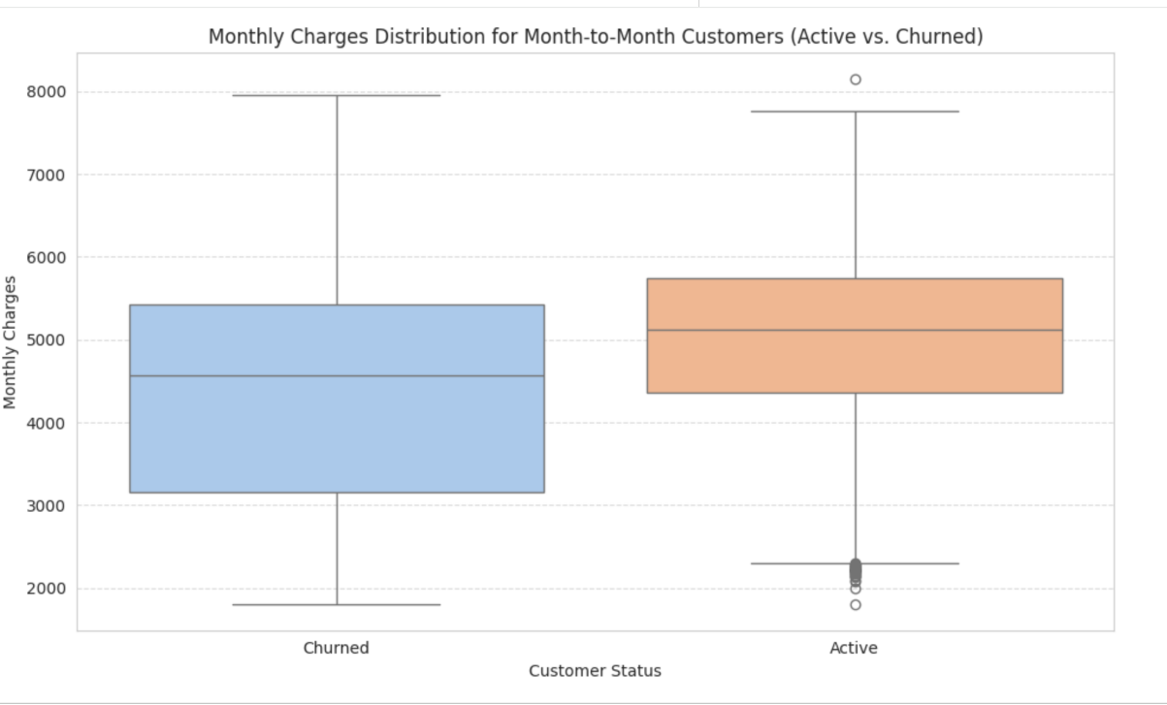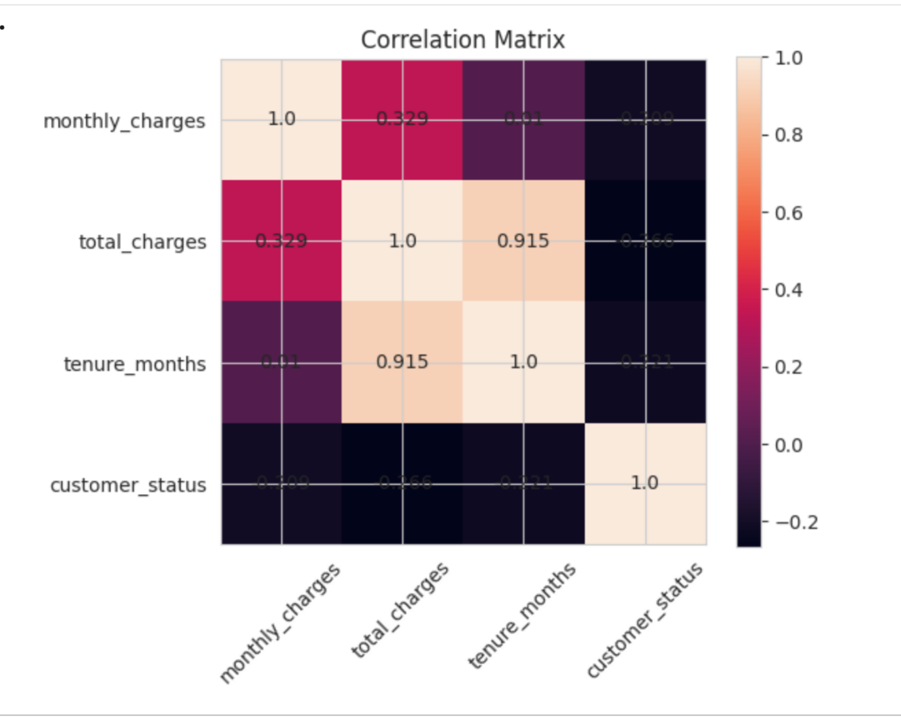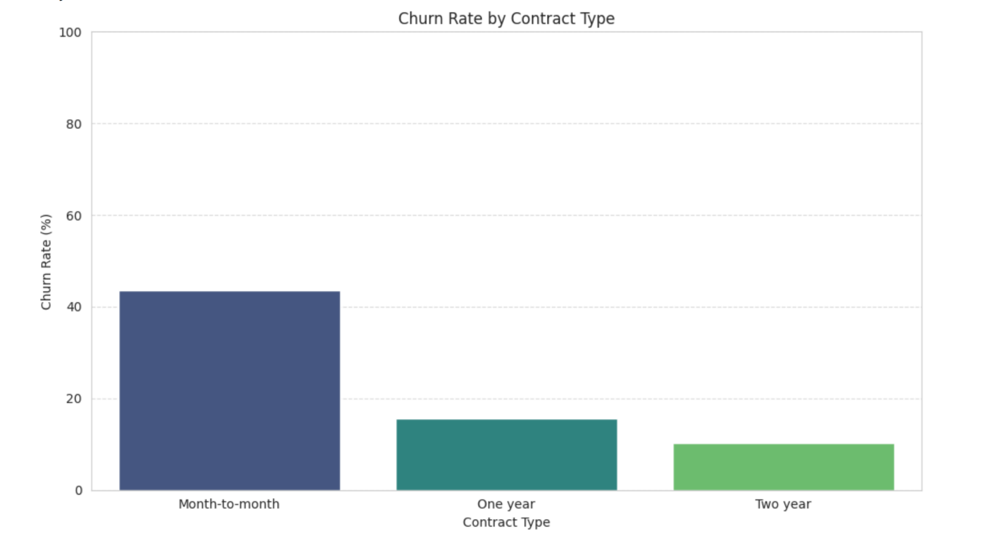

  - Business Insights & Recommendations
Based on the exploratory analysis, statistical summaries, correlation findings, service adoption patterns, tenure distribution, and payment behavior from the TeleConnect customer dataset, the following business insights and actionable recommendations will guide strategic decision-making and improve customer retention.
    - Business Insights
- Customer Tenure Is the Most Powerful Indicator of Retention
Customers with higher tenure are significantly less likely to churn.
Tenure_months shows a very strong positive correlation (0.91) with total revenue generated.
New customers (0–12 months) form the highest churn-risk group.
- High Monthly Charges Increase the Likelihood of Churn
Monthly charges distribution shows many customers pay on the higher end.
Customers with high monthly bills and short tenure are particularly vulnerable.
Those using multiple premium services without commitment contracts churn the most.
- Month-to-Month Contract Customers Have the Highest Churn Rates
Annual and two-year contracts demonstrate substantially higher retention.
Customers on flexible contracts are more sensitive to price changes and service quality.
- Service Bundle Usage Predicts Churn Behavior
Customers with only phone_service show higher churn.
Those with bundles like multiple_lines + streaming services tend to remain longer.
Add-on services increase loyalty only when bundled, not sold individually.
- Electronic Payments Strongly Reduce Churn
Customers using auto-pay, credit card, or paperless billing are more consistent and loyal.
Cash/physical payments correlate with higher churn.
- Customer Demographics Reveal Vulnerable Segments
Senior citizens and single-person households churn at higher rates.
This segment often has lower service adoption and higher price sensitivity.

    - Recommendations
Improve Retention Among First-Year Customers
Introduce a “First-Year Loyalty Accelerator” for new customers, free one month usage if the customer takes annual package, and exclusive customer support for new joiners.
Address Churn Driven by High Monthly Charges
Implement personalized pricing by lowering cost of custom bundles, allowing for usage-based pricing for low-data customers.
Long-Term Contract Adoption
Offer incentives, discounts, and loyalty points for switching to annual subscriptions.
Introduce contract renewal reminders and benefits for early and automatic renewals.
Service Bundling Strategies
Create attractive combined bundles such as: multiple-lines subscribers, Phone + internet and many more to encourage consumption of more than one product.
Accomodate phone-only subscription for users who do not need the internet by offering low-cost data add-ons.
Encourage Electronic and Auto-Pay Billing like mobile payment and internet banking
Model special packages for seniors and households
Discounts when multiple users share a plan to encourage users with dependents and partners to subscribe
Implement Predictive Churn Modeling to help flag customers about to churn and offer targeted marketing towards them.

    - Priority Levels versus expected impact
Targeting early-tenure customers - Reduced churn in first 12 months
Promoting long-term contracts - Increased customer lifetime value (CLV)
Improving service bundles - Higher ARPU and stronger loyalty
Encouraging auto-pay -Reduced involuntary churn
Fixing data issues - Improved trust and billing satisfaction
Senior & single-household targeting - Lower churn for vulnerable groups
Predictive modeling - Data-driven retention automation

