1. Write a program to perform various operations in the Array: - Insertion - Deletion - Display
#include <stdio.h>
int main() {
int arr[10], n, choice, pos, value, i;

printf("Enter number of elements: ");
scanf("%d", &n);

printf("Enter elements of the array:\n");
for(i = 0; i < n; i++) {
scanf("%d", &arr[i]);
}

while(1) {
printf("\nMenu");
printf("\n1. Insertion");
printf("\n2. Deletion");
printf("\n3. Display");
printf("\n4. Exit");
printf("\nEnter your choice: ");
scanf("%d", &choice);

switch(choice) {
case 1:
printf("Enter position to insert: ");
scanf("%d", &pos);
printf("Enter value to insert: ");
scanf("%d", &value);

for(i = n; i >= pos; i--) {
arr[i] = arr[i - 1];
}
arr[pos - 1] = value;
n++;
printf("Element inserted successfully.\n");
break;

case 2:
printf("Enter position to delete: ");
scanf("%d", &pos);

for(i = pos - 1; i < n - 1; i++) {
arr[i] = arr[i + 1];
}
n--;
printf("Element deleted successfully.\n");
break;

case 3:
printf("Array elements are:\n");
for(i = 0; i < n; i++) {
printf("%d ", arr[i]);
}
printf("\n");
break;

case 4:
return 0;

default:
printf("Invalid choice.\n");
}
}
}
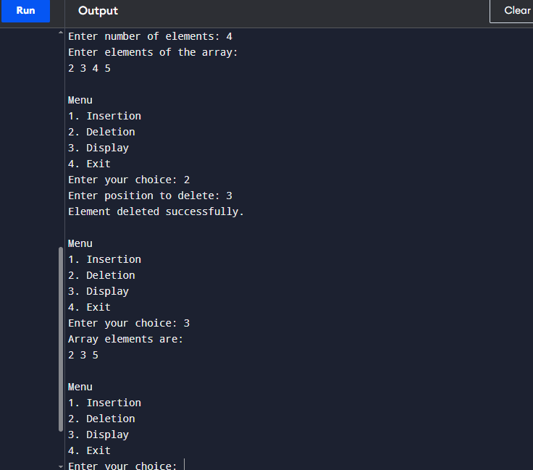

2. Write a program to find the arithmetic operations on matrices: - Sum and Subtraction - Product of 2 matrices - Transpose of a matrix
#include <stdio.h>
int main() {
int n, sum, difference, transpose;
printf("Enter the number of dimension;\n");
scanf("%d", &n);
int a[n][n], b[n][n], c[n][n];

printf("Enter Matrix A:\n");
for(int i=0; i<n; i++){
for(int j=0; j<n; j++){
scanf("%d", &a[i][j]);
}
}

printf("Enter Matrix B:\n");
for(int i=0; i<n; i++){
for(int j=0; j<n; j++){
scanf("%d", &b[i][j]);
}
}

printf("Sum of A & B:\n");
for(int i=0; i<n; i++){
for(int j=0; j<n; j++){
sum = a[i][j] + b[i][j];
printf(" %d\t", sum);
}
printf("\n");
}

printf("Difference of A & B:\n");
for(int i=0; i<n; i++){
for(int j=0; j<n; j++){
difference = a[i][j] - b[i][j];
printf(" %d\t", difference);
}
printf("\n");
}

printf("Transpose of A :\n");
for(int i=0; i<n; i++){
for(int j=0; j<n; j++){
transpose = a[j][i];
printf(" %d\t", transpose);
}
printf("\n");
}

printf("Product of A & B :\n");
for(int i=0; i<n; i++){
for(int j=0; j<n; j++){
c[i][j] = 0;
}
}

for(int i=0; i<n; i++){
for(int j=0; j<n; j++){
for(int k=0; k<n; k++){
c[i][j]+=a[i][k]*b[k][j];
}
printf(" %d\t", c[i][j]);
}
printf("\n");
}
return 0;
}
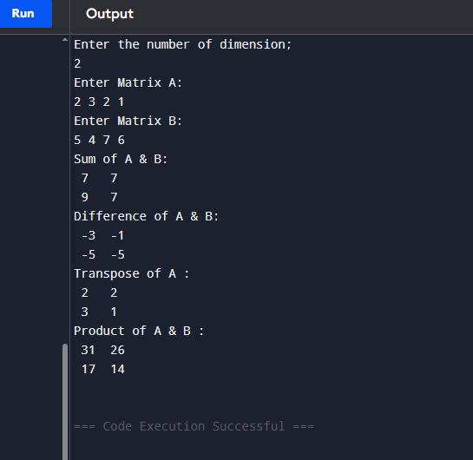
3. Write a Program to sort the list using: - Bubble Sort - Quick Sort - Insertion sort - Merge Sort - Heap Sort Also, find the comparison on the basis of time complexity.
#include <stdio.h>
#define MAX 100
void printArray(int arr[], int n) {
for (int i = 0; i < n; i++)
printf("%d ", arr[i]);
printf("\n");
}

void bubbleSort(int arr[], int n) {
for (int i = 0; i < n-1; i++) {
for (int j = 0; j < n-i-1; j++) {
if (arr[j] > arr[j+1]) {
int temp = arr[j];
arr[j] = arr[j+1];
arr[j+1] = temp;
}
}
}
}

void insertionSort(int arr[], int n) {
for (int i = 1; i < n; i++) {
int key = arr[i];
int j = i - 1;
while (j >= 0 && arr[j] > key) {
arr[j+1] = arr[j];
j--;
}
arr[j+1] = key;
}
}

int partition(int arr[], int low, int high) {
int pivot = arr[high];
int i = (low - 1);
for (int j = low; j < high; j++) {
if (arr[j] < pivot) {
i++;
int temp = arr[i]; arr[i] = arr[j]; arr[j] = temp;
}
}
int temp = arr[i+1]; arr[i+1] = arr[high]; arr[high] = temp;
return (i+1);
}

void quickSort(int arr[], int low, int high) {
if (low < high) {
int pi = partition(arr, low, high);
quickSort(arr, low, pi-1);
quickSort(arr, pi+1, high);
}
}

void merge(int arr[], int l, int m, int r) {
int n1 = m - l + 1, n2 = r - m;
int L[n1], R[n2];
for (int i = 0; i < n1; i++) L[i] = arr[l+i];
for (int j = 0; j < n2; j++) R[j] = arr[m+1+j];

int i=0, j=0, k=l;
while (i<n1 && j<n2) {
if (L[i] <= R[j]) arr[k++] = L[i++];
else arr[k++] = R[j++];
}
while (i<n1) arr[k++] = L[i++];
while (j<n2) arr[k++] = R[j++];
}

void mergeSort(int arr[], int l, int r) {
if (l < r) {
int m = l + (r-l)/2;
mergeSort(arr, l, m);
mergeSort(arr, m+1, r);
merge(arr, l, m, r);
}
}

void heapify(int arr[], int n, int i) {
int largest = i;
int l = 2*i+1, r = 2*i+2;
if (l < n && arr[l] > arr[largest]) largest = l;
if (r < n && arr[r] > arr[largest]) largest = r;
if (largest != i) {
int temp = arr[i]; arr[i] = arr[largest]; arr[largest] = temp;
heapify(arr, n, largest);
}
}

void heapSort(int arr[], int n) {
for (int i = n/2-1; i >= 0; i--)
heapify(arr, n, i);
for (int i = n-1; i > 0; i--) {
int temp = arr[0]; arr[0] = arr[i]; arr[i] = temp;
heapify(arr, i, 0);
}
}

int main() {
int arr[MAX], n, choice;
printf("Enter number of elements: ");
scanf("%d", &n);
printf("Enter elements: ");
for (int i = 0; i < n; i++) scanf("%d", &arr[i]);

printf("\nChoose Sorting Method:\n");
printf("1. Bubble Sort\n2. Insertion Sort\n3. Quick Sort\n4. Merge Sort\n5. Heap Sort\n");
scanf("%d", &choice);

switch(choice) {
case 1: bubbleSort(arr, n); break;
case 2: insertionSort(arr, n); break;
case 3: quickSort(arr, 0, n-1); break;
case 4: mergeSort(arr, 0, n-1); break;
case 5: heapSort(arr, n); break;
default: printf("Invalid choice!\n"); return 0;
}

printf("Sorted Array: ");
printArray(arr, n);
return 0;
}
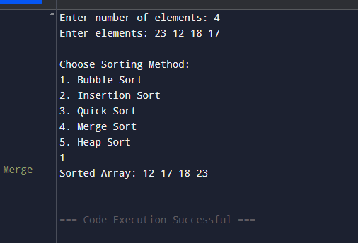
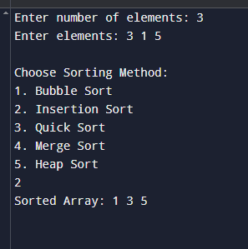
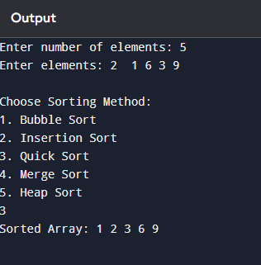
4. Write a program to search the element using: - Linear Search - Binary Search Also, find the comparison on the basis of time complexity.
#include <stdio.h>
int linearSearch(int arr[], int n, int key) {
for (int i = 0; i < n; i++) {
if (arr[i] == key)
return i;
}
return -1;
}
int binarySearch(int arr[], int n, int key) {
int low = 0, high = n - 1;
while (low <= high) {
int mid = (low + high) / 2;
if (arr[mid] == key)
return mid;
else if (arr[mid] < key)
low = mid + 1;
else
high = mid - 1;
}
return -1;
}

int main() {
int arr[100], n, key, choice, result;

printf("Enter number of elements: ");
scanf("%d", &n);

printf("Enter elements (sorted for binary search): ");
for (int i = 0; i < n; i++)
scanf("%d", &arr[i]);

printf("Enter element to search: ");
scanf("%d", &key);

printf("\nChoose Search Method:\n");
printf("1. Linear Search\n2. Binary Search\n");
scanf("%d", &choice);

switch (choice) {
case 1:
result = linearSearch(arr, n, key);
break;
case 2:
result = binarySearch(arr, n, key);
break;
default:
printf("Invalid choice!\n");
return 0;
}

if (result != -1)
printf("Element found at index %d\n", result);
else
printf("Element not found!\n");

return 0;
}
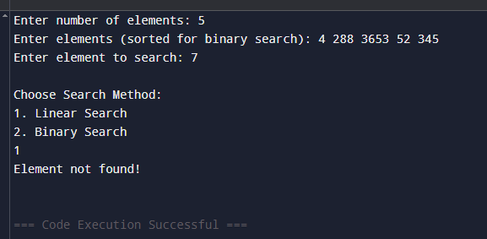
5. Write a program to perform all operations: - For the Stack using an Array. - For the Queue using an Array. - For the Circular Queue using an Array.
For the Stack using an Array.
#include <stdio.h>
#define MAX 5
int stack[MAX];
int top = -1;
void push(){
int value;
if (top==MAX-1){
printf("Stack overflow! Cannot insert element.");
}else{
printf("Enter value to push:\n");
scanf("%d", &value);
top++;
stack[top]=value;
printf("%d pushed successfully.\n", value);
}
}
void pop(){
if(top == -1){
printf("Underflow! Stack is empty. Insert elements first.\n");
}else{
printf("%d poped successfully.\n", stack[top]);
top--;
}
}
void peek(){
if(top==-1){
printf("Stack is empty. No top element.\n");
}else{
printf("Top element is: %d", stack[top]);
}
}
void display(){
if(top==-1){
printf("Stack is empty.\n");
}else{
printf("Elements are:\n");
for( int i=top; i>=0; i--){
printf("%d\n", stack[i]);
}
}
}
int main() {
int choice;
do{
printf("\n__Stack Menu__\n");
printf("1.Push\n");
printf("2.Pop\n");
printf("3.Peek\n");
printf("4.Display\n");
printf("5.Exit\n");
printf("Enter your choice:\n");
scanf("%d", &choice);

switch(choice){
case 1: push();
break;
case 2: pop();
break;
case 3: peek();
break;
case 4: display();
break;
case 5: printf("Exiting the program");
break;
default:
printf("Invalid choice! Please try again\n");
}
}while(choice!=5);
return 0;
}
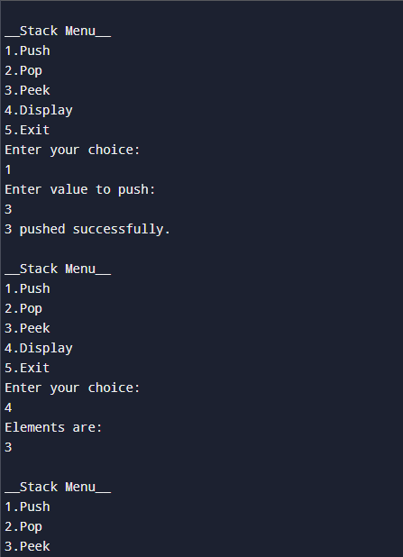

For the Queue using an Array
#include <stdio.h>
#define MAX 5
int queue[MAX], front = -1, rear = -1;

void enqueue(int x) {
if (rear == MAX - 1) {
printf("Queue Overflow\n");
} else {
if (front == -1) front = 0;
queue[++rear] = x;
}
}

void dequeue() {
if (front == -1 || front>rear) {
printf("Queue Underflow\n");
} else {
printf("Dequeued: %d\n", queue[front++]);
}
}

void displayQueue() {
if (front == -1 || front>rear ) {
printf("Queue is empty\n");
} else {
printf("Queue: ");
for(int i = front; i<=rear; i++){
printf("%d ", queue[i]);
}
printf("\n");
}
}

int main() {
enqueue(1); enqueue(6); enqueue(17); enqueue(8);
displayQueue();
dequeue();
displayQueue();
return 0;
}
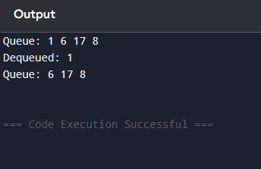
For the Circular Queue using an Array.
#include <stdio.h>
#define MAX 5
int cqueue[MAX], cfront = -1, crear = -1;

void cenqueue(int x) {
if ((cfront == 0 && crear == MAX - 1) || ((crear + 1) % MAX == cfront)) {
printf("Circular Queue Overflow\n");
} else {
if (cfront == -1) cfront = 0; // first element
crear = (crear + 1) % MAX;
cqueue[crear] = x;
}
}

void cdequeue() {
if (cfront == -1) {
printf("Circular Queue Underflow\n");
} else {
printf("Dequeued: %d\n", cqueue[cfront]);
if (cfront == crear) {
cfront = crear = -1; // queue becomes empty
} else {
cfront = (cfront + 1) % MAX;
}
}
}

void displayCQueue() {
if (cfront == -1) {
printf("Circular Queue is empty\n");
} else {
printf("Circular Queue: ");
int i = cfront;
while (1) {
printf("%d ", cqueue[i]);
if (i == crear) break;
i = (i + 1) % MAX;
}
printf("\n");
}
}

int main() {
cenqueue(5); cenqueue(6); cenqueue(7); cenqueue(8);
displayCQueue();
cdequeue();
displayCQueue();
return 0;
}
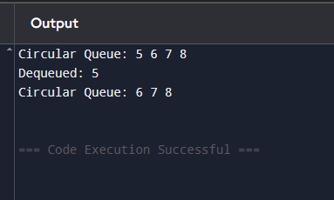
6. Write a program to evaluate the Postfix Notation.
#include <stdio.h>
#define MAX 10
int stack[MAX];
int top = -1;

void push(int value) {
if (top == MAX - 1) {
printf("Stack overflow!\n");
return;
}
stack[++top] = value;
}

int pop() {
if (top == -1) {
printf("Stack underflow!\n");
return -1;
}
return stack[top--];
}

int evaluatePostfix(char* exp) {
int i;
for (i = 0; exp[i] != '\0'; i++) {
// If character is a digit (without ctype.h)
if (exp[i] >= '0' && exp[i] <= '9') {
push(exp[i] - '0');
}
else {
int val2 = pop();
int val1 = pop();
switch (exp[i]) {
case '+': push(val1 + val2); break;
case '-': push(val1 - val2); break;
case '*': push(val1 * val2); break;
case '/': push(val1 / val2); break;
default:
printf("Invalid operator: %c\n", exp[i]);
return -1;
}
}
}
return pop();
}

int main() {
char exp[MAX];
printf("Enter postfix expression (single-digit operands): ");
scanf("%s", exp);
int result = evaluatePostfix(exp);
printf("Result of postfix evaluation: %d\n", result);
return 0;
}

7. Write a program to convert infix notation into Postfix Notation.
#include <stdio.h>
#define MAX 7
char stack[MAX];
int top = -1;

void push(char c) {
if (top == MAX - 1) {
printf("Stack overflow!\n");
return;
}
stack[++top] = c;
}

char pop() {
if (top == -1) {
return -1;
}
return stack[top--];
}

char peek() {
if (top == -1) return -1;
return stack[top];
}

int precedence(char op) {
if (op == '^') return 3;
if (op == '*' || op == '/') return 2;
if (op == '+' || op == '-') return 1;
return 0;
}

int isOperator(char c) {
return (c == '+' || c == '-' || c == '*' || c == '/' || c == '^');
}

void infixToPostfix(char* infix) {
char postfix[MAX];
int i, k = 0;

for (i = 0; infix[i] != '\0'; i++) {
char c = infix[i];

if ((c >= 'A' && c <= 'Z') || (c >= 'a' && c <= 'z') || (c >= '0' && c <= '9')) {
postfix[k++] = c;
}

else if (c == '(') {
push(c);
}

else if (c == ')') {
while (top != -1 && peek() != '(') {
postfix[k++] = pop();
}
pop();
}

else if (isOperator(c)) {
while (top != -1 && precedence(peek()) >= precedence(c)) {
postfix[k++] = pop();
}
push(c);
}
}

while (top != -1) {
postfix[k++] = pop();
}

postfix[k] = '\0';
printf("Postfix Expression: %s\n", postfix);
}

int main() {
char infix[MAX];
printf("Enter infix expression: ");
scanf("%s", infix);

infixToPostfix(infix);

return 0;
}
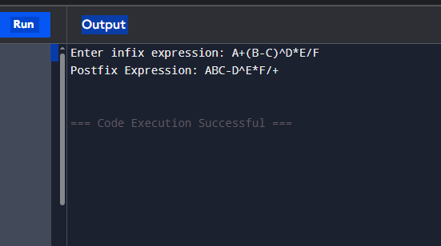

8. Write a program to perform the operations of the linked list: - Insertion – Deletion –Display
#include <stdio.h>

#define MAX 10

struct Node {
int data;
int next;
};

struct Node nodes[MAX];
int head = -1;
int freeIndex = 0;

void insert(int value) {
if (freeIndex >= MAX) {
printf("List is full!\n");
return;
}

nodes[freeIndex].data = value;
nodes[freeIndex].next = -1;

if (head == -1) {
head = freeIndex;
} else {
int temp = head;
while (nodes[temp].next != -1) {
temp = nodes[temp].next;
}
nodes[temp].next = freeIndex;
}
freeIndex++;
}

void delete(int value) {
if (head == -1) {
printf("List is empty!\n");
return;
}

int temp = head;
int prev = -1;

while (temp != -1 && nodes[temp].data != value) {
prev = temp;
temp = nodes[temp].next;
}

if (temp == -1) {
printf("Value not found!\n");
return;
}

if (prev == -1) {
head = nodes[temp].next;
} else {
nodes[prev].next = nodes[temp].next;
}

printf("Deleted %d\n", value);
}

void display() {
if (head == -1) {
printf("List is empty!\n");
return;
}
int temp = head;
printf("Linked List: ");
while (temp != -1) {
printf("%d -> ", nodes[temp].data);
temp = nodes[temp].next;
}
printf("NULL\n");
}

int main() {
int choice, value;

while (1) {
printf("\n--- Linked List Menu ---\n");
printf("1. Insert\n");
printf("2. Delete\n");
printf("3. Display\n");
printf("4. Exit\n");
printf("Enter your choice: ");
scanf("%d", &choice);

switch (choice) {
case 1:
printf("Enter value to insert: ");
scanf("%d", &value);
insert(value);
break;
case 2:
printf("Enter value to delete: ");
scanf("%d", &value);
delete(value);
break;
case 3:
display();
break;
case 4:
return 0;
default:
printf("Invalid choice!\n");
}
}
}
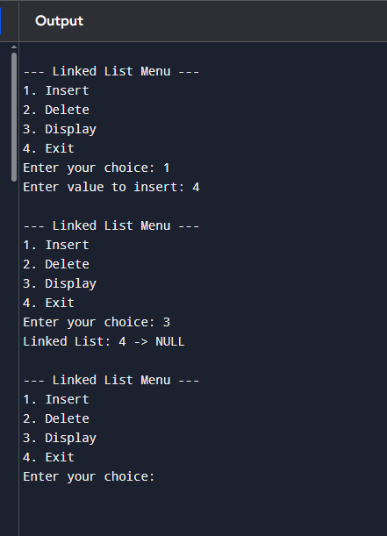
9. Write a program to perform the operations of the Circular linked list: - Insertion - Deletion - Display
#include <stdio.h>
#define MAX 25

struct Node {
int data;
int next;
};

struct Node nodes[MAX];
int head = -1;
int freeIndex = 0;

void insert(int value) {
if (freeIndex >= MAX) {
printf("List is full!\n");
return;
}

nodes[freeIndex].data = value;

if (head == -1) {
head = freeIndex;
nodes[freeIndex].next = head;
} else {
int temp = head;
while (nodes[temp].next != head) {
temp = nodes[temp].next;
}
nodes[temp].next = freeIndex;
nodes[freeIndex].next = head;
}
freeIndex++;
}

void delete(int value) {
if (head == -1) {
printf("List is empty!\n");
return;
}

int temp = head, prev = -1;

if (nodes[head].data == value) {
if (nodes[head].next == head) {
head = -1;
return;
}

int last = head;
while (nodes[last].next != head) {
last = nodes[last].next;
}
head = nodes[head].next;
nodes[last].next = head;
return;
}

do {
prev = temp;
temp = nodes[temp].next;
if (nodes[temp].data == value) {
nodes[prev].next = nodes[temp].next;
return;
}
} while (temp != head);

printf("Value not found!\n");
}

void display() {
if (head == -1) {
printf("List is empty!\n");
return;
}

int temp = head;
printf("Circular Linked List: ");
do {
printf("%d -> ", nodes[temp].data);
temp = nodes[temp].next;
} while (temp != head);
printf("(back to head)\n");
}

int main() {
int choice, value;

while (1) {
printf("\n--- Circular Linked List Menu ---\n");
printf("1. Insert\n");
printf("2. Delete\n");
printf("3. Display\n");
printf("4. Exit\n");
printf("Enter your choice: ");
scanf("%d", &choice);

switch (choice) {
case 1:
printf("Enter value to insert: ");
scanf("%d", &value);
insert(value);
break;
case 2:
printf("Enter value to delete: ");
scanf("%d", &value);
delete(value);
break;
case 3:
display();
break;
case 4:
return 0;
default:
printf("Invalid choice!\n");
}
}
}
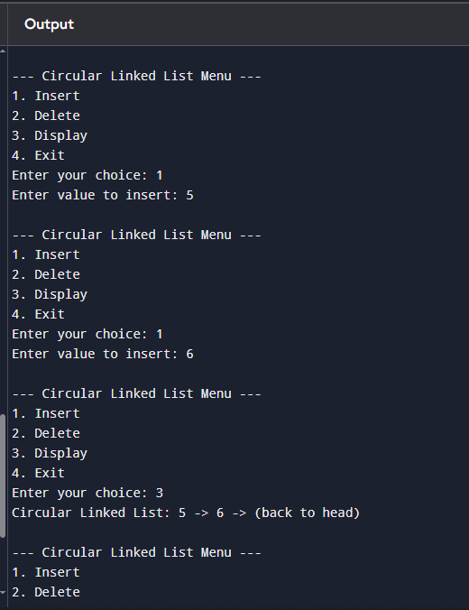
10
#include <stdio.h>

#define MAX 100

int dataArr[MAX];
int nextArr[MAX];

int stackTop = -1;
int stackFree = 0;

void push(int value) {
if (stackFree >= MAX) {
printf("Stack overflow!\n");
return;
}
dataArr[stackFree] = value;
nextArr[stackFree] = stackTop;
stackTop = stackFree;
stackFree++;
}

void pop() {
if (stackTop == -1) {
printf("Stack is empty!\n");
return;
}
printf("Popped: %d\n", dataArr[stackTop]);
stackTop = nextArr[stackTop];
}

void displayStack() {
if (stackTop == -1) {
printf("Stack is empty!\n");
return;
}
int temp = stackTop;
printf("Stack: ");
while (temp != -1) {
printf("%d -> ", dataArr[temp]);
temp = nextArr[temp];
}
printf("NULL\n");
}

int queueFront = -1, queueRear = -1;
int queueFree = 0;

void enqueue(int value) {
if (queueFree >= MAX) {
printf("Queue overflow!\n");
return;
}
dataArr[queueFree] = value;
nextArr[queueFree] = -1;

if (queueFront == -1) {
queueFront = queueRear = queueFree;
} else {
nextArr[queueRear] = queueFree;
queueRear = queueFree;
}
queueFree++;
}

void dequeue() {
if (queueFront == -1) {
printf("Queue is empty!\n");
return;
}
printf("Dequeued: %d\n", dataArr[queueFront]);
queueFront = nextArr[queueFront];
if (queueFront == -1) queueRear = -1;
}

void displayQueue() {
if (queueFront == -1) {
printf("Queue is empty!\n");
return;
}
int temp = queueFront;
printf("Queue: ");
while (temp != -1) {
printf("%d -> ", dataArr[temp]);
temp = nextArr[temp];
}
printf("NULL\n");
}

int cqFront = -1, cqRear = -1;
int cqFree = 0;

void enqueueCQ(int value) {
if (cqFree >= MAX) {
printf("Circular Queue overflow!\n");
return;
}
dataArr[cqFree] = value;
if (cqFront == -1) {
cqFront = cqRear = cqFree;
nextArr[cqFree] = cqFront;
} else {
nextArr[cqRear] = cqFree;
cqRear = cqFree;
nextArr[cqRear] = cqFront;
}
cqFree++;
}

void dequeueCQ() {
if (cqFront == -1) {
printf("Circular Queue is empty!\n");
return;
}
printf("Dequeued: %d\n", dataArr[cqFront]);
if (cqFront == cqRear) {
cqFront = cqRear = -1;
} else {
cqFront = nextArr[cqFront];
nextArr[cqRear] = cqFront;
}
}

void displayCQ() {
if (cqFront == -1) {
printf("Circular Queue is empty!\n");
return;
}
int temp = cqFront;
printf("Circular Queue: ");
do {
printf("%d -> ", dataArr[temp]);
temp = nextArr[temp];
} while (temp != cqFront);
printf("(back to front)\n");
}

int main() {
int choice, value;

while (1) {
printf("\n--- Menu ---\n");
printf("1. Stack Push\n2. Stack Pop\n3. Stack Display\n");
printf("4. Queue Enqueue\n5. Queue Dequeue\n6. Queue Display\n");
printf("7. Circular Queue Enqueue\n8. Circular Queue Dequeue\n9. Circular Queue Display\n");
printf("10. Exit\n");
printf("Enter choice: ");
scanf("%d", &choice);

switch (choice) {
case 1: printf("Enter value: "); scanf("%d", &value); push(value); break;
case 2: pop(); break;
case 3: displayStack(); break;
case 4: printf("Enter value: "); scanf("%d", &value); enqueue(value); break;
case 5: dequeue(); break;
case 6: displayQueue(); break;
case 7: printf("Enter value: "); scanf("%d", &value); enqueueCQ(value); break;
case 8: dequeueCQ(); break;
case 9: displayCQ(); break;
case 10: return 0;
default: printf("Invalid choice!\n");
}
}
}
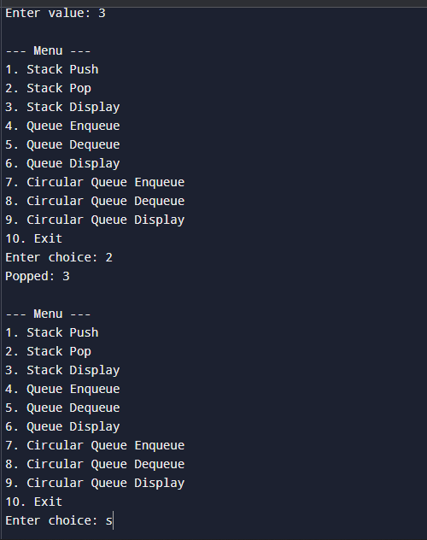
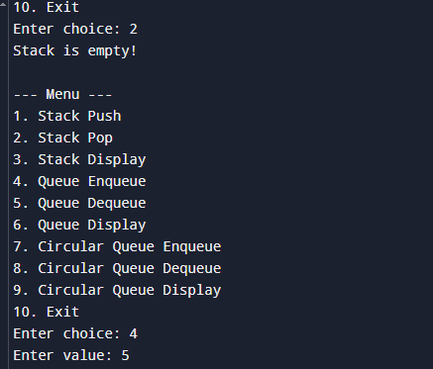
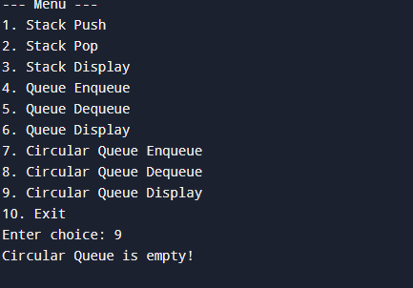
11. Write a program to perform concatenation of two linked lists.

#include <stdio.h>

#define MAX 25
int dataArr[MAX];
int nextArr[MAX];
int freeIndex = 0;

int createNode(int value) {
if (freeIndex >= MAX) {
printf("No more space!\n");
return -1;
}
dataArr[freeIndex] = value;
nextArr[freeIndex] = -1;
return freeIndex++;
}

int insert(int head, int value) {
int newNode = createNode(value);
if (newNode == -1) return head;

if (head == -1) {
head = newNode;
} else {
int temp = head;
while (nextArr[temp] != -1) {
temp = nextArr[temp];
}
nextArr[temp] = newNode;
}
return head;
}

void display(int head) {
if (head == -1) {
printf("List is empty!\n");
return;
}
int temp = head;
while (temp != -1) {
printf("%d -> ", dataArr[temp]);
temp = nextArr[temp];
}
printf("NULL\n");
}

int concatenate(int head1, int head2) {
if (head1 == -1) return head2;
if (head2 == -1) return head1;

int temp = head1;
while (nextArr[temp] != -1) {
temp = nextArr[temp];
}
nextArr[temp] = head2;
return head1;
}

int main() {
int list1 = -1, list2 = -1;
int n1, n2, val;

printf("Enter number of elements in List 1: ");
scanf("%d", &n1);
for (int i = 0; i < n1; i++) {
printf("Enter value: ");
scanf("%d", &val);
list1 = insert(list1, val);
}

printf("Enter number of elements in List 2: ");
scanf("%d", &n2);
for (int i = 0; i < n2; i++) {
printf("Enter value: ");
scanf("%d", &val);
list2 = insert(list2, val);
}

printf("\nList 1: ");
display(list1);
printf("List 2: ");
display(list2);

int concatenated = concatenate(list1, list2);
printf("\nConcatenated List: ");
display(concatenated);

return 0;
}
