PROJECT

*"Measure and model the shortest trajectory a vehicle can travel from earth to a final point between each of the planets at any given time (Gravity Assists should be applied )"*

By: Nyameaama Gambrah

**Introduction:**

In this project, I wanted to measure the shortest trajectory a vehicle can travel from earth to a final point in space and write a program in order to model this.

**Bodies in Space:**

Originally we thought we could represent the simple positions of bodies in space with a 2D x-y plane (as shown below) but we quicky encountered some problems. Each body’s trajectory in the sun's sphere of influence (The area in which the sun holds gravitational influence) was greatly affected by distance to the sun.

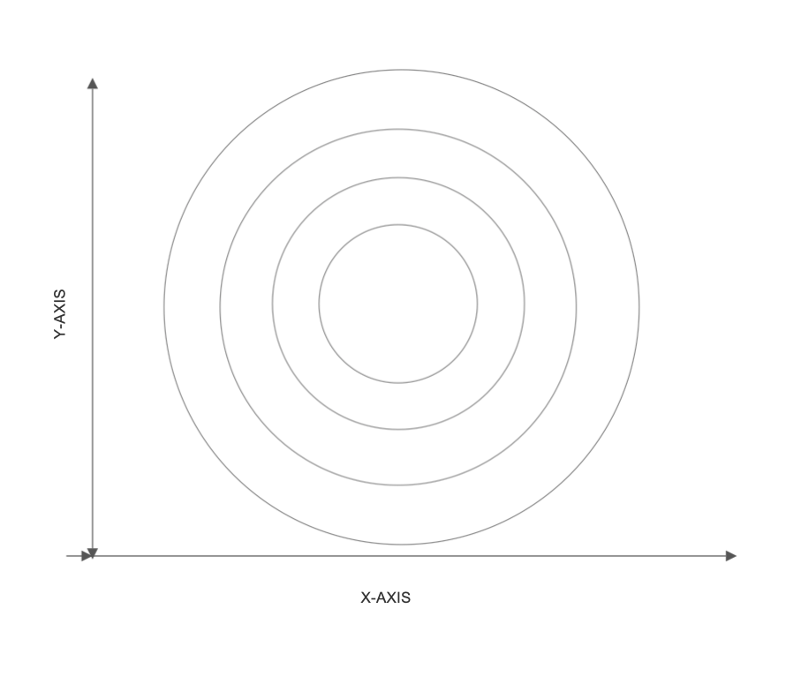

**\*Not to scale**

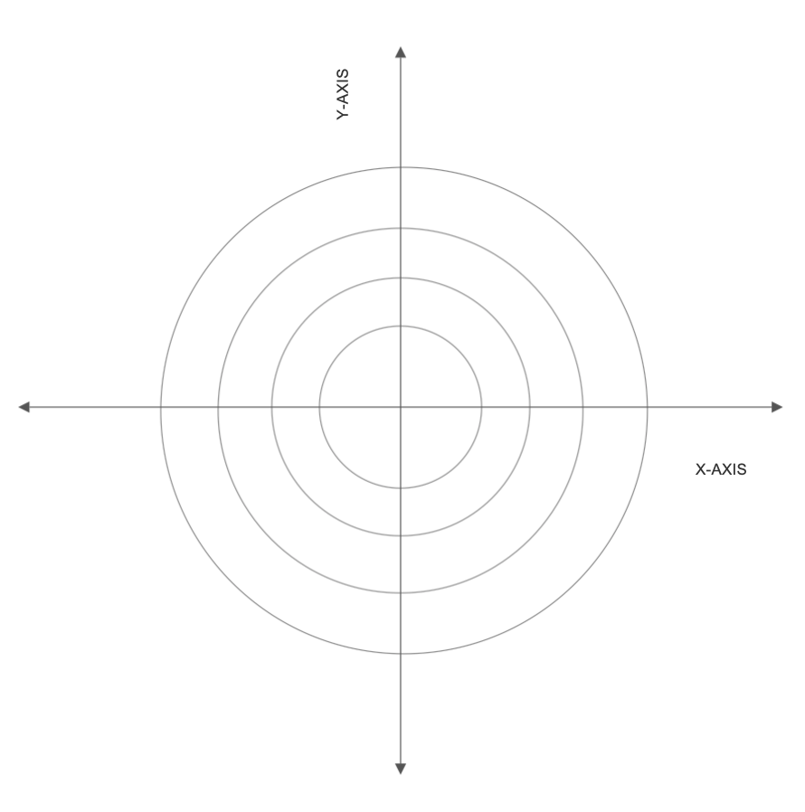

**\*Not to scale**

We could however, derive the equations of the bodies trajectories in the 2d x-y plane by graphing the circular paths (as seen below). The equation of a circle is used

**image0.png**

*Distance from Sun (0,0)*

|  |  |
| --- | --- |
| Mercury | 0.39 AU |
| Venus | 0.723 AU |
| Earth | 1 AU |
| Mars | 1.524 AU |
| Jupiter | 5.203 AU |
| Saturn | 9.539 AU |
| Uranus | 19.18 AU |
| Neptune | 30.06 AU |

With the sun being at the midpoint of (0,0) we can simplify the standard circle equation to look like image1.png

Mercury(Equation): 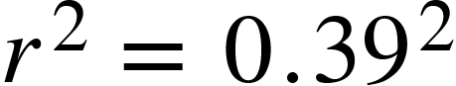

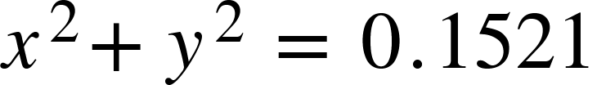

Venus(Equation):

$$r^{2}={0.723}^{2}$$

$$x^{2 }+ y^{2}=0.5227$$

Earth (Equation):

$$r^{2}=1^{2}$$

$$x^{2}+y^{2}=1$$

Mars(Equation):

$$r^{2}={1.524}^{2}$$

$x^{2}+y^{2}=2.322$

Jupiter(Equation):

$$r^{2}={5.203}^{2}$$

$$x^{2}+y^{2}=27.07$$

Saturn(Equation):

$$r^{2}={9.539}^{2}$$

$$x^{2}+y^{2}=90.99$$

Uranus(Equation):

$$r^{2}= {19.18}^{2}$$

$$x^{2}+y^{2}=367.872$$

Neptune(Equation):

$$r^{2}={30.06}^{2}$$

$$x^{2}+y^{2}= 903.6036$$

Although, all bodies in space rarely ever have a perfectly circular path as described, therefore each orbital path has to be characterized by its orbital eccentricity. The orbital eccentricity of an astronomical object is a [dimensionless parameter](https://en.wikipedia.org/wiki/Dimensionless_quantity) that determines the amount by which its [orbit](https://en.wikipedia.org/wiki/Orbit) around another body deviates from a perfect [circle](https://en.wikipedia.org/wiki/Circle).

**Elliptic orbit by eccentricity**

  0.0 **·**   0.2 **·**   0.4 **·**   0.6 **·**   0.8

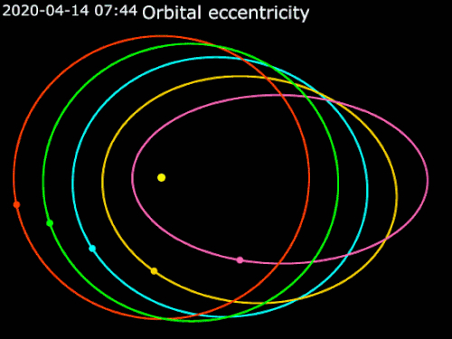

|  |  |  |  |
| --- | --- | --- | --- |
| **Planet** | **Orbital Eccentricity** | [**Perihelion**](https://www.enchantedlearning.com/subjects/astronomy/glossary/indexp.shtml#perihelion) **(Point in Orbit Closest to Sun) AU** | [**Aphelion**](https://www.enchantedlearning.com/subjects/astronomy/glossary/index.shtml#aphelion) **(Point in Orbit Farthest from Sun) AU** |
| Mercury | 0.206 | 0.31 | 0.47 |
| Venus | 0.007 | 0.718 | 0.728 |
| Earth | 0.017 | 0.98 | 1.02 |
| Mars | 0.093 | 1.38 | 1.67 |
| Jupiter | 0.048 | 4.95 | 5.45 |
| Saturn | 0.056 | 9.02 | 10.0 |
| Uranus | 0.047 | 18.3 | 20.1 |
| Neptune | 0.009 | 30.0 | 30.3 |
| Pluto | 0.248 | 29.7 | 49.9 |

The orbital eccentricity of a planet can be calculated by the result of:

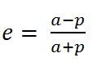

* where ***e*** is the eccentricity,
* ***a*** is the aphelion distance (Semi – major axis), and
* ***p*** is the perihelion distance (Semi – minor axis).