Engine System is based on Rocket Labs Electric Pump Feed Cycle which uses a solar powered power powering an Electric Motor which in turns powers the Fuel and Oxidizer Pumps pushing propellant into the combustion chamber.

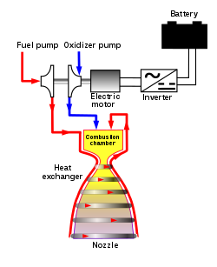

By varying the power to Fuel and Oxidizer Pumps, the pumps are supplied less power and this reduces the mass flow going into the main combustion chamber.

Engine Startup and Shutdown

Tank Valve

Flow Open

Fuel and LOX inlet flow

Tank Valves Controllers

Cmd: Startup Engine (#2)

Throttle - 100

Main Computer Unit

**1**

Igniter (Non Hypergolic)

Start

Pump

Main Fuel Valves

Main LOX Valves

Open

Open

Engine Management Controller

Engine Controller Router Unit

**2**