Blaine McMahon, Jacob Sword, Nicholas Yameen

Network Design

Project Phase 6

5/3/19

**1. Introduction:**

This code completes Phase 6 of the project by using UDP to send images from a client to a server and vice versa across a channel that has the possibility to introduce bit errors and lost packets. This version utilizes **Selective Repeat** protocol to communicate across the channel. The UDP server runs continuously to accept messages from clients. These messages contain image contents, that the receiver will write to a file. After sending this file, the client waits for a response of the same nature from the server, and then writes it’s transferred file before exiting. The below flowcharts and explanations explain these procedures in more detail.

**2. Flowcharts**

Fig 1a. Server Flowchart (Pt. 1)

Fig 1b. Server Flowchart (Pt. 2)

Fig 2a. Client Flowchart (Pt. 1)

Fig 2a. Client Flowchart (Pt. 1)

**GUI.py**

This file is the main GUI for the program. It uses tkinter to create the GUI. First, the GUI window will open and display three buttons, three input boxes, and two checkboxes. The user will first enter their intended file to send in the first input box, or leave it blank to use our default provided file path. Also, the user can now enter which checkboxes they want which correspond to which printouts are displayed. Checking “Status Msgs” will allow messages such as “Server: Finished writing received file” to be printed to the console. Checking “UDP Err Msgs” will allow messages such as “ACK Packet Dropped!” to be printed to the console. Each of these messages will be prefixed with the program time. The user then has to click Start Server. This will start the Server function shown below. This function gets the entered filepath, or uses the default, and instantiates a UDPserver class with the noted filepath, and *status_msgs.get()* which gets the state of the “Status Msgs” checkbox (Boolean variable).

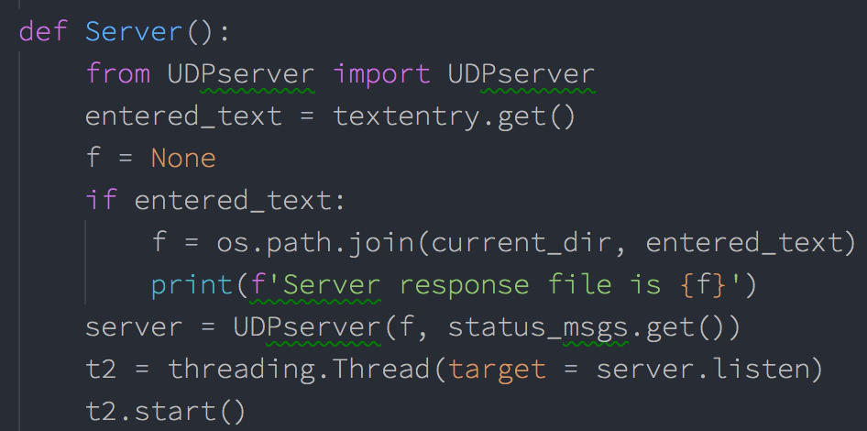

The server class’s “listen” function is then run in a new thread. Next, the user can enter their desired “Corruption Option”, “UDP Error Rate”, and “Window Size” in the corresponding input boxes of the GUI. Then, the user can click the “Start Client” button. This will call *Client* function shown below.

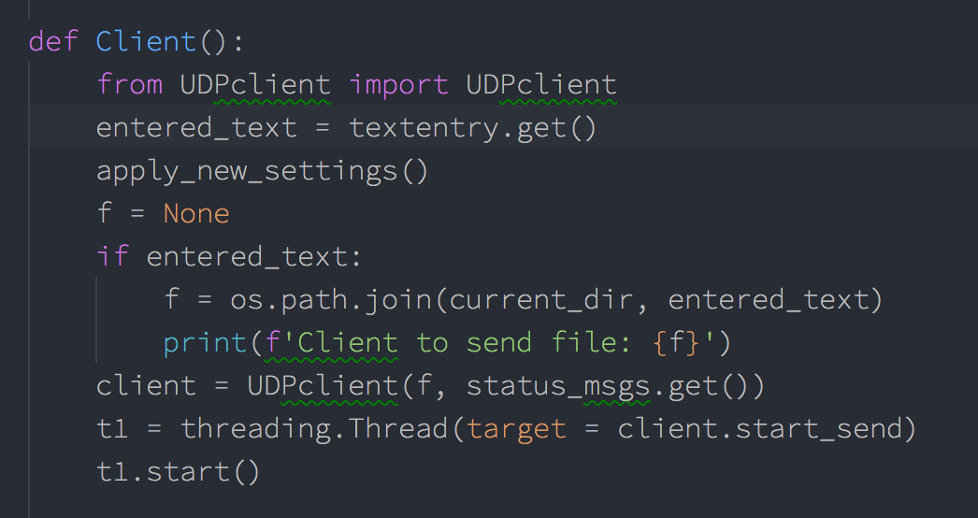

This function operates in a similar fashion to the above-detailed Server function, and the client’s *start_send* function will run in a new thread. However, before this is done, *apply_new_settings()* is called. This function gets the current data from the “Corruption Option”, “UDP error rate”, and “Window Size” input boxes, in addition to the checkboxes, and passes this data onto our *config.py* file, so that it can be later accessed by functions in the rdt_sender.py and rdt_receiver.py files.

**UDPserver.py**

In the UDP server file, there is a class called UDPserver. The *init* function will first either use the file path given by the user at the start or use the default if not specified by the user. It will then open a UDP socket and bind to it and make it an instance variable.



When called, the listen() function will continually run, where it will listen for incoming connections and starts the RDT receive sequence

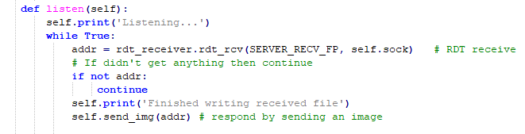

It will then preform a *rdt_rcv(),* utilizing the rdt_receiver.py file, where it will continually receive packets from the client and write them to the file until there are no packets left, in a Selective Repeat manner. Once the full image is received it will then close the file and send an image back to the client. (Note: *rdt_rcv()* is called continuously in a while loop, so if no message is received during this call, (i.e. *if not addr:*) the loop will simply continue to the next iteration, and does not send the response image.

Messages will be printed to the console through this to show the status. All messages printed from the server are run through *self.print()* to prefix it with the time and a “Server:” string for easier reading in the terminal. However, this is only done if the checkbox for status_msgs (passed in when server thread was started) was checked. Note that config.transfer_start_time is initialized at the beginning of each Client file transfer. If this value is not set, the server will take it to be 0.

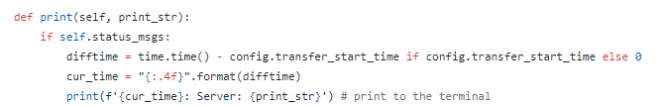

The *send_img()* function will first open the file specified or the default one for reading binary. Finally, it will send the image using the using the rdt_sender.py function *rdt_send()*.

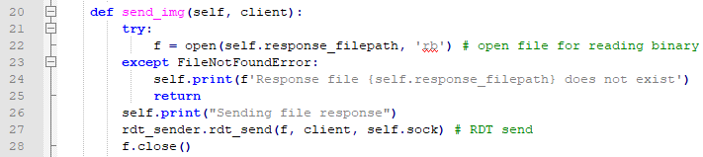

**UDPclient.py**

The UDPclient has a class which defines four functions. First, the client will initialize similar to the UDP server. It will connect to the server on the UDP socket, which is made into an instance variable

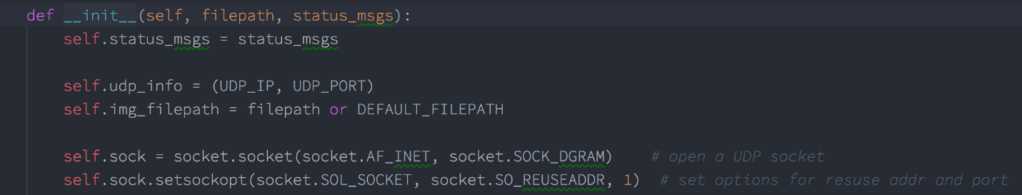

Then it will go into *start_send()* function. It will first call *send_img()* function to send the server an image.

The *send_img()* function will first either use the path given by the user or the default one. If there is an error finding the given filename, it will be caught above, and the client will stop execution. If the file is successfully found, it will open that image for reading binary. The client preforms RDT send by calling the *rdt_send()* function in the rdt_sender.py file. Once it has finished it will close that file. Additionally, the transfer_start_time is initialized here as the current system time.

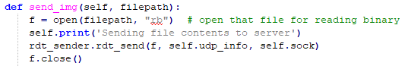

Next, the *start_send()* will call the *wait_and_receive()* function. Here the client will receive the response image name from the server. It will open that file for writing binary. After which it will call *rdt_rcv()* (from the rdt_receiver.py file) to receive all the packets of the image. After which, the file will close, and the elapsed time will be printed to the console, which is later used in data collection to constructor our graphs. The client also uses a self.print function to prepend “Client:” to all print strings.

**rtd_sender.py**

In the file, there are 5 functions defined. The server and client will use these functions to send Selective Repeat messages over a socket. The sender of the UDP interaction will use *rdt_send()* function. This function will take in a file, endpoint, and the socket. It first starts by making a buffer to hold the packets configured with a set window size and buffer capacity, defined in *config.py*. Before packets can be added to buffer a separate thread is started to ensure the receiver is listening. We have a separate thread running to ensure when packets are waiting to be received, it doesn’t block the thread which is sending the packets. Also, callback functions are used to define what will happen in the case of a timeout, and when the receiver in the listening child thread receives a packet.

After the initial configurations have been done, the main loop condition is checked, that is, if the current packets sequence number is less than the base plus the window size. This is facilitated by the method pkt_buff.ready() and is to ensure we are not sending packets that are not in the current window. The packets are then made and added to the buffer. The current window is then specified by the window size. These packets are then sent, and the timer is started for each. If a timer time’s out (does not receive an ACK with the corresponding sequence number), it will be resent via the Selective Repeat protocol (using the *repeat()* function) and it’s timer is restarted. During this processing, if a packet is received that is not corrupt and has a sequence number in the current window, the sender will “complete” the timer for the packet in the window. If the ACK’ed packet is the base number of the buffer, the base will be incremented until it finds a packet whose timer has not been marked as “complete”. If the received packet is corrupt or the wrong sequence, the sender will do nothing until there is a timeout. It will continuously make and send packets to the receiver in this fashion, each iteration until the file is completely sent, using the same timer logic each time. Once the file is completely sent, the sender still cannot return, as it must wait for all sent packets to be ACKED. This is handled by a case in the main while loop of this function (*if pkt_buff.equal_index(): break else continue)*, as it will continue the while loop indefinitely until all packets are ACKED. Finally, after this happens, the child thread responsible for listening to packets must be cleaned up. This is accomplished by setting an “Event” for the child thread. When this event is set, the child exits from it’s infinite listening loop and finishes. We then join on the child thread. This is shown below.

Additionally, data packet loss is implemented on this side, during sending. As shown below, if the user-defined corruption-option allows for data loss, and the random channel value is lower than the given present corrupt, the packet will not be sent, and will move on through the while loop.

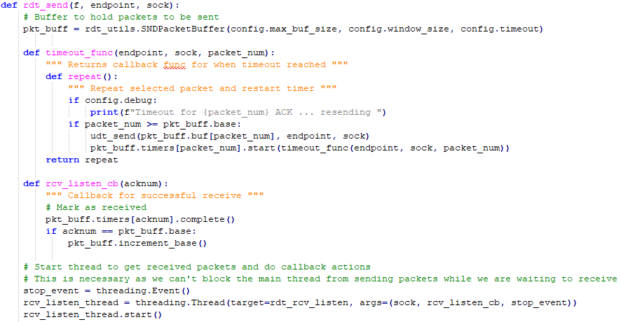

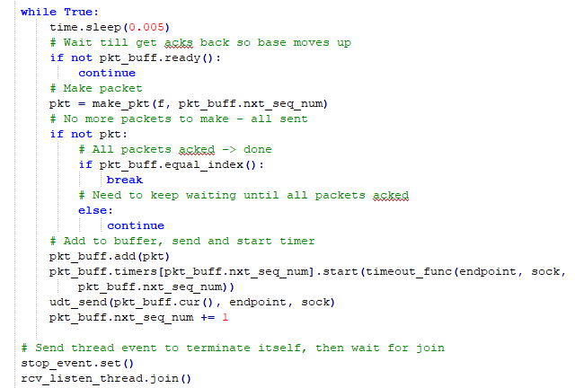

For the timer logic, a timer class RDTTimer is used (from rdt_utils.py). This timer class allows for “resetting” a timer by canceling it and creating a new one, and passing a callback function to the timer startup, which is called in the case of a timeout. For the callback function, we use the inner-defined *timeout_func­­* function, which is shown above. This function returns a function the prints a statement to the screen (if the “debug” config option is set, which is controlled by the UDT Error Rate checkbox in the GUI), then resends the packet via *repeat()*. Note, the instantiation of the timer class above uses the timeout value configurated in config.py,this default value is 50ms. The Timer class utilizes Threading.Timer, and is shown below.

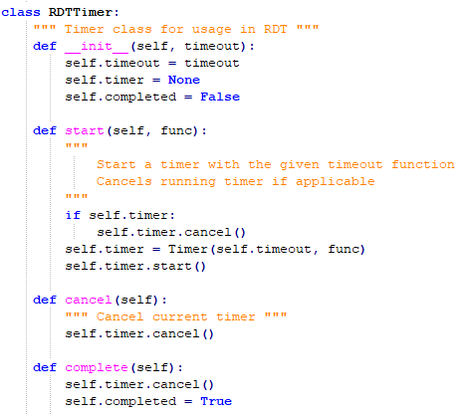

A class needed to be used for this, rather than a simple instantiation of Threading.Timer, because Python does not allow the re-assigning of variables from upper scope within a function. As such, we would not have been able to reassign *timer* to a new timer, which needs to be done after a timeout, and we had to rely on the above shown *RDTTimer.start()* function to do it instead.

Additionally, the sender buffer class that facilitates the above logic is shown below.

To make packets, the *make_pkt()* function is used to read 1024 bytes at a time. If there is nothing to read, then it will return 0. This is so the *rdt_send()* has the option to break out of its main while loop after the whole file is read. It takes the data read and the sequence number to calculate a checksum number. Finally, it creates the packet to be sent.

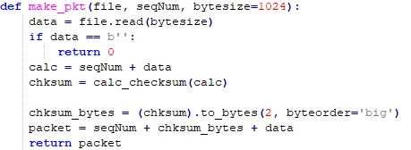

To calculate the checksum, the function *calc_checksum()­* will be called. This preformsthe 1’s complement of wraparound 16-bit sum.

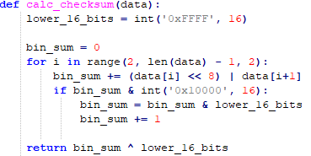

The *udt_send()­­* function will send the packets to the endpoint over the socket. It returns the number of bytes sent.



The *rdt_rcv()* function will receive the acknowledgement from the receiver. It will be called with the socket and sequence number being sent. It will first extract the ACK from the receiver using *extract()*. This function will wait for a packet using extract, if it doesn’t receive something it will timeout. If it did receive a packet it will parse that packet, and parse the checksum from the data using the *parse_checksum()* function. It then creates its own checksum, this is so the received and calculated checksums can be compared for corruption.

The *rdt_rcv()* function handles ACK corruption. In the if statement the integer should be a value between 0 (no corruption) to 60 (max corruption). This will have to be changed by the user, as noted above. There are two functions to pick a number between 0-100 called *random_channel()*. This number determines the percentage. The data will be corrupt in the *corrupt_bits()* function. When this happens, the if statement *rec_cksum != checksum* will be true, so a debug statement is printed warning of bit errors, through the *debug_print* function. This function prints the given string with a prepended timestamp only if the *config.debug* Boolean is set to true.



Additionally, packet loss is implemented here using the same logic, if the given corruption open is used. The Boolean value of corruption options states are defined by the given has*err() functions in rdt_utils, shown below.

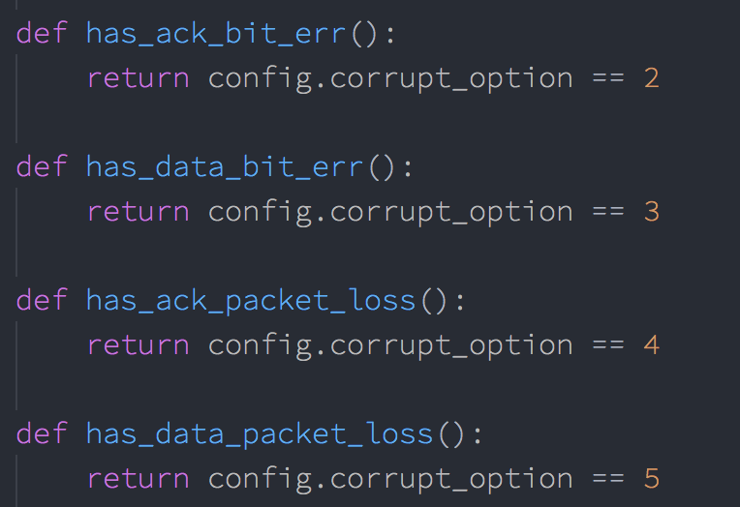

If the data is not corrupt, we return the ACK number that was received.

This function is called continuously in the child thread mentioned above via the function *rdt_rcv_listen*. This is shown below.

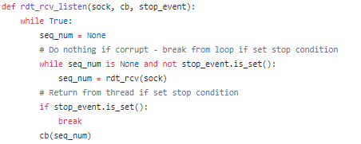

This will run continuously, looking for a valid seq_num to be returned from *rdt_rcv*. If it does get a sequence number, it will call the given callback *cb* on the sequence number. The cb function is *rcv_listen­_cb*, which was shown earlier. Finally, if this function receives a stop event, it will exit, completing the thread’s work.

**rdt_receiver.py**

The receiver will utilize the functions inside the rdt_receiver.py to complete Selective Repeats transactions. The first function is *rdt_rcv()*, which takes the file to write to, the endpoint, and the socket. This function will continuously run until there is no packet received. It will first setup initial parameters.

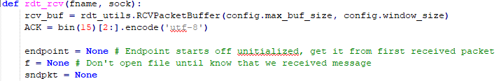

The receiver will extract a packet and parse the packet accordingly. If it is the first packet it, it will open a new file for writing binary.

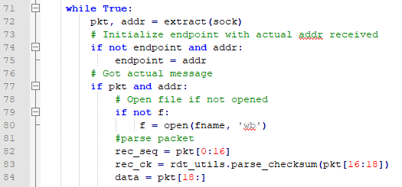

The *extract()* function will receive a packet from the socket. If there is a packet it will return it, otherwise it will return 0 (for both data, and addr).

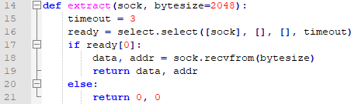

After, the packet is parsed as seen above. The received sequence number and data are stripped from the packet. The received checksum is parsed through the *parse_checksum()* function.



If the user selected some type of corruption, it will notify the user if there is corruption and corrupt the data. Otherwise it will just make its own checksum.

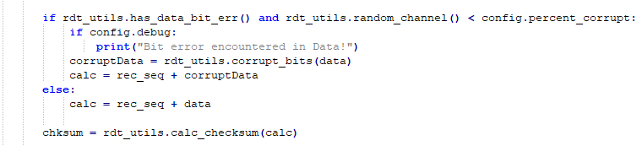

To verify the data is not corrupt, the data and sequence number received will be made into a checksum using the *calc_checksum()* function.

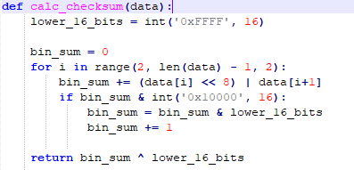

The checksum is compared. If the checksums do not match, the function returns early and makes a call to *debug_print* warning of bit errors. If they do match, an ACK packet is made for the received packet. If the received sequence number falls within the current receive window (of the receive buffer), then the data will be buffered. If this sequence number happens to be the base number of the receive buffer, we will deliver all received packet sequentially from the base, moving the base up at each step. This continues until we get to an unreceived packet, which becomes the receive buffer’s new base. This logic is shown below.

Additionally, the receive buffer class that facilitates this logic is shown below.

**rdt_utils.py**

This file holds all the functions that both the receiver and sender use. The first function is to corrupt data. Using some random number, certain bits will be changed.

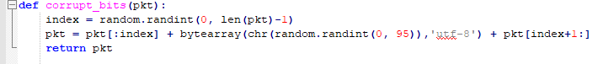

Next is the *calc_checksum* function. This function was shown in the previous sections. However, it preforms the 1’s compliment addition to create a checksum.

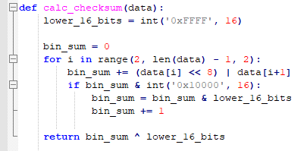

The next function if a function used to translate a decimal number to binary, called *seq_num_to_bin()*.

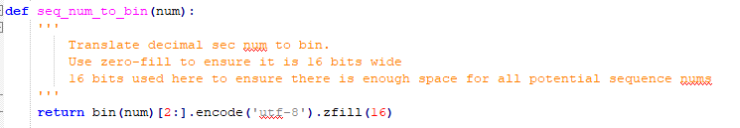

New to Phase 6 is the SNDPacketBuffer class and RCVPacketBuffer. The SNDPacketBuffer class defines 6 functions. The init function will set the next sequence number, base, and window size. The rest of the function defines what to do for the buffer window. First, cur_*window()* returns all packets from base to next sequence number, this is used in the *go­_back_n* function shown earlier. The *add()* function adds new packets to the window, at the index of *nxt_seq_num*. The *cur()*function will return packets at next sequence number. *Equal_index()* function will return when base is equal to next sequence number, which is used to determine whether to start a new timer, and whether all packets are ACKED (corresponding to different conditions detailed earlier). Lastly, *ready()* returns when the sender is ready to send more packets (i.e. has a window with unsent packets). This class was previously shown in the *rdt_sender* section.

Lastly, RCVPacketBuffer has 2 functions defined. The *init()*function initializes the buffer, base, and window size of the receiver. The *includes()* function will return true if packet number is greater or equal to the base AND if packet number is less than base + window. This class was previously shown in the *rdt_receiver* section.

**Config.py**

The last file is our config file. This file holds all of our configurations to preforms Selective Repeat and handle error rates. The contents of this file are below.

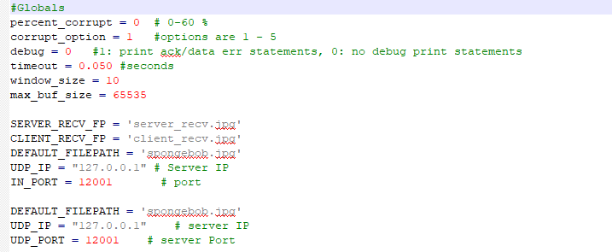

**How to Run**

1. Make sure all files laid out in the ReadMe.txt are present.
2. Issue the command “python GUI.py” on the command line. The following GUI will appear.  
   A screenshot of a computer

   Description automatically generated
3. Click Status Msgs, if you would like to see messages such as “Client: Sending file contents to server“, and click “UDP Err Msgs” if you would like to see error status messages like "Data Packet Dropped!". Enter the desired corruption option (1-5). Entering 1 denotes no errors, 2 denotes bit error in ACK packets, 3 denotes bit error in Data packets, 4 denotes loss of ACK packets, and 5 denotes loss of Data packets. Additionally, enter the desired error rate of this corruption option, along with the window size to use for Selective Repeat. These options will be used by both client and server.

1. Leave file to send blank to use default or specify path to your own picture. Click server

1. Again, leave image blank to use default, or specify a different image, this time for the client to send. Then click client.  
   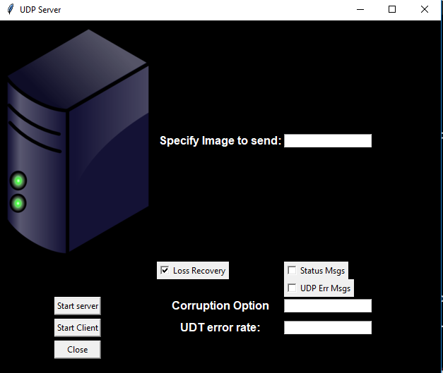
2. the terminal messages will appear (if relevant checkboxes are clicked) of what is happening as seen below.   
   A black sign with white text

   Description automatically generated
3. At the end of the bidirectional transfer, the client will print out the completion time for the transfer. This printout happens whether or not the checkboxes are clicked.
4. New files will be named “client_recv.jpg” and “server_recv.jpg” depending on which entity they were received by.
5. Click client again to re-run the client or click close to exit. Entering a new image to send, or corruption/debug options will be applied when client is run again.

**Results:**

The below images show test output of the program using a ~1MB file (spongebob.jpg, included), and corruption options 1, 2, 3, and 4 and 5 respectively with 20% error rate where applicable. “Status Msgs” and “UDP Err Msgs” output was enabled for these images. (Note: full output to completion of transfer was not included for options 2-5 as it was many pages long).

Test Output, Corruption Option 1

Test Output, Corruption Option 2 with 20% Error Rate

Test Output, Corruption Option 3 with 20% Error Rate

Test Output, Corruption Option 4 with 20% Error Rate

Test Output, Corruption Option 5 with 20% Error Rate

Finally, to test the result of different corruption options and error percentages, tests were run to compare time-to-finish the bidirectional image transfer at increments of 5% error rate for corruption options 2 through 5, and compared with a control timing that was conducted with corruption option 1. For these tests, the same ~1MB jpg file noted above was used, and all debugging print statements were turned off. Also, the default timeout value of 50ms, and window size of 10 (defined in config.py) was used. From these results, a plot was created. Each data-point in the plot represents the average of 3 trial runs at the given bit error rate. This plot can be seen below. We have also included phases 3 through 5 for reference to our selective repeat implementation.

Phase 3

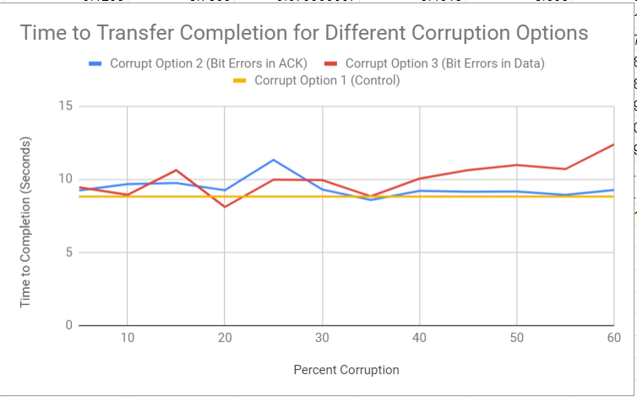

Phase 4

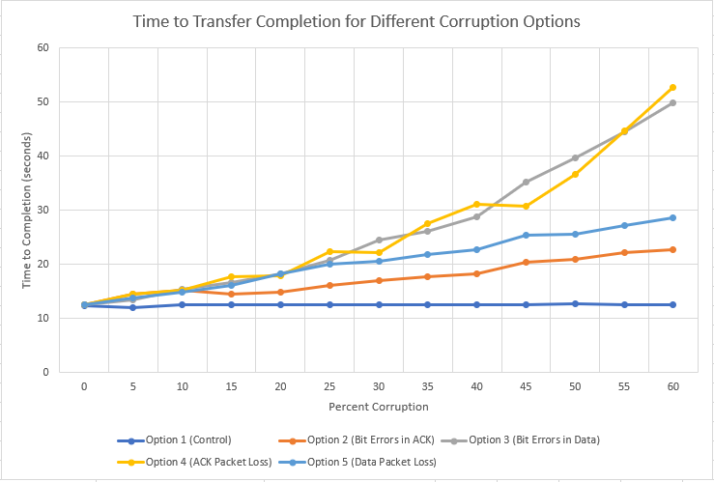

Phase 5 – Go Back N

Phase 6 – Selected Repeat

From this graph we see that all options have a somewhat linear growth. It takes longer for packet loss, as seen in Option 4 and Option 5. The reason for faster times then previous Phase’s is because of the collective ACK and the buffer on both the sender and receiver. Having two buffers allows the receiver tell the sender what packet is wrong and the sender should handle it accordingly. Option 2 has a slops of 0.043, which means it changes slightly overtime. Option 3 and Option 4 have close slopes, Option 3 at 0.153 and Option 4 at 0.159. Finally, Option 5 is the most influenced graph, having a slope of 0.167. Looking at this data, it proves that Selective Repeat can complete transfers quickly, as all the data transfers in under 20 seconds.

The next graph is the Time to Complete with a fixed loss rate of 10% while varying the window size. Again the trial was run 3 times each. Below is the results.

Here we see a window size a small window size will change the time to transfer time by almost 4 seconds. We found that a window size of 50 made it so the control case and test cases were around 9 seconds. The reason for these times being so close can be because of the two buffers. When a bad packet or loss happens the receiver only needs to resend the bad packet. Packets can come out of order and still be put into the right order. This is what makes Selective Repeat better than Go-Back-N. To conclude, a bigger window size, say 50, will make the times to transfer near identical to the control.

The last chart is comapring Phase 3, Phase 4, and Phase 5.

Here we see that Phase 6 is clearly the fastest time to complete. It has the most linear line, just under 10 seconds. This was done for 10% corruption for each of the different options. With this graph it proves that having two buffers in a Selective Repeat manner, your time to complete is much faster.