Ultrasound Lab

Machine operation and data acquisition
In this lab, you will become familiar with the controls of an ultrasound scanner while imaging a tissue-mimicking phantom. You will then acquire the radio-frequency (RF) data of the ultrasound scanner to form your own ultrasound images. It is important to keep the following in mind while you participate in this lab:
- The equipment you will be using in this lab is used by researchers everyday. Therefore, please respect the equipment.
- Handle the transducers with care. Do not drop them, as they are extremely expensive. When not in use, place the transducers in the transducer holders, located to the right of the control panel, and press the 'Freeze' button (see figure at end of the lab) to disable transmitting. Pressing the 'Freeze' button again will enable transmitting.
- Do not scan yourself or any person in your lab. The software in this scanner has not been approved for imaging humans.
- Please follow all directions carefully. This is a research scanner and can easily crash. Following the directions can help prevent crashes, damage to the scanner and the transducers, and will keep you moving quickly through this lab. If you encounter any problems or crashes, please find David in Hudson Annex room 251.

The scanner will most likely have imaging disabled when you arrive. To enable imaging, select the 'Freeze' button. The 'Freeze' button is the large blue button in the direct center of the control panel labeled with a snowflake. When imaging is disabled, the 'Freeze' button will be illuminated with a blue light.

- Find the RMI 408 spherical lesion phantom and remove the cover. Keep the phantom in the plastic container, because it leaks water. Pour enough water into the well on the top of the phantom to cover the surface of it. The water will provide a suitable contact between the transducer and the imaging medium. Place the VF7-3 transducer in the clamp of the ring stand, and tighten the clamp screws. Arrange the transducer so that it touches the surface of the phantom. Note, the shallow layers of the phantom have delaminated, so you will likely need to press down the transducer slightly on the phantom surface to couple the phantom layers together. Do not press down with too much force, as that will further damage the phantom and/or transducer. Press down just enough to remove the horizontal reverberation bands on the image.
- Find an imaging plane in the phantom that displays 4mm lesions throughout the field-of-view (FOV). This will likely not be a trivial task, but search the phantom and stabilize the transducer with the ringstand when you find a good imaging plane.

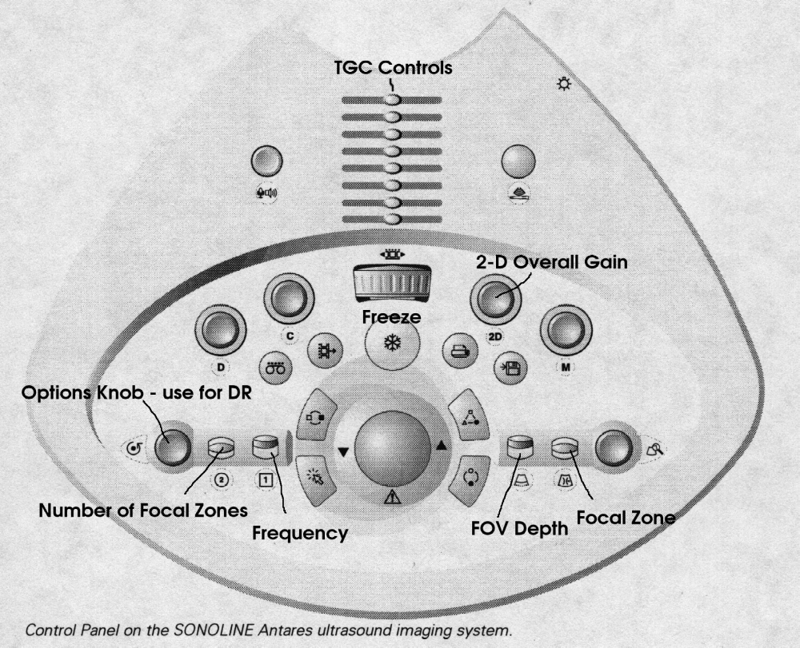

- Make sure the imaging depth is set to 4 cm. To change the imaging depth, locate the flip switch in the lower right corner of the control panel that is labeled with a trapezoidal figure (FOV Depth in the figure, which shows a trapezoid with a solid line, which has then been "extended" with a dotted line). Hit this switch up and down to change the imaging depth.
- Adjust the frequency in steps from 3.33MHz to 7.27MHz. Assess the impact of lesion visibility on effective scan depth. To change the transmit frequency, locate the flip switch in the lower left corner of the control panel that is labeled with a '1' encased in a square. Hit this switch up and down to change the frequency.
- Adjust the TGC Controls sliders to achieve a uniform brightness throughout range (to the best of your ability). The TGC Controls sliders are the linear potentiometers located at the top middle of the control panel. These can be moved from side to side to increase or decrease gain for the corresponding depth region of the image. Note the graphical display bar on the right hand side of the imaging screen as you move these controls.
- Adjust the 2-D Overall Gain to give the “best” presentation of the lesions. The knob labeled 2-D (middle, right) will adjust the gain.
- Adjust the transmit Focal Zone location in 1cm increments to 5cm. Assess the impact of lesion contrast as a function of range. To change the transmit focus, locate the flip switch in the lower right corner of the control panel which is labeled with two curved lines and an arrow pointing to the center of the lines. Hit the switch up and down to change the focal zones.
- Modify the dynamic range (DR) from 30 dB to 70 dB. Assess the impact on lesion visibility. To change the DR, locate the knob in the furthest lower left corner of the control panel that is labeled with dot encircled by an arrow. When you rotate this knob, the options on the left side of the screen are highlighted in blue. Rotate the knob until the option DR is highlighted. Press on the knob, and the option should now be highlighted in pink. Rotate the knob again to adjust the DR. At different DR levels, adjust the 2-D gain and TGC and observe the contrast of the lesions. Pressing on the knob again will release the option and allow you to select another option.
- Change the number of transmit focal zones from 1 to 4. Assess the impact on frame rate and lesion visibility. To change the number of focal zones, locate the flip switch in the lower left corner of the control panel labeled with a 2 surrounded by a circle. Hit this switch up and down to change the number of focal zones.

Now, you are ready to acquire single-channel RF echo data and create your own ultrasound images. Make sure the imaging depth is set to 4cm and the number of focal zones is 1. If these parameters are not set correctly the data acquisition will not work. Modify the parameters in steps 4 through 6 to generate the best possible image of the 4mm lesions. Record the value of the parameters you set (except TGC). Proceed with the following instructions to acquire the ultrasound channel data.
- On the scanner keyboard, hold down the Alt key and press the Tab key multiple times to select the Windows folder in the pop-up window. This should open a small window in the bottom left of the imaging screen. In the window you should see ‘grabData_Focused.bat’ and ‘grabData_Plane Wave.bat’. If this window is not there, use Alt+Tab to find the command prompt that says E:\IQBuild\ImagingSW\bin. Then type ‘Explorer’ to open Windows Explorer and navigate to the directory ‘C:\RadInPrac’. You are going to run 2 imaging scripts. The first script ‘grabData_focused.bat’ collects data using a focused transmit beam that is focused at 2.5 cm depth. The second imaging script ‘grabData_PlaneWave.bat’ transmits a single unfocused plane wave.
- Start with the focused acquisition and double click on the file ‘grabData_Focused.bat’. This will initiate the imaging script. When the script pauses (It will ask you to 'Press Enter to continue' in a new pop-up window), position the lesions of interest so that they are centered between the two thin black lines in the image. Click enter to continue the script and the scanner will begin to acquire data at this point. Do not bump or move the transducer or stand, as this will corrupt the data set. Acquisition should take about a minute. If you do accidentally move the scanner, simply re-run the acquisition script. This will save a file called ‘imageData.bin’ on the scanner that you will access in the next step.
- On the laptop next to the scanner, open Windows explorer and go to the Z:\zdt\imageData\ directory. If the laptop is logged out, log into the ‘BME848’ account with the password ‘trahey’. AT LEAST ONE GROUP MEMBER SHOULD BRING A THUMB DRIVE. Copy the file named imageData.bin to your thumb drive. (If you have run the script multiple times, or the person before didn’t delete their file, the filename will be the same, except that there will be a number appended to the end of the filename. Just be sure to copy the latest file.) Also, copy the script readBinData.m to your thumbdrive. You will need this file to process your data.
- Complete steps 2–3, but instead of ‘grabData_Focused.bat’ use the script ‘grabData_PlaneWave.bat’. Note, if the ‘grabData_Focused.bat’ created ‘imageData.bin’, then ‘grabData_PlaneWave.bat’ will create the data file ‘imageData2.bin’.
- Delete your data files from the Z:\ drive and remove your thumb drive.
- When finished, take down the setup. Return the transducer to the ringstand. Minimize (don’t close!!!) any windows on the scanner and hit the ‘Freeze’ button on the scanner control panel. Leave all windows open on the computer and do not log out.

Lab Writeup & Creation of B-mode images
Your task now is to create B-mode images from the raw single-channel data you collected for both the focused and plane wave cases. The parameters that you will need to complete this lab are as follows:
Transducer Element Spacing: 0.201 mm
Number of elements: 192
Number of Lines Acquired: 41 lines about the center of the array
Beam Spacing: 0.177 mm
Sampling Rate: 40 MHz
To view your data, copy your data file and the m-file to hard disk. In the same directory as the files, open Matlab. Use the command x=readBinData(‘imageData.bin’); to import the data. The first dimension of the matrix x is the sample number. The second dimension is the element number, and the third dimension is the A-line. Use help readBinData for further information. Note that time t = 0 begins at sample 10.

  - You will produce several images with the signal processing steps covered in class including: delay-and-sum beamforming (for receive only), bandpass filter, TGC, envelope detection, and image compression. Assume a sound velocity of 1540 m/s, a 2.5 cm focus for the beamformer, and a 50% fractional-bandwidth from the bandpass filter. Use a compression value of x = 0.6 for gray scale mapping. Create the following images with the correct perspective for both the focused transmit and plane wave transmit datasets.
- A fixed receive focus image of the transmit beam profile for the central transmit beam (note this is not the beamformed image, just that of a single transmit).
- A fixed receive focus beamformed image
- A dynamically focused image (on receive) with a minimum of 5 focal position updates.
- (a) and (b) above, apodized with two different cosine profiles. Include your apodization profiles next to your images.
- Apply gray scale transfer curves to the images in (c) with compression values of x = 0.2, 0.6, and 0.9. Which gray scale transfer curve, focusing configuration, and apodization yields the best lesion conspicuity?
In your report, show all images from each part (except part e - just show the best image). Discuss the effect of dynamic receive focusing, apodization, and image compression on the final image.

  - In your best case image for both the focused and plane wave transmits, calculate the contrast and CNR for a lesion closest to the imaging depth of 2.5 cm. Compare and discuss these values between the focused and plane wave cases. What is the maximum achievable imaging frame rate for the focused and plane wave cases?

Extra Credit: Most manufacturer's apply an aperture growth formula during beamforming to keep a constant resolution. Implement aperture growth in your beamforming process and compare it to the images in part (e). You should consider the effects of aperture growth on TGC.

