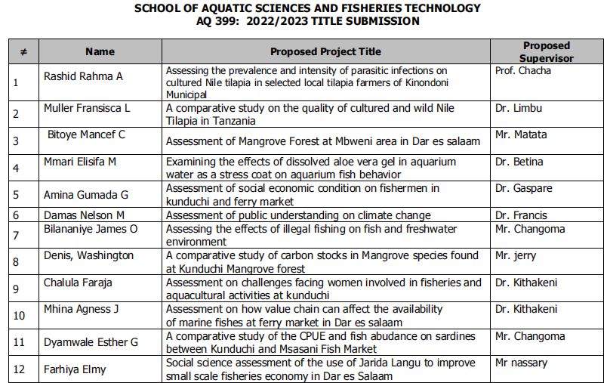

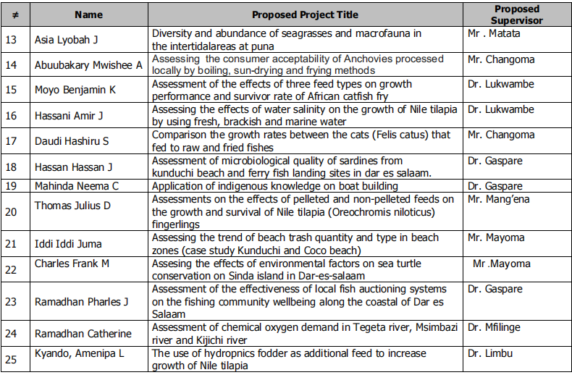

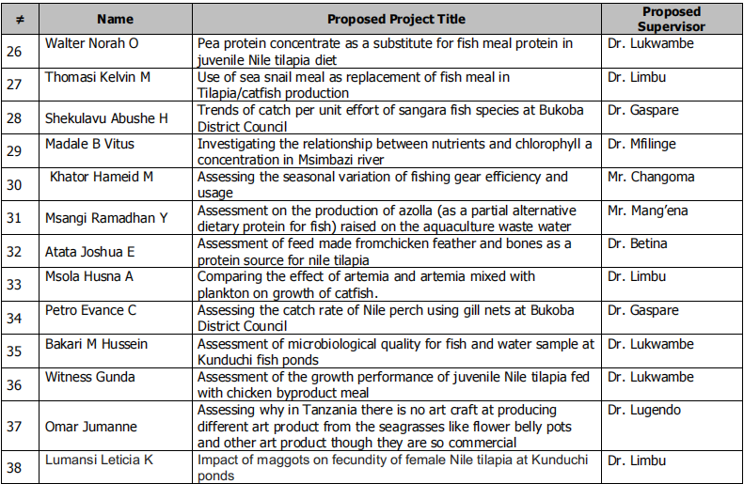

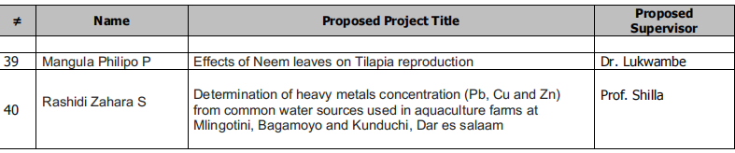

|  |  |  |  |
| --- | --- | --- | --- |
| # | NAME | PROPOSED PROJECT TITLE | PROPOSED SUPERVISOR |
| 41 | Stephen Lewis Mtalemwa | Is sardine fishing the cause of for decreased fish abundance in Lake Victoria | Dr Gaspare |
| 42 | Nsanzugwako Thomas Nestory | Assessment of the extent of marine oil spills and its response at Dar es salaam | Dr Julius |
| 43 | James Joyna | Determining and addressing reasons of conflict between seaweed farmers and fishermen in bagamoyo seaweed farms | Dr Gaspare |
|  |  |  |  |