Seasonal variation of subsurface chlorophyll maximum along Tanzania waters

Nyamisi Peter1,4, Charles Lugomela2, Margareth Kyewalyanga3

1University of Dar es Salaam, P.O. Box 35061, Dar es Salaam, Tanzania

2Nelson Mandela African Institution of Science and Technology, P.O.Box 447, Arusha, Tanzania

3Institute of Marine Sciences, P.O. Box 668, Zanzibar, Tanzania

4University of Dodoma, P.O. Box 338, Dodoma, Tanzania

29/06/2020

Table of Contents

# Abstract

Study on variation and distribution of chlorophyll-*a* fluorescence at subsurface chlorophyll maximum (SCM) layer was conducted along coastal waters of Tanzania in northeast (NE) and southeast (SE) monsoon seasons. Data was collected along five transects; at Zanzibar, Kimbiji, Mafia, Lindi and Mtwara. Subsurface chlorophyll maximum occurred at significant higher depth (greater than 50 m) in NE than in SE monsoon season (W = 0.15, *p* < 0.05) at all transects. There was a significant higher fluorescence concentration at SCM during SE than NE monsoon season for all transects (W = 324, *p* < 0.05). Higher chlorophyll fluorescence at shallower depth in SE monsoon season at SCM layer is associated with high nutrient concentration brought by vertical mixing of water column as a result of high wind stress and low sea surface temperature in this season. Surface layer of the ocean had significant lower chlorophyll fluorescence than SCM layer for both NE (W = 905, *p* < 0.05) and SE (W = 210, *p* < 0.05) monsoon season. Areas away from the coast, had higher chlorophyll fluorescence during NE and lower in SE monsoon season at SCM layer. Lower fluorescence concentration away from the coast in SE monsoon season at SCM, is a result of poor nutrient, higher salinity and warmer water drained by East Africa Coastal Current (EACC) to these areas.

# Introduction

Vertical distribution of chlorophyll-*a* in aquatic systems often exhibits a maximum peak in water column, known as subsurface chlorophyll maximum (SCM) (Cullen, 2015; Leach et al., 2018). The SCM is a subsurface layer below the surface mixed layer enriched in chlorophyll-*a* (Chl-*a*) in aquatic water bodies (Cullen, 2015; Latasa et al., 2017; Scofield et al., 2017). SCM occurs because phytoplankton balance opposing gradients of light from above with availability of nutrients, which often increase with depth under stratified conditions (Holm-Hansen and Hewes, 2004; Leach et al., 2018). This layer also forms as a result of different processes including in situ phytoplankton growth at depth, settling of algal cells and photoadaptation by phytoplankton (Cullen, 2015, 1982; Fennel and Boss, 2003; Latasa et al., 2017; Leach et al., 2018; Scofield et al., 2017). In tropics, SCM occurs at depth greater than 50 m (Holm-Hansen and Hewes, 2004) and in Western Indian Ocean it occurs at around 50–75 m depth (Conkright et al., 1998; George et al., 2013; Owens et al., 1993; Wiggert et al., 2006). This layer is ecologically important as it play a major role in primary production and nutrient cycling and their location determine vertical habitats for primary consumers in aquatic environment (Leach et al., 2018). Studies show that, SCM can contribute more than 50% of primary production in oceans (Gong et al., 2017; Leach et al., 2018). Additionally, at SCM there is always high densities of aquatic creatures such as predators, heterotrophic protozoans and bacterial biomass that are higher than 10 times elsewhere in the water column (Leach et al., 2018).

Due to its ecological potential, studies on SCM are very important in understanding distribution and dynamics of marine ecosystems. Because of decline in amount of phytoplankton biomass around the world oceans, studies on distribution and dynamics of Chl-*a* are very important in understanding the productivity potential along the water column. Indeed, variations in the fish catches observed in the oceans are mainly explained by changes in chlorophyll-*a* concentration, which is an indicator of the presence of phytoplankton biomass (Valenti et al., 2015).

Previous research in Tanzania studied phytoplankton and Chl-*a* at surface of the ocean. For example a study by Bryceson (1977); Lugomela (1996) and Kyewalyanga (2002) determined biomass and abundance of phytoplankton as well as primary production along Tanzania coastal surface waters. Other studies used both in situ and satellite data to determine the abundance and distribution of phytoplankton at Zanzibar and Pemba Channels (Peter, 2013). A study by Semba et al. (2016) assessed how the decrease in Chl-*a* impact on prawn catches at Rufiji-Mafia Channel. Other studies estimated the amount of primary production using carbon 14 (14C) in Zanzibar waters (Kyewalyanga, 2002; Lugomela et al., 2002; Wallberg and Andersson, 2000). Other studies looked on effects of environmental variables on spatial and seasonal variation of Chl-*a* at Unguja Zanzibar (Peter et al., 2018). Also, studies by Limbu and Kyewalyanga (2015); Lugomela (1996) and Bryceson (1977) determined phytoplankton species composition in Tanzania coastal waters.

These studies help to understand the distribution and abundance of phytoplankton, seasonal and spatial variation of Chl-*a* concentration, primary production as well as phytoplankton species composition in Tanzania surface waters. However, information on the vertical distribution of chlorophyll-*a* along the water column which contribute significantly in total marine primary production is poorly understood. This study dealt with (1) Determine the depth at which SCM occurs in northeast (NE) and southeast (SE) monsoon season (2) Determine the concentration of chlorophyll-*a* at SCM in both NE and SE monsoon season (3) Comparison of Chl-*a* between the surface layer and SCM layer.

# Methodology

## Study site

This study was conducted along coastal waters of Tanzania in Indian Ocean. There were five study sites at Zanzibar, Kimbiji, Mafia, Lindi and Mtwara (Figure 1). At each site, there were one transect which had different sampling stations. Zanzibar site is located at eastern coast of Zanzibar Island. Due to its distant from Zanzibar town, eastern side of Zanzibar Island have little influence from human activities (Peter et al., 2018). The Kimbiji site locates in the southern side of Dar es Salaam and in northern of Mafia Channel. Mafia site locates in the south-east of Mafia Island but within the Mafia Marine park and reserve area. Lindi and Mtwara are found in southern coast of Tanzania. Mtwara borders Mozambique country while Lindi is in the northern of Mtwara.

The coastal area of Tanzania have a tropical climate like other country in the western Indian Ocean. The climate is associated with monsoon winds; the northeast monsoon winds (NE) which starts from November to March and southeast monsoon (SE) from May to September (Nyandwi, 2013). The NE monsoon is characterized by weaker winds blowing from north to south and mean sea surface temperature of 30oC (Peter et al., 2018; Semba et al., 2016). SE monsoon winds are usually strong and blowing from south to north and characterized by mean sea surface temperature of 23oC (Mahongo et al., 2011; Peter et al., 2018; Semba et al., 2016). Coastal regions of Tanzania have two rain seasons; the short rain season which starts from October to December and the long rain season from March to May (Diop et al., 2016; Mahongo, 2015; Peter et al., 2018; Semba et al., 2016).

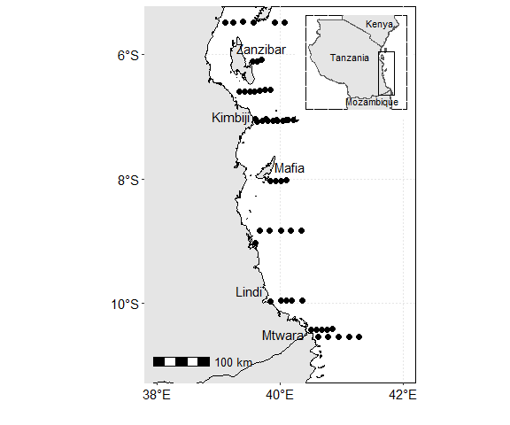

Figure 1: Map showing location of study sites at Tanzania waters. Black filled cycles show sampling stations along transect. An inset map shows location of study area at Tanzania

## Data collection

Data for this study was obtained from the 2004 Algoa cruise and 2017 International Indian Ocean Expedition 2 (IIOE-2) onboard Agulhas II. The southeast monsoon (SE) data was collected on August 2004 and northeast monsoon (NE) on November 2017 and all were sampled in coastal waters of Tanzania. Fluorescence data were sampled along the water column and recorded using Conductivity Temperature Depth, CTD (make Seabird 11 plus, Seabird Electronics, USA).

## Data processing

The raw CTD data was converted to the *.cnv* file format using the sea bird (SBE) software. The *.cnv* data format was imported to R software and processed using **oce** package (Kelley and Richards, 2020). A for loop function was used to iterate data for CTD stations at each transect for both NE and SE monsoon season. A dir() function was used to create a list of all CTD files in the working directory. A dummy file that stored CTD files was then created using a list() function. The read.ctd() function was used to read all CTD files in the working directory. The smoothing of all CTD profiles was done at a specific pressure of 1 using a ctdDecimate() function and only the downcast values of the profiles was used for analysis.

The list CTD files were then converted to section using as.section() function which was then grouped with their respective stations. Each station was converted into a dataframe using a for() loop function. Data for all stations were grouped together using bind_rows() function.

The which.max() was used to determine the index at which subsurface chlorophyll maximum (SCM) belongs for each sampling station. The location of the station, pressure (depth), fluorescence and other variable of interest at DCM was also calculated from the index obtained. Thereafter, all NE and SE monsoon season data at SCM layer were grouped together using bind_rows() function of **dplyr** package (Wickham et al., 2020) and make a single data frame.

The mean depth and chlorophyll fluorescence together with their standard error at SCM was calculated for all sampling stations. The sampling stations were grouped into transects; Zanzibar, Kimbiji, Mafia, Lindi and Mtwara based on latitude at which stations occurs.

# Results

## Seasonal and spatial variation of fluorescence and depth at SCM

Variation of subsurface chlorophyll maximum (SCM) at different seasons and transects are shown in Figure 2. The result showed that, during northeast monsoon season SCM occurred at deeper waters (between 50 and 70 m) than in SE (between 30 and 50 m) monsoon season at both Zanzibar, Kimbiji, Mafia, Lindi and Mtwara transects (Figure 2a). The Wilcoxon rank sum test showed that, there is a significant difference between depth at which SCM occurs in NE and SE monsoon season (W = 15, *p* < 0.05). While the depth at which SCM occurred increases from Zanzibar to Mafia in NE monsoon season, this depth decreases from Mafia to Mtwara site in the same season (Figure 2a). Contrary, fluorescence concentration was higher during the SE monsoon season than in NE monsoon (Figure 2b) at SCM for all transects. This difference in fluorescence concentration between NE and SE monsoon season was statistically significant during the study period (W = 324, *p* < 0.05). Figure 2a & b showed that, Lindi transect had higher fluorescence concentration but this was observed at shallower depth than other transects in SE monsoon season. Also, Zanzibar transect had lowest fluorescence concentration and this occurred at shallower depth than other transects in NE monsoon. Thus, there might be an association between amount of fluorescence concentration and the depth at which SCM occurs in different monsoon season.

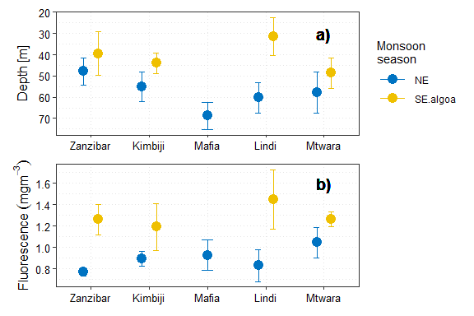

Figure 2: Seasonal and spatial variation of a) depth and b) fluorescence at SCM along the sampling transects

## Comparison between fluorescence at SCM and at surface layer

Seasonal variation of fluorescence concentration at SCM is shown in Table ?? . The result showed that, SE had higher fluorescence concentration than NE monsoon season at SCM. While chlorophyll fluorescence ranged between 0.50 and 1.39 mgm-3 with mean (mean $±$ standard error) of (0.87 $±$ 0.03) in NE monsoon season, it ranged between 0.599 and 2.13 mgm-3 and the mean (mean $±$ standard error) of (1.296 $±$ 0.06) in SE monsoon season (Table ??).

Variation of chlorophyll fluorescence at surface layer of the ocean is shown in Table ??. Like SCM, surface layer also had higher fluorescence concentration in SE than in NE monsoon season. Fluorescence ranged between 0.029 and 0.729 mgm-3 in NE monsoon season with the mean concentration (mean $±$ standard error) of (0.198 $±$ 0.036) (Table ??). During the SE monsoon season surface fluorescence ranged between 0.198 and 1.550 mgm-3 with the mean value (mean $±$ standard error) of (0.739 $±$ 0.110) (Table ??).

When comparing between surface and SCM layer, they showed that, amount of fluorescence at surface layer was lower than that at SCM in both NE and SE monsoon seasons (Figure 3). The Wilcoxon rank sum test showed that there is a significant difference in chlorophyll fluorescence between surface layer and SCM layer for both NE (W = 905, p < 0.05) and SE (W = 210, p < 0.05) monsoon season.

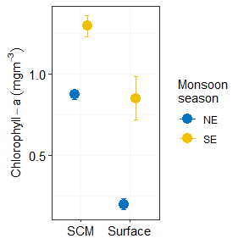

Figure 3: Seasonal variation of chlorophyll-a fluorescence at surface and SCM layer

## Isosurface at subsurface chlorophyll maximum and at surface layer

Distribution of fluorescence concentration at SCM within the sampled transects in NE and SE monsoon season are shown in Figure 4. The result shows that NE monsoon season had higher fluorescence concentration in areas away from the coast and lower in areas close to the coast (Figure 4a). Contrary, SE monsoon season showed higher fluorescence concentration in areas close to the coast and low away from the coast (Figure 4b). While most of areas between longitude 40°E and 41°E had higher fluorescence concentration greater than 1 mgm-3 in NE monsoon season, most of these areas showed low concentration below 1 mgm-3 in SE monsoon season. Also, areas between longitude 39°E and 40°E showed low fluorescence amount less than 1 mgm-3 in NE monsoon season, this area recorded higher concentration greater than 1.2 mgm-3 in SE monsoon season (Figure 4).

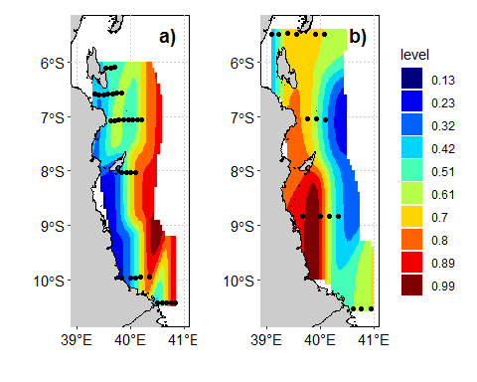

Figure 4: Fluorescence variation at subsurface chlorophyll maximum within sampled transects in a) northeast and b) southeast monsoon seasons

On the other hand, distribution of fluorescence at surface layer of the ocean also varied with seasons. During NE monsoon area in the eastern side of Unguja Island at longitude 39.5°E to longitude 40°E and latitude 6°S had higher concentration between 1 and 1.6 mgm-3 (Figure 5a). Other areas showed low fluorescence concentration less than 0.9 mgm-3 in this season. During the SE monsoon season areas between longitude 39°E and 40.5°E and latitude 10°S and 8°S had higher fluorescence between 1.2 and 1.6 mgm-3 (Figure 5b). Other areas had fluorescence less than 0.9 mgm-3 in SE monsoon season. When comparing Figure 4 and Figure 5 they show that there is higher fluorescence concentration at SCM than at surface layer in both NE and SE monsoon seasons.

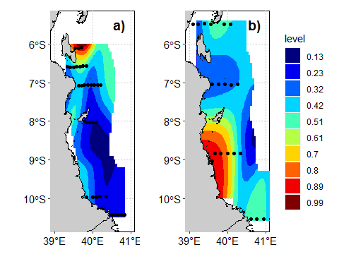

Figure 5: Fluorescence variation at surface layer within sampled transects in a) northeast and b) southeast monsoon seasons

# Discussion

The present study provides information on distribution of chlorophyll-*a* fluorescence at subsurface chlorophyll maximum (SCM) in northeast (NE) and southeast (SE) monsoon season along Tanzania coastal waters. The SCM occurred at shallower depth, less than 50 m in SE monsoon season, unlike the NE monsoon which occurred at deeper waters greater than 50 m (Figure 2a). Also SE monsoon recorded significant higher fluorescence concentration than NE monsoon season for all transects (Figure 2b). Availability of high fluorescence concentration at shallower depth in SE monsoon can be linked with environmental characteristics during this season. High wind stress and relative low sea surface temperature in SE monsoon lead to vertical mixing of water column as a result nutrient flux from the bottom are brought close to the surface where maximum light is available for photosynthesis (George et al., 2013; Mahongo et al., 2011; Richmond, 2011). This in turn cause SCM with high chlorophyll-*a* fluorescence at shallower depth during SE monsoon season. The reverse of monsoon winds with less wind stress and higher sea surface temperature in NE monsoon season cause poor mixing of the water column (George et al., 2013; Mahongo et al., 2011; McClanahan, 1988; Richmond, 2011). Warmer water at surface of the ocean cause density difference between the upper nutrient poor and bottom nutrient rich waters as a result a thermocline will be established between these two water masses. This will prevent the nutrient from the bottom to penetrate the thermocline towards the surface where they can be used by phytoplankton in photosynthesis. This will cause SCM of low chlorophyll-*a* fluorescence to occur at relatively higher depth.

It was also observed that, chlorophyll-*a* fluorescence was higher in coastal waters and low in areas away from the coast at SCM during the SE monsoon season (Figure 4b). Area with low fluorescence concentration in SE monsoon coincide with passage of East Africa Coastal Current (EACC). Flushing of poor nutrient, high salinity and warmer water by EACC (Mahongo and Shaghude, 2014) leads to low fluorescence concentration around this area. Also, because SCM in SE monsoon season occurred close to surface, higher fluorescence concentration in nearshore areas might be attributed by runoff which lead to nutrient flux within these areas.

Also, the significant higher fluorescence concentration at SCM and surface of the ocean in both NE and SE monsoon season was also observed during the study period (Figure 3). Studies showed that, vertical distribution of Chl-*a* in marine environment is governed by nutrient concentration and light intensity (George et al., 2013). At surface layer, light is plenty while nutrient is limited for phytoplankton growth (Valenti et al., 2015). At depth, light becomes limiting while nutrients are plenty. Because of these two factors (nutrient and light), there is an increase in Chl-*a* within photic layer (Cullen, 1982; George et al., 2013; Valenti et al., 2015).

# Conclusion

Generally, studies on distribution of SCM is of great importance in marine and aquatic environment due to its ecological potential. The study revealed higher chlorophyll-*a* fluorescence at SCM than at surface layer. Also, SE monsoon season had higher concentration at SCM than NE monsoon and this was recorded at shallower depth in both Zanzibar, Kimbiji, Mafia, Lindi and Mtwara transects. Thus, the amount of chlorophyll fluorescence together with depth at which SCM occurs depends on the season of the area.

# Acknowledgement

We are thankful to the second International Indian Ocean Expedition (IIOE-2) and the Algoa cruise for allowing us to use their data.

# References

Bryceson, I., 1977. An ecological study of the phytoplankton of the coastal waters of dar es salaam (Thesis). University of Dar es Salaam, University of Dar es Salaam.

Conkright, M., O’Brien, T., Levitus, S., Boyer, T., Stephens, C., Antonov, J., 1998. World ocean atlas 1998. Vol. 12 of noaa atlas nesdis.

Cullen, J.J., 2015. Subsurface chlorophyll maximum layers: Enduring enigma or mystery solved?

Cullen, J.J., 1982. The deep chlorophyll maximum: Comparing vertical profiles of chlorophyll a. Canadian Journal of Fisheries and Aquatic Sciences 39, 791–803.

Diop, S., Scheren, P., Machiwa, J.F., 2016. Estuaries: A lifeline of ecosystem services in the western indian ocean. Springer.

Fennel, K., Boss, E., 2003. Subsurface maxima of phytoplankton and chlorophyll: Steady-state solutions from a simple model. Limnology and Oceanography 48, 1521–1534.

George, J.V., Nuncio, M., Chacko, R., Anilkumar, N., Noronha, S.B., Patil, S.M., Pavithran, S., Alappattu, D.P., Krishnan, K., Achuthankutty, C., 2013. Role of physical processes in chlorophyll distribution in the western tropical indian ocean. Journal of Marine Systems 113, 1–12.

Gong, X., Jiang, W., Wang, L., Gao, H., Boss, E., Yao, X., Kao, S.-J., Shi, J., 2017. Analytical solution of the nitracline with the evolution of subsurface chlorophyll maximum in stratified water columns. Biogeosciences 14, 2371.

Holm-Hansen, O., Hewes, C.D., 2004. Deep chlorophyll-a maxima (dcms) in antarctic waters. Polar Biology 27, 699–710.

Kelley, D., Richards, C., 2020. Oce: Analysis of oceanographic data.

Kyewalyanga, M., 2002. Spatial-temporal changes in phytoplankton biomass and primary production in chwaka bay, zanzibar. Tanzania Journal of Science 28, 11–26.

Latasa, M., Cabello, A.M., Morán, X.A.G., Massana, R., Scharek, R., 2017. Distribution of phytoplankton groups within the deep chlorophyll maximum. Limnology and Oceanography 62, 665–685.

Leach, T.H., Beisner, B.E., Carey, C.C., Pernica, P., Rose, K.C., Huot, Y., Brentrup, J.A., Domaizon, I., Grossart, H.-P., Ibelings, B.W., others, 2018. Patterns and drivers of deep chlorophyll maxima structure in 100 lakes: The relative importance of light and thermal stratification. Limnology and Oceanography 63, 628–646.

Limbu, S.M., Kyewalyanga, M.S., 2015. Spatial and temporal variations in environmental variables in relation to phytoplankton composition and biomass in coral reef areas around unguja island, tanzania. Journal of SpringerPlus 4, 1–18.

Lugomela, C., 1996. Studies of phytoplankton in the near shore waters of zanzibar (Thesis). University of Dar es Salaam, University of Dar es Salaam.

Lugomela, C., Lyimo, T.J., Bryceson, I., Semesi, A.K., Bergman, B., 2002. Trichodesmium in coastal waters of tanzania: Diversity, seasonality, nitrogen and carbon fixation. Hydrobiologia 477, 1–13.

Mahongo, S., 2015. Sea/air interaction, in: Jose, P. (Ed.), The Regional State of the Coast Report: Western Indian Ocean. UNEP-Nairobi Convention; WIOMSA, Nairobi, pp. 199–210.

Mahongo, S.B., Francis, J., Osima, S., 2011. Wind patterns of coastal tanzania: Their variability and trends. Western Indian Ocean Journal of Marine Science 10, 107–120.

Mahongo, S.B., Shaghude, Y.W., 2014. Modelling the dynamics of the tanzanian coastal waters. Journal of Oceanography and Marine Science 5, 1–7.

McClanahan, T., 1988. Seasonality in east africa’s coastal waters. Marine Ecology Progress Series 44, 191–199.

Nyandwi, N., 2013. The effects of monsoons on the east african coastal current through the zanzibar channel, tanzania. The Journal of Ocean Technology 8, 65–74.

Owens, N., Burkill, P., Mantoura, R., Woodward, E., Bellan, I., Aiken, J., Howland, R., Llewellyn, C., 1993. Size-fractionated primary production and nitrogen assimilation in the northwestern indian ocean. Deep Sea Research Part II: Topical Studies in Oceanography 40, 697–709.

Peter, N., 2013. Phytoplankton distribution and abundance along the zanzibar and pemba channels (Thesis). University of Dar es Salaam, University of Dar es Salaam.

Peter, N., Semba, M., Lugomela, C., Kyewalyanga, M.S., 2018. The influence of physical-chemical variables on the spatial and seasonal variation of chlorophyll-a in coastal waters of unguja, zanzibar, tanzania. Western Indian Ocean Journal of Marine Science 17, 25–34.

Richmond, M.D., 2011. A field guide to the seashores of eastern africa and the western indian ocean islands. Sida/WIOMSA.

Scofield, A.E., Watkins, J.M., Weidel, B.C., Luckey, F.J., Rudstam, L.G., 2017. The deep chlorophyll layer in lake ontario: Extent, mechanisms of formation, and abiotic predictors. Journal of Great Lakes Research 43, 782–794.

Semba, M., Kimirei, I., Kyewalyanga, M., Peter, N., Brendonck, L., Somers, B., 2016. The decline in phytoplankton biomass and prawn catches in the rufiji-mafia channel, tanzania. Western Indian Ocean Journal of Marine Science 15, 15–29.

Valenti, D., Denaro, G., Spagnolo, B., Conversano, F., Brunet, C., 2015. How diffusivity, thermocline and incident light intensity modulate the dynamics of deep chlorophyll maximum in tyrrhenian sea. PLoS ONE 10, 1–31. <https://doi.org/10.1371/journal.pone.0115468>

Wallberg, P., Andersson, A., 2000. Transfer of carbon and phychlorinated biphenyl through the microbial food web in a tropical coastal ecosystem. Environmental Toxicology and Chemistry 19, 827–835.

Wickham, H., François, R., Henry, L., Müller, K., 2020. Dplyr: A grammar of data manipulation.

Wiggert, J., Murtugudde, R., Christian, J., 2006. Annual ecosystem variability in the tropical indian ocean: Results of a coupled bio-physical ocean general circulation model. Deep Sea Research Part II: Topical Studies in Oceanography 53, 644–676.