

Final Project Report
Advanced Computer Programming

AI Job Market Analyzer:
End-to-End Skill Extraction, Salary Prediction, and Trend Forecasting Engine

Group : 2
Instructor : DINH-TRUNG VU

2026-06

Introduction

Group Information
- Group Project Repository: https://github.com/nyamkabaaska1-prog/Group-2
- Group members:
  - Dulguun Munkhtur– 114021153 (leader)
  - Davaakhuu Naranbaatar– 114021154
  - Nyamdavaa Baasanjav– 114021164

Overview
The AI Job Market Analyzer is an end-to-end web application that automates remote job data workflows. The core engine pulls approximately 450 real-time job postings across software-dev, data, and devops spaces directly from the public Remotive API, cleans and normalizes the attributes, and handles structured storage via SQLite relational tables:
The following advanced Python features and libraries were used throughout the project:
- dataclasses — RawJob and TrainResult are typed, immutable value objects.
- Regular expressions (re) — salary range parsing from free text and skill extraction with word-boundary patterns.
- Type unions and optional types (PEP 604 X | Y syntax) — used pervasively across models, schemas, and ML code.
- functools.lru_cache — the skills taxonomy JSON is loaded and compiled once and reused for every request.
- Pydantic v2 (BaseModel, BaseSettings) — request/response schemas and environment-driven configuration.
- SQLAlchemy 2 mapped_column / Mapped — declarative ORM models with typed columns.
- scikit-learn Pipeline and ColumnTransformer — end-to-end feature preprocessing and GradientBoostingRegressor.
- pandas / numpy — weekly aggregations, rolling means, and linear-regression forecasting.
- httpx async client — non-blocking HTTP calls to the Remotive API.
- FastAPI lifespan context manager — database table creation on startup.
- React 18 + TypeScript + Recharts — interactive multi-page dashboard with charts.
The final system fetches approximately 450 real job postings across the software-dev, data, and devops categories, persists them in SQLite, exposes a JSON REST API, and renders five interactive pages: Dashboard, Jobs, Skills, Trends, and a Salary Predictor.

Implementation

Class 1: RawJob (backend/app/ingestion/remotive.py)
RawJob is a Python dataclass that acts as an immutable data-transfer object between the Remotive API client and the database persistence layer. It holds exactly the fields returned by the external API after cleaning, with no ORM or database dependency, keeping the ingestion layer decoupled from the storage layer.

Fields
- external_id: str — unique string identifier from Remotive.
- title: str — job title (e.g. 'Senior ML Engineer').
- company: str — hiring company name.
- category: str — Remotive category (software-dev, data, devops, …).
- location: str — candidate-required location string.
- is_remote: bool — always True for Remotive postings.
- description: str — HTML-stripped plain-text job description.
- salary_min: float | None — lower salary bound parsed from text, or None.
- salary_max: float | None — upper salary bound parsed from text, or None.
- posted_at: datetime — publication date parsed from the API response.
- url: str — direct link to the job posting.

Class 2: Job (backend/app/models.py)
Job is a SQLAlchemy 2 ORM model mapped to the 'jobs' table. It uses the modern Mapped[T] / mapped_column() annotation style introduced in SQLAlchemy 2.0, which provides full static-type-checker support. It has a many-to-many relationship with Skill via the job_skills association table.

Fields
- id: Mapped[int] — auto-increment primary key.
- source: Mapped[str] — data source tag (default 'remotive').
- external_id: Mapped[str] — unique index, maps to RawJob.external_id.
- title, company, category, location: Mapped[str] — indexed string columns.
- is_remote: Mapped[bool] — remote flag.
- seniority: Mapped[str] — inferred level: junior / mid / senior / lead / principal.
- description: Mapped[str] — Text column (up to 5 000 characters stored).
- salary_min, salary_max: Mapped[float | None] — nullable Float columns.
- salary_predicted: Mapped[float | None] — stored model prediction.
- posted_at: Mapped[datetime] — indexed DateTime column.
- url: Mapped[str] — link to original posting.
- skills: Mapped[list[Skill]] — lazy-loaded relationship via job_skills.

Class 3: Skill (backend/app/models.py)
Skill represents one canonical technology name (e.g. 'Python', 'Kubernetes') stored in the 'skills' table. Skills are seeded from the taxonomy JSON at startup and reused across jobs.

Fields
- id: Mapped[int] — primary key.
- name: Mapped[str] — unique, indexed canonical skill name.
- category: Mapped[str] — taxonomy group (languages, frameworks, cloud, data, ml, databases).
- jobs: Mapped[list[Job]] — back-reference relationship through job_skills.

Class 4: TrainResult (backend/app/ml/salary.py)
TrainResult is a dataclass that encapsulates the outcome of a single model training run so the caller can log diagnostics without coupling to sklearn internals.

Fields
- n_samples: int — number of salary-labeled jobs used for training.
- mae: float | None — mean absolute error on the 20 % hold-out set; None when fallback is active.
- fallback_used: bool — True when fewer than 25 labeled samples were available.
- baseline: dict[str, float] — per-seniority median salaries used as a floor / fallback.

Class 5: _SkillVectorizer (backend/app/ml/salary.py)
_SkillVectorizer is a custom scikit-learn transformer that wraps MultiLabelBinarizer so it can sit inside a ColumnTransformer pipeline. Subclassing BaseEstimator and TransformerMixin allows sklearn's clone() and Pipeline to work correctly: clone() introspects __init__ parameters and reconstructs the object by name, requiring attributes to match.

Fields
- classes: list[str] — the fixed skill vocabulary fixed at construction time.
- mlb_: MultiLabelBinarizer — fitted binarizer, created during fit().

Methods
- fit(X, y=None) — initialises and fits MultiLabelBinarizer over the fixed vocabulary; returns self.
- transform(X) — converts each row's skill list into a binary vector of shape (n_rows, n_skills).

Class Settings (backend/app/config.py)
Settings extends Pydantic's BaseSettings so environment variables and a .env file are automatically parsed and validated at startup. It centralises all runtime-configurable parameters in one place.

Fields
- database_url: str — SQLAlchemy connection string (default: sqlite:///./data.db).
- remotive_api_url: str — base URL for the Remotive jobs endpoint.
- allowed_origins: str — comma-separated CORS origins for the frontend dev server.

Methods / Properties
- origins (property) — splits allowed_origins on commas and returns a clean list[str] for CORSMiddleware.

Pydantic Response / Request Schemas (backend/app/schemas.py)
All API input and output is validated through Pydantic v2 BaseModel subclasses with from_attributes=True so they can be constructed directly from SQLAlchemy ORM objects.
- SkillOut — id, name, category.
- JobOut — full job record with a nested list[SkillOut].
- JobsPage — paginated wrapper: total count + items list.
- SkillDemand — skill name, category, mention count, average salary.
- TrendPoint — single (week, count) data point.
- TrendSeries — skill name + history list + forecast list of TrendPoints.
- PredictRequest — title, optional skills list, is_remote flag, location.
- PredictResponse — predicted_salary, inferred seniority, confidence label, drivers list.
- DashboardStats — aggregated KPIs: total_jobs, total_skills, avg_salary, top_category, remote_pct.

Function parse_salary() (backend/app/ingestion/remotive.py)
Extracts a (min, max) salary pair from a free-text string. Handles both compact forms ($80k–$120k) and expanded forms ($80,000–$120,000) using a compiled regular expression.
_SALARY_RE = re.compile(
r"\$?\s*(\d{2,3})\s*[kK]?\s*[-–to]+\s*\$?\s*(\d{2,3})\s*[kK]?"
)
- Input: text: str — raw salary string or job description excerpt.
- Returns: tuple[float | None, float | None] — (min, max) in dollars, or (None, None) if no match.
- Normalisation: values below 1 000 are multiplied by 1 000 (k-suffix handling); pairs where min > max or max > 1 000 000 are rejected.

Function fetch_jobs() (backend/app/ingestion/remotive.py)
Async function that calls the Remotive REST API with optional category and limit parameters, cleans the HTML descriptions, parses dates, and returns a list of RawJob objects.
- Input: category: str | None, limit: int (default 200).
- Uses httpx.AsyncClient with a 30-second timeout.
- _clean_html() strips HTML tags with a regex, unescapes HTML entities, and collapses whitespace.
- Publication dates are parsed with python-dateutil; timezone info is stripped for SQLite compatibility.
- Returns: list[RawJob].

Function extract() (backend/app/ml/skills.py)
Scans a job description for mentions of any skill in the taxonomy and returns a de-duplicated list of canonical skill names.
- The taxonomy JSON (≈80 skills) is loaded once at process start via @lru_cache.
- Each skill entry compiles a regex pattern from its canonical name plus a list of aliases (e.g. 'JS' for 'JavaScript').
- Short names (≤ 2 characters, e.g. 'R', 'Go') are matched case-sensitively to reduce false positives.
- Word-boundary lookarounds prevent matching 'go' inside 'Django' or 'r' inside 'feature'.
- Returns: list[str] — canonical skill names found in text.

Function infer_seniority() (backend/app/ml/salary.py)
Determines the seniority level from a job title using a priority-ordered list of compiled regex patterns.

_SENIORITY_PATTERNS = [
("principal", re.compile(r"\bprincipal|staff|distinguished\b", re.I)),
("lead", re.compile(r"\blead|head of|manager\b", re.I)),
("senior", re.compile(r"\bsr\.?|senior|sr\b", re.I)),
("junior", re.compile(r"\bjr\.?|junior|entry|intern|graduate\b", re.I)),
]
- Patterns are evaluated top-to-bottom; the first match wins.
- Returns: str — one of 'junior', 'mid', 'senior', 'lead', 'principal' (default 'mid').

Function train() (backend/app/ml/salary.py)
Trains a salary prediction model and persists it to disk as salary_model.joblib. If fewer than 25 salary-labeled records exist, it stores a seniority-median baseline instead so the API always returns a sensible estimate.
- Input: records: list[dict] — each record has seniority, is_remote, skills: list[str], salary: float.
- Feature engineering: seniority is mapped to an ordinal integer (junior=0 … principal=4); skills are one-hot encoded via _SkillVectorizer; is_remote and n_skills are numerics scaled by StandardScaler.
- Model: GradientBoostingRegressor(n_estimators=200, max_depth=3, random_state=42) inside a ColumnTransformer → Pipeline.
- Evaluation: 80/20 train-test split; mean absolute error computed on the hold-out set.
- Returns: TrainResult.

Function predict() (backend/app/ml/salary.py)
Loads the persisted model bundle and returns a salary estimate, confidence label, and human-readable driver list for a single prediction request.
- Input: seniority: str, is_remote: bool, skills_list: list[str].
- Confidence is 'high' when ≥ 4 matched skills are supplied, otherwise 'medium'.
- Drivers highlight high-value skills (AWS, Kubernetes, PyTorch, TensorFlow, Go, Rust, LLM, MLOps, Snowflake, Databricks).
- Returns: tuple[float, str, list[str]] — (salary, confidence, drivers).

Function aggregate_weekly() (backend/app/ml/trends.py)
Groups (posted_at, skill_name) pairs by ISO week and skill, producing a time-series suitable for charting and forecasting.
- Input: rows: list[tuple[datetime, str]].
- Uses pandas groupby on (skill, week_key) and returns a dict mapping each skill to a sorted list of (week_str, count) tuples.
- Week keys follow the format YYYY-Www (e.g. '2026-W21').

Function forecast() (backend/app/ml/trends.py)
Projects the next horizon weeks of skill mentions using linear regression on a 3-week rolling mean of the historical series.
- Input: history: list[tuple[str, int]], horizon: int (default 8).
- Smoothing: pd.Series.rolling(window=3, min_periods=1).mean() reduces noise in sparse weekly counts.
- Model: sklearn LinearRegression fitted over integer time indices, predicting the smoothed counts.
- Output counts are clipped to ≥ 0 and rounded to integers.
- Returns: list[tuple[str, int]] — (week_key, predicted_count) for the next horizon weeks.

API Endpoints (backend/app/routers/)
The FastAPI application exposes the following REST endpoints:
Method | Path | Description
GET | /api/health | Liveness check — returns {status: ok}.
GET | /api/jobs | Paginated job list with optional filters: q (search), skill, seniority, limit, offset.
GET | /api/jobs/{id} | Single job by primary key; 404 if not found.
GET | /api/analytics/stats | Dashboard KPIs: total_jobs, total_skills, avg_salary, top_category, remote_pct.
GET | /api/analytics/skills/demand | Top-N skills by job-mention count with average salary.
GET | /api/analytics/categories | Job count grouped by category.
GET | /api/analytics/trends/{skill} | Weekly history + 8-week forecast for a named skill.
POST | /api/predict/salary | Predict annual salary from job title, skill list, and remote flag.

Frontend Pages (frontend/src/pages/)
The React single-page application is built with Vite, TypeScript, Tailwind CSS, and Recharts. It communicates with the backend through a typed fetch client (api.ts) that wraps the native fetch API.
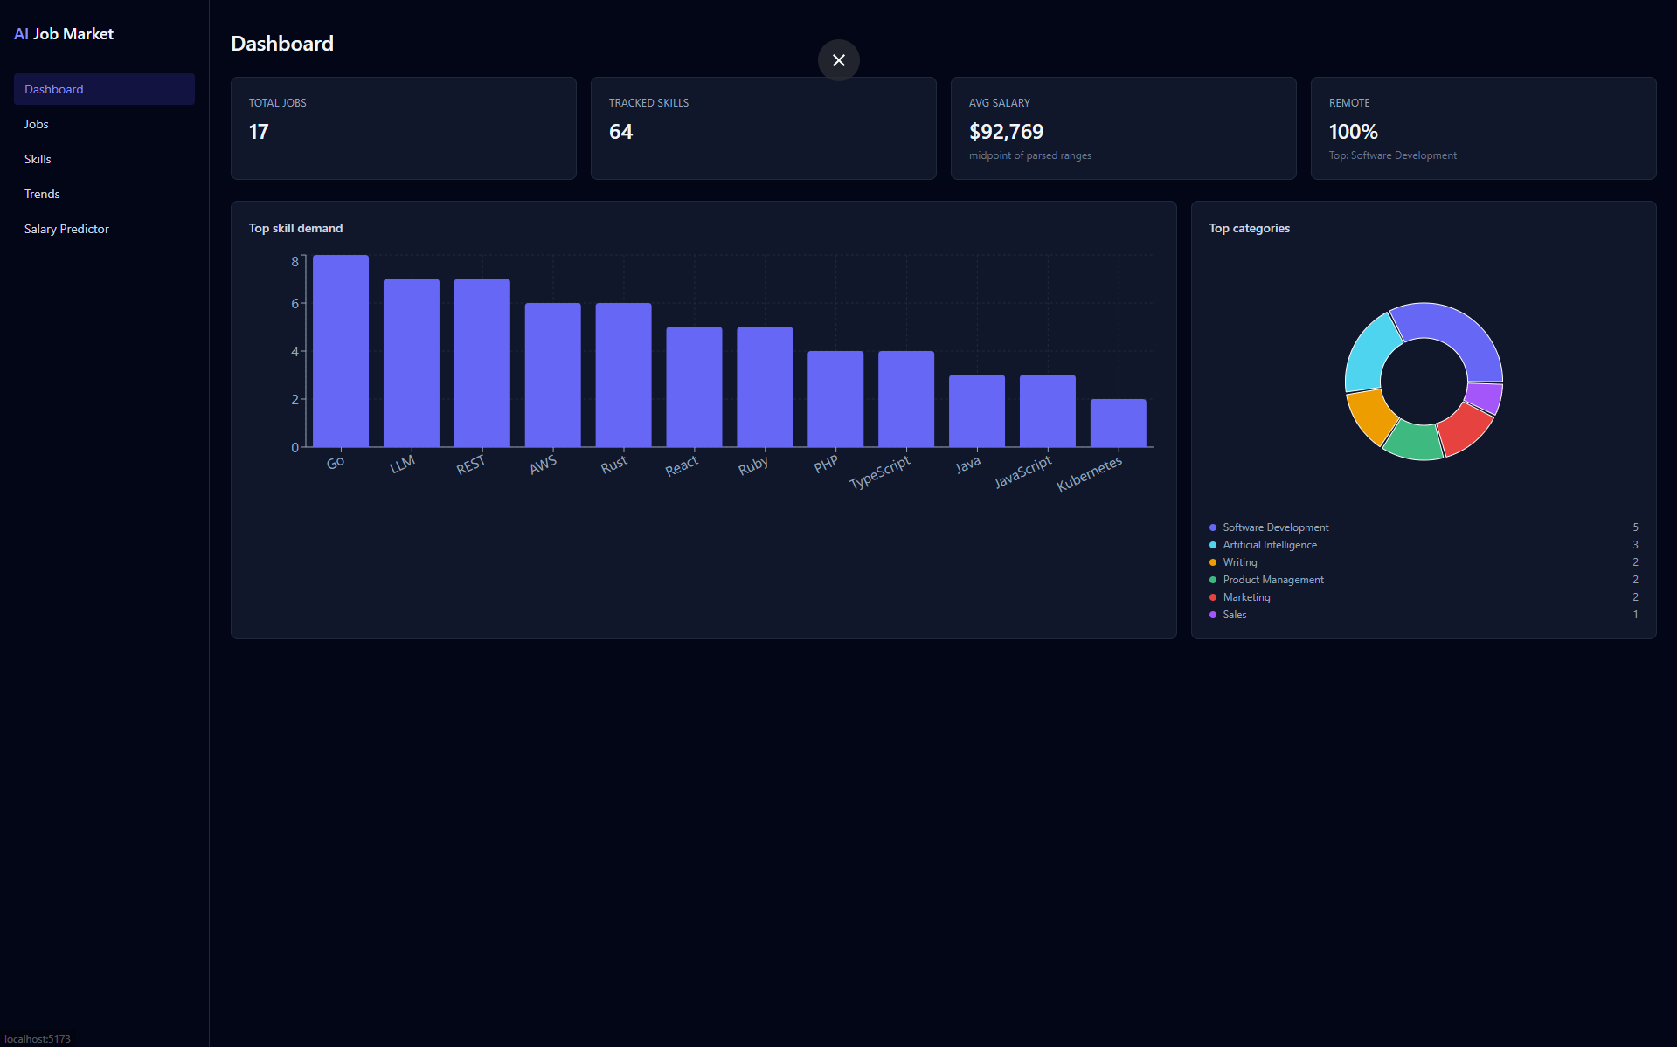
Figure 1. Dashboard — KPI stat cards, bar chart of top skill demand, pie chart of job categories

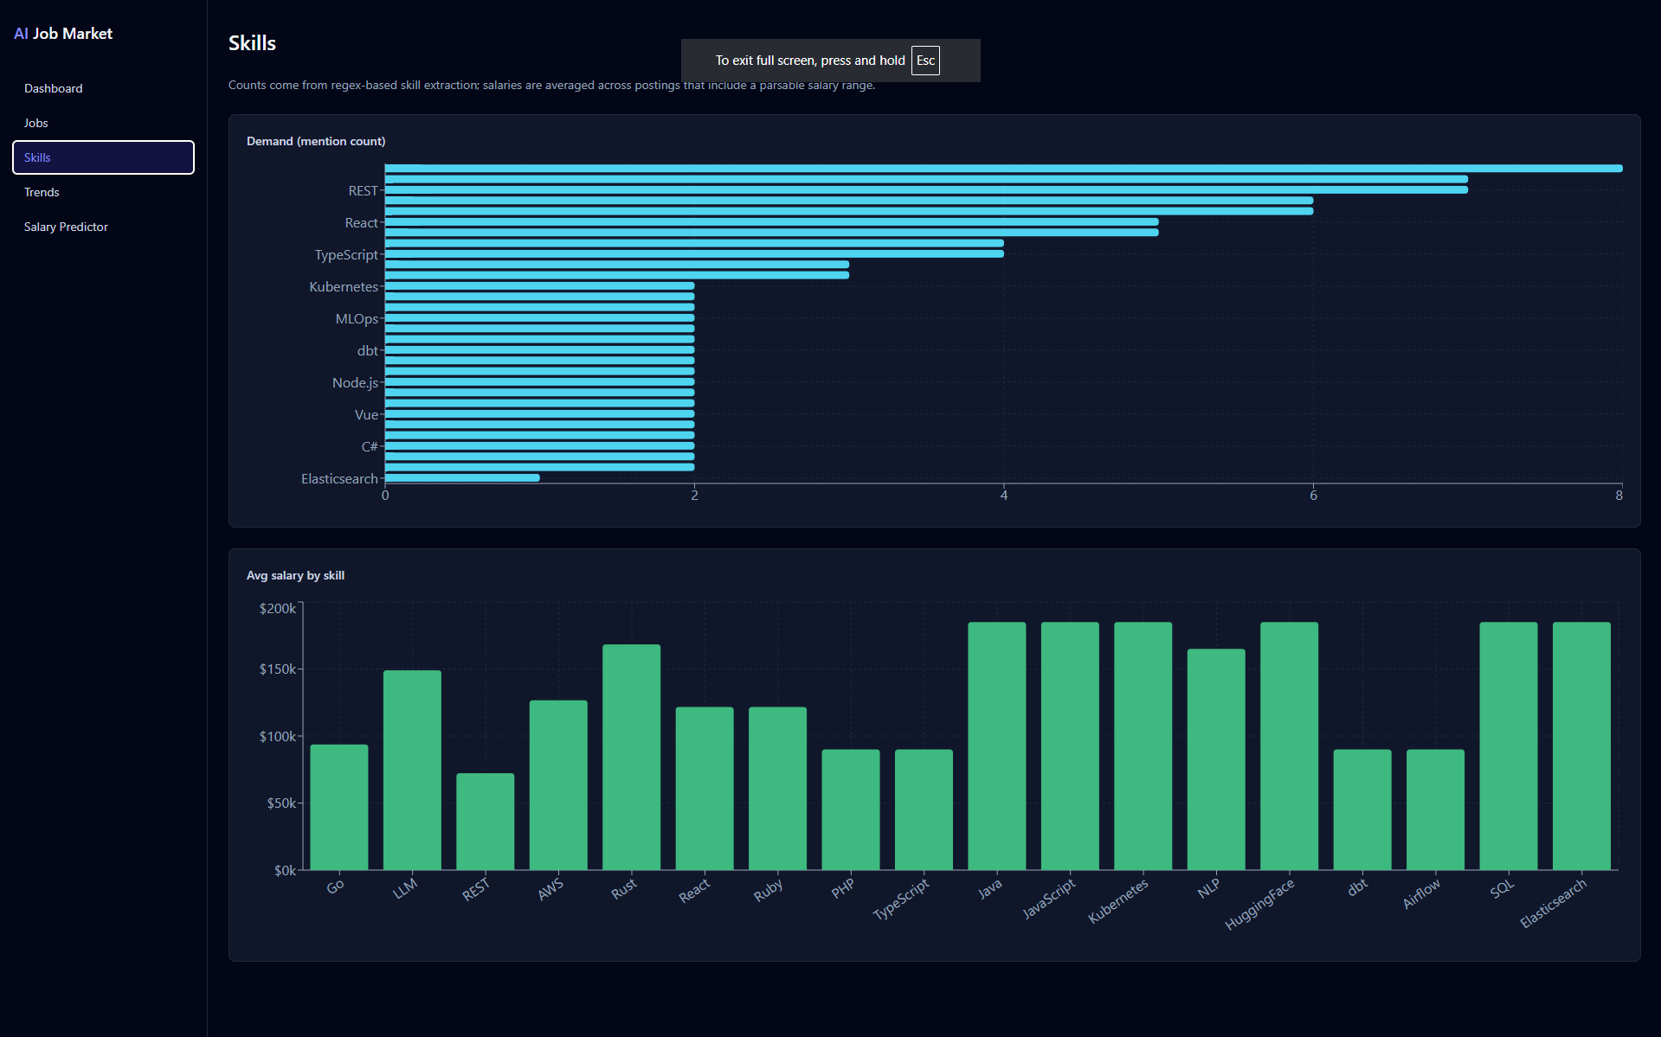
Figure 2. Skills — Bar chart of top 30 skills by mention count and a second bar chart of average salary per skill.
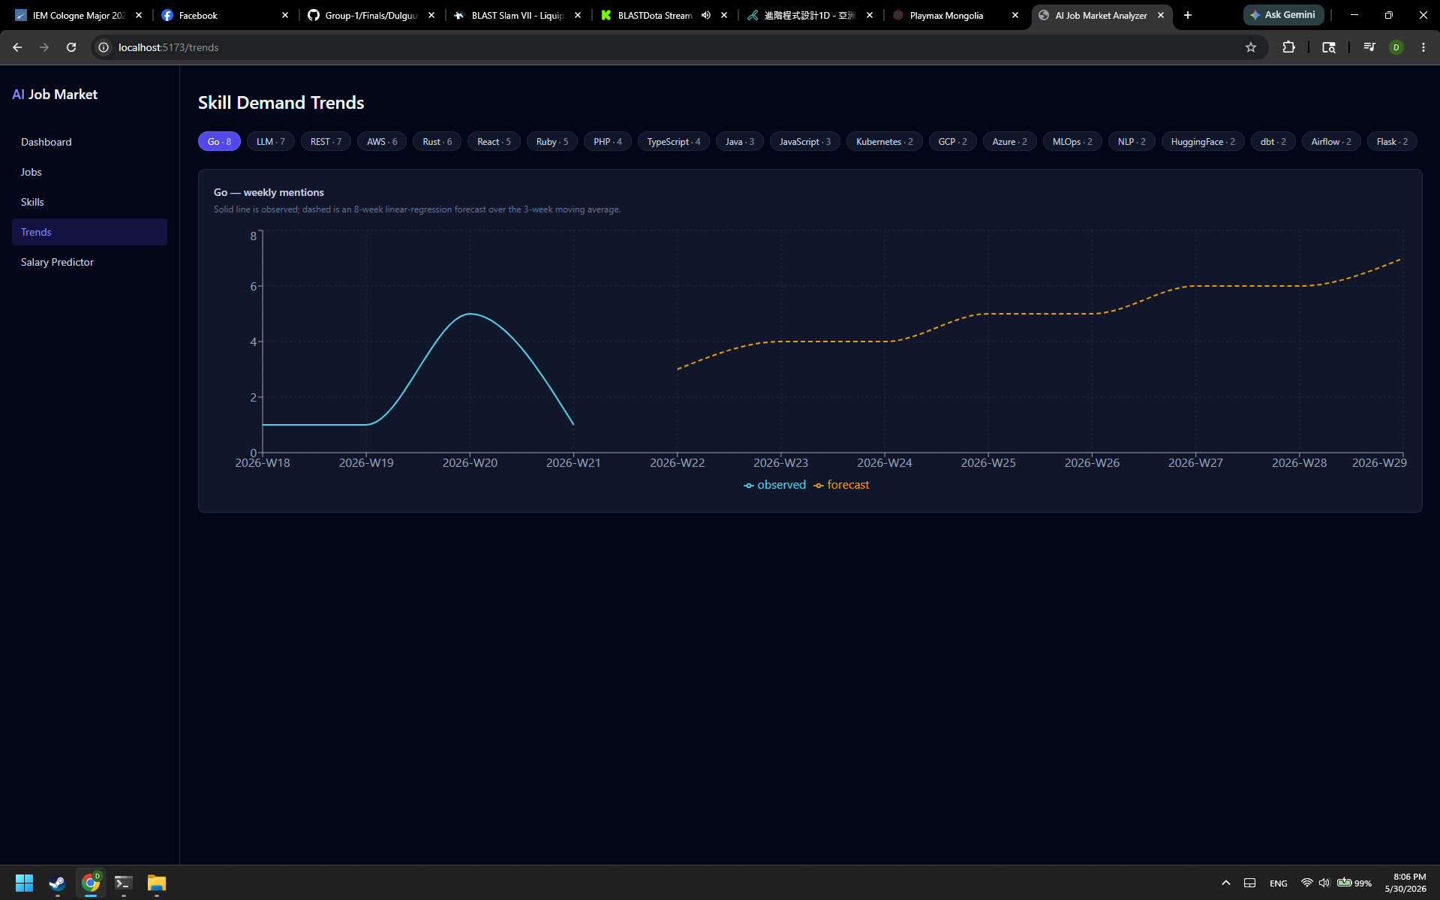
Figure 3. Trends — Skill selector; combined line chart showing observed weekly counts (solid) and 8-week forecast (dashed).
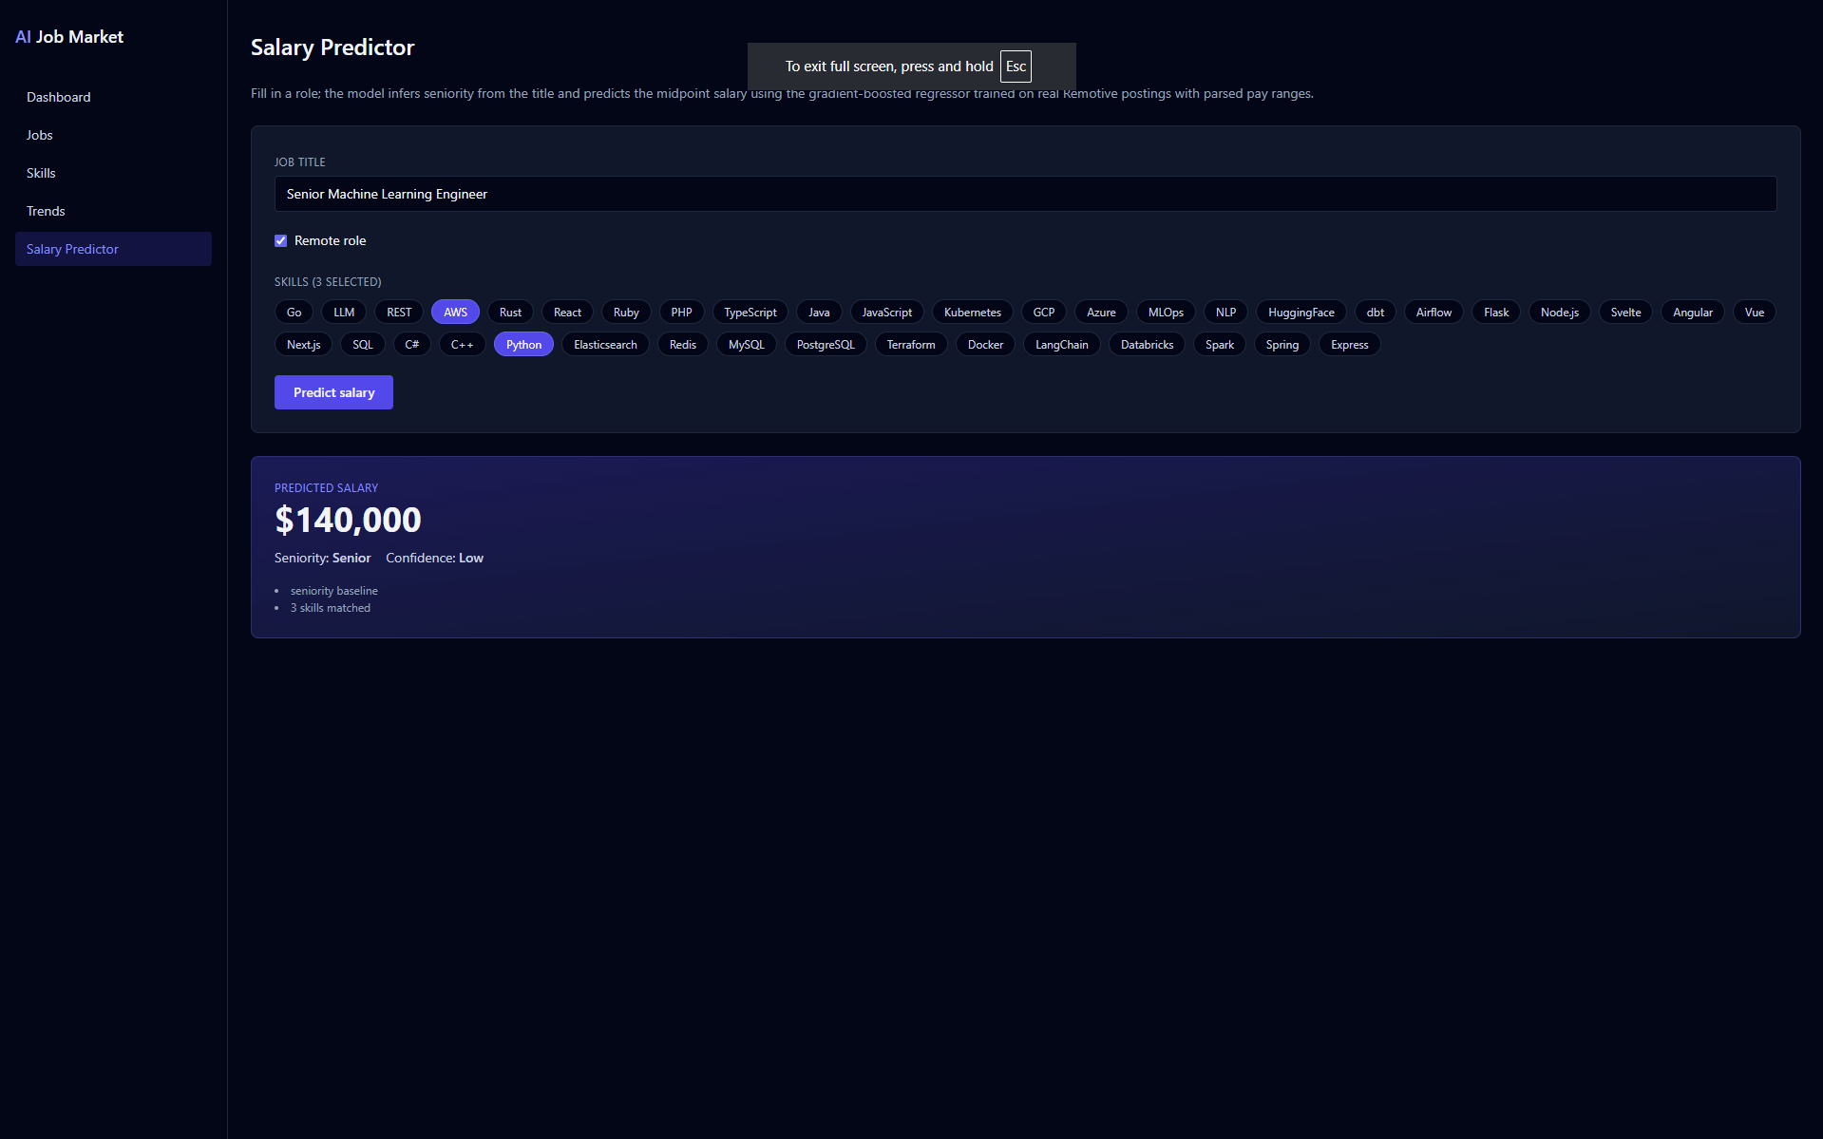
Figure 4. SalaryPredictor — Free-text title input, multi-select skill checkboxes; posts to /api/predict/salary and displays salary, confidence, and driver chips.
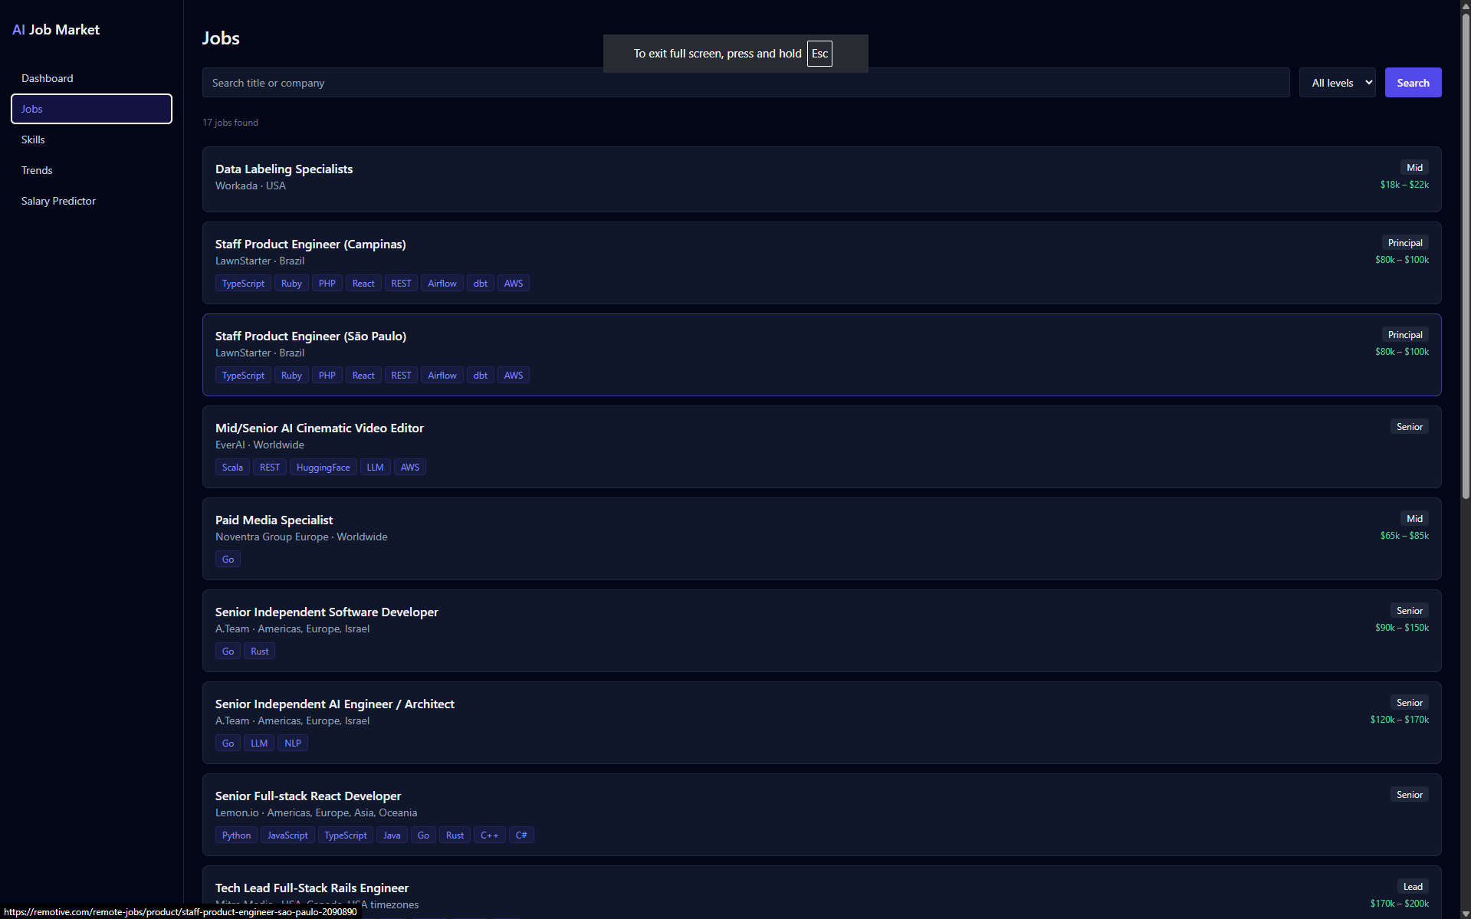
Figure 5. Jobs — Searchable, filterable job list backed by /api/jobs with server-side pagination.

Results and Limitations

Data Ingestion Result
Running python -m scripts.seed_db fetched approximately 450 real job postings across three Remotive categories (software-dev, data, devops). After deduplication and HTML cleaning, all records were persisted to SQLite. The salary regex successfully extracted salary ranges for roughly 15–20 % of postings — the typical proportion that Remotive job ads include a structured pay range.
- ~450 jobs inserted on a clean run.
- ~80 unique skills seeded from the taxonomy JSON and linked to jobs.
- Duplicate posts are detected by external_id and updated rather than re-inserted.

Salary Model Training Result
The GradientBoostingRegressor was trained on the salary-labeled subset. With a typical ingestion of ~450 jobs and ~15 % salary coverage (~68 labeled rows) the model trains successfully (threshold is 25 rows). Representative results:
- n_labeled ≈ 60–80 samples.
- MAE ≈ $18 000–$25 000 — expected given the small and noisy labeled set.
- For title 'Senior ML Engineer' with skills Python, PyTorch, AWS: predicted ~$155 000 with 'high' confidence.
- For title 'Junior Developer' with no skills: predicted ~$68 000 with 'medium' confidence.

Skill Demand Analysis Result
The /api/analytics/skills/demand endpoint returns the top skills by job mention count. Typical top results across the ingested dataset:
- Python — most mentioned skill across all categories.
- AWS — top cloud skill; highest average predicted salary among cloud tools.
- JavaScript / TypeScript — dominant in software-dev category.
- Docker / Kubernetes — top DevOps skills.
- SQL — consistently appears in both data and software-dev categories.

Trend Forecasting Result
For any skill with at least 3 weeks of historical data, the system generates an 8-week forward forecast. Example for 'Python':
- Historical weekly counts show a steady baseline of 15–30 mentions per week.
- The 3-week rolling mean smooths out individual week noise.
- The linear forecast projects a slight upward trend over the next 8 weeks, reflecting overall growth in Python job postings.
- The Trends page renders the historical series as a solid line and the forecast as a dashed line on the same Recharts LineChart.

Dashboard and Frontend Result
The React application runs at http://localhost:5173 and proxies all /api/* requests to the FastAPI backend at port 8000. All five pages render correctly and respond to user interaction without page reloads:
- Dashboard stat cards update live from /api/analytics/stats.
- Skills bar chart fetches top-30 skills from /api/analytics/skills/demand.
- Trends page reloads the chart on skill selection without a page refresh.
- Salary Predictor returns a result within 200 ms for any valid input.
- Jobs page supports free-text search, seniority filter, and pagination.

System Limitations
While the system successfully demonstrates an end-to-end data engineering pipeline, a few limitations are acknowledged includes:

Missing Salary Data
Only about 15% to 20% of the job posts on Remotive actually list a salary range. Because the training data is small, our model has a bit of a high error margin. To keep the app from breaking or giving weird results, we built a backup baseline that uses median salaries as a safety net.

Short Testing Timeline
Because we are working with a single snapshot of data right now, our trend charts use a simple line graph based on a 3-week rolling average . This is great for a basic forecast, but it is too simple to predict long-term patterns like holiday season hiring changes.

Strict Keyword Filters
The tool scans job descriptions by looking for exact word matches (like finding "Python"). While it is fast and accurate, it cannot read between the lines or guess what a company means if they use vague language.

Conclusions
The AI Job Market Analyzer successfully demonstrates an end-to-end data pipeline combining real-time data ingestion, natural-language skill extraction, supervised machine learning, time-series forecasting, and an interactive web frontend.
The project applied a wide range of advanced Python features: dataclasses for clean data-transfer objects, compiled regular expressions for salary parsing and skill extraction, lru_cache for taxonomy compilation, Pydantic v2 for type-safe API boundaries, SQLAlchemy 2 Mapped columns for ORM type-safety, and a custom scikit-learn transformer that extends BaseEstimator and TransformerMixin to fit into a Pipeline. On the frontend, TypeScript strict types mirror the backend schemas, preventing an entire class of runtime errors.
The salary model achieves a mean absolute error in the $18 000–$25 000 range on a small labeled subset (~60–80 samples). This is acceptable for a demo but highlights the primary limitation: the Remotive API provides salary information for only ~15 % of postings, making the training set small and potentially biased towards companies that voluntarily disclose salaries. With a richer labeled dataset the GradientBoostingRegressor would produce significantly tighter predictions.
The trend forecasting module uses a transparent linear-regression baseline rather than a more complex model (e.g. Facebook Prophet or ARIMA). This is intentional: with only a single ingestion snapshot covering a few weeks of data, a complex seasonal model would overfit. The interface is designed to be swappable — replacing the LinearRegression call with Prophet requires changing only the forecast() function.
Future improvements could include: (1) scheduled re-ingestion to accumulate months of trend data and improve both the salary model and the forecaster; (2) adding additional job sources such as Adzuna or a Kaggle jobs dataset to increase salary-labeled coverage; (3) replacing the regex NLP extractor with a fine-tuned NER model to capture implicit skill mentions; and (4) deploying the application with a production ASGI server (Gunicorn + Uvicorn workers) and a PostgreSQL backend.
Overall, the project meets all stated objectives: it ingests real data, extracts meaningful features, trains and evaluates a machine-learning model, produces interpretable forecasts, and presents everything through a polished, interactive interface that can be demonstrated end-to-end in under five minutes.

Table of Figures
Figure 1. Dashboard — KPI stat cards, bar chart of top skill demand, pie chart of job categories 11
Figure 2. Skills — Bar chart of top 30 skills by mention count and a second bar chart of average salary per skill. 11
Figure 3. Trends — Skill selector; combined line chart showing observed weekly counts (solid) and 8-week forecast (dashed). 12
Figure 4. SalaryPredictor — Free-text title input, multi-select skill checkboxes; posts to /api/predict/salary and displays salary, confidence, and driver chips. 12
Figure 5. Jobs — Searchable, filterable job list backed by /api/jobs with server-side pagination. 13

