ASSIGNMENT 3 – BUG REPORT AUTHENTICATION
SCREENSHOT EVIDENCE
Name: Duong Thien Nhan
Roll number: CE190741
Project folder: assignment3_nhandtce190741 | Database: BugReport | Port: 8002
Instructions: Capture screenshots of your own application and paste each screenshot into the matching placeholder. Ensure the endpoint, request body (when applicable), response status, and response body are visible. Do not paste screenshots from another project.

Task 1 – Project and Database Setup

Screenshot 1: Start the application
Show the project opened in VS Code and the terminal running `npm run dev`. The terminal should show that the database connection is successful and the server is running on port 8002.
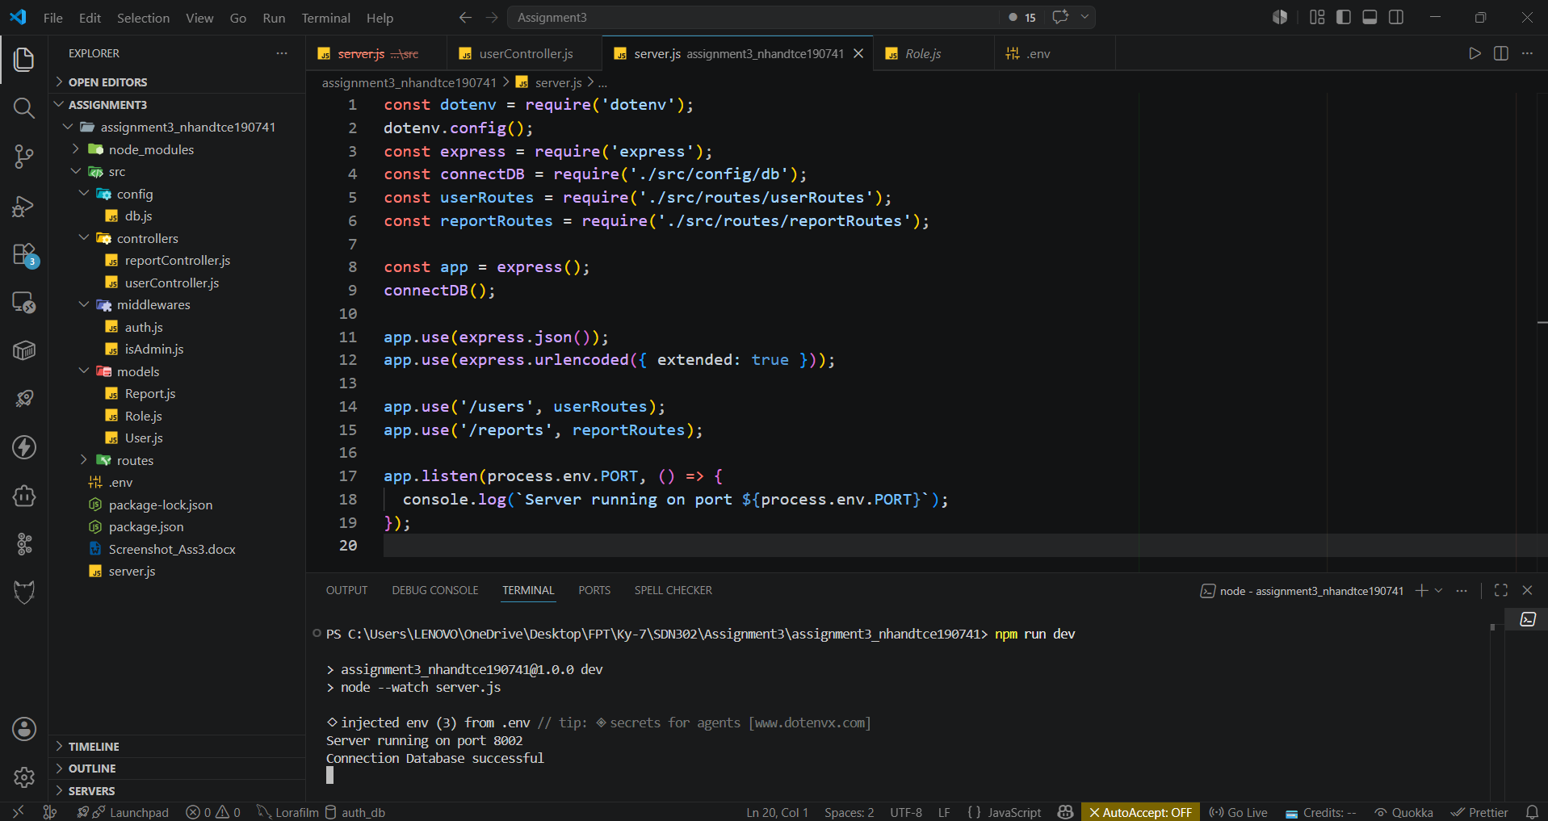

Screenshot 2: MongoDB database and collections
Show MongoDB Compass with database `BugReport` and the three collections: `roles`, `users`, and `reports`. If sample data is imported, show the documents in the relevant collection.
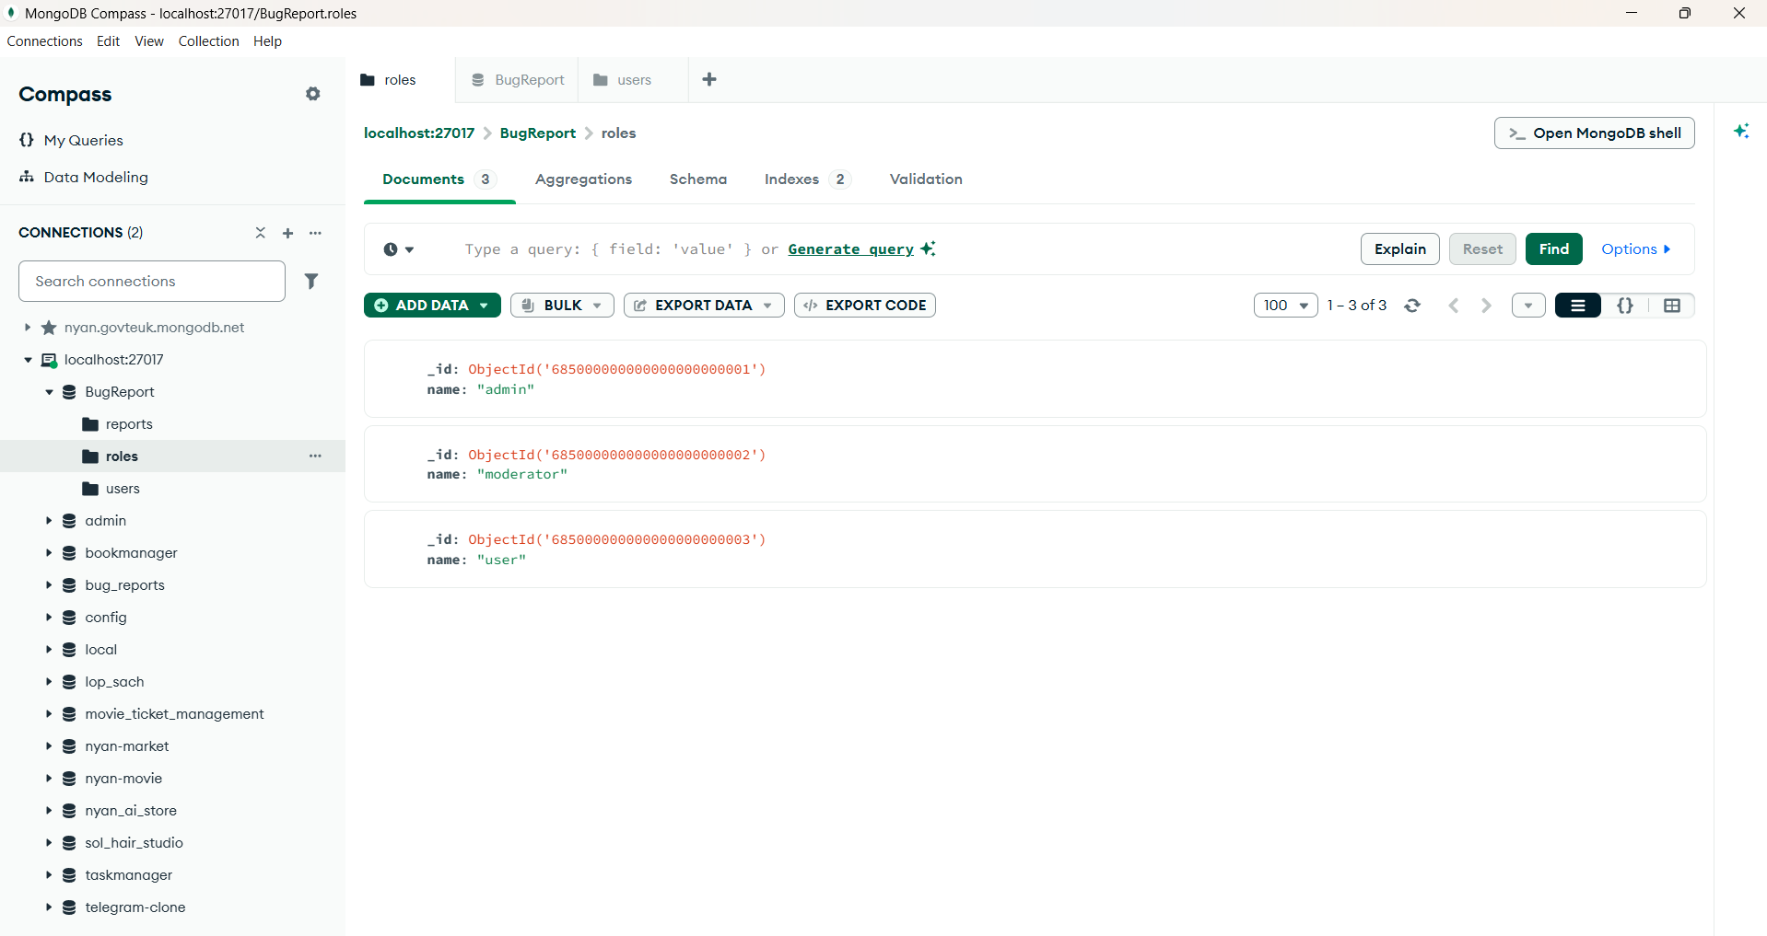

Screenshot 3: Successful user registration
Postman request: POST `http://localhost:8002/users/signup`.
Body (raw JSON):
{
"username": "student1",
"email": "student1@assignment3.com",
"password": "123456",
"role": "user"
}
Show the successful response. If this account already exists, use a different email.
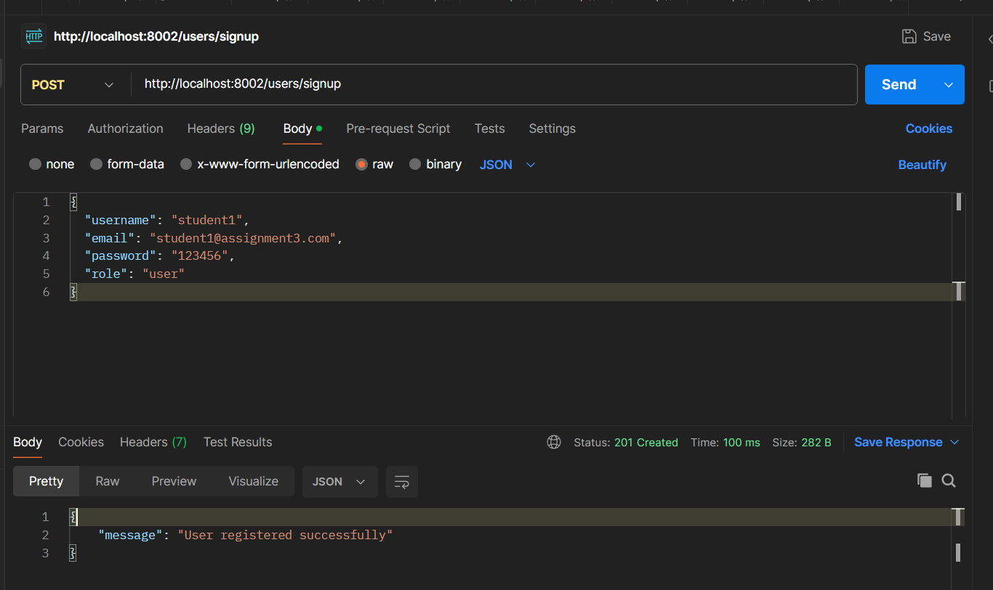

Screenshot 4: Registration with duplicate email
Send the signup request again using an email that already exists. Show the error response indicating that the email is already registered. Use the status code returned by your implementation.
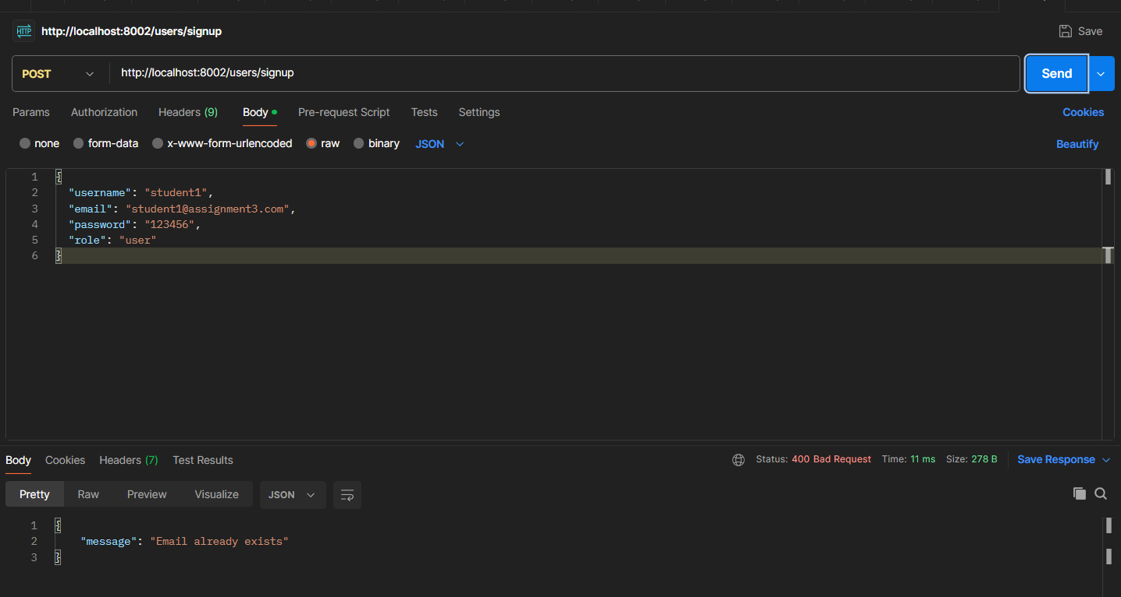

Screenshot 5: Sign-in with invalid password
Postman request: POST `http://localhost:8002/users/signin`.
Body (raw JSON):
{
"email": "student1@assignment3.com",
"password": "0123456"
}
Expected: HTTP 401 Unauthorized with an invalid-credentials message.
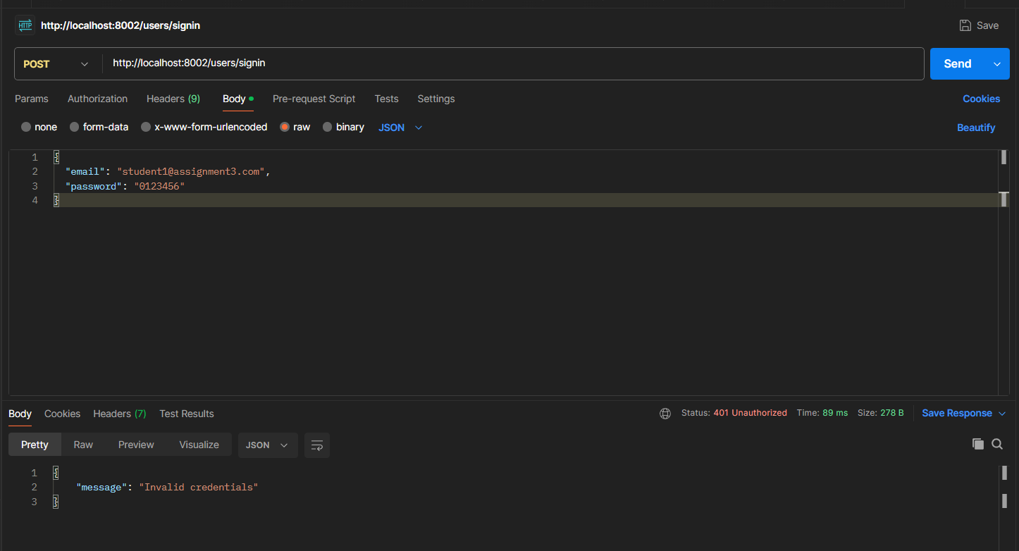

Screenshot 6: Sign-in with valid password
Postman request: POST `http://localhost:8002/users/signin`.
Body (raw JSON):
{
"email": "student1@assignment3.com",
"password": "123456"
}
Expected: HTTP 200 OK and a JWT token in the response.
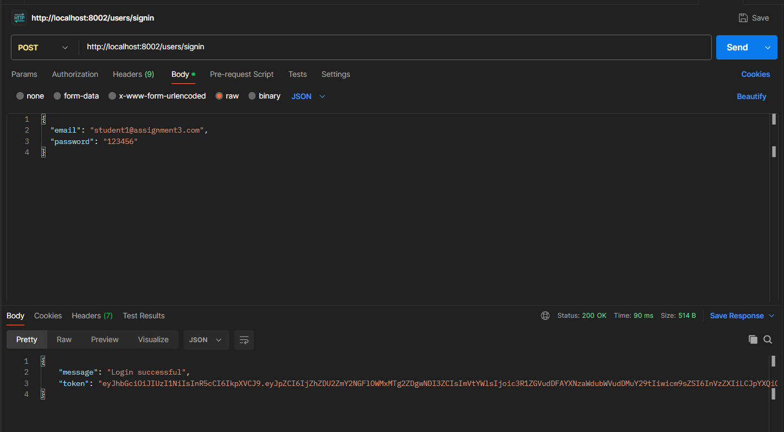

Screenshot 7: Get reports assigned to User 1
Log in as `user1@assignment3.com` and use that login's JWT as a Bearer Token.
Request: GET `http://localhost:8002/reports`.
Show that only reports assigned to User 1 are returned. With the supplied sample data, the expected reports are `Login page validation error` and `Password reset link expires too early`; `assignedTo` should include `_id`, `username`, and `email`.
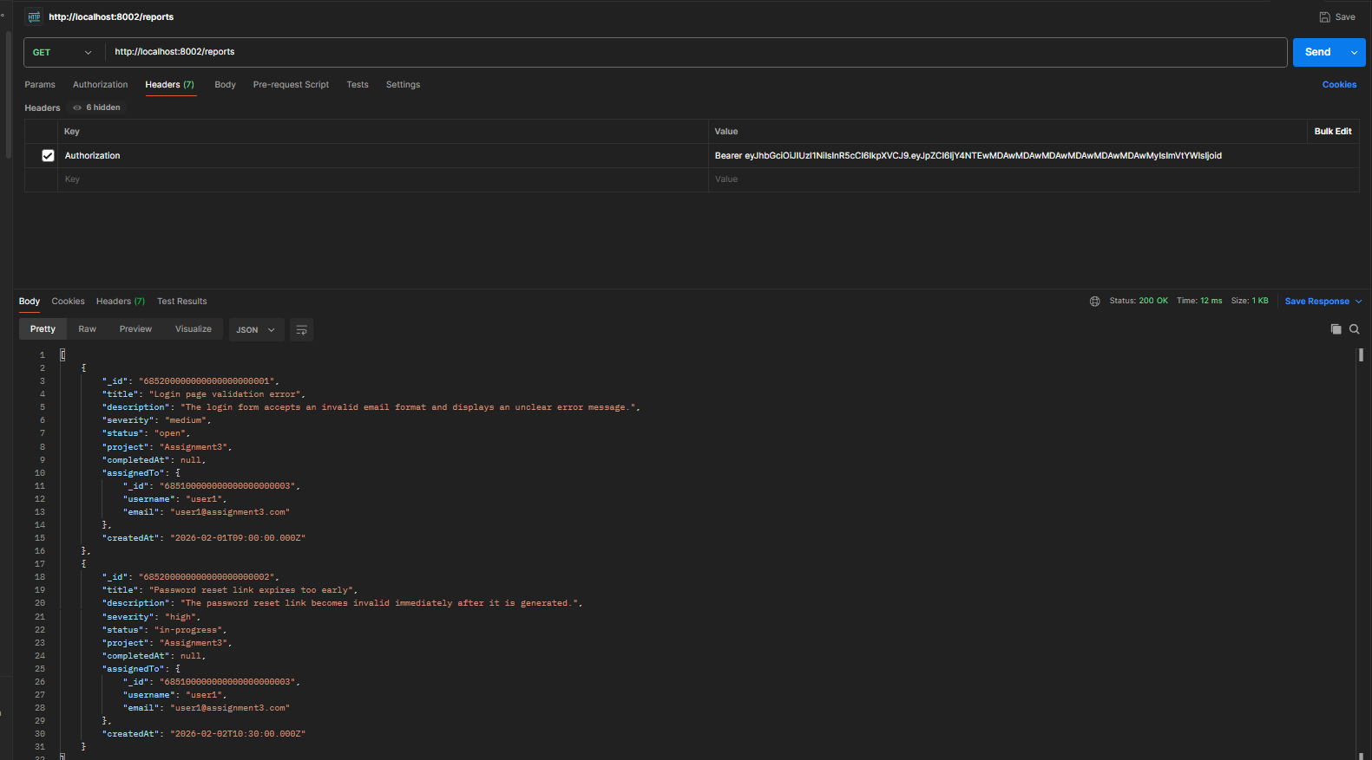

Screenshot 8: Get reports without a token
Request: GET `http://localhost:8002/reports` without an Authorization header. Expected: HTTP 401 Unauthorized.
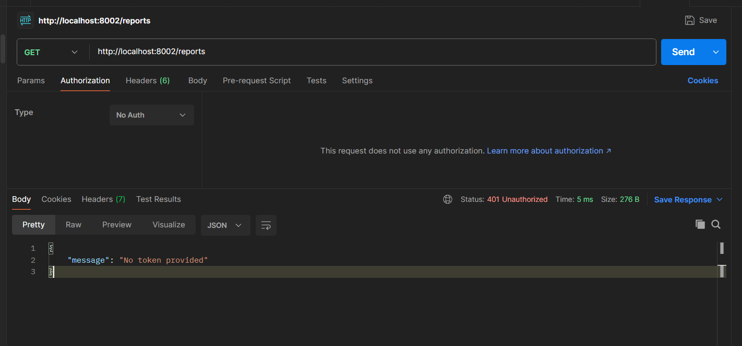

Screenshot 9: Get reports with an invalid token
Request: GET `http://localhost:8002/reports` with Authorization type Bearer Token and value `abcxyz`. Expected: HTTP 401 Unauthorized.
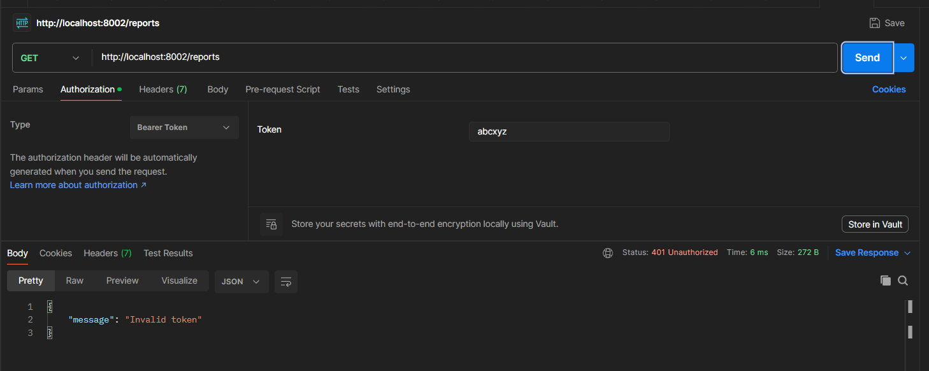

Screenshot 10: Verify cross-user report isolation
Log in as `user2@assignment3.com`, then request GET `http://localhost:8002/reports` using User 2's JWT. Show that only reports assigned to User 2 are returned and User 1's reports are not included.
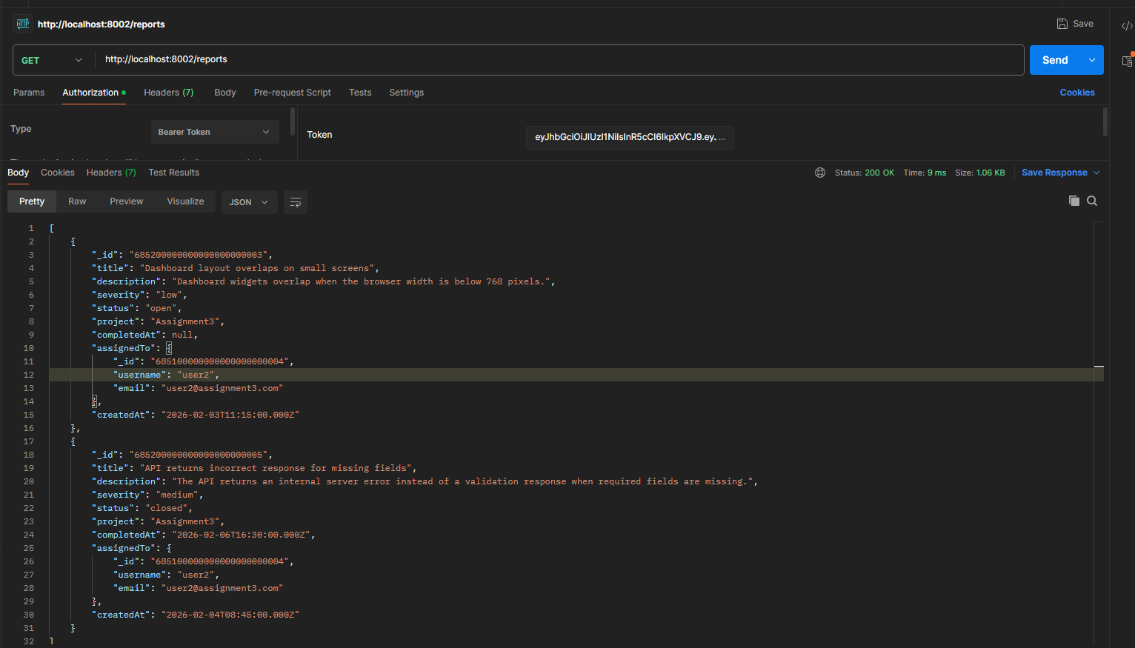

Screenshot 11: Admin creates a bug report
Log in as `admin1@assignment3.com` and use the JWT as a Bearer Token.
Request: POST `http://localhost:8002/reports`.
Body (raw JSON):
{
"title": "Search page fails to load",
"description": "The search page displays a blank screen after submitting a valid query.",
"severity": "medium",
"project": "Assignment3",
"assignedTo": "685100000000000000000003"
}
Expected: successful creation; the new report should have status `open` and a `createdAt` value. The assigned user ID above is User 1's ID in the supplied sample data.
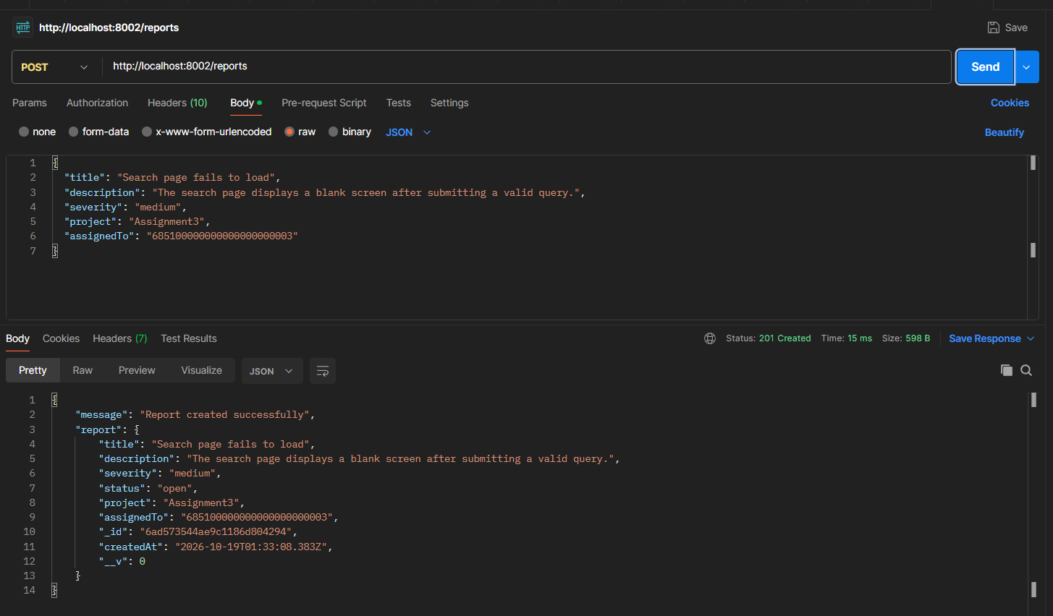

Screenshot 12: Non-admin attempts to create a report
Log in as `moderator1@assignment3.com` or `user1@assignment3.com` and send the same POST `http://localhost:8002/reports` request. Expected: HTTP 403 Forbidden.
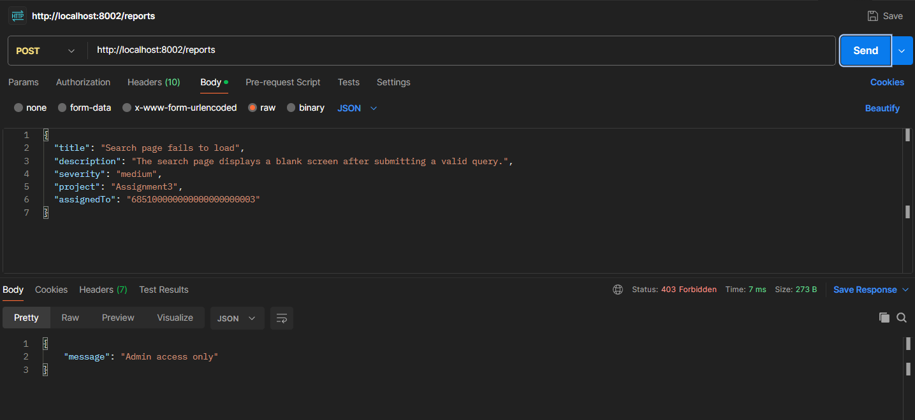

Screenshot 13: Assigning a report to an invalid role
Log in as Admin and send POST `http://localhost:8002/reports`, but set `assignedTo` to the ID of an existing Moderator or Admin. Show that the API rejects the request because a report can only be assigned to a user whose role is `user`.
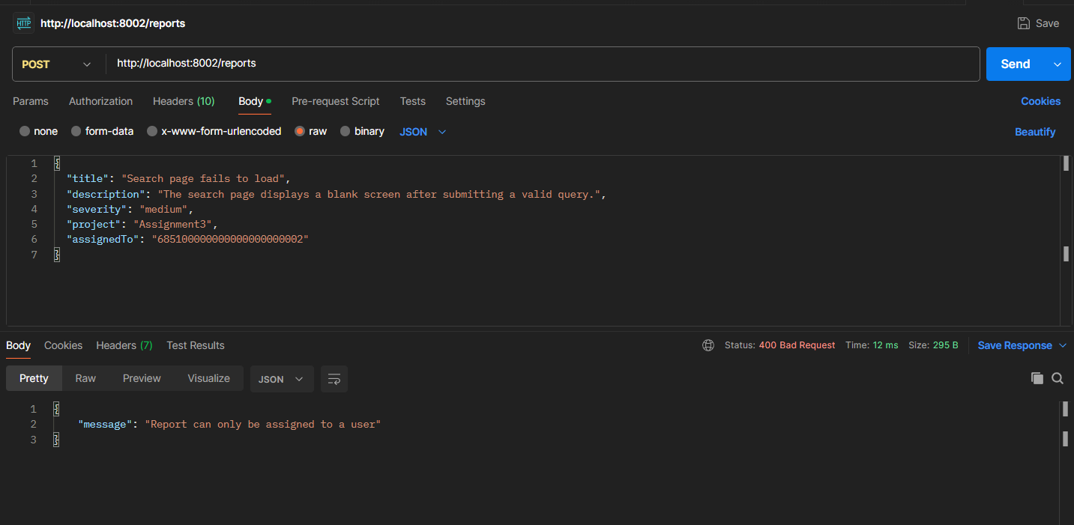

Screenshot 14: Assigning a report to a nonexistent user
Log in as Admin and send POST `http://localhost:8002/reports` with `assignedTo` set to a validly formatted ObjectId that does not belong to any user, for example `685100000000000000000099`. Show the API's error response.
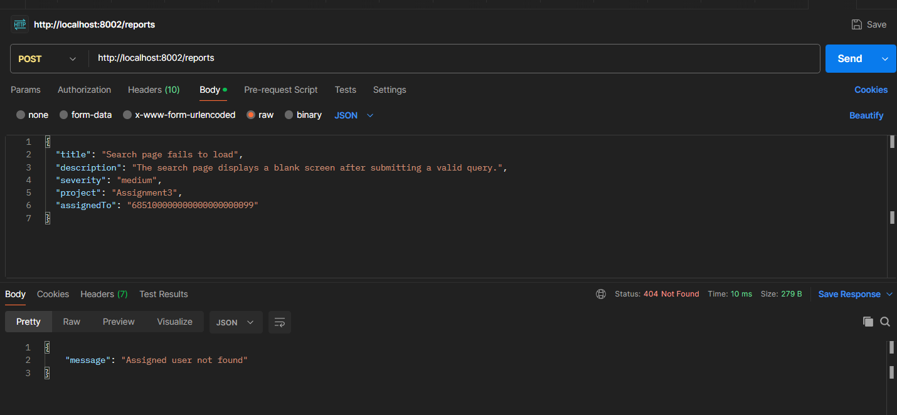

Sample accounts
All supplied sample accounts use password: 123456.
- Admin: admin1@assignment3.com
- Moderator: moderator1@assignment3.com
- User 1: user1@assignment3.com
- User 2: user2@assignment3.com
- User 3: user3@assignment3.com
- User 4: user4@assignment3.com
Important: Use the exact route paths and port specified in the Assignment 3 test guide. The correct database name is `BugReport` (case-sensitive), not `bug_reports`. Screenshots should show real test results from your own implementation.

