TUT C++ NCV Level 3 Robotics Training
Reflection| Days 1–5 Summary
MR S. NYANGAZA |NCV ROBOTICS LEVEL3

Introduction
This PoE summarises my learning at the Tshwane University of Technology (TUT) C++ Level 3 Training. Over five days the programme moved from basic syntax to structured, menu-driven applications, then to modular functions, arrays and introductory object-oriented programming. The goal is two-fold: to master C++ and to learn how to design 20-mark practical assessments and marking memos.
Day | Theme | Main deliverables
Day 1 | Introduction to C++ | Gender determination app; Guess the Number game
Day 2 | Foundations to complete programs | Water-tank program; debugging clinic; 20-mark practical
Day 3 | Advanced control structures | Menu-driven Statistics Program
Day 4 | Functions, arrays and strings | Call hierarchy; linear search; bubble sort; rubric
Day 5 | Classes and objects | Person class; UML diagram; GitHub project plan

Day 1 — Introduction to C++
- Concepts: program layout, variables, cin/cout and if / else if / else logic.
- Activities: a Gender Determination app (if-else branching) and a Guess the Number game (secret, guess, tries, with a do-while loop).
- Takeaway: clean syntax habits and early confidence through interactive feedback.

Day 2 — Foundations to Complete Programs
- Concepts: data types, const, operator precedence, accumulators, type casting, stream formatting, input validation and the <cmath> functions sqrt() and pow().
- Project: a water-tank volume program planned with an IPO chart, flowchart and test data.
- Debugging clinic: integer truncation, operator precedence errors and uninitialised variables. Closed by designing a 20-mark practical and memo.

Day 3 — Advanced Control Structures
- Concepts: nested conditions, switch statements, sentinel-controlled while, do-while validation, for loops, loop tracing, break and continue.
- Project: a menu-driven Statistics Program using a do-while menu, switch, accumulators, sentinel loops and validation. Also designed a practical using random data and switch-case.

Day 4 — Modularity, Functions, Arrays and Strings
Earlier programs forgot each mark as soon as the next was read, so we could not list or sort them. Day 4 fixed this with arrays and functions.
- Modularity: big problems are split into small functions, shown in a call hierarchy (main() calling populateArray(), displayArray(), countEven(), sortArray()). Each function has a prototype, a definition and a call, and is tested on its own.
- Parameters: arguments are the values in a call, parameters are the variables in the definition. Pass by value copies; pass by reference (&) changes the original. Arrays are passed by reference, so changes made in the function persist in main().
- Scope: keep variables local; globals are bad practice.
- Algorithms: linear search and bubble sort written from first principles, with no library sort.
- Strings: length(), at(), find(), substr(), erase(), and getline() to read full lines with spaces.
- Debugging: off-by-one errors (i <= size), missing return statements, and swaps without a temp variable, traced with cout.
- Rubric: marks are awarded separately for algorithm (IPO, flowchart), modularity (functions, prototypes), array processing (loops, bounds) and testing (test data, screenshots).

Day 5 — Introductory Classes and Objects
Concept: a spaza shop owner managing products with a name, price and quantity, where a Product class makes the code read like the problem.
- Terms: a class is a blueprint (abstract data type); an object is an instance; attributes are private data; methods are functions; a constructor runs on creation; instantiation is creating the object.
- UML: - means private, + means public; the boxes hold class name, attributes and methods.
- Person class: private attributes, a default and a parameterised constructor, getters and a validating setter (age outside 0–120 is stored as 0; a test value of 200 returned 0).
- Objects: created with Person ps; or Person p2("Lerato",19,'F'); and used with the dot operator. string is already a class, so we have used OOP since Day 1.
- Version control: plan a project brief and use meaningful GitHub commits such as "Add validation in setPerson", not "update".
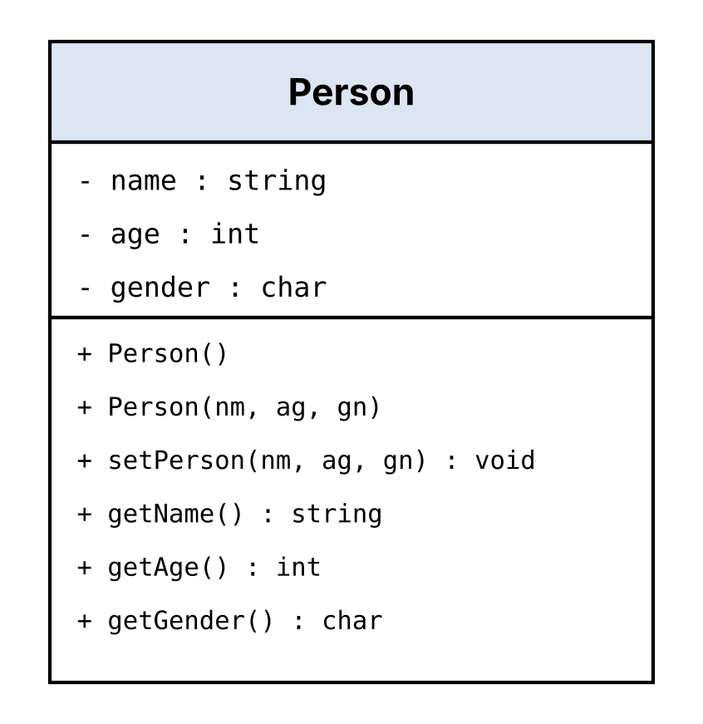
Figure 1: Person class UML diagram
Assessment design principle: each part of a practical earns marks separately.
Rubric area | What earns marks
Algorithm | IPO chart and flowchart
Modularity | Proper functions and prototypes
Array processing | Correct loops and bounds
Testing | Test data and screenshots

Overall Summary
The training progressed from basic syntax (Day 1), to planning, testing and debugging (Day 2), to selection and repetition (Day 3), to functions, arrays and strings (Day 4), and finally to classes and objects (Day 5). Day 5 shifted my thinking from procedural (functions doing things) to object-oriented (objects being things). For NC(V) Level 3 the pattern stays simple: one class, about three attributes, two constructors, getters, one validating setter and one or two calculate methods. Throughout, assessments are designed so that each part earns marks separately, not just a working output. I can now teach this with relatable examples such as a spaza shop Product or a Mucube Mobile Employee.
Key skills gained:
- Technical: menu-driven programs, modular functions, array algorithms and basic class design.
- Pedagogical: planning with IPO charts and flowcharts, teaching through debugging, and writing rubrics and memos.
- Professional: meaningful GitHub commits and testing each function in isolation.

