**SEEDS FOR FUTURE – 2019**

**CANDIDATE NAME: BYAMUGISHA EMMANUEL**

**UNIVERSITY: MUNI UNIVERSITY**

**COURSE: BACHERORS OF INFORMATION SYSTEMS**

**YEAR: 2**

**EMAIL ADDRESS: emmanuelbyamugisha3@gmail.com**

**PHONE NUMBER: 0750613666/0780393997**

**THEMATIC AREA: AGRICULTURE**

**PROBLEM: LATE AND UNRELIABLE METHODS OF DETECTING**

**CROP DISEASES**

**PROPOSED SOLUTION: ONLINE CROP DISEASE SURVAILLENCE SYSTEM**

**Who is affected by the problem or challenge and how they suffer?**

Farmers are most affected by the problem.

In Uganda, agriculture is the backbone of the economy and provides approximately 24% of gross domestic product (GDP) .However, crop pests and diseases are identified as the greatest risk to Ugandan agriculture. Losses due to pests and diseases are estimated at: 10-20% (pre-harvest); 20-30% (post-harvest); and up to 100% for perishable crops and export crops. [1]. There has been late and unreliable methods of detecting crop diseases resulting into low production of both quality and quantity of the farmer’s produce causing; unnecessary losses, famine, low levels of food security and reduction in the country’s export earnings. Therefore, there is need to develop early and reliable methods of detecting crop diseases.

**Proposed approach for a solution to this problem.**

An **Online Crop Disease Surveillance system** is a great and reliable solution to the above mentioned problem**.** The system shall be used by different stakeholders from the government MDA’s (Ministries, Departments and Agencies), farmers, crop experts, emergency response units, researchers and many more to track crop diseases in their early stages such that solutions can be implemented in time before the disease spreads leading to early disease control hence increase in production of both quantity and quality agricultural products.

**How ICT’s and networks would be used in the implementation of your solution?**

The system shall have inputs like motioned controlled cameras monitoring the crops, scanners, smart wireless sensors which shall be used to input data from crops in the garden into a repository (central database) [2]. The data from the crops shall be transmitted by Ethernet module and Wi-Fi routers from the monitoring points to the repository (central database) where it can be accessed by the different stakeholders. In the repository, the data collected shall be processed using machine leaning and artificial intelligence algorithms like decision tree algorithms and other decision support systems. The system shall therefore output its findings on dashboards (like charts, graphs) to different stakeholders through the internet which is widely accessible in most parts of the country.

**How the affected people might need to change their behavior to use your solution?**

Stakeholders(like crop experts,researchers,farmers) need to be training on the application. The government needs to embrace and develop relevant policies that will support the use of the current technologies like the proposed one to solve the problem of late and unreliable methods of detecting crop diseases. The relevant government MDA’s (Ministries, Departments and Agencies) like NAAD's(National Agriculture Advisory Services) need to support this system for its implementation to be effective.

**The impact of the solution on Uganda’s economy?**

If the system is implement, there will be early detection of diseases and therefore early interventions of the solutions to counteract the disease will be developed and availed in time. This will result into increased productivity of both quality and quantity of the agricultural produces. This will help to reduce famine and hence increasing the country’s agricultural output potential which will maintain Uganda at the food export level within the region thus increasing the government export earnings. Therefore, the system is very fundamental to the country’s economic growth and to attaining middle income status by 2020.

**APPENDICES**

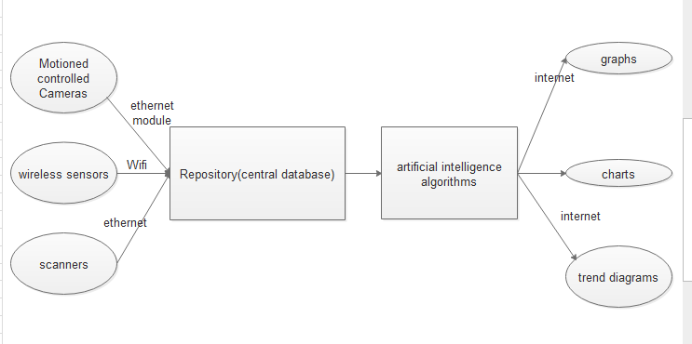

**Fig.1** Conceptual diagram of the proposed system

# References

|  |  |
| --- | --- |
| [1] | Ministry of Agriculture, Animal Industry and and Platform for Agricultural Risk Management (PARM), "Crop pests and disease management in Uganda: status and investment needs," 2017. |
| [2] | K. Young-Duk, Y. Yeon-Mo, K. Won-Seok and K. Dong-Kyun, "Computer Standards & Interfaces," *ScienceDirect,* vol. 36, no. 2, pp. 288-299, February 2014. |