**THE SOIL**

**Soil** is finely divided material covering the earth crust or surface. It consists of air,water, humus, living organisms, and weathered rocks.

**Importance of soil**

1. Soil provides nutrients e.g. water and minerals to plants which are the chief producers of food in the environment.
2. Soil is a habitat (home) for many organisms such as earth worms, termites, bacteria fungi and arthropods.
3. Soil provides a medium through which man and all other animals dispose of their wastes.
4. Soil is an important natural resource which provides construction materials, supports agriculture, craft and art materials.

**SOIL FORMATION**

soil is formed from parent rocks by the process of weathering. This occurs over several years. The process of weathering takes place in three ways;

**1. Physical weathering:**

This occurs in the following ways;

1. Alternate heating and cooling of the rocks on exposed mountain sides, causes expansion and contraction which cause the rock to crack and break up.
2. By water; this is where rivers and streams wear away the rocks over which they flow by rolling pebbles and other hard particles on them.
3. During sandstorm when wind blows sand against bare rocks
4. Frosting: frost is weather condition where temperatures fall below 00C, water in cracks freezes and expand, causing the rock to break up.

**2. Chemical weathering:**

This is brought about mainly by the action of water especially rain water on the rocks. As it rains, rain dissolves carbon dioxide in the atmosphere to form weak solution of carbonic acid which when falls on soft rocks for example lime, it dissolves them, this results in the release of mineral elements like calcium, magnesium, Aluminium, etc. which are components of soil.

In hot damp conditions (tropics) the constituency of rocks especially those containing iron, oxidizes very quickly. The oxidized rocks disintegrate to form soil.

**3. Biological weathering:**

This is brought about by the action and presence of living organisms on rocks. Certain organisms such as lichens are able to grow on bare rock while other small flowering plants are able to grow between the rock fragments. When these die, they form humus which is a component of soil.

Man contributes to biological weathering through direct splitting of rocks during road and house construction and indirectly through cultivation.

**FACTORS INFLUENCING SOIL FORMATION**

There are 5 major factors influencing soil formation:

1. Climate
2. Living organisms
3. Nature of soil parent material
4. Topography of the area
5. Time that the parent rock material is subjected to soil formation.

**i) Climate**

The main climatic factors involved in the soil formation are rainfall, temperature and wind.

Rainfall and temperature influence the chemical and physical break down of the parent rock e.g. rainfall promotes weathering of rocks into small particles by leaching of soluble constituent compound in the rock.

**ii) Living organisms**

These include the vegetation cover, living microorganisms (bacteria and fungi) and invertebrates e.g. earth worms. The vegetation cover influences the characteristics of the soil formed through the litter and roots remains which add to the soil.

The termites feed on dead vegetation there by decomposing it. The bi-products of decomposition are added into the soil.

**iii) Parent rock**

This influences physical properties and chemical constituents of the soil e.g. granite and sand stones which are rich in mineral content giving rise to sand soil while volcanic larva produces clay soils.

**iv) Topography**

It influences the movement of products of weathering which consist of soluble substances and solid soil particles.

Ti affects soil depth and vegetation thus on a steep or rolling topography there is a tendency for soil erosion to occur with a result that relatively shallow soils develop. Therefore it modifies the effects of soil climate and vegetation on soil formation.

**v) Time**

The length of time over which soil forming processes have been in action affects the age of the soil. When soils forming have taken place for a long time, one tends to get deep mature soils, provided other factors are constant.

**SOIL PROFILE**

***This is the vertical arrangement of the various soil layers called horizons***. Itrepresents the different layers at various stages of soil development. A soil with distinguished soil layers is known as mature and that without clear profile is immature or young. The profile consists of the following:

1. Top soil
2. Sub soil
3. Parent or underlying rock

**Diagram to show the soil profile**

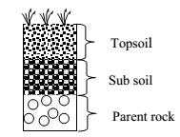

**1) Horizon A – Top soil**

This is the upper most soil layer. It’s usually about 20cm deep and is the most important horizon that supports the growth of plants. It has got the following characteristics:

* 1. It’s usually better aerated
  2. It has more active soil microorganisms
  3. It contains humus so it’s usually dark in colour.
  4. It contains more plant root and usually litter.

1. **Horizon B – Sub soil**

This is a thicker light brown layer lying immediately below the top soil. It’s composed of mainly rock fragments, clay and gravel. It has the following characteristics:

* 1. It is less aerated than top soil.
  2. It contains only deep roots of plants and hardly any other organism.
  3. It contains very little or no humus
  4. It tends to contain a lot of mineral salts due to leaching and therefore referred to as the layer of accumulation.

1. **Horizon C – Parent rock**

This is a solid rock layer found below the sub soil. It represents the original parent material which is still intact and unweathered.

The common parent rocks in East Africa are granites, volcanic and sedimentary rocks. This horizon lack humus completely. It has low air content and mineral salts.

**COMPONENTS OF SOIL**

There are basically six components of soil. These are:

1. Inorganic particles,
2. Humus,
3. Water,
4. Air,
5. Mineral salts, and
6. Soil living organisms.

**1. INORGANIC PARTICLES**

These are produced during the process of weathering. Soil particle vary in size and their sizes are used to classify them. The different soil particles are clay, silt, fine sand, coarse sand and gravel.

**Table showing sizes of soil of particles**

|  |  |  |
| --- | --- | --- |
| **Soil particle** | **Diameter (mm)** |  |
|  |  |  |
| Gravel | > 2.0 |  |
|  |  |  |
| Coarse | 0.2 – 2.0 |  |
|  |  |  |
| Fine sand | 0.02 | – |
|  | 0.2 |  |
|  |  |  |
| Silt | 0.002 – 0.02 |  |
|  |  |  |
| Clay | < 0.002 |  |
|  |  |  |

**Uses of soil particles**

1. They provide a surface for anchoring plant roots hence providing support to the plants.
2. Soil particles give a rigid frame work to the soil.
3. They provide mineral elements to the soil which are the absorbed by plants using roots.

**Experiment to show the soil texture of topsoil Apparatus/materials:**

Measuring cylinder, Top soil, Stirrer, Beaker

**Procedure:**

Put water in a measuring cylinder half way. Pour soil (20cm3) in water and stir thoroughly. Leave the experiment to stand for 3 minutes and observe.

**Observation**

When the soil particles settle down, the particles arrange themselves according to their particle size where the heaviest settle at the bottom and the small and lightest at the top as shown above.

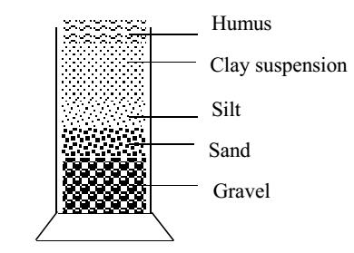

**Conclusion**

Soil is made up of different particles, which have varying sizes and densities.

**2. SOIL AIR**

**Soil air** exists between the soil particles. Airspaces in the soil are important forgrowth of plant roots and health of soil organisms. It is mainly oxygen and nitrogen. (Carbon dioxide is usually in solution as carbonic acid). The depth to

which the roots can grow depends on how deep the air can penetrate through the soil

**Importance of soil air**

1. It provides oxygen for respiration of soil organisms and plant roots.
2. Oxygen is also needed for the decay that produces humus.
3. It also provides nitrogen for fixation by the nitrogen-fixing bacteria in the soil. The nitrogen absorbed is needed in the formation of nitrates and proteins.
4. Carbon dioxide present in the air helps in increasing soil acidity which favours proper growth of some plants.
5. Carbon dioxide present in the air dissolves in water to form carbonic acid for weathering.

**EXPERIMENT TO DETERMINE THE PERCENTAGE OF AIR IN THE**

**SOIL**

**Apparatus**

Measuring cylinders (2) Dry soil sample

Water Glass rode

**Method**

1. Measure about 50cc of dry soil in a measuring cylinder and tap the container to level out the soil.
2. Measure 50 cc of water in another measuring cylinder.
3. Add the two together (observe carefully as you pour the water onto the soil)
4. Allow the mixture to stand until no more bubbles appear. Read and record the final level of water plus soil in the measuring cylinder.
5. Calculate the air content in terms of percentage.

|  |  |  |  |  |  |
| --- | --- | --- | --- | --- | --- |
| **Example** |  |  |  |  |  |
| Volume of soil | = | | 50cc |  |  |
| Volume of water | = |  | 50cc |  |  |
| Final volume of water + soil after mixing = | | | | 85cc | |
| Volume of air in soil (100-85)= | | | | 15cc | |
| Percentage of air in soil sample= | |  | vol of air in soil × 100% | | |
|  |  |  |  | |  |
|  |  |  | vol of soil used | | |

**3. WATER**

Soil water comes from rain. Also some rise up from the ground water by capillary action to replace water lost by evaporation from the surface. It is found as a thin film surrounding the soil particles.

**Soil water has the following functions**

1. It moistens soil and keeps it humid/moist, making it favorable for survival of micro-organisms.
2. It dissolves mineral salts making them available for plants to take.
3. It dissolves carbon dioxide produced by living organisms to form carbonic acid which causes chemical weathering of rocks.
4. It is a raw material for photosynthesis.
5. Water absorbed from the soil allows plant cells to be rigid (turgid), and this is very important for support of the plant, particularly herbaceous plants.

**EXPERIMENT TO DETERMINE THE PERCENTAGE OF WATER IN A**

**SOIL SAMPLE**

**Apparatus:**

Evaporating dish or basin, fresh soil, weighing scale and oven or Bunsen burner.

**Procedure:**

1. Weigh a clean evaporating dish and record its weigh. (Let the weight be X g).
2. Fill the evaporating dish with soil and record the weight of the soil plus the evaporating dish. (Let the weight be Y g).
3. Dry the soil by heating it gently over a Bunsen burner flame for about 30 min.
4. Heating and weighing is repeated until a constant mass is achieved. (Take care not to burn the soil (no smoke))
5. Re-weigh the soil and the evaporating dish. (Let it be Z g).
6. Then calculate the water content in the soil sample as shown below;

**Note:**

You should cool in a desiccator before weighing. This ensures that no fresh vapour enters the soil.

**Results:**

Weight of the evaporating dish= X

Weight of soil + evaporating dish = Y

Weight of soil + evaporating dish after heating = Z

Weight of soil sample = Y-X

Weight of water in the soil sample = Y-Z

%age of water = weight of water x 100 Weight of soil

Therefore percentage of water = (Y-Z) × 100 Y-Z

**4. HUMUS**

**Humus** is decaying plant and animal material- the dead bodies of animals, fallenleaves, dead plants and animal droppings. It is a dark brown, rather sticky material that gives soil its dark colour. For the decay process that form humus to work properly plenty of oxygen is needed.

**Importance of humus**

1. Because humus is dark-coloured, soil rich in humus absorbs more heat, and this warmth is useful for the germination of seeds and helps to speed up decomposition, making more humus.
2. It has a high absorptive capacity for water.
3. It forma\s a sticky coat around soil particles and binds several together to form soil clumps. The clumps structure greatly improves the drainage of the soil.
4. Humus retains moisture and minerals in the top soil and so, greatly reduces the effects of drying and leaching (washing of minerals).
5. It is a source of nutrients used by plants after it is decomposed.
6. It improves soil aeration.
7. It improves soil structure by reducing the sticky properties of clay.
8. It stabilizes soil pH.
9. It leads to improvement of activities of soil organisms by providing them with food and shelter.
10. It insulates soil against extreme heat and cold temperatures changes.

**EXPERIMENT TO DETERMINE THE PERCENTAGE OF HUMUS**

**(ORGANIC MATTER) IN THE SOIL**

**Apparatus:**

Crucible, soil sample, weighing scale, heat source, wire, tripod stand, pipe clay triangle

**Procedure:**

1. Weigh a clean empty crucible and record its weight (W g).
2. Half fill the crucible with soil and record the exact weight of soil plus crucible on weighing scale (X g).
3. Dry the soil by heating it in an oven at 1050C to constant weight (Y g) (the loss in weight of soil at this temperature is due to the water driven out by evaporation)
4. Reweigh the soil and crucible and record the weight.
5. Heat the dried soil on a crucible to redness in an oven.
6. Weigh the soil after cooling and record its weight.
7. Repeat this till a constant weight is achieved (Z g).

**Results:**

Weight of crucible = W g

Weight of crucible + fresh soil = X g

Constant weight of soil + crucible after heating at 1050C =Y g

Constant weight of soil + crucible after heating after heating to redness = Z g Weight of soil = X - W

Weight of dry soil = Y-W

Weight of dry soil after burning off humus = Z - P Weight of humus = Y - Z g

Percentage of humus = weight of humus x 100% Weight of soil

Percentage of humus = (Y-Z) × 100% X - W

**Exercise**

The following experiment was done to find out the percentage of humus in a given soil sample. The soil sample weighing 120g was heated in an oven kept at 100o C. The dry soil weighed 112g. The soil was then heated slowly to burn away humus.

The weight of soil after all humus had burnt was 106g

1. Why was the soil not heated properly at first?
2. What was the weight of humus in the soil?
3. Calculate the percentage of humus in the soil.
4. How many times was water more than humus?

**Solution:**

a) It was not because it will burn the humus containing water

|  |  |  |
| --- | --- | --- |
| b) Weight of soil after burning humus | = | 106g |
| Weight of dry soil | = | 112g |

|  |  |  |
| --- | --- | --- |
| Weight of humus | = | (112 – 106) |
|  | = | 6 g |
| c) Percentage of humus | = | 6 × 100 |
|  |  | 20 |
|  | = | 5% |

**5. MINERAL SALTS**

These are chemical elements inform of ions, dissolved in the film of water, surrounding the soil particle.

Some of the mineral elements in soil are; Sulphur, phosphorous, nitrogen, silicon, magnesium, iron and Aluminium ions which results from weathering of rocks.

**6. SOIL LIVING ORGANISMS a) Micro organisms**

They include bacteria and fungi. They play an important part in maintaining soil fertility through decomposition of plant and animal remains nitrifying bacteria convert nitrogen into nitrates thus making it available to plants.

**b) Macro organisms.**

They include roots of higher plants, earth worms, nematodes e.g. ascaris, hookworms, filarial worm, and soil arthropods.

Earth worms are common in moist soils rich in humus. They dislike dry or acidic soils. They tunnel into the soil by force, thus improving the soil aeration and drainage.

**Importance of living organisms**

1. They improve fertility of the soil through fixing atmospheric nitrogen by nitrogen fixing bacteria and decomposing litter and other wastes into humus carried out by termites and bacteria.
2. Some living organisms like earth worms burrow in the soil and this improve soil aeration and drainage.
3. Some living organisms in soil cause diseases to man and his plants.
4. Wastes from soil living organisms add fertility to the soil.

**EXPERIMENT TO INVESTIGATE THE PRESENCE OF LIVING**

**ORGANISMS IN SOIL**

**Apparatus**

Two test tubes

Muslin bag

Top soil

Two corks

Lime water/ bicarbonate indicator solution

**Procedure**

1. Collect a hand full of fresh top soil and divide it into 2 equal portions.
2. Sterilize one portion of the soil sample by heating it strongly on a crucible for 30 minutes. Leave it to cool and place it in a muslin bag.
3. Place the remaining portion of the fresh soil sample in another muslin bag.
4. Add equal amounts of lime water or bicarbonate indicator in the test tubes and then suspend the muslin bags with soil in the test tubes as shown in the set up below.

Allow the test tubes to stand for about 2 days and observe the appearance of lime water or bicarbonate solution.

**Observation**

Lime water turns milky or the bicarbonate indicator solution turns yellow in test tube A but remains clear in test tube B.

**Conclusion**

Carbon dioxide was produced in test tube A during respiration indicating the presence of living organisms.

Lime water remained clear in test tube B because the living organisms in soil in test tube B were killed by heating

**ALTERNATIVE EXPERIMENT**

The experiment is set up as shown below;

The setup is left to stand for about 2 days and any changes in the water level in the U-tube are observed.

**Observation**

Water level in the u-tube increases in the left arm and decreases in the right arm. This is due to oxygen in the air inside conical flask A being absorbed by the living organisms in the soil causing reduced pressure in conical flask A hence the raised pressure of the remaining gases in conical flask B causing water to raise in the left arm of the u-tube.

**TYPES OF SOIL**

Soil is grouped basing on size and nature of soil particles. On this basis, there are 3 main types of soil namely:

Clay soil Loam soil Sand soil

1. **Sandy soils;**
   1. Sandy soils contain large space between the particles and these spaces allow water to drain off very quickly.
   2. They have a gritty feel when wet and felt between the thumb and figure.
   3. They contain only very small quantities of water and they may be deficient in calcium and magnesium
   4. They are described as light soils because they are relatively easy to work with.
2. **Clay soil:**
   1. They have small fine particles i.e. fine texture.
   2. The soil particles in clay are closely parked together leaving very small spaces between them. This causes clay soils to have poor water drainage and also become water logged.
   3. They are difficult to work with and therefore described as heavy soils.
   4. They have a sticky feel when wet.
3. **Loam soil:**

This is a mixture of sand (about40%), silt (about40%), clay (15%), organic matter (1-4%) it has stable crumb structure and is the best for crop production.

**Differences between clay and sand soil**

|  |  |  |
| --- | --- | --- |
|  | **Clay soil** | **Sand soil** |
|  |  |  |
| 1. | Very small air spaces between particles | Large air spaces between particles |
|  |  |  |
| 2. | Rich in dissolved salts | Poorly dissolved salts |
|  |  |  |
| 3. | Has high water retention capacity | Has only very low water retaining capacity |
|  |  |  |
| 4. | Poor drainage i.e. low permeability | Very easy drainage i.e. high permeability |
|  |  |  |
| 5. | Water can rise to high level by | Water cannot rise to high level by |
|  | capillarity | capillarity |
|  |  |  |
| 6. | More than 30% clay and less than 40% | More than 70% sand and less than 20% |
|  | sand | clay |
|  |  |  |

**PHYSICAL PROPERTIES OF SOIL**

**1. Porosity:**

Sandy soil possess large spaces between the soil particles and so more porous. Clay soils possess very small spaces between the soil particles thus less porous. Loam soil is moderately porous.

**2. Air content:**

Sand contains a lot of air so it is well aerated. This is because it has large spaces existing between the particles.

Clay soil contains little air so it is poorly aerated due to presence of small spaces between the particles.

Loam soil has varying amounts of air.

**3. Drainage of water:**

Sand has good water drainage so it allows water to pass through it very quickly. Clay soil has poor drainage of water and this makes clay water logged. This can be improved by adding humus to it.

Loam drains water moderately.

**4. Water retention capacity:**

This refers to the amount of water soil can hold. Sand soil holds little water so it has a poor water retention capacity. It can be improved by adding humus to it. Humus sticks sand particles together.

Clay soil tends to become water logged i.e. it holds a lot of water so has a high water retention capacity.

Loam soil holds water moderately but not becoming water logged.

**EXPERIMENT TO COMPARE THE DRAINAGE AND RETENTION OF**

**WATER IN SAND AND CLAY SOILS**

**Apparatus**

2 filter funnels,

2 measuring cylinders,

2 filter papers

Equal volumes of samples of dry sand and dry clay soils, Water and

Beakers

**Procedure**

1. Measure an equal volume of each soil sample.
2. Fold filter papers properly and put one in each funnel.
3. Then place clay soil in the filter paper in one funnel and the sand in the other funnel.
4. Place the funnels with their contents over measuring cylinders and at the same time pour an equal volume of water on each of the soil samples as shown in the diagrams.

**Setup:**

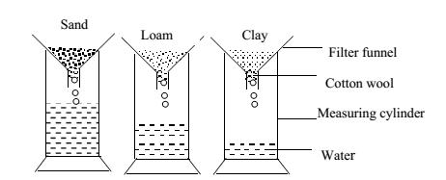

Observe which soil allows water to drain through quickly.

Allow the set up to stand for some time till water stops draining through the soils.

**Observation**

Water passes through sand soil faster than clay soil. So much water is collected in the cylinder with sand soil and less water is collected in the cylinder containing clay soil.

**Conclusion**

Clay soil holds more water than sand soil and sand soils drains water faster than clay.

**Explanation**

Sand soil has larger air spaces which enable water to drain through more rapidly and on the other hand clay soil retains more water than sand because it has many small particles which can hold more water.

**5. Water capillarity through different soils:**

Capillarity through soil means how well water can rise up in the soil and this depends on the size of air spaces between the soil particles.

Sand soil has the lowest capillarity of water while clay soil has the highest water capillarity and loam soil has medium water capillarity.

**EXPERIMENT TO DEMONSTRATE AND COMPARE WATER CAPILLARITY THROUGH SAND, CLAY AND LOAM SOIL**

**Materials**

3 long glass tubes Glass troughs

Muslin bags and threads 3 retort stands and clamps

3 samples of dry sand, clay and loam soils.

**Procedure**

1. Tie a muslin sheath tightly at the end of the glass tubes.
2. Fill one glass tube with dry sample of sand soil and pack it well ensuring that there are no spaces in the soil.
3. Repeat this with clay and loam soils.
4. The glass tubes are stood vertically with the ends tied with muslin sheath immersed in a glass trough containing enough water.
5. The glass tubes are supported upright with retort stands and clamps as shown in the diagram below.

Setup

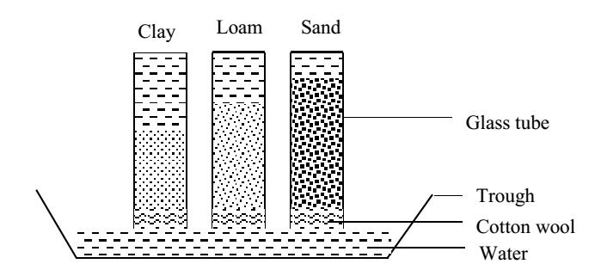

**Observation**

Water rises faster for a short distance in sand soil while in clay soil water rises slowly but to higher distances. In loam soil, water rises moderately to a moderate distance.

**Conclusion**

Clay soil has the highest capillarity of water.

Sand soil has the lowest capillarity while loam has moderate water capillarity.

**Explanation**

Water rises to the greatest height at the nearest stages of the experiment in sand soil because sand has large spaces that enable water to rise more rapidly in the first hours.

Clay soil shows the highest rise of water hence the highest water capillarity because it is composed of tiny soil particles which present the large surface area over which water molecules cling.

Water rises at a slow rate in clay soil because clay has small air spaces between its particles.

**CHEMICAL PROPERTIES OF SOIL**

**1. Soil colour**

This determines the amount of heat that can be trapped in a soil sample. Dark soils retain heat more than light soils.

**2. Soil pH**

This is the degree of acidity or alkalinity of the soil. Most soils in the tropics are acidic but some are alkaline. Soil pH affects the rate at which mineral salts e.g. nitrogen, phosphorous, iron are absorbed by plant roots. Most plants grow best in slightly acidic or neutral soil.

**EXPERIMENT TO DETERMINE THE SOIL PH**

**Materials**

Soil Petri dish

Universal indicator Indicator chart

**Procedure**

1. Place about 3g of soil on a Petri dish and soak it with universal indicator. Leave for 2-3 minutes.
2. Tilt the Petri dish so that the indicator drains out of the soil.
3. Compare the indicator color with the indicator chart.

**Alternatively:**

a) Soak the soil sample with distilled water.

1. Drain off/ filter off and test with universal indicator solution or universal indicator papers.

**SOIL EROSION**

This is the removal or washing a way of top soil by animals, wind or running water. The extent of soil erosion is dependent upon the intensity with which the rain falls and not the amount of water.

**Types of soil erosion**

**Sheet erosion**

This is where thin uniform layers of soil are eroded over the whole slope.

**Rill erosion**

This is where water cuts shallow channels called rills. The channels deepen as volume of water run off increases.

**Gulley erosion**

This results from rill erosion when the channels deepen and form galleys. Here a lot of soil is carried a way over greater distances. It is facilitated by careless ploughing (up& down the slope). It may follow tracks made by vehicles and from animals.

**Splash erosion or raindrop erosion**

This occurs when intense raindrops displace soil.

**Wind erosion**

In dry conditions, herds of farm animals trample and compact the soil, causing a layer of dust on top. When wind comes, it can blow away the dust.

**CAUSES OF SOIL EROSION**

**1) Slopes of land**

The deeper the slope the greater the erosion and this is coupled with the intensity of rain.

**2) Over grazing**

This is caused by the keeping of many grazing animals on a small area. They finish the grass, i.e. remove the grass cover and open it to water erosion. They trample the soil and make it dusty, thus erosion can take place.

**3) Deforestation**

Foliage of trees reduces intensity at which raindrops reach the ground. Extensive falling of trees in an area removes this cover thus facilitating erosion on slopes.

**4) Bush burning**

Uncontrolled burning of bushes in dry seasons removes the grass top cover, thus leaving the soil bars for erosion.

**5) Poor farming methods:**

**Ploughing:** It lessens the soil and destroys its natural structure. Failure to replacehumus after successive crops reduces water holding properties, so soil dries easily and can easily be blown away.

Ploughing up and down a slope accelerates water erosion.

**Over cropping**; over use of soil depletes fertility, thus causing loss of plant cover.This leaves the soil bare and so susceptible to erosion.

**Methods of reducing (preventing) soil erosion**

**a) Contour ploughing**

Ploughing a long contours i.e. across a slope and not up and down. It allows furrows to trap water rather than to channel it a way.

**b) Strip cropping**

This consists of alternate bands of cultivated and uncultivated soil, following contours. Un tilled soil is covered with grass.

By alternating the grass and crops each year, the soil is allowed to rebuild its structure while under grass.

**c) Terracing**

This is cultivation a long contours in horizontal strips supported by stones or walls, so breaking up the step down water rush of the surface run-off. The steeper the slope, the closer the terraces must be.

**d) Correct crop for soil**

Steep slopes which should not be ploughed are covered with pasture crops, their roots hold the soil

**e) Afforestation**

This is the Planting large areas of land with trees. They act as wind brakes, hold the soil together, and prevent raindrops from hitting the soil directly

They conserve water and control flooding.

**f) Mulching**

covering of top soil with plant material e.g. banana leaves, maize stems after harvest, cut grass etc. it protects the top soil and conserves the water in the soil.

**Effects of soil erosion (to farmers)**

1. Nutrients and soil organisms are carried a way in the top soil.
2. The soil left behind is unproductive.
3. Fields may be cut into irregular pieces by rill and gulley erosion
4. Floods carry a way or submerge and suffocate crops and soil organisms.

**SOIL FERTILITY AND CONSERVATION**

**SOIL FERTILITY**

Soil fertility refers to the amount of nutrients in the soil that can support the growth of plants. Soil can lose its fertility through the following ways.

1. **Soil erosion**.
2. **Leaching**; this is the washing down of soluble minerals from topsoil layers tobottom layers where they cannot be accessed by plants.
3. **Soil exhaustion**; this is the depletion/reduction in soil nutrients as a result ofmonoculture, over cropping, etc.
4. **Soil compaction**; this is the hardening of soil on the surface due to action ofheavy machinery, movement of animals and man on soil, etc. Soil compaction prevents water from penetrating into the soil.

**SOIL CONSERVATION**

This is the protection and careful management of soil to maintain its fertility. It includes methods of controlling erosion and others such as:

**Intercropping**

Here, plants are alternately planted in a systematic or even random manner e.g. coffee, beans, and banana can be intercropped.

**Fallowing**

Land is left to rest and grow back to bush.

**Crop rotation**

The farmer carefully rotates his crops season after season, so that the plants make different demands on the soil.

Deep rooted crops like cassava are rotated with shallow rooted ones e.g. g. nuts

**Application of manure (organic manure)**

**1) Green manure;**

These are green plants, mostly legumes which can be dug back into the soil. However, any available green plants can do.

**2) Farm yard manure;**

This is from wastes of farm animals like urine and faeces when left become manure. This improves the process of nitrification (addition of nitrates to the soil) e.g. poultry dropping, goats, pigs, cows etc.

**3) Compost manure;**

This is made by collecting all available organic materials like chicken waste, weeds, fresh leaves into a pit with alternating layers of soil, and leaving them to rot. Water is added periodically to keep it moist for bacteria and fungi in the soil speed up the process. When well decayed, the compost is spread over the garden. Organic manure adds humus to the soil and maintains the crumb

Structure

**4) Artificial fertilizers;**

These are added directly. The most common element lacking in highly cultivated soils are nitrogen, phosphorus and potassium. They are supplied in form of K2SO4, (NH4)2SO4 and calcium phosphate which lead to high yield.

**THE NITROGEN CYCLE**

Nitrogen is one of the elements that make up proteins. Nitrogen makes up to 80% of air but it is un reactive so cannot be used by plants and animals in its elemental form. It becomes part of the bodies of organisms in a process called the nitrogen cycle. The changing of nitrogen into more reactive forms is called nitrogen fixation.

Nitrogen fixation takes place during lightening, in the manufacture of artificial fertilizers and in the metabolism of the nitrifying and nitrogen fixing bacteria. Plants absorb nitrogen as ammonium salts or nitrates.

Animals obtain nitrogen they need by eating plants or other animals that have eater plants

At death or by leaf fall, egestion, excretion (urine), the nitrogen of plants and animals is returned to the soil

Nitrogen is in constant circulation between autotrophs, heterotrophs, and the soil in atmosphere

Plants absorb nitrogen inform of nitrates and ammonium salts, for manufacture /build up of proteins they require.

At death or by leaf fall, egestion, excretion (urine), the nitrogen of plants and animals is returned to the soil.

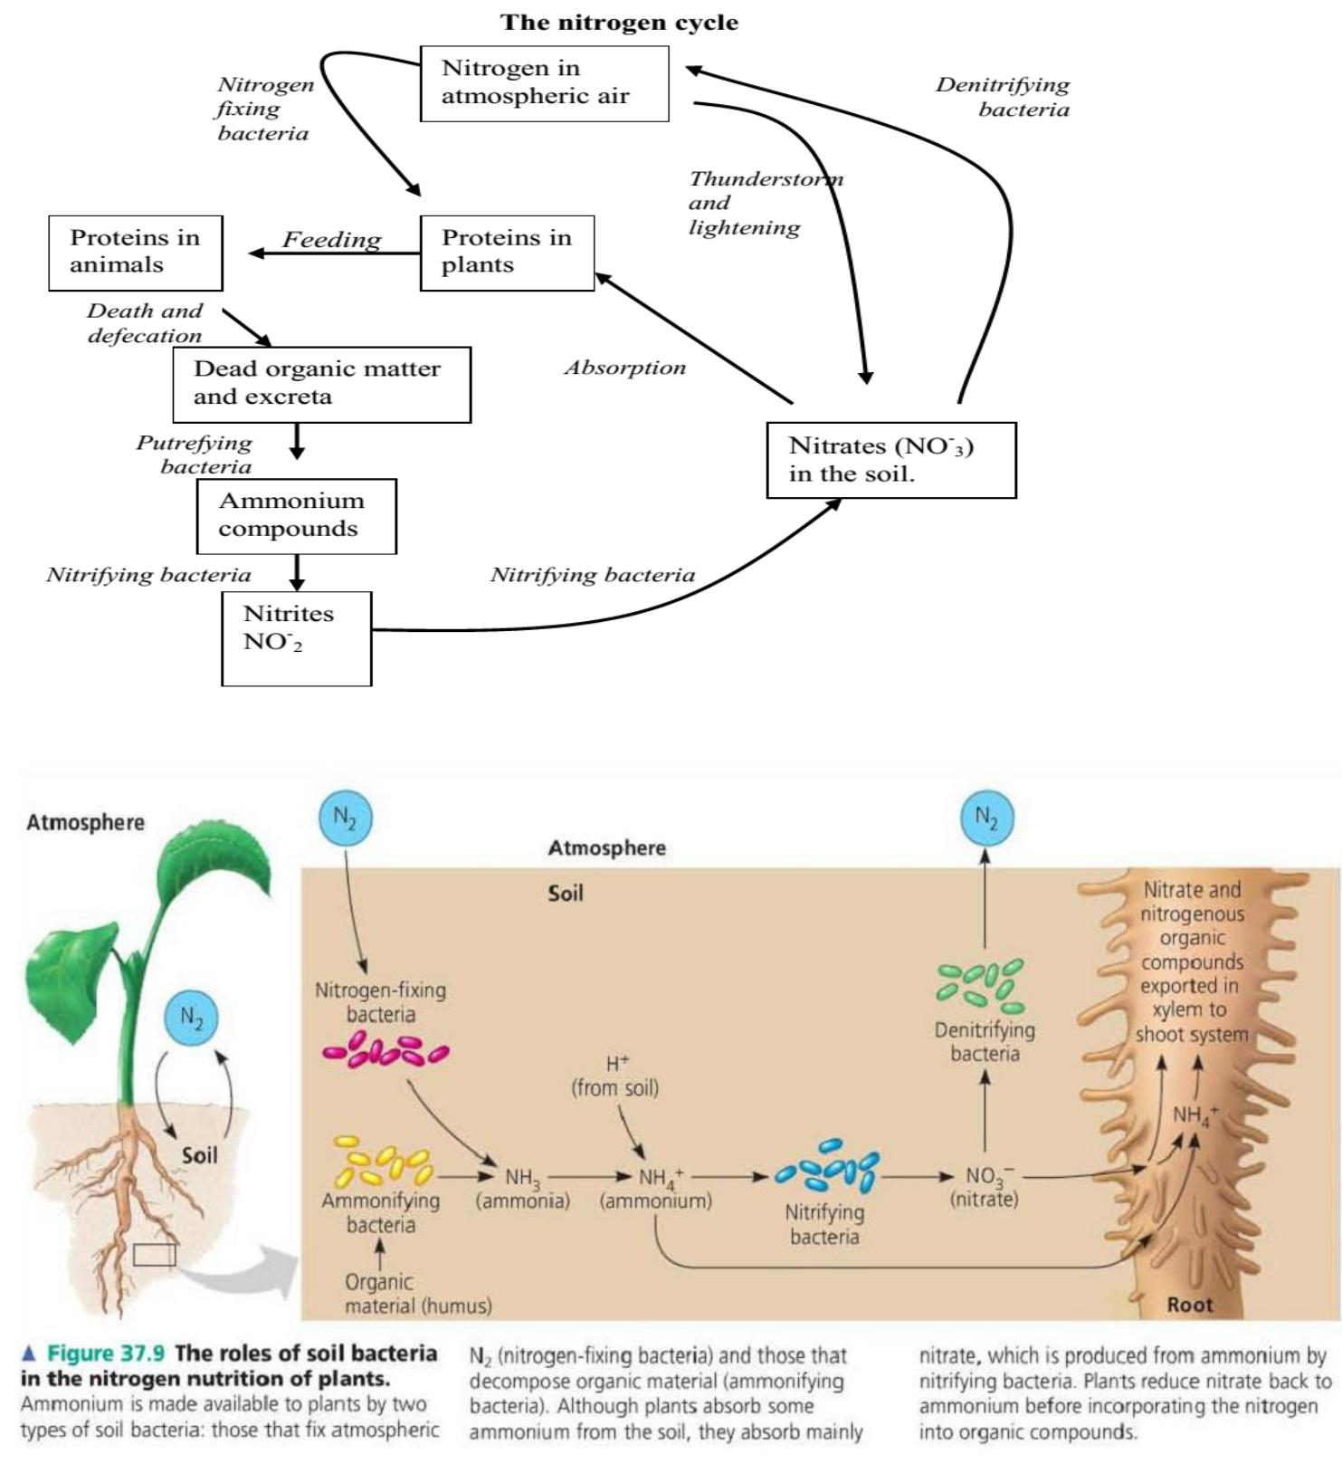

**THE CARBON CYCLE**

Carbon is an element which occur in all elements that make up a living organism. Carbon is therefore a major component of all organic matter. Plants get carbon from the atmosphere in the air during the process of photosynthesis. Plants use carbon to make food like starch. Starch is eaten by animals to get energy.

When animals die, they decay and release the carbon and other nutrients in the soil. The circulation of carbon in nature from the atmosphere into the living organisms and back into the atmosphere forms the carbon cycle.

**The cycle**

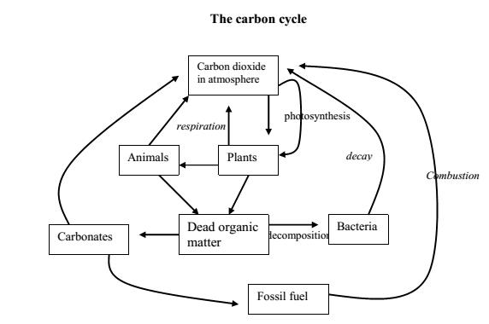

**Removal of CO2 from the atmosphere:**

Green plants remove CO2 into the atmosphere during the process of photosynthesis.

Some of the CO2 in the atmosphere dissolves in rain water to form carbonic acid. This acid reacts with soil mineral salts to form carbonates.

**Addition of CO2 in the atmosphere:**

a) Combustion (burning)

When carbon containing fuels e.g. petroleum, coal, natural gas, fire wood are burnt, CO2 is released into the atmosphere. Formation of such fuels over millions of years is referred to as fossilation.

1. Respiration in animals and plants.
2. Decomposition of organic matter by bacteria and fungi. During this process, CO2 is released into the atmosphere.