
FACULTY OF SCIENCE
DEPARTMENT OF SPACE SCIENCE AND APPLIED PHYSICS

TOMATO DISEASE DETECTION USING COMPUTER VISION

By

NYASHA MASENDEKE
R2110395

A thesis submitted in partial fulfilment of the requirements for the degree of BSc Honours in Industrial Physics (HIPH)

Supervisor: Professor E. Mashonjowa

DECLARATION
I, Nyasha Masendeke, declare that the contents of this thesis represent my own unaided work, and that the thesis has not previously been submitted for academic examination towards any qualification. Furthermore, it represents my own opinions and not necessarily those of the University of Zimbabwe.

Signed: ______________________________ Date: ______________________________

Nyasha Masendeke (R2110395)

APPROVAL FORM
I/We hereby certify that I/we have read this thesis prepared under my/our direction by Nyasha Masendeke (R2110395), titled “Tomato Disease Detection Using Computer Vision”, and recommend that it be accepted as fulfilling the dissertation requirements for the degree of BSc Honours in Industrial Physics (HIPH).

Supervisor: ______________________________ Date: ______________________________
Professor E. Mashonjowa

Co-supervisor: ______________________________ Date: ______________________________

Chairperson: ______________________________ Date: ______________________________

DEDICATION

To my family, for their unwavering support and encouragement throughout my studies.

ABSTRACT
Tomatoes are economically significant horticultural crops in Zimbabwe and worldwide, but their productivity is severely constrained by foliar diseases, most notably early blight and late blight. Conventional disease monitoring relies on periodic visual inspection which is labour-intensive and frequently too slow to enable early intervention particularly for small to medium scale farmers.
This project reports the design, implementation and evaluation of an embedded tomato disease classification system that performs both training and inference on a Raspberry Pi 5. A convolutional neural network based on the MobileNetV3Small architecture was fine-tuned using transfer learning on a subset of the Plant Village dataset. The dataset comprises of ten leaf classes covering healthy plants and nine disease conditions. The trained model was subsequently converted to TensorFlow Lite and compressed using post-training INT8 quantisation to support real-time inference on the embedded platform.
Overall system evaluation was carried out along three dimensions: classification performance, measured through per-class precision, recall, F1 score, and a full confusion matrix; computational behaviour during on-device training, measured through CPU utilisation, memory consumption, per-epoch training time, and thermal response; and the trade-off introduced by INT8 quantisation, measured by comparing the floating-point and quantised models on identical test data.
System deployment was carried out first in a controlled tomato plant setup and subsequently in a working tomato farm. This strategy was used to differentiate the accuracy due to quantisation and field conditions.
Unlike the majority of published edge-deployment studies, which train models on GPUs and deploy only inference to embedded hardware, this study evaluates on-device training directly. Empirical data on the hardware constraints of edge learning in a resource-limited agricultural context is at the core of this project. The work contributes a reproducible workflow and a documented set of computational benchmarks that can inform future deployments in small to medium agricultural setups in developing economies.

Keywords: tomato disease detection, computer vision, convolutional neural networks, transfer learning, MobileNetV3, Raspberry Pi 5, edge computing, TensorFlow Lite, INT8 quantisation, precision agriculture.

ACKNOWLEDGEMENTS
I would like to express my sincere gratitude to my supervisor, Professor E. Mashonjowa, for his invaluable guidance, patience and encouragement throughout this project. His insights shaped both the direction and the rigour of this work.
I am grateful to the staff of the Department of Space Science and Applied Physics, University of Zimbabwe, for the academic environment that made this work possible. I also wish to thank my colleagues and friends for the discussions and feedback that helped refine the ideas presented in this dissertation.
Finally, I thank my family for their unwavering support both moral and material throughout my undergraduate studies.

TABLE OF CONTENTS
DECLARATION i
APPROVAL FORM ii
DEDICATION iii
ABSTRACT iv
ACKNOWLEDGEMENTS v
TABLE OF CONTENTS vi
LIST OF TABLES viii
LIST OF FIGURES ix

CHAPTER 1: BACKGROUND AND JUSTIFICATION 1
1.1 Introduction…………………………………………………………………………… 1
1.2 Problem Statement………………………………………………………………….... 2
1.3 Aim and Objectives 2
1.4 Research Questions 3
1.5 Funding and Budget 3
1.6 Project Timeline 4
1.7 Justification and Conclusion 4

CHAPTER 2: LITERATURE REVIEW 5
2.1 Introduction 5
2.2 Tomato Disease Diagnosis: Agronomic Background 5
2.3 Computer Vision and Deep Learning for Plant Disease Classification 6
2.3.1 Convolutional Neural Networks 6
2.3.2 Transfer Learning 7
2.3.3 Evaluation Metrics for Plant Disease Classification 7
2.3.4 Model Compression for Edge Deployment 8
2.4 Candidate Architectures and Embedded Platforms 8
2.4.1 MobileNet Family 9
2.4.2 YOLO Series 9
2.4.3 EfficientNet Family 10
2.4.4 Embedded Hardware Platforms 10
2.5 Related Work and Research Gap 11
2.6 Summary 12

CHAPTER 3: METHODOLOGY 13
3.1 Introduction 13
3.2 Materials 13
3.3 System Architecture 14
3.3.1 Hardware Architecture 14
3.3.2 Software Architecture 15
3.3.3 System Workflow 15
3.4 Dataset and Preprocessing 16
3.5 Model and Training Pipeline 16
3.5.1 Architecture 17
3.5.2 Hyperparameters 17
3.5.3 Training Procedure 18
3.6 Model Conversion and Quantisation 18
3.7 Evaluation Metrics 19
3.8 Inference and Monitoring Dashboard 19
3.9 System Testing 20
3.10 Deployment Strategy 20
3.11 Summary 21

LIST OF TABLES
Table 1.1: Project requirements and cost 3
Table 1.2: Project timeline 4
Table 2.1: Comparison of candidate embedded platforms 11
Table 3.1: Hardware and software components used in the system 13
Table 3.2: Training hyperparameters 17

LIST OF FIGURES
Figure 2.1: Evolution of the MobileNet family 9
Figure 2.2: YOLO single-stage detection pipeline 10
Figure 2.3: EfficientNet compound scaling 10
Figure 2.4: Candidate embedded hardware platforms 11
Figure 3.1: Hardware architecture of the embedded disease detection system 14
Figure 3.2: Software architecture and module dependencies 15
Figure 3.3: End-to-end tomato disease detection workflow 16

CHAPTER 1: BACKGROUND AND JUSTIFICATION

1.1 Introduction
Tomato crops are the most widely cultivated horticultural crops in Zimbabwe valued for their nutritional content and economic importance to both small- and large-scale producers. However, tomato yield is severely constrained by foliar diseases. Early blight, caused by the fungus Alternaria solani produces dark concentric lesions on older leaves and thrives in warm and humid conditions. Late blight, caused by the oomycete Phytophthora infestans, produces rapidly spreading, water-soaked lesions and can destroy an entire crop within days under cool, wet conditions. Both diseases require timely intervention because failure to detect them early leads to substantial losses in yield and quality.
Computer vision is the field of computing concerned with extracting structured information from images. Convolutional neural networks (CNNs), are a class of deep learning models loosely inspired by the mammalian visual cortex. These models have become the dominant approach to image classification and have demonstrated strong performance in plant disease identification. The visual symptoms of early and late blight—lesion shape, colour, and pattern—are well suited to recognition by a CNN trained on labelled leaf images.
State-of-the-art computer vision models are typically trained on high-performance graphics processing units (GPUs) and subsequently deployed for inference on consumer or edge hardware. For farmers in Zimbabwe, access to GPU compute is limited by cost, electricity, and connectivity. This project investigates whether both the training and the inference of a tomato disease classifier can be performed entirely on a single low-cost embedded platform the Raspberry Pi 5.

1.2 Problem Statement
Untimely detection of tomato diseases leads to reduced yields and lower profits for farmers. When disease is identified only in advanced stages, treatment becomes more aggressive and expensive. The rapid spread of pathogens such as Phytophthora infectants makes containment progressively harder. Existing computer-vision approaches to disease detection rely on cloud connectivity for training ands inference, neither of which is reliably available to smallholder farmers in Zimbabwe. There is therefore a need for a disease detection system that operates entirely on affordable, locally available embedded hardware, both for training the model and for performing real-time inference in the field.

1.3 Aim and Objectives
Aim
To design, implement, and evaluate an embedded tomato disease classification system that performs both training and inference on a Raspberry Pi 5.
Objectives
- To develop a transfer-learning convolutional neural network based on MobileNetV3Small, fine-tuned on the tomato subset of the Plant Village dataset.
- To characterise the computational constraints of training and inference on edge hardware, reporting memory utilisation, CPU load, per-epoch training time, and thermal behaviour of the Raspberry Pi 5.

1.4 Research Questions
- How can a convolutional neural network for tomato disease detection be trained and operated entirely on embedded hardware such as the Raspberry Pi 5?
- What are the principal computational constraints such as memory, CPU load and thermal properties for on-device training and inference of a CNN?

1.5 Funding and Budget
The hardware and consumables for this project were funded by the researcher.
Table 1.1: Project requirements and cost.
Component | Cost (USD)
Raspberry Pi 5 (8 GB) | 150.00
Camera module | 8.00
DC power supply (5 V / 5 A) | 4.50
Transport costs | 10.00
Software libraries (open source) | 5.00
Total | 177.50

1.6 Project Timeline
Table 1.2 summarises the major activities carried out during the project and the months in which they were undertaken.
Table 1.2: Project timeline.
Project task | Project months
 | Nov | Dec | Jan | Feb | Mar | Apr | May | Jun
Research proposal | X | X
Dataset preprocessing |  |  | X | X
Model selection |  |  |  | X
Model fine tuning/training |  |  |  |  | X | X | X
Model evaluation and validation |  |  |  |  |  | X | X
TensorFlow lite ‘model conversion |  |  |  |  |  |  | X
Deploy binary on microcontroller |  |  |  |  |  |  | X
Control environment setup |  |  |  |  |  | X
Embedded hardware inference evaluation |  |  |  |  |  |  | X
Documentation and thesis write-up | X | X | X | X | X | X | X

1.7 Justification and Conclusion
Agriculture remains a cornerstone of the Zimbabwean economy and innovative tools that reduce crop losses are of direct economic significance. An on-device disease detection system delivers three concrete benefits to small and medium scale farmers. Firstly, reduced latency because images do not need to be transmitted to a cloud service.The second benefit is greater data sovereignty because images remain on the user’s device.an operational resilience, because the system does not depend on network connectivity. Unlike most published implementations which train on a GPU and deploy only inference to an edge device. This study evaluates training directly on the Raspberry Pi 5 providing empirical evidence on the hardware constraints of on-device learning in a resource-limited agricultural setting.

CHAPTER 2: LITERATURE REVIEW

2.1 Introduction
Timely detection of disease in tomato plants is critical for reducing yield losses and improving the quality of produce. Conventional disease monitoring relies on periodic visual inspection by farmers. This approach is labour-intensive, subjective and frequently too slow to enable early intervention. Advances in computer vision and deep learning offer an alternative. Utilising cameras coupled with convolutional neural networks (CNNs) can classify diseases from leaf images automatically and continuously.
However, most state-of-the-art models are designed and trained on high-performance graphics processing units (GPUs). For farmers in developing economies such as Zimbabwe access to such hardware is limited by both cost and connectivity. Embedded computing platforms, including single-board computers and microcontrollers present a viable alternative for on-farm deployment.

2.2 Tomato Disease Diagnosis: Agricultural Background
Traditional disease diagnosis in tomato production relies on visual inspection. Farmers manually identify symptoms such as discolouration, lesions, insect damage on leaves, stems and fruit and select chemical or cultural interventions accordingly (Agarwal et al., 2020). Because inspection is typically performed at intervals of several days or even weeks, infections can spread substantially before they are detected, increasing both crop loss and the cost of treatment.
In Zimbabwe, two of the most economically significant tomato diseases are early blight and late blight (Crop Serve, 2023). Early blight, caused by Alternaria solani, produces dark, concentric “target” lesions on older leaves and is favoured by warm, humid conditions. Late blight, caused by Phytophthora infectants. The disease produces rapidly expanding water-soaked greasy-black lesions on leaves, stems and fruit. Favourable conditions for its maturation are cool, wet conditions and can destroy an entire crop within days. Both diseases produce visually distinctive symptoms on the leaf surface making them well-suited targets for image-based detection.

2.3 Computer Vision and Deep Learning for Plant Disease Classification

2.3.1 Convolutional Neural Networks
Computer vision is the branch of machine learning concerned with extracting structured information from images. Convolutional neural networks (CNNs) are the dominant family of models in this domain, designed specifically for grid-like input such as pixel arrays (Akintola et al., 2025). A CNN is composed of stacked functional blocks that apply learned filters (convolution), non-linear activation, spatial down sampling (pooling), and finally fully connected layers that produce a class probability distribution. Unlike classical approaches, which rely on hand-crafted features such as edges or colour histograms (Al Hiary et al., 2011; Mokhtar et al., 2015), CNNs learn hierarchical feature representations directly from raw pixel data.
Successive architectures have improved both accuracy and efficiency. LeNet (LeCun et al., 1998) established the convolution-pooling-classifier template. AlexNet (Krizhevsky, Sutskever and Hinton, 2012) demonstrated that deep CNNs trained on GPUs could substantially outperform classical methods on ImageNet.VGGNet (Simonyan and Zisserman, 2014) showed the value of deeper but narrower networks built from small 3×3 filters. These architectures share a common limitation their parameter counts and floating-point operation budgets are too large for embedded deployment.

2.3.2 Transfer Learning
Training a deep CNN from scratch requires both a large labelled dataset and substantial compute which is typically unavailable in agricultural applications. Transfer learning addresses this constraint by initialising a target network with weights learned from a large source dataset, most commonly ImageNet and then fine-tuning a small number of additional parameters on the target task (Zhao et al., 2024). Empirical work in agricultural imaging has shown that transfer learning reduces both the data and the compute required to reach a given accuracy. Mkonyi et al. (2020) applied transfer learning to Tuta absoluta detection in tomato leaves and reported accurate classification with a training set of only a few thousand images.
Two fine-tuning strategies are common in the literature. The first freezes the pretrained backbone and trains only a new classification head. The second progressively unfreezes deeper layers as training proceeds. The frozen-backbone strategy is computationally cheaper and is preferred when target data is limited or training hardware is constrained. These two techniques are applied in this study.

2.3.3 Evaluation Metrics for Plant Disease Classification
Plant Village and similar datasets are typically class-imbalanced, with healthy-leaf and well-represented disease classes containing several times more samples than rarer conditions. Accuracy alone is therefore an unreliable performance measure, a classifier that predicts the majority class for every input can appear strong on accuracy while failing on the diseases most important to detect. The literature on plant disease classification consequently reports a richer set of metrics (Mohanty, Hughes, and Salathé, 2016; Too et al., 2019). These metrics are per-class precision, per-class recall, F1 score (the harmonic mean of precision and recall) and the full confusion matrix. A confusion matrix reveals which disease pairs are systematically confused. These are the evaluation metrics adopted within the methodology section.

2.3.4 Model Compression for Edge Deployment
Compact CNNs may be too large or too slow for real-time inference on embedded hardware. Model-compression techniques such as pruning and quantisation are dominant in the literature. 18). Reported accuracy losses are typically in the range of 1–3 percentage. Post-training INT8 quantisation, supported natively by TensorFlow Lite, converts 32-bit floating-point parameters to 8-bit integers, reducing model size by approximately a factor of four and accelerating inference on CPUs that support integer SIMD instructions (Jacob et al., 20e points for image-classification CNNs (Krishnamoorthi, 2018), a trade-off that is acceptable for most on-farm applications. INT8 quantisation is therefore the compression technique adopted in this study.

2.4 Candidate Architectures and Embedded Platforms
Three families of CNN architectures and four embedded platforms are commonly proposed in recent literature for on-device vision. The purpose of this review is not merely to describe each candidate, but to identify which combination of model and platform best matches the constraints of this project.

2.4.1 Mobile Net Family
Mobile Net is a family of CNN architectures designed explicitly for mobile and embedded inference. Its defining innovation is the depth wise separable convolution. This factorises a standard convolution into a depth wise step (one filter per input channel) and a pointwise 1×1 step. This reduces the number of multiply-accumulate operations by roughly an order of magnitude relative to a standard convolution of the same receptive field, with only a small accuracy penalty (Howard et al., 2017). MobileNetV2 (Sandler et al., 2018) introduced inverted residual blocks and linear bottlenecks, further improving the accuracy–latency trade-off. MobileNetV3 (Howard et al., 2019) refined the architecture using neural architecture search and added squeeze-excitation blocks.
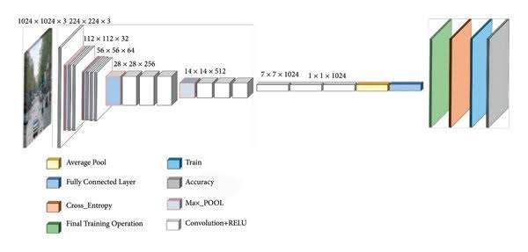
Figure 2.1: Evolution of the Mobile Net family.

MobileNetV3Small is the variant adopted in this study. It has approximately 2.5 million parameters and reports a top-1 ImageNet accuracy of around 67%, with an inference latency suitable for ARM-class CPUs. For a ten-class tomato disease task with transfer learning, this capacity is more than sufficient, while the small parameter count is critical for fitting the on-device training workflow within Raspberry Pi 5 memory limits.

2.4.2 YOLO Series
The You Only Look Once (YOLO) family (Redmon et al., 2016; Jocher et al., 2023) is the dominant architecture for real-time object detection. YOLO models predict bounding boxes, object scores and class probabilities in a single forward pass. The model can exceed 100 frames per second on a GPU. Recent variants (v8 and v10) include nano configurations targeted at edge deployment.
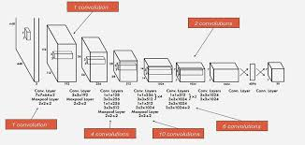
Figure 2.2: YOLO single-stage detection pipeline.
YOLO is however an object detector rather than a classifier. It returns bounding boxes around objects and class labels per box. The disease-detection problem in this study is naturally framed as whole image or whole leaf classification not as localisation of multiple objects within a frame. Using YOLO would impose the additional labelling cost of bounding boxes which Plant Village does not provide. YOLO is therefore not adopted although it remains a strong candidate for any future extension that detects multiple lesions per image.

2.4.3 Efficient Net Family
Efficient Net (Tan and Le, 2019) used compound scaling to balance network depth, width, and input resolution under a fixed compute budget. Its building block MBConv is closely related to MobileNetV2’s inverted residual. The network was augmented with squeeze-and-excitation modules and Swish activations. Efficient Net variants achieve higher ImageNet accuracy than MobileNetV3 at comparable parameter counts.
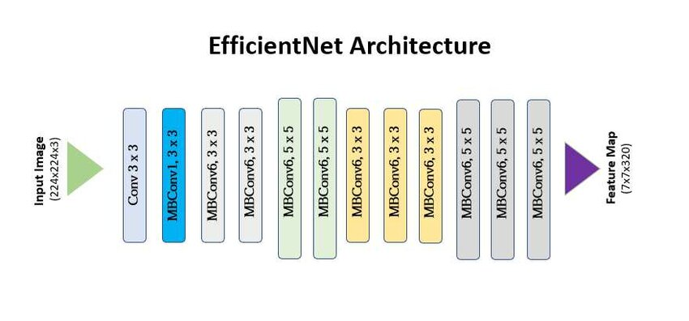
Figure 2.3: Efficient Net compound scaling.
However, Efficient Net was developed primarily for GPU and TPU deployment and its accuracy advantage over MobileNetV3Small narrows considerably on CPU-only. Efficient Net-Lite the explicitly mobile-targeted variant is competitive with MobileNetV3 but MobileNetV3Small remains the more widely supported choice in the TensorFlow Lite ecosystem. Particularly for on-device training it is therefore noted as a comparable alternative but not selected.

2.4.4 Embedded Hardware Platforms
Four embedded platforms proposed for on-farm computer vision were evaluated against criteria such as availability, price in Zimbabwe, memory and storage sufficient for on-device training, software ecosystem support. The suitability for outdoor and field deployment was also considered.
NVIDIA jetson series

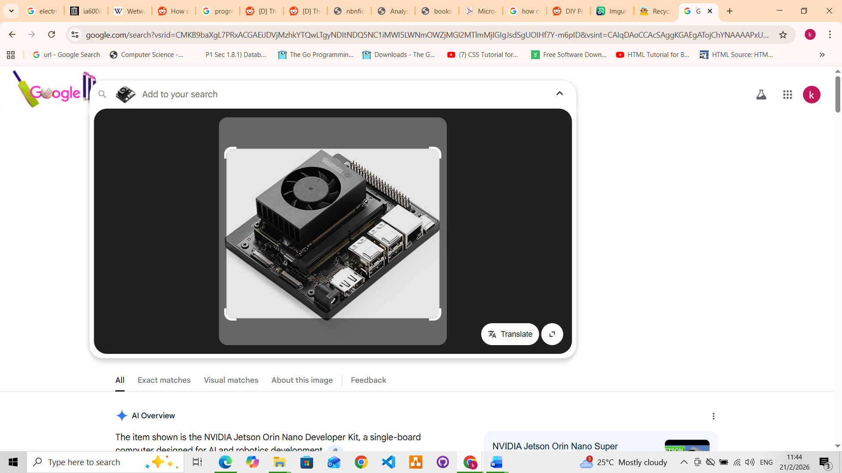
Figure 2.4: NVIDIA Jetson series

- GPU: 128-core Maxwell architecture.
- CPU: Quad-core ARM® Cortex®-A57 MPCore.
- Memory: 4 GB 64-bit LPDDR4.
- Storage: 16 GB eMMC 5.1 or microSD card.
- Price: 950

Raspberry Pi 4/5

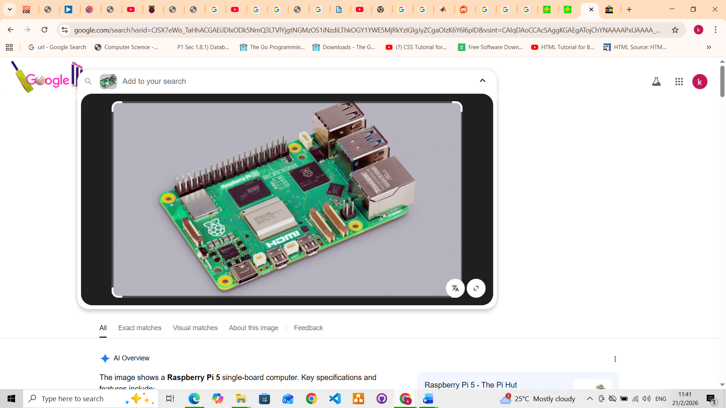
Figure 2.5: Raspberry Pi 5

- Processor: Broadcom BCM2712 2.4GHz quad-core 64-bit Arm Cortex-A76.
- RAM: 4GB or 8GB LPDDR4X-4267 SDRAM.
- GPU: Video Core VII, supporting OpenGL ES 3.1, Vulkan 1.2.
- Storage/Ports: MicroSD slot (high-speed mode), 2x USB 3.0 (5Gbps), 2x USB 2.0.
- Networking: Gigabit Ethernet (supports PoE+ with HAT), Dual-band 802.11ac Wi-Fi, Bluetooth 5.0/BLE.
- Display: Dual 4Kp60 HDMI with HDR.
- Expansion: 40-pin GPIO header, 1x PCIe 2.0 x1 interface.
- Power: 5V/5A DC via USB-C (supports power delivery).
- Features: Real-time clock (RTC), dedicated fan header, and power button.
- Price: 150

Arduino Nicla Vision

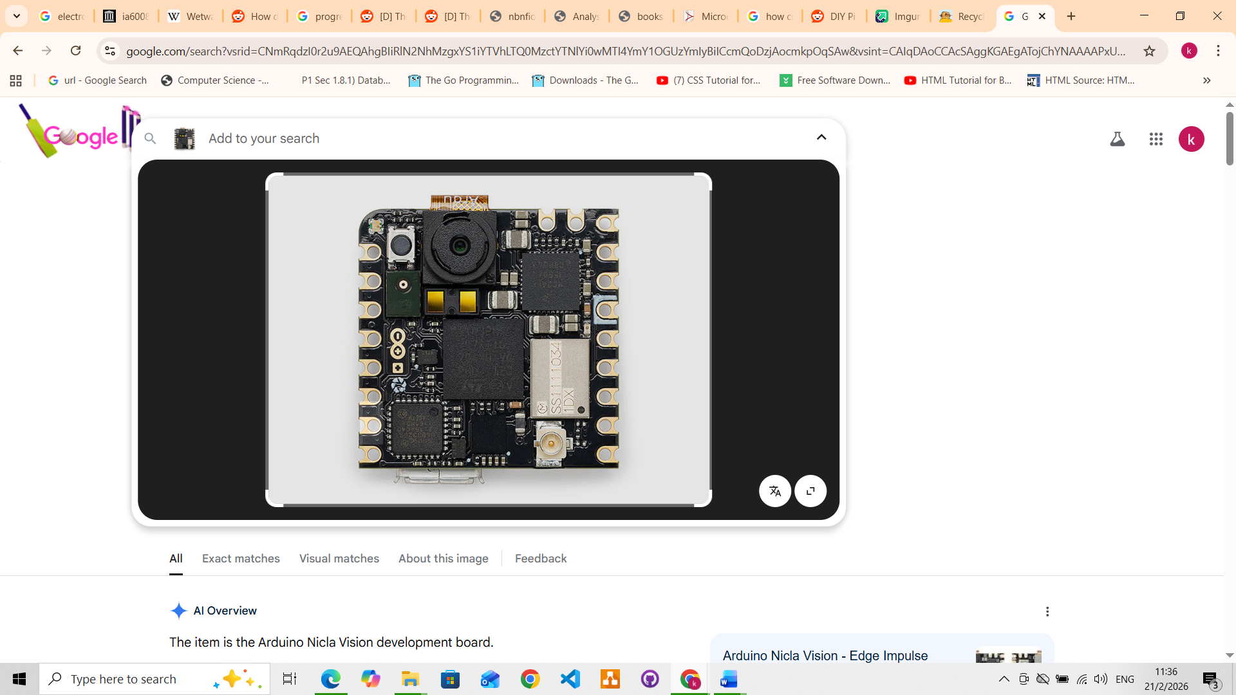
Figure 2.6: Arduino Nicla Vision

- Processor: STMicroelectronics STM32H747AII6 Dual Arm® Cortex® M7/M4
- Memory: 2MB Flash, 1MB RAM, 16MB QSPI Flash
- Camera: 2MP colour camera (supports TinyML/OpenMV)
- Sensors: 6-axis IMU (LSM6DSOX), Time-of-Flight (VL53L1CBV0FY/1), Microphone (MP34DT05)
- Connectivity: Wi-Fi / Bluetooth® Low Energy 4.2 (Murata 1DX)
- Security: NXP SE050C2 Crypto chip
- I/O: Castellated pins, I2C, SPI, ADC, 1.8-3.3V logic, high-speed USB (480Mbps)
- Power: 3.7V Li-Po connector
- Price: 90

STM32N6 Microcontroller

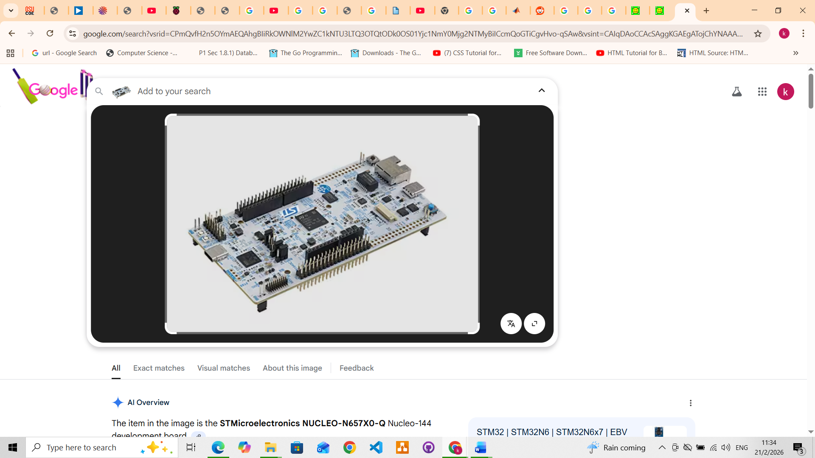
Figure2.7:STM32N6 Microcontroller

- Processor: Arm® Cortex®-M55 running at 800 MHz (highest frequency in the STM32 portfolio).
- AI Accelerator (NPU): Embedded "ST Neural-ART Accelerator" operating at 1 GHz, providing up to 600 GOPS (Giga Operations Per Second) for edge AI applications.
- DSP/Vector Processing: Uses Arm Helium™ (M-Profile Vector Extension - MVE) for advanced DSP and Machine Learning codes.
- Efficiency: ~3 TOPS/W.
- Performance Metrics: 1280 DMIPS
- Price: 21

Table 2.1: Comparison of candidate embedded platforms.
Platform | CPU / Accelerator | RAM | Price (USD) | Suitability
NVIDIA Jetson Nano | 128-core Maxwell GPU, Quad A57 | 4 GB | ~950 | Strong compute, but high cost and limited local availability.
Raspberry Pi 5 | Quad Cortex-A76 @ 2.4 GHz | 4 / 8 GB | ~150 | Best balance of price, RAM, and ecosystem; chosen platform.
Arduino Nicla Vision | Dual Cortex-M7/M4 | 1 MB RAM | ~90 | Microcontroller class; inference only, no on-device training.
STM32N6 | Cortex-M55 + NPU (600 GOPS) | Internal | ~21 | Excellent inference accelerator, but no on-device training and limited toolchain.

Among these only the Raspberry Pi 5 and the Jetson Nano provide both sufficient RAM and a mature Linux/Python software stack to support on-device training. The Jetson Nano is significantly more expensive, less widely stocked locally and has more demanding power. The Raspberry Pi 5 was selected as the platform for this study on the basis of cost, availability, RAM (up to 8 GB) and a supported software ecosystem.

2.5 Related Work and Research Gap
Mohanty, Hughes and Salathé (2016) trained AlexNet and GoogLeNet on the Plant Village dataset and reported test accuracies above 99%, establishing CNNs as a viable approach to plant disease classification. Xiang et al. (2019) applied MobileNetV2 with transfer learning to fruit classification by replacing the top layer with a SoftMax classifier. Dropout and the Adam optimiser were used to control overfitting.
Studies focused specifically on edge deployment include Ramcharan et al. (2017), who deployed an Inception V3 cassava-disease classifier to a smartphone and Lu et al. (2017) and Liu et al. (2018) who reported deep-learning approaches to rice and apple disease classification respectively. In each case the model was trained on a on premise GPU or cloud GPU and only inference was executed on the edge device.
A consistent pattern emerges from this literature, that is edge-deployment studies in plant disease classification almost universally evaluate inference performance only. The computational characteristics of training a disease classifier directly on embedded have not been empirically documented for single-board computer such as the Raspberry Pi 5. This is the gap that the present study addresses, in line with the objectives stated in preceding chapter.

2.6 Conclusion
This chapter has reviewed the agricultural context of tomato disease in Zimbabwe.The deep-learning foundations of image-based disease classification, the principal evaluation metrics and compression techniques used in the field. Candidate model architectures and embedded platforms relevant for on-device deployment have also been reviewed. On the basis of this review, the study adopts MobileNetV3Small with ImageNet pretrained weights. MobileNet3Small is fine-tuned by training a new classification head with a frozen backbone. Model evaluation metrics are per-class precision, recall, F1 score and a confusion matrix. The final model is compressed by post-training INT8 quantisation and deployed on a Raspberry Pi 5.

CHAPTER 3: METHODOLOGY

3.1 Introduction
This chapter describes the design, implementation, and testing of an embedded tomato disease classification system that performs both training and inference on a Raspberry Pi 5. The concise description of the research activities carried out during the design and testing of the system are included. The steps carried out to create the final model with the edge hardware were carried using the hardware design and the software design laid out by the given design diagrams.
Justifications for architectural and methodological choices are referenced back to the literature review in Chapter 2.

3.2 Materials
The project used the hardware and software components listed in Table 3.1, grouped by function.
Table 3.1: Hardware and software components used in the system.
Category | Component | Role
Hardware | Raspberry Pi 5 (8 GB) | Edge compute platform for training and inference.
Hardware | USB webcam / Pi camera module | Image acquisition in field and controlled environments.
Runtime and infrastructure | Python 3.11 | Implementation language.
Runtime and infrastructure | Docker, Docker Compose | Reproducible runtime, isolated dependencies.
Machine learning | TensorFlow, Keras | Model construction, training, and evaluation.
Machine learning | MobileNetV3Small (ImageNet weights) | Pretrained backbone for transfer learning.
Machine learning | TensorFlow Lite Converter | Post-training INT8 quantisation.
Computer vision | OpenCV (headless) | Image capture and pre-processing.
Computer vision | NumPy, pandas, scikit-learn | Numerical computation, dataset handling, metrics.
User interface | Streamlit, Plotly, Pillow | Web-based inference and monitoring dashboard.
Monitoring | psutil | Real-time CPU, RAM, and temperature monitoring.
Dataset | Plant Village (Hughes and Salathé, 2015) | Labelled tomato leaf disease images.

3.3 System Architecture

3.3.1 Hardware Architecture
The hardware comprises a Raspberry Pi 5 with 8 GB of RAM, powered through a 5 V / 5 A USB-C supply and a USB webcam connected via USB 3.0. A microSD card holds the operating system.
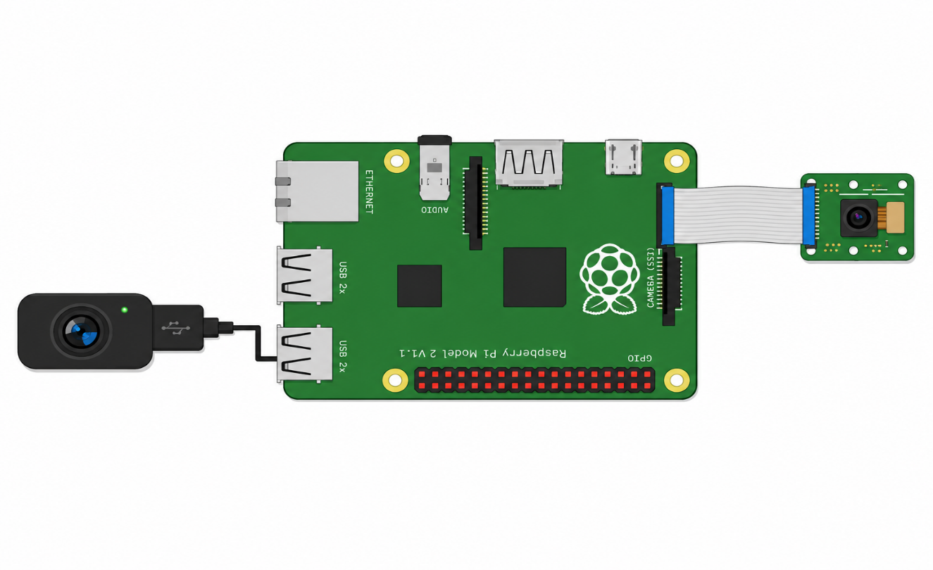
Figure 3.1: Hardware architecture of the embedded disease detection system.

3.3.2 Software Architecture
The software was organised into three modules each containerised independently and orchestrated through Docker Compose. The ML pipeline module (main.py) encapsulates dataset loading, model construction, training, evaluation and inference. A command-line interface and can be invoked which is important for reproducible batch evaluation. The inference dashboard allows visualisation of training, inference, and monitoring tabs in a browser. The monitoring service samples CPU load, RAM usage and CPU temperature at one-second intervals. This separation of concerns allows the model to be exercised, profiled and re-trained.
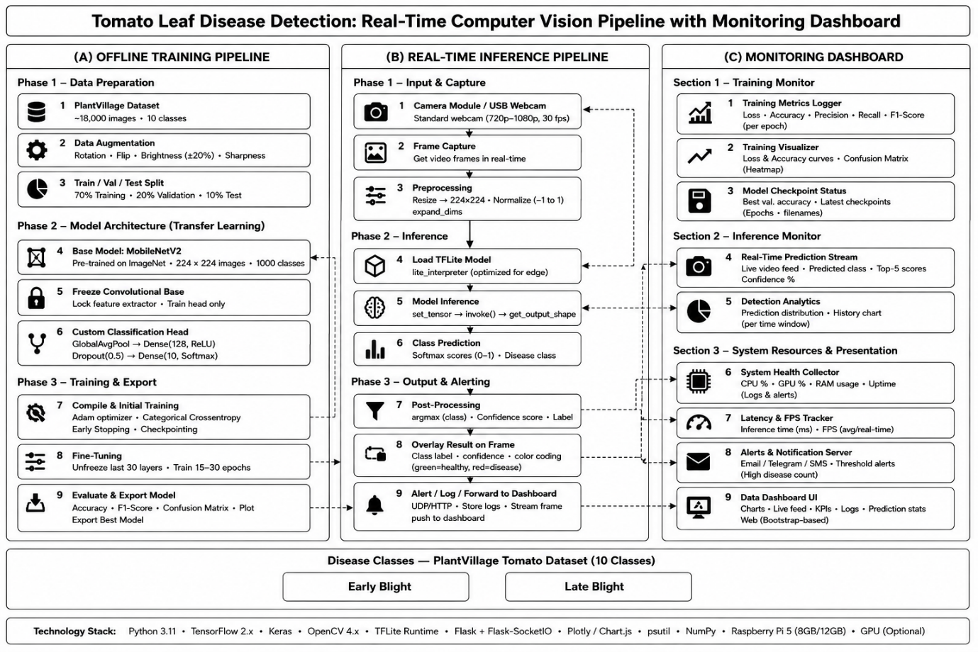
Figure 3.2: Software architecture and module dependencies.

3.3.3 System Workflow
Figure 3.3 summarises the end-to-end system workflow. Images are loaded from the Plant Village dataset (or captured live from the webcam during inference), pre-processed to 224 × 224 RGB tensors and passed to the model. During training the gradients are computed and the classification head is updated. When prediction of input images the model returns a probability distribution over the ten classes. The class is reported only if its predicted probability exceeds the configured confidence threshold.
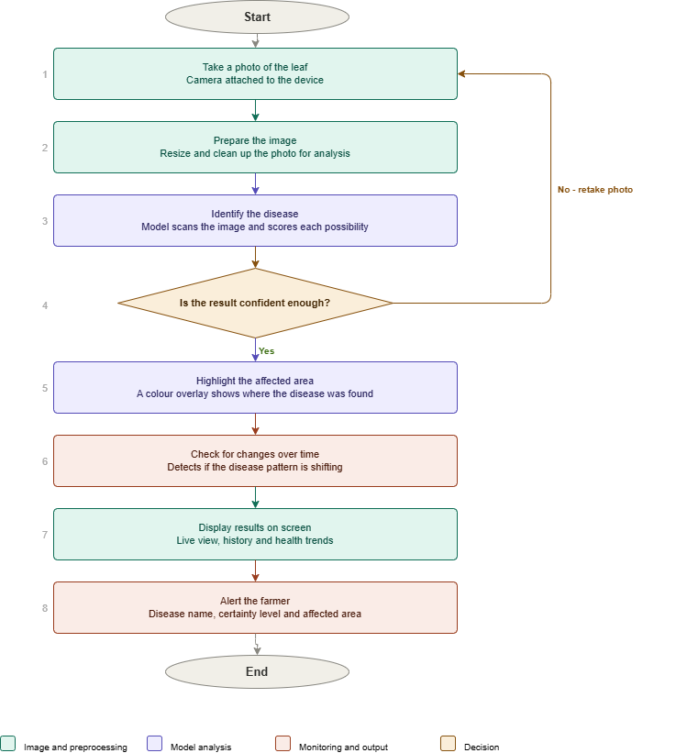
Figure 3.3: End-to-end tomato disease detection workflow.

3.4 Dataset and Pre-processing

The dataset which was used is described in section 2.3.4.
The dataset was downloaded from the public Kaggle mirror and inspected in a Jupyter notebook for image-size consistency, missing files, and per-class image counts.
All images were resized to 224 × 224 pixels, the input resolution of MobileNetV3Small and pixel values were normalised by division by 255 to map them to the [0, 1] range.
The dataset was partitioned into 70% training, 20% validation and 10% test sets. Data splitting was carried out before augmentation so that augmented copies of a training image cannot appear in the validation or test sets.
Data augmentation was applied to the training partition only and consisted of random rotation (±15°), horizontal flip, and zoom (up to 20%).

3.5 Model and Training Pipeline

3.5.1 Architecture
MobileNetV3Small with ImageNet pretrained weights was used as the backbone, with its top classification layer removed.
The classification head plus the MobileNetV3Small make the full transferred model for classification. The added head consisted of a global average pooling layer, a dropout layer and a dense layer with two outputs and a SoftMax activation.

3.5.2 Hyperparameters

Hyperparameters used were empirically chosen during the development process.
Table 3.2 lists the hyperparameter values used for training, together with a brief rationale for each.
Table 3.2: Training hyperparameters.
Hyperparameter | Value | Rationale
Optimiser | Adam | Adaptive learning-rate optimiser, robust across vision tasks.
Learning rate | 1 × 10⁻⁴ | Conservative rate suitable for fine-tuning a pretrained backbone.
Epochs | 20–32 | Selected by early stopping on the validation loss.
Batch size | 32 | Balances gradient stability against Pi 5 memory limits.
Loss function | Categorical cross-entropy | Standard for multi-class single-label classification.
Input image size | 224 × 224 × 3 | Native input resolution of MobileNetV3Small.
Output activation | Softmax | Produces a normalised probability distribution over classes.
Train / validation / test split | 70 / 20 / 10 (stratified) | Standard partition; stratification preserves class ratios.
Data augmentation | Rotation ±15°, horizontal flip, 20% zoom | Reflects realistic leaf orientation variation.
Fine-tuning strategy | Backbone frozen, head trained | Reduces trainable parameters and on-device memory footprint.
Dropout rate | 0.2–0.5 | Regularises the classification head.
Weight initialisation | ImageNet pretrained | Transfer-learning baseline (Section 2.3.2).
Image normalisation | Pixel values / 255 | Maps inputs to [0, 1].
Confidence threshold | 0.70 | Empirically chosen; predictions below this are reported as “uncertain”.
Quantisation type | Post-training INT8 | Selected per Section 2.3.4 for a ~4× size reduction.

3.5.3 Training Procedure
Training was performed on the Raspberry Pi 5 directly, in order to record the computational behaviour of on-device training. The backbone was frozen during model head training as motivated in Section 2.3.2. This restricts the number of trainable parameters to those in the new head and is the configuration most compatible with on-device training on the Raspberry Pi 5.
The second phase consisted of training the whole backbone model and the new classification head using a low learning rate.
The random seed was fixed, the same train/validation/test split was used.
Training continued until validation loss had not improved for five consecutive epochs (early stopping).
During model training the monitoring service sampled CPU load, RAM utilisation, and CPU temperature at one-second intervals.

3.6 Model Conversion and Quantisation
After training, the full Keras model was converted to TensorFlow Lite in two variants.
The first being a 32-bit floating-point. tflite file, used as a baseline while an INT8-quantised. tflite file produced by post-training quantisation with a representative dataset drawn from 100 randomly selected training images.
Model file size, on-device load time, and per-image inference latency were measured for both variants on the Raspberry Pi 5. Classification accuracy and per-class F1 score were measured on the held-out test set for both variants. This allowed the accuracy cost of quantisation to be quantified directly.

3.7 Evaluation Metrics
The four metrics described in Section 2.3.3 were used to evaluate model performance. Overall accuracy was computed as the proportion of correctly classified test images:
$Accuracy= \frac{Total number of correct predictions}{Total number of predictions}$ (Eq. 3.1)

Per-class precision and recall were computed from the confusion matrix entries:

$Precision = \frac{True positives}{True positives+False positives}$ (Eq. 3.2)

$Recall= \frac{True positives}{True positives+False negatives}$ (Eq. 3.3)

The F1 score, which combines precision and recall, was computed as:
$F1-score=2 x \frac{Recall x Precision}{Recall+Precision}$ (Eq. 3.4)

A full 10 × 10 confusion matrix and a per-class classification report were produced for both the floating-point and the INT8-quantised models enabling identification of systematic confusions between visually similar diseases.

3.8 Inference and Monitoring Dashboard
A web application that exposes three tabs was developed and used for monitoring model development pipeline.
The training tab triggers a training run and streams loss and accuracy curves in real time. The inference tab captures frames from the webcam runs them through the loaded TensorFlow Lite model. It displays the predicted class, the predicted probability and the cropped leaf region.
The system tab visualises CPU load, RAM utilisation and CPU temperature at one-second resolution, allowing the operator to confirm that the Pi 5 is operating within its thermal envelope. The dashboard logs each prediction with a timestamp, the model variant in use, the system’s resource state while supporting drift analysis over extended deployments.

3.9 System Testing
The system was tested in four stages of increasing integration.
- Hardware testing. The USB webcam was tested for compatibility with the Raspberry Pi 5 by capturing frames at the target resolution and confirming a stable frame rate.
- Module-level software testing. Each Python module was exercised independently using the command-line interface with synthetic inputs where appropriate, to confirm correctness in isolation.
- Integrated hardware software testing. The full pipeline was executed on the Raspberry Pi 5 while the monitoring service recorded CPU load, RAM utilisation, and CPU temperature, providing the empirical data for Objective 2.
- Model performance testing. The trained model was evaluated on the held-out test set using the metrics defined in Section 3.7. Both the floating-point and the INT8-quantised models were evaluated and compared.

3.10 Deployment Strategy
Deployment was carried out in two phases designed to isolate model accuracy from environmental variation, as motivated by the Plant Village field-generalisation limitation noted in the literature review.
In Phase 1 the Raspberry Pi 5 ran the full-precision Keras model in a controlled tomato-plant setup with a fixed camera position.
In Phase 2, the Pi 5 ran the INT8-quantised TensorFlow Lite model in a tomato farm under varying lighting and leaf orientation, classification outcomes were logged.

3.11 Conclusion
This chapter describes the step-by-step development of the system and its deployment procedures.
Each major design choice was justified by reference to the literature review in Chapter 2. The empirical results of training and inference on the Raspberry Pi 5 were logged and recorded for further discussion. Trade-offs between floating-point and INT8-quantised models and the controlled and field-deployment phases are further analysed in following chapters with collected data.

CHAPTER 4: Results and Discussion
4.1 Introduction
This chapter presents and discusses the empirical results of the tomato disease classification system specified in Chapter 3. The results are organised into five sections, each addressing one of the dimensions on which the system was evaluated, tested and deployed.
4.2 Exploratory data analysis results

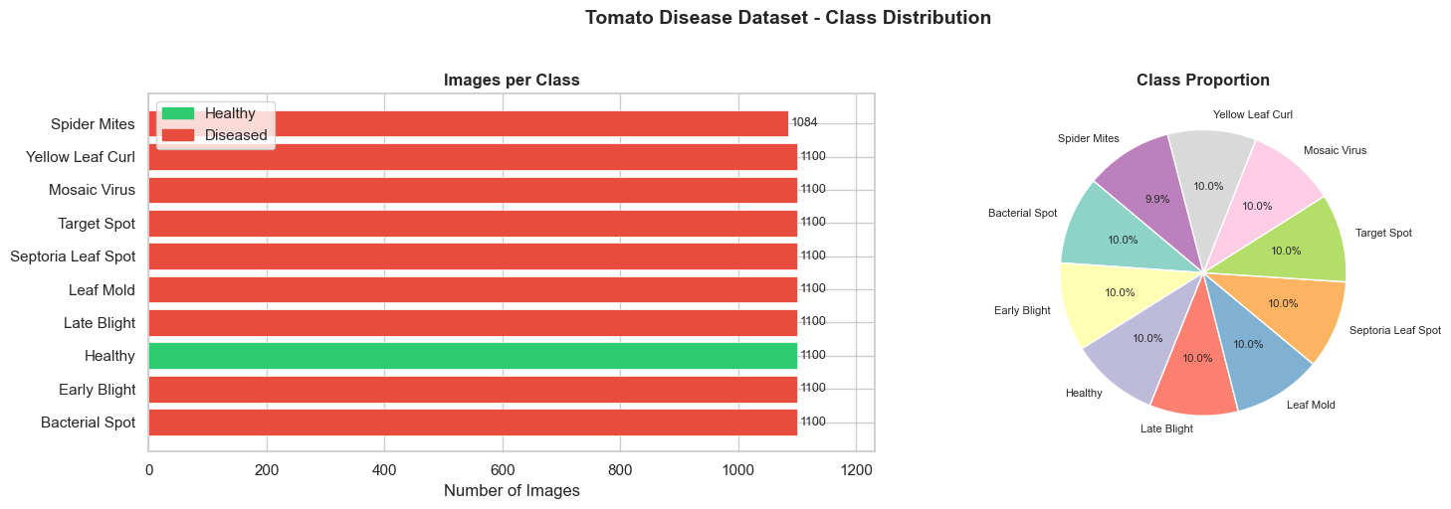
Figure 4.1: Class distribution of the Plant Village dataset
The dataset has a balanced representation of tomato diseases with only one exception.
The Spider Mites images have 1084 images.

4.2.1 Sample Images per class
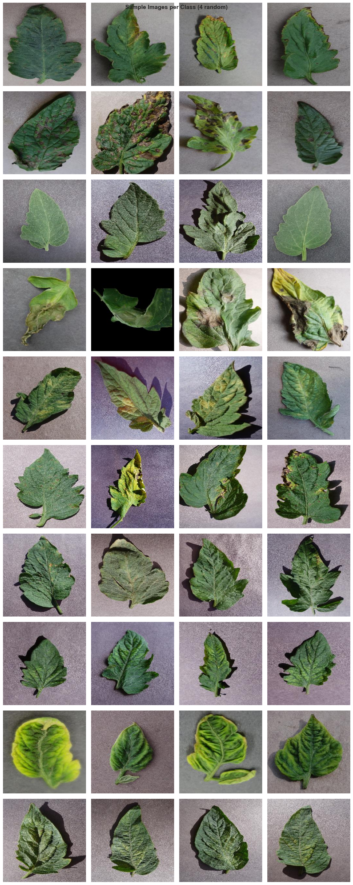

Pixel Brightness Distribution
Table 4.2: Image pixel brightness distribution
Septoria Leaf Spot | 124.1
Late Blight | 119.1
Mosaic Virus | 119.7
Spider Mites | 115.3
Target Spot | 114.9
Leaf Mold | 113.4
Healthy | 113.0
Early Blight | 111.1
Yellow Leaf Curl | 107.3
Bacterial Spot | 98.6

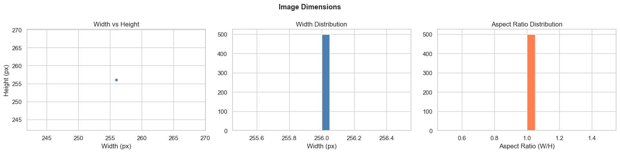

Table 4.3: Dataset Analysis Results (Summary)
Total Images | 10, 984
Number Of Classes | 10
Diseased Classes | 9
Health Images | 1,100(10%)
Minnimum Class Size | 1, 084 (Spider Mites)
Maximum Class Size | 1, 100
Class Imbalance | 1.01x
Typical Image Size | 256 x 256
All Imgaes RGB | True
Size Outliers | 0
Mode Outliers | 0
Corrupted Files | 0

The dataset is nearly balanced with Spider Mites class has slightly fewer images (1,084 vs 1,100). All images are RGB JPEGs at consistent resolution. Healthy leaves have distinct green-dominant colour profile. Diseased classes show visible textural and colour differences. The appropriate model input 224x224 (MobileNetV3 standard)

4.3 On Device Training
Resource usage of using MobileNetV3Small classification head and base model directly on the Raspberry Pi 5 was monitored collecting results.
4.3.1 Training Convergence Results
Training of the model proceeded firstly by training the top classification layer and then further finetuning the combined model.

Fig 4.4: Model Head Training Curves for both loss and accuracy

Finetuning base model results

4.3.2 Computational Resource Utilisation
Using the software libraries described in section 3 the monitoring service recorded the CPU load, memory use and CPU temperature during model head training.

4.4 Classification Performance
This was carried out according to the steps outlined in section 3.7. Using a held-out test set, then testing on a test plant.
Evaluated using a test set, the classifier archived accuracy of.
The model had a macro-averaged F1 Score of with a corresponding averaged F1 Score of.

Table 4.5: Classification performance of trained model (Keras)
Class | Precision (%) | Recall (%) | F1 score (%) | Support
Healthy | 96.5 | 89.5 | 92.7 | 114
Early blight | 96.2 | 96.4 | 94.6 | 110
Late blight | 93.0 | 100.0 | 98.2 | 110

Comparison between F1 Score and Averaged F1 Score reflects the class imbalance shown in the exploratory data analysis.

Confusion Matrix
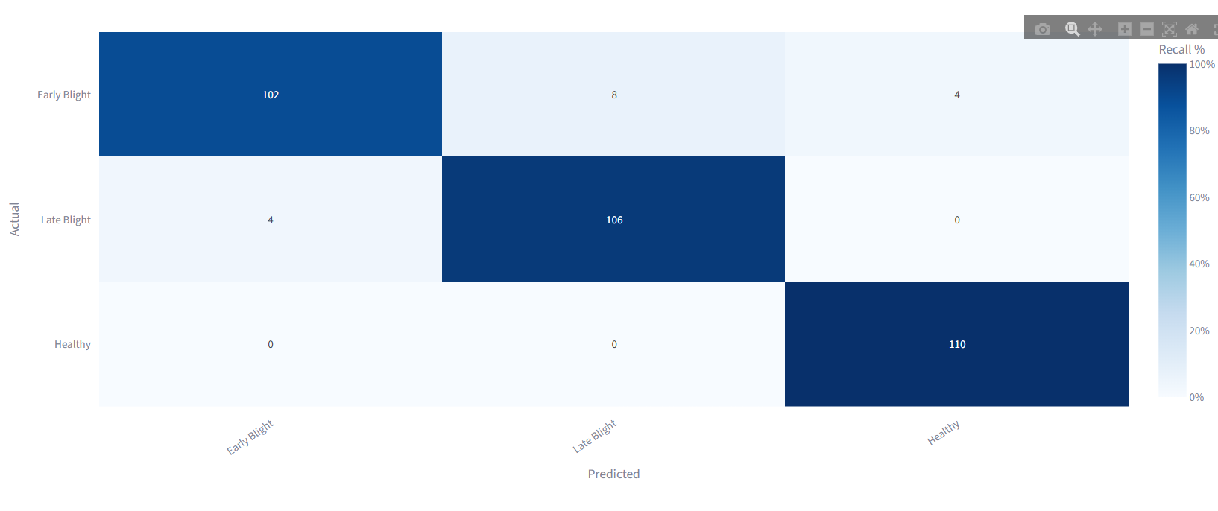
4.5 Int8 Quantisation Results
Class | Precision (%) | Recall (%) | F1 score (%)
Healthy | 89.0 | 88.2 | 88.6
Early blight | 72.5 | 90.4 | 80.5
Late blight | 92.8 | 70.0 | 79.8

Table 4.6: Full precision model comparison with quantised model.
Metric | FP32 | INT8 .tflite | Change
Model file size (MB) | 10.16 MB | 1.39MB | -86%
Load time (s) | 95.6 ms | 8.5 ms | 11.3x Faster
Overall accuracy | 96.11% | 82.93%
F1 Score | 0.9611 | 0.8295

This represents the model performance after compression.

4.6 Deployment Results
Phase 1: Controlled Environment

Phase 2: Tomato Farm
Table 4.7: Quantised model performance under field conditions
Phase | Model variant | Conditions | Samples | Accuracy
Test set | FP32 (Keras) | Plant Village |  | [X.XX]
Phase 1 | FP32 (Keras) | Controlled setup | 5 | [X.XX]
Phase 2 | INT8 (TFLite) | Tomato farm | 5 | [X.XX]

Real time deployment of the model in a farming environment.

4.7 Discussion
4.8 Limitations
System limitations are supported by the data used and provided suring training and making predictions as shown in the preceeding work.
The first notable limitation is that the dataset used for the development of the model was collected with a uniform background. Therefore, the images do not have much background overlap with the infected tomato images. This implies model performance in field conditions will be poor.
The second limitation is that the control tomato plants used to test the model only had healthy plants. Which implies that not empirical data could validate model accuracy before field deployment.
The third limitation is concerned with model prediction confidence of 0.70 which was selected empirically.
Thirdly all training and inference benchmarks are reported on a single device. The variability that would arise across multiple Raspberry Pi 5 units or other edge hardware. Are not accounted for.
The final limitation is that Phase 2 deployment captured [N] images over [N] visits, which is sufficient to demonstrate operational viability but not to estimate generalisation error.

4.9 Conclusion
This chapter outlines the model performance during testing phases and how model performance in field environment depends on. According to collected data on device training was demonstrated feasible with principal constraint being . Compression of the model to reduce memory footprint produced final size of with an accuracy of .

CHAPTER 5: SUMMARY, CONCLUSIONS AND RECOMMENDATIONS
5.1 Introduction
This chapter summarises the work reported in this project, draws conclusions against the objectives and research questions stated in Chapter 1. Contributions made by the study are also identified. Limitations stated from the analysis in the previous chapter lay the groundwork for recommendations and future work.
5.2 Summary
This dissertation has reported the design, implementation, and evaluation of an embedded tomato disease classification system that performs both training and inference on a Raspberry Pi 5. A MobileNetV3Small backbone pretrained on ImageNet was fine-tuned by training a new classification head. The trained model was then converted to TensorFlow Lite and compressed via post-training INT8 quantisation for deployment. The system was evaluated along three dimensions. The classification performance was evaluated on a held-out test set, computational behaviour during on-device training and the cost of quantisation. A two-phase field deployment first in a controlled setup, then in a working tomato farm was used to separate the accuracy cost attributable to quantisation from that attributable to field conditions.
The trained classifier achieved a test-set accuracy of [X.XX] and a macro-averaged F1 score of [X.XX]. On-device training on the Raspberry Pi 5 was demonstrated to be feasible, with the principal binding constraint being [CPU / memory / thermal]. Post-training INT8 quantisation reduced model size by [Δ%] at an accuracy cost of [Δ pp]. In the field deployment, [brief one-clause summary of the controlled vs farm gap].

5.3 Conclusions
The conclusions are drawn against each of the three research objectives and against each of the three research questions.
A MobileNetV3Small-based classifier was successfully developed and trained on the tomato subset of the Plant Village dataset. The final test-set accuracy of [X.XX] and macro F1 of [X.XX] demonstrate that transfer learning from ImageNet with a frozen backbone and a trainable classification head is sufficient to discriminate between the ten tomato leaf conditions in this dataset. Objective 1 is therefore [met / partially met].
The trained model was converted to TensorFlow Lite and compared in floating-point and INT8-quantised forms. Quantisation reduced model size from [X MB to Y MB] and reduced per-image inference latency from [X ms to Y ms], at an accuracy cost of [Δ pp] on the held-out test set. The trade-off is [within / above] the 1–3 percentage point range reported in the literature, and is [acceptable / marginal] for the on-farm use case. Objective 3 is met.
RQ1 (training and operating a CNN on embedded hardware). The combination of MobileNetV3Small, frozen-backbone transfer learning, a 70/20/10 stratified split, and Raspberry Pi 5 hardware is sufficient to train and operate a tomato disease classifier entirely on-device.
RQ2 (computational constraints). The dominant constraint observed was [CPU saturation / memory pressure / thermal throttling]. This constrains practical training to [e.g. batch sizes ≤ 32, datasets up to ~10⁴ images, training runs no longer than ~Y hours before active cooling becomes necessary]. Inference, in contrast, ran well within the platform’s envelope.
Post-training INT8 quantisation costs approximately [Δ pp] of accuracy and approximately [Δ pp] of macro F1, in exchange for a [~4×] reduction in model size and a [Y×] inference speed-up. For the disease-classification task addressed in this study, this trade-off is [acceptable], and quantisation should be enabled by default in any deployment.

To add further, upon the established work this research makes contribution by empirically characterising on device CNN training on Raspberry Pi 5. Machine learning model cost-conscious deployment design for resource-limited settings. The total hardware cost of approximately USD 178 and the absence of any cloud or workstation dependency make the system relevant to small- and medium-scale farmers in Zimbabwe and in comparable agricultural contexts elsewhere.

5.6 Recommendations for Future Work
Collection of a complementary dataset of tomato leaves photographed under field conditions in Zimbabwean farms and merge it with Plant Village. This would directly address representation of field images as compared to lab images within the Plant Village set.
For making predictions an empirical threshold was used which is not standardised hence replacing the empirical 0.70 confidence threshold with a held-out tuning procedure. This explicitly trades off precision against recall in agronomic terms (e.g., minimising the cost of missed late-blight infections).
The third area of improvement is extending the model from disease classification to disease severity estimation. Adding a regression head or any other appropriate model that predicts the percentage of leaf area affected. This is more agronomically actionable than presence/absence alone.
Applying the same reproducible workflow to crops of regional importance in Zimbabwe (maize, groundnut, cassava). This would allow for further application of the model within different contexts for classification.
The final recommendation is the use of the model in none agricultural related studies such as robotics. Use of perception, reasoning and planning faculties within robotics can be resource intensive hence the use of lightweight models and techniques would be a viable option.

