Darius Nyaundi

Home work a6 -seis 764

1. Include a WORD document to describe your RNN architecture.

My RNN is a LSTM model that will determine the last column of power

generated on each day over 100.

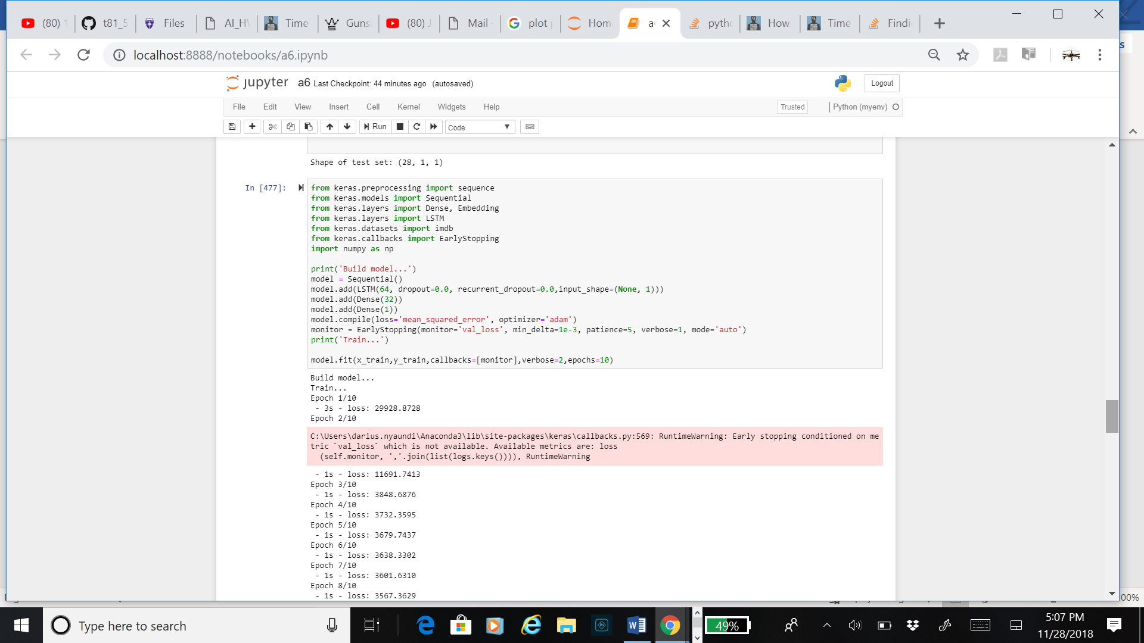

2. Describe your sequence training steps in detail.

Sequence is 30

Testing

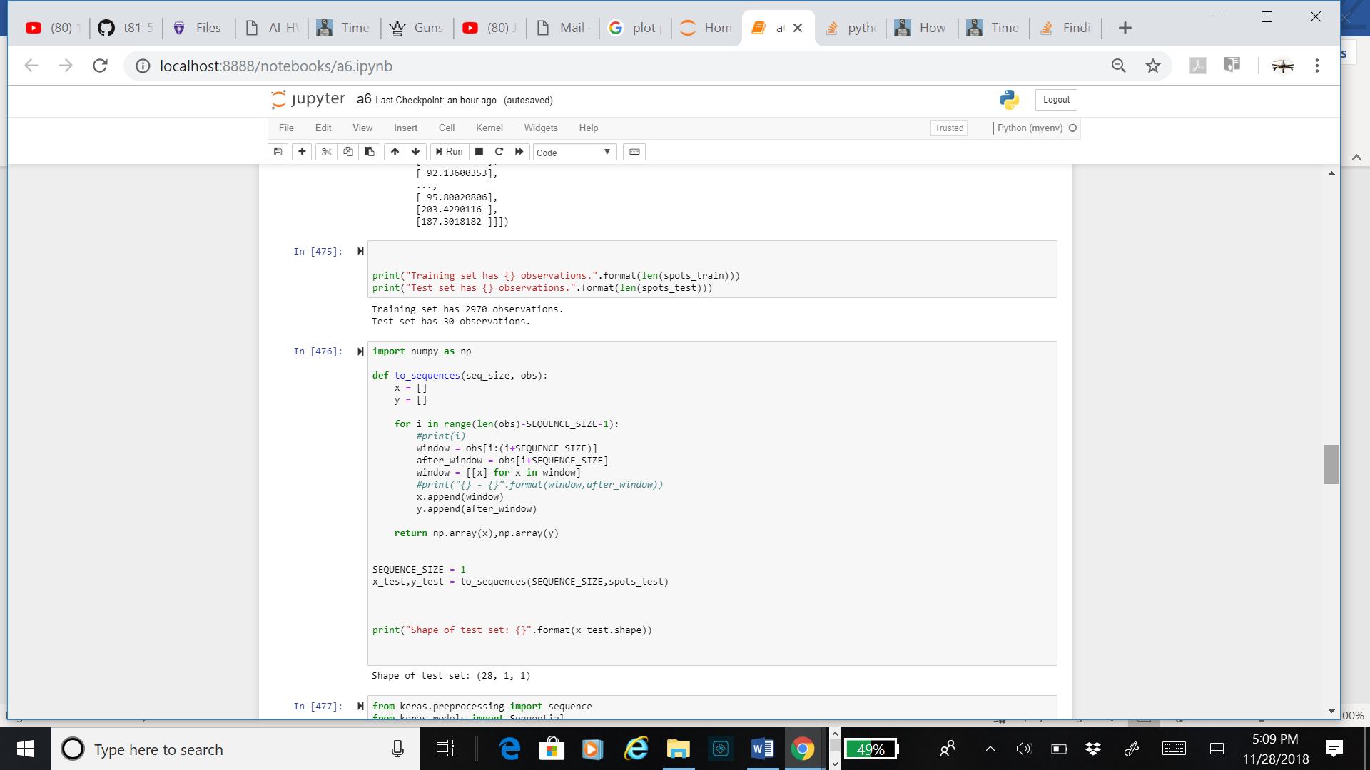

Training

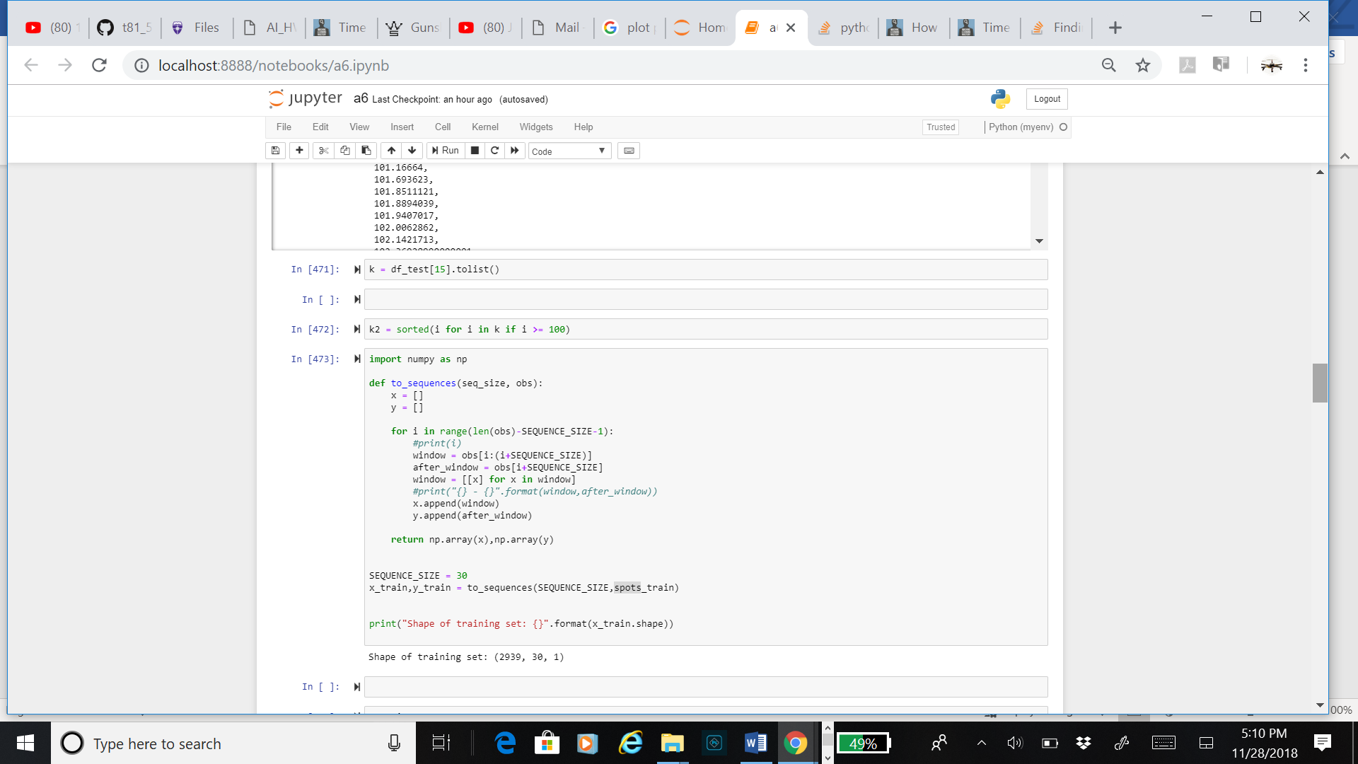

3. Use the last 30-day data as test data. What is the total RMSE on your test data? Please make sure that you clearly describe how to interpret your RMSE.

58 for training 63 for testing

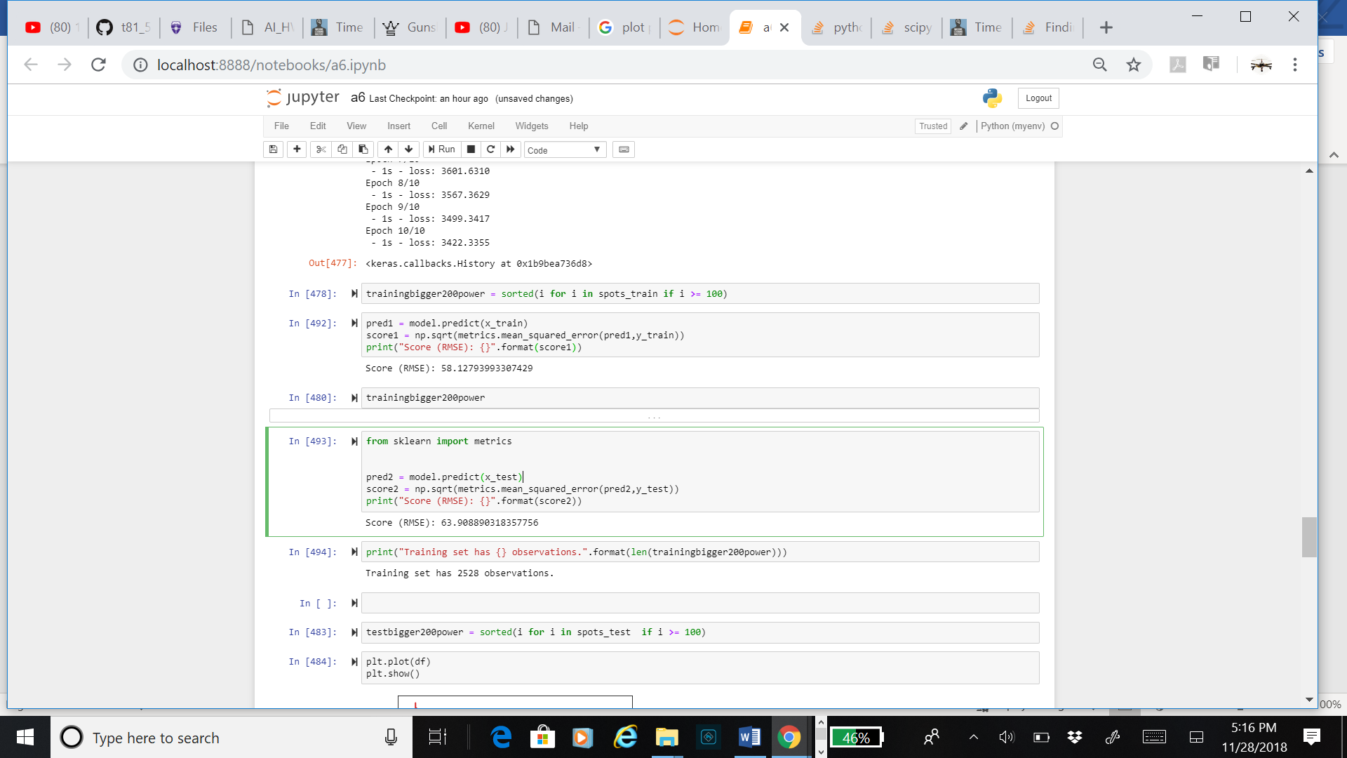

4. Create a figure that plots the test data and your prediction.

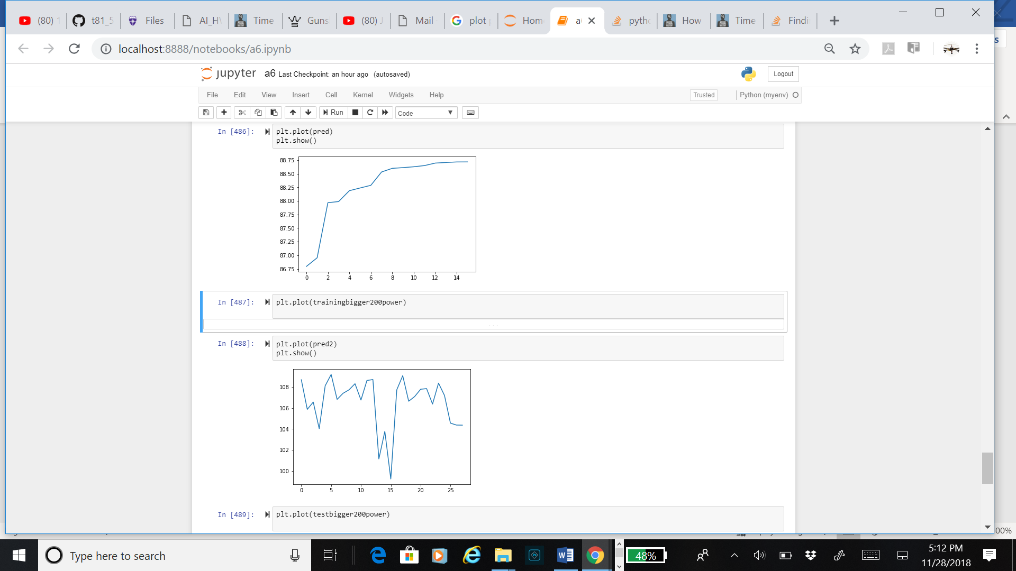

5. Create another figure that plots the RMSE over time.

