Author: Nobutaka Kim

Please open the scene NexPlayerDLL, and you will see the following:

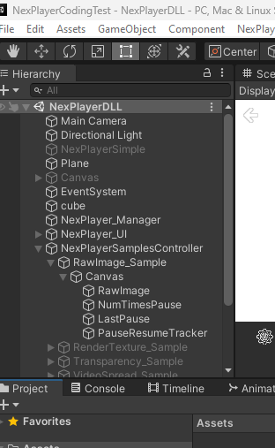

Here you can see NumTimesPause, LastPause and Empty Game Object PauseResumeTracker.

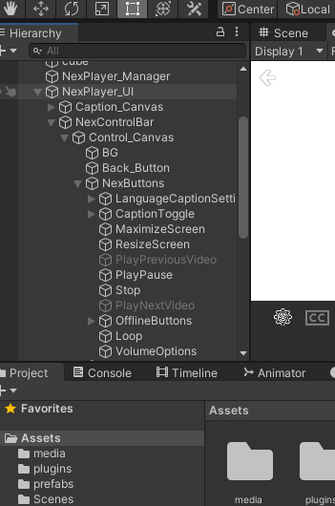

Just a screenshot of the PlayPause button I reference in my script.

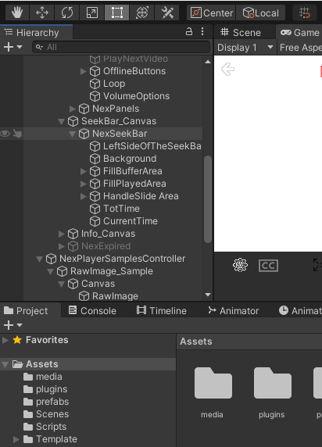

And another screenshot of the CurrentTime Game Object I reference in my script.

My Unity version is 2020.3.34f1 on Windows.

I had to rebuild the DLL for x64 as I first built it for x86.

I learned a lot and enjoyed this. Thanks very much and I look forward to your decision.

I should be in Korea on August 19 if I pass my Rapid Antigen Test on August 17 in Canada.