COMP 3271 Assignment 1: T00057442, Nobutaka Kim

Chapter 2
•
Questions: Q2-2, Q2-10, and Q2-12
•
Problems: P2-4, P2-6, P2-8, P2-14

Q2-2: Which layers of the TCP/IP protocol suite are involved in a link-layer switch?
The physical and data link layers are involved.
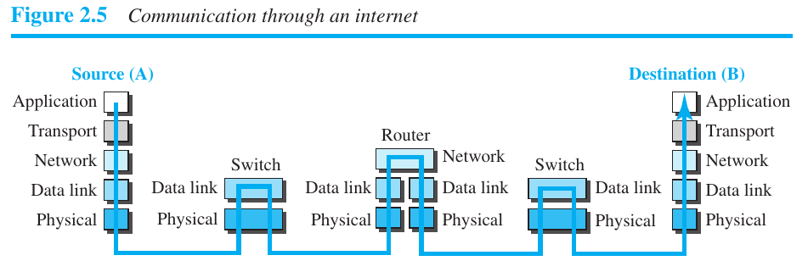

Q2-10: If a port number is 16 bits (2 bytes), what is the minimum header size at the
transport layer of the TCP/IP protocol suite?
Transport layer is responsible for delivering data to appropriate process in the destination so source and destination port numbers are in the header. Assuming 2 bytes is for either source or destination, we need another 2 bytes for whichever port number is missing. Furthermore, these port number are a part of the TCP/UDP header shown below in the transport layer.

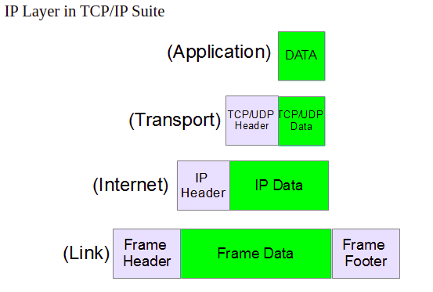

The TCP header is comprised of :

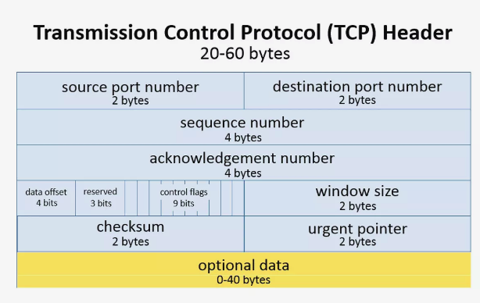

UDP headers are much smaller at 8 bytes with only the source port number (2 bytes), destination port number (2 bytes), length of data (2 bytes), UDP checksum (2 bytes).

Q2-12: When we say that the transport layer multiplexes and demultiplexes application-
layer messages, do we mean that a transport-layer protocol can combine
several messages from the application layer in one packet? Explain.

No, each packet from differing protocols in the application layer are encapsulated individually, it is just that the transport layer is CAPABLE OF accepting these messages that use for example FTP, HTTP for TCP and DNS, SNMP for UDP. This occurs one packet at a time. Refer below.

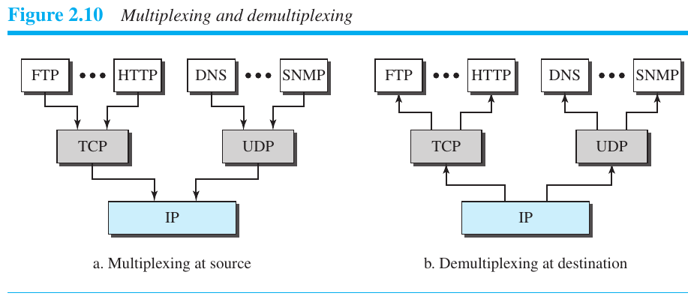

P2-4: Assume a system uses five protocol layers. If the application program creates a
message of 100 bytes and each layer (including the fifth and the first) adds a
header of 10 bytes to the data unit, what is the efficiency (the ratio of application-
layer bytes to the number of bytes transmitted) of the system?

100 / 100 + (10*5) = 100/ 150 = 0.6666 = approx. 67% efficiency

P2-6: Match the following to one or more layers of the TCP/IP protocol suite:
a. route determination
b. connection to transmission media
c. providing services for the end user

a. The data link layer takes datagram, encapsulates it in frame and is responsible for moving it across the link to the next hop. The network layer is responsible for host-to-host communication and routing the packet through possible routes.
b. The physical layer is responsible for converting bits to signals for example using different voltages or frequencies (electrical or optical signals).
c. The application layer is responsible for this since that is the only layer that the end user actually interacts with. However, you could argue that all layers do this indirectly since they are all necessary.

P2-8: In Figure 2.10, when the IP protocol decapsulates the transport-layer packet, how does it know to which upper-layer protocol (UDP or TCP) the packet should be delivered?

The headers for TCP and UDP are quite different as explained in an earlier question so this would distinguish one from the other. Also, it is possible for the network layer IP protocol to multiplex TCP and UDP as show in the diagram above.
Furthermore, an IP header has a field called Protocol, shown below, which defines whether TCP or UDP is used in the data portion of the IP datagram. TCP is represented by 6 and UDP 17.
In hindsight, this question is worded strangely because the IP protocol at the network layer encapsulates a packet from the transport layer at source and decapsulates a packet from the data link layer at the destination. So I assume the 6 or 17 in the IP protocol header plays a key role during decapsulation at the destination. The main duty of the network layer is to check and match the IP addresses.

P2-14: Assume that an application-layer protocol is written to use the services of
UDP. Can the application-layer protocol uses the services of TCP without
change?

No because UDP is connection-less where as TCP is a connection based protocol so the application layer protocol would need a mechanism to switch from one to the other. TCP first establishes a connection.
“Where as TCP uses a receive buffer and signals to the sender the available space, UDP does not have this FLOW CONTROL so packets arrive in a stream or they are dropped.” This quote was found on the internet but from implementations I have seen, I have not yet seen a TCP server that sends this statistic back to the client.
However, using select, http://man7.org/linux/man-pages/man2/select.2.html, it is possible to multiplex TCP and UDP sockets.
For Chapter 3, answer the following questions:
1. A device is sending out data at the rate of 2000 bps.
a. How long does it take to send out 10 bps?

It takes 10/2000 = 1/20 or 0.05 seconds. rounding error 0.005 seconds
b. How long does it take to send out a single character (8bits)?
8/2000 = 0.004 seconds.
c. How long does it take to send a file of 100,000 characters?
100k * 8 bits = 800 kb
800 kb / 2 kb = 400 seconds
2. The attenuation of a signal is -10 dB. What is the final signal power if it was
originally 500 mW?

dB = 10log_10 (p2/p1)

-10 dB = 10log_10 (p2/ 500mW)

refer Example 3.30 in text:

dB = 10 log_10(P2/500mW) = -10, (P2/500 mW) =10^ (-0.10) = > (P2/500mW) = 0.1 => P2 = 50 mW

3. If the bandwidth of the channel is 4Kbps, how long does it take to send a
frame of 100,000 bits out of this device?

100 k / 4kbps = 25 seconds

4. We measure the performance of a telephone line (4KHz of bandwidth). When
the signal is 5 V, the noise is 1 mV. What is the maximum data rate supported
by this line?

SNR = avg signal power/avg noise power = 5V / 0.001 V = 5000
Capacity = Bandwidth * log2(1+SNR) but when SNR is very high, assume SNR = SNR +1, simplify to Capacity = Bandwidth *SNR_dB where SNR_dB = 10 log10SNR
2nd formula:
SNR_dB = 36.989
4000 * 36.989 = 147956 = 147 kbps
1st formula:
4KHz * log2(1+5000) = 49.152 kbps

I am inclined to chose the second formula’s answer of 147 kbps but the textbook does not specify what the threshold for a large SNR is.

5. A computer monitor has a resolution of 600 by 480 pixels. If each pixel uses
1024 colours, how many bits are needed to send the complete contents of a
screen?

With 1024 colors, that is 2^10 so 10 bpp (bits per pixel). 600 * 480 *1024 = 294,912,000 bits = 294 Mb. calculation error: 600 * 480 * 10 = 2.88 Mb

6. What is the transmission time of a packet sent by a station if the length of the
packet is 1 million bytes and the bandwidth of the channel is 400Kbps?

1 million * 8 / 400 k = 20 seconds
1 Mb / 0.4 Mbps = 2.5 seconds *calculaiton error

7. How many bits can fit on a link with a 5 ms delay if the bandwidth of the link
is
a. 1 Mbps?
b. 10 Mbps?
c. 100 Mbps?

Bandwidth delay product is a performance metric tha measures the number of bits that can fill the link.
Important if we want to send bursts and wait for acknowledgement before sending next. For maximum capability of link, we need to make size of our burst 2 times product rate and delay. This is because RTT (round trip time) is required to get the acknowledgement.

Bandwidth * delay = answer

a. 1 Mbps * 5 ms = 1000000 bps * 0.005 = 5000 bps or 5 kbps
b. 10 Mbps * 5 ms = 50 kbps
c. 100 Mbps * 5 ms = 500 kbps

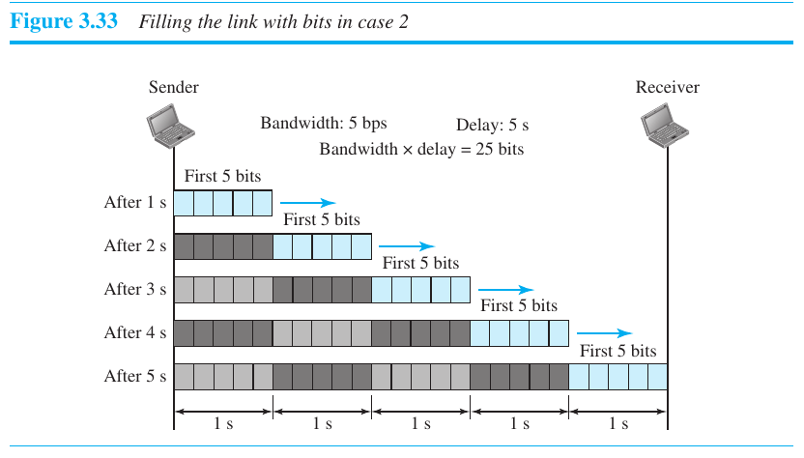

Chapter 4

Q4-8
List five line coding schemes discussed in this book.
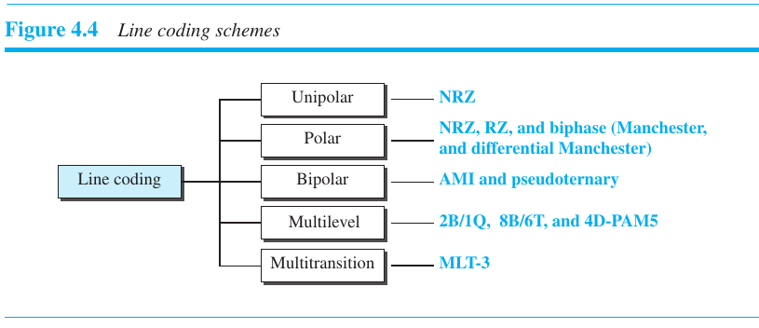

The above is from the text book listing the line coding schemes. A summary is below:

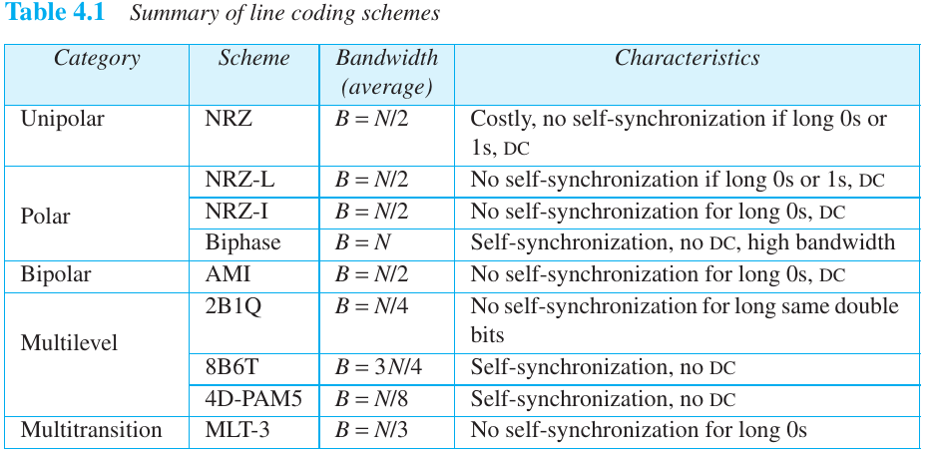

Q4-8 Define block coding and give its purpose
Problems: P4-12.a. and P4-16.a.

P4-12a.

The input stream to a 4B/5B block encoder is
0100 0000 0000 0000 0000 0001

a. What is the output stream?

Using the mapping codes below we get: 01010 11110 11110 11110 11110 01001
But keep in mind that there are never more than three consecutive 0s, no more than one leading zero (left bit) and no more than two trailing zeros (right bits).

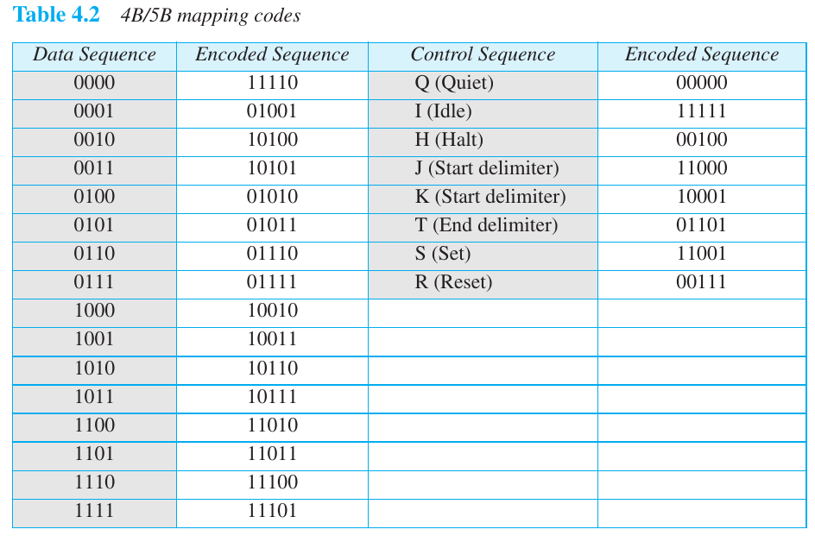

P4-16
We have sampled a low-pass signal with a bandwidth of 200 KHz using
1024 levels of quantization.
a. Calculate the bit rate of the digitized signal.

bit rate = sampling rate * number of bits per sample = f * nb

num levels = log2L = log2(1024) = 10 bits
Nyquist rate is 2 * highest freq of 200 kHz = 400 kHz

bit rate = 400 kHz * 10 bits = 4000 kbps = 4 Mbps

Chapter 5
•
Questions: Q5-2 and Q5-4
•
Q 5-2 Define carrier signal and explain its role in analog transmission.
From page 138, “the sending device produces a high frequency signal that acts as a base for the information signal. This base signal is the carrier signal or carrier frequency. The receiving device is tuned to the frequency of the carrier signal that it expects from the sender. Digital information then chagnes the carrier signal by modifying one or more of its characteristics (amplitude, frequency, phase). This is called modulation (shift keying). “

Q5-4 Which characteristics of an analog signal are changed to represent the digital
signal in each of the following digital-to-analog conversions?
a. ASK: Amplitude shift keying changes amplitude for example max for 1 and zero for 0
b. FSK: Frequency shift keying changes frequencies so higher for 1 and lower for 0. Two carrier signals f1 and f2 are modulated by signal frequencies so this takes more bandwidth.
c. PSK: Phase shift keying where two signals 0 and 1 have different phases of 0 and 180 degrees. The first signal element in the figure has 0 degree phase
d. QAM: Quadrature amplitude modulation is a combination of ASK and PSK with same minimum bandwidth for ASK and PSK with same advantages as PSK over ASK. Below is a constellation diagram for 16 QAM in which you can see 4 bits per signal (2^4).

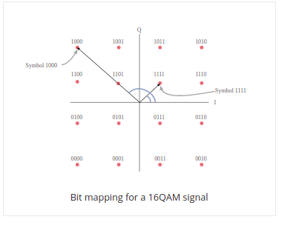

In general constellation diagrams contain the following info regarding the amplitude and phase.

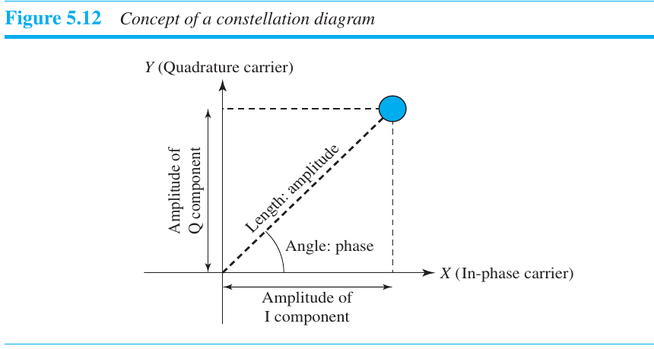

Problems: P5-2, P5-8, and P5-10
P5-2
Calculate the bit rate for the given baud rate and type of modulation.
We need to assume for a, b, c that there is one bit per signal element.
a. 1000 baud, FSK
S = 1000, assuming 1 bit per signal element then L = 2 and r = log2L so r =1.
Since r = 1 and r = N/S, N = 1000 bps.

b. 1000 baud, ASK
Using formula of B = (1+d) * S where d =0 for this class, B = 1000 Hz
Assume 1 bit per signal element and we get S = N for 1000 bps

c. 1000 baud, BPSK
Assuming 1 bit per signal element, again the figures in the text, in this case fig 5.9 show S=N with r=1 so N = 1000 bps.

d. 1000 baud, 16-QAM: Assuming there are 8 levels in the signal, four positive and four negative for L=8, r = log2L so r = 3 meaning there are 3 bits per signal element and since 3 = N/1000, N = 3000 bps.

Wrong! 16 QAM sends at 4000 bps. 4 bits per baud, 2^4 = 16.

The above is a very odd line of questioning since a,b,c require assumptions to be made or referral to diagrams in the textbook which usually show the “base” case of 1 bit per signal element.

Chapter 6
•
Questions: Q6-4
Which of the three multiplexing techniques is (are) used to combine analog
signals? Which of the three multiplexing techniques is (are) used to combine
digital signals?

Analog signals are combined via frequency division multiplexing and wavelength division multiplexing. Time division multiplexing is used for digital to digital.
In FDM, signals generated by each sending device modulate different carrier frequencies (say three). Combine these into a single composite signal but separate with enough bandidth to accommodate modulated signal with guard bands in between.

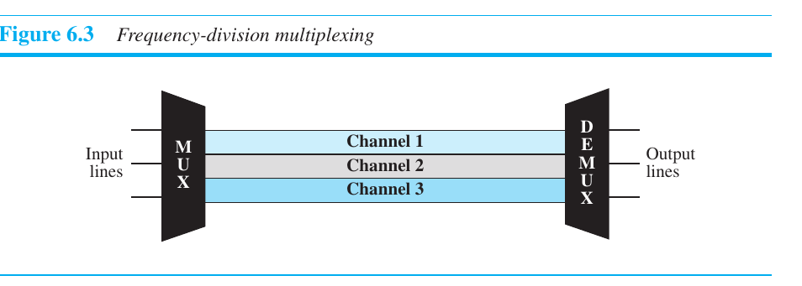

wave length division multiplexing: use high data rate capability of fiber optic cable. Conceptually the same as FDM but multiplexing and demultiplexing involve optical signals transmitted through fiber optic channels. Ie. combine different signals of different frequencies where the frequencies are very high.
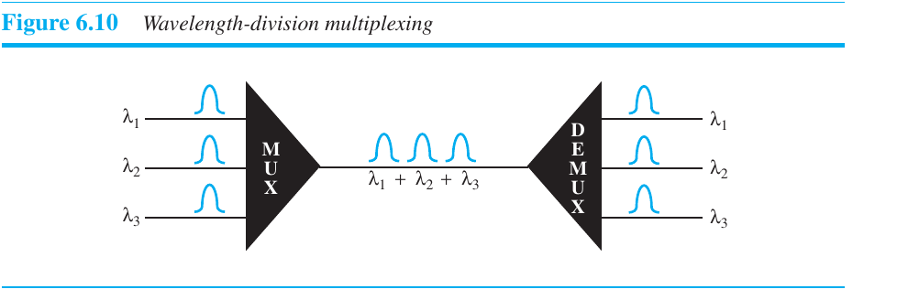

Time division multiplexing (TDM) is a digital process that allows several connections to share bandwidth of a link. Instead of sharing bandwidth, time is shared.

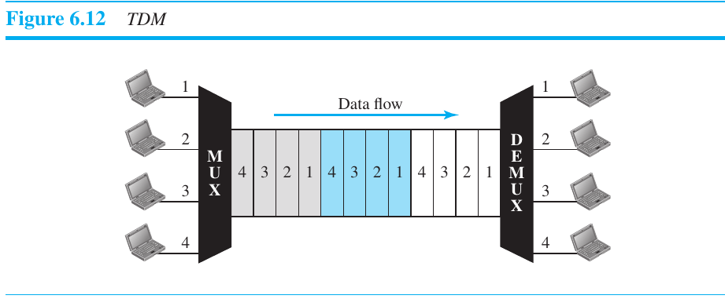

Problems: P6-2, P6-4, and P6-8
P6-2 We need to transmit 100 digitized voice channels using a passband channel of
20 KHz. What should be the ratio of bits/Hz if we use no guard band?

Divide 20 Khz by 100 channels = 0.2 kHz per channel or 200 Hz

After this point, the textbook and provided notes are of no help. So I went online for an answer:
https://stackoverflow.com/questions/16548759/ratio-of-bits-hz-of-digitized-voice-channel
https://dsp.stackexchange.com/questions/22107/why-is-telephone-audio-sampled-at-8-khz

Both mention a sampling rate of 64 kbps.

So bits/Hz would be 64 kbps / 0.2 kHz = 320 bits/Hz

P6-4
We need to use synchronous TDM and combine 20 digital sources, each of
100 Kbps. Each output slot carries 1 bit from each digital source, but one extra
bit is added to each frame for synchronization. Answer the following questions:
a. What is the size of an output frame in bits?
frame size = 20 + 1 bits

b. What is the output frame rate?
frame rate = 1/frame duration = 1/input slot duration
= 1/100 Kbps = > 100k frames per second

c. What is the duration of an output frame?
frame duration = 1/frame rate = 1/ 100k = 0.01 milliseconds

d. What is the output data rate?
frame rate * frame size = 100k * 21 = 2.1 Mbps

e. What is the efficiency of the system (ratio of useful bits to the total bits)?

efficiency = useful bits/total bits sent = 20/21 = 0.9524

P6-8
Four channels, two with a bit rate of 200 kbps and two with a bit rate of
150 kbps, are to be multiplexed using multiple-slot TDM with no synchroni-
zation bits. Answer the following questions:
a. What is the size of a frame in bits?
b. What is the frame rate?
c. What is the duration of a frame?
d. What is the data rate?

Very similar to Example 6.11
Allocate 4 slots, 2 each to the 200 kbps channels:
2*200 kbps = 400 = 4 * 100 kbps
Allocate 3 channels for the two at 150 kbps.
2 * 150 kbps = 300 = 3 * 100 kbps
Basically divide all channels into those of 100 kbps.

a. So we have a total of 7 slots so each frame carries 7 bits.

b. frame rate = 1/frame duration = 1/input slot duration
= 1/100 Kbps = > 100k frames per second

c. 0.01 milliseconds

d. frame rate * frame size = 100k * 7 = 700 kbps

Actually use multiple slot multiplexing for this to make each line 50 kbps and allocated more slots in the frame, ie. 4 each for the 200 lines and 3 for the 150 line

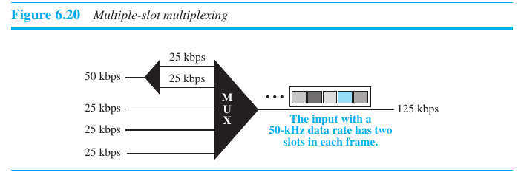

That means there are 14 bits in the frame.
b. What is the frame rate?

Each frame has 4 bits from 200 kbps lines, and 3 bits from the 150 kbps lines, so to keep up it needs to send 50,000 frames per second since 50k * 4b = 200 kbps and 50 k * 3b = 150 kbps.
c. What is the duration of a frame?
1/50,000 = 0.00002 seconds
d. What is the data rate?
50,000 frames per second * 14 bits = 700,000 bps or 700 kbps.

