Inner join, Left Join and Full Join:

Inner Join:

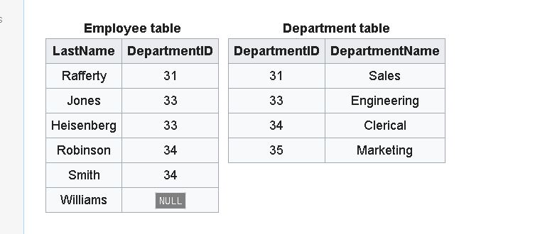

SELECT employee.LastName, employee.DepartmentID, department.DepartmentID

FROM employee

INNER JOIN department ON

employee.DepartmentID = department.DepartmentID

Result:

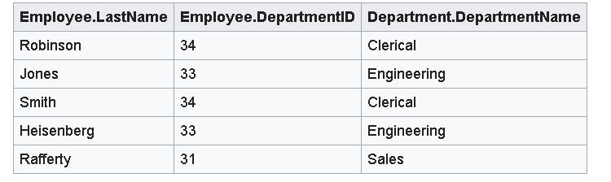

Left Join or Left Outer Join:

Always contains all rows of the left table “employees” even if join condition doesn’t find any matching row in “right” table.

SELECT \*

FROM employee

LEFT OUTER JOIN department ON employee.DepartmentID = department.DepartmentID;

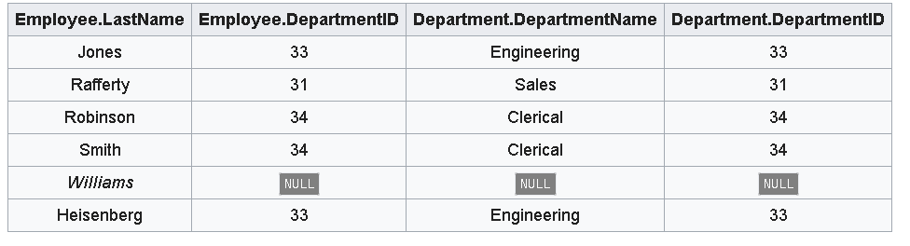

Full Join or Full Outer Join:

Where rows don’t match, result set will have NULL values for every column of table that lacks a matching row. For rows that match, a single row is produced in result set (with columns populated from both tables)

SELECT \*

FROM employee FULL OUTER JOIN department

ON employee.DepartmentID = department.DepartmentID;

