Homeworlds
Original by John Cooper, 2001.
Reference v1.4 by Nick ‘Nycki’ Lamicela, 2025.
Summary: Build an army of star ships to corner your opponent. Capture or destroy their star system to win.
Setup: Sort the pieces to form a bank. The bank has three copies of each piece, in three sizes (Small, Medium, Large) and four colors (Red, Yellow, Green, Blue).
Choose someone to go first. A more experienced player should go second.
In turn order, each player forms their initial homeworld. Select any two pieces from the bank, stack them upright, and place them in front of you, forming your home star system.
Select a third piece and place it pointing forwards from you. This is your first ship.
You will usually want to start with three different colors, including both Blue and Green. You will also usually want a Large piece for your ship.
The Board: The board is made up of star systems, placed anywhere on the table. You will start with just two star systems, but can discover more during a Warp action.
Star systems are connected if they have no star sizes in common. A Medium star is connected to Smalls, Larges, and Small-Large homeworlds.
Your homeworld is special, as it has two stars. Other star systems will only have one.
A star ship is always in orbit around a star system, indicated by placing the ship next to the star. A ship points forwards from the player that owns it. A star system may have any number of ships from one or more players. If a star system is orbited by zero ships, it is immediately returned to the bank.
Goal: You must own at least one ship in your homeworld at the start and end of your turn. If your homeworld is destroyed, or all your home ships are captured, you lose.
Turn Actions: Each turn, choose one of your own ships to activate. It may use any of the four Color Actions, as long as it has access to that color. A ship has access to itself, its current star system, and other pieces you own at that system. On the first turn, your first ship has access to its own color, plus both star colors in your homeworld.
- Red: Capture. Pick another ship in the same system, of equal or lesser size to your own. You now own that ship, rotate it appropriately. Remember that you can capture with a non-Red ship, as long as it has access to Red.
- Yellow: Warp. Move the active ship to any existing star, or discover a new one by placing it from the bank. It must be connected.
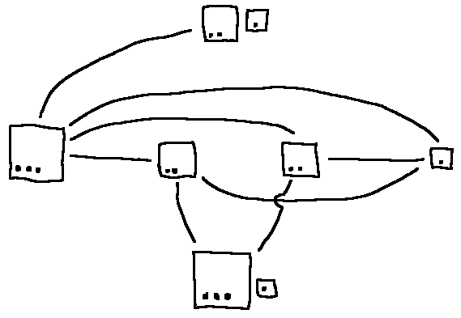Figure 1: Examples of Warp connections.
- Green: Clone. Take a Small from the bank of the same color as the active ship, and place it as a new ship you control in the same system. If all the Small pieces of that color are used up, take a Medium instead. If all the Smalls and Mediums are used up, take a Large.
- Blue: Trade. Replace the ship with a different colored piece from the bank of that exact size.
Sacrifice: Instead of taking a normal action, you can sacrifice one of your own ships for more actions. Return the ship to the bank. If it was a Small, Medium, or Large, take 1, 2, or 3 actions, respectively. The actions must match the color of the sacrificed ship. The actions may be taken by any ship or ships your own, even ones that wouldn’t otherwise have access to that color.
Pass: You may pass your turn. During a sacrifice, you are not required to use all of your actions.
Catastrophe: Whenever any star system has 4 or more pieces of the same color, counting both ships and stars, that is an overpopulation. At any time during your turn, you may call “catastrophe” on any overpopulation. All the pieces of that color in that system are returned to the bank immediately. If this destroys a star, return all stranded ships to the bank, too.
Because your homeworld has two stars, it can survive one catastrophe. If both stars in your homeworld are destroyed, you lose.
It is possible to eliminate yourself and your opponent in the same turn. In this situation, the game is a draw.

Strategy Tips:
The game will always end with a Capture or a Catastrophe. Keep an eye out for large invading pieces, or swarms of matching colored pieces.
If you have a Small Green ship in orbit around a Large star, you may Sacrifice the ship, return the empty star to the bank, and then immediately build the Large as a ship! You must have another ship of a matching color to Clone with, and there must be no Smalls or Mediums in the bank. This is called “Banking”.
If you have a Large Green ship and a Small Green Ship at the same system, you may sacrifice the Large ship for three Clone actions, use one of them to re-build the Large ship, and then get two bonus Clone actions, known as a “Factory”.
If you sacrifice a Medium or Large Yellow ship, you can use the extra Warp actions to flood your opponent’s homeworld with several ships of the same color, causing a fast catastrophe! Some players call this a “Doomsday Device”.
Sinister Variant, Babamots’ Version:
For more than two players. Add one extra copy of every piece per extra player. If you eliminate the player before you in turn order, you win. If you eliminate anyone else, they are removed from the turn order and the game continues.
Space Jam Variant, by Nycki: Roll a d6 each turn. Assign numbers to colors, for instance:
Yellow = 1, Red = 2, Green = 3, Blue = 4.
If you roll that color, you cannot use actions of that color on this turn. On a 5 or a 6, nothing happens.

